Advancing Healthcare Diagnostics: Machine Learning-Based Multi-Disease Prediction System
Chithjyot Kaur
CSE - Cloud Computing
SRM Institute of Science and Technology
Ghaziabad, UP, India
ck4092@srmist.edu.in

Abstract— In the ever-evolving landscape of healthcare, the integration of machine learning techniques has ushered in a new era of predictive analytics, revolutionizing disease diagnosis and prognosis. Machine learning is pivotal in the realm of disease prediction, where algorithms are harnessed to sift through vast datasets and discern patterns linked to specific health conditions. Many existing machine learning models related to healthcare, focus primarily on identifying individual diseases. However, this study introduces a system designed to predict multiple diseases simultaneously using a single user interface. The model developed in this study can forecast various conditions such as diabetes, heart disease and Parkinson’s disease. These diseases pose significant threats to human health if left undetected and untreated. The project's scope is comprehensive, aiming to predict the likelihood of various diseases in individuals based on their unique health profiles. Machine learning models, particularly techniques like Logistic Regression and Support Vector Machine, serve as the core predictive engines, leveraging diverse data sources to provide accurate and personalized risk assessments. Furthermore, the implementation of a user-friendly interface via Streamlit enhances accessibility and usability of the developed model. The project envisions a centralized platform that empowers both healthcare providers and individuals to make informed decisions about health risks and preventive measures.
Keywords—Machine Learning, Streamlit, SVM, Logistic Regression, Diabetes, Heart Disease, Parkinson’s Disease.

Introduction

The advent of machine learning techniques has catalysed a paradigm shift in healthcare, empowering practitioners with powerful tools for data-driven decision-making. Traditional healthcare practices often rely on symptom-based diagnosis, which can be limited in scope and accuracy, particularly in cases of complex diseases. In contrast, machine learning approaches have demonstrated remarkable capabilities in analysing vast amounts of data, identifying intricate patterns, and predicting disease outcomes with unprecedented accuracy.
In today's healthcare system, the challenge of early detection and prompt intervention for diverse diseases persists, often resulting in serious health consequences and heightened healthcare expenses. Conventional disease prediction methods heavily depend on manual evaluations and past data, constraining their precision and effectiveness. The incorporation of machine learning offers a paradigm shift by enabling the analysis of varied datasets and the extraction of intricate patterns, ultimately enhancing the predictive capabilities in healthcare. With the emergence of extensive medical datasets and progress in machine learning algorithms, there has been a path opened for the creation of advanced multi-disease prediction systems. These systems offer the prospect of early detection, tailored treatment approaches, and enhanced patient outcomes spanning various diseases.
This project, focuses on harnessing the potential of machine learning algorithms to predict and identify the risk of three prevalent diseases: diabetes, heart disease, and Parkinson's disease. Machine learning algorithms are employed to construct prediction models for various diseases, with Support Vector Machine (SVM) utilized for diabetes and Parkinson's disease and Logistic Regression for heart disease. The project initiates by gathering relevant data from Kaggle.com, which is then processed for training and testing the prediction models. Each disease prediction is addressed by a specific machine learning algorithm best suited for that ailment.
The application interface presents three options, each corresponding to a distinct disease. Upon selection, the user is prompted for the necessary parameters required by the corresponding model to predict the disease outcome. After the user provides the requisite parameters, the application presents the prediction outcome based on the input. Streamlit Cloud and the Streamlit library are employed to deploy the prediction models. Streamlit Cloud furnishes a platform for hosting and sharing the application, ensuring easy accessibility for users. Additionally, the Streamlit library simplifies the development of interactive and user-friendly web applications.
This project aims to deliver accurate predictions for multiple diseases in an intuitive manner by harnessing machine learning algorithms and streamlining the deployment process with Streamlit. The application's user-friendly interface enables users to input disease-specific parameters and acquire prediction results, thereby facilitating early detection and proactive healthcare management.
When developing a multiple disease prediction model, there are several key research questions to ensure the model's effectiveness, accuracy, and applicability. Some important research questions include:
- Which features are most relevant for predicting multiple diseases?
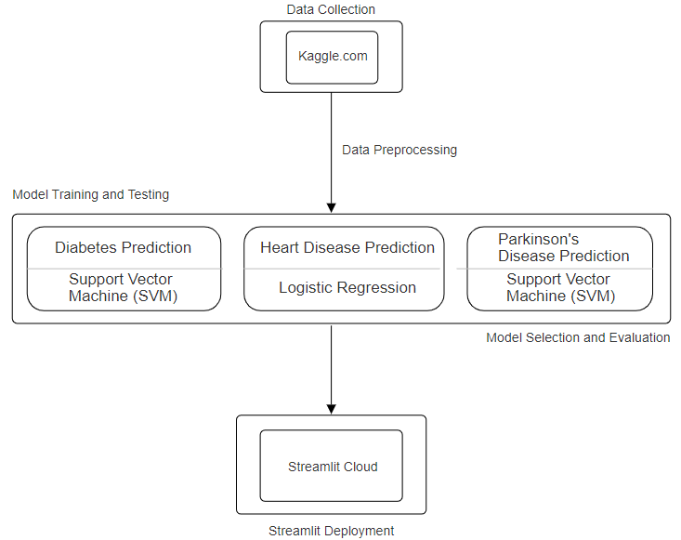
- How should data be structured to capture relationships between diseases and risk factors?
- What machine learning algorithms are best for predicting multiple diseases?
- How scalable and generalizable is the prediction model across diverse populations?
- What metrics should be used to evaluate the model's performance in multi-class prediction?

METHODOLOGY

The methodology for developing a multiple disease prediction machine learning model typically involves several key steps:

1) Data Collection : Diverse datasets are collected from Kaggle.com encompassing a broad spectrum of information pertinent to predicting Diabetes, Heart Disease, and Parkinson's Disease.

2) Data Preprocessing : The collected data is preprocessed to handle missing values, outliers, and inconsistencies. Feature engineering is performed to extract relevant features, encode categorical variables, and normalize or scale the data as needed.

3) Model Selection : Suitable ML algorithms are selected considering factors like the nature of the data, the complexity of the relationships between features and diseases, and computational efficiency. Support Vector Machine (SVM) and Logistic Regression are selected as the algorithms for various diseases based on their performance and suitability for the specific prediction tasks.

4) Model Training and Testing : Data is split into training and testing sets, followed by training using the training dataset and their performance is evaluated using the testing data.

5) Model Evaluation : The trained models are evaluated using appropriate performance metrics such as accuracy, precision, recall, F1-score, and area under the ROC curve (AUC). Models' generalization performance is accessed using the test set to ensure their effectiveness on unseen data.

6) Model Deployment : For model deployment, Streamlit is utilized along with its cloud deployment functionalities to develop an interactive web application. The application features a user-friendly interface offering options for three disease predictions: diabetes, heart disease, parkinson’s disease. Upon selecting a specific disease, the application guides the user to input the necessary parameters for prediction and predicts whether the patient suffers from the disease or not.

Multiple Disease Prediction : Methodology

PROBLEM STATEMENT

Within modern healthcare, the early detection of diseases and proactive intervention stand as pivotal factors for enhancing patient outcomes and curbing healthcare expenditures. However, existing disease prediction models predominantly concentrate on individual ailments, lacking the ability to predict multiple diseases concurrently. This gap underscores the necessity for a comprehensive multiple disease prediction model, integrating varied datasets and machine learning methodologies to accurately identify individuals susceptible to diverse conditions such as Diabetes, Heart Disease, and Parkinson's Disease, among others. The development of such a model poses a considerable challenge due to the intricate interconnections between different diseases and the diverse array of associated risk factors. Thus, there exists an urgent need to devise and implement a robust multiple disease prediction model, not only refining disease risk assessment but also providing actionable insights for personalized healthcare interventions and resource allocation.

EXISTING SYSTEM

In the realm of healthcare analysis, the predominant focus of machine learning models lies in individual diseases, requiring separate analyses for each specific ailment such as Diabetes, Heart Disease, and Parkinson’s disease. This approach treats each condition as a distinct entity, leading to a fragmented methodology. Consequently, users aiming to predict multiple diseases encounter challenges as they navigate through various platforms. Unfortunately, there is a notable absence of a unified system capable of conducting comprehensive disease predictions across multiple conditions.
Additionally, some existing models suffer from inadequate accuracy, posing potential risks to patient well-being. Organizational efforts to analyse patient health reports often involve deploying numerous models, resulting in heightened costs and time consumption. Furthermore, several prevailing systems rely on a limited set of parameters, raising concerns about potentially erroneous outcomes.
However, recently there have been researches in the field of multiple disease prediction utilizing different machine learning models like Logistic Regression, Naïve Bayes, Random Forest, SVM, KNN, etc. Different researches have proposed various models with varying accuracies in order to precisely predict the occurrence of such diseases. Multiple research studies have undertaken comparisons between Support Vector Machines (SVM) and alternative machine learning algorithms in disease prediction. For instance, Ahmad et al. (2019) pitted SVM against Random Forest and Artificial Neural Networks (ANN) in forecasting heart disease, revealing SVM's notable performance in both accuracy and interpretability. Similar investigations have been carried out concerning diabetes and Parkinson's disease prognosis, shedding light on distinct model strengths and weaknesses, and their suitability within multi-disease prediction contexts. Research has shown that simpler systems, such as logistic regression and support vector machines utilizing linear kernels, often yield more accurate results compared to more complex alternatives.

SYSTEM DESIGN

- PROPOSED SYSTEM

The proposed project encompasses a comprehensive disease prediction system leveraging various machine learning algorithms, including Support Vector Machine (SVM) and Logistic Regression. It aims to predict multiple diseases such as Diabetes, Heart disease and Parkinson's disease accurately. The system is designed to offer precise disease predictions based on input parameters through a user-friendly interface developed using Streamlit and deployed on Streamlit Cloud. Data sourced from the Kaggle platform, a renowned data science community, undergoes preprocessing to ensure its quality and suitability for training the models. Subsequently, the pre-processed data is utilized to train individual machine learning algorithms tailored to each disease. These trained models undergo rigorous testing to assess their accuracy in disease prediction.

Utilizing the SVM algorithm, the system attains a 78.33% accuracy in predicting diabetes, showcasing its efficacy in discerning the presence or absence of the condition among patients. This capability facilitates early detection and efficient disease management. In the case of Parkinson's disease prediction, the system achieves an accuracy of 87.17% with the SVM algorithm. Such high precision underscores the SVM model's effectiveness in distinguishing individuals afflicted with Parkinson's disease from those who are healthy. The Logistic Regression algorithm is employed for heart disease prediction, achieving an accuracy of 85%. This model adeptly assesses the probability of heart disease in patients, enabling timely intervention and suitable treatment.

The proposed system offers a Streamlit based user interface with a menu presenting three disease choices to select from: Diabetes, Heart disease and Parkinson’s disease. Upon selecting a particular ailment, users are prompted to input the requisite parameters for prediction. Following parameter submission, the system generates and displays the prediction outcome, empowering users with informed decision-making and proactive health monitoring.

ALGORITHMS

1) LOGISTIC REGRESSION :

Logistic Regression is a statistical method used for binary classification tasks, where the outcome variable (also called the dependent variable) is categorical and has two possible classes. It can take one of two values, often denoted as 0 and 1. For example, in a medical context, 0 might represent absence of a disease and 1 might represent presence of the disease.

Logistic Regression models the relationship between the predictor variables X1​,X2​,...,Xn​ (also called independent variables) and the log-odds of the binary outcome. It assumes a linear relationship between the predictors and the log-odds of the outcome. The log odds (logit) of the probability that the outcome variable equals 1 is obtained by taking the natural logarithm (ln) of the odds ratio. The odds ratio is the ratio of the probability of the event happening to the probability of the event not happening:
logit =log ( p/1−p)
Where:
- p is the probability of the event (in logistic regression, the probability of the outcome being 1).
- 1−p is the probability of the event not happening.

The logistic regression model can be used to predict the probability of the outcome being 1 for new observations based on their predictor variables. If the predicted probability is greater than a chosen threshold (e.g., 0.5), the observation is classified as belonging to the positive class; otherwise, it is classified as belonging to the negative class.
The model is trained with Logistic Regression for predicting heart disease in an individual. Dataset is divided into two subsets: a training set and a test set. The training set is typically larger and used to train the model, while the test set is used to evaluate its performance. The model learns the relationship between the predictor variables and the probability of disease occurrence. This involves estimating the coefficients (weights) associated with each predictor variable. Each trained logistic regression model is applied to new data (individuals' features) to predict the probability of disease occurrence.

2) SVM (Support Vector Machine) :

SVM aims to find the hyperplane that best separates data points belonging to different classes in the feature space. In a binary classification scenario, this hyperplane is a line that separates data points of one class from those of the other class with the maximum margin. The margin is the distance between the hyperplane and the nearest data points (called support vectors) of each class. SVM seeks to maximize this margin, as it indicates robustness to noise and better generalization to unseen data.

SVM can efficiently handle non-linear classification tasks by using a kernel function to map the input features into a higher-dimensional space where the data becomes linearly separable. Common kernel functions include linear, polynomial, radial basis function (RBF), and sigmoid. Given a dataset with labelled instances (i.e., individuals with known disease status), SVM learns the optimal hyperplane or decision boundary that separates the classes. The optimization problem of finding the maximum-margin hyperplane is formulated as a convex optimization problem. SVM seeks to minimize a cost function while satisfying constraints that ensure proper classification of training data. Linear kernel function is used for diabetes and Parkinson’s prediction model.
The results for all the ML models of final completed project are shown in the following figures and tables:

S.no | Name of Disease | Name of Algorithm | Proposed System Accuracy
1 | Diabetes | SVM | 78.33%
2 | Heart Disease | Logistic Regression | 85%
3 | Parkinson’s Disease | SVM | 87.17%

- Diabetes Prediction:
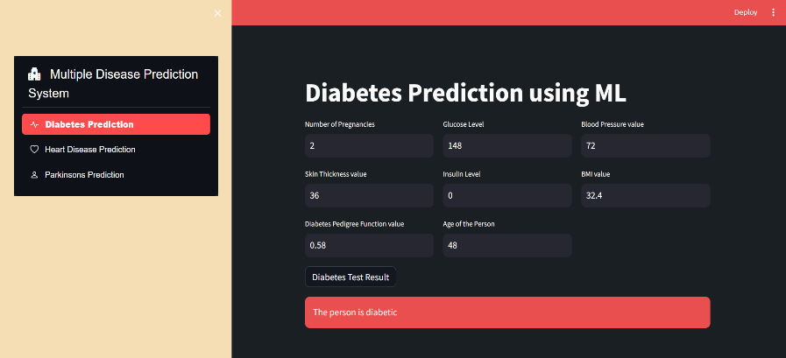
- Heart disease Prediction:
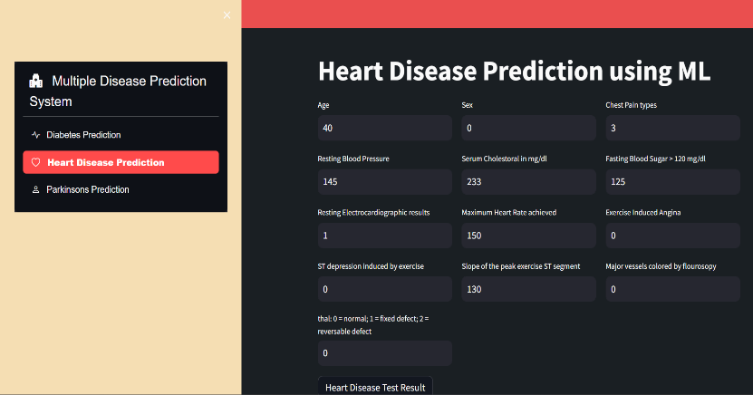
- Parkinson’s disease Prediction:
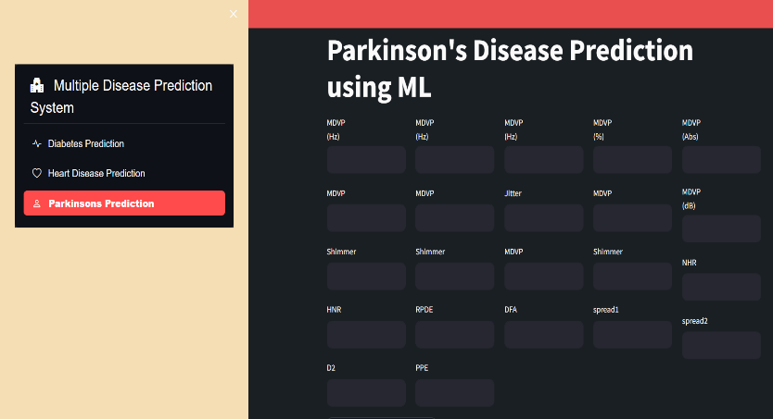

CONCLUSION

Through the utilization of advanced algorithms and techniques, this study demonstrates the potential of machine learning to enhance medical diagnosis and prognosis, thereby contributing to improved patient outcomes and healthcare decision-making. The findings of this research underscore the effectiveness of SVM in predicting diabetes, leveraging its ability to construct optimal hyperplanes for separating data points of different classes with maximum margin. Additionally, logistic regression emerges as a valuable tool in predicting heart disease and Parkinson's disease, offering a probabilistic interpretation of the relationship between predictor variables and disease occurrence. This project showcases the promise of machine learning in conjunction with the Streamlit library for crafting disease prediction models. Such an application holds substantial potential in aiding both healthcare professionals and individuals in the timely detection and prevention of various diseases. While the current system represents a significant step forward, there remains room for improvement and fine-tuning to enhance both accuracy and usability. With further enhancements and refinements, this tool can become an even more indispensable resource in the realm of disease prediction and prevention.

FUTURE SCOPE

The project has demonstrated promising outcomes in forecasting various diseases with commendable accuracies. Looking ahead, there are several areas where future development and enhancement emerge:
a) Expansion in the scope of diseases : While the current project addresses diabetes, heart disease and Parkinson's disease, there is potential for broadening the scope to encompass additional diseases. This expansion could result in a more comprehensive and diversified disease prediction system.
b) Integration of various Machine Learning Algorithms: Although the project already incorporates Support Vector Machines (SVM) and Logistic Regression, there exists a multitude of other machine learning algorithms worth exploring. The inclusion of algorithms such as Random Forest, Gradient Boosting, or Neural Networks may further enhance the accuracy and efficacy of the disease prediction models.
c) Real-time Monitoring: Augmenting the application to offer real-time monitoring and feedback can be advantageous. Functionalities such as reminders for routine health check-ups, tailored suggestions for disease prevention, or notifications for irregular health indicators can enable users to take proactive steps toward maintaining their health.

REFERENCES

- Srinidhi B, T.P Manasa “Multiple disease prediction using machine learning algorithms” International Research Journal of Engineering nd Technology (IRJET) Feb 2023 (Volume 10, Issue 02).

- R Manne, C Kantheti “Application of Artificial Intelligence in Healthcare: Chances and Challenges” Current Journal of Applied Science and Technology 40(6):78-89 DOI: 10.9734/CJAST/2021/v40i631320 (2021)

- D Dahiwade, G Patle, E Meshram “Designing Disease Prediction Model Using Machine Learning Approach” IEEE (2019) ISBN:978-1-5386-7808-4 DOI: 10.1109/ICCMC.2019.8819782

- A Atiq, L Manikandan “A Review on Machine Learning-Based Algorithms for Heart Disease Diagnosis and Prediction” International Journal of Scientific Research in Computer Science Engineering and Information Technology Vol 8, Issue 6 DOI:10.32628/CSEIT228686

- V. Sharma, S. Yadav and M. Gupta, "Heart Disease Prediction using Machine Learning Techniques," 2020 2nd International Conference on Advances in Computing, Communication Control and Networking (ICACCCN), Greater Noida, India, 2020, pp. 177-181, doi: 10.1109/ICACCCN51052.2020.9362842.

- M. Chen, Y. Hao, K. Hwang, L. Wang and L. Wang, "Disease Prediction by Machine Learning Over Big Data From Healthcare Communities," in IEEE Access, vol. 5, pp. 8869-8879, doi: 10.1109/ACCESS.2017.2694446. 2017

- P. Sonar and K. JayaMalini, "Diabetes Prediction Using Different Machine Learning Approaches," 2019 3rd International Conference on Computing Methodologies and Communication (ICCMC), Erode, India, 2019, pp. 367-371, doi: 10.1109/ICCMC.2019.8819841.

- V. Anuja Kumari, R.Chitra “Classification Of Diabetes Disease Using Support Vector Machine” International Journal of Engineering Research and Applications (IJERA) ISSN: 2248-9622 Vol. 3, Issue 2, March -April 2013, pp.1797-1801 1797

- A. Patle and D. S. Chouhan, "SVM kernel functions for classification," 2013 International Conference on Advances in Technology and Engineering (ICATE), Mumbai, India, 2013, pp. 1-9, doi: 10.1109/ICAdTE.2013.6524743.

- X. Zou, Y. Hu, Z. Tian and K. Shen, "Logistic Regression Model Optimization and Case Analysis," 2019 IEEE 7th International Conference on Computer Science and Network Technology (ICCSNT), Dalian, China, 2019, pp. 135-139, doi: 10.1109/ICCSNT47585.2019.8962457.

- W. Wang, J. Lee, F. Harrou and Y. Sun, "Early Detection of Parkinson’s Disease Using Deep Learning and Machine Learning," in IEEE Access, vol. 8, pp. 147635-147646, 2020, doi: 10.1109/ACCESS.2020.3016062.

- S. Mohanty, A. Jain, A. Jha, S. Thakur and S. Prakash, "Various Disease Forecast Using Machine Learning and Streamlit," 2023 IEEE 11th Region 10 Humanitarian Technology Conference (R10-HTC), Rajkot, India, 2023, pp. 841-846, doi: 10.1109/R10-HTC57504.2023.10461917.

