Web Trade Analytics
Jaydeep Patidar ^{[1]}, Raj Parmar ^{[2]}, Shlok Kumar Jain ^{[3]}, Vishesh Shrivastava ^{[4]}, Sumeet Dhillon ^{[5]}
Department of Computer Science and Engineering,
Samrat Ashok Technological Institute,
Vidisha, 464001, India

Abstract— This research introduces an innovative web application developed using the MERN (MongoDB, Express.js, React, Node.js) stack, enhanced with fundamental machine learning algorithms, designed to address the complexities of stock market analysis. The central focus is on creating a user-customizable dashboard, allowing investors to select specific stocks for real-time analysis, sentiment tracking, and future price prediction.
The methodology integrates historical stock data with sentiment analysis sourced from news and social media. The machine learning algorithms leverage this data to generate buy or sell recommendations and forecast future price trends. Our findings underscore the practicality of this approach, enhancing investors' abilities to navigate the unpredictable stock market landscape and make informed decisions with an eye on the future.
Keywords— Stock Market, MERN Stack, Predictive Analysis, Future Forecasting

Introduction
India's stock market ranks 12th globally in terms of market capitalization. Despite its significant potential, stock market trading accounts for only 4% of India's GDP, a fraction compared to developed countries like the USA, where it accounts for around 55%. To address this underutilization, our web app leverages the MERN (MongoDB, Express.js, React, Node.js) stack and basic machine learning algorithms to empower investors and contribute to India's economic growth.

CONVENTIONAL STOCK ANALYSIS SHORTFALLS

Limitations of Traditional Approaches
Conventional stock analysis methods, primarily focused on technical and fundamental analysis, face limitations when it comes to predicting individual stock movements. Often applied at a macroeconomic level, these approaches struggle to provide precise insights for selected stocks.
- Fundamental Analysis:
This approach relies on a company's historical performance, such as P/E ratios, to forecast stock prices. However, it overlooks the complex interplay of factors affecting individual stocks.
- Technical Analysis:
Technical analysis uses historical price data and indicators like RSI and moving averages for market trend predictions. Yet, it often falls short of capturing the nuances of individual stock behaviors.

Modern Stock Analysis in Our Web App
Our web app adopts a contemporary approach to stock market analysis, harnessing the potential of fundamental machine learning algorithms. These core algorithms, which include Support Vector Machines (SVM), Recurrent Neural Networks (RNN), and Ensemble Learning (EML), underpin our platform, elevating the decision-making capabilities of investors.
- Qualitative Research:
We acknowledge the significant influence of news sentiment on stock market trends. Our app seamlessly integrates real-time newsfeeds, recognizing that market sentiment can substantially impact stock prices. Staying updated with positive and negative news gives investors a comprehensive view of market dynamics, facilitating more informed decision-making.
- Quantitative Research:
By utilizing historical stock data, our platform employs essential machine learning algorithms for in-depth analysis of individual stock movements. Unlike traditional cumulative approaches, our models concentrate on unraveling the unique behaviors of each stock. This adaptability empowers them to excel in diverse market conditions and economic scenarios, providing investors with tailored insights for their stock portfolios.

Literature Review

Existing Literature:
A substantial body of literature delves into stock market prediction, financial analysis, and the role of web-based tools in investment decision-making. Traditional methods such as fundamental and technical analysis have historically played a pivotal role in stock market prediction (Hirshleifer, 2015). These established approaches heavily rely on historical financial data and statistical indicators to forecast price trends.
Simultaneously, web-based tools have ushered in a new era for investors, granting them real-time access to market data, news, and analytical insights. These platforms, driven by technological advancements, offer user-friendly interfaces and customizable dashboards that empower investors to monitor stock performance effectively (Barberis et al., 2018).

Identified Gap:
A conspicuous void in the current literature pertains to the integration of basic machine learning algorithms into accessible, user-centric web-based stock analysis platforms that seamlessly combine stock market prices with in-depth analysis. Existing studies often gravitate towards either traditional methods or delve into complex machine learning techniques, which can be daunting for the average investor.

Methodologies

Architecture and Components:
Our web app's architecture comprises three integral components: front-end, back-end, and the database. The front end is developed using React.js, ensuring a responsive and engaging user interface. Node.js and Express.js form the core of our back-end, handling user requests, data processing, and database interactions. MongoDB serves as our database system, storing user profiles, customized stock preferences, and real-time stock data.

Technologies and Tools:
Front-end development is powered by React.js, which enables us to create a dynamic and responsive user experience. Node.js and Express.js are chosen for the back-end due to their scalability and efficiency. MongoDB, a NoSQL database, offers flexibility in managing user data and stock-related information.

Real-Time Stock Data Collection:
We source real-time stock data through APIs from reputable financial data providers. These APIs grant us access to the latest stock prices, historical data, and newsfeeds. To ensure our users have access to the most up-to-date market information, we maintain continuous data updates to our database.

Price Prediction Models:
In line with our project's focus on basic machine learning algorithms, we employ regression models like Linear Regression and Time Series Forecasting for stock price prediction. These models utilize historical stock data to provide predictions for selected stocks. Although less complex than deep learning models, these algorithms yield reliable insights for investors.

User Customization and Dashboard Creation:
User customization is central to our web app's design. We have implemented user profiles where investors can personalize their stock portfolios. Our dashboard is dynamically created, allowing users to select specific stocks for analysis and monitoring. Machine learning models generate personalized recommendations based on user preferences and real-time data.

Data collection and analysis

Sources of Data:
Our web app relies on multiple sources for real-time stock data and newsfeeds. These sources include well-established financial data providers and news outlets known for their accuracy and reliability. We collect data on stock prices, historical trends, and sentiment analysis from these sources to ensure a comprehensive and up-to-date dataset.

Data Preprocessing Steps:
Prior to analysis, we perform extensive data preprocessing to ensure the quality and reliability of the dataset. Data preprocessing steps include:
- Data Cleaning:
Removing duplicate or inconsistent entries and handling missing data to maintain data integrity.
- Normalization:
Scaling data to a consistent range to ensure uniformity for machine learning algorithms.
- Feature Engineering:
Selecting relevant features and creating new ones, such as technical indicators for stock analysis.

User interface and user experience

Stock Prediction:
Upon logging in, users have the flexibility to handpick the companies they wish to include in their personal dashboard. This feature allows users to curate their stock portfolio according to their investment preferences and objectives.

Detailed company analysis:
Once users have selected their preferred companies, they can easily access comprehensive detailed analyses for each chosen company. Our intuitive interface allows users to delve into intricate company-specific data and insights, aiding them in making well-informed investment decisions.

User-Friendly navigation:
Navigating through the dashboard and accessing detailed company analyses is designed to be user-friendly. We employ clear and intuitive navigation menus and interfaces, ensuring users can seamlessly switch between various features and selected companies.

Real-Time Updates:
Our web app ensures that users receive real-time updates on stock prices and news related to their chosen companies. This feature guarantees that users always have access to the most current market information.

Performance Metrics Comparison::
In addition to detailed company analysis, users can compare key performance metrics across the top four stock market companies simultaneously. This feature enables users to evaluate the financial health and growth potential of their chosen companies relative to each other, facilitating more informed investment decisions.

results
Through the utilization of a substantial dataset, we evaluated the efficiency of our developed stock performance and price prediction model. In contrast to traditional analysis approaches, our model consistently yielded strong outcomes, displaying a remarkable level of precision in forecasting both stock performance and pricing. This underscores the potential of machine learning in enhancing stock research and prediction.
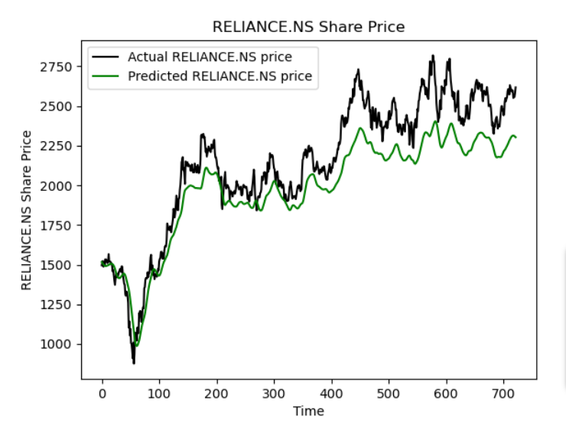
Fig.1- Reliance (NSE) fetched from Yahoo finance API

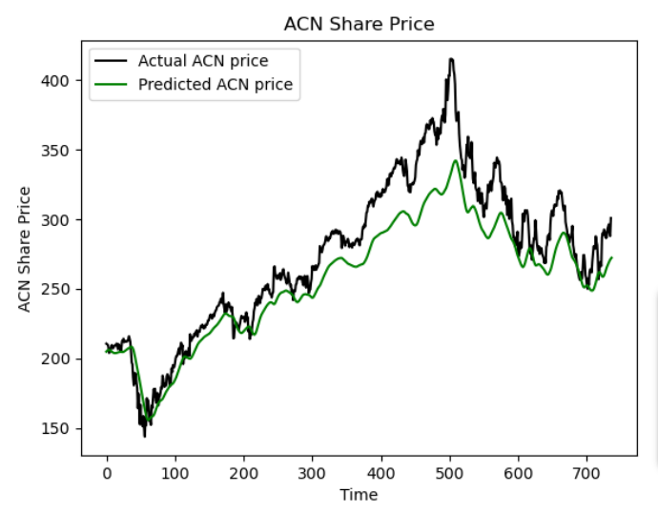
Fig.2- Accenture (NYSE) fetched from Yahoo finance API

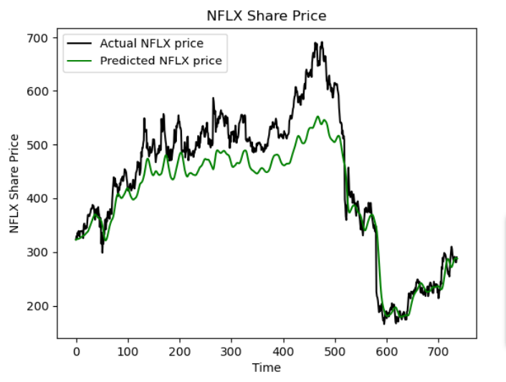
Fig.3- Netflix (NYSE) fetched from Yahoo Finance API
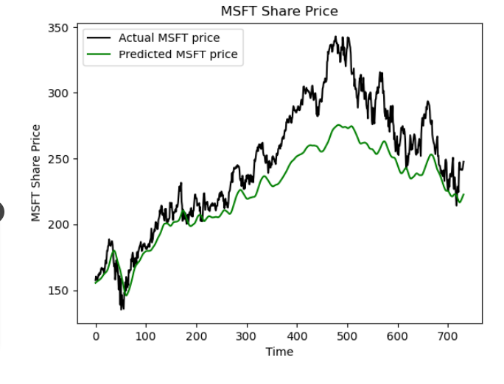
Fig.4- Microsoft (NYSE) fetched from Yahoo finance API

Future Scope and Conclusion

Future Enhancement:
Our web app lays the foundation for ongoing improvements and expansions. Here are some potential directions for future development:
- Advanced ML Algorithms:
Implementing more advanced machine learning algorithms, such as deep learning and ensemble methods, to further improve prediction accuracy and uncover deeper insights into stock data.
- Predictive Analysis:
Expanding the scope to include predictive analytics for market trends, economic indicators, and sector-specific analyses to provide users with a comprehensive view of the market.
- User Interactivity:
Enhancing user interactivity with features like virtual trading simulations, sentiment analysis customization, and real-time chat support to create a more engaging user experience.

Conclusion:
In conclusion, our web app represents a significant step in democratizing stock market analysis and prediction. Our main contributions can be summarized as follows:
- Democratizing Access:
We aim to make stock market analysis accessible to a wider audience, leveling the playing field for all types of investors, from novices to experts.
- User-Centric Design:
Our user-centric approach prioritizes customization and interactivity, ensuring users can personalize their stock portfolios and access tailored insights.
- Real-Time Insights:
We provide users with real-time stock data and sentiment analysis, empowering them with the latest market information for informed decision-making.

Acknowledgements
The authors would like to extend their heartfelt appreciation to Samrat Ashok Technological Institute for their steadfast support and encouragement in facilitating this research and development endeavor.
We are immensely grateful to our dedicated project mentor, Mrs. Sumeet Dhillon, whose valuable guidance and insightful inputs have been instrumental in shaping the project's success.

References

- https://www.geeksforgeeks.org/stock-price-prediction-using-machine-learning-in-python/
- https://www.analyticsvidhya.com/blog/2021/10/machine-learning-for-stock-market-prediction-with-step-by-step-implementation/
- https://www.datacamp.com/tutorial/lstm-python-stock-market
- https://www.javatpoint.com/machine-learning-random-forest-algorithm
- https://www.analyticsvidhya.com/blog/2022/01/the-complete-lstm-tutorial-with-implementation/
- https://ieeexplore.ieee.org/abstract/document/10061120
- https://www.ijert.org/?s=stock+market
- The Python Bible Volume 5: Python For Finance (Stock
- Analysis, Trading, Share Prices) by Florian Dedov

