“IMMERSIVE LEARNING: VIRTUAL REALITY'S IMPACT ON MEDICAL CURRICULUM”
Dr. Arjun B. C¹, Sachith Gowda M²
¹Prof. and HOD, Information Science and Engineering, Rajeev Institute of Technology, Hassan
²Information Science and Engineering, Rajeev Institute of Technology, Hassan

---------------------------------------------------------------------***--------------------------------------------------------------------

ABSTRACT

Virtual Reality (VR) is revolutionizing education by offering immersive and interactive learning experiences that enhance engagement and retention. Despite its potential benefits, implementing VR in education faces challenges such as high costs, technical requirements, and content development. In the medical field, VR is transforming medical education by providing realistic simulations for training in various procedures, anatomy visualization, and patient interactions. Studies indicate that VR improves procedural skills, anatomical understanding, and diagnostic accuracy among medical students. Furthermore, VR offers personalized learning experiences, remote training capabilities, and collaborative opportunities in medical training. Looking ahead, VR has the potential to revolutionize healthcare by enhancing patient care, treatment planning, and telemedicine services through immersive experiences and advanced simulations.

Key Words: Virtual Reality (VR), VR education, Immersive Experience, VR in medical field, VR anatomy, Technological Innovation.

INTRODUCTION

Virtual Reality (VR) has emerged as a groundbreaking technology with the potential to revolutionize various sectors, including education and healthcare. The concept of VR revolves around creating immersive and interactive simulated environments that allow users to engage with a three-dimensional, computer-generated world. In the realm of education, VR offers experiential learning opportunities that significantly enhance student engagement, understanding, and retention. Unlike traditional educational methods, which primarily rely on lectures and textbooks, VR bridges this gap by providing a novel approach to experiencing and interacting with educational content, thereby making learning more engaging and interactive.

However, despite the promising potential of VR in education, its implementation presents several challenges. One of the most significant hurdles is the high initial costs associated with acquiring the necessary equipment and software, as well as the technical expertise required for setup and maintenance. Additionally, the development of high-quality VR content tailored to educational needs demands considerable time and resources.

Nevertheless, the benefits of incorporating VR into education are substantial. Research has demonstrated that VR can significantly enhance student outcomes by offering personalized learning experiences that cater to individual needs and learning styles. Moreover, VR facilitates remote training capabilities, enabling students to access educational content from virtually anywhere, thereby breaking down geographical barriers to learning. Furthermore, VR-based group activities foster collaborative learning environments, promoting teamwork and communication skills essential for success in various professional fields.

In the medical domain, VR is driving a paradigm shift in medical education and training. By providing realistic simulations for a wide range of medical procedures, anatomy visualization, and patient interactions, VR enables medical students to practice and refine their skills in a safe and controlled virtual environment without posing any risk to patients. Studies have consistently shown that VR enhances procedural skills, anatomical understanding, and diagnostic accuracy among medical students, thereby augmenting the quality of medical education and training programs.

Moreover, VR opens up avenues for interdisciplinary collaboration among healthcare professionals, facilitating the exchange of knowledge and expertise across different specialties. By fostering teamwork and communication skills, VR-based medical training programs not only prepare students for the complexities of real-world healthcare settings but also contribute to improving patient outcomes.

LITERATURE SURVEY

Title | Year | Author Name | Proposed Methodology
[1] Effects of Virtual Reality training on medical students | 2019 | Mian Usman Sattar, PhD, (Informatics) Student, School of Science and Engineering, Malaysia University of Science and Technology. | Effects of Virtual Reality training on medical students
[2] Revolutionizing medical education: the impact of Virtual and Mixed Reality on training and skill acquisition | 2024 | Fabiana D'Urso and group, Student at University of Georgia. | This paper delves into a Revolutionizing Medical Education: The Impact of Virtual and Mixed Reality on Training and Skill Acquisition.
[3] Virtual reality and augmented reality in medical education: | 2024 | Veronica Penza, Italian Institute of Technology (IIT), Italy. | This paper explores the utilization of Mixed Reality (MR) for medical Simulations, encompassing benefits and drawbacks. It emphasizes the significance of accurate training for doctors and discusses how MR aids in this aspect, while also addressing areas for improvement.
[4] Virtual Reality in Medical Education | 2020 | Ahmet Berk Ustun, amazan Yılmaz, atma Gizem Karaoğlan Yılmaz  Bartin University | The aim of this research is to examine student acceptance and use of virtual reality technologies in medical education. Within the scope of the research, a questionnaire consisting of 4 sub-dimensions and 21 items was developed by the researchers.
[5] Effects of Medical Education Program Using Virtual Reality: A Systematic Review and Meta-Analysis | 2023 | Hyeon-Young Kim, Eun-Young Kim | This study is a systematic review and meta-analysis that was conducted to integrate and determine the effects of VR-based medical education on current and prospective health personnel. This study was conducted according to the reporting guidelines outlined in the Preferred Reporting for Systematic Reviews and Meta-Analysis (PRISMA) statement.

APPLICATIONS

3.1 VR Anatomy application:

AR Virtual Reality (VR) offers an innovative approach to anatomy education by providing immersive and interactive experiences for medical students. With VR anatomy, students can explore detailed 3D models of the human body, allowing for a deeper understanding of anatomical structures and their spatial relationships. This hands-on learning experience enhances retention and comprehension compared to traditional 2D textbooks or lectures. VR anatomy also allows students to interact with different layers of the body, from skeletal structures to organs and tissues, providing a comprehensive view of human anatomy. Moreover, VR anatomy can be tailored to individual learning needs, allowing students to focus on specific areas of interest or study complex anatomical relationships in detail. Overall, VR anatomy offers a transformative learning environment that bridges the gap between theoretical knowledge and practical application in medical education.

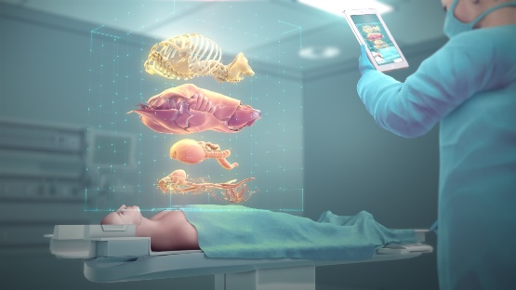

Figure 3.1: VR Anatomy

3.2 VR application to Reducing Pain and Anxiety for Kids:

Virtual Reality (VR) has shown promising results in alleviating pain and anxiety among pediatric patients undergoing medical procedures or treatments. By immersing children in engaging and distracting virtual environments, VR helps shift their focus away from the medical setting, reducing their perception of pain and discomfort. These immersive experiences, such as underwater adventures or space exploration, serve as effective distractions that make medical procedures more tolerable for children. Additionally, VR offers calming and soothing virtual landscapes that can help lower anxiety levels in children before or during medical interventions. This personalized and interactive therapy approach empowers children with a sense of control and choice, further enhancing their overall medical experience. Research has supported the effectiveness of VR in reducing pain and anxiety in pediatric patients, highlighting its potential as a valuable tool in pediatric healthcare settings.

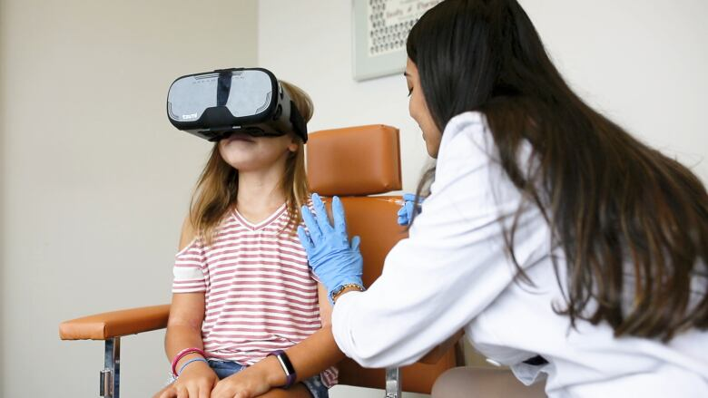

Figure 3.2: VR for reduce Pain and Anxiety for Kids

3.3 Hologrammatic Mixed Reality application
Hologrammatic education from Mixed Reality (MR) combines the virtual and physical worlds to create immersive educational experiences. In medical education, MR allows students to interact with holographic representations of anatomical structures, medical devices, or surgical procedures. This hands-on approach enables students to visualize complex concepts in three dimensions, enhancing their understanding and retention of medical knowledge. MR also facilitates collaborative learning by allowing multiple users to interact with the same holographic content simultaneously, fostering teamwork and communication skills among medical students. Moreover, MR offers a flexible learning environment where students can customize their educational experiences based on their learning styles and preferences. By integrating hologrammatic education from Mixed Reality into medical curriculum, educators can create engaging and interactive learning opportunities that prepare students for real-world healthcare challenges.

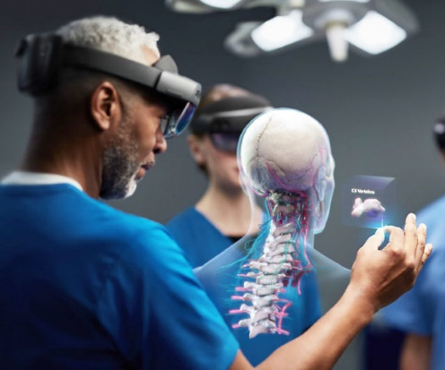

Figure 3.3: Hologrammatic education from Mixed Reality

- ARCHITECTURE OF VIRTUAL REALITY

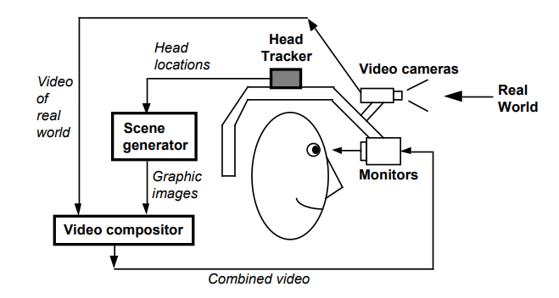

Figure 4.1: Virtual Reality Architecture

The architecture of a Virtual Reality (VR) system typically consists of several interconnected components that work together to create immersive virtual experiences.

  - Key Elements of Virtual Reality Architecture:

4.1.1. Hardware Components:
VR Headset: The primary interface between the user and the virtual environment, providing stereoscopic displays and head tracking capabilities.
Input Devices: Controllers, gloves, or other peripherals used to interact with virtual objects and navigate within the VR environment.
Sensors: Positional tracking sensors (e.g., cameras, infrared sensors) to track the user's movements and gestures, enabling real-time interaction and immersion.
Audio Devices: Headphones or speakers to provide spatial audio cues and enhance the sense of presence in the virtual world.

4.1.2. Software Components:
Rendering Engine: A software engine responsible for rendering 3D graphics in real-time, generating the visual elements of the virtual environment based on input from the user and the application.
Physics Engine: Simulates the physical behavior of virtual objects, including collision detection, gravity, and object interactions, to create a realistic and immersive experience.
Input Processing: Software modules that process input from sensors and input devices, translating user actions into interactions within the virtual environment.
Scene Graph: A hierarchical data structure representing the objects and elements in the virtual scene, facilitating efficient rendering and manipulation of virtual objects.
Interaction Logic: Algorithms and scripts that govern the behavior of virtual objects, user interfaces, and interactive elements within the VR environment.
Networking: Support for networked multiplayer experiences, enabling multiple users to interact and collaborate within the same virtual space.

4.1.3. System Architecture:
Client-Server Model: In networked VR applications, a client-server architecture may be used, where the server manages the virtual environment and synchronizes state between multiple clients.
Event-Driven Architecture: VR applications often utilize an event-driven architecture, where user actions and system events trigger responses and updates within the virtual environment.
Latency Reduction Techniques: Techniques such as predictive tracking, asynchronous time warp, and frame interpolation are employed to reduce latency and improve responsiveness, minimizing motion sickness and enhancing user comfort.

4.1.3. Integration and Optimization:
Hardware-Software Integration: Ensuring seamless integration between hardware components (e.g., headsets, controllers) and software systems to deliver a cohesive VR experience.
Performance Optimization: Optimizing rendering performance, input latency, and overall system responsiveness to deliver smooth and immersive VR experiences across a range of hardware configurations. In medical field using VR, various sensors play a crucial role in tracking and enhancing the user's experience. Here are some commonly used sensors:

  - Commonly Used Sensors and Haptic Feedback in Medical Training:

4.2.1. Motion Tracking Sensors:
Motion tracking sensors, such as accelerometers, gyroscopes, and magnetometers, are integral components in medical VR applications. These sensors track the user's head and body movements in real-time, allowing medical professionals to navigate and interact with anatomical models or surgical simulations. By providing accurate positional tracking, motion tracking sensors enhance the precision and realism of medical VR experiences, enabling more effective training and skill development.

4.2.2. Gesture Recognition Sensors:
Gesture recognition sensors, like depth cameras and infrared sensors, play a vital role in medical VR training by detecting and interpreting hand gestures and body movements. These sensors allow medical students and professionals to interact with virtual medical devices, patient data, or surgical tools using natural gestures. This intuitive interaction method enhances immersion and engagement, making medical training more interactive and effective.

4.2.3. Biometric Sensors:
Biometric sensors, including heart rate monitors, electrodermal activity sensors, and eye-tracking cameras, are used to monitor physiological responses and cognitive states during medical training sessions. By tracking stress levels, attention, and performance, these sensors provide valuable feedback to trainers. This data-driven approach enables personalized training scenarios, helping to optimize learning outcomes and improve the overall effectiveness of medical training programs.

4.2.4. Force Feedback Sensors:
Force feedback sensors, such as force-sensitive resistors and pressure sensors, contribute to the realism and tactile feedback in medical VR simulations. Medical students and professionals can feel the resistance and texture of virtual anatomical structures or surgical tools, enhancing their understanding and mastery of complex medical procedures.

Full-Body Haptic Feedback Suits in Medical Training:
Full-body haptic feedback suits offer a transformative approach to medical training by providing tactile sensations and haptic feedback across the user's entire body. These advanced wearable devices simulate realistic medical scenarios, enhancing immersion and realism in VR experiences.

Actuators and Vibrating Motors:
The suits are equipped with a network of actuators and vibrating motors strategically placed throughout the body. These components simulate tactile sensations and vibrations corresponding to virtual medical interactions and environmental stimuli.

Flexible Fabric and Lightweight Design:
Made from flexible and lightweight materials, full-body haptic feedback suits ensure comfort and mobility during extended medical VR sessions. The design allows medical professionals to practice physical examinations, surgical procedures, or patient care simulations without restrictions.

Haptic Feedback Control Software:
Specialized software controls the haptic feedback patterns, synchronizing them with virtual medical events and interactions in real-time. This software adjusts the intensity, frequency, and location of haptic feedback sensations based on user actions and medical scenarios.
Wireless Connectivity:
Many haptic feedback suits feature wireless connectivity options, allowing seamless integration with medical VR systems. Wireless communication enables real-time data transmission and synchronization between the VR application and the haptic feedback suit, enhancing user experience and flexibility.

Customizable Feedback Profiles:
Users can customize haptic feedback profiles based on personal preferences and comfort levels. Adjustable parameters may include vibration intensity, frequency ranges, and haptic response patterns tailored to individual medical training needs and sensory sensitivities.

IMPACT OF VIRTUAL REALITY IN MEDICAL INSTITUTES

5.1 VR Simulation at Johns Hopkins University School of Nursing
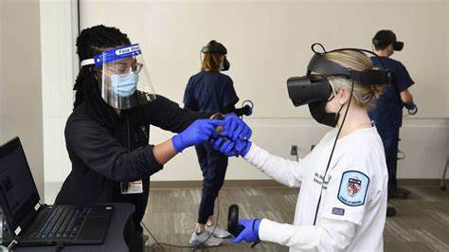

Johns Hopkins University (JHU) School of Nursing is one of the world’s leading nursing programs, driving advancements in education, research, and practice. The newly implemented VR program is part of their integrated simulation training program, including manikins and live actors, and complements clinical visits with hospital patients. JHU’s Virtual Reality lab provides fully immersive virtual placements for multiple nursing programs, including the newly launched DNP Nurse Anesthesia and DNP Pediatric Dual Primary/Acute Care Nurse Practitioner programs. The program’s implementation in 2020 helped JHU maintain training momentum during the COVID-19 pandemic [9].

  - Harvard Medical School - Biomedical Visualization Lab

The Harvard Medical School - Biomedical Visualization Lab is a pioneering institution located within the Harvard Medical School campus in Boston, Massachusetts. Dedicated to advancing medical education and research, the lab specializes in creating interactive 3D visualizations of human anatomy and medical data. Leveraging state-of-the-art VR and AR technologies, they develop immersive experiences for teaching anatomy, assisting in surgical planning, and visualizing complex medical data. Their collaborations with researchers, clinicians, and industry partners have led to innovative tools and techniques that are widely used in medical training and clinical practice.

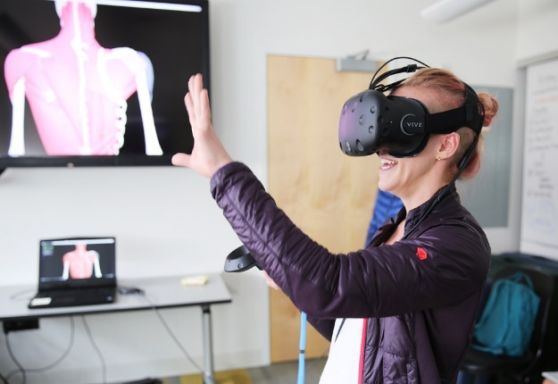

Through their impactful work, the Biomedical Visualization Lab continues to push the boundaries of medical visualization, enhancing both patient care and medical education globally [8].

  - University of Oxford - Immersive Technologies Lab

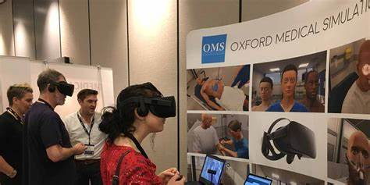

The University of Oxford - Immersive Technologies Lab is a leading research facility focused on the development and application of virtual reality (VR) and augmented reality (AR) technologies in healthcare. Located within the University of Oxford, this lab explores innovative ways to use immersive technologies for medical education, surgical planning, and patient care. Utilizing advanced VR and AR platforms, the lab creates interactive simulations, 3D models, and visualizations to enhance medical training and research. Collaborating with healthcare professionals, educators, and industry partners, the Immersive Technologies Lab plays a pivotal role in advancing the use of immersive technologies in medicine. Through their groundbreaking work, they continue to contribute to the evolution of healthcare, improving outcomes and transforming medical practice [7].

  - VR in Aarupadai Veedu Medical College and Hospital (AVMCH), Puducherry, India

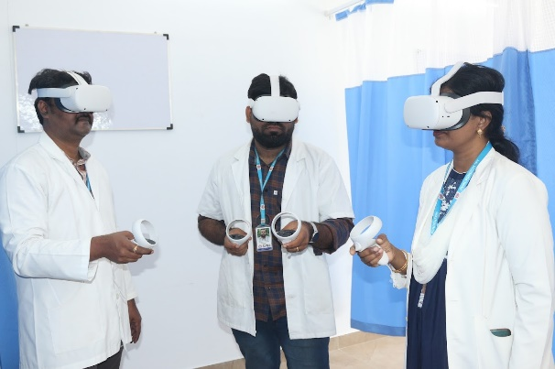

AVMCH has shown interest in adopting advanced technologies to enhance medical training and patient care. The college has been known to invest in state-of-the-art facilities, including simulation labs and technology-driven learning environments. It's likely that AVMCH is exploring or has implemented VR technology to supplement traditional teaching methods, providing students with immersive experiences for learning anatomy, practicing surgical procedures, or engaging in interactive medical simulations. For the most accurate and up-to-date information on VR implementation at Aarupadai Veedu Medical College, it would be best to visit their official website or contact the college directly [6].

- CONCLUSION

The integration of virtual reality (VR) technology into medical education represents a transformative leap in enhancing healthcare professionals' readiness and proficiency. Our immersive VR learning environments offer lifelike simulations that emulate real-world medical scenarios, allowing students and professionals to practice and refine essential clinical skills safely. Through collaborative efforts between medical institutions and technology developers, our VR simulations cover diverse medical training modules, ensuring comprehensive skill development and clinical preparedness. This cost-effective and scalable VR system enables repetitive practice and mastery of medical techniques in a controlled environment. As VR technology evolves, our system is poised to leverage advancements to enhance medical education, improve clinical decision-making, and ensure healthcare professionals' adaptability to meet the challenges of modern healthcare. The adoption of VR in medical education signifies a shift towards more immersive and effective learning methodologies, equipping healthcare professionals with the skills and confidence to navigate the evolving healthcare landscape competently.

REFERENCES

- Baukal, C. E., Ausburn, F. B., & Ausburn, L. J. (2013). A Proposed Multimedia Cone of Abstraction: Updating a Classic Instructional Design Theory. Journal of Educational Technology, 9(4), 15–24.
- Seymour, N. (2008). VR to OR: A review of the evidence that virtual reality simulation improves operating room performance. World Journal of Surgery, 32(2), 182–188.
- Mesko B. The promise of the metaverse in cardiovascular health. Eur Heart J 2022; 43:2647–2649.
- Yi WS, Rouhi AD, Duffy CC, Ghanem YK, Williams NN, Dumon KR. A Systematic Review of Immersive Virtual Reality for Nontechnical Skills Training in Surgery. J Surg Educ. 2024, 81(1):25-36. doi: 10.1016/j.jsurg.2023.11.012.
- Yang D, Zhou J, Chen R, et al. Expert consensus on the metaverse in medicine. Clin Health 2022; 5: 1–9.
- https://avmc.edu.in/virtual-reality-augmented-reality-lab/
- https://newatlas.com/virtual-reality-training-uk-doctors-diabetes/59105/
- https://www.asiaone.com/business/jolly-good-and-harvard-university-hospital-collaborate-medical-vr-full-scale-entry-us
- https://oxfordmedicalsimulation.com/vr-simulation-at-johns-hopkins-university-school-of-nursing/

