Unveiling Emotional Stress: Analyzing EEG Signals With Deep Learning Insights
Aishwarya B N¹, Sahana Prasad H G², Roopashree C S³
¹Student, B.E [Information Science and Engineering], BNM Institute of Technology, Bangalore
²Student, B.E [Information Science and Engineering], BNM Institute of Technology, Bangalore
³Assistant Professor, Dept. of Information Science and Engineering, BNM Institute of Technology, Bangalore

---------------------------------------------------------------------***---------------------------------------------------------------------
Abstract - This study focuses on a comprehensive exploration of EEG-based emotion recognition, with a particular focus on leveraging recurrent neural network (RNN) architectures, including long short-term memory (LSTM) and gated recurrent unit (GRU). The investigation is rooted in a publicly available EEG Brainwave Dataset, meticulously curated to capture human responses to emotional stimuli. The dataset features signals obtained from frontal and temporal brain lobes, categorized into distinct emotional states encompassing positive, neutral, and negative emotions. The analysis spans four distinct scenarios, each representing different combinations of features and preprocessing strategies. Notably primary emphasis is on LSTM and GRU architectures due to their proven effectiveness in sequential data processing tasks. In addition to evaluating the performance of LSTM and GRU models a thorough examination of all the four cases to assess their efficacy in accurately predicting emotional states from EEG signals. The study also emphasis on the importance of meticulous feature selection and preprocessing in optimizing model accuracy and robustness, highlighting the intricate interplay between data representation, model architecture, and task-specific requirements. Ultimately, the research findings contribute to advanced understanding of EEG-based emotion recognition and pave the way for further research in this exciting interdisciplinary field.

Key Words: Electroencephalography(EEG), Long short-term memory (LSTM), Gated recurrent unit (GRU), Feature extraction, Preprocessing techniques, Statistical metrics, Frequency domain analysis.

- INTRODUCTION

In recent years, there has been an increasing interest in the study of the brain and its activity, particularly in relation to consciousness. Electroencephalography (EEG) is a non- invasive tool used to measure and record the electrical activity of the brain, which allows to examine the neural correlates of various states of mind.
Emotions serve as non-verbal cues that encapsulate an individual's mental state, encompassing their thoughts, feelings, and reactions to external stimuli. As posited by Charles Darwin, emotions are adaptive traits honed through evolution, facilitating both human and animal survival and reproduction. They play a pivotal role in shaping decision-making processes, influencing various aspects of human behavior.
In the realm of cognitive analytics, recent years have witnessed remarkable advancements fueled by technological maturation, vast datasets, and deeper insights into human psychology. Electroencephalogram (EEG) signals hold particular promise for emotion analysis. EEG signals reflect the electrical activity of the brain, offering a direct window into the neural processes underlying emotional states. Leveraging EEG signals for emotion recognition entails extracting meaningful patterns that correspond to different emotional states. In this study the focus is on EEG signals and their application in emotion recognition. Specifically, a novel framework is proposed utilizing a merged Recursive Neural Network (RNN) architecture comprising Long Short-Term Memory (LSTM) and Gated Recurrent Unit (GRU) models for emotion classification. The proposed approach aims to harness the temporal dynamics captured by LSTM and the computational efficiency of GRU to effectively discern emotional states from EEG data.
- LITERATURE SURVEY
Yihang Wu Et al. [1] focus on "Electroencephalography (EEG)”, valuable tool in neuroscience and clinical applications for monitoring brain activity. The signal is denoised using SVD and then the peak is detected, which yields superior results Time– frequency analysis, high-order spectral analysis, and nonlinear dynamic analysis, and their applications.
Vaishali M. Joshi Et al [2] shows the operational flow of the EEG system with four phases. The four phases are database collection, band selection, feature extraction, and emotion classification. Psychiatric and neurosurgeons may get quicker access and analysis of mental state faster and simpler. Using a single EEG channel may not capture all the complex spatial information present in multi-channel EEG setups, potentially leading to reduced accuracy.
Julio Rodriguez-Larios Et al. [3] study the EEG spectral properties during meditation and mind wandering in experienced meditators. Paper proposes a structured meditation protocol to guide participants through a specific meditation technique and Record EEG data during meditation. The combination of quantitative EEG data and qualitative reports offers a holistic view of the subject's experiences during meditation and mind wandering. Ethical concerns may arise, particularly when working with novice participants who may not fully understand the meditative experience or its potential implications.
Sofien Gannouni Et al. [4] focus on Emotion recognition, healthcare, with applications ranging from affective computing to mental appropriate metrics like accuracy, precision, recall, F1 score, and confusion matrices. The zero-time windowing-based epoch estimation approach can provide better temporal resolution, capturing rapid emotional changes that may be missed by fixed time windows. Collecting a large and diverse dataset for emotional EEG analysis can be time-consuming and resource- intensive.
Rajdeep Ghosh A Et al. [5] study on stress as a significant concern in various domains from education to the workplace. The Stroop color-word test is a well-established tool for inducing stress, Monitor and record subjective stress levels using self-report questionnaires (e.g., perceived stress scales) before and after the Stroop test. The dataset can serve as a valuable resource for researchers studying stress, cognition and EEG-based stress detection. Self-reported stress levels may not always align with physiological changes and interpretation of stress can vary.
Dorota Kaminska Et al. [6] study on Mental stress as a significant concern in today's fast-paced society, impacting various aspects of health and well-being. They proposed to creating a realistic and immersive Virtual Reality environment that can induce mental stress. The environment may involve stressful scenarios. The VR environments can realistically induce stress providing a controlled and immersive platform for stress research.
- DATA COLLECTION
The dataset used in this study was meticulously collected through a carefully designed experimental setup aimed at capturing electroencephalogram (EEG) signals associated with emotional responses. Utilizing a MUSE EEG headband outfitted with four dry extra-cranial electrodes positioned strategically at TP9, AF7, AF8 and TP10 locations specific brain regions were targeted including the Frontal and Temporal lobes. Two subjects, one male and one female aged between 20 and 22 participated in the data collection process. Emotional responses were elicited using a curated selection of film clips chosen to evoke both positive and negative emotions. Three film clips were dedicated to inducing negative emotions, while another three were crafted to evoke positive emotions. Each film clip had a duration of 12 minutes, resulting in a total of 720 seconds of brain activity data per subject. During each emotional state (positive and negative), subjects underwent a one-minute rest period, during which their EEG signals were captured and labeled as neutral emotions. To ensure the purity of the EEG signals, participants were instructed to watch the emotional videos without engaging in conscious movements, such as drinking coffee, which could introduce artifacts into the data. This precaution aimed to minimize the influence of Electromyography (EMG) signals known for their prominence over brainwaves in terms of signal strength. Through meticulous experimental design and adherence to stringent data collection protocols a reliable dataset was curated laying a solid foundation for subsequent analysis and modeling endeavors.
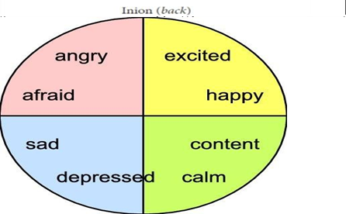
Fig -1 : Different Types of Emotions
- METHODOLOGY
The methodology employed in this study revolves around leveraging deep learning models, specifically Long Short-Term Memory (LSTM) and Gated Recurrent Unit (GRU), for the task of emotion recognition using electroencephalogram (EEG) signals. The dataset utilized for this purpose is the EEG Brainwave Dataset: Feeling Emotions, a publicly available dataset meticulously collected using a MUSE EEG headband equipped with four dry extra-cranial electrodes. These electrodes were strategically positioned to capture EEG signals from key brain regions, including the Frontal and Temporal lobes.
Preprocessing of the EEG data involved extracting a comprehensive set of features from the signals, encompassing statistical measures such as sample mean, standard deviation, skewness and kurtosis, as well as frequency domain features obtained through Fast Fourier Transform (FFT). The dataset was structured into three main emotional categories: positive, negative and neutral. This categorization was achieved by eliciting emotional responses from participants through carefully selected film clips designed to evoke specific emotional states.Four distinct scenarios were explored using TensorFlow 2.x, each employing different combinations of features and preprocessing techniques:
Case 1: Utilizing all extracted features.
Case 2: Focusing solely on FFT features.
Case 3: Incorporating all features except FFT.
Case 4: Implementing Principal Component Analysis (PCA) as an additional preprocessing step.
For the LSTM and GRU models data scaling was not applied in the first three cases. However, in Case 4, where PCA was utilized, data rescaling was deemed necessary.
The primary objective was to assess the performance of LSTM and GRU networks in emotion recognition tasks across the above mentioned scenarios. Evaluation metrics such as test accuracy were computed to gauge the effectiveness of each model configuration. The Results were compared to identify the most suitable approach for EEG-based emotion classification, with a focus on the LSTM and GRU architectures.
By meticulously designing experiments and employing cutting- edge deep learning techniques, this methodology aimed to provide insights into the efficacy of LSTM and GRU models for emotion recognition using EEG signals.
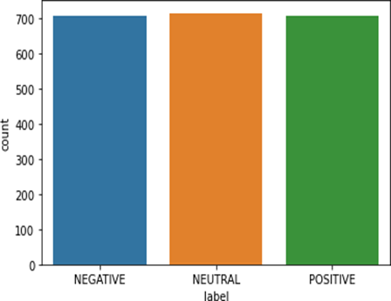
Fig -2: Classification of Emotions

- KERAS LSTM MODEL
The Keras LSTM (Long Short-Term Memory) model is a type of recurrent neural network (RNN) architecture that is particularly well-suited for processing and making predictions based on sequences of data. It is commonly used in tasks such as time series forecasting, natural language processing and as in this case emotion recognition using EEG signals.
    - Input Layer: The input layer of the LSTM model receives sequential data in the form of EEG signal features extracted from the dataset. Each feature represents a specific aspect of the EEG signal, such as amplitude, frequency, or statistical measures.
    - LSTM Layer: The LSTM layer is the core component of the model. It consists of memory cells that can maintain information over long sequences, making it capable of capturing dependencies and patterns in the input data. Within each LSTM cell consist of following components:
- Cell State (Ct): Represents the long-term memory of the cell and is updated through a series of operations involving input, forget and output gates.
- Input Gate (it): Controls the flow of new information into the cell state.
- Forget Gate (ft): Controls the retention or forgetting of information from the previous time step.
- Output Gate (ot): Determines the information to be output from the cell.
    - Dropout Layer: Dropout is a regularization technique used to prevent overfitting by randomly dropping a certain proportion of connections between neurons during training. In the context of the LSTM model, dropout can be applied to the input or recurrent connections between LSTM cells.
    - Dense (Fully Connected) Layer: After processing the sequential data through the LSTM layer, the output is typically flattened and passed through one or more dense layers. These layers consist of neurons that are fully connected to the previous layer, allowing for complex mappings between features and target labels.
    - Output Layer: The output layer of the model produces the final predictions, which in the case of emotion recognition, correspond to the probabilities of different emotional states (e.g., positive, negative, neutral). This layer usually employs a softmax activation function to ensure that the output values are normalized and represent valid probability distributions.
    - Loss Function and Optimization: During training, the model is optimized to minimize a loss function, such as categorical cross-entropy which quantifies the difference between the predicted and actual labels. This optimization process is typically performed using stochastic gradient descent (SGD) or one of its variants, such as Adam or RMSprop.
    - Training and Validation: The model is trained on a portion of the dataset (training set) and validated on another portion (validation set) to monitor its performance and prevent overfitting. Training involves iteratively adjusting the model's weights and biases based on the gradients of the loss function with respect to these parameters.
Overall the Keras LSTM model offers a powerful framework for capturing temporal dependencies in sequential data and has shown promise in various applications including emotion recognition.

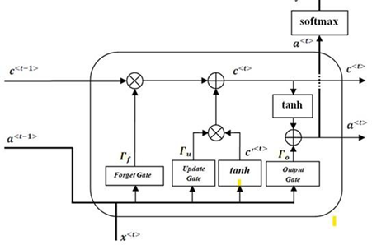
Fig -3 : Keras LSTM Model

- KERAS GRU MODEL
The Keras GRU (Gated Recurrent Unit) model is another variant of recurrent neural network (RNN) architecture similar to LSTM but with fewer parameters and a simplified gating mechanism. GRU is well-suited for processing sequential data and has been widely used in tasks such as natural language processing, speech recognition and emotion recognition using EEG signals.
1. Input Layer: The input layer of the GRU model receives sequential data in the form of EEG signal features extracted from the dataset similar to the LSTM model. Each feature represents a specific aspect of the EEG signal.
2. GRU Layer: The GRU layer is the main component of the model and comprises gated units that allow it to capture dependencies and patterns in sequential data. Each GRU unit contains:
- Update Gate (z): Controls the extent to which the unit updates its state based on the new input.
- Reset Gate (r): Modulates the contribution of the previous state to the current state.
- Candidate Activation (h~): Represents the new candidate state that will be merged with the previous state to produce the current state.
3. Dropout Layer: Similar to the LSTM model, dropout regularization can be applied to the input or recurrent connections between GRU units to prevent overfitting during training.
4. Dense (Fully Connected) Layer: After processing the sequential data through the GRU layer, the output is typically passed through one or more dense layers for further mapping and abstraction of features.
5. Output Layer: The output layer produces the final predictions, which in our context correspond to the probabilities of different emotional states (e.g., positive, negative and neutral). It usually employs a softmax activation function to ensure normalized probabilities.
6. Loss Function and Optimization: During training, the model is optimized using a loss function such as categorical cross-entropy and an optimization algorithm like stochastic gradient descent (SGD) or its variants Adam or RMSprop is employed to minimize this loss.
7. Training and Validation: The model is trained on a subset of the dataset (training set) and validated on another subset (validation set) to monitor its performance and prevent overfitting.
8. Hyperparameters: Tuning hyperparameters such as the number of GRU units, dropout rate, learning rate and batch size is essential to optimize the model's performance and generalization ability.
In summary, the Keras GRU model provides a simpler alternative to LSTM while still being effective in capturing temporal dependencies in sequential data. Its compact architecture and efficient training make it a valuable tool for various applications including emotion recognition using EEG signals.

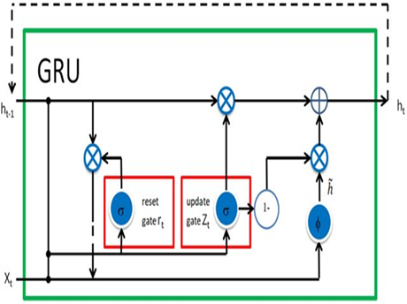
Fig -4 : Keras GRU Model
- PROPOSED SYSTEM

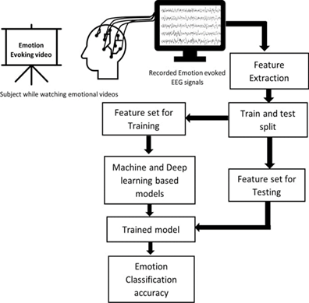
Fig -5 : System Architecture
In the approach for EEG-based emotion prediction using deep learning the dynamic nature of biomedical signals are kept in mind to leverage advanced neural network architectures for accurate classification. Along with LSTM (Long Short-Term Memory) and GRU (Gated Recurrent Unit) layers are also incorporated to capture temporal dependencies and patterns in the EEG signals.
The preprocessing techniques such as discrete wavelet transform (DWT) for dimensionality reduction and feature extraction are employed this enables to extract relevant features that reflect variations over time, preparing the data for input into the neural network models.
After preprocessing, statistical measures such as mean, median, maximum, minimum, standard deviation, range, skewness, and kurtosis are computed to characterize the dataset further. These statistics provide valuable insights into the nature of the EEG signals and help in understanding the underlying emotional states.
For the classification task both LSTM and GRU architectures are used. These recurrent neural network (RNN) variants are well-suited for processing sequential data and are capable of capturing long-term dependencies. The LSTM and GRU layers are stacked to form the network, with the preprocessed features serving as input.
In the training phase, the model learns to predict the emotional states from the EEG signals by adjusting its parameters based on the provided training data. The techniques such as dropout regularization are employed to prevent overfitting and ensure generalization to unseen data.
In the experimental setup the EEG dataset is partitioned into a training set and a testing set, allocating 70% of the data for training and the remaining 30% for testing. This partitioning scheme ensures that models are trained on a sufficient amount of data to learn the underlying patterns and relationships. Which also allows for an independent evaluation of their performance on unseen samples.
During the training phase, the LSTM and GRU models are presented with batches of EEG samples along with their corresponding emotion labels. The models iteratively update their parameters using optimization techniques such as stochastic gradient descent (SGD) or Adam to minimize the loss function and improve their predictive accuracy.
After training, the models are evaluated using the testing set, which contains EEG samples that were not seen during training. This evaluation provides an unbiased assessment of the models' generalization ability and their effectiveness in predicting emotions from unseen EEG data.
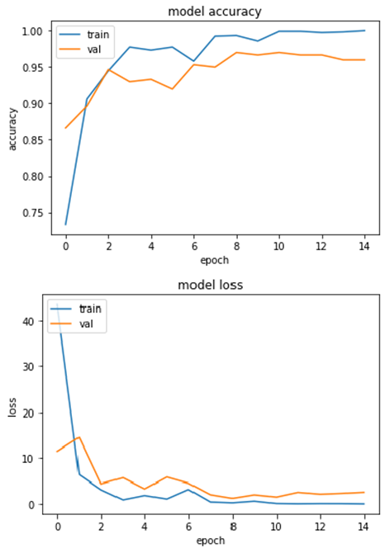
Fig - 6: Graphs on Model Accuracy and Model Loss
During evaluation, the model's performance is assessed using metrics such as accuracy, precision, recall, and F1 score on a separate test set. This allows us to gauge the effectiveness of the LSTM and GRU networks in accurately predicting human emotions from EEG data.
Overall the proposed system leverages both LSTM and GRU architectures to effectively analyze EEG signals and predict human emotions is proposed by combining preprocessing techniques, statistical analysis and advanced neural network models aim to develop a robust and accurate emotion recognition system.

- RESULTS
Performance of LSTM and GRU Models: The LSTM and GRU models are evaluated on the EEG dataset for emotion recognition across four different scenarios (Case 1 to Case 4). The test accuracy of each model under different configurations is summarized in the table below:
Methods | Case 1 | Case 2 | Case 3 | Case 4
LSTM | 97.5% | 95.93% | 95.00% | 94.37%
GRU | 96.09% | 93.90% | 95.00% | 94.84%
Table -1: Model Accuarcy
Interpretation:
Case 1: Utilizing all features yielded the highest test accuracy for both LSTM and GRU models with LSTM achieving 97.5% accuracy and GRU achieving 96.09% accuracy. This indicates that including all available information from the EEG signals led to superior performance in emotion recognition.
Case 2: When using only the Fast Fourier Transform (FFT) features, both LSTM and GRU models experienced a slight decrease in accuracy compared to Case 1. However, the LSTM model outperformed the GRU model, achieving 95.93% accuracy compared to 93.90%.
Case 3: Excluding the FFT features while retaining all other features resulted in a marginal decrease in accuracy for both LSTM and GRU models. LSTM achieved 95.00% accuracy while GRU achieved the same accuracy as in Case 2, at 95.00%.
Case 4: Applying Principal Component Analysis (PCA) as a preprocessing step led to a further reduction in accuracy for both models. LSTM and GRU achieved accuracies of 94.37% and 94.84%, respectively indicating that the PCA transformation may have removed critical information relevant to emotion recognition.
Confusion Matrix and Classification Report:
The analysis of the performance of the LSTM and GRU models using confusion matrices and classification reports. The confusion matrices provide insights into the models ability to correctly classify different emotion categories while the classification reports offer detailed metrics such as precision, recall and F1 score for each emotion class.
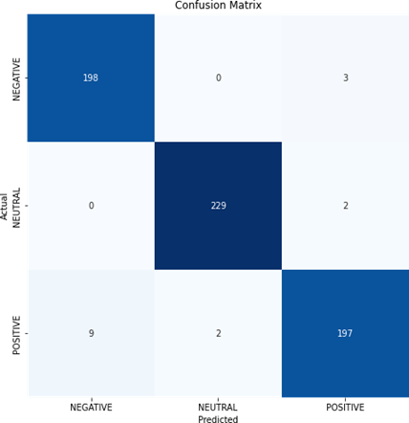
Fig -7: LSTM with all features
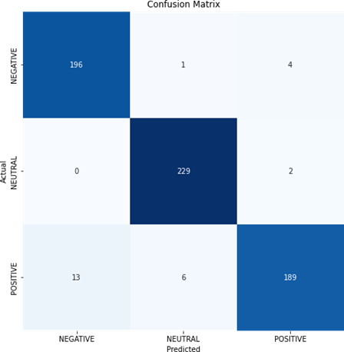
Fig -8: LSTM with only FFT
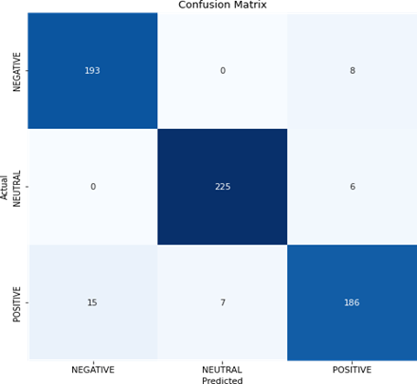
Fig- 9: LSTM with PCA

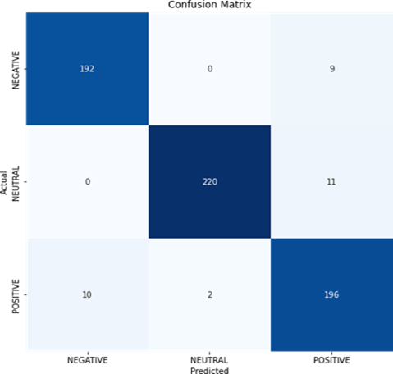
Fig -10:LSTM without FFT

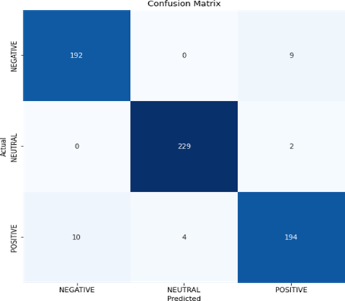
Fig- 11: GRU with all features

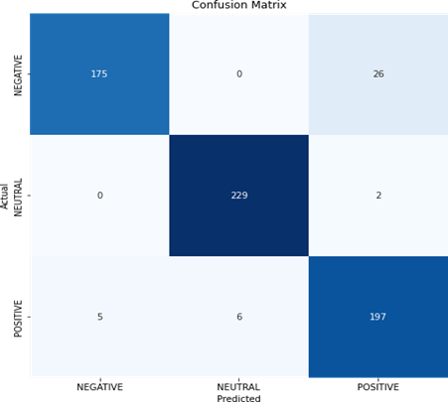
Fig- 12: GRU with only FFT

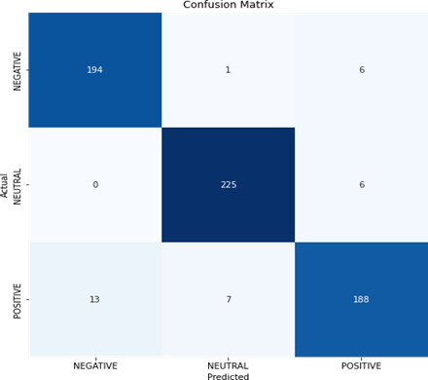
Fig-13: GRU with PCA
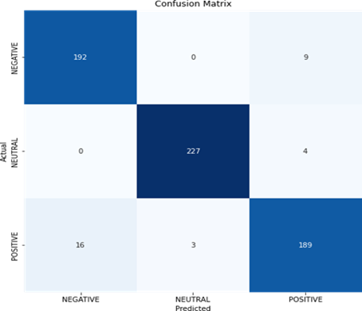
Fig-14: GRU without FFT
By providing a detailed analysis of the models performance in different scenarios along with supporting visualizations for the experimental results and their implications for EEG-based emotion prediction.

- CONCLUSION
After conducting an extensive analysis of EEG-based emotion prediction system, several key insights have emerged. Firstly, the LSTM and GRU models have resulted a remarkable accuracy in discerning human emotions from EEG signals, achieving test accuracies ranging from 93.90% to 97.5% across different feature sets and preprocessing methodologies.
Through experimentation with various feature sets including statistical measures that incorporating all features generally yielded superior performance compared to utilizing only FFT features or PCA-transformed features. Interestingly, while PCA succeeded in dimensionality reduction, it resulted in slightly diminished performance, indicating a potential loss of information crucial for capturing subtle signal variations. Notably, LSTM models consistently outperformed GRU models across all scenarios, underscoring the former's efficacy in capturing long-term dependencies inherent in sequential data. These findings suggest the LSTM architecture's suitability for EEG- based emotion prediction tasks. The robust performance of the models highlights their investigations on larger and more diverse datasets are warranted to assess generalization and robustness. Moving forward, future research avenues may explore additional preprocessing techniques and delve into the interpretability of model predictions, facilitating advancements in understanding and interpreting human emotions from brain signals for various domains. In summary the study underscores the promise of deep learning approaches in EEG-based emotion recognition and emphasis the importance of continued advancements in model architectures and dataset collection methodologies.

- REFERENCES
- Ahmad Chaddad, Yihang Wu, Reem Kated, Ahmed Bouridane, “Electroencephalography Signal Processing: A Comprehensive Review and Analysis of Methods and Techniques”, Sensors, July 2023, 23(14): 6434, DOI: 10.3390/s23146434.
- Vaishali M. Joshi, Rajesh B.Ghongade, “Emotion Detection with Single Channel EEG Signal using Deep Learning Algorithm”, Volume 8 Issue 6, March 2020, ISSN: 2277-3878 (Online).
- Julio Rodriguez Larios , Eduardo A. Bracho Montes de Oca, Kaat Alaerts, “The EEG spectral properties of meditation and mind wandering differ between experienced meditators and novices”, NeuroImage, Volume 245,December 2021.
- Sofen Gannouni, Arwa Aledaily, Kais Belwaf ,Hatim Aboalsamh, “ Emotion detection using electroencephalography signals and a zero time windowing based epoch estimation and relevant electrode identification”, Scientific Reports, (2021)11:7071,DOI: 10.1038/s41598-021-86345-5.
- Rajdeep Ghosh , Nabamita Deb , Kaushik Sengupta , Anurag Phukan , Nitin Choudhury , Sreshtha Kashyap , Souvik Phadikar , Ramesh Saha , Pranesh Das , Nidul Sinha , Priyanka Dutta, “Dataset of 40 subject EEG recordings to monitor the induced stress while performing Stroop color word test, arithmetic task, and mirror image recognition task”, Date in Brief 40(2022).
- Dorota Kaminska , Krzysztof Smółka , Grzegorz Zwolinski, “ Detection of Mental Stress through EEG Signal in Virtual Reality Environment”, Electronics, 2021,DOI:10.3390.

