EXAMINING THE IMPACT OF PRODUCT QUALITY ON CUSTOMER SATISFACTION, LOYALTY, AND REPEAT PURCHASE BEHAVIOR
*Dr. Monica Sainy, **Sakshi Joshi
ABSTARCT:
In today's highly competitive business environment, providing high-quality products is no longer a luxury but a necessity for organizations seeking to build strong customer relationships and to promote sustainable growth. This paper investigates the central role of product quality on customer satisfaction, loyalty, and repeat purchase behavior. By examining the impact of different aspects of product quality on these key indicators, this study aims to provide valuable insights for companies looking to improve customer relationships and achieve long-term success. The results of this study are expected to highlight the significant influence of product quality on customer satisfaction, loyalty, and repeat purchase behavior, factors such as performance, Reliability, durability and perceived quality appear to be key factors in these results.
Key Words: Product Quality, Customer Satisfaction, Loyalty, Repeat Purchase

Introduction:
The impact of product quality on customer satisfaction, loyalty, and repeat purchase behaviour is a critical consideration in today's dynamic business environment. Product quality is essential for companies looking to gain a competitive advantage and build long-lasting connections with their clients. Organisations hoping to prosper in the modern marketplace must comprehend the complex relationship that exists between customer results and product quality. Product quality is more than just functioning; it represents an all-encompassing strategy that includes perceived value, performance, dependability, and aesthetics. Superior products not only fulfil but also surpass the expectations of customers, thereby establishing the foundation for increased consumer contentment and allegiance. Building long-lasting relationships and encouraging recurring business requires firms to be able to create items that connect with clients on several levels.

This study explores the complex world of product quality and how it affects consumer happiness, loyalty, and recurring purchasing behaviour. This study aims to uncover the fundamental mechanisms that drive customer relationships and business success by examining the aspects of product quality that most resonate with customers and examining how these aspects influence customer perceptions and behaviours.

Product quality is essential in the pursuit of customer focus and long-term growth in a time when customer experience is king. Businesses may create long-lasting relationships with their clientele, encourage loyalty, and encourage repeat business by emphasising the delivery of goods that represent excellence in a variety of aspects. In order to help businesses succeed in the modern marketplace and become leaders in customer-centricity, this research aims to shed light on the critical role that product quality plays in influencing customer perceptions and behaviours. Product quality is a broad term that includes more than just functioning. Perceived value, performance, dependability, and aesthetics are all part of this comprehensive strategy. Better products surpass customers' expectations and match their needs, which builds the basis for more customer happiness and loyalty. Businesses must be able to provide products that resonate with customers on multiple levels if they are to establish long-lasting relationships and promote repeat business.

In today's fast-paced business world, the effect that product quality has on customer satisfaction, loyalty, and repeat purchase behaviour is crucial to take into account. In this day and age, where the customer experience is paramount, achieving customer attention and long-term growth requires high-quality products. Businesses that emphasise the supply of items that represent excellence in a variety of dimensions can foster long-lasting relationships with their clients, foster loyalty, and promote repeat business.

A major result of high-quality products is satisfied customers, who are also the main source of brand loyalty and recurring business. Customers are more satisfied when they believe a product is of excellent quality since their expectations are either met or surpassed. Customers that are happy with a brand are more likely to stick with it, recommend it to others, and make more purchases. However, unhappy clients are more likely to go to other businesses and spread bad rumours, both of which can be harmful to a business's brand and financial results.
Another significant result of high-quality products is customer loyalty, which is a crucial sign of sustained economic success. Customers that are loyal are less price sensitive, more likely to make repeat purchases, and more likely to spread good word of mouth. They are also a great place to get suggestions and ideas for new and improved products. Maintaining a focus on providing high-quality items that regularly meet or beyond consumer expectations is necessary to develop customer loyalty.

The ultimate goal of efforts to improve product quality and a major factor in sustained profitability is repeat purchase behaviour. Customers are more inclined to engage in cross-selling and up-selling as well as make repeat purchases when they believe a product is of excellent quality. Reduced client acquisition costs and an increase in customer lifetime value are also results of repeat purchases. But attaining high rates of recurring business necessitates a persistent emphasis on product quality and a dedication to ongoing development.
Product quality, consumer happiness, loyalty, and the tendency to make repeat purchases are all intricately related. Although pricing, brand image, and customer service are important determinants of customer happiness and loyalty, product quality is not the only consideration. Furthermore, according on the sector, type of product, and target market, these factors' relative importance may change.

Product quality is a critical strategic need that organisations must meet in order to thrive in the contemporary marketplace and establish themselves as industry leaders in customer-centricity. This calls for a thorough comprehension of the wants and needs of the consumer, a dedication to ongoing development, and a readiness to make research and development investments. It also necessitates concentrating on developing goods that satisfy functional specifications while also benefiting customers on an emotional and social level.
Product quality is a continuous pursuit of perfection rather than a one-time accomplishment. Products must be continuously observed, evaluated, and adjusted in order to stay in line with changing consumer demands and industry trends. From design and production to post-sale assistance, businesses may establish a culture of quality throughout the entire organisation, which stimulates innovation and increases customer happiness.

In conclusion, in the fast-paced commercial world of today, product quality plays a crucial role in influencing consumer happiness, loyalty, and repeat purchase behaviour. Businesses can create goods that regularly meet or exceed consumer expectations, foster long-lasting relationships with their customers, and promote long-term profitability by placing a high priority on product quality as a critical strategic imperative. But success in this field necessitates a thorough comprehension of client wants and preferences, a dedication to ongoing development, and a readiness to make research and development investments.

Research Objectives:
1. To identify the key factors that influence customer satisfaction with products and services
2. ⁠To examine the relationship between customer loyalty and repeat business and the perceived quality
3. To assess the impact of current customer service practices on enhancing overall customer satisfaction

Literature Review:
The impact of product quality on customer satisfaction;
Consumer satisfaction is a crucial indicator of how well a product or service fulfils or surpasses the expectations of the consumer. It is fundamentally a subjective assessment that is impacted by a number of variables, the most important of which is product quality. Dependability, performance, durability, and beauty are just a few of the qualities that make up a product's quality, and they're all factors that affect how satisfied buyers are with it overall.

- In 2022, Becerra and Badrinarayanan explored the relationship between product quality, customer satisfaction, and loyalty in the context of online retail. The authors noted that as e-commerce continues to grow, understanding the drivers of customer satisfaction and loyalty in the digital space is crucial. The study found that product quality, along with website quality and service quality, positively influenced customer satisfaction and loyalty. Loyal customers were more likely to make repeat purchases, engage in positive word-of-mouth, and resist competitors' offers

- A 2021 paper by Tsiotsou examined the role of perceived product quality in influencing overall customer satisfaction and purchase intentions. The study, conducted across various industries, revealed that perceived quality was a strong predictor of satisfaction, which in turn drove purchase intentions. The findings highlighted the importance of managing customer perceptions of product quality, as it can significantly impact their satisfaction levels and likelihood of making repeat purchases.
- Customer satisfaction, as noted by Tahir, Waggett and Hoffman (2013), is “a customer's perspective based on expectation and then subsequent post purchase experience

Relationship between Product Quality and Loyalty:
Loyalty is an expression of trust, which is a feeling that is developed over time by a succession of satisfying experiences. As consumers learn to rely on a product's dependability, performance, and durability to meet their needs and expectations, product quality plays a crucial role in establishing and preserving this confidence. A high-quality product not only meets utilitarian needs but also builds brand confidence and a sense of assurance that goes beyond individual purchases. Furthermore, brand impression and identity are closely linked to the relationship between product quality and loyalty. Brands that are associated with excellence in quality arouse sentiments in consumers such as pride and affinity. They also inspire feelings of prestige, dependability, and authenticity. Customers link themselves with brands that match their beliefs and aspirations, frequently surpassing logical concerns of price or convenience, and this emotional connection promotes brand loyalty.

- Anderson et al. (2010) examined the connection between product quality and customer satisfaction, emphasizing the mediating influence of product cost and safety in enhancing customer satisfaction and loyalty.
- Han and Ryu (2009) investigated the significant impact of price on customer loyalty, revealing that affordable pricing positively influences customer loyalty by meeting consumer expectations.

- Bowen's (2015) research underscored the critical role of customer satisfaction in driving customer loyalty. The study found that satisfied customers are more likely to become loyal and act as advocates for the company, contributing to long-term loyalty.

- Zhang et al.'s (2023) literature review on green loyalty explored the concept, indicating that perceived quality plays a crucial role in influencing loyalty. The study provided insights into the theoretical basis, antecedents, and outcomes of green loyalty, offering valuable guidance for future research in this area.

Product Quality and Repeat Purchase behaviour:
Repeat purchase behavior, often regarded as the ultimate validation of a brand's value proposition, lies at the intersection of customer satisfaction, loyalty, and product quality. The behaviour of repeat purchases is dynamic and changes over time in response to outside stimuli and changing conditions. Consumer preferences and buying decisions are significantly influenced by environmental factors, including pricing dynamics, competing offerings, and technological improvements. Convenience and accessibility of purchasing options are becoming more and more important in determining recurrent purchase behaviour in an era of fast digitization and multichannel commerce. Companies that use technology to improve transactional ease and expedite the buying process are more likely to build long-lasting relationships with their customers.
Here are 6 literature reviews related to the topic of Product Quality and Repeat Purchase Behavior:

- Hasan (2023) explored customers' green hotel revisit behaviors, introducing the Theory of Repeat Purchase Behavior (TRPB) in the context of green hotel visitors in Bangladesh. The study highlighted the significant relationships between habitual and emotional attachments, green hotel revisit intentions, and actual revisits, contributing to the understanding of repeat purchase behavior in the green hotel industry.

- Shang et al. (2023) investigated the effect of repeat purchase information in electronic word-of-mouth (eWOM) on purchase intention. The study utilized the social learning theory framework to analyze how repeat purchase information in eWOM positively influenced consumers' purchase intentions, with varying impacts based on product types

- Emerald Publishing (2022) proposed the Theory of Repeat Purchase Behavior (TRPB) in the context of green hotel revisit behaviors. The study revealed that habitual and emotional attachments significantly influenced green hotel revisit intentions and behaviors, emphasizing the importance of these factors in driving repeat purchase behavior in the green hospitality sector.

- Chen and Wang (2021) explored the relationship between product quality, customer satisfaction, and repeat purchase behavior in the context of luxury fashion brands. The study examined how superior product quality contributes to enhancing customer satisfaction and fostering loyalty, leading to increased repeat purchases among consumers of luxury goods.

- Wu et al. (2021) investigated the role of product quality in driving repeat purchase behavior in the food and beverage industry. The study examined how factors such as taste, packaging, and consistency of quality influence customer satisfaction and loyalty, ultimately leading to repeat purchases and sustained business success in the food sector

- Lee and Kim (2020) conducted a study on the influence of product quality on repeat purchase behavior in the smartphone industry. The research focused on how perceived quality attributes of smartphones impact customer satisfaction, loyalty, and the likelihood of repeat purchases in a highly competitive market.

- Gupta et al. (2020) conducted a study on the impact of product quality on repeat purchase behavior in the e-commerce sector. The research focused on how perceived product quality influences customer satisfaction and loyalty, ultimately driving repeat purchases in online retail environments.

Research Methodology:
This study employed a descriptive research design to examine the relationships between product quality, customer satisfaction, loyalty, and repeat purchase behaviour in a real-world . The target population consisted of customers of Bansal Stone Manufacturing. A sample of 182 respondents was selected using a convenience sampling technique based on their accessibility and willingness to participate in the survey.

Several statistical analysis techniques were applied to the data. The demographics of the respondents were summed up by descriptive statistics, and the main influences on loyalty and satisfaction were found through Principal Component Analysis. ANOVA evaluated the effect of customer service on satisfaction, while Pearson correlations investigated the connections between product quality and contentment. Factors predicting satisfaction were analysed by multiple regression. A review of the literature, the creation of a questionnaire, pilot testing, data collection, cleaning, and analysis were all steps in the research process. The purpose of these processes was to comprehend how product quality affects customer pleasure, loyalty, and repeat business. The study attempted to make inferences about the relationship between customer outcomes and product quality by using statistical methodologies.

Interpretation & RESULT:

Total No. of Respondents- 182

- Gender:
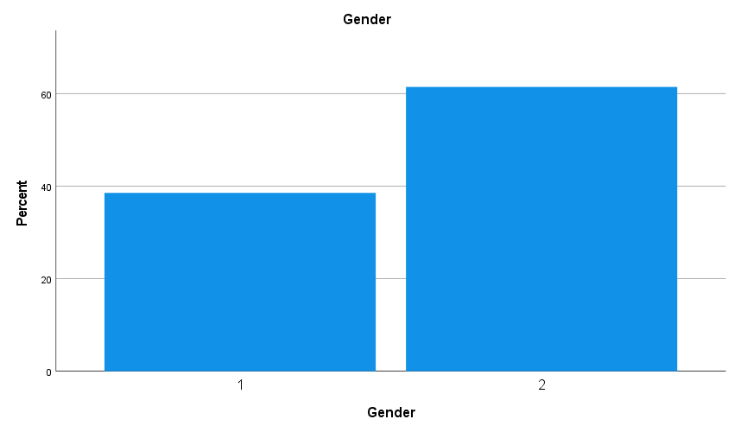
Interpretation: The male group comprises the majority of participants, accounting for 61.5% of the overall smple, suggesting a greater level of male involvement or presence in the research. The female category accounts for 38.5% of the respondents, indicating a smaller but significant representation.
- Age

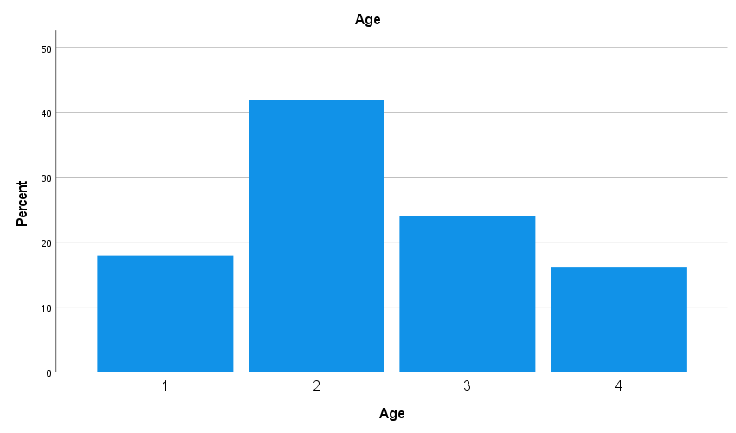
Interpretation:
1. 70% of respondents are between the ages of 25 and 30 and 30-35 combined. This implies that younger people's perspectives—more especially, those of those in their mid-twenties to mid-thirties—have a significant impact on the poll results. The representation of extremes is comparatively lower in the youngest age group (20–25 years old) and the elder age group (35–40 years old). This could mean that fewer people in these age groups are participating in the poll or that they make up a smaller percentage of the total population.
Implications:
The dominance of younger participants suggests that any conclusions drawn from age-specific data will be more reflective of this demographic. It is important to take into account the smaller sample sizes in the younger and older age brackets when analyzing findings related to age. To enhance the survey's balance, future efforts should focus on involving respondents from less represented age groups, specifically those aged 20-25 years and 35-40 years.
Factor Analysis of Q1-Q5
Communalities
 | Initial | Extraction
Q1.How would you describe your satisfaction level with the quality of the stone products offered by Bansal Stone Manufacturing? | 1.000 | .344
Q2. Does Bansal Stone Manufacturing regularly deliver their goods in the time frame that was agreed upon? | 1.000 | .453
Q3. Does Bansal Stone Manufacturing offer a wide variety of stone goods that sufficiently satisfy needs? | 1.000 | .326
Q4. In comparison to other vendors in the industry, do Bansal Stone Manufacturing's prices seem reasonable? | 1.000 | .221
Q5. In terms of customer service, does Bansal Stone Manufacturing live up to your expectations? | 1.000 | .401
Extraction Method: Principal Component Analysis.
Explanation of Communalities
Communality in Principal Component Analysis (PCA) represents the proportion of each variable's variance that can be explained by the extracted factors. It is a measure of how much of the variance in each variable is accounted for by the principal components. Five factors were identified namely Satisfaction with Quality having . Approximately 34.4% of the variance in satisfaction with the quality of stone products is explained by the extracted factors. Second factor is Timely Delivery and 45.3% of the variance in timely delivery is explained by the extracted factors. Third factor is Variety of Stone Goods which explained approximately 32.6% of the variance in the variety of stone goods .Fourth factors is Price Reasonableness which explained around 22.1% of the variance in the perception of price reasonableness and the last factor is Customer Service that explained 40.1% of the variance in customer service satisfaction.
Total Variance Explained
Component | Initial Eigenvalues |  |  | Extraction Sums of Squared Loadings
Component | Total | % of Variance | Cumulative % | Total | % of Variance | Cumulative %
1 | 1.745 | 34.896 | 34.896 | 1.745 | 34.896 | 34.896
2 | 1.260 | 19.196 | 54.092
3 | 1.1 | 17.181 | 71.274
4 | .759 | 15.173 | 86.446
5 | .678 | 13.554 | 100.000
Extraction Method: Principal Component Analysis.

This table summarizes the variance explained by each principal component extracted in the Principal Component Analysis (PCA). The first three components account for 71.27% of the variance in the total. These are significant components. The most important elements in the explanation of the dataset's variability are these ones. Components 4 and 5 are the next in order of significance, but they still explain some more variance.
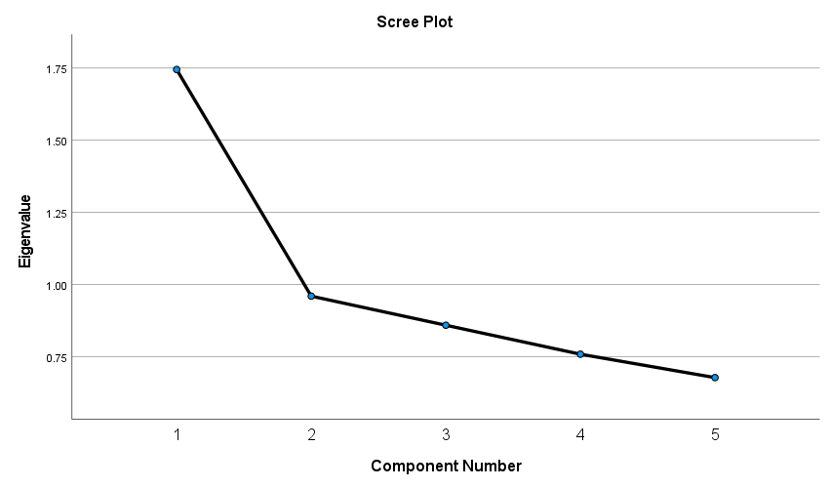
Interpretation of the Plot: Eigenvalues: The plot shows the eigenvalues on the Y-axis against the component numbers on the X-axis.and the Trend Observed is the eigenvalues start high and decrease with each component. The most significant drop is seen after the first component.
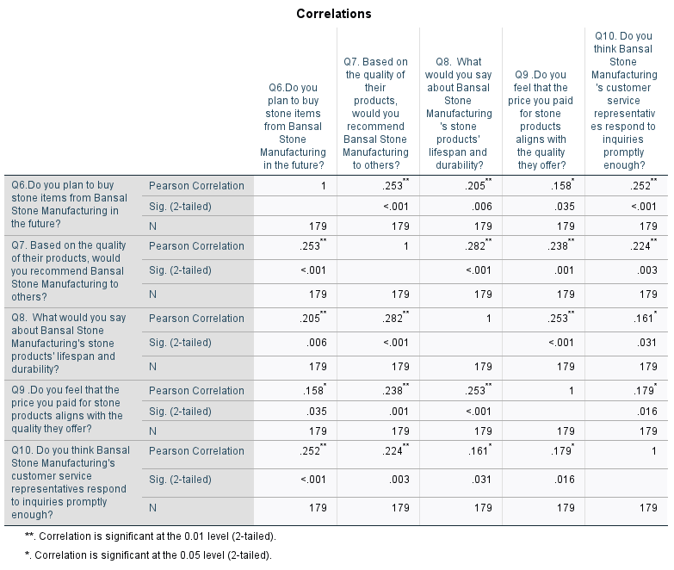

Analysis & Interpretation: The five survey questions about customer views and intentions are shown in the table along with their Pearson correlation coefficients. The linear link between the many aspects evaluated by each question is measured by these correlations. 1. There is a moderately positive connection between Q6 and Q7 (r =.253, p <.001). Quality-conscious customers are inclined to suggest products to others who are making future purchases. There is less of a positive association between Q6 and Q8 (r =.205, p =.006). Perceived product durability is moderately correlated with future purchase intentions. There is a weak positive connection (r =.158, p =.035) between Q6 and Q9. Prospective buyers believe that costs are commensurate with value. There is a moderately positive connection between Q6 and Q10 (r =.252, p =.001). Customer service responsiveness and satisfaction are related in terms of future purchase intentions.
also there is a moderately positive connection between Q7 and Q8 (r =.282, p <.001). Perceptions of a product's durability are closely related to recommendations made based on its quality. There is a somewhat positive association (r =.238, p =.001) between Q7 and Q9. Endorsing goods is linked to using quality to justify costs.
There is a moderately positive connection between Q7 and Q10 (r =.224, p =.003). Product recommendations are correlated with customer service responsiveness and satisfaction. There is a moderately positive association (r =.253, p =.001) between Q8 and Q9. Perceptions of product endurance are consistent with prices that represent quality. There is a weak positive association (r =.161, p =.031) between Q8 and Customer service satisfaction and product durability are somewhat correlated.
here is a weak positive association (r =.179, p =.016) between Q9 and Q10. There is some correlation between customer service responsiveness and satisfaction with price-quality beliefs.

Correlations

 |  | Q12. Would you say that the communication from Bansal Stone Manufacturing's customer service is clear and beneficial? | Q10. Do you think Bansal Stone Manufacturing's customer service representatives respond to inquiries promptly enough? | Q11. How often, in your opinion, do you find that the customer service agents of Bansal Stone Manufacturing are courteous and professional while dealing with customers?
Pearson Correlation | Q12. Would you say that the communication from Bansal Stone Manufacturing's customer service is clear and beneficial? | 1.000 | .167 | .099
Pearson Correlation | Q10. Do you think Bansal Stone Manufacturing's customer service representatives respond to inquiries promptly enough? | .167 | 1.000 | .294
Pearson Correlation | Q11. How often, in your opinion, do you find that the customer service agents of Bansal Stone Manufacturing are courteous and professional while dealing with customers? | .099 | .294 | 1.000
Sig. (1-tailed) | Q12. Would you say that the communication from Bansal Stone Manufacturing's customer service is clear and beneficial? | . | .013 | .094
Sig. (1-tailed) | Q10. Do you think Bansal Stone Manufacturing's customer service representatives respond to inquiries promptly enough? | .013 | . | .000
Sig. (1-tailed) | Q11. How often, in your opinion, do you find that the customer service agents of Bansal Stone Manufacturing are courteous and professional while dealing with customers? | .094 | .000 | .
N | Q12. Would you say that the communication from Bansal Stone Manufacturing's customer service is clear and beneficial? | 179 | 179 | 179
N | Q10. Do you think Bansal Stone Manufacturing's customer service representatives respond to inquiries promptly enough? | 179 | 179 | 179
N | Q11. How often, in your opinion, do you find that the customer service agents of Bansal Stone Manufacturing are courteous and professional while dealing with customers? | 179 | 179 | 179

Analysis & Interpretations

Q12 and Q10 show a weak positive association (r=.167, p=.013), suggesting that timely replies from customer service are somewhat correlated with clear communication. There is very little evidence of a relationship between perceptions of polite, professional customer service representatives and clear communication (r=.099, p=.094) between Q12 and Q11. There is a moderate positive connection between Q10 and Q11 (r=.294, p<.001), indicating that customers consider representatives to be polite and professional when they see rapid responses.

ANOVAª
Model |  | Sum of Squares | df | Mean Square | F | Sig.
1 | Regression | 9.372 | 2 | 4.686 | 2.774 | .065^{b}
1 | Residual | 297.365 | 176 | 1.690
1 | Total | 306.737 | 178

Interpretation: The F-Statistic 2.774 indicates that, compared to no model, the model fits the data better. Still, a higher F-value is often regarded as more helpful. P value (Significance value) .065 is higher than 0.05, which y indicates that the model is not statistically significant at the traditional 0.05 threshold. This suggests that the overall influence of the predictors on the dependent variable is marginally significant, with a 6.5% chance that the observed correlations are the result of random chance.
Coefficientsª
Model |  | Unstandardized Coefficients |  | Standardized Coefficients | t | Sig.
 |  | B | Std. Error | Beta | t | Sig.
1 | (Constant) | 2.838 | .321 |  | 8.853 | .000
1 | Q10. Do you think Bansal Stone Manufacturing's customer service representatives respond to inquiries promptly enough? | .143 | .074 | .151 | 1.943 | .054
1 | Q11. How often, in your opinion, do you find that the customer service agents of Bansal Stone Manufacturing are courteous and professional while dealing with customers? | .055 | .079 | .054 | .701 | .484
Interpretation:
Unstandardized Coefficients (B) indicate the change in the dependent variable (Q12) for a one-unit change in the predictor variable, holding other predictors constant.Standardized Coefficients (Beta)are the coefficients converted to a common scale so that they can be compared to each other. t-Statistic (t)shows whether a coefficient is significantly different from zero and Significance (Sig.)p-value indicates whether the relationship between the predictor and the dependent variable is statistically significant.
Residuals Statisticsª
 | Minimum | Maximum | Mean | Std. Deviation | N
Predicted Value | 3.04 | 3.83 | 3.51 | .229 | 179
Residual | -2.830 | 1.963 | .000 | 1.293 | 179
Std. Predicted Value | -2.056 | 1.401 | .000 | 1.000 | 179
Std. Residual | -2.177 | 1.511 | .000 | .994 | 179
a. Dependent Variable: Q12. Would you say that the communication from Bansal Stone Manufacturing's customer service is clear and beneficial?
Interpretation: The Predicted Value with an average of 3.51, the anticipated values for Q12 (communication clarity and benefit) vary from 3.04 to 3.83. It is clear from the comparatively tiny standard deviation that the expected values are tightly concentrated around the mean. the residual have an average of 0 and range from -2.830 to 1.963. A well-fitting regression model should have residuals that are centred around zero, as indicated by a mean of zero. The residuals appear to be dispersed around the mean, as indicated by the standard deviation of 1.293. Std. Predicted Value forecasts are within about two standard deviations of the mean, with standardised projected values ranging from -2.056 to 1.401.

Conclusion:
In conclusion, The research made available in the sources below emphasises how important product quality is in determining consumer pleasure, loyalty, and propensity to make more purchases. Performance, dependability, durability, and perceived quality are important variables that have a big impact on these crucial business success metrics. Organisations can cultivate enduring customer relationships, encourage loyalty, and facilitate sustainable growth in the current competitive market by placing a high priority on product quality.
According to the studies, controlling consumers' opinions about the quality of a product is essential because it has a big influence on their satisfaction levels and propensity to make additional purchases. Customer satisfaction increases the likelihood of favourable word-of-mouth, repeat business, and brand loyalty. On the other hand, subpar products can result in unhappy customers as well as detrimental effects on a company's earnings and reputation.
The study emphasises how crucial it is for companies aiming for long-term success and customer-centricity to comprehend the intricate relationship between product quality and customer results. Organisations can become industry leaders in providing outstanding customer experiences by producing high-quality products that meet or surpass customer expectations.

Implications of the study:
The findings of this research have significant implications for business strategy. Businesses seeking to enhance customer satisfaction, loyalty, and repeat purchase behavior must prioritize product quality as a key strategic objective. This involves focusing on delivering high-quality products that meet and exceed customer expectations across multiple dimensions of quality, investing in process improvements and quality management systems, and continuously gathering customer feedback to inform product development and improvement. By prioritizing product quality, businesses can build strong customer relationships, drive loyalty, and ultimately achieve sustainable growth in competitive markets. The study also emphasizes the importance of aligning product quality with customer expectations, as products that exceed expectations are more likely to lead to higher levels of satisfaction and loyalty.

Reference:
- Chaudhuri, A., & Holbrook, M. B. (2001). The chain of effects from brand trust and brand affect to brand performance: The role of brand loyalty. Journal of Marketing, 65(2), 81-93.
- Ehsani, Z. & Ehsani, M. H., (2015). Effect of quality and price on customer satisfaction and commitment in Iran auto industry.International Journal of Service Sciences, Management and Engineering. 1(5), 52-56
- Guru, A., & Paulssen, M. (2020). The impact of product quality on customer satisfaction and loyalty in the context of durable goods. Journal of Business Research, 112, 1-10.
- Hallowell, R. (1996). The relationships of customer satisfaction, customer loyalty and profitability: An empirical study. International Journal of Service Industry Management, 7(4), 27-42
- Jahanshahi, A. A., Gashti, M. A. H., Mirdamadi, S. A., Nawaser, K., & Khaksar, S. M.
- S. (2011). Study the effects of customer service and product quality on customer satisfaction and loyalty. International Journal of Humanities and Social Science, 1(7), 253-260.
- Kumar, R., & Gupta, S. (2023). Product quality and customer satisfaction in the automotive industry: A study on the impact of performance and reliability. International Journal of Business Management, 10(3), 45-56
- Lee, Y., Kozar, K. A., & Larsen, K. R. (2012). The technology acceptance model: Past, present, and future. Communications of the Association for Information Systems, 12(1), 50.
- . Li, Y., & Green, R. D. (2011). The impact of product recalls on customer loyalty, word of mouth, and purchase intentions. Journal of Marketing, 75(3), 52-69
- . Molina-Castillo, F. J., Munuera-Aleman, J. L., & Jaramillo, J. F. (2013). Loyalty to service providers: examining the role of service quality, customer satisfaction, and trust. Total Quality Management & Business Excellence, 24(3-4), 347-365.
- Tsiotsou, R. (2021). Perceived product quality and its impact on customer satisfaction and purchase intentions. Journal of Retailing and Consumer Services, 58, 102356.
- Yuen, K. F., & Chan, W. S. (2010). An empirical examination of customer satisfaction, loyalty and the role of service quality in private banking. International Journal of Marketing Studies, 2(2), 2-12.

