ENHANCING MILITARY TRAINING THROUGH VR APPLICATIONS
Dr. Arjun B C¹, Sanjay K R²
¹Prof. and HOD, Information Science and Engineering, Rajeev Institute of Technology, Hassan
²Information Science and Engineering, Rajeev Institute of Technology, Hassan
---------------------------------------------------------------------***--------------------------------------------------------------------

ABSTRACT

Virtual Reality (VR) technologies have ushered in a new era for military education and training, offering immersive learning environments that replicate real-world scenarios with unprecedented realism and detail. This paper delves into the multifaceted application of VR within military training, delving into its efficacy in bolstering soldier readiness, facilitating skill acquisition, and honing decision-making abilities crucial for operational success. Through a comprehensive review of recent literature and insightful case studies, the paper illuminates the myriad advantages VR brings to the forefront of military training methodologies. Notably, VR is lauded for its capacity to engender experiential learning, providing trainees with hands-on exposure to diverse combat situations without exposing them to physical harm. Moreover, the paper underscores the significant cost-saving potential inherent in VR-based training modalities, as they obviate the need for large-scale live exercises while still delivering unparalleled training value. Despite these remarkable benefits, the paper also addresses pertinent challenges impeding the widespread adoption of VR in military training contexts. Issues such as technological constraints, fidelity of simulation, and seamless integration into existing training frameworks warrant careful consideration to fully harness the transformative potential of VR. Nonetheless, by leveraging VR technologies judiciously, military organizations stand poised to optimize training effectiveness, enhance operational readiness, and adeptly navigate the ever-evolving landscape of security threats on a global scale.

Key Words: Virtual Reality (VR), Military Training
Experiential Learning, Operational Readiness,
Technological Challenges

INTRODUCTION

In an era defined by rapid technological advancement, the integration of virtual reality (VR) applications into military education and training stands as a testament to innovation in preparing soldiers for the multifaceted challenges of modern warfare. This paradigm shift from traditional training methodologies to immersive learning environments represents a strategic investment in equipping military personnel with the necessary skills and capabilities to navigate the complexities of contemporary conflict scenarios. As such, the exploration of VR's applications in military training is not merely a foray into cutting-edge technology but a deliberate effort to enhance readiness, resilience, and operational effectiveness across all branches of the armed forces. At its core, VR technology offers a transformative approach to education and training by providing immersive, interactive simulations that closely mimic real-world scenarios. By leveraging state-of-the-art hardware and software solutions, VR environments afford trainees the opportunity to engage in hands-on learning experiences without exposing them to the inherent risks associated with live-fire exercises or field training. This level of realism and fidelity not only enhances the effectiveness of instruction but also accelerates the acquisition of critical skills, from individual marksmanship to collective team coordination, in a controlled and repeatable manner.
The adoption of VR in military education and training is driven by a recognition of the evolving nature of warfare and the need to adapt training methodologies accordingly. Traditional approaches, while valuable, often fall short in adequately preparing soldiers for the dynamic and unpredictable nature of modern conflict. By contrast, VR simulations offer a dynamic and adaptive training environment that can be customized to replicate a wide range of operational scenarios, from urban warfare to counterinsurgency operations, with unparalleled accuracy and realism.
Furthermore, VR facilitates experiential learning by stimulating multiple senses and fostering a sense of presence that closely mirrors the intensity of actual combat situations. Through immersive simulations, trainees develop muscle memory, situational awareness, and critical thinking skills essential for success on the battlefield. Moreover, VR platforms enable trainees to receive immediate feedback and performance metrics, allowing for continuous assessment and refinement of skills throughout the training process.
The applications of VR in military education and training are multifaceted, encompassing various aspects of individual and collective skill development, mission rehearsal, and post-deployment rehabilitation.

LITERATURE SURVEY

Title | Year | Author Name | Proposed Methodology
[1] Virtual reality as a tool for physical training. | 2017 | Syed Faizan Ali, Syed Aaqib Azmat, Ahmed Ullah Noor, Hammad Siddiqui, Shaheena Noor. | This paper delves into a VR application designed for physical training, boasting high accuracy rates of 81.23% for non-technical users and 83.36% for technical users. It highlights VR's potential in enhancing military training by offering immersive simulations that push individuals to their physical limits, ultimately fostering readiness and effectiveness in demanding environments.
[2] Research on the Application of VR Technology in Military Electronic Countermeasure Teaching. | 2020 | Yang Tao, Junrong Feng. | A new Electronic Countermeasure Simulation Training System (ECSTS) utilizes VR technology to overcome deficiencies in existing systems. It enhances functionality, antagonism, and ease of operation. Key features include military modeling and distributed interactive simulation. Successful implementation and testing have led to improved teaching outcomes, earning the system an outcome, earning the system a second prize in scientific and technological progress.
[3] AR and VR in Military Combat: Enhancing Soldier Performance and Safety. | 2023 | LavSoni, Amanpreet Kaur. | This study explores the use of AR and VR technologies in military applications, emphasizing benefits for training and decision-making. It covers various applications and discusses challenges such as technical limitations and cost. The study concludes by highlighting future research directions in the military.
[4] Virtual Reality and Its Application in Military | 2018 | Xinxiong Liu1, Jing Zhang1, Guoxiang Hou1 and Zenan Wang2 | It summarizes the current developments in hardware and software of virtual reality technology and its application in the military field, and then analyzes the future development trends of the application of virtual reality in military.
[5] Usage of Mixed Reality for Military Simulations. | 2018 | W.G.R.M P.S. Rathnayake. | This paper explores the utilization of Mixed Reality (MR) for Military Simulations, encompassing benefits and drawbacks. It emphasizes the significance of accurate training for soldiers and discusses how MR aids in this aspect, while also addressing areas for improvement.

APPLICATIONS

3.1 The application of VR in military:

The military sector stands as a primary domain for the implementation of virtual reality (VR) technology, being among the earliest adopters and most extensive users. Recognizing its significance, the U.S. Department of Defense has designated VR technology as one of seven pivotal technologies crucial for maintaining U.S. military superiority in the 21st century. This technology has ushered in paradigm shifts and novel approaches within the military sphere. Its applications encompass virtual training, simulated battlefield exercises, and the virtual development of weaponry.

3.2 Virtual training:

Simulation represents a form of physical emulation technology primarily aimed at honing the combat proficiency of individual soldiers or small-scale combat units by replicating genuine vehicles, actual personnel, or real combat scenarios. Examples include the prevalent employment of driving simulation systems and versatile Compound laser warfare simulation systems. These simulation systems have witnessed significant enhancements in accuracy and realism, nearly matching the authenticity of real-world experiences. For instance, Fracas's aviation flight training equipment is crafted as a simulator featuring specific cockpit configurations, high-resolution visual systems, climate control, electric load controls, digital audio capabilities, power management, integrated flight panels, electronic instrumentation, engine indication and crew alert systems, airborne collision avoidance systems, theater airborne alert systems, enhanced ground proximity warning systems, and manufacturing systems. Such high-fidelity simulations enable trainers to conduct military exercises in relatively safe environments with minimal resource consumption.
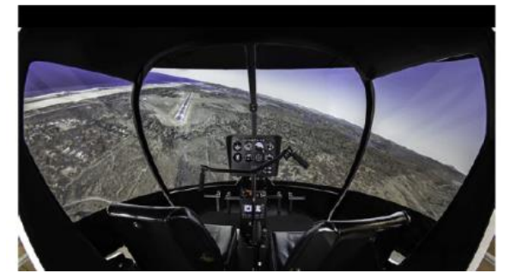

Figure 1: Frasca virtual reality flight training simulation equipment

3.3 Virtual battlefield environment exercises training

Conventional military drills are prolonged and resource-intensive. By utilizing virtual military systems for training, large-scale theater-of-war exercises and strategic maneuvers can be conducted with minimal expenditure and within shorter timeframes. These exercises allow for the identification and resolution of potential challenges encountered in real combat scenarios. By establishing virtual battlefields, both participating factions engage in simulated confrontations based on various scenarios and environmental changes, mirroring real-world conditions. This virtual combat environment enables the involvement of numerous military units without the constraints of geographical limitations, thereby enhancing the effectiveness of battle training, evaluating the overall performance of weapon systems, and fostering innovative operational strategies.

3.4 Virtual weapon manufacturing
Virtual reality (VR) technology holds significant applicability in weapon design, research analysis, production planning, and manufacturing, among other areas. In the realm of weapon design and development, VR technology facilitates advanced demonstrations, enabling developers and users to immerse themselves in virtual combat environments to test design schemes, tactical and technical performance metrics, and operational feasibility. This integration of cutting-edge design concepts into weapon development accelerates the development cycle while ensuring thorough assessment of operational effectiveness, thereby enhancing overall quality and alignment with real-world combat needs. Utilizing VR to simulate future high-tech battlefield environments aids in selectively prioritizing the development of weaponry and equipment systems, optimizing their quality and operational efficiency. Notably, the F-22 and JSF, both fourth-generation fighters of the USAF, achieved a 50% reduction in development cycles and over 93% savings in development costs by adopting VR technology throughout the development process, integrating 3D digital design and manufacturing. Additionally, the aircraft carrier CVN21 pioneered full virtual design during its design phase, resulting in significant reductions in development cycle and costs through detailed virtual modeling of assembly processes at reduced expenses and risks..
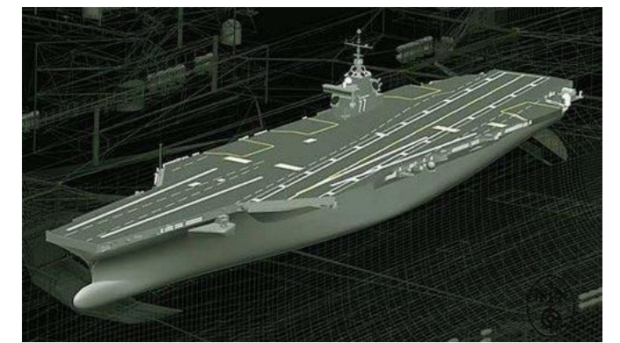

Figure 2: CVN21 aircraft carrier model

3.5 Equipment Familiarization Training

Numerous heavy machinery and military vehicles comprise intricate electromechanical systems. Understanding their operation and ensuring safe operation are vital aspects of training for participants seeking to acquaint themselves with specific equipment, aiding in the enhancement and retention of their current skill sets.
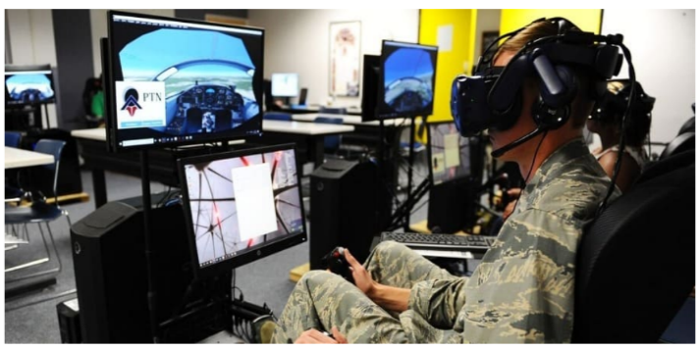
Figure 3: Equipment Simulation Using VR

- ARCHITECTURE OF AR

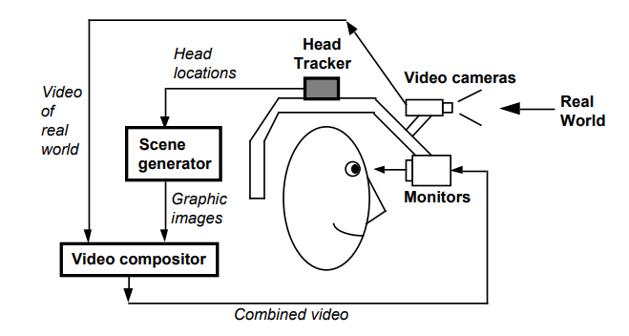

Figure 4: Virtual Reality Architecture.

The architecture of a Virtual Reality (VR) system typically consists of several interconnected components that work together to create immersive virtual experiences.
4.1 Key Elements of VR Architecture:
1. Hardware Components:
VR Headset: The primary interface between the user and the virtual environment, providing stereoscopic displays and head tracking capabilities.
Input Devices: Controllers, gloves, or other peripherals used to interact with virtual objects and navigate within the VR environment.
Sensors: Positional tracking sensors (e.g., cameras, infrared sensors) to track the user's movements and gestures, enabling real-time interaction and immersion.
Audio Devices: Headphones or speakers to provide spatial audio cues and enhance the sense of presence in the virtual world.

2. Software Components:
Rendering Engine: A software engine responsible for rendering 3D graphics in real-time, generating the visual elements of the virtual environment based on input from the user and the application.
Physics Engine: Simulates the physical behavior of virtual objects, including collision detection, gravity, and object interactions, to create a realistic and immersive experience.
Input Processing: Software modules that process input from sensors and input devices, translating user actions into interactions within the virtual environment.
Scene Graph: A hierarchical data structure representing the objects and elements in the virtual scene, facilitating efficient rendering and manipulation of virtual objects.
Interaction Logic: Algorithms and scripts that govern the behavior of virtual objects, user interfaces, and interactive elements within the VR environment.
Networking: Support for networked multiplayer experiences, enabling multiple users to interact and collaborate within the same virtual space.
3. System Architecture:
Client-Server Model: In networked VR applications, a client-server architecture may be used, where the server manages the virtual environment and synchronizes state between multiple clients.
Event-Driven Architecture: VR applications often utilize an event-driven architecture, where user actions and system events trigger responses and updates within the virtual environment.
Latency Reduction Techniques: Techniques such as predictive tracking, asynchronous time warp, and frame interpolation are employed to reduce latency and improve responsiveness, minimizing motion sickness and enhancing user comfort.
4. Integration and Optimization:
Hardware-Software Integration: Ensuring seamless integration between hardware components (e.g., headsets, controllers) and software systems to deliver a cohesive VR experience.
Performance Optimization: Optimizing rendering performance, input latency, and overall system responsiveness to deliver smooth and immersive VR experiences across a range of hardware configurations.

In military training using VR, various sensors play a crucial role in tracking and enhancing the user's experience. Here are some commonly used sensors:
4.2 Commonly used sensors in Military Training:
1. Motion Tracking Sensors: These sensors, such as accelerometers, gyroscopes, and magnetometers, track the user's head and body movements in real-time. They are integrated into VR headsets and controllers to provide accurate positional tracking, enabling users to navigate and interact within the virtual environment.
2. Gesture Recognition Sensors: Gesture recognition sensors, such as depth cameras (e.g., Kinect) and infrared sensors, detect and interpret hand gestures and body movements.
3. Biometric Sensors: Biometric sensors, including heart rate monitors, electrodermal activity sensors, and eye-tracking cameras, monitor physiological responses and cognitive states during training sessions.
4. Force Feedback Sensors: Force feedback sensors, such as force-sensitive resistors (FSRs) and pressure sensors, measure the pressure and force exerted by the user's hands and fingers when interacting with virtual objects.
Suits:
The suit is equipped with a network of actuators and vibrating:
1. Actuators and Vibrating Motors: motors strategically placed throughout the body to simulate tactile sensations and vibrations corresponding to virtual interactions and environmental stimuli.
2. Flexible Fabric and Lightweight Design: Full-body haptic feedback suits are typically made from flexible and lightweight materials, ensuring comfort and mobility during extended VR sessions. The design allows users to move freely and perform physical activities without restrictions.
3. Haptic Feedback Control Software: The suit is controlled by specialized software that synchronizes haptic feedback patterns with virtual events and interactions in real-time. The software adjusts the intensity, frequency, and location of haptic feedback sensations based on user actions and environmental cues.
4. Wireless Connectivity: Many full-body haptic feedback suits feature wireless connectivity options, allowing seamless integration with VR systems and reducing cable clutter. Wireless communication enables real-time data transmission and synchronization between the VR application and the haptic feedback suit.
5. Customizable Feedback Profiles: Users can customize haptic feedback profiles and settings based on personal preferences and comfort levels. Adjustable parameters may include vibration intensity, frequency ranges, and haptic response patterns tailored to individual preferences and sensory sensitivities.

- VIRTUAL REALITY IN MILITARY

Within this domain, a scarcity of seasoned support personnel presents a notable challenge, necessitating the transfer of their expertise through alternative means. Virtual and mixed-reality technologies emerge as viable solutions to this predicament. For instance, in the marine corps, individual boats may exhibit distinct engineering constraints, resulting in varying maintenance requirements from one vessel to another. To expedite operational readiness, technicians can access CAD models in virtual reality (VR) and undergo specialized training programs tailored to the specific vessel, facilitating on-site familiarization before deployment.
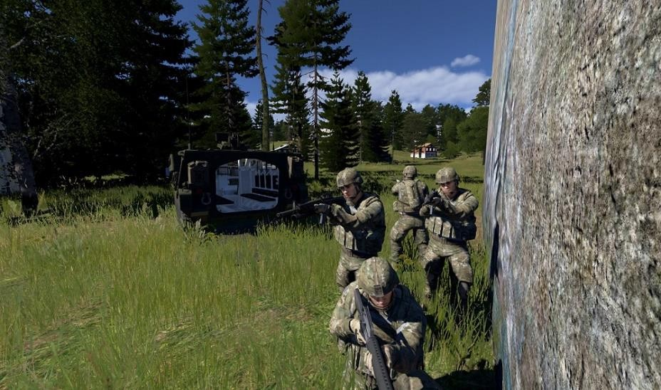

Figure 5: Virtual Battlespace 3 (VBS3)

5.1 Vehicles and Aircraft Simulations:
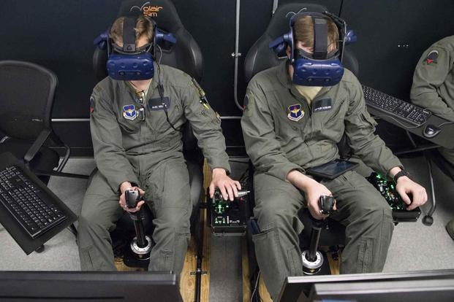

Figure 6: Pilot Training Next students train on a virtual reality flight simulator

VR technology is increasingly employed for military personnel training, particularly in the operation of vehicles and aircraft. Simulations offer a cost-efficient and secure method for pilots and vehicle operators to refine their skills without jeopardizing valuable equipment or lives. Through VR, pilots and vehicle operators can undergo training to navigate diverse terrains, weather conditions, and combat scenarios.

For example, the United States Air Force utilizes VR for pilot training across various aircraft models, including the F-35 Lightning II and the T-6 Texan II. These VR simulations enable pilots to practice maneuvers in a range of conditions and mission scenarios, encompassing air-to-air combat, ground attack operations, and formation flying.

CONCLUSION

Augmented Reality (AR) has the potential to significantly enhance education by providing immersive and interactive learning experiences. By integrating AR technology into educational settings, we can create a more engaging and effective learning environment for students. AR enables educators to transform abstract concepts into tangible experiences, allowing students to interact with digital content overlaid onto the physical world. This level of engagement fosters deeper understanding and retention of knowledge among learners. Additionally, AR facilitates personalized learning experiences tailored to individual student needs and preferences. Students can explore topics at their own pace and receive personalized feedback, leading to more effective learning outcomes.
Moreover, AR encourages collaborative learning, as students can interact with AR content together, fostering teamwork and communication skills.

REFERENCES

[1] Syed Faizan Ali, Syed Aaqib Azmat, Ahmed Ullah Noor, Hammad Siddiqui, Shaheena Noor. Virtual reality as a tool for physical training in CVPR, 2017.
[2] Junrong Feng Research on the Application of VR Technology in Military Electronic Countermeasure Teaching. 2020.
[3] Amanpreet Kaur: AR and VR in Military Combat: Enhancing Soldier Performance and Safety. IEEE, 2023.
[4] F. Bogo, A. Kanazawa, C. Lassner, P. Gehler, J. Romero, and M. J. Black. Keep it SMPL: Automatic estimation of 3d human pose and shape from a single image. In ECCV, 2016.
[5] Xinxiong Liu1, Jing Zhang1, Guoxiang Hou1 and Zenan Wang2: Virtual Reality and Its Application in Military. In CVPR, 2018.
[6] W.G.R.M P.S. Rathnayake. Daniilidis Usage of Mixed Reality for Military Simulations. In IEEE, 2018.

