COST EFFICIENCY ENHANCEMENT IN BIOMASS PELLET MANUFACTURING THROUGH RAW MATERIALS OPTIMIZING
C.Sasidharan¹, J.Ajay², P.Sanjaikanth³, V.Pughalmannan⁴
¹Assistant Professor -Mechanical Engineering& M.A.M College of Engineering and Technology
²Students-Mechanical Engineering & M.A.M College of Engineering and Technology
³Student-Mechanical Engineering & M.A.M College of Engineering and Technology
⁴Student-Mechanical Engineering & M.A.M College of Engineering and Technology

---------------------------------------------------------------------***---------------------------------------------------------------------
Abstract –“This project explores innovative approaches to enhance efficiency and reduce costs in biomass pellet production. By integrating smart technologies, process optimization, and sustainable practices, the aim is to make biomass pellet production more affordable and environmentally friendly. By implementing smart solutions, the goal is to address challenges related to variability in biomass feedstock, energy inefficiencies, and operational costs.
This research not only seeks to improve the economic viability of biomass pellet production but also aims to contribute to the broader goal of fostering renewable energy solutions for a more sustainable future. In addition, the project explores the incorporation of renewable energy sources, such as solar or biomass-based energy, into the production process to further reduce environmental impact and operational costs.

The optimization of supply chain logistics is also a focal point, aiming to minimize transportation-related emissions and ensure a more sustainable overall production lifecycle. Through a holistic approach, this research endeavors to provide a roadmap for the integration of smart and sustainable practices, fostering a greener and economically feasible future for biomass pellet production.”

Key Points : Feed Hopper, Motor, Roller, Cycle Chain

1. INTRODUCTION
Compound feed is a homogenous mixture of many different foods, which are combined together according to a formula established from scientific research to ensure nutrition for livestock. The introduction of compound feed allowed the industrialization of the livestock industry .The introduction of compound feed has overcome the situation of seasonal feed supply and gives a more uniform product quality.
In addition, compound feeds enable rapid adoption of the latest achievements in nutrition, allowing widespread mechanization and automation in feeding, saving labor and food preparation time. Therefore, compound feed is of great significance. Developing the livestock feed that can utilize all sources of animal feed, including by-products of the agro- food processing industry, allows the development of livestock in the necessary directions.
Recently, following the general trend, our country's animal feed industry has paid attention to the processing of mixed feed into pellets .In pellet form, it will be easier to use, as well as better to pack, transport, and preserve. Poultry feed pelletizing machine is the machine used in the turning of fish feeds into pellet form. More emphasis are laid on the agricultural sector as a veritable self-employment tool, a means of improving the standard of living and a means of improving the technological challenges inherent globally in the sector. Hence, the need for diversification of human occupation in the area of agro- fish business. For the continual upkeep of this business, fish-feed machines of various kinds are important. Pelletizing can simply be described as the change in phase of raw materials due to the application of medium to raise the temperature in order to have a final phase in a solid and capsular form after passing through the die of desired shape.

2. METHODOLOGY
The idea is to fabricate a machine which would have mixing, blending, and compressing chambers. The first section would be comprised of a hopper to feed the input, which would pass to cutting chamber. The cutter would cut the input material into powdered form. A sieve-like plate would be mounted below it to pass this powdered biomass to blending chamber. Here the binder and water would be added to the powdered biomass. Many naturally occurring binders may be used like wheat flour (wastage from mills), wet paper pulp, cow dung etc. The mixing would be done by helical blender, as it is the most efficient blender for handling highly viscous fluids. Due to the helix shape of the blender, the thick viscous mixture would then follow its helix to reach the next chamber.
The next part would be the final stage of the machine. The thick mixture would be passed onto a die. The rollers would be mounted such that there is a clearance between the rollers and the die. The die, being mounted on the
Central shaft along with the cutting blade and blender, would rotate during the operation. The rollers have their axis perpendicular to the central shaft axis, and the axle that passes through the rollers would be mounted in the casing. The collection of cylindrical shaped briquettes would be done in the chamber under the die from which the briquettes would proceed to drying.

3. DESIGN AND DRAWING
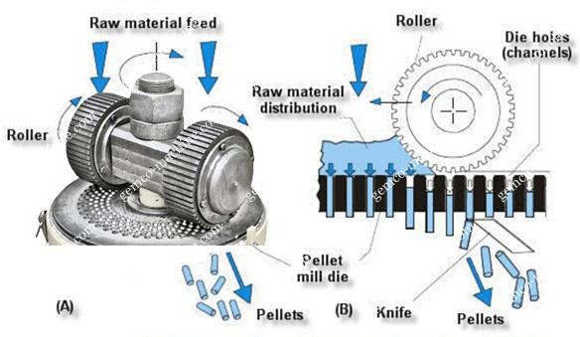

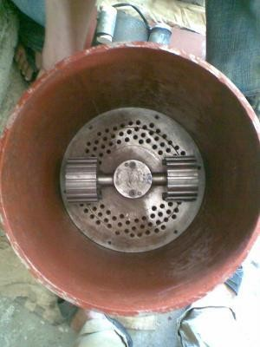

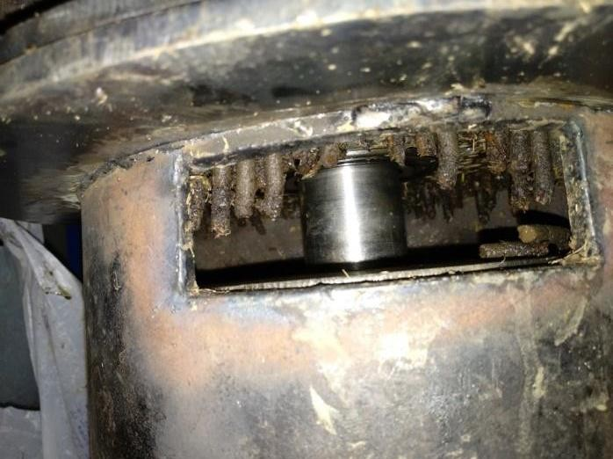

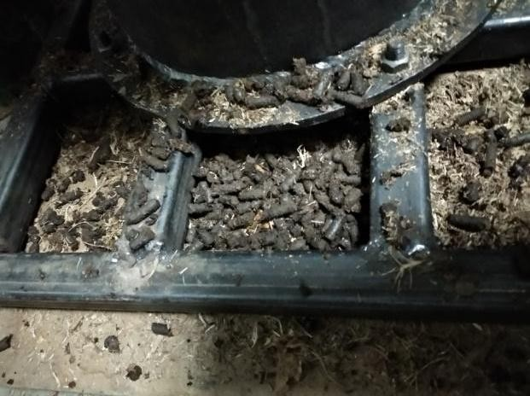

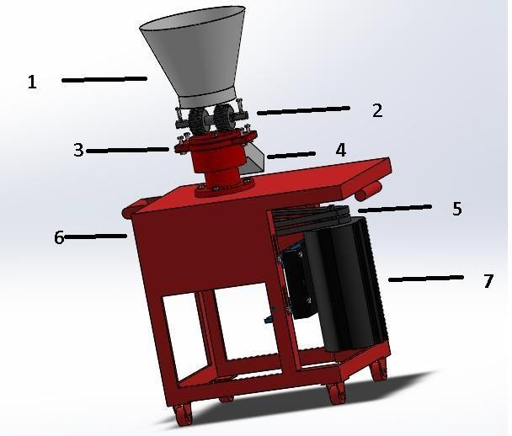
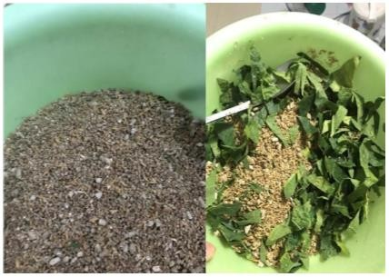
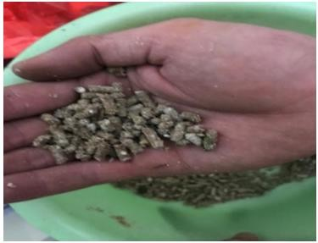

3. Working Principle
“The machine works on the principle that it uses a roll-type extrusion press. The formulated feeds are fed into the pelleting chamber by the pellet rolls. As the pellet rolls rotate, force is applied creating rearrangement of the particles in order to fill the voids or holes of the die plate.
The pressure is increased in compression step, causing brittle particles to break and malleable particles to deform forcing them to be fed in the die and come out as pellets. The pellets then fall naturally due to impact created by the rotating die plate, hence, no need for a cutter. After design of the machine, according to the required specifications, it was fabricated.
The required material was procured and individual parts were manufactured using operations like turning, milling, slotting, drilling, etc. The frame was fabricated using pipes of size 1 inch which were joined using welding. Different parts were joined using bolted joints. The whole assembly is placed on a wooden board to minimize the effect vibration.
When starch was used as binder, the pulse of feed through the die was generally smooth for all mixes as against when water alone was used to condition the feed. The pellets formed with starch binder were smooth and brightly coloured but those formed with water were scorched and pale.
This was due to the friction and the heat generated during the process which was higher with just water being used as preconditioner. This was evidenced by the temperature around the caking section which was relatively hotter when water was used as preconditioner than with starch.
The pellets with 500 and 750 cm3 of starch or water were properly formed. However, when 1000 cm3 of water was used, no pellets were formed. This was due to the excessive moisture in the feed which overcame the required friction needed as feed passed through the die. Hence the feed could not be caked as there were no restrictions to keep it in the caking section. In addition, the pellets derived when 1000 cm3 of starch was used were poorly formed.
4. CONCLUSIONS
Feed drying is an important aspect for all small scale and commercial feed production in most developing countries and is a special problem in Nigeria. In this work, pelletizer of 4.82t/hr has been successfully designed, constructed and tested. This effort will boost local production of fish feeds. The higher production capacity results from mechanizing the various component of the machine. In the extrusion process, the screw conveyor efficiency was established to be a function of die size and material feed rate.
The efficiency of the extruder increases with an increase in die size regardless of the feed formulation used. The possibility of die clogging is affected by material feed- rate and die size. Increase in feed rate and use of small size die raises the probability of die blockage and by implication causes a reduction in the efficiency of the extruder.

REFERENCES

- R. S. Hegarty, "Livestock nutrition–a perspective on future needs in a resource-challenged planet," Animal Production Science, vol. 52, no. 7, pp. 406-415, 2012.
- D. Sauvant, J.-M. Perez, and G. Tran, Tables of composition and nutritional value of feed materials: pigs, poultry, cattle, sheep, goats, rabbits, horses and fish. Wageningen Academic Publishers, 2004.
- G. O. Tona and nutrition, "Current and future improvements in livestock nutrition and feed resources," Animal husbandry and nutrition, pp. 147-169, 2018.
- G. Alderman, "Prediction of the energy value of compound feeds," Recent advances in animal nutrition, vol. 285, 1985.
- P. Broadbent, "Mechanization of feeding in relation to feeding systems," BSAP Occasional Publication, vol. 2, pp. 103-114, 1980.
- T. I. N. Ezejiofor, U. E. Enebaku, and C. Ogueke, "Waste to wealth- value recovery from agro-food processing wastes using biotechnology: a review," British Biotechnology Journal, vol. 4, no. 4, p. 418, 2014.K. Aarseth and E. Prestløkken, "Mechanical properties of feed pellets: Weibull analysis," Biosystems engineering, vol. 84, no. 3, pp. 349-361, 2003. [8] Đ. Vukmirović, R. Čolović, S. Rakita, T. Brlek, O. Đuragić, and
D. Solà-Oriol, "Importance of feed structure (particle size) and feed form

