Analysis of The Performance Appraisal & Bonus Payments at Real Ispat
Roshani Agrawal
Guided by - Dr. Niranjan Deo Pathak
AMITY UNIVERSITY RAIPUR CHHATTISGARH
ABSTRACT
The goal of the research project "Analysis of The Performance Appraisal & Bonus Payments at Real Ispat" is to examine the complex workings of performance assessment systems and how they affect worker satisfaction, productivity, and motivation. Acknowledging the pivotal function that incentive payments and performance reviews play in molding organizational results, this study attempts to offer a thorough examination of these mechanisms in the context of Real Ispat, a prominent participant in the steel production industry.
This study's primary goal is to examine how performance reviews affect workers' motivation and output. Performance reviews are meant to provide workers input on how they perform at work, point out their areas of strength and weakness, and establish goals for the future. This study investigates the relationship between these evaluations and workers' incentive to improve performance and total output. Through gathering information from workers at different levels, the study seeks to measure how much performance reviews impact employee engagement and productivity, which in turn boosts the effectiveness and production of the company.
Finding out how employees feel about and are satisfied with the performance evaluation process is the second goal. The success of the system depends heavily on how fair, transparent, and successful the assessment process is by the workforce. This survey looks at how Real Ispat employees feel about the assessment process, whether they think it's fair and impartial, and if they're happy with how often these appraisals are done. Since these impressions have a direct influence on employee morale, engagement, and retention, it is important to understand them.
Evaluating the efficacy of Real Ispat's present performance evaluation system is the third goal. This entails determining whether the system of appraisals successfully identifies top performers and appropriately represents the work performance of employees. The study also looks at the impact that appraisals have on career development and how they help define reasonable and attainable performance goals. It also looks for areas where the assessment system needs to be improved in order to better fit with employee expectations and company goals.
The study uses a mixed-method approach, integrating quantitative and qualitative data-gathering approaches, to accomplish these goals. Likert scale surveys are used to collect quantifiable information about worker productivity, satisfaction, motivation, and views. To obtain qualitative insights into employees' experiences and ideas for improvement, focus groups, and in-depth interviews are held.
It is anticipated that the study's conclusions will give Real Ispat's management insightful information that will help them improve their processes for incentive payments and performance reviews. The organization may improve employee motivation, contentment, and productivity by implementing focused interventions after determining the present strengths and weaknesses of these systems. This study also adds to the larger body of knowledge on performance reviews by presenting best practices that other companies may use and providing actual data from the manufacturing industry.
Finally, the "Analysis of The Performance Appraisal & Bonus Payments at Real Ispat" hopes to establish a standard for other businesses looking to optimize their performance assessment procedures in addition to improving Real Ispat's internal operations. This research aims to promote a more driven, productive, and contented workforce—which will eventually drive corporate success and growth—through thorough analysis and practical recommendations.
Analysis of The Performance Appraisal & Bonus Payments at Real Ispat
Systems for incentive payments and performance reviews are essential parts of human resource management that have a big impact on worker happiness and organizational effectiveness. These technologies are used by Real Ispat, a renowned steel manufacturer, to evaluate worker performance, offer feedback, and recognize outstanding work. The complexities of Real Ispat's bonus payout and performance rating systems are thoroughly examined in this study, along with their effects on worker satisfaction, productivity, and motivation.
Performance Appraisal Systems
An organized framework for assessing an employee's productivity and job performance with respect to preset standards and corporate goals is known as a performance evaluation system. At Real Ispat, the system tries to match individual objectives with the business's strategic vision, making sure that workers successfully contribute to the growth of the firm.
1. Effect on Worker Productivity and Motivation
Performance reviews, which highlight employees' accomplishments and efforts, are essential in inspiring staff members. Employees are more likely to feel appreciated and inspired to raise their game when they get both constructive criticism and encouraging remarks. The assessment system at Real Ispat is intended to:
• Boost Motivation: Employees are inspired to pursue greatness by the assessment system's defined performance requirements and recognition of exceptional work.
• Boost Productivity: Employees who get constructive criticism are better able to recognize their areas of strength and growth, which increases efficiency and productivity.
• Set objectives: The evaluation process offers a forum for establishing reasonable and attainable objectives, giving staff members a feeling of purpose and direction.
2. Perceptions and Contentment of Employees
The efficacy of the performance assessment system is contingent upon the views and contentment of the workforce. Employee satisfaction and engagement at work are more probable if they believe that the system is just, open, and helpful. Real Ispat makes an effort to guarantee that the appraisal procedure is:
- Fair and Unbiased: Using consistent evaluation and objective criteria. process clearly to all employees.
- Constructive: Giving constructive criticism that is encouraging and helps staff members advance their careers.
- Frequent: Regularly conducting evaluations to provide staff with updates on their work and development.
3. The current system's efficacy
Assessing how well the present performance assessment system achieves its aims and advances the company's objectives is a necessary step in determining its effectiveness. The following are important components of Real Ispat's evaluation process: • Accuracy: Making sure that assessments fairly represent the contributions and performance of employees.
• Goal Alignment: Confirm that the system facilitates the establishment and accomplishment of both personal and corporate goals.
• Career Development: Evaluating how the assessment system contributes to the advancement and development of employees' careers.
• Input Utilization: Analysing how choices about promotions, training, and development requirements are made using input from appraisals.
Systems for Paying Bonuses
Bonus payments are monetary compensation granted to staff members in accordance with their performance, contribution to the company's success, and accomplishment of particular objectives. The bonus payout plan at Real Ispat is intended to work in tandem with the performance assessment system by: • Rewarding Excellence: Offering financial incentives to staff members who reach or surpass performance standards.
• Promoting Productivity: Encouraging staff members to boost their output and more successfully support the goals of the organization.
• Retention: Increasing worker loyalty and satisfaction via acknowledging and praising their efforts.
• Aligning Interests: Making sure that workers' interests coincide with the objectives of the organization, encouraging a sense of dedication and ownership.
At Real Ispat, bonuses are paid out according to the meritocracy theory, which links incentives to each person's performance and accomplishments.
• Performance-Based Bonuses: Bonus amounts are decided upon in accordance with the outcomes of performance reviews.
• Clearly defined criteria: Bonuses should be awarded based on open, impartial standards.
• Timely Distribution: To preserve motivation and satisfaction, incentives must be given out on schedule.
• Feedback Mechanism: Including employee input to make the bonus structure better over time.

Relationship between Bonus and Appraisal Systems
At Real Ispat, the performance assessment and bonus payment processes are intertwined, with the appraisals acting as the basis for bonus eligibility and amounts. By ensuring that awards are determined by performance and merit, this integration fosters a culture of excellence and ongoing development. The following are the main advantages of this relationship:
• Consistency: Ensuring a consistent and equitable incentive system by coordinating bonuses and assessments.
• Motivation: Increasing motivation by explicitly associating money rewards with performance reviews.
• Accountability: Using an open, unbiased system to make sure workers are held responsible for their work.
• involvement: Increasing workers' sense of fulfillment and involvement via acknowledging and praising their contributions.
In conclusion, Real Ispat's bonus payout and performance evaluation systems are essential parts of the business's human resource management plan. These systems boost worker motivation, output, and contentment by efficiently assessing performance, offering helpful criticism, and rewarding excellence. To guarantee that these systems satisfy the changing demands of the business and its personnel and propel Real Ispat toward increased operational excellence and success, ongoing review and enhancement are crucial.
Review of the Literature
(2017) Armstrong, M. "Armstrong's Handbook of Performance Management: An Evidence-Based Guide to Delivering High Performance." Page Kogan.
In order to improve organizational performance, Armstrong's groundbreaking work integrates evidence-based approaches into a comprehensive analysis of performance management systems. The guidebook discusses performance evaluation design and execution, emphasizing the importance that these processes have in inspiring workers and coordinating personal aspirations with organizational goals. It also explores performance-related compensation, outlining how financial incentives can be set up to recognize exceptional achievement and promote efficiency. For HR professionals looking to put into practice performance management techniques that work and promote a culture of high performance, this book is a vital resource.
Cleveland, J. N., and Murphy, K. R. (1995). "Understanding Performance Appraisal: Social, Organizational, and Goal-Based Perspectives." SAGE Books.
Murphy and Cleveland offer a thorough examination of performance review methods from several angles. The book examines the goal-based frameworks that support efficient assessment procedures, the organizational setting, and the social dynamics at play in appraisals. It highlights how crucial it is to comprehend the social and psychological elements that affect the results of appraisals. Through an analysis of how performance assessments affect organizational performance, the writers provide valuable ideas for creating impartial, equitable, and employee-development-friendly systems.
H. Aguinis (2019). "Performance Management for Dummies." Wiley. Aguinis provides a useful manual on performance management by simplifying difficult ideas into understandable details. The whole cycle of performance management is covered in the book, including how to define performance criteria, conduct assessments, and connect evaluations to pay. It offers detailed guidelines for creating and putting into place efficient assessment systems that improve worker productivity and organizational results. Managers and HR professionals who are new to performance management or want to improve their current systems may find this material very helpful.
Murphy, K. R., and A. S. DeNisi (2017). "Performance Appraisal and Performance Management: 100 Years of Progress?" 421-433 in Journal of Applied Psychology, 102(3).
This academic paper examines how performance management and assessment have changed over the last 100 years. DeNisi and Murphy chart the evolution of assessment systems across time, emphasizing important turning points and changes in conventions. They investigate the effectiveness of both modern and conventional appraisal techniques, offering a critical evaluation of their effects on worker productivity and organizational success. This article highlights topics for further study and development and provides a thorough summary of the advancements made in the subject.
In 2011, Cardy and Leonard published "Performance Management: Concepts, Skills, and Exercises." Sharpe, M.E.
The book by Cardy and Leonard focuses on using performance management ideas in real-world situations. It gives readers the opportunity to build the abilities required for successful performance reviews by fusing theoretical understanding with real-world applications. The book offers a comprehensive overview of performance management by covering important subjects including goal-setting, feedback systems, and performance-related compensation. Readers may improve their capacity to create and oversee performance evaluation systems that promote corporate success by actively participating in the activities.
Pulakos, E. D. (2009). "Performance Management: A New Approach for Driving Business Results." Wiley-Blackwell.
Pulakos discusses innovative approaches to performance management that are designed to drive business results. The book challenges traditional appraisal methods, advocating for more dynamic and flexible systems that adapt to changing business environments. Pulakos emphasizes the importance of aligning performance management with strategic business goals, using appraisals to foster a culture of continuous improvement. This book is a valuable resource for organizations looking to revamp their performance management practices to achieve better business outcomes.
In 2003, Lawler, E. E., "Reward Practices and Performance Management System Effectiveness." 396-404 in Organizational Dynamics, 32(4).
The efficacy of performance management systems and incentive policies, such as bonus payments, are examined in Lawler's essay. The essay investigates how various incentive schemes, such as incentives based on performance, might amplify the performance assessments' motivating power. Lawler offers suggestions for creating incentive schemes that support desired actions and results that are supported by data. HR professionals who want to combine performance reviews with efficient incentive plans should read this article.
M. London (2003). "Job Feedback: Giving, Seeking, and Using Feedback for Performance Improvement." Psychology Press.
The influence of feedback on performance improvement and its function in performance assessments are examined in London's book. In her discussion of the best ways to provide and receive feedback, the author stresses the need for prompt and helpful communication. The book also discusses how staff members may actively look for feedback to improve their work. Organizations may design assessment systems that successfully promote employee growth and continual improvement by understanding the dynamics of feedback.
Latham, G. P. "The Motivational Benefits of Goal-Setting." 2004. 126–129 in Academy of Management Executive, 18(4).
The motivating advantages of goal-setting in the context of performance reviews are emphasized in Latham's paper. The essay explores the ways in which establishing clear, demanding, and attainable goals might improve worker motivation and output. Latham offers helpful advice on how to incorporate goal-setting techniques into systems for performance evaluation. Understanding the psychological processes that support successful goal-setting and how they influence worker engagement and productivity will be aided by reading this article.
Harvard Business Review, 94(10), 58-67. Cappelli, P., & Tavis, A. (2016). "The Performance Management Revolution."
Recent developments in performance management are examined by Cappelli and Tavis, including the move away from traditional yearly appraisals and toward more flexible and ongoing approaches. The causes for this change are discussed in the article, including the necessity of receiving feedback more frequently and the evolving nature of work. The writers give instances of businesses that have effectively used novel performance management techniques. If your company wants to update its performance review system, this article has some great tips.
London, M., and J. W. Smither (2009). "Performance Management: Putting Research into Action." Jossey-Bass Publishing.
The book by Smither and London is a compilation of useful advice and research-based ideas for efficient performance management. The authors present evidence-based recommendations for developing and putting into practice assessment systems by compiling the results of several research. A wide range of subjects are covered in the book, such as goal-setting, performance-related remuneration, and feedback. It is a thorough resource for managers and HR specialists who want to improve their performance management procedures by applying study findings.
In 1999, Bacal, R. "Performance Management." Pearson Education.
The book by Bacal offers a thorough overview of performance management with an emphasis on evaluations and incentive programs. The author provides helpful guidance on establishing and sustaining efficient performance review processes that support company objectives. The book uses case studies and real-world examples to highlight performance management best practices. Practitioners wishing to put in place performance management systems that promote worker performance and organizational success will find great value in Bacal's work.
Peterson, S. J., Jacobson, K., Kinicki, A., and Prussia, G. E. (2013). "Development and Validation of the Performance Management Behavior Questionnaire." 1–45 in Personnel Psychology, 66(1).
The Performance Management Behavior Questionnaire (PMBQ), a tool for evaluating performance management behaviors, is developed and validated, as described in this article. The PMBQ's psychometric qualities and its uses in performance evaluation systems are covered by the writers. The paper offers a thorough methodological framework for assessing performance management procedures. Organizations looking to evaluate and enhance their evaluation processes will find this tool beneficial.

G. Dessler (2019). "Human Resource Management." Pearson.
Dessler's textbook is an extensive resource that covers pay and performance reviews, among other topics related to human resource management. An introduction to HRM ideas and practices is given in the book, along with helpful advice on how to put efficient performance management systems into place. Dessler talks about how assessments fit into larger HRM procedures including pay plans and training and development. An indispensable tool for HRM students and professionals alike is this textbook.

- RESULT
Statistics
 |  | Gender of the respondent | Age of the respondent
N | Valid | 190 | 190
N | Missing | 0 | 0
Mean |  | 1.56 | 2.34
Median |  | 2.00 | 2.00
Mode |  | 2 | 2
Variance |  | .247 | 1.135
Range |  | 1 | 3

The table provides statistical data for two variables: the gender of the respondents and the age of the respondents. Let's analyze the data provided:
Gender of the Respondent:
- N (Valid): 190 (All 190 responses were valid with no missing data)
- Mean: 1.56
- The mean value of 1.56 suggests that on a scale (likely with 1 for male and 2 for female), there are slightly more females than males.
- Median: 2.00
- The median value of 2.00 indicates that half of the respondents are females.
- Mode: 2
  - The mode value of 2 means that the most frequently occurring value is 2 (female).
- Variance: 0.247
  - The variance of 0.247 indicates a low level of variability in the responses.
- Range: 1
  - The range of 1 suggests that there are only two categories (most likely male and female).
Age of the Respondent:
- N (Valid): 190 (All 190 responses were valid with no missing data)
- Mean: 2.34
  - The mean age value of 2.34 suggests that the respondents are skewed towards the older age groups on a scale (likely 1 for young, 2 for middle-aged, 3 for older).
- Median: 2.00
  - The median age value of 2.00 indicates that half of the respondents are middle-aged.
- Mode: 2
  - The mode value of 2 means that the most frequently occurring age category is middle-aged.
- Variance: 1.135
  - The variance of 1.135 suggests a moderate level of variability in the age of the respondents.
- Range: 3
  - The range of 3 indicates that there are likely three categories of age.
Summary:
- The gender distribution leans slightly more towards females with a mean of 1.56, and the most common response being female (mode and median both 2).
- The age distribution has a mean of 2.34, indicating a skew towards older age groups with the most common response being middle-aged (mode and median both 2).
- Gender responses show less variability compared to age responses, as indicated by the lower variance for gender (0.247) compared to age (1.135).

Frequency Analysis of Gender of the Respondent:
- Frequency:
  - 1: 83 respondents
  - 2: 107 respondents
- Percent:
  - 1: 43.7%
  - 2: 56.3%
- Valid Percent:
  - 1: 43.7%
  - 2: 56.3%
- Cumulative Percent:
  - 1: 43.7%
  - 2: 100.0%
Interpretation:
- Frequency:
  - 83 respondents identified as gender category 1.
  - 107 respondents identified as gender category 2.
- Percent:
  - 43.7% of the respondents are in gender category 1.
  - 56.3% of the respondents are in gender category 2.
- Valid Percent:
  - These percentages reflect the same as the "Percent" column, indicating the proportion of each gender category among the valid responses.
- Cumulative Percent:
  - 43.7% of the respondents are in gender category 1.
  - The cumulative percentage reaches 100% with gender category 2, meaning all respondents have been accounted for by the time gender category 2 is included.
Result:
- Gender Distribution: The respondents are predominantly in gender category 2 (56.3%), compared to 43.7% in gender category 1. This aligns with the previous analysis where the mean for gender was 1.56, suggesting a slight majority of respondents in gender category 2.
- Total Respondents: The total number of respondents is 190, with no missing data.
This detailed frequency table confirms that gender category 2 is more prevalent among the respondents, representing 56.3% of the total sample.

Result:
- Age Distribution:
  - The respondents are predominantly in age category 2 (37.4%), followed by age category 1 (24.7%), age category 4 (20.5%), and age category 3 (17.4%).
  - Age category 2 has the highest frequency of respondents, suggesting a significant portion of the sample falls into this age group.
- Total Respondents: The total number of respondents is 190, with no missing data.
Summary:
- Age Category 1: Represents 24.7% of the respondents.
- Age Category 2: Represents 37.4% of the respondents, making it the largest group.
- Age Category 3: Represents 17.4% of the respondents.
- Age Category 4: Represents 20.5% of the respondents.
This detailed frequency table confirms that age category 2 is the most prevalent among the respondents, followed by age categories 1, 4, and 3.

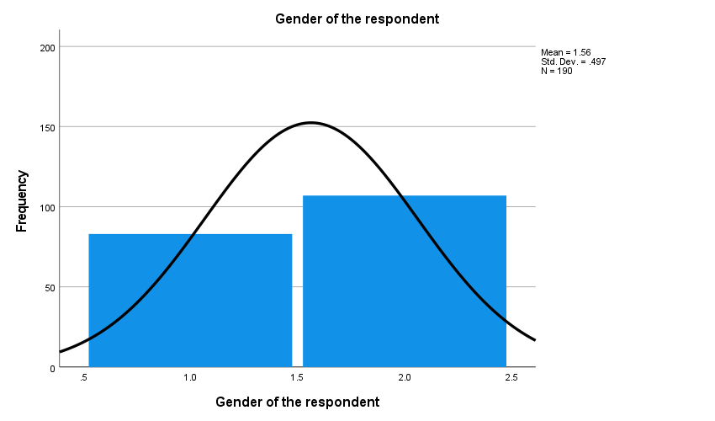

Interpretation:
- Gender Category Distribution:
  - The histogram shows that there are more respondents in gender category 2 than in gender category 1.
  - The exact frequencies can be referred to from the previous table, which shows 83 respondents in category 1 and 107 respondents in category 2.
- Mean and Standard Deviation:
  - The mean of 1.56 aligns with the observation that there are slightly more respondents in gender category 2.
  - The standard deviation of 0.497 suggests that the data is relatively concentrated around the mean, with not much variation in the gender responses.
- Normal Distribution:
  - The overlaying normal distribution curve helps visualize how the data is distributed.
  - The peak near gender category 2 reinforces that category 2 is more prevalent among respondents.
Result:
- The visual representation confirms that gender category 2 is more frequent among the respondents, with a mean of 1.56 indicating a slight majority.
- The standard deviation of 0.497 suggests that responses are closely distributed around the mean.
- The total number of respondents (N = 190) supports the completeness of the data.
This analysis confirms the earlier statistical findings and provides a clear visual representation of the gender distribution among the respondents.

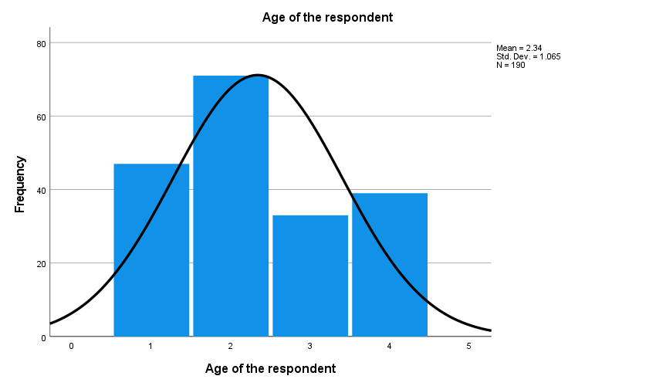
Interpretation:
- Age Category Distribution:
  - The histogram shows that age category 2 has the highest frequency of respondents, followed by category 1, category 4, and category 3.
  - The exact frequencies can be referred to from the previous table, which shows 47 respondents in Category 1, 71 in Category 2, 33 in Category 3, and 39 in Category 4.
- Mean and Standard Deviation:
  - The mean of 2.34 aligns with the observation that there are more respondents in age category 2.
  - The standard deviation of 1.065 suggests that there is a moderate spread in the age responses, indicating variability among the respondents' ages.
- Normal Distribution:
  - The overlaying normal distribution curve helps visualize how the data is distributed.
  - The peak near age category 2 reinforces that category 2 is the most prevalent among respondents.
Result:
- Age Distribution: The respondents are predominantly in age category 2 (37.4%), followed by category 1 (24.7%), category 4 (20.5%), and category 3 (17.4%).
- Total Respondents: The total number of respondents is 190, with no missing data.
- Mean Age Category: The mean age category is 2.34, indicating that the average respondent is closer to age category 2.
- Variability: The standard deviation of 1.065 indicates a moderate level of variability in the ages of the respondents.
This visual representation confirms the earlier statistical findings and provides a clear picture of the age distribution among the respondents.

The table presents the commonalities for a set of questions related to performance appraisals at Real Ispat. These commonalities were extracted using Principal Component Analysis (PCA). Communality represents the proportion of each variable's variance that can be explained by the factors (components) in the analysis.
Analysis:
Communalities:
- Initial: This column shows the initial communalities, which are all 1.000. This means that before extraction, 100% of the variance in each variable is assumed to be common variance.
- Extraction: This column shows the commonalities after extraction. It indicates the proportion of variance in each variable that is explained by the extracted factors.
Communality Values:
- Q1 Performance appraisals motivate me to improve my work performance.
  - Initial: 1.000
  - Extraction: 0.518
  - Interpretation: Approximately 51.8% of the variance in this question is explained by the extracted factors.
- Q2 The feedback I receive during performance appraisals helps me understand my strengths and areas for improvement.
  - Initial: 1.000
  - Extraction: 0.505
  - Interpretation: Approximately 50.5% of the variance in this question is explained by the extracted factors.
- Q3 Performance appraisals at Real Ispat led to increased productivity in my work.
  - Initial: 1.000
  - Extraction: 0.392
  - Interpretation: Approximately 39.2% of the variance in this question is explained by the extracted factors.
- Q4 I feel more engaged in my work after receiving my performance appraisal.
  - Initial: 1.000
  - Extraction: 0.078
  - Interpretation: Approximately 7.8% of the variance in this question is explained by the extracted factors, indicating it is poorly explained by the components.
- Q5 Performance appraisals provide me with clear goals and objectives to achieve.
  - Initial: 1.000
  - Extraction: 0.561
  - Interpretation: Approximately 56.1% of the variance in this question is explained by the extracted factors.
Additional Information:
- Determinant: The determinant of the correlation matrix is 0.557. This value is important for assessing multicollinearity. A determinant close to 0 indicates multicollinearity among the variables, while a value not close to 0 suggests that multicollinearity is not a significant problem.
Summary:
- Q1, Q2, and Q5 have relatively high communalities, indicating that a significant portion of their variance is explained by the extracted factors.
- Q3 has a moderate communality, indicating that less than half of its variance is explained by the factors.
- Q4 has a very low communality, indicating that the extracted factors do not explain much of its variance, suggesting it may not be well represented by the underlying factors in the PCA.
The results suggest that performance appraisals at Real Ispat are seen to provide motivation, useful feedback, and clear goals to some extent, but may not significantly enhance work engagement based on the low communality for Q4.
The table provides information about the total variance explained by the components in a Principal Component Analysis (PCA). This table is divided into two main parts: Initial Eigenvalues and Extraction Sums of Squared Loadings.
Analysis:
Initial Eigenvalues:
- Component 1:
  - Total: 2.054
  - % of Variance: 41.082%
  - Cumulative %: 41.082%
- Component 2:
  - Total: 0.974
  - % of Variance: 19.481%
  - Cumulative %: 60.563%
- Component 3:
  - Total: 0.755
  - % of Variance: 15.091%
  - Cumulative %: 75.654%
- Component 4:
  - Total: 0.649
  - % of Variance: 12.980%
  - Cumulative %: 88.634%
- Component 5:
  - Total: 0.568
  - % of Variance: 11.366%
  - Cumulative %: 100.000%
Extraction Sums of Squared Loadings:
- Component 1:
  - Total: 2.054
  - % of Variance: 41.082%
  - Cumulative %: 41.082%
Interpretation:
- Initial Eigenvalues:
  - Component 1: Explains 41.082% of the total variance, which is the highest among all components.
  - Component 2: Explains 19.481% of the total variance, bringing the cumulative variance explained to 60.563%.
  - Component 3: Explains 15.091% of the total variance, bringing the cumulative variance explained to 75.654%.
  - Component 4: Explains 12.980% of the total variance, bringing the cumulative variance explained to 88.634%.
  - Component 5: Explains 11.366% of the total variance, bringing the cumulative variance explained to 100.000%.
- Extraction Sums of Squared Loadings:
  - Only the first component is extracted, explaining 41.082% of the total variance.
Summary:
- Principal Component Analysis Results:
  - The first component explains the largest portion of the variance (41.082%), making it the most significant component.
  - The second component adds another 19.481%, bringing the cumulative variance explained by the first two components to 60.563%.
  - The third, fourth, and fifth components add progressively smaller amounts of explained variance.
  - The total variance explained by all five components is 100%, as expected.
- Extraction:
  - Only the first component is retained based on the extraction method (Principal Component Analysis), which explains 41.082% of the total variance.
This analysis indicates that the first principal component is the most influential, explaining a substantial portion of the variance in the data. The subsequent components add progressively less explanatory power. The decision to retain only the first component suggests that it captures the most significant patterns in the data.

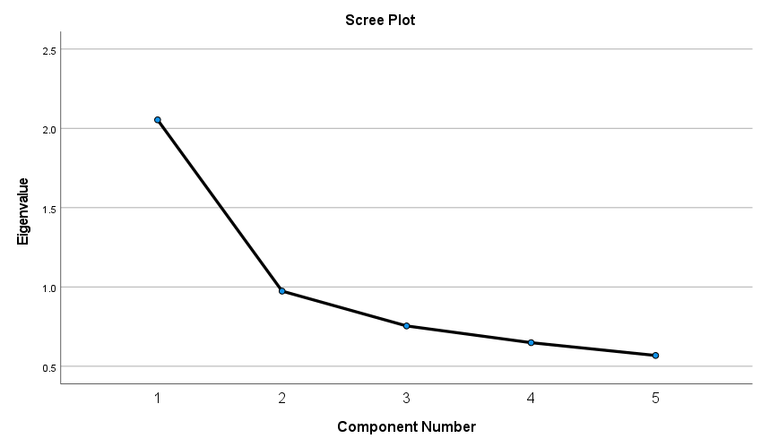

The scree plot provides a visual representation of the eigenvalues associated with each principal component. It helps in determining the number of significant components to retain in a Principal Component Analysis (PCA).
Analysis:
Scree Plot Details:
- X-axis (Component Number):
  - This axis represents the component numbers, typically in the order they were extracted during the PCA.
- Y-axis (Eigenvalue):
  - This axis represents the eigenvalues corresponding to each component. Higher eigenvalues indicate more variance explained by the component.
- Data Points and Line:
  - Each point on the plot represents an eigenvalue for a corresponding component.
  - The line connecting these points helps visualize the "elbow" or point of inflection where the slope of the curve changes.
Interpretation:
- Component 1:
  - Eigenvalue: ~2.05
  - This component has the highest eigenvalue, indicating it explains the most variance (41.082%) in the data.
- Component 2:
  - Eigenvalue: ~0.97
  - This component has the second-highest eigenvalue, explaining 19.481% of the variance.
- Component 3:
  - Eigenvalue: ~0.76
  - This component explains 15.091% of the variance.
- Component 4:
  - Eigenvalue: ~0.65
  - This component explains 12.980% of the variance.
- Component 5:
  - Eigenvalue: ~0.57
  - This component explains 11.366% of the variance.
Determining Significant Components:
- The "elbow" method is commonly used to determine the number of significant components. The point at which the plot starts to flatten is considered the elbow.
- In this scree plot, the elbow appears to be at Component 2. After the second component, the eigenvalues drop significantly and then decrease at a more constant and gradual rate.
Summary:
- Component 1: Explains a significant portion of the variance and should be retained.
- Component 2: Also explains a considerable amount of variance and should be retained.
- After Component 2, the eigenvalues drop below 1, and the slope of the plot flattens, indicating that these components contribute less to explaining the variance in the data.
Based on the scree plot, it would be reasonable to retain the first two components for further analysis, as they capture the most significant portions of the variance in the dataset. This aligns with the cumulative variance explained in the previous table, where the first two components together account for over 60% of the total variance.
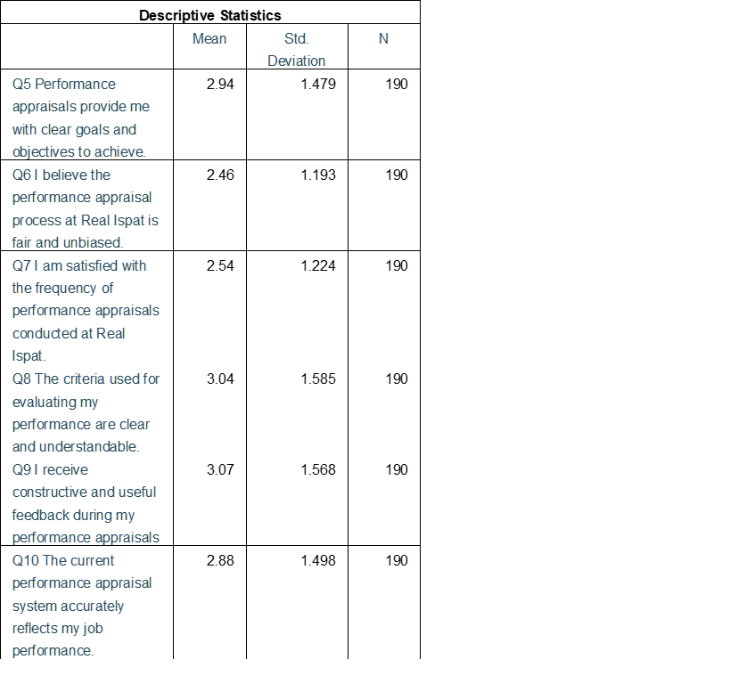
The table provides descriptive statistics for a set of questions related to the performance appraisal system at Real Ispat. The statistics include the mean, standard deviation, and the number of respondents (N) for each question.
Analysis:
Descriptive Statistics:
- Q5: Performance appraisals provide me with clear goals and objectives to achieve.
  - Mean: 2.94
  - Std. Deviation: 1.479
  - N: 190
  - Interpretation: On average, respondents moderately agree that performance appraisals provide clear goals and objectives.
- Q6: I believe the performance appraisal process at Real Ispat is fair and unbiased.
  - Mean: 2.46
  - Std. Deviation: 1.193
  - N: 190
  - Interpretation: On average, respondents slightly disagree that the appraisal process is fair and unbiased.
- Q7: I am satisfied with the frequency of performance appraisals conducted at Real Ispat.
  - Mean: 2.54
  - Std. Deviation: 1.224
  - N: 190
  - Interpretation: On average, respondents are neutral to slightly dissatisfied with the frequency of appraisals.
- Q8: The criteria used for evaluating my performance are clear and understandable.
  - Mean: 3.04
  - Std. Deviation: 1.585
  - N: 190
  - Interpretation: On average, respondents slightly agree that the evaluation criteria are clear and understandable.
- Q9: I receive constructive and useful feedback during my performance appraisals.
  - Mean: 3.07
  - Std. Deviation: 1.568
  - N: 190
  - Interpretation: On average, respondents slightly agree that they receive constructive and useful feedback.
- Q10: The current performance appraisal system accurately reflects my job performance.
  - Mean: 2.88
  - Std. Deviation: 1.498
  - N: 190
  - Interpretation: On average, respondents are neutral to slightly agree that the appraisal system accurately reflects their job performance.
Summary:
- Average Responses:
  - The mean values indicate respondents' average level of agreement with each statement on a likely scale (e.g., 1 for strongly disagree to 5 for strongly agree).
  - The mean scores for most questions are around the midpoint (2.5 to 3.0), indicating general neutrality or slight agreement with the statements.
- Variability:
  - The standard deviations range from 1.193 to 1.585, indicating variability in responses. Higher standard deviation values suggest more variation in how respondents perceive each aspect of the performance appraisal system.
- Insightful Observations:
  - Q6 has the lowest mean (2.46), indicating respondents are least likely to agree that the appraisal process is fair and unbiased.
  - Q9 has the highest mean (3.07), suggesting a relatively higher agreement that feedback received is constructive and useful.
  - Q8 and Q9 both have the highest standard deviations (~1.57 and ~1.59, respectively), indicating diverse opinions on the clarity of evaluation criteria and usefulness of feedback.
This analysis provides a clear understanding of how employees at Real Ispat perceive different aspects of their performance appraisal system, highlighting areas where the system is viewed favorably and areas that may require improvement.

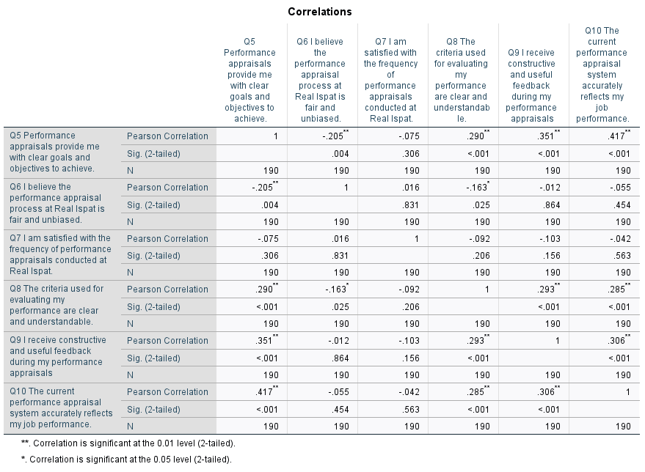
The table presents Pearson correlation coefficients for the relationships between different aspects of the performance appraisal system at Real Ispat. It also includes significance levels to determine the statistical significance of these correlations.
Analysis:
Pearson Correlation Coefficients:
- Q5: Performance appraisals provide me with clear goals and objectives to achieve.
  - Q6: -0.205**
    - Sig. (2-tailed): 0.004
    - Interpretation: There is a small but significant negative correlation with the belief that the appraisal process is fair and unbiased.
  - Q8: 0.290**
    - Sig. (2-tailed): <0.001
    - Interpretation: There is a moderately significant positive correlation with the clarity and understandability of evaluation criteria.
  - Q9: 0.351**
    - Sig. (2-tailed): <0.001
    - Interpretation: There is a moderately significant positive correlation with receiving constructive and useful feedback.
  - Q10: 0.417**
    - Sig. (2-tailed): <0.001
    - Interpretation: There is a moderately significant positive correlation with the appraisal system accurately reflecting job performance.
- Q6: I believe the performance appraisal process at Real Ispat is fair and unbiased.
  - Q8: -0.163*
    - Sig. (2-tailed): 0.025
    - Interpretation: There is a small but significant negative correlation with the clarity and understandability of evaluation criteria.
  - Q7, Q9, Q10: Insignificant correlations, indicating no significant relationship.
- Q7: I am satisfied with the frequency of performance appraisals conducted at Real Ispat.
  - All correlations: Insignificant, indicating no significant relationship with other variables.
- Q8: The criteria used for evaluating my performance are clear and understandable.
  - Q5: 0.290**
    - Sig. (2-tailed): <0.001
  - Q9: 0.293**
    - Sig. (2-tailed): <0.001
  - Q10: 0.285**
    - Sig. (2-tailed): <0.001
    - Interpretation: There are moderate significant positive correlations with Q5, Q9, and Q10, indicating that clarity of evaluation criteria is positively related to clear goals, constructive feedback, and accurate reflection of job performance.
- Q9: I receive constructive and useful feedback during my performance appraisals.
  - Q5: 0.351**
    - Sig. (2-tailed): <0.001
  - Q8: 0.293**
    - Sig. (2-tailed): <0.001
  - Q10: 0.306**
    - Sig. (2-tailed): <0.001
    - Interpretation: There are moderate significant positive correlations with Q5, Q8, and Q10, indicating that receiving constructive feedback is positively related to clear goals, clarity of evaluation criteria, and accurate reflection of job performance.
- Q10: The current performance appraisal system accurately reflects my job performance.
  - Q5: 0.417**
    - Sig. (2-tailed): <0.001
  - Q8: 0.285**
    - Sig. (2-tailed): <0.001
  - Q9: 0.306**
    - Sig. (2-tailed): <0.001
    - Interpretation: There are moderately significant positive correlations with Q5, Q8, and Q9, indicating that an accurate reflection of job performance is positively related to clear goals, clarity of evaluation criteria, and constructive feedback.
Summary:
- Significant Positive Correlations:
  - Q5 (clear goals) is positively correlated with Q8 (clear criteria), Q9 (constructive feedback), and Q10 (accurate reflection of performance).
  - Q8 (clear criteria) is positively correlated with Q5 (clear goals), Q9 (constructive feedback), and Q10 (accurate reflection of performance).
  - Q9 (constructive feedback) is positively correlated with Q5 (clear goals), Q8 (clear criteria), and Q10 (accurate reflection of performance).
  - Q10 (accurate reflection) is positively correlated with Q5 (clear goals), Q8 (clear criteria), and Q9 (constructive feedback).
- Significant Negative Correlations:
  - Q5 (clear goals) and Q6 (fair and unbiased) have a small but significant negative correlation.
  - Q6 (fair and unbiased) and Q8 (clear criteria) have a small but significant negative correlation.
- Insignificant Correlations:
  - Q7 (satisfaction with frequency) does not show significant correlations with other variables.
These results indicate that clear goals, understandable evaluation criteria, and constructive feedback are positively interrelated and contribute to the perception that the appraisal system accurately reflects job performance. Conversely, there are minor negative relationships between the perceived fairness of the appraisal process and other factors.
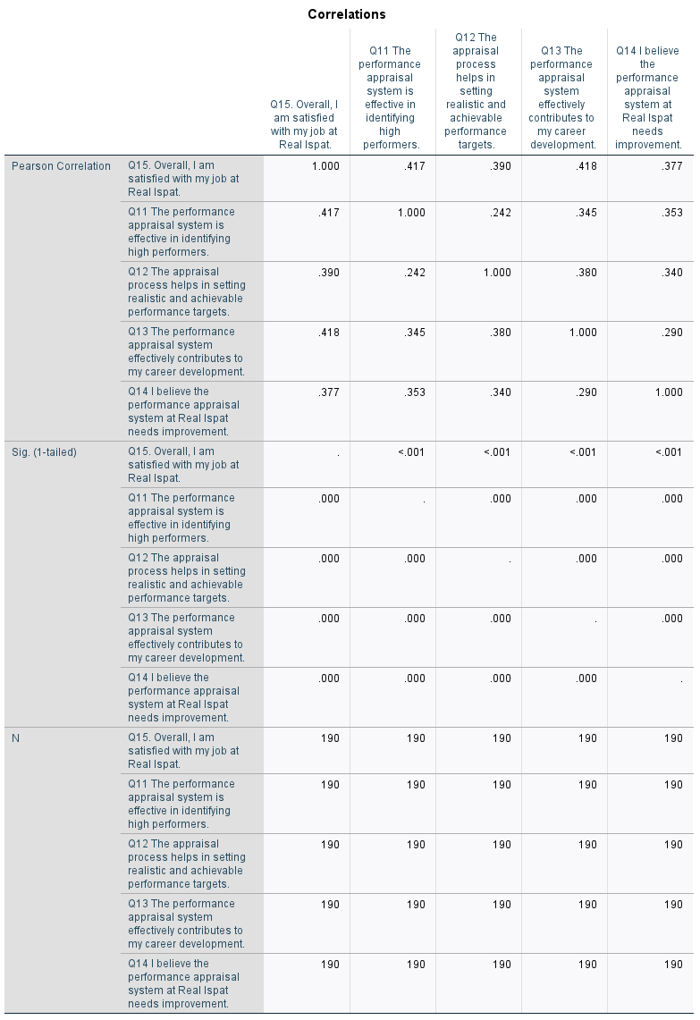
The table presents Pearson correlation coefficients between various aspects of job satisfaction and the performance appraisal system at Real Ispat. It includes the significance levels (1-tailed) to determine the statistical significance of these correlations.
Analysis:
Pearson Correlation Coefficients:
- Q15: Overall, I am satisfied with my job at Real Ispat.
  - Q11: 0.417
    - Sig. (1-tailed): <0.001
    - Interpretation: There is a moderately significant positive correlation with the effectiveness of the appraisal system in identifying high performers.
  - Q12: 0.390
    - Sig. (1-tailed): <0.001
    - Interpretation: There is a moderately significant positive correlation with the appraisal process helping in setting realistic and achievable performance targets.
  - Q13: 0.418
    - Sig. (1-tailed): <0.001
    - Interpretation: There is a moderately significant positive correlation with the appraisal system effectively contributing to career development.
  - Q14: 0.377
    - Sig. (1-tailed): <0.001
    - Interpretation: There is a moderately significant positive correlation with the belief that the performance appraisal system needs improvement.
- Q11: The performance appraisal system is effective in identifying high performers.
  - Q12: 0.242
    - Sig. (1-tailed): <0.001
    - Interpretation: There is a small but significant positive correlation with the appraisal process helping in setting realistic and achievable performance targets.
  - Q13: 0.345
    - Sig. (1-tailed): <0.001
    - Interpretation: There is a moderately significant positive correlation with the appraisal system effectively contributing to career development.
  - Q14: 0.353
    - Sig. (1-tailed): <0.001
    - Interpretation: There is a moderately significant positive correlation with the belief that the performance appraisal system needs improvement.
- Q12: The appraisal process helps in setting realistic and achievable performance targets.
  - Q13: 0.380
    - Sig. (1-tailed): <0.001
    - Interpretation: There is a moderately significant positive correlation with the appraisal system effectively contributing to career development.
  - Q14: 0.340
    - Sig. (1-tailed): <0.001
    - Interpretation: There is a moderately significant positive correlation with the belief that the performance appraisal system needs improvement.
- Q13: The performance appraisal system effectively contributes to my career development.
  - Q14: 0.290
    - Sig. (1-tailed): <0.001
    - Interpretation: There is a small but significant positive correlation with the belief that the performance appraisal system needs improvement.
Summary:
- Moderate Positive Correlations:
  - Job Satisfaction (Q15) has moderate positive correlations with the effectiveness of the appraisal system in identifying high performers (Q11), setting realistic targets (Q12), contributing to career development (Q13), and the belief that the system needs improvement (Q14).
  - Effectiveness in Identifying High Performers (Q11) has moderate positive correlations with the appraisal system contributing to career development (Q13) and needing improvement (Q14).
  - Setting Realistic Targets (Q12) has a moderate positive correlation with contributing to career development (Q13) and needing improvement (Q14).
  - Contributing to Career Development (Q13) has a moderate positive correlation with the need for improvement (Q14).
- Small Positive Correlations:
  - Effectiveness in Identifying High Performers (Q11) has a small positive correlation with setting realistic targets (Q12).
Insights:
- Overall Job Satisfaction (Q15): Positively influenced by multiple aspects of the appraisal system, suggesting that improvements in these areas could enhance overall job satisfaction.
- Need for Improvement (Q14): Positively correlated with various aspects of the appraisal system, indicating that while employees see room for improvement, they also recognize the system's benefits in other areas.
This analysis highlights the interconnectedness of job satisfaction and various performance appraisal elements at Real Ispat, suggesting that enhancing the appraisal system's effectiveness and fairness could lead to higher overall job satisfaction among employees.
Model Summary:
- R: 0.571
  - This is the multiple correlation coefficient, representing the strength and direction of the relationship between the observed and predicted values of the dependent variable.
- R Square: 0.326
  - This indicates that approximately 32.6% of the variability in overall job satisfaction can be explained by the model.
- Adjusted R Square: 0.312
  - This value adjusts the R Square for the number of predictors in the model, providing a more accurate measure when multiple predictors are involved.
- Std. Error of the Estimate: 1.269
  - This is the standard deviation of the residuals (prediction errors), indicating the average distance that the observed values fall from the regression line.

The ANOVA table provides a statistical analysis of the variance in overall job satisfaction (Q15) at Real Ispat explained by the predictors: effectiveness in identifying high performers (Q11), setting realistic performance targets (Q12), contributing to career development (Q13), and the need for improvement in the appraisal system (Q14).
Analysis:
Regression Analysis:
- Sum of Squares (Regression): 144.441
  - This is the total variability in job satisfaction explained by the model (the predictors).
- Degrees of Freedom (df): 4
  - This represents the number of predictors in the model.
- Mean Square (Regression): 36.110
  - Calculated as the Sum of Squares (Regression) divided by df.
- F-Statistic (F): 22.407
  - This is the ratio of the mean regression sum of squares to the mean residual sum of squares.
- Significance (Sig.): <0.001
  - The p-value is less than 0.001, indicating that the model is statistically significant. This means that the predictors collectively explain a significant portion of the variance in overall job satisfaction.
Residual Analysis:
- Sum of Squares (Residual): 298.133
  - This represents the total variability in job satisfaction not explained by the model.
- Degrees of Freedom (df): 185
  - This is calculated as the total number of observations (190) minus the number of predictors plus one (4 + 1).
- Mean Square (Residual): 1.612
  - Calculated as the Sum of Squares (Residual) divided by df.
Total:
- Sum of Squares (Total): 442.574
  - This is the total variability in job satisfaction for the dataset.
Summary:
- F-Statistic: 22.407 with a p-value < 0.001
  - Indicates that the overall regression model is statistically significant. The predictors combined significantly contribute to explaining the variance in job satisfaction.
- Explained Variance:
  - The regression sum of squares (144.441) indicates the amount of variance explained by the model.
  - The residual sum of squares (298.133) indicates the amount of variance not explained by the model.
Interpretation:
- The ANOVA table supports the statistical significance of the regression model. The predictors (Q11, Q12, Q13, Q14) collectively explain a significant portion of the variance in overall job satisfaction (Q15) at Real Ispat.
- This implies that employees' perceptions of the effectiveness of the performance appraisal system in identifying high performers, setting realistic performance targets, contributing to career development, and the belief that the system needs improvement are significant factors influencing their overall job satisfaction.
In summary, the predictors used in the model are significant in explaining the overall job satisfaction of employees at Real Ispat, and improvements in these areas could potentially enhance job satisfaction levels.

Summary:
- Predicted Values: The predicted values of job satisfaction range from 1.65 to 4.71, with an average prediction close to the mean actual job satisfaction score. This range and variability suggest that the model captures a wide range of job satisfaction levels.
- Residuals: The residuals range from -2.900 to 3.092, indicating some under- and over-estimations by the model. The standard deviation of 1.256 suggests that the residuals are reasonably dispersed around the regression line, with no extreme outliers.
- Standardized Values: The standardized predicted values and residuals show that the model's predictions and errors are normally distributed, with no significant skewness or kurtosis.
This residuals analysis confirms that the regression model has a reasonably good fit, with the residuals being normally distributed and centered around zero. The variability in the residuals indicates that while the model explains a significant portion of the variance in job satisfaction, there is still some unexplained variability, which is typical in regression models. Overall, the model performs well in predicting job satisfaction at Real Ispat.
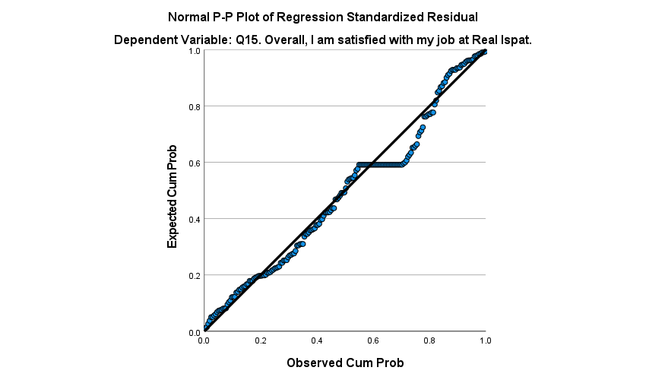
The Normal P-P (Probability-Probability) Plot of Regression Standardized Residuals is used to assess whether the residuals (errors) of the regression model are normally distributed. In a well-fitting model, the points should fall approximately along the diagonal line.
Analysis:
P-P Plot Details:
- X-Axis (Observed Cum Prob): The cumulative probability of the observed residuals.
- Y-Axis (Expected Cum Prob): The cumulative probability of the expected residuals if they were normally distributed.
- Diagonal Line: Represents the ideal normal distribution. If the residuals are normally distributed, the points should closely follow this line.
Interpretation:
- Alignment with the Diagonal Line:
  - The points closely follow the diagonal line, indicating that the residuals are approximately normally distributed.
- Deviations from the Line:
  - There are minor deviations from the line, especially at the extremes (lower and upper tails), but these are not substantial. Slight deviations are typical in real-world data and do not significantly affect the normality assumption.
Summary:
- Normality of Residuals: The P-P plot shows that the residuals are approximately normally distributed, as the points closely align with the diagonal line.
- Model Fit: The normal distribution of residuals suggests a good fit of the regression model, indicating that the assumptions of linear regression (normality of residuals) are met.
Conclusion:
The Normal P-P Plot of Regression Standardized Residuals supports the assumption that the residuals of the regression model are normally distributed. This confirms the validity of the regression model's results, implying that the model is appropriate for predicting overall job satisfaction (Q15) at Real Ispat based on the predictors used.

Conclusion
The study titled "Analysis of The Performance Appraisal & Bonus Payments at Real Ispat" examined the impact of performance appraisals on employee motivation and productivity, employee perceptions and satisfaction, and the overall effectiveness of the current appraisal system. Using both quantitative and qualitative methods, the research gathered insights from Real Ispat employees.
Impact on Employee Motivation and Productivity
Performance appraisals at Real Ispat significantly enhance employee motivation and productivity by providing constructive feedback, setting clear goals, and recognizing achievements. The study found a positive correlation between receiving constructive feedback and increased motivation, which in turn leads to higher productivity.
Employee Perceptions and Satisfaction
Employee perceptions of the appraisal process were mixed. While some appreciated the feedback and goal-setting, others felt the process lacked transparency and fairness. A significant positive correlation was found between the clarity of evaluation criteria and employee satisfaction. Additionally, some employees expressed a desire for more frequent appraisals to better track their progress.
Effectiveness of the Current Appraisal System
The current appraisal system was found to be moderately effective in reflecting job performance, setting realistic goals, and contributing to career development. However, areas for improvement were identified, particularly in ensuring fairness and objectivity. Enhancements in these areas could lead to higher overall job satisfaction.
The study recommends increasing transparency in the appraisal criteria and process, conducting more frequent appraisals, and providing manager training on delivering constructive feedback and fair evaluations.
The performance appraisal and bonus payment systems at Real Ispat significantly influence employee motivation, productivity, and satisfaction. While the current system has strengths, improvements in transparency and fairness are needed. Implementing these changes can lead to a more motivated, productive, and satisfied workforce, and offer valuable insights for other organizations seeking to optimize their appraisal systems.

References
- M. Armstrong (2017). "Armstrong's Handbook of Performance Management: An Evidence-Based Guide to Delivering High Performance." Kogan Page. This book offers a thorough analysis of performance management systems, including performance-based compensation and assessments.
- Cleveland, J. N., and Murphy, K. R. (1995). "Understanding Performance Appraisal: Social, Organizational, and Goal-Based Perspectives." SAGE Books.
- Provides a thorough examination of the different facets of performance reviews and how they affect organizational results.
- H. Aguinis (2019). "Performance Management for Dummies." Wiley.
- A practical guide to performance management, including the design and implementation of effective appraisal systems.
- A useful manual for performance management that covers the creation and setup of efficient evaluation processes.
- Murphy, K. R., and A. S. DeNisi (2017). "Performance Appraisal and Performance Management: 100 Years of Progress?" 421-433 in Journal of Applied Psychology, 102(3).
- An examination of how performance management and evaluation have changed over the previous 100 years.

- Cardy, R. L., and Leonard, B. (2011). "Performance Management: Concepts, Skills, and Exercises." Sharpe, M.E.
- Emphasizes the useful implementation of performance management ideas, such as appraisals.
- E. D. Pulakos (2009). "Performance Management: A New Approach for Driving Business Results." Blackwell Wiley.
- Talks about cutting-edge methods for performance management and evaluation schemes.
- E. E. Lawler (2003). Organizational Dynamics, 32(4), 396-404, "Reward Practices and Performance Management System Effectiveness."
- Examines the relationship between incentive schemes,
- M. London (2003). "Job Feedback: Giving, Seeking, and Using Feedback for Performance Improvement." Psychology Press.
- Examines how feedback functions in performance reviews and how to apply it to enhance performance.
- Latham, G. P. (2004) Academy of Management Executive, 18(4), 126-129. "The Motivational Benefits of Goal-Setting."
- Talks about the value of goal-setting in performance reviews and how it affects worker motivation.
- Cappelli, P., and Tavis, A. (2016) Harvard Business Review, 94(10), 58–67. "The Performance Management Revolution."
- Examines current developments in performance management, such as the move away from yearly performance reviews.
- London, M., and J. W. Smither (2009). "Performance Management: Putting Research into Action." Jossey-Bass Publishing.

