RESEARCH ON
BRAND ANALYSIS OF NEXA
SHIVAM URMALIYA
AMITY BUSINESS SCHOOL
AMITY UNIVERSITY, CHHATTISGARH.
Shivamurmalia22@gmail.com

Dr. SHIV JAGGARWAL
ASSISTANT PROFESSOR
AMITY BUSINESS SCHOOL
AMITY UNIVERSITY, CHHATTISGARH.
skjaggarwal@rpr.amity.edu

Abstract
The analysis of NEXA as a Premium Brand is the goal of this study. Maruti Automobile Brands are not regarded as premium brands, as is well known. As the primary target market since the company's founding, the Indian market is seeing significant growth in sales and recognition for the distinctive and prominent Indian brand NEXA. India's top automaker, Maruti Suzuki, has done a great job of holding onto its coveted title for a number of years. Nevertheless, Maruti Suzuki was not expected to control more than 60% of the market when the industry was opened up in the early 1990s.
This business was not without its share of issues, though. Perception was the main problem the organization was dealing with at the time. Maruti's sincere attempt to appeal to a tech-savvy and brand-conscious generation of customers is NEXA, the next generation showroom.

Introduction
Maruti Suzuki India Limited's creative venture Nexa has transformed brand management in the automobile sector with its own strategy emphasizing sophistication, technology, and customer-centricity. With its positioning as a high-end retail network, Nexa is a paradigm shift in the car-buying process, appealing to affluent people who want a lifestyle statement rather than merely a means of mobility.
A keen awareness of its target market is essential to Nexa's brand management approach. Through careful market segmentation and a thorough understanding of the requirements and preferences of today's consumers, Nexa has established a brand identity that is closely associated with exclusivity, luxury, and modern living. This stance reflects Nexa's dedication to providing an upgraded experience that goes beyond typical auto dealerships rather than being a simple marketing gimmick.
A fundamental aspect of Nexa's brand management is its unwavering commitment to maintaining coherence and consistency throughout all channels. Every experience interacting with Nexa supports its brand values, from the streamlined and contemporary design of its showrooms to the flawless integration of digital platforms. Customers get a consistent brand experience online and off that speaks to their goals and values, making them feel a part of the Nexa community and more a part of it.
Furthermore, Nexa's brand management goes beyond the transactional side of auto sales; it focuses on building enduring client relationships. Nexa prioritizes individualized services to make sure every customer feels heard and appreciated. Customers at Nexa receive unmatched care and attention from the minute they walk into a showroom until long after they drive home in their new automobile, fostering a relationship based on mutual respect and trust.
As a sign of distinction and aspiration, Nexa's brand presence is further amplified through strategic partnerships and compelling marketing initiatives. Nexa is able to maintain its audience's interest and encourage brand loyalty by utilizing cutting-edge marketing methods, collaborating with well-known brands and influencers, and capturing their attention.
Nexa's brand management approach, which skillfully combines technology and human touchpoints to produce an unmatched consumer experience, essentially captures the spirit of contemporary luxury and convenience. Nexa is at the vanguard of the automobile industry's evolution, redefining what it means to be a premium automotive brand in the digital era and setting new benchmarks for brand management.

Review of Literature

Gerald D. Bell (1967) investigates the emotions a buyer of a new car experiences and the variables that influence his reaction once he begins to drive his new vehicle. The study's findings point to the relationship between a customer's self-assurance and personality and the standard of the surroundings he experiences when shopping and his cognitive dissonance. Dr. Garima Malik (2008) presents findings from a study on Tata Nano customers' perceptions and expectations. led by an assistant professor at Amity Business School in Noida.
The study's primary goals are to comprehend how people generally see NANO, what influences consumers' decisions to buy, and what they anticipate from NANO. The Maruti Story by R.C. Bhargava (2010) highlights the advancements made by Maruti Suzuki.
In this book, Mr. Bhargava examined how Maruti Udyog set high standards for customer service and productivity across the board for the Indian auto sector.
knowing the customer, by C. W. Park et al. (1994), notes that knowing consumer knowledge is essential to understanding consumer behavior, including information processing and search. A decline in the use of salespeople's advice was correlated with an increase in one's own knowledge.
In his work titled "The Impact of Brand Awareness on Consumer Purchase Intention," Chi Hsin-Kuang (2002) attempts to elucidate the relationships between perceived quality, brand loyalty, and customer purchase intention. In their 1995 work, "The Complex Relationship Between Consumer Satisfaction and Brand Loyalty," Kasper and Bloemer
aims to clarify brand loyalty by highlighting six essential components that are present in a group of these companies. the comparison with one or more other brands; and the non-random, or biased, comparison; According to Jacoby and Kyner's 1973 work, "Brand Loyalty," there are significant variations between the midpoints of recurrent purchasing behavior and brand loyalty. They claim that brand loyalty can be defined as the mutually satisfying set of seven very important conditions.

Research Methodology

Sampling Method and Size of Sample
Data was gathered from 104 randomly selected participants in the study. The information was gathered online and offline. Individuals with varying socioeconomic and professional backgrounds were contacted. The majority of the data sources are secondary data from student publications and research articles that are published in internationally recognized journals.

Dataanalysistool-

DataAnalysisandInference
  - AgeGroupofRespondents

AgeGroup | NumberofRespondents
18to 20 | 3
21to 25 | 22
26to 35 | 9
36andAbove | 69

Table1:AgeGroup(inyears)

  - GenderofRespondents

Gender | NumberofRespondents
Male | 72
Female | 31

Table2:GenderofRespondents
  - ApproximateMonthlyIncome(inINR).

Gender | NumberofRespondents
Male | 72
Female | 31

Table3:MonthlyIncome(inINR)

  - AgeGroupMostInterestedinBuyingPremiumCars,AccordingtoRespondents.

AgeGroup | NumberofRespondents
18to 24 | 4
25to 34 | 34
35to 44 | 39
Above44 | 26

  - AwareoftheParentGroupofNEXA.

AwareofParentGroupofNEXA | NumberofResponses
Yes | 59
No | 43

  - OftenHearPeopleTalkingAboutNEXA.

OftenHearPeopleTalkAbout NEXA | NumberofResponses
Not At All | 33
Sometimes | 59
Often | 11
Allthe Time | 0
- AssociationofNEXAwithMarutiSuzukiLeadstoaPreferenceinBuyingDecision.

PreferenceinBuyingDecision | NumberofResponses
Never | 13
Rarely | 15
Sometimes | 38
Often | 28
Always | 9
Table4:PreferenceinBuyingDecision

- FactorsThatInfluencePurchaseDecisionforPremiumSegmentCars.

Factors | NumberofResponses
Style | 53
Comfort | 76
Mileage | 33
Price | 45

- LevelofAgreementfortheFollowing:
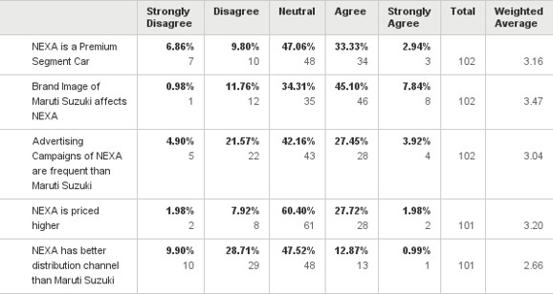

- ParametersThatHelpBuildaGoodBrandImageofNEXA.

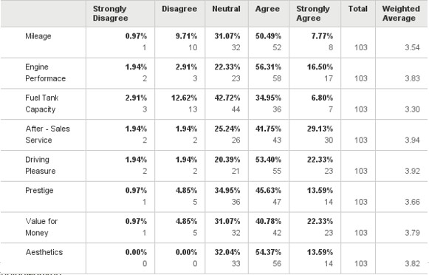
- FamiliaritywithNEXAinAccordancewiththeFollowingFactors:

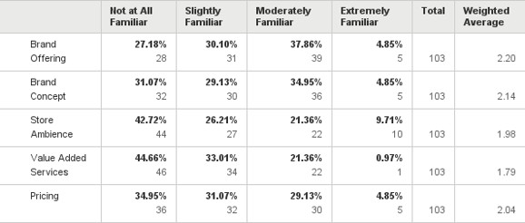

- 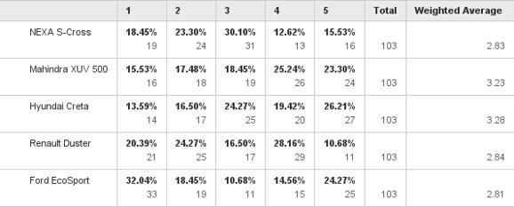RateontheBasisofLuxuryBrandonaScaleof1to5.

Conclusion

- The majority of respondents associated Nexa with its parent brand, Maruti Suzuki, according to the report. On NEXA, the parent brand does, however, lose its solid dependability.

• Although respondents were aware of the premium qualities of the brand Nexa, they did not think it to be as opulent as other brands in its range. This is likely because respondents were not as familiar with the value-added services that Nexa offers.

- Holistic Insights: A thorough grasp of Nexa's positioning, customer attitudes, and market dynamics is provided by the brand analysis.
Implementable Suggestions: The analysis provides implementable suggestions to improve Nexa's customer engagement, brand strategy, and competitive advantage.
- Data-Driven Decisions: Nexa can make well-informed decisions that promote customer happiness and business growth by utilizing real-time feedback mechanisms and powerful analytics.
Continuous Improvement: Based on changing consumer preferences and market trends, brand strategies must be regularly refined and iterated, as the brand analysis makes clear.
- Strategic Alignment: By ensuring that brand objectives and overarching business goals are aligned, the analysis maximizes return on investment and promotes long-term success.
Competitive Edge: Nexa can preserve its lead in premium car retailing and keep a competitive edge in the automotive sector by continuing to be proactive, flexible, and adaptable.
- Customer-Centric Focus: To set Nexa apart in the industry, the brand study highlights how crucial it is to put customers' needs first, cultivate loyalty, and provide outstanding experiences.
Ethical Concerns: In order to preserve Nexa's integrity and reputation, ethical concerns about data protection and customer trust have remained crucial throughout the investigation.
- Collaborative Approach: Nexa's data-driven culture and cross-functional collaboration are fostered by the brand analysis, which promotes innovation and ongoing development throughout the company.
Future Outlook: With a strong framework for brand analysis in place, Nexa is prepared to take advantage of opportunities, meet difficulties, and continue to be a leader in the automotive sector.

Limitations of Nexa's Brand Analysis:

1. Depending too much on conventional indicators, like as sales numbers and customer surveys, may miss subtle customer behavior.
2. The challenge of precisely assessing the mood and inclinations of digital consumers.
3. Potential obstacles in maintaining pace with rapidly developing market dynamics and emerging rivals.
4. The possibility of lost opportunities or mismatched plans as a result of inaccurate or out-of-date data.

Future Scope of Nexa's Brand Analysis:

1. Using AI, machine learning, and big data analytics to gain deeper insights into consumer preferences and industry trends.
2. Using sentiment analysis and social media listening techniques to get input in real time.
3. Using proactive tactics to quickly adjust to shifting consumer needs and market situations.
4. Adopting cutting-edge technologies to improve brand analysis procedures and maintain competitiveness.

Recommendations for Brand Analysis of Nexa:

Diversify Your Data Sources: For a more thorough grasp of customer perspectives, go beyond traditional metrics and use sentiment analysis, online reviews, and social media analytics.
Adopt Predictive Analytics: To predict future consumer preferences, market trends, and competitive environments, use predictive modeling techniques.

Improve Mechanisms for Customer Feedback: Use real-time feedback tools like chatbots, questionnaires, and social media monitoring to get quick insights and quickly resolve consumer issues.
Work Together with Technology Partners: To take use of cutting-edge tools for more precise and useful insights, collaborate with tech companies that specialize in AI, machine learning, and big data analytics.

Regularly analyze your competitors' plans, pricing patterns, and consumer feedback to find areas where you may stand out from the competition.

Promote a Data-Driven Culture: To guarantee that insights are successfully incorporated into decision-making processes, promote cross-functional cooperation and data literacy throughout the company.
Iterate and Improve Constantly: Review and adjust brand analysis techniques on a regular basis in response to changing market conditions, new technology, and input from internal and external stakeholders.

Put Privacy and Data Security First: To preserve credibility and confidence, make sure that data protection laws are followed and give top priority to the moral gathering and use of customer information.
Link Brand Analysis to Corporate Goals: Link brand analysis findings with broader business goals to drive strategic initiatives, optimize resource allocation, and maximize ROI.

Keep Yourself Flexible and Responsive: To stay competitive and relevant, keep your brand analysis strategies updated in response to shifts in consumer behavior, market trends, and competitive environments.

References
- The impact of brand awareness on consumer purchase intention: The mediating role of perceived quality and brand loyalty.

- 2. Kaspar, Bloemer. (1995). The intricate relationship between consumer satisfaction and brand loyalty.

- Makeover Time, Features, Metroplus, The Hindu, August 2, 2015, http://www.thehindu.com/features/metroplus/maruti-suzuki-NEXA-makeovertime/article7492055.ece (accessed August 2, 2015).
- "We aim to create market disruption," stated R.S. Kalsi in "Business, Industry, The Hindu," July 5, 2015.We aim to create market disruption, according to Maruti Suzuki's executive director of marketing and sales, RS Kalsi. This information can be found at http://www.thehindu.com/business/Industry/article7386945.ece. On July 23, 2015, Mitsubishi Suzuki launched NEXA: A New Premium Automotive Experience. Press release, Annexure – A, Corporations, BSE India.
See http://corporates.bseindia.com/xmldata/corpfiling/AttachLive/EEF0166A_5A75_49AB_AD CE_73BD4218E556_123645.pdf for more information.

- NEXA: A Novel Exclusive Automobile Experience, July 17, 2015; Investors; Mercedes-Benz; Suzuki; Background Material; NEXA for Analysts.This URL points to background material on NEXA for analysts from Marutisuzuki.com.
6. Vineet Singh, Short-Term Sovereignty Analysis of India's Top Automobile Players.pp. 11–17 in International Journal of Advanced Research in Management, 6(3), 2015.

