Streamlining College Inquiries: Developing an Intelligent Chatbot for Accessing Course, Fee, and Admission Details

Shyamjee Prajapati¹, Saraswati Verma², Uday Singh Kushwaha³, Neelesh Shrivastava⁴
^{1,2}B.Tech Student, Assistant Professor, Department of Computer Science Engineering, Vindhya Institute of Technology and Science, Satna, Madhya Pradesh, India
^{3,4}Assistant Professor, Department of Computer Science Engineering, Vindhya Institute of Technology and Science, Satna, Madhya Pradesh, India

Abstract:
In the past, students faced the arduous task of physically visiting colleges to inquire about courses, fee structures, admission processes, and other relevant information. Recognizing the inefficiency of this traditional approach, we propose the development of a College Enquiry Chatbot—a Python-based web application designed to provide comprehensive information to users about college-related queries. Leveraging machine learning techniques, this chatbot aims to streamline the inquiry process, offering prompt and accurate responses to user inquiries.
Keywords: Chatbot, Python, Chatter Bot, Django.

Introduction:
Chatbots represent a significant advancement in human-computer interaction, offering users the convenience of conversational interfaces for obtaining information and assistance. Our project focuses on leveraging chatbot technology to address the challenges faced by students in accessing college-related information efficiently. By harnessing machine learning concepts, the College Enquiry Chatbot aims to serve as a virtual assistant, providing users with timely and relevant details about courses, fees, admissions, and other pertinent topics.
In recent years, there has been a paradigm shift in how individuals seek information, with a growing preference for instant access and interactive communication. Traditional methods of inquiry, such as visiting college campuses or making phone calls, are often time-consuming and may not always yield satisfactory results. Moreover, the proliferation of online platforms and digital communication channels has led to an increased demand for more convenient and accessible means of information retrieval.

Problem Formulation:
In the dynamic landscape of higher education, accessing accurate and timely information about colleges poses a significant challenge for students. The advent of the College Enquiry Chatbot project, leveraging JavaScript algorithms, offers a transformative solution. This initiative aims to revolutionize the college inquiry experience by providing users with instant responses to their queries, eliminating the need for physical campus visits and mitigating the risk of misinformation. By streamlining communication between students and college administrations, the chatbot addresses prevalent issues like time constraints and unreliable information sources.
Implemented as a JavaScript web application, the College Enquiry Chatbot ensures a seamless user experience. Its intuitive interface simplifies the interaction process, enabling students to navigate through various inquiries effortlessly. Through the integration of sophisticated algorithms, the chatbot analyzes user queries and delivers tailored responses promptly, enhancing the efficiency and reliability of the inquiry process. By serving as a virtual guide, it empowers students to make informed decisions regarding their college choices

Scope:
The functionalities of the College Enquiry Chatbot encompass various aspects of the college inquiry process, including information gathering, admissions assistance, program exploration, virtual campus tours, event updates, financial aid, scholarships, and student support services.
Information Gathering: The chatbot serves as a virtual assistant capable of collecting pertinent information from prospective students regarding their academic interests, career aspirations, preferred majors, and other relevant details. This data helps the chatbot tailor its responses and recommendations effectively.
Admissions Assistance: Prospective students often have queries regarding the admissions process, including application requirements, deadlines, and procedures. The chatbot streamlines this process by providing clear and concise information, guiding applicants through each step, and addressing any concerns they may have.
Program Exploration: With a plethora of academic programs available, it's crucial for students to explore their options thoroughly. The chatbot facilitates this by offering detailed descriptions of various programs, including curriculum details, faculty information, career prospects, and testimonials from current students or alumni.
Virtual Campus Tours: As physical campus visits may not always be feasible, especially for international or remote students, the chatbot offers virtual campus tours. Through multimedia content such as videos, images, and interactive maps, prospective students can explore campus facilities, residence halls, academic buildings, and other amenities from the comfort of their homes.
Event Updates: Colleges often host various events such as open houses, information sessions, webinars, and workshops. The chatbot keeps users informed about upcoming events, providing details such as dates, times, agendas, and registration links. It may also answer specific questions about event topics or speakers.
Financial Aid: Understanding the financial aspect of college education is essential for many students and their families. The chatbot offers guidance on financial aid options, including scholarships, grants, loans, and work-study programs. It assists in navigating the complexities of financial aid applications, eligibility criteria, deadlines, and required documentation.
Scholarships: In addition to general financial aid information, the chatbot highlights available scholarships tailored to students' profiles, including academic achievements, extracurricular activities, leadership roles, and demographic backgrounds. It provides details on scholarship amounts, eligibility requirements, application processes, and deadlines.
Student Support Services: Transitioning to college life can be daunting, especially for first-year students. The chatbot serves as a resource hub for student support services, including academic advising, counseling, tutoring, career services, disability accommodations, and health and wellness programs. It offers guidance on accessing these services and connects students with relevant campus resources.
By encompassing these functionalities, the College Enquiry Chatbot aims to streamline the college inquiry process, empower prospective students with comprehensive information and assistance, and ultimately contribute to their successful transition to higher education

Literature Review:
Our project draws inspiration from pioneering chatbot systems such as A.L.I.C.E. and ELIZA, which laid the foundation for natural language processing and conversational AI. By building upon these early developments and leveraging modern machine learning techniques, we aim to create a sophisticated chatbot tailored to the specific needs of college inquiries.
A.L.I.C.E. (Artificial Linguistic Internet Computer Entity) and ELIZA are landmark examples in the history of artificial intelligence and natural language processing. They demonstrated early capabilities in simulating conversation and understanding human language, albeit in limited contexts. Here's how our project builds upon their legacy:
Foundation in Natural Language Processing (NLP): A.L.I.C.E. and ELIZA pioneered the use of NLP techniques to interpret and respond to user input in a conversational manner. They laid the groundwork for understanding the structure of human language, including syntax, semantics, and context. Our project inherits this foundation and further advances it with modern NLP algorithms and models.
Conversational AI Principles: Both A.L.I.C.E. and ELIZA employed principles of conversational AI, such as pattern matching, rule-based responses, and simple language generation techniques. These systems showcased the potential for computers to engage in dialogue with users. Our project extends these principles by integrating more sophisticated dialogue management strategies, context-aware responses, and multi-turn conversational capabilities.
Leveraging Modern Machine Learning Techniques: While A.L.I.C.E. and ELIZA relied primarily on handcrafted rules and patterns, our project leverages modern machine learning techniques to enhance the chatbot's capabilities. This includes utilizing deep learning algorithms, such as recurrent neural networks (RNNs) and transformers, for tasks such as natural language understanding, generation, and dialogue management. By training on large datasets, our chatbot can learn to understand and respond to a wider range of inquiries with higher accuracy and fluency.
Tailored to College Inquiries: While A.L.I.C.E. and ELIZA were general-purpose chatbots, our project is specifically designed to address the unique needs of college inquiries. This includes providing information on admissions, academic programs, campus life, financial aid, and student support services. The chatbot is trained on domain-specific data related to higher education, allowing it to offer accurate and relevant responses to prospective students' questions and concerns.
User Experience Focus: Building upon the concept of conversational agents, our project emphasizes delivering a seamless and intuitive user experience. This involves designing an engaging conversational interface, implementing proactive assistance features, and optimizing response times to mimic natural human interaction. The goal is to create a chatbot that feels personalized, informative, and easy to use for individuals navigating the college inquiry process.

Methodology:
The College Enquiry Chatbot is developed using machine learning algorithms to analyze user queries and generate appropriate responses. Leveraging the ChatterBot library in Python, the system offers a flexible and intuitive interface for users to interact with. Additionally, an administrative interface allows for the management of the chatbot's dataset, enabling continuous improvement and refinement of responses.
Machine Learning Algorithms: The College Enquiry Chatbot utilizes machine learning algorithms to analyze user queries and generate relevant responses. These algorithms enable the chatbot to understand the intent behind user input, identify key information, and formulate appropriate replies. By leveraging machine learning, the chatbot can continuously improve its performance over time through exposure to a diverse range of user interactions.
ChatterBot Library in Python: The system is built using the ChatterBot library in Python, which provides a robust framework for developing conversational agents. ChatterBot offers a wide range of functionalities, including natural language processing, conversation management, and response generation. Its modular design and ease of integration make it well-suited for building flexible and customizable chatbot systems tailored to specific use cases.
Flexible and Intuitive Interface: The College Enquiry Chatbot features a flexible and intuitive interface designed to enhance user experience. Users can interact with the chatbot through various channels, such as web browsers, messaging platforms, or mobile applications. The interface provides a conversational environment where users can ask questions, seek information, and receive assistance in a natural and engaging manner.
Administrative Interface: In addition to the user-facing interface, the chatbot includes an administrative interface for managing its dataset and configurations. This interface allows administrators to review and update the chatbot's knowledge base, including adding new responses, modifying existing ones, or removing irrelevant information. By providing tools for dataset management, the administrative interface empowers administrators to ensure the accuracy and relevance of the chatbot's responses.
Continuous Improvement and Refinement: The administrative interface facilitates continuous improvement and refinement of the chatbot's capabilities. Administrators can analyze user interactions, gather feedback, and monitor performance metrics to identify areas for enhancement. By iteratively updating the dataset and fine-tuning the algorithms based on real-world

Flowchart:
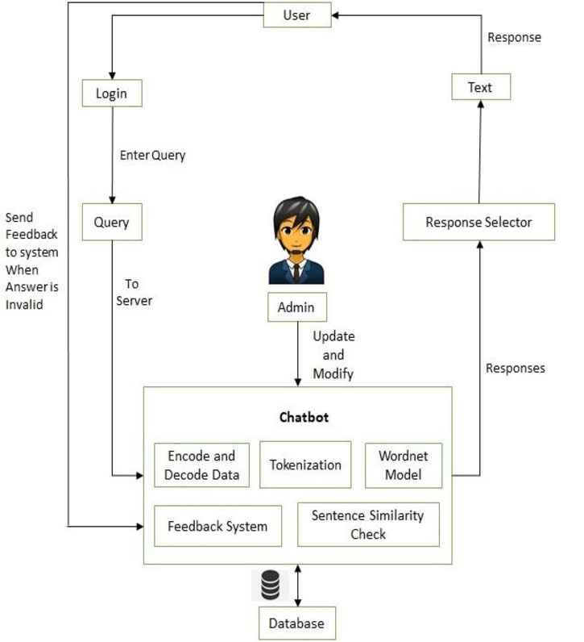

Conclusion:
In conclusion, our project is focused on achieving several key objectives. We aim to develop an algorithm capable of accurately identifying user queries and providing relevant answers. Additionally, we are creating a comprehensive dataset to store the necessary information for the chatbot's responses. Furthermore, we are implementing an intuitive web interface to ensure seamless interaction with users. Through thorough background research and analysis, our goal is to deliver a robust and user-friendly chatbot solution tailored specifically for college inquiries.
References:
Wikipedia - Kuki (chatbot)
Chatbots.org - Parry
International Research Journal of Engineering and Technology (IRJET) - College Enquiry Chatbot
Resin Cap Journal of Science and Engineering - Web Based College Enquiry Chatbot with Results
Chatbot.com
ChatterBot Documentation

