Sign Language Action Recognition System Based on Deep Learning

Dr. U.NILABAR NISHA¹ MAHENDIRAN S² , NTHISH KUMAR K S³ , RAHUL V S⁴
VITTALRAJ .S S⁵
¹Head of the Department, Computer Science And Engineering, Mahendra Institute Of Engineering And Technology, Namakkal-637503
²Student, Computer Science And Engineering, Mahendra Institute Of Engineering And Technology, Namakkal-637503
³Student, Computer Science And Engineering, Mahendra Institute Of Engineering And Technology, Namakkal-637503
³Student, Computer Science And Engineering, Mahendra Institute Of Engineering And Technology, Namakkal-637503

Abstract—Sign language is a special language that relies on body movements and visual communication. Aiming at the problem that the hearing-impaired can not communicate well with the outside world, a sign language recognition method based on skeleton extraction and residual network is proposed. Firstly, we build the RGB video data set of Chinese sign language, which contains commonly used Chinese sign language words and phrases. Next, we use OpenPose technology to extract human skeleton from Chinese sign language video and obtain human skeleton video. OpenPose can not only collect the whole body skeleton, but also collect the fine hand skeleton. Finally, a video sequence classification model based on ResNet and GRU is constructed. The constructed sign language sequence classification model is an end-to-end system, which inputs sign language skeleton video and outputs sign language classification results. The testing accuracy of this model is 98% in our small sign language database.

Keywords—hearing impaired people, sign language recognition, OpenPose, ResNet, GRU
- INTRODUCTION
Deafness and dysphonia have been one of the major diseases that human beings have been facing for centuries. According to the statistical data of the World Health Organization, as of March 20, 2019, there are about 466 million people with hearing loss worldwide, including 432 million adults and 34 million children. It is estimated that by 2050, more than 700 million people, or one tenth of the population, will suffer from hearing loss due to disability [1]. Although hearing-impaired people can communicate through sign language, they are still faced with communication barriers and other urgent problems in some public service business environments, such as airport, civil affairs, real estate transaction, tax payment, real estate registration, etc. Therefore, the hearing-impaired people should not be ignored. A communication method that can effectively solve the communication barriers between deaf-mute groups and normal groups, as well as between deaf-mute groups in different regions, has become an urgent need for the fair development of human society.
Sign language recognition (SLR) is an effective way to alleviate.Sign language recognition (SLR) is an effective way to alleviate. These sign language combine the shape and trajectory of human body parts such as arms, elbows, wrists

and fingers [2][3]. The collected sign language are accurately performed through human-computer interaction technology. Recognize the semantics of their sign language and display them in text or video to assist the deaf-mute people to communicate with the outside world, alleviate the social problems [4] caused by the deaf-mute people in real life due to communication barriers, and enable them to be more natural and harmonious Social integration [5].
Sign language research is of great significance. It can not only improve the quality of life of the deaf, but also improve the learning and working environment of the hearing-impaired; Sign language research has great application prospects in many aspects, such as intelligent space, entertainment games, computer-aided dumb language teaching, bilingual broadcasting series, virtual human research, medical research [6][7] and so on. At the same time, there are also some major challenges in the research of SLR, including how to scientifically create the human sign language action video database [8], the design of preprocessing, the distance and spatial perspective between people and cameras, and the interaction and occlusion between people [9]. In the second, third, fourth and fifth sections of this paper, the methods, experiments, results and the final conclusions are discussed.
- RELATED WORKS
SLR is a comprehensive task across multiple technical fields, which mainly involves Computer Vision (CV) and Pattern Recognition (PR). SLR not only has far-reaching research significance, but also has broad prospects for practical use. Researchers at home and abroad have also done a lot of research work. These methods can be roughly divided into glove or sensor-based methods and vision-based methods. Liang [10] and others at National Taiwan University used a single data glove as a sign language input device, which can recognize 250 basic entries in Taiwanese sign language textbooks. The research of vision-based sign language recognition [11][12] mainly focuses on the processing method of vision. This technology reduces the user's dependence on sensor equipment, at the same time, reduces the additional cost of special sensors. In [13], to take features from video recordings and use HMM [14] technical information to identify 262 isolated words. We know that the HMM is improved from the original speech recognition model. It is a time scale invariant and can better extract the features of spatiotemporal

dynamic objects. This inherent property makes it suitable for gesture recognition. However, using this model alone has some limitations, especially when training context dependent models.
A large number of scholars have done a lot of meaningful research on the research of sign language based on deep learning [15]. It is mainly divided into two categories: non- continuous SLR and continuous SLR. In recent years, non- continuous sign language recognition based on network architectures such as 3D convolutional neural networks [16] and recurrent neural networks has emerged. Luo Yuan [17] et al. Aimed at the insufficient extraction of temporal and spatial features in current sign language recognition tasks, and proposed a model based on temporal and spatial attention for Chinese sign language recognition. In the spatial dimension, the model uses the residual 3D convolutional network spatial attention module to obtain spatially significant regions, and in the temporal dimension, the temporal attention module based on convolutional long short-term memory network is used to obtain key frames. A weak supervised continuous sign language recognition framework based on deep neural network is proposed. This method is applied to a real continuous sign language recognition benchmark, and achieves the same results as the latest technology without additional supervision [18]. A deep learning method for Indian sign language recognition, Convolutional neural networks were used and segmented hand
images/videos were used as an input to them. 36 static hand gestures from Indian Sign Language were trained and a classification accuracy of 98.81% was achieved on the test data [19]. Dynamic sign language recognition of video sequences based on BLSTM-3D residual network [20], Multimodal fusion Chinese sign language recognition based on LSTM and a pair of conditional hidden Markov models [21] has done a good research work on sign language action recognition using deep learning methods.
- METHOD
Sign language action video is composed of a group of closely related image frame sequences, from which to obtain effective temporal and spatial information is the primary consideration. In order to recognize sign language well, this paper proposes a deep learning model, namely ResNet-GRU model. A pre-trained convolutional neural network (such as ResNet) is used to transform the video into a sequence of feature vectors to extract features from each frame. The feature vector is the output of the activation function on the last pooling layer of ResNet. GRU networks are trained on sequences to predict Video Tags. By combining the layers from two networks, a sign language action recognition system is assembled, which can directly classify and recognize videos. The overall scheme design of the system is shown in Fig. 1.

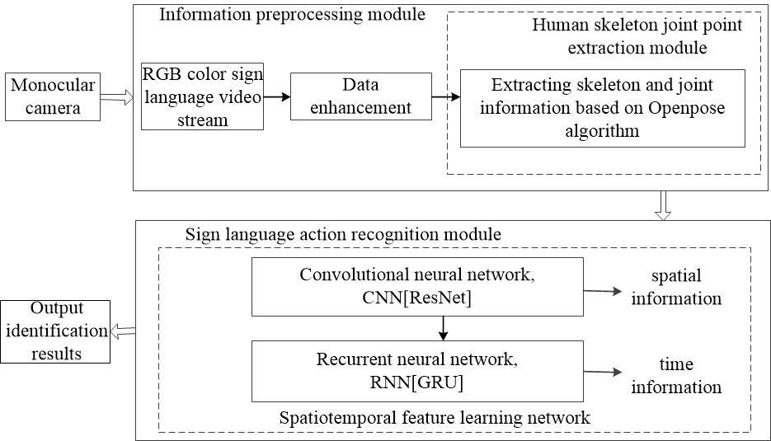

Fig. 1. The overview of proposed method.

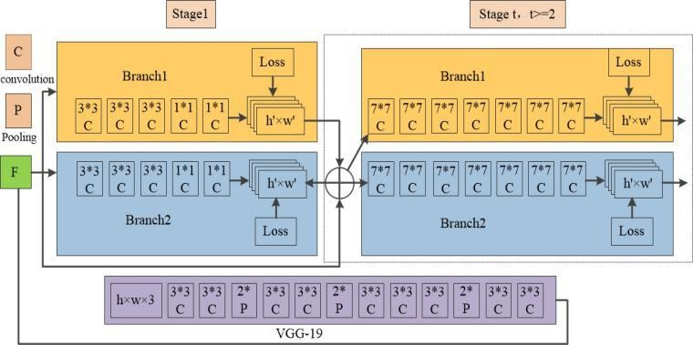
Fig. 2. Basic idea of OpenPose method.

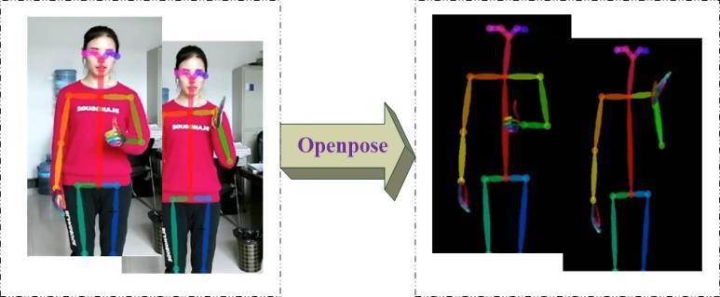
Fig. 3. Skeleton key frames extracted from sign language video sequences.

- Using OpenPose to Obtain Skeleton
For the input video frame sequence, the openpose [22] algorithm is used for iterative prediction, and the structure is shown in Fig. 2. The skeleton of sign language action video sequence is extracted, as shown in Fig. 3.
The first 10 layers of vgg-19 initialize and fine tune to generate a set of function diagram f input to the first stage. In this stage, the network generates a set of affinity fields, which is the reasoning of CNN in stage 1. In each subsequent stage, the prediction of the previous stage is connected with the feature F of the original image to generate fine prediction:
the convolution layer is used to restore the sequence structure by using the sequence expansion layer and flattening layer, and the output is reshaped into a vector sequence, which is sent to the GRU layer to classify the final vector sequence, Finally, the classification results are output through the output layer. The resnet50 of the ResNet-GRU network model is a kind of network structure with appropriate depth and residual module. Batch normalization is used to accelerate training. The purpose of batch normalization is to make our batch, feature map meet the distribution law of mean value 0 and variance 1. In resnet50 network structure, there are two special layers: batch- norm layer and scale layer.

L^{t} = Φ^{t} (F , L^{t−1}),
2 ≤ t ≤ Tp
(1)
The algorithm is implemented as follows:

The total number of PAF [23] stages Tp is iterated and the confidence map detection is repeated in the latest updated PAF:
Input: Values of x over a mini-batch: Data =｛x₁,..., m｝; Parameters to be learned:γ,β
Output: yi = BatchNormγ,β( xi )
1 μβ←
1
m
∑ i
m
x
// mini-batch mean
i=1
2 σ
2
Data
←
1
m
∑
m
(x − μ⋅ Data) // mini-batch variance
2
i
i=1
3 xˆ ←
x − μ⋅ Data
i
i
σ2
// normalize
Data
+ε
4 yi ←γxˆi + β≡ BatchNormγ,β( xi ) // scale and shift

S^{T}p = ρ^{t} (F , L^{T}p ),
∀t = Tp

(2)

S^{T} = ρ^{t} (F , L^{T}p , S^{t−1}), ∀T ≤ t ≤ T + T (3)
p p c

2
The L loss function is used to estimate the attitude and
label the true value of the confidence map or affinity field.
C

f ^{t}i = ∑∑ w( p)⋅ || L^{t}i ( p) − L* ( p) ||²
(4)

L
c=1 P

j
C C 2

f ^{t}k = ∑∑ w( p)⋅ || S ^{t}i ( p) − S * ( p) ||²
(5)

S
j=1 P
j j 2

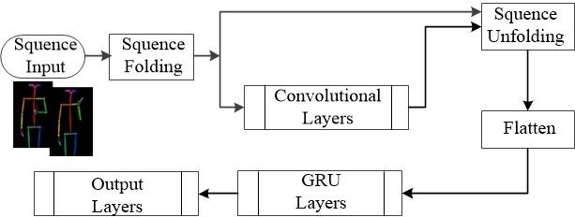
Algorithm 1: ResNet-GRU model algorithm
This layer is to normalize the output features. Let M be the number of selected mini-batch, and each batch has r × q feature points, then m = M × r × q. take the average of the m feature points, then calculate the variance, subtract the average value from each point, divide by the variance to get the result of batch-norm layer, and then scale.
The gated recurrent unit layer GRU learns the dependency between the time step in the time sequence and the sequence

Fig. 4. ResNet-GRU network structure flow diagram.

- ResNet-GRU Model Structure
On the basis of supervised learning of data, a ResNet-GRU model which can recognize sign language actions is established by using convolutional neural network (CNN) and bidirectional recurrent neural network (RNN) deep learning technology, as
data. The hidden state of this layer at time step t contains the output of the GRU layer at this time step. At each time step, the layer adds information to or removes information from the state. This layer uses gates to control these updates. The hidden state of the control layer of the following components. Reset gate r for the degree of state reset control:

shown in Fig. 4.
ResNet is used to learn the spatial feature information of sign language action video sequence. Residual connection is used to solve the problem of performance degradation of
rt =σg (Wr xt + bWr + Rrht −1 )
rt =σg (Wr xt + bWr + Rrht −1 + bRr )
(6)

(7)

convolutional neural network when the network depth is too deep; GRU timing learning module is used to learn the time feature information of sign language action video. The
The update gate z used to control the degree of status update:

sequence input layer is used to input the image sequence into the network, the convolution layer is used to extract features, the sequence folding layer is used to apply the convolution operation to each frame of the video independently, and then
zt =σg (Wz xt + bWz + Rzht −1 )
(8)

zt =σg (Wz xt + bWz + Rzht −1 + bRz )
(9)

Candidate state for the degree of update control added to
~
the hidden state h :

~

ht =σ_{s} (W~ xt + bW~ + rt ⊙ (R~ht−1 ))
(10)

h h h

~

ht =σ_{s} (W~ xt + bW~ + R~ (rt ⊙ ht−1 ))
(11)

h h h

~
ht =σ_{s} (W~ xt + bW~ + rt ⊙ (R~ht−1 + bR~ )) (12)
h h h h

In these calculations, σg
and σs
represents the gate and

state activation function respectively. The learnable weights of GRU layer are input weights (W), recurrent weights (R) and bias (b). The matrices W and R are the concatenation of the input weights and the cyclic weights of each component, respectively. These matrices are connected as follows:
⎡Wr ⎤ ⎡ Rr ⎤

W = ⎢W ⎥, R = ⎢ R ⎥
(13)

Fig. 5. Some examples for our sign language dataset.

⎢ z ⎥ ⎢ z ⎥
⎢W~ ⎥ ⎢R~ ⎥

⎣ h ⎦ ⎣ h ⎦
where r, z and ~ denote reset gate, update gate and candidate state respectively. The offset vector b depends on the attributes of the reset gate model, and the hidden state of time step t is given by the following formula:
h
B. Training and Testing
In the training phase, 80% of the samples are randomly selected from each kind of sign language action set and provided to the ResNet-GRU model together with the corresponding tags. At first, we fixed the learning rate to 0.0001 and optimized it by using the parametric Adam method,

ht = (1 − zt ) ⊙ ht + zt ⊙ ht −1
- RESULTS
(14)
which iteratively approximates the ResNet-GRU weight vector on the training set,the formula is as follows:
N

During our experiment, our system configuration is as
w := w −η.∑δFi (w)
i=1
(15)

follows. (1) Processor: Intel (R) Xeon (R) silver 4110 CPU @
2.10 GHz 2.10 GHz (2 processor). (2) Installed memory (RAM): 32.0 GB (31.6 GB available). (3) System type: 64 bit operating system, x64 based processor.
In this work, we use an RGB camera to collect sign language action video data, and use C++ to realize the preprocessing of sign language action video, extract the human skeleton video of sign language action, and get the accurate upper body skeleton joint video sequence. Through the ResNet-GRU network model, the spatio-temporal features of skeleton video sequence are learned, and the system is built using Matlab platform. Detailed information about data sets, training and testing, and results are discussed in the following sections.
where w is the weight vector, η is the learning rate, Fi (w) is the objective function. Our data and training in the network, the training accuracy rate is 99%, the verification accuracy rate is 98%, as shown in Fig. 6, its accuracy is very high, with low loss value.
Finally, we use the test data to test the robust performance of the system, and calculate the precision and recall rate on the test data set. The calculation formula is as follows:
Precision = TruePositive (16)
TruePositive + FalsePositive

A. Data Set
In this study, we created 10 types of Chinese sign language. Each type of sign language is performed by 5 people at the
Recall =
TruePositi ve TruePositi ve + FalseNegative

(17)

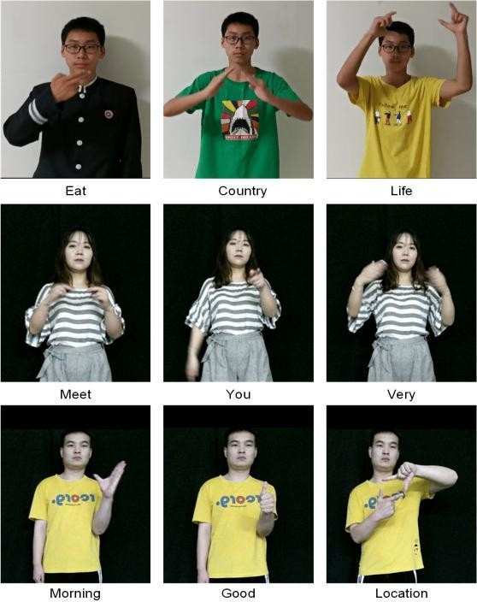
same time, and each person does 40 groups of sign language actions. In this way, each type of sign language action is 200 videos. Using random scaling operation, 1000 videos are generated, and then 1000 videos are taken from the total data set as the test set, including 10 categories, each category contains 100 videos, and the rest are used as training data and verification data. Some examples are shown in Fig. 5.
The some test results are shown in Table I. Table I shows the recognition accuracy of each type of sign language action, which shows that the system has good robustness and accuracy in the test set.

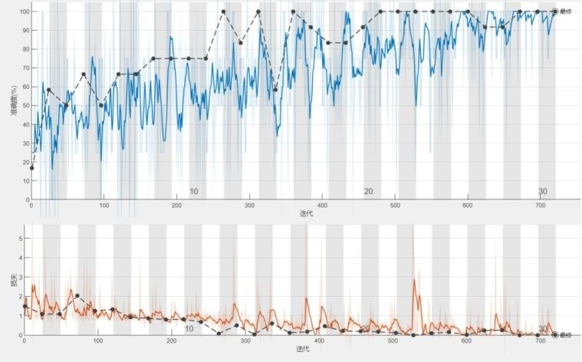
Fig. 6. Model training results.

TABLE I. PRECISION AND RECALL

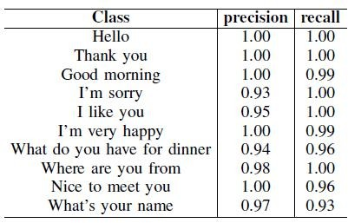

- CONCLUSION
In this paper, a sign language action recognition system based on deep learning is implemented. The system has been successfully trained in all 10 types of sign language action data sets. The training accuracy is 99%, and the test verification accuracy is 98%. Sign language action recognition is an extensive research field, which includes finger spelling, dynamic letters, dynamic words, isolated words and so on. The proposed system framework can extend additional modules and technologies, and form a fully automated sign language action recognition system in the future.
ACKNOWLEDGMENT
This work was supported by the National Natural Science Foundation of China (Nos. 60972095, 61271362, 61671362) and the Natural Science Basic Research Plan of Shaanxi Province in China (Nos. 2020JM566).
REFERENCES
- Deafness and hearing loss. https://www.who.int/zh/news-room/fact- sheets/detail/deafness-and-hearing-loss.
- Wang Yanzhang. Sign language translation based on spatiotemporal convolution network. Ph.D Thesis, Nanjing University of Posts and telecommunications, 2020.
- Avola Danilo, Bernardi Marco, Cinque Luigi, Foresti Gian Luca, Massaroni Cristiano. Exploiting Recurrent Neural Networks and Leap Motion Controller for the Recognition of Sign Language and Semaphoric Hand Gestures. IEEE Transactions on Multimedia, 2019, vol.21, no.1, pp. 234-245.
- Tan Yanchao, Shang Xiaoli. Application status and development countermeasures of information technology in special education in China. Journal of Suihua University, 2020, vol. 40, no.10, pp.153-155.
- Chen Suiqing, Zhang Jijia. The influence of language on the cognition of hearing-impaired people from the perspective of new language relevance theory. Chinese Journal of hearing and language rehabilitation, 2018, vol. 16, no. 2, pp. 150-153.
- Liang Zhijie. Research on key Technologies of deaf mute sign language recognition. Master Thesis, Central China Normal University, 2019.
- Camgoz Necati Cihan, Hadeld Simon, Koller Oscar, Ney Hermann, Bowden Richard. Neural Sign Language Translation. CVPR, 2018, pp.7784-7793.
- Huang Jie, Zhou Wengang, Zhang Qilin, Li Houqiang, Li Weiping. Video-based sign language recognition without temporal segmentation. AAAI Conference on Artificial Intelligence, 2018, pp.2257-2264.
- Yan S, Xiong Y, Lin D. Spatial temporal graph convolutional networks for skeleton-based action recognition. Proceedings of the AAAI conference on artificial intelligence. 2018, 32(1).
- Rung-Huei Liang and Ming Ouhyoung. A sign language recognition system using hidden markov model and context sensitive search. Proceedings of the ACM Symposium on Virtual Reality Software and Technology. Hong Kong, 1996, pp.59~66.
- Koller Oscar, Forster Jens, Ney Hermann. Continuous sign language recognition: Towards large vocabulary statistical recognition systems handling multiple signers. Computer Vision and Image Understanding, 2015, vol.141, pp.108-125.
- Starner T, Weaver J, Pentland A. Real-time american sign language recognition using desk and wearable computer based video. IEEE Transactions on Pattern Analysis and Machine Intelligence, 1998, 20(12): 1371-1375.
- Grobel K, Assan M. Isolated sign language recognition using hidden Markov models. IEEE International Conference on Systems, Man, and Cybernetics. 1997, vol. 1, pp. 162-167.
- Koller Oscar, Zargaran Sepehr, Ney Hermann, Bowden Richard. Deep Sign: Enabling Robust Statistical Continuous Sign Language Recognition via Hybrid CNN-HMMs. International Journal of Computer Vision, 2018, vol.126, no.12, pp.1311-1325.
- Cui Runpeng, Liu Hu, Zhang Changshui. A Deep Neural Framework for Continuous Sign Language Recognition by Iterative Training. IEEE Jie, Zhou Wengang, Li, Houqiang, Li Weiping. Attention based 3D-CNNs for Large-Vocabulary Sign Language Recognition. IEEE Transactions on Circuits and Systems for Video Technology, 2018, vol.15.
- Luo Yuan, Li Dan, Zhang Yi. Chinese sign language recognition based on spatiotemporal attention network. Semiconductor optoelectronics, 2020, vol. 41, no. 3, pp. 414-419.
- R. Cui, H. Liu and C. Zhang, Recurrent Convolutional Neural Networks for Continuous Sign Language Recognition by Staged Optimization. IEEE Conference on Computer Vision and Pattern Recognition, 2017, pp. 1610-1618.

