Development of Sleep Apnea Monitoring System in IoT Environment.
Shailesh Khaparkar¹ Vaishali kori ²
1,2 Gyan Ganga Institute of Technology and Sciences, Jabalpur, 482005

^{Abstract}
Sleep apnea, a disease in which a person stops breathing while they are awake for 10 seconds to a minute, is one of the most prevalent sleep disorders in the modern world. This occurs as a result of the throat muscles' obstruction of the upper airway. The gold standard for diagnosing sleep apnea has been polysomnography, which requires a patient to go to a sleep clinic and spend the entire night under the care of a sleep specialist. The body is equipped with a large number of sensors to record the readings. As a result, the procedure is costly, time-consuming, and invasive. Heart rate variability, SpO2, and other physiological parameters are included in the readings. The purpose of this study to develop IoT based monitoring system for automated screening of sleep apnea subjects using Spo2 and heart rate recorded by sensors, by staying at home. For deciding if a person has sleep apnea or not, this study used MAX30100 Pulse Oximeter and Heart-Rate Sensor, LM393 microphone sound sensor. The results of this study can be utilized to identify sleep apnea.

Keywords: Sleep Apnea, Obstructive Sleep Apnea,Sp02, Heart rate, IoT

I Introduction
Sleeping is a crucial component being a human. It has a major impact on one's mental and physical health as well as their overall level of life. A few signs of sleep disturbances include emotional instability, fatigue, lethargy, energy loss, lack of focus, and issues with memory. High blood pressure, diabetes, and depression are the three most common adverse outcomes of sleep apnea. Sleep apnea (SA) is a sleep disorder that causes brief pauses in breathing during sleep. Globally, the prevalence of OSA ranges from 3 to 5 percent, with 3-7% of adult men and 2-5% of adult women having the condition (Adnan et al., 2022). Apnea, or total closure of the airway near the throat, or partial obstruction, is the reasons for it. of this to see limiting the amount of oxygen the body absorbs by 50%. (i.e. hypopnea). While sleeping, a person's breathing normally stops for ten seconds or more, although it can sometimes stop for upto a minute.

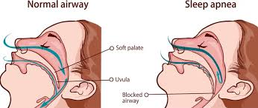

Figure 1: Normal airway and Sleep apnea
According to the World Health Organization, 200 million people globally have sleep apnea. The disease affects between 2 and 4 percent of people. Sleep apnea is not just widespread, but also dangerous because it can lead to several potentially fatal situations. Frequent arousals result in inadequate sleep and continuous sleep loss, which impairs cognitive ability and supports daytime fatigue, irritability, and exhaustion. Often, these symptoms are followed by even more severe outcomes, like car accidents and disputes at work. Additional problems brought on by sleep apnea include heart attacks, hypertension, morning migraines, stroke, reduced life expectancy, irregular heartbeats, etc.The two main types of sleep-disordered breathing (SDB) are obstructive sleep apnea (OSA) and central sleep apnea (CSA). But OSA is the most frequent type of SBD, accounting for almost 80% of cases; CSA is much less common. OSA is characterized by airflow limitation due to airway obstruction or upper airway collapse in the throat muscles for at least 10 seconds or more, even when respiration is being tried (Nguyen et al., 2014). In CSA, the brain fails to tell the muscles to breathe, so instead of an obstruction of the airway, breathing ceases from insufficient respiratory effort (Randerath, 2022). When someone has hypopnea, their breathing becomes somewhat restricted as they sleep, and they suffer Breathing slowly for at least 10 seconds. When hypopnea occurs, the amount of airflow is 30% less than it is when breathing normally. Other subtypes of hypopnea include obstructive hypopnea, central hypopnea, and mixed hypopnea.
Overnight polysomnography (PSG) in specialized sleep laboratories is the primary method used to identify and diagnose sleep apnea (Nguyen et al., 2014). During polysomnography, a number of physiological markers are assessed, such as oxygen saturation, breathing, heart rate, and sleep quality. It covers non-invasive techniques for gathering physiological data, including ECG (electrocardiogram), SpO2 (pulse oxygenation), EEG (electroencephalogram), EMG, nasal airflow, and thoracic and abdominal actions.
Much research has been done on how to use portable devices to diagnose sleep apnea at home, with the goal of reducing the pain related to the PSG technique. Research has been conducted to ascertain the physiological signal that can be employed to detect sleep apnea in the home setting with wearable technology. The most promising results are often demonstrated by blood oxygen levels and heart rate variability.

II . PROPOSED TELE-HEALTH MODEL FOR SLEEP APNEA DETECTION
A few distinct steps are coupled with the system. Each stage has an individual task to do, and both contribute to the user's benefit. Fig.2 depicts our entire hardware configuration. These several processes are combined in the programmable Arduino UNO programme. Different functionality for the various sensors and Bluetooth modules that link the Arduino UNO and the Blynk app are merged with the Arduino programme. After the code was uploaded to the Arduino UNO, the system's workflow began in the Arduino IDE. The Bluetooth module, the sensors' setup, and how they function are all contained in the code. The loop that governs the code's primary function permits. the data will be shown every second by the system. The Max30102 module's sound sensor organization is managed by the loop. This module also handles the data conversion and transmission tasks, as well as the data passing to the mobile Blynk application and serial monitor. The data is shown on the serial monitor and stored for in-depth examination after the Bluetooth module and mobile device have paired.
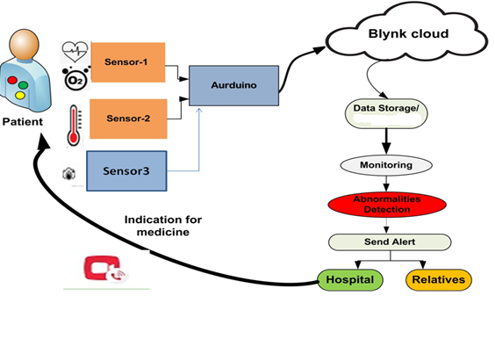

Figure2: Proposed Tele-Health Model For Sleep Apnea Detection

- Hardware set-up
At the start of the program execution, the Arduino hardware board reads the sensor reading. The sensor data is then sent to Blynk cloud. The sensor-1 is being simultaneously read by a Arduino. The data is sent to the cloud using an indirect approach by the Python programming language. Python is used to read the data from the serial port and transmit it to cloud Sheets. Fig3 shows the hardware setup of proposed system.
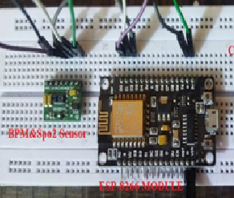

Figure3: Hardware setup For Sleep Apnea Detecti
- MAX30100-Sensor
The MAX30100 is a sensor system that can detect pulse oximetry and heart rate. It has superior optics, two LEDs, a photo-detector, low-noise analog data processing, and the ability to detect pulse oximetry and heart rate signals. It uses 1.8V and 3.3V power sources to operate.
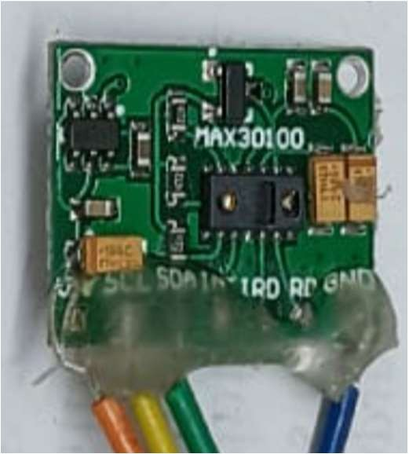

Figure 4: BPM &Spo2 Sensor

- WeMos D1 R1
The ESP8266 12E is the basis of a Wi-Fi development board known as WEMOS D1. NODE-MCU operates more similarly to the Arduino UNO, despite the hardware being designed to be a copy.
D. Sound Sensor.
Snoring is one of the major symptoms of obstructive sleep apnea or OSA. It indicates the problem with breathing. Snoring is a raspy or loud sound produced by air passing through relaxed tissues in the throat, causing the tissues to vibrate while you breathe. From a health standpoint, OSA-related snoring is more concerning. To detect OSA, monitoring of snoring sound and frequency is important. An unusual change in snoring replicates the intensity of the sleep apnea problem. Figure 5 shows the sound sensor module.

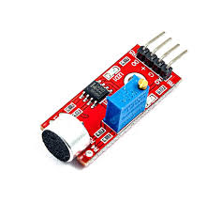
Figure5: Sound Sensor

E. Blynk
Blynk is a comprehensive set of tools for transmitting sensor data to the cloud. Prototyping, deploying, and remotely managing connected electrical devices of any scale, from small personal IoT initiatives to large commercial connected product deployments, is required.
F Arduino IDE
The Arduino Integrated Development Environment (IDE), often known as the Arduino Software (IDE), is also available. It features a text editor for writing code, a message box, a text terminal, a toolbar with buttons for frequently used operations, and a number of menus. It links to the Arduino hardware to upload and communicate with program

III. RESULTS AND DISCUSSION
This system introduces a Blynk cloud and IoT-based sleep apnea monitoring system for telemedicine purposes. The methodology that has been proposed evaluates the values of the many health metrics that are obtained from sensors. This system pro- vides faster and more reliable medicinal treatment to people, and information is recorded via the internet and communication devices, which are then linked to cloud services. The data obtained from the Blynk cloud server is updated in real- time, depending on the service provider’s internet speed. The continuous recording of , heart rate, and Spo2 level The same dashboard will be visible on the mobile phone of the operator. The data from the sensor to the cloud is also updated in real time with the date and time stamping. Functional testing of the proposed system has also been done in real time by measuring the physiological characteristics. The heart rate and SpO₂ level are used to diagnose sleep apnea. The data were acquired from five subjects (3 males and 2- females).
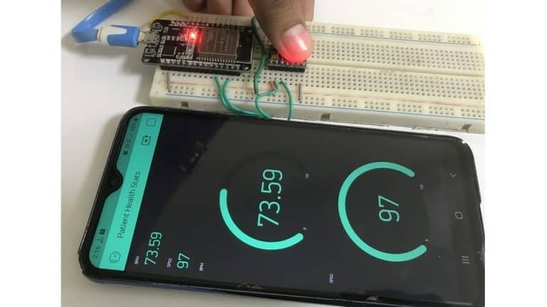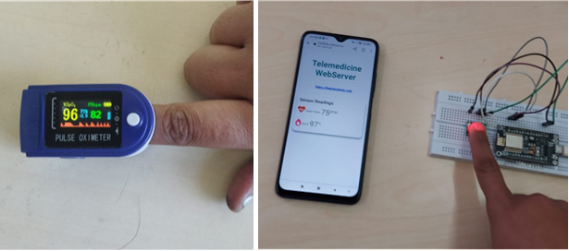
Figure 6 : continuous recording of heart rate, and Spo2 level on Mobile dashboard
The following table shows characteristics of the subjects are considered for experimentation Parameter was recorded during night time in the sleep condition for five hours (11 pm to 4 am).
TABLE 1. Characteristics of the subjects

Subject | Age group | Gender | Mean of Spo2 | Mean of Heart Rate | Body status
1 | 5-17 | Male | 95.82 | 74.77 | Normal
2 | 18-35 | Male | 95.95 | 83.27 | Overweight
3 | 18-35 | Male | 97.81 | 70.31 | Physically fit
4 | 36-50 | Female | 96.49 | 91.39 | Heart issue
5 | 50 + | Male | 94.55 | 80.72 | Lung Issue

Sound Intensity Analysis
Of the individuals the system tracked, snoring a sign of obstructive sleep apnea was found in three of them. Everybody had a different pattern when it came to snoring. The sensor gathers information every second for the snore detection experiment. The outcome demonstrates that the sound has a consistent rhythm during sleep for a particular individual. The snoring patterns of the individuals under study are shown on the graph in Figures. 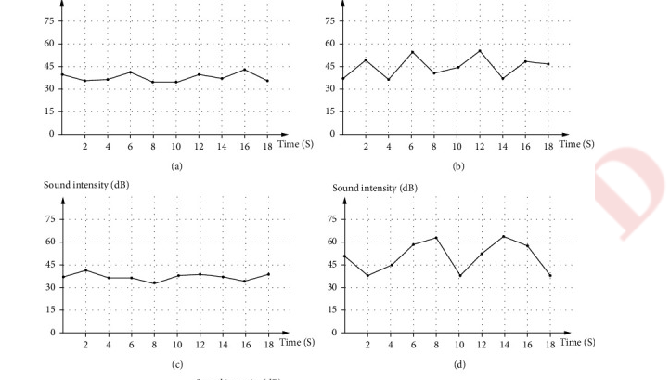

Conclusion
This study demonstrates the use of IoT devices for sleep apnea monitoring. We employed many of the most important health-related sensors along with a simple microcontroller to build the system. A very basic web application for app development was used to generate the mobile application. The technology provides pretty excellent findings for making conclusions regarding sleep apnea after monitoring five individuals. It is evident from the results that two individuals do not exhibit any signs of sleep apnea. One individual, who is between the ages of 36 and 50, has serious problems sleeping. For that individual, the technology has successfully identified sleep apnea. The device can also identify a person who has obstructive sleep apnea. Upon examination of the data, it is evident that the individual whose age is A patient with OSA is above 50. People who use that type of monitoring will be able to identify sleep apnea early on. Therefore, people can benefit from this research by learning more about sleep apnea, how to identify it, and how to get rid of all of their sleeping issues.

References
1. Adnan, M. M., Kassim, N. K., Mohd Rasid, N. M., Ibrahim, H. A., Ramli, R., Ghani, N. and Hanafi, M. H. (2022). Knowledge and attitude of obstructive sleep apnea among dental students in north east penisular malaysia, Banglad. J. Med. Sci. 21(2): 384–390.
2. Bahrami, M. and Forouzanfar, M. (2022). Sleep apnea detection from single-lead ecg: A comprehensive analysis of machine learning and deep learning algorithms, IEEE Transactions on Instrumentation and Measurement 71: 1–11.
3. Cen, L., Yu, Z. L., Kluge, T. and Ser, W. (2018). Automatic system for obstructive sleep apnea events detection using convolutional neural network, 2018 40th Annual International Conference of the IEEE Engineering in Medicine and Biology Society (EMBC), pp. 3975–3978.
4. Chen, X., Xiao, Y., Tang, Y., Fernandez-Mendoza, J. and Cao, G. (2021). Apneade- tector: Detecting sleep apnea with smartwatches, Proc. ACM Interact. Mob. Wearable Ubiquitous Technol. 5(2).URL: https://doi.org/10.1145/3463514
5. Fatimah, B., Singh, P., Singhal, A. and Pachori, R. B. (2020). Detection of apnea events from ecg segments using fourier decomposition method, Biomedical Signal Processing and Control 61: 102005URL: https://www.sciencedirect.com/science/article/pii/S1746809420301610
6. Ghandeharioun, H. (2021). Online obstructive sleep apnea detection based on hy- brid machine learning and classifier combination for home-based applications, CoRR abs/2110.00660.
URL: https://arxiv.org/abs/2110.00660
7.Goldberger, A. L., Amaral, L. A., Glass, L., Hausdorff, J. M., Ivanov, P. C., Mark, R. G., Mietus, J. E., Moody, G. B., Peng, C. K. and Stanley, H. E. (2000). PhysioBank, PhysioToolkit, and PhysioNet: components of a new research resource for complex physiologic signals, Circulation 101(23): E215–20.
8. Marcos, J. V., Hornero, R., A´lvarez, D., del Campo, F. and Zamarr´on, C. (2009). As- sessment of four statistical pattern recognition techniques to assist in obstructive sleep apnoea diagnosis from nocturnal oximetry, Medical Engineering & Physics 31(8): 971– 978. URL:https://www.sciencedirect.com/science/article/pii/S1350453309001246

