The Applications of Artificial Intelligence in Human Resources

Priyal Gordiya

MBA (Amity University, Raipur)

Abstract

The study examines the transformative role of artificial intelligence in Human resources and its profound implications for the future of workforce management. Questionnaires are used to evaluate the current perception, applications & adoption of artificial intelligence in human resources practices, as well as its potential impact and ability to shape tomorrow's Human Resource landscape. Understanding of how people view the integration of AI in human resources functions, by rigorously analysing questionnaire responses. These findings reveal the apprehensions, expectations and acceptance levels of AI driven human resource management processes. In addition, important foresight is provided on the evolution of technology and Human Capital dynamics within organisational structures. Moreover, a compelling case study is presented to demonstrate the effectiveness of AI when it comes to human resource management on an actual basis. The case study shows how AI solutions simplify recruitment, enhance employee engagement, optimise talent management and mitigate biases in the decision making process for a more agile, data driven environment that is inclusive. Finally, this research aims at breaking down the complex implications of artificial intelligence for human resources and providing information on its transformative potential which will make it easier to adopt effective decisions as part of organisational HR strategies.

Keywords: Artificial Intelligence, Human Resources, Case Study, Perception, Awareness

1.1 INTRODUCTION
Human Resources is one of the core parts of a company as it directly relates to the personal lives of its employees. A healthy working environment and good communication are also sought by employees. Ensuring that all employees feel safe and receive assistance is a key role of the HR, providing them with resources to carry out their tasks effectively. Artificial Intelligence, which is one of the most advanced and growing technologies has helped improve the HR department.AI has the capability to revolutionize employee experiences from recruiting to talent acquisition and promote a way for better decision making and do the work more productively. The main problem in today's HR department is repetition and time intensive tasks that can be managed by integrating AI into the HR function, while concentrating on more complex functions.

1.2 BACKGROUND OF THE STUDY

Artificial intelligence, the ability to perform tasks normally performed by an intelligent being through a digital device or a computer controlled robot. The importance of AI technology is that it allows software, which has become more effective, efficient and at a low cost, to take advantage of people's understanding, reasoning, planning, communication and perception capacities. Projects to develop systems, to analyse human behaviour, to classify it, and to learn from past experience and ability to reason are frequently covered by this term. Human resources are the people who make up a company, business sector, industry or economy's workforce. Human capital, the knowledge and skills which individuals possess, is a narrower concept. Integrating Artificial Intelligence with Human Resources -
The use of AI for the purpose of analyzing, predicting and diagnosing will benefit an organisation because it is capable of making more precise decisions by means of these applications that can be applied to HR practices. This study will show how artificial intelligence is used in human resources and how it contributes to human resource functions. In this research will be focusing on the Indian Company IBM, which is the first company in India to adopt AI technology in HR functions. IBM said while using AI in HR, “AI can be applied in almost any area of HR, including candidate attraction, hiring, learning, compensation, career management, and HR support”.

1.3 NEED OF THE STUDY

The integration or amalgamation of AI with HR has the potential to revolutionize employee experiences in a variety of ways, from recruiting to talent management, by processing massive amounts of data quickly and accurately.
Companies will experience an upgraded, evolved environment for their applicants,
Contribute to the promotion of the value of producing better and faster outcomes,
Booking best candidates or applicants in the process of talent acquisition & recruitment,
Enhancement of employee experience,
Tracking of all the important details,
Faster decision making,
Improved employee performance etc.
1.4 OBJECTIVES OF THE STUDY
The Objectives of this study are -
To know how many employees are aware of AI in the field of human resources and how they feel about it?
To find the functional areas in which AI has greater potential in the field of Human Resources.
To assess the importance of AI in HR in the upcoming years.
1.5 METHODS
The study was done with the help of primary data. Primary & Secondary data were collected through -
- Questionnaires
- Discussions
- Interviews
- Search Engine
- Research Papers

2.LITERATURE REVIEW
Artificial intelligence is transforming every aspect of work and life in today's world. Companies and organisations are using artificial intelligence to enhance their competitive advantage, as well as supporting new productivity enhancing mechanisms. In order to increase the scope of artificial intelligence in human resources, major technology companies in the world, such as IBM, with a strong hardware background, are developing various AI programs and capabilities. IBM, which was the first company to integrate AI into its human resource functions, has initiated a report from Nigel Guenole, Ph.D. and Sheri Feinzig, Ph.D. describing the impact of artificial intelligence on HR activities. IBM's Vice President of Talent Solutions & People Analytics, Tom Stachura explains that Artificial Intelligence is an accelerator and allows us to collect a wide range of data in order to give context to the decision maker or employee or business leader. When the machine imitates "cognitive" functions that humans have in common with other people's minds, e.g. "learning" and "solving problems," it is referred to as artificial intelligence. Three different types of artificial intelligence are identified by Kaplan and Haenlein: analytical, human inspired, and Humanized AI. Analytical AI is a type of artificial intelligence which has characteristics that are consistent with cognitive intelligence, namely the creation of an accurate representation of the world and its use of learning derived from previous experience in decision making. Human inspired AI has elements of cognition and emotions, in addition to their intelligence or comprehension, as well as emotion considerations when it comes to making a decision. Humanized AI has characteristics of all kinds of competencies such as ability to be autonomous and self aware in interactions with others, i.e. cognitive, emotion or socially intelligent skills; etc. The roles may be replaced by artificial intelligence and automation, but it is easy to forget that these very same technologies play an important role in finding, securing and retaining staff. Finding the perfect talent is becoming more and more difficult in an age of continuous change and a shortage of ICT skills. With the use of artificial intelligence and automation, businesses are able to identify a wide range of top candidates quickly and easily while keeping up with the rapid pace of modern business. However, the advanced AI solutions rely on custom algorithms which are designed to connect specific measures of job performance with prospective candidates most likely to display these qualities. HireVue is a company that's working on developing these advanced AI human resource solutions. At present, their most popular program is a video interview which develops questions specifically designed to elicit an answer that will predict job success and determine the right behavior.' Each applicant's answers, body language, tone, emotional state and keywords are analyzed by HireVue's artificial intelligence program.

Some tools which are driving the future of HR are -

Candidate Resumes on Smart Digital Forms
HR is all about connecting businesses with existing and prospective employees on a personal level. In particular, in their journey with NewHire, companies usually require new applicants to reword the information on a number of occasions. This repetitive, tedious work may have a bad impression on them. Companies use artificial intelligence to help job seekers move information from their resume into smart forms and more effectively complete applications, in order to reduce some of the monotony. For example, an AI can identify the pertinent information on a candidate's resume and save it to his or her next form so that he or she doesn't have to reword everything over and over again.

Understanding Employee Referrals
The AI may also analyse performance data from previous referrals and recognize when recommendations are made to candidates who match the success of existing staff. Artificial intelligence is an opportunity for human resource departments to improve the experience of candidates and employees by streamlining repetitive, low value tasks while freeing up time so that they can focus on more strategic or creative work in order to achieve their objectives.
Data-Backed Resources and Insights
AI provides HR professionals with data based resources and insights derived from employees, says Michael Cohen, CMO of Achievers. This will allow HR professionals to take action in order to give their staff the skills they require and demand, as well as increase participation and turnover.
AI-Backed Chatbots Keep Engagement Conversation Going
According to Cohen, the engagement of employees is also a science and part of it consists in measuring and analysing employee sentiment on a day by day basis. AI chatbots that support the conversation, all year round, empower both workers and human resource professionals to engage. Chatbots can serve as a communication tool that will engage the user in personalised conversations, naturally humanlike and always available to them," Cohen explained. In order to deal with potential obstacles that might prevent them from taking action and demonstrating their voice by increasing employee engagement and decreasing turnover, HR professionals can use AI chatbots to identify sentiment. The roles may be replaced by Artificial Intelligence and automation, but the fact that these technologies are also very much important for recruitment, security and retention of employees is easily overlooked.

THE VARIOUS APPLICATIONS OF AI IN HR THROUGH CONSTANT RESEARCH AND ANALYSIS HAS BEEN SEEN THAT IT PLAYS A MAJOR ROLE IN -
TALENT ACQUISITION & RECRUITMENT
Artificial intelligence has a significant impact on talent acquisition and recruitment, from sourcing potential employees to integrating them into the workforce. The officials are more precise in selecting candidates, and the procedure is easier to follow.
TRAINING THE RECRUITS
The AI will immediately recognize and authorise appropriate training for the staff member, as a result of its examination of documents and tests. In order to increase growth, they will be provided with appropriate information on their skills set, as a result of their job description.

COMPENSATION AND BENEFITS
Compensation and benefits, which is one of the main factors in creating an employee's satisfaction as well as affecting his or her engagement with work. In order to improve the professional experience of employees, AI can be used in combination with machine learning to make operations more automated. Artificial intelligence can identify patterns, predict performance and understand drivers and influencers that lead to the optimization of compensation models and programs, resulting in increased employee performance and retention.

PERFORMANCE MANAGEMENT (appraisal & feedback)
Artificial intelligence has a great role to play in the performance management system. In order to maintain transparency and avoid misunderstandings or doubts, the data driven appraisal or review system helps. In addition, AI can be used to help employees in the areas of EMPLOYEE ENGAGEMENT, EMPLOYEE RETENTION, OPTIMUM HR UTILIZATION, EXEMPLIFYING, FLASH DECISION MAKING and it will have a positive effect on how they work. Implementing AI in HR will increase productivity and has the potential to reduce operational costs and time spent on mundane, repetitive tasks. It can also boost the overall employee experience, which will drive retention rates upwards.

AI TOOLS WHICH CAN BE USED IN HR DEPARTMENT -

TEXTIO
For the creation of highly effective job advertisements, it is an AI powered SaaS tool. Their tool predicts the effectiveness of job vacancies when they are being written and helps to improve their efficiency in a timely manner. They say that on average, they fill positions 20 % more quickly. The tool helps to increase the diversity of candidates applying for these positions.
TALLA
Talla's a perfect complement to human resources when recruiting new staff. For policy, procedures, benefits and more, it provides a contextually relevant answer. It's going to save time, and it's going to help employees find answers to their questions very quickly.
MICROSOFT 365
Microsoft 365 is a great tool for human resource professionals because it helps them to drive efficiencies across core HR processes, while at the same time supporting more complex and related objectives such as providing an excellent employee experience.

THE BUSINESS CASE FOR AI IN HR - IBM

IBM’s HR function was one of the first to adopt (AI) technology and this means it has a wealth of insights and learnings to share to help others get started. The IBM Smarter Work Force Institute summarises these experiences gathered by interviewing the heads of Human Resources, who are in charge of bringing AI to HR.

HOW IBM USED AI FOR CANDIDATE ENGAGEMENT, COMPENSATION PLANNING & AI BASED LEARNING -

AI CANDIDATE ENGAGEMENT AT IBM :
IBM’s goal was to create a meaningful experience that engages job seekers from the first interaction, while at the same time developing a shared understanding of their suitability for roles that match their skills. The AI solution IBM developed to address this challenge is called Watson Candidate Assistant (WCA). WCA has changed the way job seekers engage with IBM. Previously, candidates and employers would meet for the first time at the job interview, after learning about the opportunity from an online jobs board or career website. By leveraging AI, candidates and employers can now have real-time interaction via a chatbot, resulting in a more personalized application process for job seekers. The richer information applicants receive in turn leads to a stronger fit of job applicants for roles. These chatbots get smarter with every interaction. Videos can also be embedded into the process to give a much more realistic preview of what it’s like to work at the organization. The end result of implementing these capabilities at IBM has been an increased flow of high potential candidates.

AI - SUPPORTED COMPENSATION PLANNING AT IBM :
It is a challenge to make accurate, complex compensation decisions within an organization and one which IBM addresses through artificial intelligence. IBM has created a tool to help managers avoid underweighting or overweighting the key data points, which is an AIpowered Decision Support Tool that helps them plan compensation. Following the success of early trials in targeted geographic regions, this application is now being used for tens of thousands of First Line Managers to assist with compensation planning. Importantly, when using the tool, managers have the opportunity to override the AI recommendation about any given employee, and the system can continue to learn from managers’ actual decisions. In general, managers tend to follow the recommendations the AI provides, and this has helped ensure employees are not overpaid or underpaid at IBM. IBM also emphasizes transparency in AI-based compensation support: employees can see where they sit relative to the market, because the low and high range of compensation for workers with their skills is provided, in addition to their personal salary.

AI BASED LEARNING AT IBM:
At IBM, the introduction of AI in learning has produced impressive results. Using AI, IBM has developed Your Learning, a rich, personalized digital marketplace for learning, visited by 98% of employees every quarter. IBMers complete an average of 60 hours of learning per year. IBMers can navigate to the learning most popular with their peers, sign up for targeted learning channels, and explore the skills and badges they need to prepare for the company’s hottest roles. A learning chatbot answers questions 24/7. As a result, IBM’s AI-driven learning platform is increasing enrollments and course completions, thereby accelerating strategic skill acquisition.

3. METHODOLOGY

3.1 RESEARCH DESIGN
This study used a Descriptive type of research design. A descriptive survey design attempts to establish the range and distribution of some social characteristics such as education or training, occupation & location, and to discover how these characteristics may be related to certain behavior patterns and attitudes. The research method used here is quantitative & qualitative both. Quantitative data collection method involved questionnaires filled by the respondents. It also allows broader study and enhances the generalization of the results. This method will provide summaries of data that support the phenomena under study. Qualitative data is derived from the observations during interviews held over calls.

3.2 SAMPLE SIZE
The Sampling Size is 56. The sampling plan of my research is Random Sampling.

3.3 DATA COLLECTION METHOD
Data is collected through questionnaires & interviews. Total no. of respondents is 56 where the analysis is done through pie charts & graphs.

3.4 RESEARCH TOOL
A research tool plays a major role in any useful analysis because it is the sole factor in evaluating the sound data and in drawing perfect conclusions about the issue or study on hand,which eventually helps to provide effective remedial steps to the problems concerned. Questionnaire- data is collected from respondents using the questionnaire. In a statistical enquiry the information is often collected through a provided appraisal in the form of a questionnaire. The investigator intends to make the use of “Google forms” to research on the topic of artificial intelligence in Human resources. This questionnaire consists of different types of questions including checkboxes, multiple choice questions, likert scale.The respondents are supposed to tick the options they feel are most likely true from their perception. All the questions in this questinnaire are compulsory to answers.

4. Data Analysis
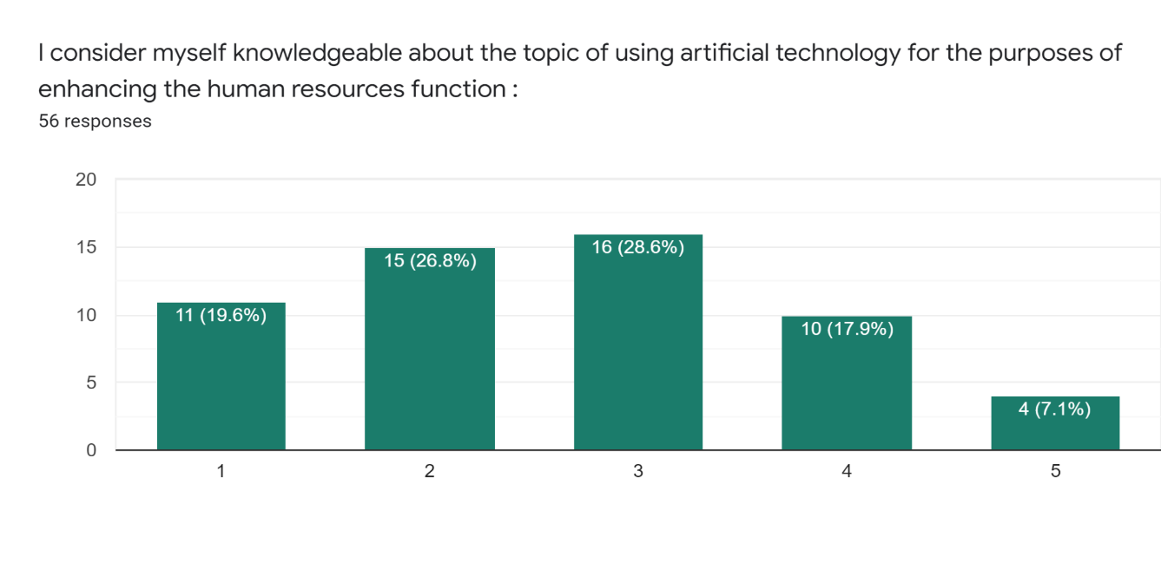

INTERPRETATION-

1-5
Strongly Agree - Strongly Disagree.

This analysis clears out our first objective of this research.
Most of the respondents are knowledgeable about AI technology being used in human resources and some see it as a future scope. AI will itself be a crucial change in the field of HR and it will boost the employee productivity, enhance the HR functions with fast decision making and good technology in hand and promote wider scope for managing work simultaneously.

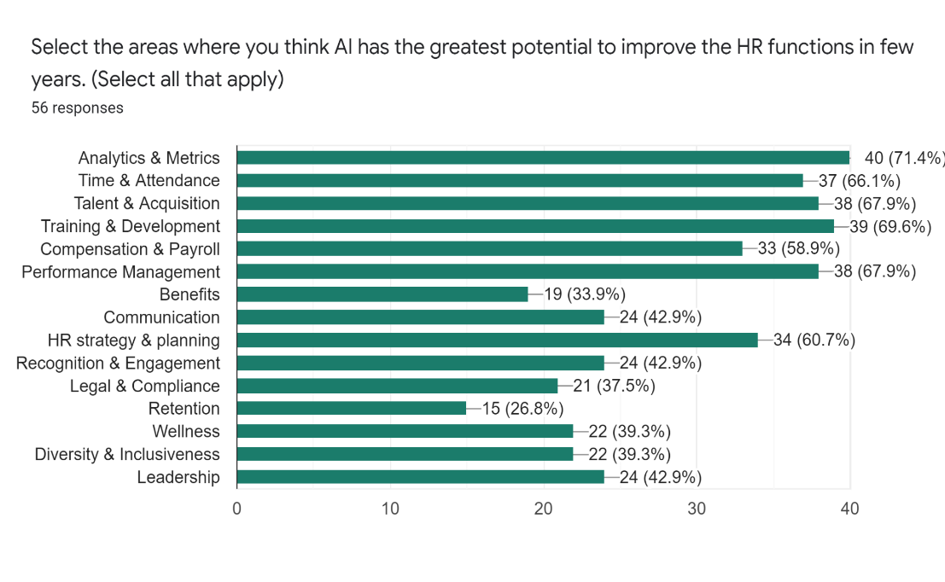
As seen in the chart, the respondents see AI in HR as a great future scope and after a period of time every employee will work using AI and taking its help for accuracy, organizing, analyzing, predicting etc.

INTERPRETATION -

Analytics is viewed as the area of highest HR potential.

When the respondents were provided with the questionnaire about where they thought AI has the greatest potential to improve HR, the most popular responses were-

- Analytics & Metrics,
- Training & Development,
- Talent Acquisition,
- Time & Attendance &
- Compensation & Payroll.

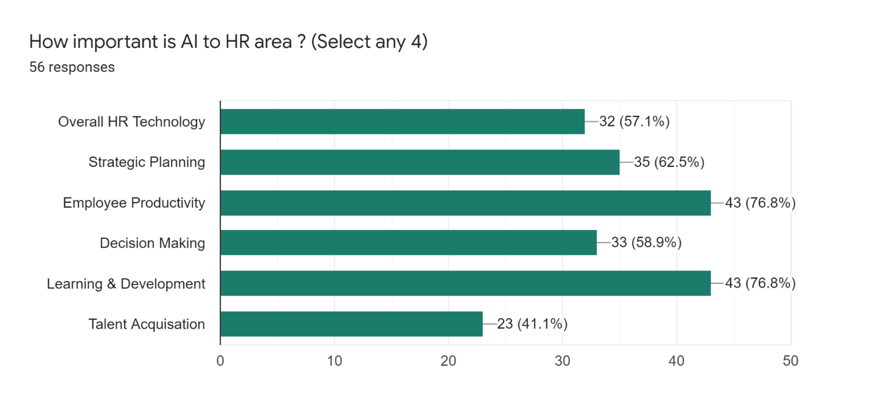
The majority of organizations need to track the time & attendance & also compensation of the employees, so applying AI to these complex data makes sense, specially from an analytics point of view. This analysis clears out our second objective of this research.

INTERPRETATION-

As we know that AI has been seen as an important technology in the HR dept, the respondents feel that in the near future the AI technology will become more important to their Employee Productivity, learning & development of the employees, strategic planning and the overall HR technology.

At a glance, AI is expected to have a major impact on the employee productivity as well as the learning and the education of the employees to enhance their strategic planning and faster decision making process. This analysis clears out our third objective of this research.

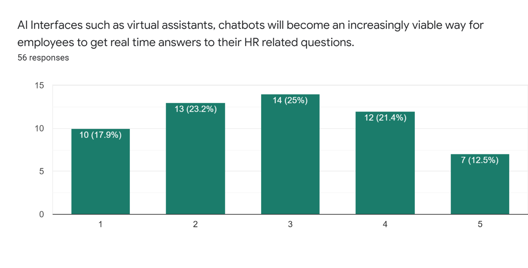
INTERPRETATION -

1-5
Strongly Agree - Strongly Disagree.

23.2% of the respondents Agree that AI interfaces such as chatbots, virtual assistants will become an increasingly viable way for employees to get real-time answers to their HR related questions. Whereas 25% respondents being neutral in this decision, this will depend on how employees adopt this technology and make it an advanced one in the future because there is a lot of frustration on the part of users so the adoption will depend on its growth in the future.

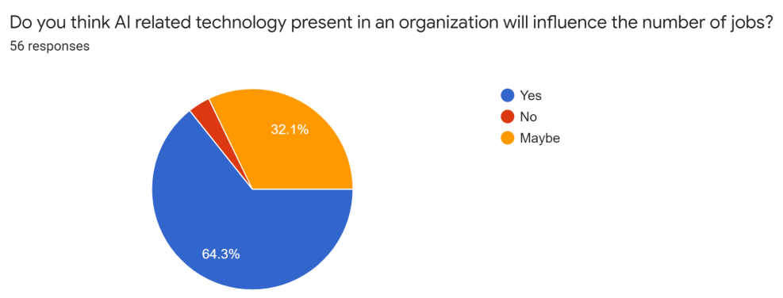

INTERPRETATION-

As the majority of the respondents feel that yes AI will influence the number of jobs, it is because AI will lead to increased level of productions, specializations in job roles, and the increased importance of Human related skills.

This will increase the retention rates and also will be able to increase employment and new talent acquisition in the company.

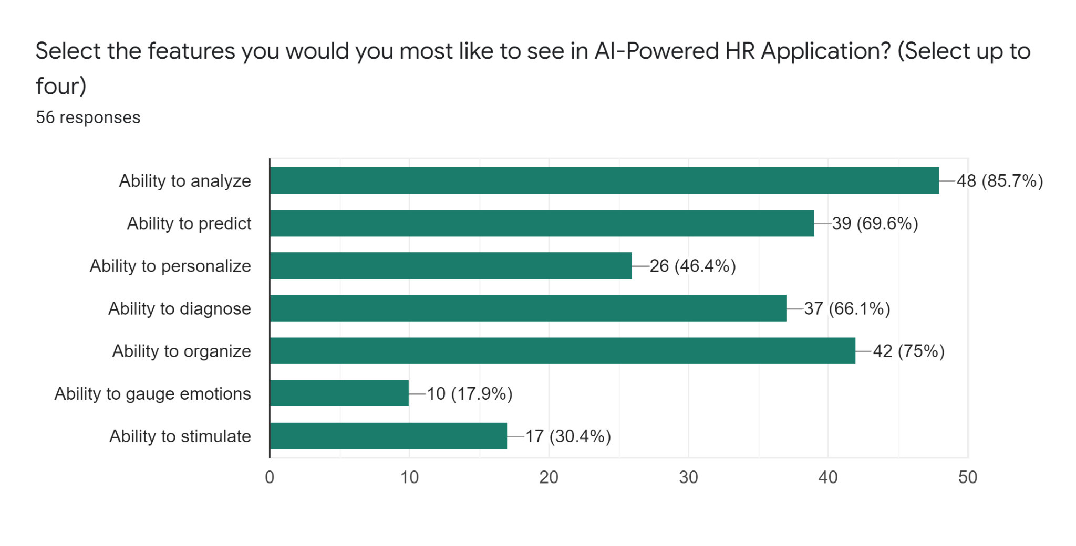INTERPRETATION-
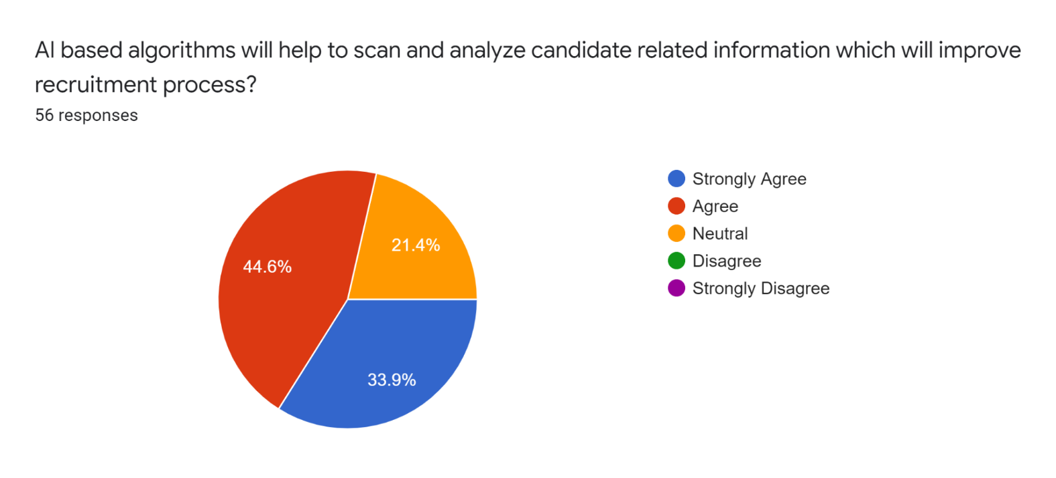
When the respondents were asked about the feature they’d most like to see in an AI- powered application, their top response was the ABILITY TO ANALYZE. The tools designed for HR leaders will help predict, analyze & organize the data for fast decision making and understanding complex data, employee preferences and not repeating tasks.

INTERPRETATION-

INTERPRETATION-

Majority of the respondents feel that AI based algorithms will help in the recruitment process of the organization. This will be ensured by the technology which will briefly study, scan the candidate and according to job preference the best candidate would be selected and enter to the interviewees list.

This will help employees not repeat similar tasks, increase the efficiency of the employees to focus on the more important task and make its decision faster.

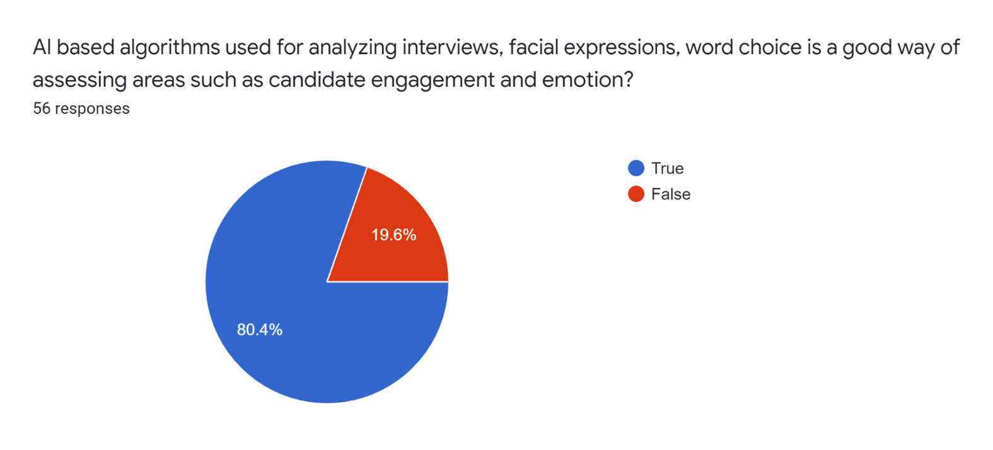

INTERPRETATION-
Most of the respondents feel that AI will help in analyzing interviews, facial expressions and word choice for assessing candidate engagement and emotions.
During video call interviews, the facial expression of the employees will be analyzed so that there will be honest answers and emotions. Companies like Unilever, IBM are already using this technology to avoid biases and create a platform for best candidate selection.
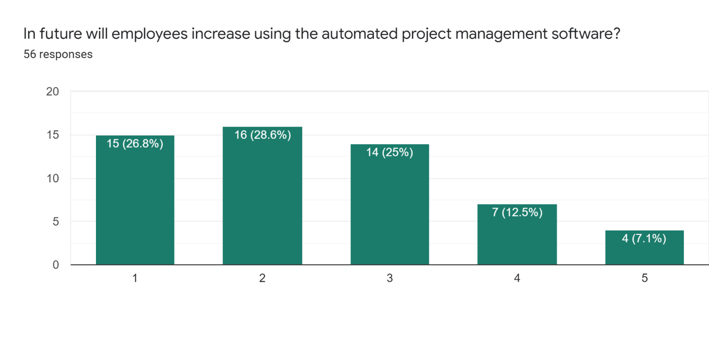

INTERPRETATION-

1-5
Strongly Agree - Strongly Disagree.
The respondents agree that in future the employees will be using the automated project management software. This technology will be a crucial change in the organization towards reducing cost and increasing efficiency of its employees. The automated project management software will help complete basic projects management tasks without intervention. It can plan, organize, and manage resources and develop estimates.

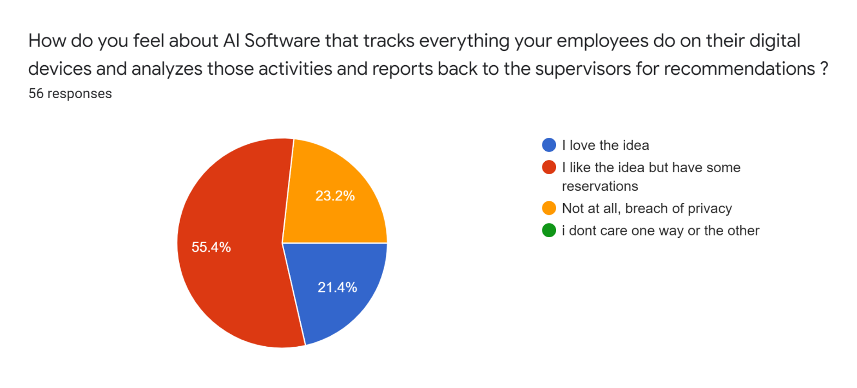

INTERPRETATION-

Most of the respondents like the idea but they have some reservations. The AI software for tracking must be applied to the company laptops phones rather than employees personal gadgets.

This will help their manager or supervisor gather the information and assess the personality, traits and capabilities of the employees and it will also not account for any breach of privacy.

- Conclusion

As we have analyzed through the responses the respondents are aware and are excited to see how Artificial Intelligence will be applied in the field of Human Resources and how it will impact the department when everything will become easy.

By analyzing and figuring out what all the respondents chosen in the questionnaire it becomes clear that -

- The respondents believe that Artificial Intelligence will promote productivity, faster decision making.

- AI will help in not overlapping the activities, no repetition of the tasks and focus on more complex problems.

- In future, the respondents feel that AI will definitely be able to analyze the data, organize it and understand the complex data set.

- The automated project management software should be inculcated in the working HR for fast work, increased productivity and making it easier to focus on different tasks and not only one task.

- Artificial Intelligence used in recruiting, interviewing, analytics and metrics is still one of the functions of HR that AI will boost and provide good outcomes.

- HR professionals need to understand the employees behavior through their facial expression, hand gestures etc., AI should be inculcated for better understanding of emotions and employee engagement and enhancement of performance.

- AI will provide a good feedback system through chatbots software as it will directly connect an employee to its server and the AI will respond and give feedback to the employees.
- The functions of Compensation & Payroll, talent acquisition, Time & attendance will be much easier when AI takes place in these complicated functions for faster decision making and less load.

- The respondents feel that in the near future the AI technology will become more important to their Employee Productivity, learning & development of the employees, strategic planning and the overall HR technology.

- The respondents feel that the AI should not monitor them on a personal level by looking at what they do in their personal devices but they should be monitored by their supervisors on the basis of an AI in their office devices which can track their work and the supervisor can give them feedback.

- There are a number of higher value jobs that are being created in HR due to AI. AI to analyze data, identify top talent, leverage enhanced decision support, and predict success – all in a way that appeals to candidates.

- Persistent challenges, like having the people resources to deliver on the business strategy and allocating financial resources accordingly, can be addressed through the thoughtful application of AI solutions.

The business world is constantly being disrupted. In order to cope with this disruption, businesses need to respond faster to opportunities, and to work in an agile way to stay ahead of competitors.
This means finding an effective way to compete for the skills required to innovate in this new operating environment. AI applications enable HR departments to acquire and develop employee skills in lockstep with shifting market demand.

- Suggestions

In light of these analyses, what step should every organization take?

- Determining where AI can help the HR function most:

The respondents see the greatest potential in analytics and metrics, time and attendance, compensation and payroll, talent acquisition and recruiting. If some of the HR functions are running smoothly there is no need to take the AI- powered option. But if the operations are clunky and inefficient, then it may well be worth seeking out an AI-Powered solution that boosts performance.

- Look for ways to augment employees:

AI-based applications have the potential to dramatically raise the productivity of employees. This is true both within and outside of the HR function. For example, AIs may help healthcare workers diagnose patients more easily or aid financial analysts in spotting important patterns in recent sales data. Although HR professionals can’t possibly keep up with every AI application in every job category, they can become knowledgeable internal consultants on the topic of how to boost employee performance via AI-related technologies and how to estimate potential productivity increases.
- Investigate how the “AI bosses” will influence employees:

As more projects and workflows are “managed” by AIs, employees will be affected in multiple ways, from the establishment of new work processes to the development of new work attitudes. How will this change the need for human contact? Does it increase or diminish social skills and emotional intelligence? Are some types of employees more suited for AI-management than others?HR professionals will need to track these issues and help human managers cope with challenges as they arise.

- Boost HR’s AI IQ:

Few HR professionals believe they are very knowledgeable about using AI to enhance HR, so the first order of business is for more HR professionals to “get up to speed” in the area of AI. This means reading reports and articles, speaking with internal and external experts, attending conferences, tracking trends, and otherwise climbing the AI learning curve.

REFERENCES

- Ahmed, O. (2018). Artificial intelligence in HR. International Journal of Research and Analytical Reviews, 5(4), 971-978.
- Buck, B., & Morrow, J. (2018). AI, performance management and engagement: keeping your best their best. Strategic HR Review.
- Eubanks, B. (2022). Artificial intelligence for HR: Use AI to support and develop a successful workforce. Kogan Page Publishers.
- Guenole, N., & Feinzig, S. (2018). The business case for AI in HR. With Insights and Tips on Getting Started. Armonk: IBM Smarter Workforce Institute, IBM Corporation.
- Gulliford, F., & Dixon, A. P. (2019). AI: the HR revolution. Strategic HR Review.
- He, E. (2018). Can artificial intelligence make work more human?. Strategic HR Review.
- Krithika, J., Venkatraman, P., & Sindhujaa, E. (2019). Virtual HR era in human resource management. EPRA International Journal of Multidisciplinary Research, 5(10), 49-57.
- Nunn, J. (2019). Emerging Impact of AI on HR.
- Papageorgiou, D. (2018). Transforming the HR function through robotic process automation. Benefits Quarterly, 34(2), 27-30.
- Rathi, R. A. (2018). Artificial intelligence and the future of hr practices. IJAR, 4(6), 113-116.
- Tambe, P., Cappelli, P., & Yakubovich, V. (2019). Artificial Intelligence in Human Resources Management: Challenges and a Path Forward. California Management Review, 61(4), 15–42.
- Yano, K. (2017). How artificial intelligence will change HR. People & strategy, 40(3), 42-47.

