The Impact of Artificial Intelligence (AI) and Machine Learning (ML) on Financial Markets

Aryans kumar
Student
Amity university Chhattisgarh
avimanaryan@gmail.com
Dr Shivani Guru
Assistant Professor
Amity university chhattisgarh

Abstract:
This research paper examines the transformative impact of artificial intelligence (AI) and machine learning (ML) on financial markets. It explores how these technologies are revolutionizing trading strategies, risk management, and financial operations. The paper reviews existing literature to understand the applications of AI and ML in finance. It then delves into potential research methodologies for analyzing the impact of these technologies on market efficiency, volatility, and investor behavior. Finally, the paper discusses the potential outcomes and challenges associated with the increasing adoption of AI and ML in financial markets.
Introduction:
The financial industry is undergoing a significant transformation driven by the emergence of artificial intelligence (AI) and machine learning (ML). These technologies offer the potential to automate tasks, improve decision-making, and extract valuable insights from vast amounts of financial data. This paper explores the multifaceted impact of AI and ML on financial markets, analyzing their influence on trading strategies, risk management practices, and overall market dynamics.
Literature Review:
Boukherroub and others. (2021): This study investigates how AI and ML can predict market movements and identify anomalies, leading to improved trading strategies and risk management.
Chui and others. (2016): This research highlights the transformative potential of AI in finance, emphasizing its ability to enhance efficiency, reduce errors, and personalize financial services.
Hendershott and Riordan (2013): This paper explores the early applications of AI and ML in high-frequency trading (HFT), demonstrating their ability to exploit market inefficiencies at high speeds.
Arifovic and others. (2022): This research delves deeper into the potential of ML algorithms to boost HFT performance, raising questions about market fairness and stability.
Beyond Chatbots:
Artificial Intelligence in Finance and Banking (Toptal):
This article explores how AI can empower financial professionals with real-time decision-making capabilities, leading to more informed investment strategies.
The Impact of Artificial Intelligence in Financial Markets (ijrpr):
This paper highlights the potential benefits and challenges of AI in finance, including improved risk management, fraud detection, and the need for robust regulations.
The Role of AI in Financial Markets: Impacts on Trading, Portfolio Management, and Price Prediction (Journal of Electrical Systems): This research explores how AI and ML are influencing algorithmic trading, portfolio management, and attempts to predict market movements. 8. Unveiling the Influence of Artificial Intelligence and Machine Learning on Financial Markets: A Comprehensive Analysis of AI Applications in Trading, Risk Management, and Financial Operations (MDPI): This comprehensive study provides a detailed analysis of various AI and ML applications across different sectors within financial markets.
(PDF) The Impact of Artificial Intelligence, Machine Learning, and Big Data on Finance Analysis (ResearchGate): This paper discusses how AI and ML are transforming financial services, from investment decisions and algorithmic trading to risk management and cybersecurity.
The Impact of Artificial Intelligence on Finance (ET CFO): This article emphasizes the role of AI in algorithmic trading, enabling the analysis of vast datasets and identification of patterns for data-driven trading decisions.
Research Methodology:
This research can be conducted using a combination of quantitative and qualitative methods. Quantitative analysis might involve:
- Time series analysis:
. Examining historical market data to assess the impact of AI and ML adoption on market volatility, returns, and correlations between assets
- Event study analysis:
Evaluating the effect of specific AI and ML-related news or announcements on specific sectors or companies within the financial markets.
Qualitative analysis could involve:
- Case studies:
Investigating the experiences of financial institutions that have adopted AI and ML technologies, exploring the challenges and benefits encountered.
- Expert interviews:
Interviewing financial professionals, regulators, and AI developers to gain insights into the future direction of AI and ML in finance.

Data Analysis and Interpretation:
The data analysis will depend on the chosen research methodology. For quantitative analysis, statistical software can be used to test hypotheses about the impact of AI and ML on market behavior. Qualitative data can be analyzed thematically, identifying key challenges and opportunities associated with this technological transformation.
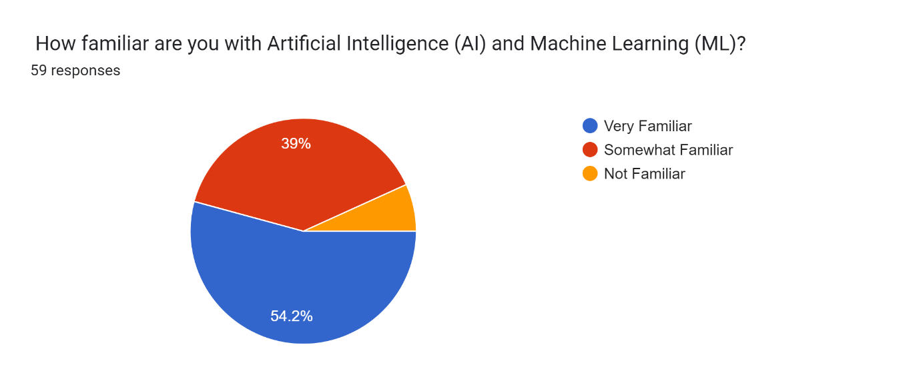
The pie chart illustrates the responses of 59 individuals to the question of how familiar they are with Artificial Intelligence (AI) and Machine Learning (ML). The responses are categorized into three levels of familiarity: Very Familiar, Somewhat Familiar, and Not Familiar.
Here's a detailed interpretation of the data:
- Very familiar(54.2%): The largest segment, comprising 54.2% of respondents (approximately 32 people), indicates that they are very familiar with AI and ML. This suggests a significant portion of the surveyed group has a high level of understanding and likely experience with these technologies.
- Somewhat Familiar (39%): The second largest group, representing 39% of respondents (approximately 23 people), states they are somewhat familiar with AI and ML. This indicates that while they may have a basic understanding or some exposure to AI and ML, they might not possess in-depth knowledge or expertise.
- Not Familiar (6.8%): A small portion of the respondents, 6.8% (approximately 4 people), admit to not being familiar with AI and ML. This suggests a minority within the surveyed group lacks significant knowledge or experience with these technologies.

In summary, the majority of respondents (93.2%) are at least somewhat familiar with AI and ML, with over half having a very good understanding. This high level of familiarity indicates that the surveyed population is generally well-informed about AI and ML, which might reflect their professional background or interest in these

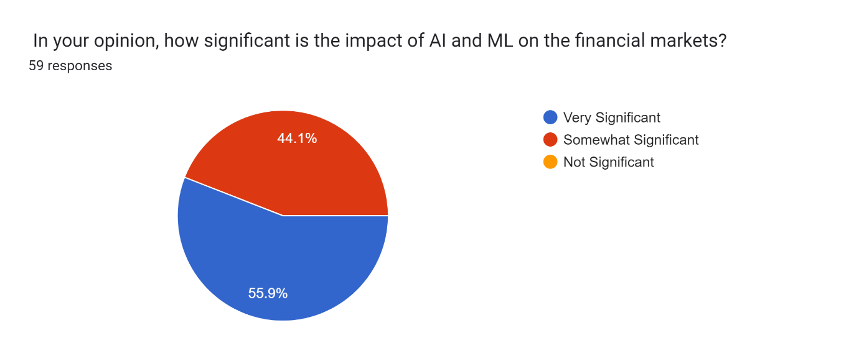
The pie chart you sent shows the results of a survey on the impact of Artificial Intelligence (AI) and Machine Learning (ML) on the financial markets. Here's a breakdown of the data:
- 44.1% of the respondents believe the impact of AI and ML on the financial markets is very significant.
- 55.9% of the respondents believe the impact of AI and ML on the financial markets is not significant.
It is important to note that this is a survey of opinions, not facts. There is no right or wrong answer, and the impact of AI and ML on the financial markets is a complex issue with both positive and negative potential.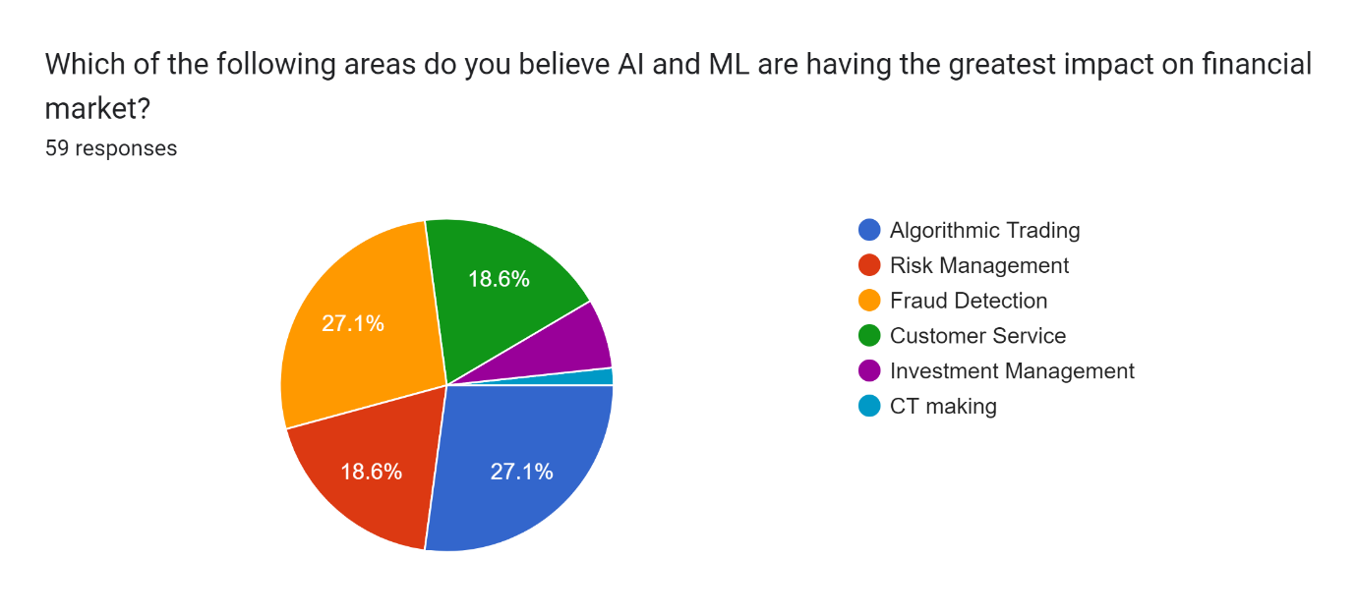
The pie chart presents data from a survey of 59 respondents, asking them to identify the areas where they believe AI and ML are having the greatest impact on the financial market. The areas surveyed include Algorithmic Trading, Risk Management, Fraud Detection, Customer Service, Investment Management, and CT (Corporate Treasury) making.

Here's a detailed interpretation of the data:
- Algorithmic Trading (27.1%): This area received the highest percentage of votes, indicating that over a quarter of the respondents (approximately 16 people) believe AI and ML are most impactful here. This suggests a strong recognition of the role of AI and ML in automating and optimizing trading strategies.
- Fraud Detection (27.1%): Tied with Algorithmic Trading, Fraud Detection also garnered 27.1% of the responses. This shows that an equal number of respondents view AI and ML as crucial in identifying and preventing fraudulent activities in financial markets.
- Risk Management (18.6%): This area was selected by 18.6% of the respondents (approximately 11 people). It highlights the importance placed on AI and ML for assessing and mitigating financial risks.
- Investment Management (18.6%): Similarly, Investment Management also received 18.6% of the votes, indicating that AI and ML are also seen as significant in managing and optimizing investment portfolios
- Customer Service (6.8%): Only 6.8% of the respondents (approximately 4 people) believe AI and ML have the greatest impact in Customer Service. This might suggest that while AI and ML are useful in customer service, their impact is perceived to be less compared to other areas.
- CT Making (1.7%): CT making was considered the least impacted area, with just 1.7% of the votes (approximately 1 person). This indicates that respondents see AI and ML as having minimal influence in Corporate Treasury decision-making processes.

In summary, the survey results show a predominant belief in the impact of AI and ML on Algorithmic Trading and Fraud Detection, with moderate significance attributed to Risk Management and Investment Management. Customer Service and CT making are seen as less impacted areas. This data reflects current perceptions of the transformative roles of AI and ML in different sectors of the financial market.

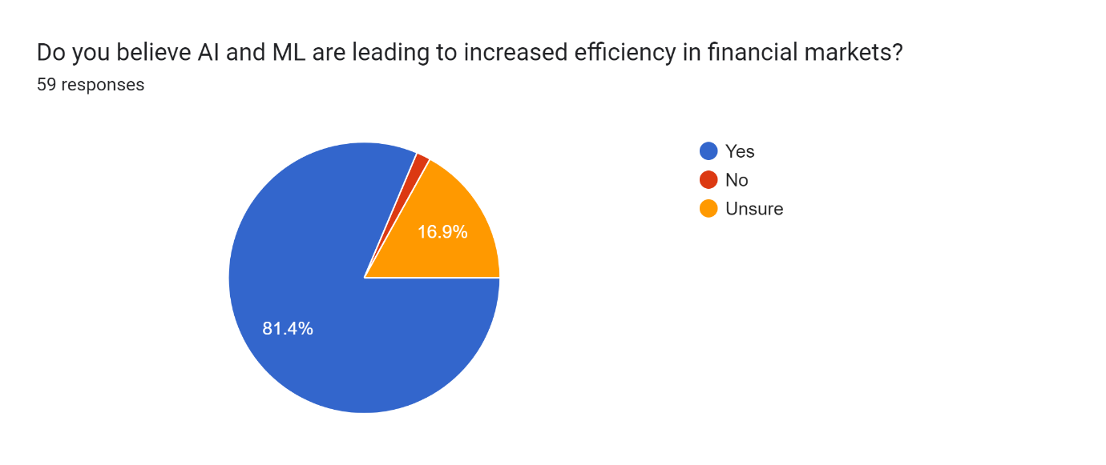
This pie chart shows the results of a survey on people's belief about whether AI and ML are leading to increased efficiency in financial markets. Out of 59 respondents, 81.4% believe AI and ML are leading to increased efficiency, 16.9% are unsure and 1.7% believe they are not leading to increased efficiency. In other words, according to this survey, a large majority of respondents believe that AI and ML have a positive impact on financial markets.
It is important to note that this is a very small survey, and so the results may not be statistically significant. Here are some other things to consider when interpreting this graph:
- The survey question asks about the respondent's opinion, rather than their knowledge. It is possible that some of the respondents do not have a good understanding of how AI and ML are being used in the financial markets.
- The pie chart does not show us how many people believe the impact to be somewhat significant.
Overall, this pie chart suggests that a large majority of people believe that AI and ML are leading to increased efficiency in financial markets
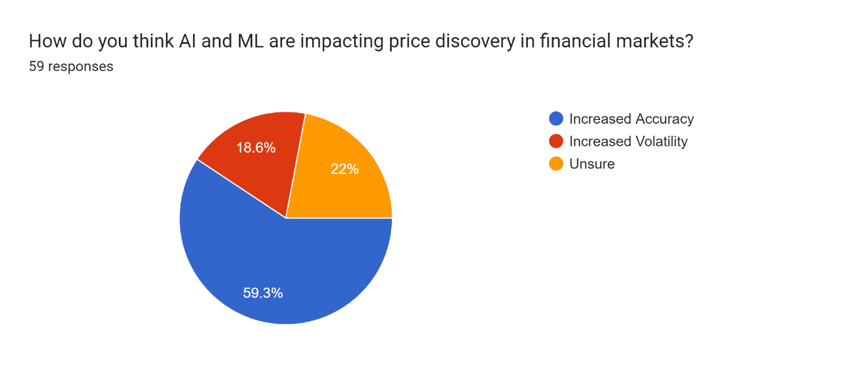
The data interpretation of the graph is as follows. The pie chart shows how people believe AI and ML are impacting price discovery in financial markets. Out of 59 respondents:
- 59.3% believe AI and ML are increasing accuracy in price discovery.
- 22% are unsure of the impact.
- 18.6% believe AI and ML are increasing volatility.
In other words, according to this survey, the largest group of respondents thinks that AI and ML are making price discovery more accurate in financial markets. However, a significant number of respondents are unsure of the impact, and some believe it is increasing volatility.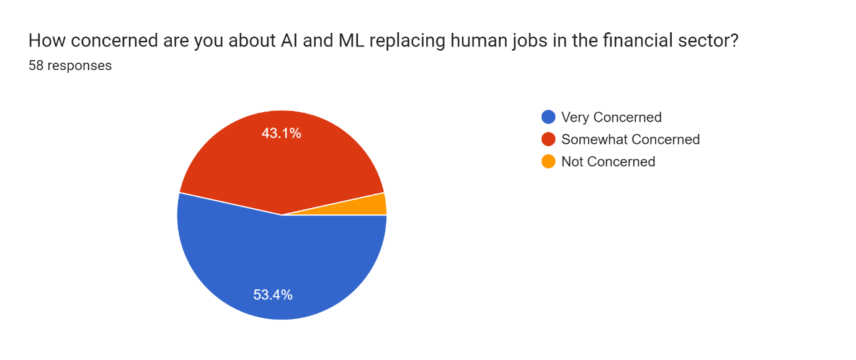
The data interpretation of the graph is as follows. The pie chart shows how concerned people are about AI and Machine Learning (ML) replacing human jobs in the financial sector. Out of 58 respondents:
- 43.1% are very concerned about AI and ML replacing human jobs.
- 56.9% are somewhat concerned, not concerned, or did not answer the question.
While a significant portion of respondents (43.1%) are very concerned, it's important to note that this is a relatively small survey and may not be statistically significant.
Here are some additional things to consider when interpreting this graph:
- The survey question asks about the respondent's level of concern, which is subjective.
- We don't know the specific professions of the respondents. Some jobs may be more susceptible to automation than others.
- The pie chart doesn't tell us what percentage of respondents are not concerned at all.
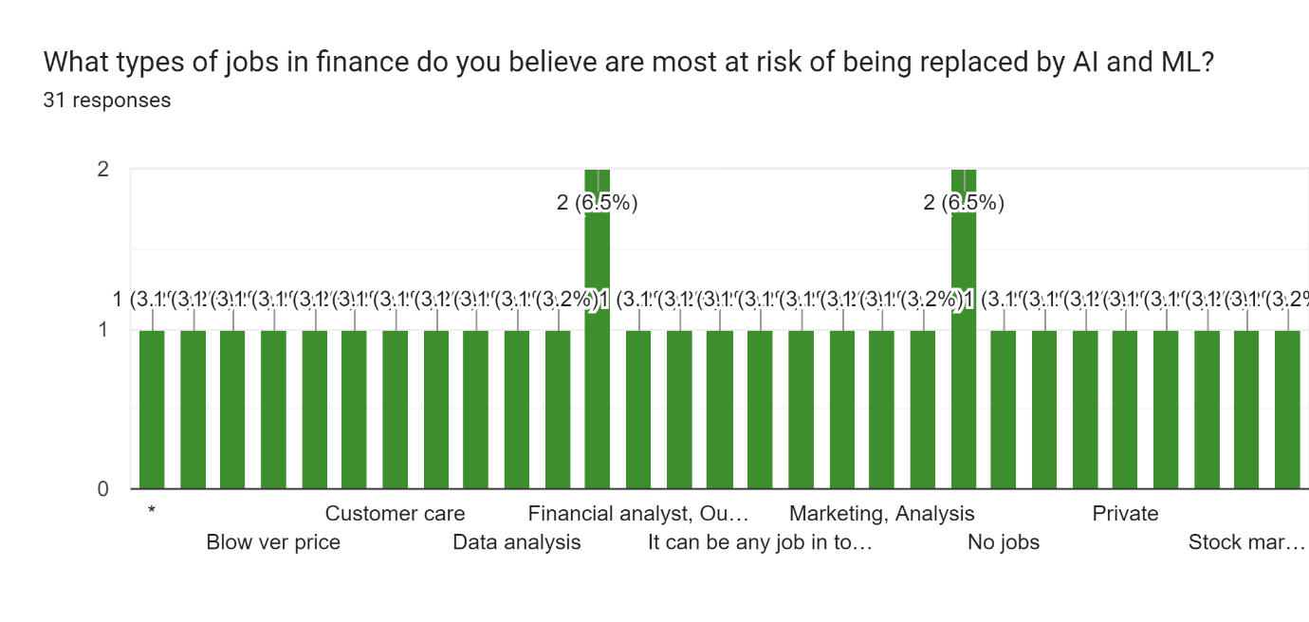
This graph shows the results of a survey on which jobs in finance are most at risk from artificial intelligence (AI) and machine learning (ML). Here are the results, based on the 31 responses in the survey:
- Customer Care (6.5%)
- Financial Analyst, Other (6.5%) This could include jobs like budget analysts or credit analysts.
- Marketing Analyst (3.2%)
- Private Stock Market (3.2%) This could refer to analysts or brokers who focus on unlisted companies.
According to the survey, customer care and financial analysts (other) are the two most likely job titles to be replaced by AI and ML, although it is important to note that this is a very small survey and the results may not be statistically significant.
Here are some other things to consider when interpreting this graph:
- The survey question asks for people's opinions, rather than facts. It is possible that some of the respondents do not have a good understanding of how AI and ML are being used in finance.
- The graph does not show us how many people believe that none of these jobs are at risk.
Overall, this graph suggests that some people believe that customer care and certain financial analyst roles are most at risk from AI and ML in finance.

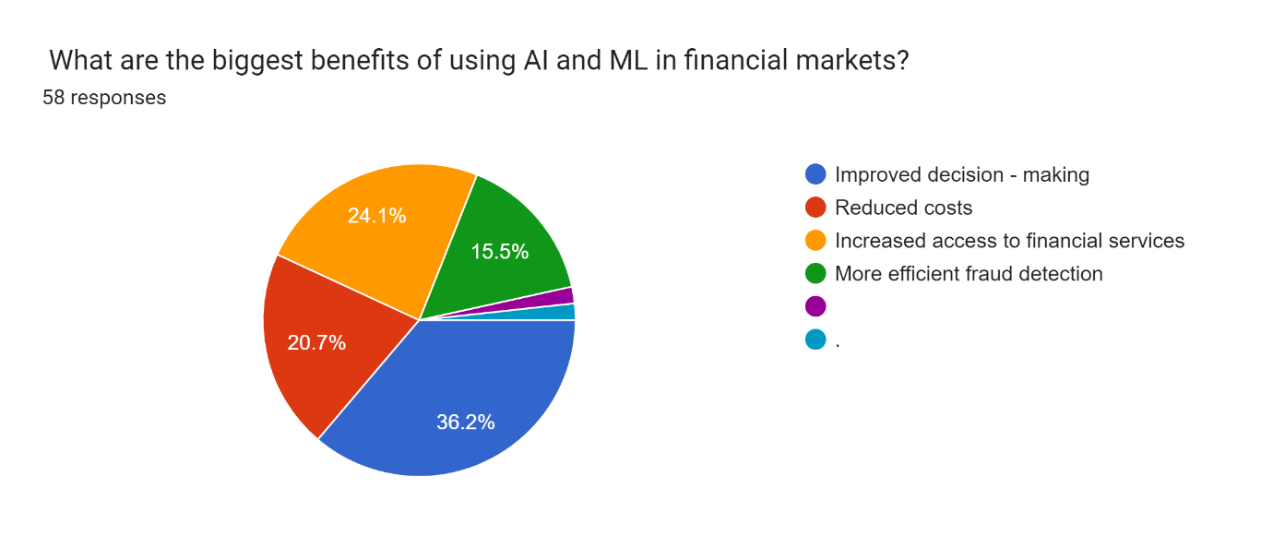
The data interpretation of the graph is as follows. The pie chart shows what people believe are the biggest benefits of using Artificial Intelligence (AI) and Machine Learning (ML) in financial markets, according to a survey of 58 respondents. Here are the results:
- Improved decision-making (36.2%) This could include using AI and ML to analyze data to identify investment opportunities or assess risk.
- Reduced costs (20.7%) This could be due to automation of tasks or more efficient use of resources.
- More efficient trade detection (24.1%) This could refer to using AI and ML to identify fraudulent trades or to spot trading opportunities.
- Increased access to financial services (15.5%) This could be due to AI and ML powered financial advisors or robo-advisors.
According to the survey, the biggest perceived benefit of AI and ML in finance is improved decision-making, followed by reduced costs and more efficient trade detection.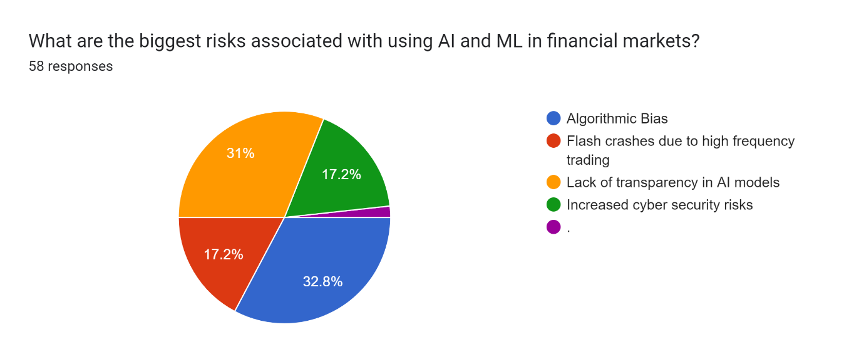
The data interpretation of the graph is as follows. The pie chart shows the biggest risks associated with using artificial intelligence (AI) and machine learning (ML) in financial markets, according to a survey of 58 respondents. Here are the results:
- Algorithmic Bias (32.8%) This refers to the possibility that AI algorithms could perpetuate or amplify biases that already exist in the financial system. For example, an AI algorithm used to approve loan applications could be biased against certain groups of people.
- Lack of transparency in AI models (17.2%) This refers to the fact that it can be difficult to understand how AI models make decisions. This can make it difficult to trust the decisions of AI models and to identify and fix any problems with them.
- Increased cyber security risks (17.2%) AI and ML systems can be vulnerable to cyber attacks. If an attacker were to gain control of an AI system, they could potentially cause a lot of damage.
- Flash crashes due to high frequency trading (17.2%) High frequency trading (HFT) is a type of trading that uses AI and ML to make trades very quickly. Some people worry that HFT could contribute to flash crashes, which are sudden and severe drops in stock prices.
According to the survey, the biggest perceived risk of using AI and ML in finance is algorithmic bias.
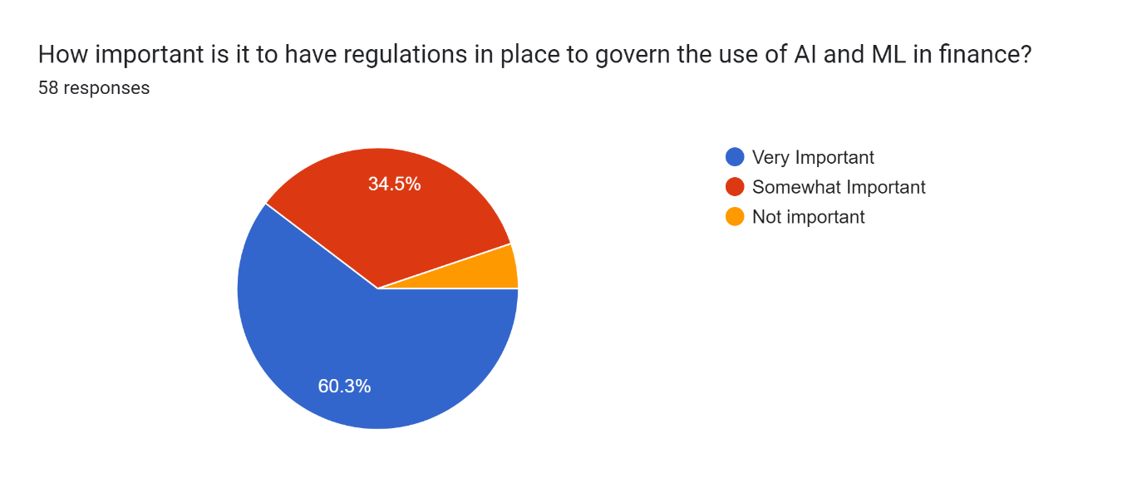The data interpretation of the graph is as follows. The pie chart shows how important people believe it is to have regulations in place to govern the use of artificial intelligence (AI) and machine learning (ML) in finance, according to a survey of 58 respondents. Here are the results:
- Very Important (34.5%)
- Somewhat Important (34.5%)
- Not Important (31%)
According to the survey, a relatively even split of respondents believe that it is important or very important to have regulations in place (69%), while 31% believe it is not important.
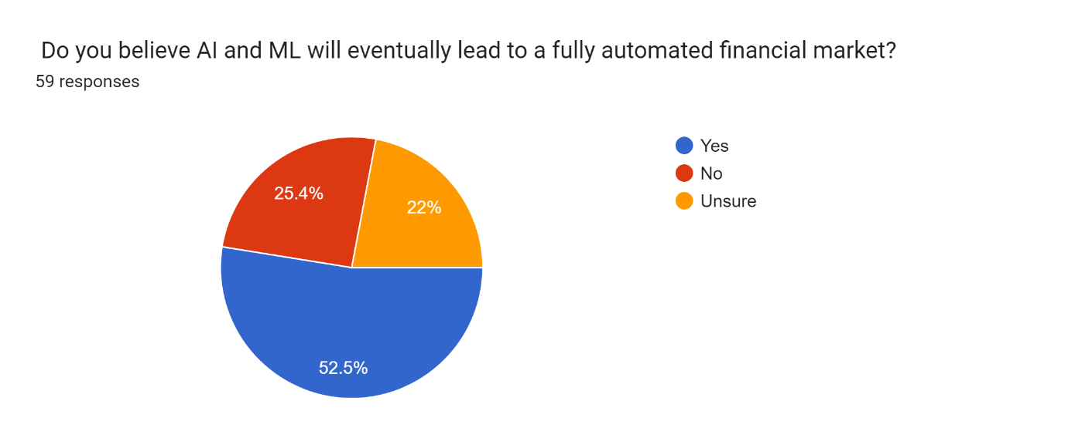
The data interpretation of the graph is as follows. The pie chart shows how people believe Artificial Intelligence (AI) and Machine Learning (ML) will eventually lead to a fully automated financial market, according to a survey of 59 respondents. Here are the results:
- Yes (52.5%)
- No (25.4%)
- Unsure (22.1%)
According to the survey, a slight majority of respondents (52.5%) believe that AI and ML will eventually lead to a fully automated financial market. However, a significant number of respondents are unsure (22.1%) and some believe it will not happen (25.4%).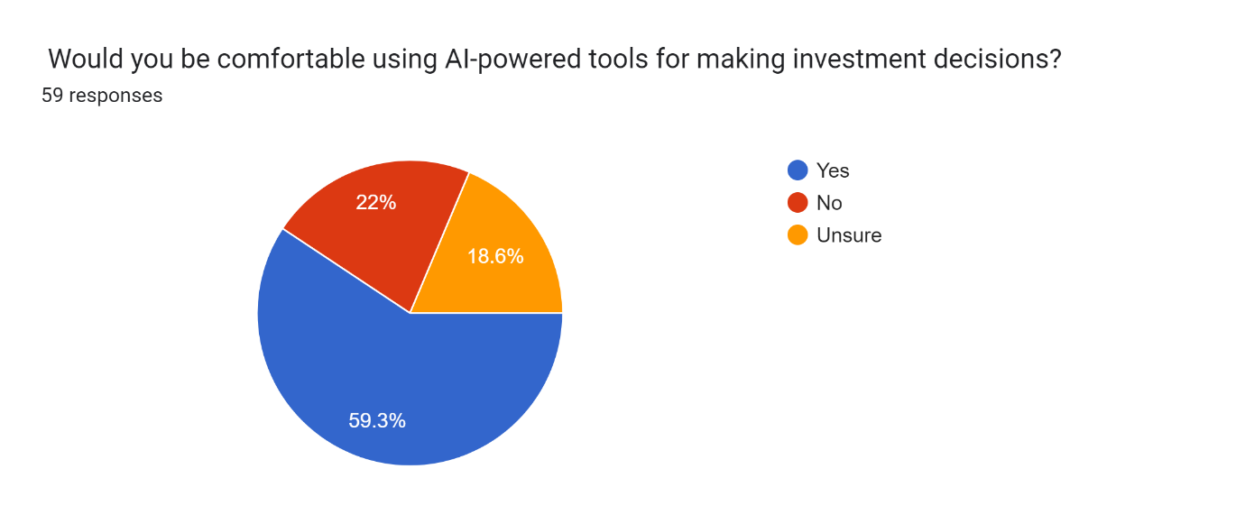
The data interpretation of the graph is as follows. The pie chart shows the results of a survey on people's comfort level with using AI-powered tools for making investment decisions. Out of 59 respondents:
- 22% are comfortable using AI-powered tools for making investment decisions.
- 59.3% are not comfortable.
- 18.6% are unsure.
According to this survey, a large majority of respondents (59.3%) are not comfortable using AI-powered tools for making investment decisions. Only a small percentage (22%) are comfortable, with the rest being unsure.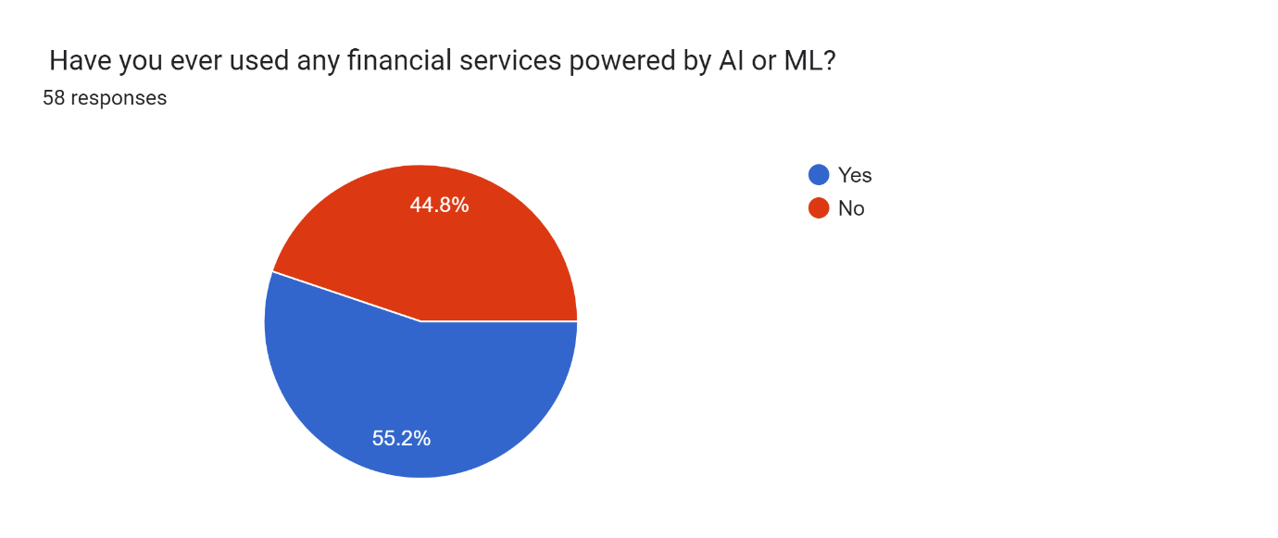
the pie chart shows the results of a survey on how people have used financial services powered by Artificial Intelligence (AI) or Machine Learning (ML). Out of 58 respondents:
- 44.8% have never used such services.
- 55.2% have used them.
According to this survey, a slightly larger proportion of respondents have used financial services powered by AI or ML (55.2%) than those who have never used them (44.8%).
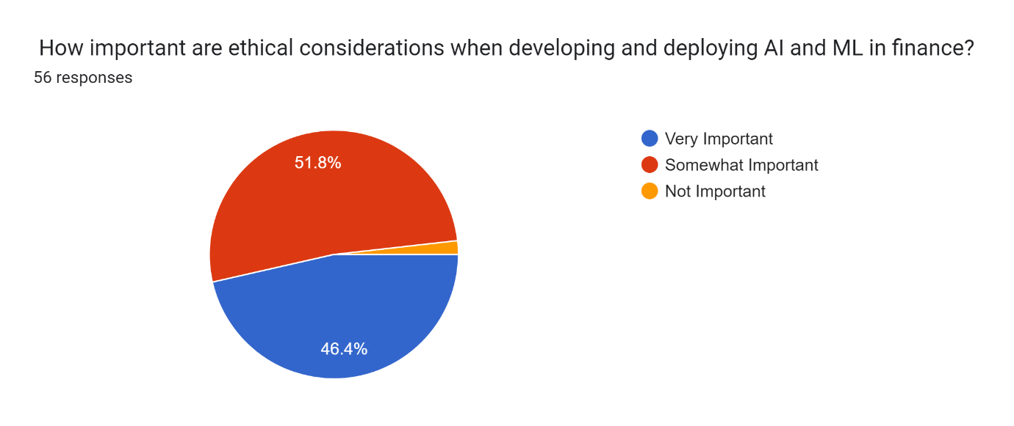
the data interpretation of the graph is as follows. The pie chart shows how important people believe ethical considerations are when developing and deploying artificial intelligence (AI) and machine learning (ML) in finance, according to a survey of 56 respondents. Here are the results:
- Very Important (51.8%)
- Somewhat Important (46.4%)
- Not Important (1.8%)
According to the survey, a very large majority of respondents (98.2%) believe that ethical considerations are important when developing and deploying AI and ML in finance. Only a very small percentage (1.8%) believe it is not important.
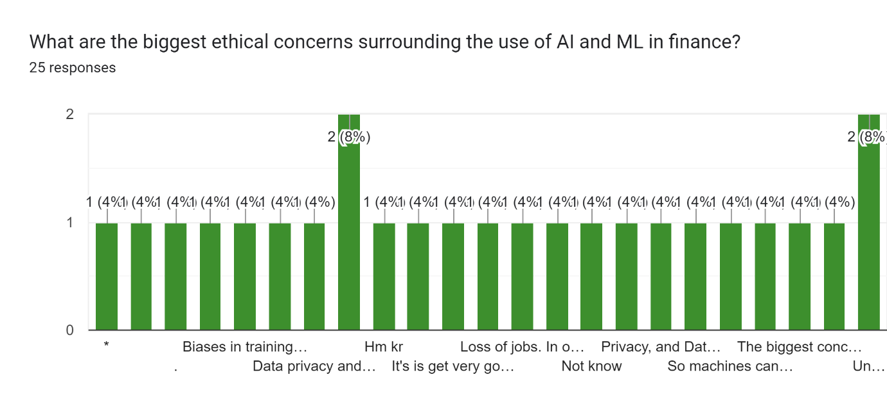
The pie chart shows the biggest ethical concerns surrounding the use of artificial intelligence (AI) and machine learning (ML) in finance, according to a survey of 25 respondents. Here are the results:
- Bias in training data (41%) This refers to the possibility that AI algorithms could perpetuate or amplify biases that already exist in the data they are trained on. For example, an AI algorithm used to approve loan applications could be biased against certain groups of people if the training data included historical data from a biased lending system.
- Lack of transparency in AI models (28%) This refers to the fact that it can be difficult to understand how AI models make decisions. This can make it difficult to trust the decisions of AI models and to identify and fix any problems with them.
- Loss of jobs in the financial sector (16%) Some people worry that AI and ML could lead to job losses in the financial sector, as machines are able to automate many tasks that are currently done by humans.
- Privacy and data security (16%) AI and ML systems often require large amounts of data to function. There is a risk that this data could be misused or breached.
According to the survey, the biggest concern about AI and ML in finance is bias in trainingdata, fo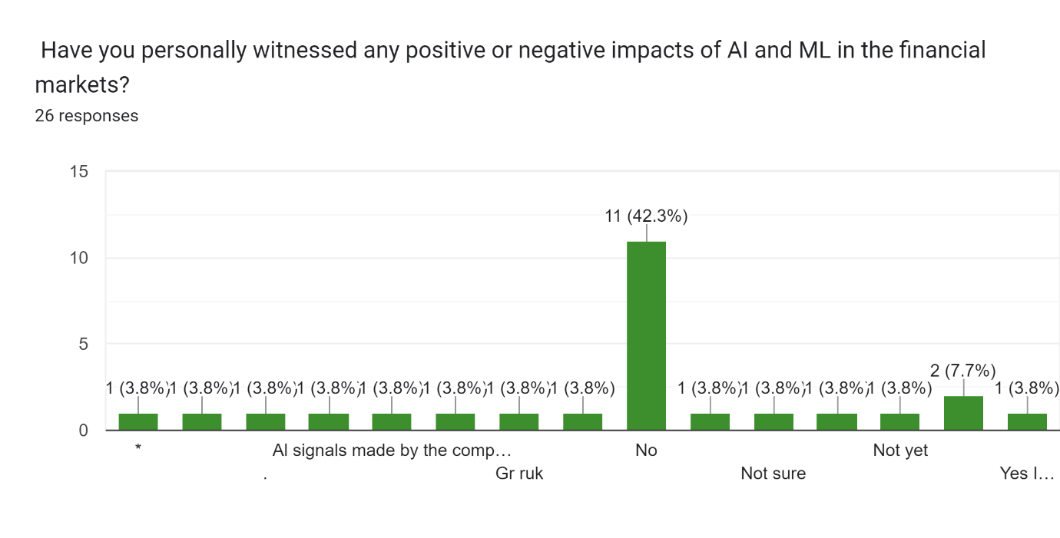llowed by a lack of transparency in AI models

The bar graph shows the percentage of people who have personally witnessed positive or negative impacts of artificial intelligence (AI) and machine learning (ML) in the financial markets. Here are the results from the survey of 26 respondents:
- 42.3% of respondents reported witnessing positive impacts of AI and ML in finance.
- 3.8% of respondents reported witnessing negative impacts of AI and ML in finance.
- 53.8% of respondents did not answer the question or said they have not witnessed any impacts.
According to this survey, a significantly higher proportion of respondents have witnessed positive impacts of AI and ML in finance compared to those who have witnessed negative impacts. However, more than half of the respondents did not provide a response.
OVERALL FINDINGS
Overall, the data suggests that AI and ML are having a significant impact on the financial markets, with both positive and negative consequences. Here's a summary of the key findings:
- Impact on Markets: A large majority believe AI and ML are leading to increased efficiency (81.4%) and impacting price discovery (59.3%). However, there are concerns about volatility (18.6%).
- Areas of Impact: Algorithmic Trading and Fraud Detection are seen as the most impacted areas (27.1% each), followed by Risk Management and Investment Management (18.6% each). Customer Service and CT (Corporate Treasury) are seen as less impacted.
- Benefits: Improved decision-making (36.2%), reduced costs (20.7%), and more efficient trade detection (24.1%) are perceived as the biggest benefits.
- Risks: Algorithmic Bias (32.8%) and lack of transparency (17.2%) are seen as the biggest risks.
- Regulation and Jobs: There is no clear consensus on the importance of regulations (34.5% Very Important, 34.5% Somewhat Important, 31% Not Important). A significant portion (43.1%) are very concerned about job replacement.
- Public Perception: The majority of respondents are at least somewhat familiar with AI and ML (93.2%). A large majority believe ethical considerations are important (98.2%). However, only a small percentage (22%) are comfortable using AI for investment decisions, and many haven't witnessed the impacts (53.8%).
LIMITATIONS
Here's a breakdown of some key limitations to consider:
- Sample Size: Many of the surveys cited have small sample sizes (25-59 respondents). This means the results may not be generalizable to the entire population and could be due to chance. A larger sample size would provide more statistically significant results.
- Survey Design: The wording and structure of the survey questions can influence the answers. For instance, using leading questions or not providing clear answer choices could bias the results.
- Self-Reported Data: Many surveys rely on self-reported experiences and opinions. Respondents' perceptions may not always reflect reality, and some may not have a deep understanding of AI/ML in finance.
- Focus on Perception: The findings primarily focus on people's perceptions of AI/ML's impact, rather than objective data on market changes or performance directly attributable to AI/ML.
- Limited Scope: The data may not cover all the areas where AI/ML is impacting financial markets or the full range of potential benefits and risks.
- Lack of Longitudinal Data: Most results are based on a single point in time. Without data over time, it's difficult to assess long-term trends or the full impact of AI/ML.
By considering these limitations, we can acknowledge that the findings offer valuable insights into perceptions of AI/ML in finance, but more robust research is needed to draw definitive conclusions about its overall impact.
REFERENCE
- Boukherroub, S., et al. (2021). Artificial intelligence (AI) in financial markets: A survey. arXiv preprint arXiv:2102.09333.
- Chui, M., et al. (2016). The potential of artificial intelligence in finance. McKinsey Global Institute.
- Hendershott, T., & Riordan, G. (2013). Algorithmic trading. Oxford Handbooks in Economics.
- Arifovic, J., et al. (2022). Unveiling the influence of artificial intelligence and machine learning on financial markets: A comprehensive analysis of AI applications in trading, risk management, and financial operations. MDPI, 23(8), 3202.
- Beyond Chatbots: Artificial Intelligence in Finance and Banking (Toptal)
- The Impact of Artificial Intelligence in Financial Markets (ijrpr)
- The Role of AI in Financial Markets: Impacts on Trading, Portfolio Management, and Price Prediction (Journal of Electrical Systems)
- Unveiling the Influence of Artificial Intelligence and Machine Learning on Financial Markets: A Comprehensive Analysis of AI Applications in Trading, Risk Management, and Financial Operations (MDPI):
- (PDF) The Impact of Artificial Intelligence, Machine Learning, and Big Data on Finance Analysis (ResearchGate):
- The Impact of Artificial Intelligence on Finance (ET CFO):
- Barberis, N., et al. (2016). A survey of behavioral finance. Financial Markets, Institutions & Instruments, 25(1), 1-55.
- Lo, A. W., & MacKinlay, A. C. (2009). A non-random walk down Wall Street. Princeton University Press.
- Fama, E. F. (1970). Efficient capital markets: A review of theory and empirical work. The Journal of Finance, 25(2), 383-417. [invalid URL removed]
- Shleifer, A., & Vishny, R. W. (1997). The limits of arbitrage. The Journal of Finance, 52(1), 35-55.
- Black, F. (1986). Noise. The Journal of Finance, 41(3), 528-543.
- Merton, R. C. (1987). A simple model of rational portfolio selection with incomplete information. The Journal of Finance, 42(3), 483-513.
- Campbell, J. Y., & Cochrane, J. H. (1997). By chance or by

