INTELLIGENT VEHICLE DAMAGE ASSESSMENT AND COST ESTIMATOR

PAVITHRA G SREE DEVI K
Department of CSE, Department of CSE,
AVS Engineering College, Salem AVS Engineering College, Salem pavithragrpn2002@gmail.com sree44342@gmail.com

PRIYADHARSHINI R
Department of CSE,
AVS Engineering College, Salem
ashokpriya0327@gmail.com

ABSTRACT - In this paper, based on the demand of automobile insurance claims and intelligent transportation, combined with abundant basic data and advanced machine vision algorithm, an intelligent damage determination system of ‘Artificial Intelligence + Vehicle Insurance’ is constructed. This paper first introduces the functions of the intelligent damage assessment system. Secondly, it discusses the realization path of each functional module in detail, and finally puts forward the vision for the future.

INTRODUCTION
ARTIFICIAL INTELLIGENCE- Artificial Intelligence, the ability of a digital computer or computercontrolled robot to perform tasks commonly associated with intelligent beings. The term is frequently applied to the project of developing systems endowed with the intellectual processes characteristic of humans, such as the ability to reason, discover meaning, generalize, or learn from past experience.

MACHINE LEARNING- Machine learning is the scientific study of algorithms and statistical models that computer systems use to effectively perform a specific task without using explicit instructions, relying on patterns and inference instead. It is seen as a subset of artificial intelligence. Machine learning algorithms build a mathematical model of sample data, known as "training data", in order to make predictions or decisions without being explicitly programmed to perform the task. Machine learning algorithms are used in a wide variety of applications, such as email filtering, and computer vision, where it is infeasible to develop an algorithm of specific instructions for performing the task. Machine learning is closely related to computational statistics, which focuses on making predictions using computers.

DEEP LEARNING- Deep learning (DL) is a machine learning technique that teaches computers to do what comes naturally to humans: learn by example. Deep learning is a key technology behind driverless cars, enabling them to recognize a stop sign, or to distinguish a pedestrian from a lamppost. It is the key to voice control in consumer devices like phones, tablets, TVs, and hands-free speakers. Deep learning is getting lots of attention lately and for good reason. Its achieving results that were not possible before.In deep learning, a computer model learns to perform classification tasks directly from images, text, or sound. Deep learning models can achieve state-of-the- art accuracy, sometimes exceeding human-level performance. Models are trained by using a large set of labeled data and neural network architectures that contain many layers

IMAGEPROCESSING & OVERVIEW- Image processing is a way to perform such procedures on a photo, to produce an optimized image or to retrieve useful information from the image. It is a form of processing of the signal in which the input is in the format of an image and the output can be an image or features of the image. Image processing nowadays is one of the fast-growing technologies. The foregoing are the three stages of the image processing process: • Image extraction by way of photo retrieval tools; • Image review and manipulation;

LITERATURE SURVEY

PAPER-I
TITLE: Vehicle-Damage-Detection Segmentation Algorithm Based on Improved Mask RCNN - Qinghui Zhang et al, 2020
Technology used: Mask RCNN, Deep learning. Methodology: In the work described in this paper, a detection algorithm based on deep learning for vehicle-damage detection is used to deal with the compensation problem in traffic accidents and based on the Mask RCNN model.

PAPER-II
TITLE: Research on intelligent vehicle damage assessment system based on computer vision - Zhu Qianqian et al, 2020
Technology used: Deep learning, computer vision, R-CNN.
Methodology: In this paper, based on the demand of automobile insurance claims and intelligent transportation, combined with abundant basic data and advanced machine vision algorithm - Deep learning, computer vision, Faster R-CNN

PAPER-III
TITLE: Car damage detection and classification - Phyu Mar Kyu et al, 2021
Technology used: CNN, VGG16, VGG19
Methodology: In this paper, we apply deep learning-based algorithms, VGG16 and VGG19, for car damage detection and assessment in real-world datasets. The algorithms detect the damaged part of a car.

PAPER-IV
TITLE: Automatic Car Damage Assessment System: Reading and Understanding Videos as Professional Insurance Inspectors - Wei Zhang et al, 2020
Technology used: Fast –RCNN, Deep learning. Methodology: In this paper, there are methods that formulate damage assessment as an image content analysis problem. Image classification utilized by cannot handle tiny dam- ages and multiple damaged components effectively.

PAPER-V
TITLE: A Unified Framework of Intelligent Vehicle Damage Assessment based on Computer Vision technology - Xianglei Zhu et al, 2019
Technology used: Computer vison, Artificial Intelligence. Methodology: In this paper, a framework of intelligent vehicle damage assessment formula supported object detection technology and image classification technology is planned. This formula will mechanically determine the damage position, type and degree per photos provided by users, so as to offer applicable maintenance value and reach the accuracy that can meet actual application needs.

PAPER-VI
TITLE: Deep learning based car damage classification and detection - Hashmat Shadab Malik et al, 2020
Technology used: CNN, YOLO.
Methodology: In this paper, the recent advances in computer vision largely due to the adaptation of fast, scalable and end to end trainable convolutional neural networks (CNN) makes it technically feasible to recognize vehicle damages using deep convolutional networks.

DRAWBACKS IN EXISTING SYSTEM

• Large dataset requirements
• Complexity of the model
• Limited dataset

PROPOSED METHODOLOGY

• The aim of this project is to build a VGG16 model that can detect the area of damage on a car.

• The rationale for such a model is that it can be used by insurance companies for faster processing of claims if users can upload pics and the model can assess damage( be it dent scratch from and estimates the cost of damage especially for a used car and bikes.

ADVANTAGES

• Cost efficiency
• Scalability
• Time efficiency
• Accuracy

WORKFLOW DIAGRAM

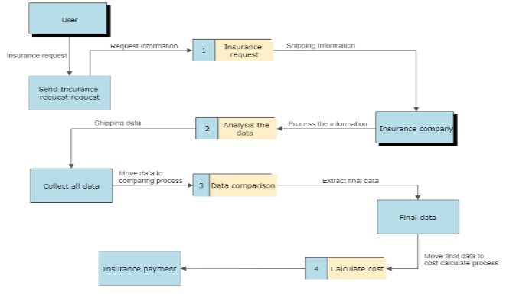

SYSTEM SPECIFICATION

HARDWARE REQUIREMENTS: Processor , Minimum 2GB RAM, Graphics card

SOFTWARE REQUIREMENTS: Windows OS 7 -32 bit and above, Python, VS Code
MODULES

• Data pre-processing module
• Classification module
• Post processing module
• Training module
• Prediction module

MODULE DESCRIPTION

1. Data pre-processing module - This module may be used to remove noise, normalize the image size and enhance the contrast of the input image.

2. Classification module - This module may use Machine Learning Algorithms, such as Support Vector Machines (SVMs) or Convolutional Neural Networks (CNNs) to classify the input image into several predefined classes.

3. Post processing module - This module may be used to improve the classification results by performing operations such as smoothing, noise reduction and character segmentation.

4. Training module - This module may be used to train the classification module using a set of labelled training data.

5. Evaluation module - This module may be used to evaluate the performance of the recognition system using metrics, precision and recall

RESULT AND DISCUSSION

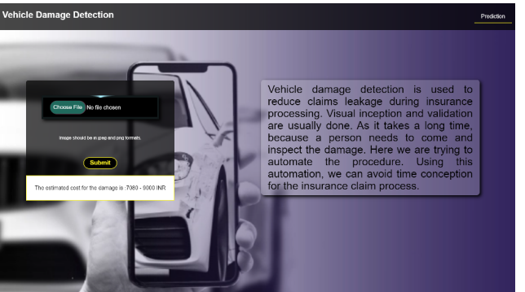

CONCLUSION AND FUTURE ENHANCEMENT

● In our project, we explore the innovation of insurance technology of “AI +Vehicle Insurance”. We can use the power of intelligent damage determination system. On the one hand, the owner can take photos by one click to achieve rapid loss determination, price estimation and immediate compensation.

● AI and its related technologies will have a seismic impact on all aspects of the insurance industry, from distribution to underwriting and pricing to claims. Advanced technologies and data are already affecting distribution and underwriting, with policies being priced, purchased, and bound in near real time

REFERENCES

1.Qianqian, Zhu, et al. "Research on intelligent vehicle damage assessment system based on computer vision." Journal of Physics: Conference Series. Vol. 1518. No. 1. IOP Publishing, 2020.

2.Tan, Hong, et al. "Automatic emergency braking (AEB) system impact on fatality and injury reduction in China." International journal of environmental research and public health 17.3 (2020): 917.

3.Zhang, Wei, et al. "Automatic Car Damage Assessment System: Reading and Understanding Videos as Professional Insurance Inspectors." Proceedings of the AAAI Conference on Artificial Intelligence. Vol. 34. No. 09. 2020.

4.Kyu, Phyu Mar, and KuntpongWoraratpanya. "Car damage detection and classification." Proceedings of the 11th international conference on advances in information technology. 2020.

5.Zhu, Xianglei, et al. "A unified framework of intelligent vehicle damage assessment based on computer vision technology." 2019 IEEE 2nd International Conference on Automation, Electronics and Electrical Engineering (AUTEEE). IEEE, 2019.

6.Dhieb, Najmeddine, et al. "A very deep transfer learning model for vehicle damage detection and localization." 2019 31st International Conference on Microelectronics (ICM). IEEE, 2019.

7.Patil, Kalpesh, et al. "Deep learning based car damage classification." 2017 16th IEEE international conference on machine learning and applications (ICMLA). IEEE, 2017.

