A METAMATERIAL SLOTTED PATCH ANTENNA WITH
METASURFACE

Sivasankari Narasimhan
Department of ECE,
Mepco Schlenk Engineering College, Anna University
Chennai,Tamilnadu, India
sivasankari2015@mepcoeng.ac.in
Jeya Boomika Nathan
Department of ECE,
Mepco Schlenk Engineering College, Anna University
Chennai,Tamilnadu, India
boomikanathan23@gmail.com
Kiruthika Ravichandran
Department of ECE,
Mepco Schlenk Engineering College, Anna University
Chennai,Tamilnadu, India
kiruthikaraji19@gmail.com

Abstract—In this project, a novel, compact, high-gain, directive, and superstrate configuration-based metasurface (MS) antenna has been designed, which incorporates a fractal-shaped slotted patch having a periodic arrangement of square patches along with a shorting via at its center and a couple of rectangular slots in the ground plane. The MS is designed over the FR4 dielectric by introducing a periodic arrangement of unit cells in which the unit cell is structured by a S-type patterned patches. The MS is separated by a layer from the conventional patch antenna designed over the FR4 dielectric, thereby acting as a superstrate. The proposed antenna provides good impedance matching across the frequency region of 10.14–10.94 GHz with a unidirectional radiation pattern. A maximum return loss of -18.4dB have been realized at 10.2GHz. As the proposed antenna is more efficient, it can be promoted for X-band operations, such as satellite communication, defense purpose, and medical supervision.

Keywords— Metasurface (MS), microstrip, slotted fractal patch, superstrate.

Introduction
A metamaterial slotted patch antenna is a type of antenna that combines a slotted patch as the radiator and a metasurface as a superstrate. The metasurface, which consists of sub-wavelength resonators, is designed to manipulate the electromagnetic wave path, thereby enhancing the radiation performance of the antenna. This design offers high-gain, low-profile, and wideband performance, making it suitable for various applications such as communication, radar, and sensing. The metasurface's parameters, like the geometrical shape, size, and orientation of the meta-atoms, can be tuned to adjust the antenna's operating frequency and polarization. Although the design process is more complex and may require advanced simulation tools and potentially higher costs, the metamaterial slotted patch antenna's enhanced performance makes it an attractive option in modern technology.
.

DESIGN PROCEDURE
The proposed antenna design has been designed and simulated using ANSYS HFSS software. The metamaterial antenna design specifications are discussed below. The step by step procedure for designing the antenna is given below.

CREATING A MODEL OR GEOMETRY
BOTTOM LAYER
The designed antenna accumulates with a square patch arranged in a fractal manner, where the shorting via is in the center of the patch and an array of square patches are arranged in a regular manner on top of the patch. Dual-rectangular shaped slots have been established on the ground surface to enhance the impedance bandwidth of the antenna. The primary radiating element and the bottom layer of the antenna are separated by a 1.6 mm thick FR4 dielectric layer.This layer is shown in the Figure 1.

TOP LAYER
An MS was used in the structure by combining a periodic arrangement of unit cells in which the unit cell is composed of a concentric S-type patterned patch significantly improve the gain of the antenna. The MS layer is also organized on the FR4 dielectric with a thickness of 0.8 mm. Moreover, the conventional patch and the MS layer have been separated by a 6 mm thick air substrate.The designed antenna works in the X-band region in which the operational band can be tuned by just adjusting the location of the shorting via and dimensions of the periodic slots.This layer is shown in the Figure 2.

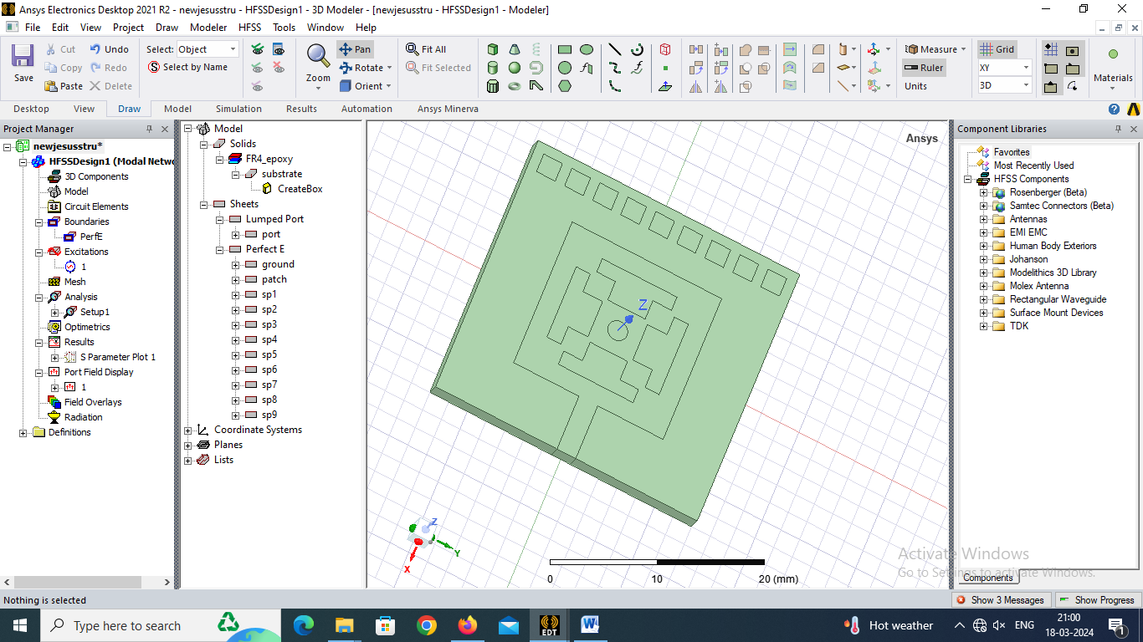
Figure 1: Bottom layer of the proposed structure
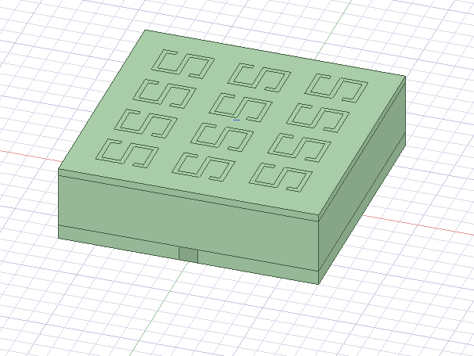 Figure 2: Top view of the proposed structure

Assignment of boundary
The next step is assigning the boundaries to the antenna structure. The open model in HFSS can be created by assigning the radiation boundaries. While simulating an antenna, the radiation boundary should be positioned in such a way, that it is quarter the wavelength away from the surface of radiation is shown in the fig 3. Assignment of boundary to the antenna structure is much essential as it have direct impact on the result provided by the HFSS software.

Assignment of excitation
The excitations or ports needs to be connected after the assignment of boundaries gain this assignment of ports also plays a vital role. The antenna result provided by the HFSS software greatly depends on the assignment of excitations or ports. Hence it is highly recommended that the user needs to take intensive care while assigning the excitations. While assigning excitations care should be taken in assigning the direction to the port is shown in the fig 4.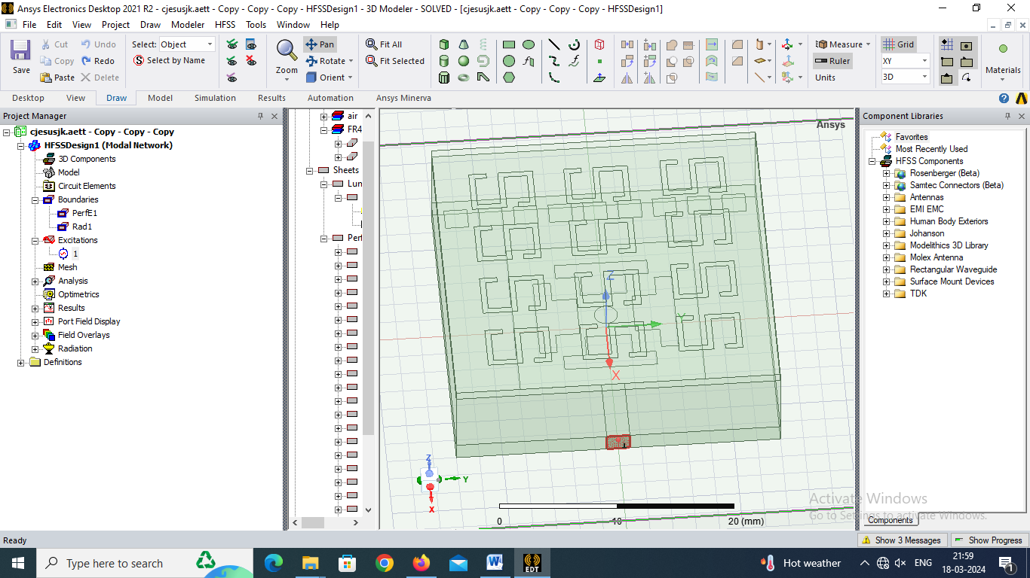

Fig 3: Boundary assignment

Fig 4 :Excitation assignment to the microstrip feed.

SIMULATON RESULTS

- Return Loss
Return loss is a crucial parameter that measures the efficiency of power transmission between the antenna and the transmission line. It is defined as the ratio of power reflected from the antenna to the power transmitted into the antenna, usually expressed in decibels (dB). A low return loss indicates that most of the power is being transmitted into the antenna, with minimal reflection back towards the source.
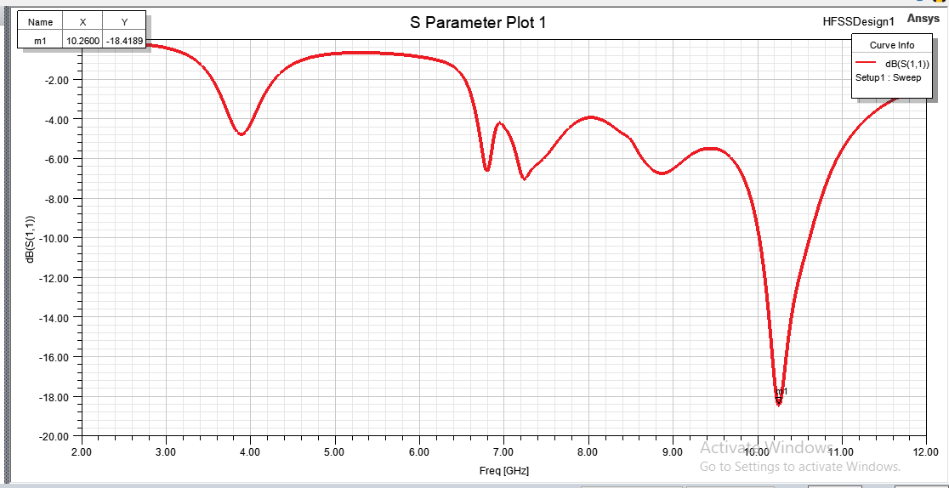
Fig 5: From this graph we have inferred that the return loss is -18.4dB which is obtained at the frequency of 10.2GHz.
- VSWR
VSWR stands for Voltage Standing Wave Ratio. It is a measure used in radio frequency (RF) engineering to quantify how efficiently radio frequency power is transmitted from a power source, such as a transmitter, to a load, such as an antenna or a transmission line.
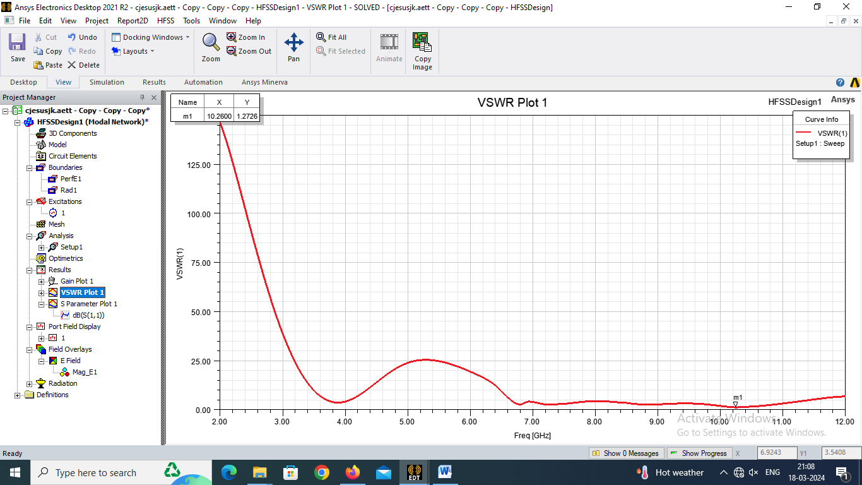
Fig 6: The standing wave ratio is obtained at 10.2Hz as 1.27726.
- E-Plane AND H-Plane
The E-field pattern represents the distribution of the electric field surrounding the antenna. It shows the intensity and direction of the electric field vectors at various points in space around the antenna.
The H-field pattern depicts the distribution of the magnetic field surrounding the antenna. Similar to the E-field pattern, it shows the intensity and direction of the magnetic field vectors at different points in space around the antenna.
Both the field patterns provides insights about the antenna's radiation characteristics, including its polarization, directivity, and radiation efficiency.

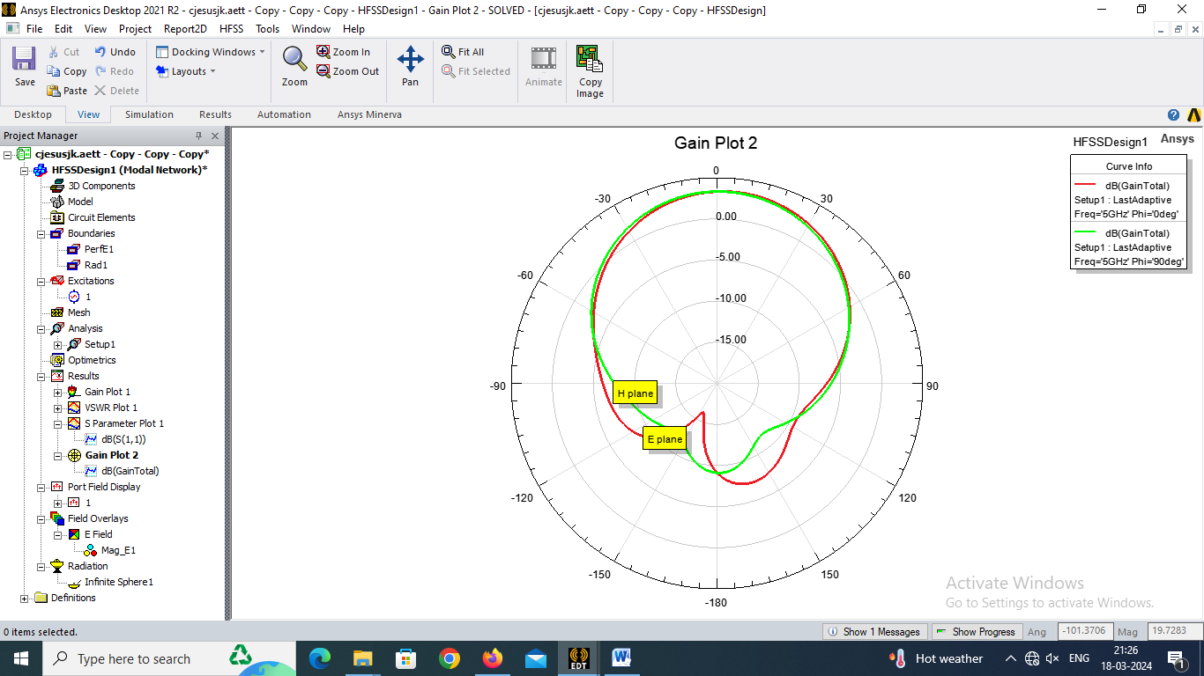

Fig7:The E plane and H plane radiation pattern mearurements of the designed antenna is given above.

- Radiation pattern
A radiation pattern is a graphical representation or description of how the antenna radiates electromagnetic energy into space. It illustrates the directional characteristics of the antenna, showing how much power is radiated in different directions relative to the antenna's orientation.
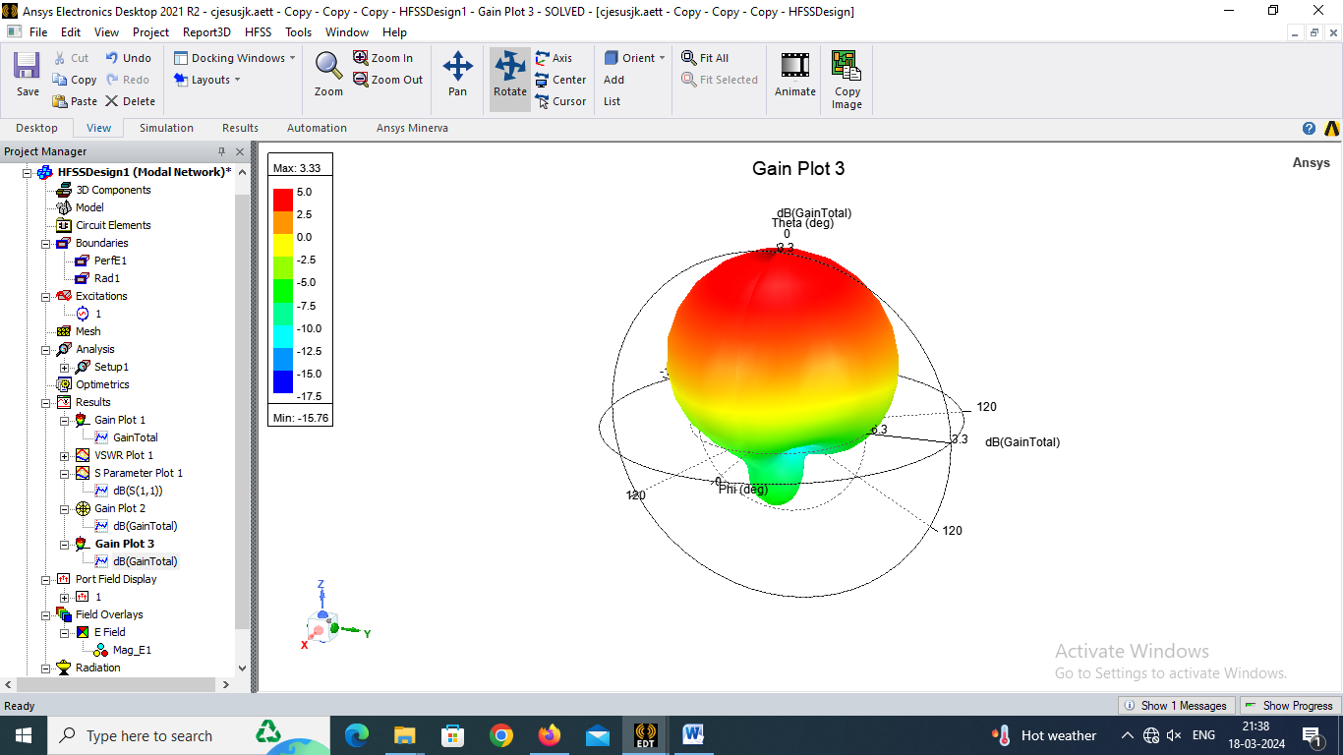

Fig 8: 3-D radiation pattern of the proposed antenna

- Field distribution

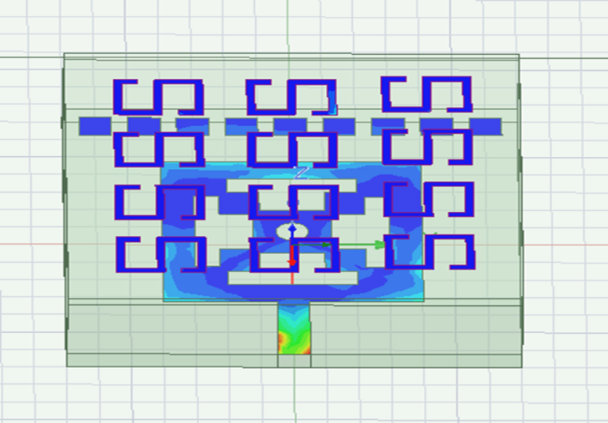
Fig 9:Field Distribution of the proposed structure

ANTENNA PARAMETER ANALYSIS

PARAMETERS | VALUES
U(mW/Sr) | 26.101
P_{rad} (mW) | 69.896
D | 4.6926
G | 2.153
Efficiency | 0.45881
Front to Back ratio | 32.617

- COMPARISON

Antenna literature | Fr | S11 | D | Efficiency
Diptiranjan et al. [1] | 10.44GHz | -26dB | 7.57dB | 87.66%
F. H. Lin et al. [2] | 14.2GHz | 17.3dB | 7.6dB | 70.8%
T.Sleasman et al.[3] | 10.44GHz | -26dB | 7.57dB | 87.66%
Zheng et al.,[4] | 17.5GHz | 9dB | 6.57dB | 81.7%
Proposed | 10.2GHz | -18.4dB | 3.33dB | 45.88%

- CONCLUSION

The metamaterial slotted patch antenna combines metamaterial structures with traditional designs, promising enhanced performance in wireless communications. Offering wider bandwidth, higher gain, and increased directivity, it suits applications like satellite communications and radar systems. In our implementation using air material, we achieved a high gain of 2.153 dB and a return loss of -18.4 dB at a resonant frequency of 10.2 GHz, validating its potential for practical use.

REFERENCE

- Diptiranjan Samantaray and Somak Bhattacharyya, “A Gain-Enhanced Slotted Patch Antenna Using Metasurface as Superstrate Configuration,” Sci. Rep., vol. 6, no. 1, pp. 1–8, May 2016.
[2] F. H. Lin and Z. N. Chen, “Low-profile wideband metasurface antennas using characteristic mode analysis,” IEEE Trans. Antennas Propag., vol. 65, no. 4, pp. 1706–1713, Apr. 2017.
[3] Y. Zheng et al., “Wideband gain enhancement and RCS reduction of Fabry–Pérot resonator antenna with chessboard arranged metamaterial superstrate,” IEEE Trans. Antennas Propag., vol. 66, no. 2, pp. 590–599, Feb. 2018
[4] T. Sleasman et al., “Experimental synthetic aperture radar with dynamic metasurfaces,” IEEE Trans. Antennas Propag., vol. 65, no. 12, pp. 6864–6877, Dec. 2017.

