ABSTRACT
RFID - Radio-Frequency Identification technology offers an automated wireless solution for attendance tracking. This system replaces traditional methods with a more efficient and time-saving approach. It utilizes two key components: an RFID tag (often a card) carried by individuals and an RFID reader that captures data from the tags.
Implementing RFID technology streamlines attendance management for authorities. The proposed system, demonstrated through a functional prototype, proves the effectiveness of RFID automation in simplifying attendance logistics.
The system's design is characterized by its simplicity, cost-effectiveness, and adaptability, making it a strong candidate for both commercial and academic applications.
Keywords: RFID, Attendance Management, Automation

I.INTRODUCTION
Radio Frequency Identification (RFID) technology is rapidly gaining traction across various sectors, including industries, offices, transportation, and agriculture. In educational and working institutions, the traditional way of manual attendance marking can be tedious and inefficient. However, RFID technology offers a promising solution to address this challenge.
RFID is an automated identification system that allows for contactless data retrieval and storage on RFID/NFC tags [1]. An RFID system typically consists of an MFRC reader, tags, a database for storing collected data, and electronic components that facilitate communication.
Enhancing Attendance Management with RFID
An RFID-based attendance system can store unique identification numbers of students or employees. This user-friendly system has commercial applications and aims to:
- Identify authorized individuals entering a designated area.
- Record their attendance data, including the date and time of entry.
- Store data initially on an internal memory for backup purposes.
- Finally, transfer the data to a more permanent storage like EEPROM (Electrically Erasable Programmable Read-Only Memory).
The system integrates h/w and s/w components to achieve these objectives. The MFRC reader serves as the hardware component responsible for capturing user attendance. Each user is assigned a unique RFID tag, and their attendance records are maintained within the system.
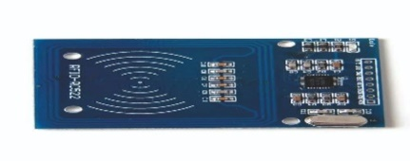
Fig. 1.MFRC reader and cards
II. LITERATURE REVIEW
Several studies have explored the potential of RFID technology. For instance, a 2013 system design by Zhang Yuru, Chen Delong, and Tan Liping utilized RFID-based hardware nodes to demonstrably enhance productivity and minimize resource waste [2].
Existing literature acknowledges the vast potential of RFID systems, opening doors to previously unimaginable applications [3]. These studies delve into the technology's evolution and the roles of its individual components.
The use of object counters within RFID systems has been proposed to significantly improve the current manual attendance process in universities. This approach promotes a fully automated system for student monitoring across campuses [4].
The possibility of integrating GSM technology with RFID systems has also been explored. This could involve sending SMS notifications to guardians upon a student's arrival on campus [5].
III. METHODOLOGY
A. Hardware Components:
•MFRC reader: This device acts as the information collector, using radio waves to read data from RFID/NFC tags attached to individuals or objects. Unlike other technologies, MFRC readers don't require a direct line of sight – they can detect tags even if obstructed.
•RFID/NFC tags: These small tags contain two parts: an antenna for communication and a chip for storing unique identification data (ID) and potentially additional information. They are attached to items or worn by individuals for tracking purposes.
•Microcontroller Board: This system utilizes a microcontroller board, the brain of the system. It processes information received from the reader and controls other components.
•Real-Time Clock (RTC) Module: This module ensures the system keeps accurate time, even during power outages, thanks to a built-in battery.
•Liquid Crystal Display (LCD): This display acts as a user interface, providing information such as the current time, attendance status (valid/invalid card), and student attendance messages. In this case, a 20x4 alphanumeric LCD is used.

B. Software Requirements:
•Development Environment (IDE): An Integrated Development Environment (IDE) specifically designed for the Raspberry Pi is used. This cross-platform application (compatible with Windows, macOS, and Linux) allows programmers to write the code and upload the same code for the RFID components. Common options include Thonny or Visual Studio Code.
•Circuit Simulation Software: For simulating the electronic circuit behavior before physical construction, a circuit simulation software is employed. Proteus Design Suite is one such option, but there are various free and open-source alternatives available.

C. Interfacing MFRC reader to Raspberry-Pi
The MFRC reader and Raspberry Pi are connected by grounding their respective ground pins. This ensures a common electrical reference point..To enable communication between the reader and the Raspberry Pi, we leverage the Raspberry Pi's Software Serial library. This library allows us to use regular digital pins for serial communication instead of the dedicated hardware RX and TX pins. In this case, we've chosen pin 9 on the Raspberry Pi as the receive (RX) pin. While other options like the hardware RX pin (pin 0) are also viable.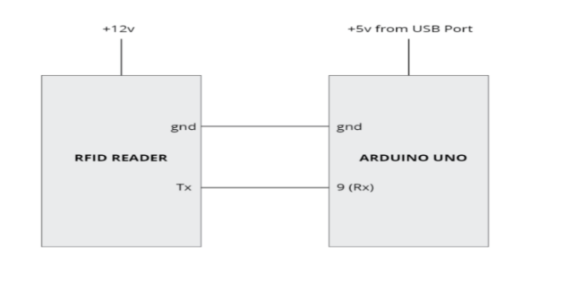
Fig 2. Interfacing with Raspberry-Pi
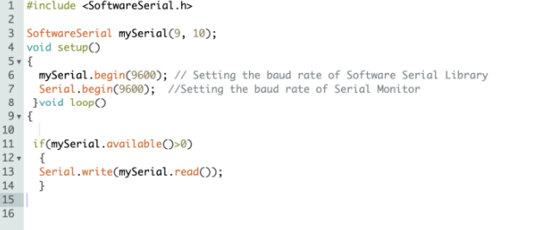
Fig 3. Program for Interfacing MFRC reader with
Raspberry-Pi

D. Interfacing 20x4 LCD Display with Raspberry-Pi
Our 16-pin LCD display was wired according to the provided schematic diagram. To verify its functionality, we powered on the Raspberry Pi. The system utilizes the built-in "LiquidCrystal.h" library for controlling the LCD.
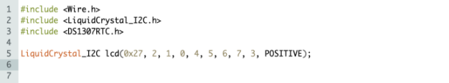
Fig 4. Code for interfacing the LCD display
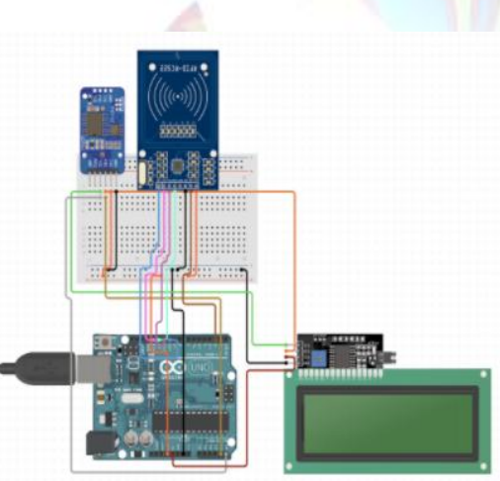
Fig 5 : Schematic diagram of circuit
IV. PRINCIPLE OF OPERATION
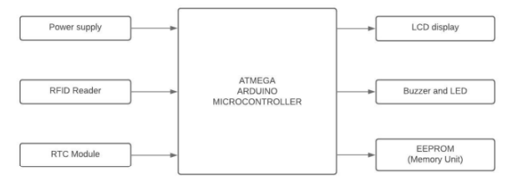
First off, The RFID is interfaced with the Raspberry-Pi as
shown.
The system employs RFID technology for real-time student attendance tracking. Students are issued unique RFID/NFC tags containing their roll numbers. These tags, with built-in antennas, wirelessly transmit data to the MFRC reader when brought nearby.
The MFRC reader transfers the received data to the microcontroller, which continuously scans for incoming tags. The system verifies the authenticity of the tag before registering attendance. Valid attendance data is then stored in a database.
As illustrated in the circuit diagram, the reader's communication pins are connected to the corresponding pins of the microcontroller. This establishes a channel for data transfer from the MFRC reader to the Raspberry Pi.
The system incorporates a 20x4 LCD display to provide visual feedback. It also utilizes a Real-Time Clock (RTC) module to maintain accurate timekeeping. The RTC module connects to the Raspberry Pi using the I2C protocol via the SCL and SDA pins.
V.RESULTS
The Project “NON COHESIVE SMART ATTENDANCE SYSTEM” has been completed and final Testing is completed. For testing, we used the following data of a random student
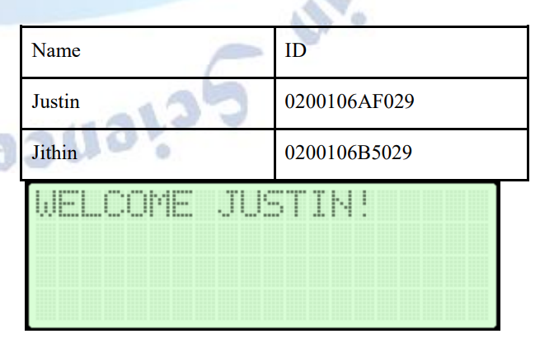
Fig.7 LCD snapshot while attendance is being registered

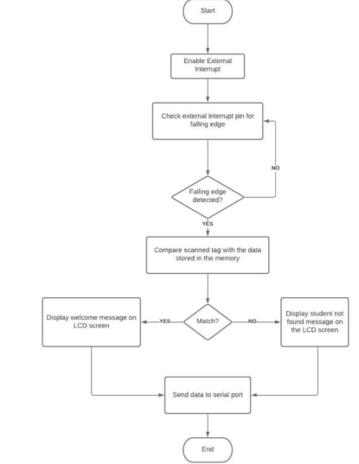
Fig.8 Flowchart of the Operation

VI. CONCLUSION
In testing mode, we used a variety of data points to simulate real-world scenarios. This included student identifiers (anonymized for testing), timestamps, and attendance statuses (present/absent).
The final testing phase employed a diverse range of test cases to thoroughly evaluate the system's functionality. This ensured the system could accurately identify and record student attendance under various conditions.
VII. FUTURE WORK
Radio Frequency Identification (RFID) technology is gaining popularity as the world embraces contactless solutions. Unlike barcode scanners that require a direct line of sight, RFID/NFC tags can be read from several feet away, offering greater convenience. Additionally, RFID systems are cost-effective and minimize errors and potential for misuse. These advantages make them a valuable tool for various applications.
For instance, RFID technology can be further enhanced by integrating fingerprint scanners for an extra layer of security. Beyond attendance systems, RFID's applications are vast. Libraries can utilize RFID/NFC tags in books to streamline checkout and self-service returns, while parking security can leverage them for automated vehicle access control.
REFERENCES
- Agrawal, A., &Bansal, A. "Online Attendance Management System Using RFID with Object Counter." International Journal of Information and Computation Technology, vol. 3, no. 3, 2013, pp. 131-138.
- Bardaki, C., &Kalogeras, A. (2013). An RFID Based System for Attendance Recording in Educational Institutions. International Journal of Emerging Technologies in Learning (IJET), 8(2), 35-44.
- Lim, T. S., Sim, S. C., &Mansor, M. M. "RFID Based Attendance System." Presented at the 2009 IEEE Symposium on Industrial Electronics and Applications (ISIEA 2009), Kuala Lumpur, Malaysia, 4-6 Oct. 2009.
- Nainan, S., Parekh, R., & Shah, T. "RFID Technology Based Attendance Management System." IJCSI International Journal Of Computer Science Issues, vol. 10, no. 1, Oct. 2009.
- Nikraz, M. S., &Seemab, M. (2012). A Smart Attendance Management System Using RFID and GSM Technology. International Journal of Scientific & Engineering Research, 3(5), 1-5.
- Shukla, A. K. "Microcontroller Based Attendance System Using RFID and GSM." International Journal of Emerging Technologies in Engineering Research (IJETER), vol. 5, no. 8, 2017.

