

A STUDY ON FINANCIAL FORECASTING AND BUDGETING ANALYSIS WITH REFERENCE BY REVELE INDIA PRIVATE LIMITED COMPANY
By

GAYATHRI B

REG. NO. 211422631038

Of

PANIMALAR ENGINEERING COLLEGE

PROJECT REPORT

Submitted to the

FACULTY OF MANAGEMENT STUDIES
In partial fulfillment of the requirements for the award of the degree

of

MASTER OF BUSINESS ADMINISTRATION

MAY - 2024

PANIMALAR ENGINEERING COLLEGE
AN AUTONOMOUS INSTITUTION AFFILIATED TO ANNA UNIVERSITY, CHENNAI JAISAKTHI EDUCATIONAL TRUST
APPROVED BY AICTE
BANGALORE TRUNK ROAD, VARADHARAJAPURAM, NASARATHPETTAI, POONAMALLEE,
CHENNAI– 600 123


DEPARTMENT OF MANAGEMENT STUDIES

BONAFIDE CERTIFICATE

This is to certify that this project report titled “A STUDY ON FINANCIAL FORECASTING AND BUDGETING ANALYSIS WITH REFERENCE BY REVELE
INDIA PRIVATE LIMITED COMPANY” is the bonafide work of GAYATHRI B, 211422631038 who carried out the research under my supervision. Certified further, that to the best of my knowledge the work reported herein does not form part of any other project report or dissertation on the basis of which a degree or award was conferred on earlier occasion on this or any other candidate.

Internal Guide Head of the Department

Internal Examiner External Examiner

ACKNOWLEDGEMENT
I would like to express my sincere gratitude to Our Secretary and Correspondent Dr.P. CHINNADURAI M.A., Ph.D., for providing excellent environment and infrastructure and for his valuable support throughout the course of study.

I express my sincere thanks to Our Directors Mrs. C. VIJAYA RAJESWARI, Dr.

C. SAKTHIKUMAR, M.E., Ph.D., and Dr. SARANYASREE SAKTHIKUMAR, B.E.,
M.B.A., Ph.D., I also express my gratitude to the Principal Dr. K. MANI M.E., Ph.D. for providing all the required facilities for the successful completion of this project work.

I take this opportunity to express my gratitude to the Dean & Professor, Department of Management Studies, Dr. N. VENKATESWARAN B.E, M.B.A., Ph.D., for providing me an opportunity and Dr. A. ELLAIYARAJA M.B.A., Ph.D., who has given me guidance to do this project work.

I also take this opportunity to express my gratitude to Mr. PRAKESH Sr FINANCE MANAGER for his/her valuable guidance for the successful completion of the project report.

GAYATHRI B

TABLE OF CONTENTS

S.NO | CONTENTS | Page No.
 | Abstract | i
 | List of tables | ii
 | List of charts | iii
 | List of abbreviations | iv
I | INTRODUCTION
1.1 | Introduction | 1
1.2 | Industry Profile | 6
1.3 | Company Profile | 12
II | DEVELOPMENT OF MAIN THEME
2.1 | Need of the study | 18
2.2 | Objectives of the study | 19
2.3 | Scope of the study | 20
2.4 | Limitations of the study | 21
2.5 | Review of Literature | 22
III | DATA ANALYSIS AND INTERPRETATION
3.1 | Research Methodology | 28
3.2 | Data Analysis and Interpretation | 41
3.3 | Summary of Findings | 83
3.4 | Suggestions | 85
3.5 | Conclusion | 86
 | ANNEXURE
 | Bibliography
 | Secondary Data

ABSTRACT

The Revele company's financial performance from last five years reveals fluctuations in key statistics and metrics, including liquidity ratios (current, quick, and cash ratios), operating cycle, and working capital management. While cash inflows have been robust, operational efficiency and payables turnover vary. The volatility in net income and asset utilization suggests the need for stable financial methods such as enhancing inventory management and optimizing cash conversion cycles. Diversifying revenue streams and monitoring supplier relationships can further strengthen the company's overall financial health. Employing statistical analysis, such as correlation and regression, can help pinpoint additional variables affecting return on assets. By adopting these targeted strategies and continually evaluating financial metrics, the company can improve its competitiveness and ensure long-term success.

LIST OF TABLES

S. No | TITLE | Page  No
3.2.1 | Table showing current ratio | 41
3.2.2 | Table showing quick ratio | 43
3.2.3 | Table showing cash ratio | 45
3.2.4 | Table showing operating cycle | 47
3.2.5 | Table showing days payables outstanding | 49
3.2.6 | Table showing inventory turnover ratio | 51
3.2.7 | Table showing cash conversion cycle | 53
3.2.8 | Table showing return on total assets | 55
3.2.9 | Table showing working capital investment policy | 57
3.2.10 | Schedule of change in working capital of the year 2019&2020 | 59
3.2.11 | Schedule of change in working capital of the year 2020&2021 | 61
3.2.12 | Schedule of change in working capital of the year 2021&20222 | 63
3.2.13 | Schedule of change in working capital of the year 2022&2023 | 65

3.2.14 | Table showing payback periods | 67
3.2.15 | Table showing discounted cash flow method/net present value | 69
3.2.16 | Table showing profitability index | 71
3.2.17 | Table showing arr on original investment and average investment | 73
3.2.18 | Table showing fitting a straightline trend (method of least squares) | 76
3.2.19 | Table showing descriptive statistics of variables | 78
3.2.20 | Table showing the correlations | 79
3.2.21 | Table showing the regressions | 80

LIST OF CHARTS

S. No | TITLE | Page No
3.2.1 | chart showing current ratio | 42
3.2.2 | chart showing quick ratio | 44
3.2.3 | chart showing cash ratio | 46
3.2.4 | chart showing operating cycle | 48
3.2.5 | chart showing days payables outstanding | 50
3.2.6 | chart showing inventory turnover ratio | 52
3.2.7 | chart showing cash conversion cycle | 54
3.2.8 | chart showing return on total assets | 56
3.2.9 | chart showing working capital investment policy | 58
3.2.14 | chart showing payback periods | 68
3.2.15 | chart showing discounted cash inflow method/ net present value | 70
3.2.16 | chart showing profitability index | 72

3.2.17 | chart showing arr on original investment and average investment | 74
3.2.18 | chart showing fitting a straightline trend (method of least squares) | 77

CHAPTER 1 INTRODUCTION

INTRODUCTION

Financial forecasting and budgeting analysis are indispensable components of financial management within the healthcare sector. In an environment characterized by escalating costs, evolving regulatory landscapes, and increasing demand for quality care, healthcare organizations must possess robust financial planning capabilities to navigate these complexities effectively. Financial forecasting involves the prediction of future financial outcomes based on historical data, industry trends, and economic indicators. It enables healthcare institutions to anticipate revenue streams, forecast expenses, and project cash flows, thereby facilitating proactive decision-making and resource allocation.

Budgeting analysis, a complementary process, entails the evaluation of actual financial performance against budgeted targets. By comparing budgeted figures with actual results, healthcare organizations can identify variances, assess operational efficiency, and pinpoint areas for improvement. This analysis provides valuable insights into the effectiveness of resource utilization, cost management practices, and revenue generation strategies. Moreover, budgeting analysis serves as a diagnostic tool, enabling healthcare leaders to detect deviations from financial plans and implement corrective measures promptly.

Within the healthcare sector, financial forecasting and budgeting analysis fulfil several critical functions. Firstly, they support resource allocation by providing insights into future financial needs and priorities. Healthcare organizations must allocate resources judiciously to meet patient demands, invest in technology and infrastructure, and maintain quality standards. Financial forecasting guides resource allocation decisions by identifying funding requirements for key initiatives and strategic objectives. Similarly, budgeting analysis evaluates the efficiency of resource utilization and helps healthcare leaders optimize resource allocation to maximize value and outcomes.

Cost management is another primary concern for healthcare organizations, given the relentless upward pressure on expenses. Financial forecasting aids in cost management by projecting future cost trends and identifying cost-saving opportunities. By analysing historical cost data and forecasting future expenses, healthcare institutions can develop strategies to contain costs effectively. Budgeting analysis complements this process by monitoring actual spending

against budgeted amounts and identifying variances. This analysis enables healthcare leaders to identify cost overruns, analyse their root causes, and implement corrective actions to align actual spending with budgeted targets.

Revenue optimization is equally crucial for healthcare organizations seeking to maintain financial sustainability and invest in growth initiatives. Financial forecasting facilitates revenue optimization by predicting revenue streams from diverse sources, including patient services, insurance reimbursements, grants, and donations. By forecasting future revenues, healthcare organizations can develop strategies to enhance revenue generation and diversify funding sources. Budgeting analysis assesses revenue performance against budgeted targets and identifies opportunities to improve revenue capture. This analysis enables healthcare leaders to identify underperforming revenue streams, implement revenue enhancement initiatives, and strengthen financial performance.

Strategic planning is inherently linked to financial forecasting and budgeting analysis, as it involves aligning financial goals with organizational objectives. Financial forecasting provides critical insights into the financial implications of strategic initiatives, such as mergers and acquisitions, capital investments, and service expansions. By forecasting the financial outcomes of strategic decisions, healthcare leaders can evaluate their feasibility, assess their impact on financial performance, and make informed choices. Budgeting analysis supports strategic planning by evaluating the financial performance of strategic initiatives against budgeted targets. This analysis enables healthcare organizations to monitor progress, identify deviations from plans, and adjust strategies accordingly to achieve desired outcomes.

In financial forecasting and budgeting analysis are vital processes within the healthcare sector, enabling organizations to anticipate future financial outcomes, allocate resources effectively, manage costs efficiently, optimize revenue generation, support strategic planning, and mitigate risks. By leveraging these processes effectively, healthcare leaders can navigate the complexities of the healthcare landscape while delivering high-quality care, achieving financial sustainability, and driving long-term success.

FINANCIAL FORECASTING

The forecasting process involves using historical data, trends, market conditions, and analytical tools to estimate your company’s future outcomes. Forecasting helps you:
- Anticipate the demand for your products or services

- Plan production and inventory levels

- Allocate resources and budget

- Set goals and strategies, and

- Evaluate performance and risks

Forecasting is done for various stretches of time, such as short-term, medium-term, or long- term, depending on your business needs. You can also forecast using qualitative or quantitative methods, depending on data availability and reliability.

FINANCIAL BUDGETING

- Budgeting is aligning financial resources and activities with your strategic goals and objectives.
- It helps you plan, coordinate, communicate, control, and evaluate performance to match your company’s goals and objectives.
- The process includes estimating revenues and expenses, cash flows, production lines, working capital, and capital expenditures for a specific period.
- You can compare the actual results of budgeting with the expected ones to identify any gaps or opportunities for improvement.

SIGNIFICANCE OF FINANCIAL FORECASTING AND BUDGETING

Financial forecasting and budgeting analysis are cornerstone processes in organizational management, providing invaluable insights into financial performance, guiding strategic decision-making, and ensuring the efficient allocation of resources. Their significance lies in their ability to facilitate proactive planning, mitigate risks, evaluate performance, and support communication with stakeholders.

- Strategic Planning: Financial forecasting serves as a roadmap for organizations, allowing them to anticipate future financial trends and align their long-term goals with their financial capabilities. By projecting future revenues, expenses, and cash flows, organizations can develop strategic initiatives, invest in growth opportunities, and navigate market uncertainties with confidence. Budgeting analysis complements this process by evaluating the financial feasibility of strategic plans and ensuring alignment with organizational objectives.
- Resource Allocation: Effective resource allocation is essential for optimizing organizational performance and achieving strategic objectives. Financial forecasting enables organizations to anticipate future resource needs, such as capital investments, operating expenses, and staffing requirements. This foresight allows organizations to allocate resources efficiently, ensuring that funds are directed towards priority areas that align with organizational goals. Budgeting analysis further supports this process by evaluating the efficiency of resource utilization and identifying opportunities for improvement.
- Risk Management: Financial forecasting and budgeting analysis play a crucial role in identifying and mitigating financial risks. By forecasting future revenues, expenses, and cash flows, organizations can anticipate potential financial challenges and develop contingency plans to mitigate risks. Budgeting analysis helps organizations monitor actual financial performance against budgeted targets, enabling them to detect variances and take corrective actions promptly. This proactive approach to risk management enhances financial resilience and minimizes the impact of adverse events on organizational stability.
- Performance Evaluation: Financial forecasting and budgeting analysis provide valuable insights into organizational performance. By comparing actual financial results with forecasted outcomes and budgeted targets, organizations can evaluate their financial health, identify areas of improvement, and measure progress towards strategic goals. This enables continuous performance improvement and helps organizations make informed decisions to enhance operational efficiency and profitability.
- Decision Support: Financial forecasting and budgeting analysis serve as essential decision support tools for organizational leaders. By providing accurate and timely financial information, these processes enable decision-makers to assess the financial implications of various options, evaluate alternative courses of action, and make informed decisions that align with organizational objectives. Whether it is evaluating investment opportunities,

expanding operations, or restructuring business processes, financial forecasting and budgeting analysis provide the foundation for sound decision-making.
- Stakeholder Communication: Financial forecasting and budgeting analysis facilitate effective communication with internal and external stakeholders. By transparently presenting financial forecasts, budgets, and performance reports, organizations can build trust and confidence among investors, lenders, regulators, and other stakeholders. This fosters transparency, accountability, and credibility, enhancing the organization's reputation and supporting its long-term growth and sustainability.
In financial forecasting and budgeting analysis are indispensable processes in organizational management, providing critical insights and guiding decision-making processes at all levels of the organization. Their significance lies in their ability to enable proactive planning, mitigate risks, evaluate performance, support decision-making, and foster communication with stakeholders. By leveraging these processes effectively, organizations can achieve financial stability, drive growth, and maximize value for stakeholders.

USEFULNESS OF FINANCIAL FORECASTING AND BUDGETING ANALYSIS

Financial analysis involves evaluating historical financial data, performance metrics, and market trends to assess an organization's financial health and performance. This process provides valuable insights into the strengths, weaknesses, opportunities, and threats facing the organization. Financial analysis serves several key purposes:

- Decision Support: Financial analysis provides decision-makers with the information needed to make informed strategic and operational decisions. By analysing financial data, organizations can evaluate the financial feasibility of investment opportunities, expansion projects, and strategic initiatives. This helps mitigate risks and maximize returns on investment.
- Forecasting and Planning: Financial analysis supports forecasting and planning activities by providing insights into future financial trends and outcomes. By analysing historical data and market trends, organizations can develop realistic financial forecasts and set achievable goals. This enables better resource allocation, budgeting, and strategic planning
- Budgeting, on the other hand, involves setting financial targets, allocating resources, and monitoring performance against predefined goals. Budgeting serves several critical functions within organizations:

- Resource Allocation: Budgeting helps organizations allocate resources effectively to support their strategic objectives. By setting budget targets for revenue, expenses, and investments, organizations can ensure that resources are allocated to priority areas and aligned with organizational goals.
- Financial Control: Budgeting provides a framework for financial control and accountability. By comparing actual performance against budgeted targets, organizations can identify variances and take corrective actions as needed. This helps prevent cost overruns, optimize resource utilization, and improve operational efficiency.

In summary, financial analysis and budgeting are indispensable tools for organizations seeking to achieve financial stability, drive growth, and maximize value. By providing insights into financial performance, supporting decision-making processes, enabling effective resource allocation, and promoting transparency and accountability, financial analysis and budgeting play a central role in organizational success.

INDUSTRY PROFILE

The healthcare sector is a vast and complex industry encompassing a wide range of services aimed at promoting health, preventing illness, and treating medical conditions. Service-based companies within this sector play a crucial role in providing specialized services and solutions to healthcare providers, payers, and patients. From healthcare consulting and technology integration to revenue cycle management and telemedicine, these companies offer essential support services that contribute to the delivery of high-quality patient care and the overall efficiency of the healthcare system.
The healthcare sector is characterized by its diversity, rapid technological advancements, and evolving regulatory landscape. With an aging population, increasing prevalence of chronic diseases, and rising healthcare costs, there is a growing demand for innovative solutions and services that enhance patient outcomes, improve operational efficiency, and contain costs. Service-based companies in the healthcare sector are well-positioned to capitalize on these trends by offering specialized expertise, technology-driven solutions, and value-added services that address the evolving needs of healthcare organizations and patients.
Several key trends are shaping the healthcare sector and driving growth opportunities for service-based companies:
- The shift towards value-based care models emphasizing quality, outcomes, and patient satisfaction.
- The increasing adoption of digital health technologies such as telemedicine, electronic health records (EHR), and mobile health apps.
- The expansion of healthcare services beyond traditional settings to include telehealth, home-based care, and community-based initiatives.
- The emphasis on healthcare cost containment, efficiency improvements, and revenue cycle management to address financial pressures.
- The growing demand for specialized consulting services, technology integration, and data analytics to support healthcare delivery and management.
The healthcare industry is subject to a complex regulatory environment governed by federal, state, and local regulations. Service-based companies must navigate various regulatory

requirements related to healthcare privacy and security (e.g., HIPAA), healthcare reform (e.g., ACA), reimbursement and billing practices, and healthcare technology standards. Compliance with these regulations is essential to ensure legal and ethical conduct, protect patient confidentiality, and maintain eligibility for reimbursement and government incentives.
The healthcare sector is highly competitive, with numerous players competing for market share and differentiation. Service-based companies face competition from a diverse array of entities, including healthcare consulting firms, technology vendors, outsourcing providers, and niche service providers. Success in this competitive landscape requires differentiation, innovation, and a deep understanding of the unique needs and challenges facing healthcare organizations and patients.
The future of the healthcare sector holds significant opportunities for service-based companies that can innovate, adapt, and collaborate effectively. As healthcare organizations continue to prioritize patient-centric care, value-based outcomes, and operational efficiency, the demand for specialized services and solutions is expected to grow. Service-based companies that can offer expertise in areas such as healthcare analytics, population health management, telehealth, and revenue cycle optimization will be well-positioned to thrive in this dynamic and evolving industry landscape.
HOW TO RESEARCH

Researching the healthcare sector requires a structured approach to gather relevant information, analyse industry trends, and identify opportunities and challenges. Begin by clearly defining the objectives of your research. Determine what specific aspects of the healthcare sector you want to explore, such as market trends, regulatory developments, technological innovations, or investment opportunities. Clarifying your research objectives will help focus your efforts and guide your research process effectively.

Start your research by gathering background information on the healthcare sector. Explore industry reports, market analyses, and academic studies to gain a comprehensive understanding of key trends, challenges, and opportunities shaping the healthcare landscape. Familiarize yourself with the structure of the healthcare industry, major players, regulatory frameworks, and emerging technologies.

Next, identify and analyse key trends driving the healthcare sector. This may include trends related to demographic shifts, healthcare spending, technological advancements, regulatory reforms, and consumer preferences. Pay attention to emerging trends such as telemedicine, personalized medicine, value-based care, and healthcare digitization, as these are likely to have significant implications for the industry's future.

Assess the current market dynamics within the healthcare sector. Analyse market size, growth projections, competitive landscape, and market segmentation. Identify market opportunities and potential areas for disruption or innovation. Consider factors such as patient demographics, healthcare delivery models, reimbursement trends, and competitive positioning of companies within the market.

Understand the regulatory environment governing the healthcare sector. Research relevant healthcare regulations, legislation, and policy developments at the local, national, and international levels. Consider the impact of regulatory changes on healthcare providers, payers, pharmaceutical companies, medical device manufacturers, and other stakeholders. Pay particular attention to regulations related to healthcare privacy and security, reimbursement, quality of care, and healthcare technology.

Examine technological innovations driving transformation in the healthcare sector. Research advancements in healthcare IT, telemedicine, digital health, wearable devices, artificial intelligence, and genomics. Evaluate how these technologies are being adopted and integrated into healthcare delivery systems to improve patient outcomes, enhance operational efficiency, and reduce costs. Identify opportunities for collaboration and investment in emerging healthcare technologies.

Consider socio-economic factors influencing the healthcare sector. Research healthcare disparities, access to care issues, socioeconomic determinants of health, and healthcare workforce challenges. Consider how socio-economic factors impact healthcare utilization, health outcomes, and disparities in healthcare delivery. Explore initiatives aimed at addressing healthcare inequities and improving access to care for underserved populations.

Assess investment opportunities within the healthcare sector. Research investment trends, mergers and acquisitions, venture capital funding, and private equity investments in healthcare companies and startups. Evaluate promising areas for investment, such as healthcare

technology, biotechnology, pharmaceuticals, medical devices, and healthcare services. Consider factors such as market growth potential, competitive positioning, regulatory risks, and return on investment considerations.

Synthesize your research findings to draw conclusions and insights about the healthcare sector. Identify overarching trends, opportunities, and challenges shaping the industry's trajectory. Consider implications for healthcare stakeholders, policymakers, investors, and consumers. Provide recommendations for future research directions or areas of focus within the healthcare sector.

Finally, communicate your research findings effectively through reports, presentations, articles, or other channels. Tailor your communication to your target audience, whether it be healthcare professionals, policymakers, investors, or the public. Clearly articulate key insights, supported by evidence and data, and provide actionable recommendations for stakeholders to consider.

By following these steps, you can conduct thorough research on the healthcare sector, gain valuable insights, and contribute to a deeper understanding of this critical industry.

FINANCIAL YEAR

According to the Centre for Budget and Governance Accountability’s (CBGA) analysis of the Union Budget, the overall allocation¹ in 2024-25 for the health sector stood at Rs. 98,461 crores, which is a marginal increase of 2.6% from the previous budget estimates (BE) and a 14.2% increase from the revised estimates (RE)². However, despite the enhanced allocations, the sector’s share in the total Interim Budget and as percentage of GDP has declined over the years (Figure 1). The 143rd Report of the Parliamentary Standing Committee notes that such trends of budgetary allocations do not align with the targets set by the NHP (2017) and highlights the need to assign adequate priority to the health sector.

PROSPECTS

- Healthcare sector experiencing increasing demand for services like consulting, medical billing, revenue cycle management, telemedicine, and healthcare IT solutions.

- Healthcare organizations seek specialized expertise and support from service-based companies to improve patient outcomes, enhance operational efficiency, and navigate regulatory challenges.

- Rapid advancements in healthcare technology create opportunities for service-based companies to offer value-added solutions.

- Technologies like telemedicine, electronic health records (EHR), digital health platforms, and artificial intelligence (AI) transform healthcare delivery and management, driving demand for consulting, implementation, and support services.

- Transition from fee-for-service to value-based care emphasizes quality, outcomes, and patient satisfaction.

- Rising healthcare costs drive organizations to seek cost-effective solutions and optimize resource utilization.

- Service-based companies specializing in regulatory compliance, healthcare law, policy analysis, and reimbursement strategies assist organizations in navigating regulatory challenges and ensuring compliance.

- Emphasis on population health management and preventive care initiatives to improve health outcomes and reduce costs.

- Accelerated adoption of telemedicine and remote care solutions due to COVID-19 pandemic.

- Opportunities for service-based companies in telehealth consulting, technology integration, and remote monitoring services as telemedicine becomes integral part of healthcare delivery.

COMPANY PROFILE

Revele India Private Limited is a Private incorporated on 01 September 1999. It is classified as non-govt company and is registered at Registrar of Companies, Chennai. Its authorized share capital is Rs. 25,000,000 and its paid-up capital is Rs. 20,459,060. It is involved in Software publishing, consultancy, and supply [Software publishing includes production, supply, and documentation of ready-made (non-customized) software, operating systems software, business & other applications software, computer games software for all platforms. Consultancy includes providing the best solution in the form of custom software after analysing the users’ needs and problems. Custom software also includes made-to orders software based on orders from specific users. Also, included are writing of software of any kind following directives of the users; software maintenance, web-page design]. Revele India Private Limited's Annual General Meeting (AGM) was last held on N/A and as per records from Ministry of Corporate Affairs (MCA), its balance sheet was last filed on 31
March 2023. Directors of Revele India Private Limited are Murugavel Selvan, Magaral Sarangapani Murali and Arunkumar Murali. Revele India Private Limited's Corporate Identification Number is (CIN) U72200TN1999PTC145595 and its registration number is 145595.Its Email address is venkat.rao@revelemd.com and its registered address is G 2 Elnet Software City, TS 140, Block 2 & 9, Rajiv Gandhi Salai, Taramani Chennai Chennai TN 600113 IN.
Status of Revele India Private Limited is - Active.

COMPANY DETAILS

Company REVELE INDIA PRIVATE LIMITED

Name
Company Active Status
RoC RoC-Chennai
Registration 145595 Number

Company Category
Company limited by Shares

Company Sub Category
Class of
Private
Company
Non-govt company

Date of Incorporation
Age of
24 years, 6 month, 24 days
Company
01 September 1999

Activity Software publishing, consultancy, and supply [Software publishing includes production, supply, and documentation of ready-made (noncustomized) software, operating systems software, business & other applications software, computer games software for all platforms. Consultancy
includes providing the best solution in the form of custom software after
analysing the users’ needs and problems. Custom software also includes made- to-order software based on orders from specific users. Also, included
CIN U72200TN1999PTC145595
Share Capital
Authorised Capital ₹25,000,000
Paid up capital ₹20,459,060

Listing and Annual Compliance Details
Listing status Unlisted

Date of Last Annual General Meeting | N/A
Date of Latest Balance Sheet 31 March 2023

Revele is a leading provider of healthcare revenue cycle and electronic health record services. Revele partners with physician groups and health systems to optimize their revenue cycle performance and EHR utilization through a data-driven approach. Since 1999, we have led the industry in implementing technology to enhance the revenue cycle management process. Revele is committed to bringing a full suite of products and services to healthcare to simplify the business of medicine through in-house research and development and strategic partnerships. Simplifying the business of medicine starts with forming a true partnership with our clients. At Revele, we do this by following our proven process: 1. Assess: Our teams approach every conversation by understanding each client's unique needs and challenges. 2. Build: We design an onboarding and implementation process to make the transition to a new EHR or RCM solution seamless. 3. Consult: Our Client Success Teams exist to provide long term planning, strategic consulting, and best practices that help to differentiate your business.
Website :http://www.revelemd.com

Industry
Hospitals and Health Care

Company size
51-200 employees

Headquarters
Indianapolis, Indiana

Type
Privately Held

Founded 1999

Specialties

Merit-based Incentive Payment System, Financial Improvement, Healthcare Consulting, Back Office Solutions, Medical Coding, Medical Billing, EHR Optimization, Collections, Accounts Receivable, Business Process Outsourcing, Healthcare Analytics, Denial Management, eClinicalWorks Billing, eClinicalWorks Training, eClinicalWorks Training, eClinicalWorks Consulting, and eClinicalWorks RCM.

PRODUCTS


eClinicalWorks - Consulting, Training, RCM, and Medical Billing
ENCOURAGE MUTUAL OUR VALUES

We respect, transparency, and compliance. These behaviours combined with our core values of fulfilment, ingenuity, and teamwork serve as Revele foundation and cultural pillars.
FULFILMENT

We are ambitious and optimistic. We are passionate about our work and when we make a promise, we keep our word. We remain determined against all odds and we never lose sight of our dreams.
INGENUITY

We are curious and think creatively to find solutions. We always embrace cutting-edge technology and new ideas. We use our knowledge, skills, and resources to overcome challenges.
TEAMWORK

We always give more than we take. We communicate with confidence, integrity, and humility. We are approachable, honest, and collaborative. We accept the negative consequences of mistakes and learn by taking risks.
Since 1999, we have led the industry in implementing technology to enhance the revenue cycle management process.
And with over 25 years in the healthcare reimbursement and technology industry, we have endured a vast amount of change- the Affordable Care Act, ICD-10,

Electronic Health Records, to name a few. What does all this mean? It means at Revele we do not run from change; we embrace it. We are entrepreneurs at heart and today, we rely on the Entrepreneurial Operating System (EOS) to run our business. Inspired by change, we commit to improving ourselves and our services so that we can create more value for our customers. We believe by doing so, we can build happier and healthier communities that improve the quality of life globally.
PURPOSE

Improve the quality of life.

VISION

To create growth and opportunity for our clients, employees, communities, and those that we serve.
MISSION

Simplify the Business of Medicine.
What does this mean? This means we are persistent about improving ourselves, fostering innovation, and modernizing processes so that every client can grow and scale to expand care delivery.
MEET OUR LEADERSHIP TEAM

We understand that physicians set out to help people, and we did too. But healthcare is complicated and making it simpler starts at the top. That is why at the heart of Revele's leadership team you will find innovation, commitment, and a passion for healthcare.


Arun Murali
Chief Executive Officer



Kurt Lage Madan Murali
Chief Financial Officer Director of Sales



Murugavel Selvan Roy Orr
President and Managing Director Director of Client Success

CHAPTER II DEVELOPMENT OF
MAIN THEME

NEED OF THE STUDY

Strategic planning involves aligning organizational goals with anticipated resources by optimizing resource allocation, instilling investor confidence, and making strategic investments to adapt to changing market conditions. Effective resource allocation requires prioritizing goals and distributing resources to achieve maximum impact. This involves continuously assessing and adjusting allocations based on progress and changing needs. Building investor confidence is crucial for long-term success, so transparency, reliable financial projections, and clear communication with investors about business performance and future plan’s are essential. Strategic investment requires staying updated on market trends, emerging technologies, and competitive landscapes to identify opportunities and threats. By balancing short-term goals with a long-term vision and maintaining flexibility, organizations can remain agile and responsive in a dynamic market environment. This approach helps in achieving sustainable growth and success.

OBJECTIVES OF THE STUDY

PRIMARY OBJECTIVE:

- To analysis financial forecasting and budgeting analysis with the reference of revele company.

SECONDARY OBJECTIVES:

  - To identify areas costs reduction and efficiency improvements in service delivery processes.
  - To Optimize financial planning and budgeting processes to allocate resources effectively.
  - To evaluate financial performance to identify areas for improvement and strategic decision-making.
  - To develop and implement financial forecasting models to anticipate future financial performance and trends.

SCOPE OF THE STUDY

- To study operational efficiency in Evaluation of processes and workflows to found areas for productivity improvement and cost reduction.
- To identification of cost management improvements at pinpointing specific areas within the organization where costs can be better managed, such as through supplier contract renegotiation or inventory optimization.
- To forecasting future trends using historical data and trend analysis to anticipated future financial performance and adjust strategies accordingly.

LIMITATIONS OF THE STUDY

- Difficulty in accurately predicting future performance.
- Variability in accounting standards across industries and regions.
- Complexity in analysing interdependencies between financial metrics.
- Challenges in comparing performance across different time periods or companies.

REVIEW OF LITERATURE

Alice C. Lee, Cheng F Lee, and John C. Lee (2009) “Financial Analysis, Planning and Forecasting: Theory and Application”: This is based on our years of study and experience in financial analysis, planning, and forecasting. Our overall objective is to produce an introductory level book that integrates, evaluates, and explores business analysis and planning from a theoretical and practical standpoint. Five categories apply to financial analysis, planning, and forecasting: (1) Financial Analysis Information and Methodology; (2) Alternative Finance Theories and Cost of Capital: (3) Decisions Regarding Capital Budgeting and Leasing, (4) Corporate Policies and Their Interactions: (5) Forecasting and Financial Plannings. To structure our discussion of the subject, we concentrate on three ideas: (1) to combine theory and practice;
(2) to achieve a balance between summary and in-depth comprehension; and (3) to illustrate how management requires fundamental quantitative training.
N Castellina, D Hatch-Masachussets: Harla (2011)" Financial Planning, Budgeting, and Forecasting in the New Economy”: A sound financial plan is the vehicle which clearly states strategic business objectives in financial terms. A well-prepared budget form’s the foundation for decision-making throughout the fiscal year. However, it is the forecast which allows the business to adjust future expectations based on recent actual performance. With a renewed focus on growth as a strategic goal, and alignment of strategy with corporate performance, companies that hope to achieve Best-in-Class status must be armed with tools that provide visibility and flexibility to strike a balance between aggressive plans for recovery and caution.

Harry white (2013) “Financial statement analysis, forecasting and budgeting: an integrative teaching approach”:
Principles of Finance textbooks do an inadequate job of integrating financial statement analysis with forecasting and budgeting and then utilizing the forecasting and budgeting tools to expedite the lessons on project cash flow estimation. This paper will document the present state of coverage in Principles of Finance textbooks and offer an alternative approach to teaching these important tools to business majors. The approach integrates the tools of financial analysis: statement of cash flows and ratios into the forecasting and budgeting process. The integrated approach will be illustrated through examples that have been used extensively in class. The examples take a firm from historical analysis to forecasting to show the link between the two.

The paper will also include a discussion of how well the alternative approach helps students learn these important financial management tools.

Fred Thompson, Bruce L. Gates (2013) “Betting on the future on the future with a cloudy crystal balls! How financial, theory can financial, theory can improver revenue forecasting and budgets in the states”
This chapter focuses on how four tools of financial analysis—growth analysis, portfolio analysis, hedging, and consumption smoothing—can help elected officials, budgeters, and scholars anticipate the answers to four basic questions about forecasting uncertain financial futures. The basic questions are: how much can revenues be expected to grow? how much revenue volatility is likely to occur? how much can volatility be reduced without jeopardizing growth expectations? and finally, how long is it safe to wait before acting? It shows how two basic ideas that have dominated modern financial theory variance and drift-can enhance crystal- ball gazing for budget practitioners and theorists alike. The chapter identifies some of the analytical tools needed to use these concepts-mean-variance analysis, Monte Carlo simulation, optimal control theory, and covariance analysis. These concepts, techniques, and applications are all borrowed from modern financial theory, and they can be applied to a wide array of public sector financial management problems.

Michael Samonas john Wiley & Sons (2015)” Financial forecasting analysis, and modelling: a framework for long-term forecasting”
These days, risk analysis is essential to sophisticated financial planning. Finance professionals may include uncertainty into their planning and budgeting process with the aid of Financial Forecasting, Analysis and Modelling, which offers a comprehensive framework of long-term financial projections in a useful and approachable manner. This book takes readers step-by-step through the whole projection plan generation process with its comprehensive treatment of financial statement simulation models and its clear, succinct application guidance. The tools, methods, and unique factors that enhance workflow, boost accuracy, and strengthen financial strategy are all taught to readers. They also help them build more reliable analytical processes. To help readers make informed decisions, the companion website offers a comprehensive operational model that can be customized to create financial predictions or a variety of other important financial metrics. Due to organizations' hasty adjustments to economic instability and uncertainty during the recent financial crisis, there has been a steady increase in demand for seasoned financial modelling personnel. This book offers the in-depth knowledge required

to create more effective financial planning strategies using methods adapted to actual circumstances. Utilizing Excel, create long-term projection plans. Make use of the right models to create a more proactive plan. Utilize risk and uncertainty estimates more precisely Learn how to use Sensitivity Analysis, Monte Carlo Simulation, Excel Scenario Manager, and more. More than ever, risk is a factor in financial planning, and choices must be taken after weighing all potential outcomes. In today's financial planning, uncertainty has become an essential element that must be handled with care to ensure accuracy. Especially emphasizing the unpredictability in financial forecasting, analysis and modelling is a thorough manual on the principles of contemporary finance, covering planning, modelling, and analysis.

Passoja, Pekka (2015)” Budgeting and forecasting application development: an evaluation’
The purpose of this study was to assess the overall gains made by a Finnish stock listed company because of an application development project for cost forecasting and cost planning. For the Finnish and Russian organizations of the case company, two distinct development projects were completed. The project began when the case company realized it needed to begin utilizing rolling cost forecasting to modify its fixed and variable costs in response to changes in the business environment. Additionally, the Russian corporation, which had been using an Excel software for budgeting and forecasting, was to have a completely new budgeting and forecasting application implemented by the case company in place of its outdated annual cost planning application. The primary conclusions of this study demonstrate that the example company benefited greatly from the new budgeting and forecasting program from a technological standpoint. Across the board, the organization, the usage of the new tool has enhanced annual planning and forecasting work. Further research demonstrates that the business, which mostly depends on practices thought to be secure, like annual budgeting, must make a significant shift by switching to rolling forecasting. Furthermore, it may be said that extremely sophisticated budgeting and forecasting applications can now be implemented thanks to technological advancements. On the other hand, if the specifications are very stringent, the program loses usability and becomes harder to maintain.

Sue Nugus (2015) “Financial Planning Using Excel: Forecasting, Planning and Budgeting Techniques”
The objective of this book is to help financial planners improve their spreadsheet skills by providing a structured approach to developing spreadsheets for forecasting, financial planning, and budgeting applications. The book assumes that the roader is familiar with the basic operation of Excel and is not intended for beginners. The book has been divided into four parts covering the areas of spreadsheet design for all types of planning, forecasting, business planning and budgeting. Although it is recommended that read- errs follow the book from the beginning, the text is also intended as a reference book that will be a valuable aid during model development. The structure of the book has been designed to help financial managers develop Excel skills. The first part on Spreadsheet Design aims to ensure that a disciplined approach to spreadsheet development is undertaken to ensure that whatever the purpose of the spreadsheet, it has been designed in a robust manner that will facilitate updates and enhancements.

Helmut Wasser basher, Martin Spindler, Digital Finance 4 (1), 63-88, 2022 “Machine learning for financial forecasting, planning and analysis: recent development and pitfalls” This article is an introduction to machine learning for financial forecasting, planning and analysis (FP&A). Machine learning appears well suited to support FP&A with the highly automated extraction of information from large amounts of data. However, because most traditional machine learning techniques focus on forecasting (prediction), we discuss the particular care that must be taken to avoid the pitfalls of using them for planning and resource allocation (causal inference). While the naive application of machine learning usually fails in this context, the recently developed double machine learning framework can address causal questions of interest. We review the current literature on machine learning in FP&A and illustrate in a simulation study how machine learning can be used for both forecasting and planning. We also investigate how forecasting and planning improve as the number of data points increases.

Jacques Hendieh, Journal of Commerce and Accounting Research 2023 “Budgeting and financial techniques used by SME’s during crisis”
The COVID-19 pandemic topped the financial and economic crisis faced by small and medium- sized enterprises (SMEs) in Lebanon. The purpose of this article is to explore the budgeting and financial techniques used by the Lebanese SMEs during the crisis, using an exploratory and qualitative approach to discuss the impact of the crisis on the techniques used. Data

collection involved sending questionnaires to the managers of 133 different SMEs. Results have shown that a low number of financial management techniques are used, while most SMEs tend to abandon their prior budgeting techniques. The usage of financial techniques is related to financial literacy and could be explained by the tendency to focus on short-term profitability and liquidity. We found that younger and more educated managers have a higher tendency to use more techniques. Managers are encouraged to rely on budgeting and financial techniques to increase their survival chances. Long-term planning can be a powerful tool to avoid reactive strategic behaviour. Managers need to anticipate environmental constraints using different scenarios or by testing the robustness of strategic initiatives using diverse tools like financial planning and control.

Jema Roig, Carlos T. Calafate (2023) “Optimized financial planning: integrating individual and cooperative budgeting models with recommendations”
Financial planning is a difficult task for both individuals and households in the current complicated economic climate. New approaches to individual and group financial budgeting (household) are presented in this research. First, we provide an optimization methodology for personal budget allocation, with the goal of maximizing savings through effective monthly income distribution across different categories of expenses. Next, we apply this approach to homes, where we handle the challenges of managing multiple incomes and shared spending. In addition to maximizing savings, the cooperative model considers the interests and demands of each member, promoting a harmonious financial environment regardless of whether the goals are short-term or long-term. Our method's incorporation of a large language model's (LLM) suggestions is a noteworthy advance. With its extensive training data and powerful.

Vineet Jain, Parth A Kulkarni (2023) “Integrating AI techniques for enhanced financial forecasting and budgeting strategies”
In the realm of modern business decision-making, the integration of Artificial Intelligence (AI) techniques into Financial Forecasting and Budgeting is reshaping traditional paradigms. This paper uncovers the profound impact of AI on these crucial practices. By leveraging historical data and advanced algorithms, AI-driven forecasts transcend the limitations of conventional methods, adapting seamlessly to evolving market dynamics. Simultaneously, AI-powered budgeting optimizes resource allocation and enables swift adjustments, aligning financial strategies with real-time requirements. The paper's exploration of key AI techniques amplifies forecasting accuracy and enhances the depth of variance analysis. Acknowledging challenges

surrounding computational complexity and interpretability, this study underscores AI's transformative potential and addresses concerns. The convergence of AI and financial practices is underscored through illuminating case studies, collectively revealing AI's prowess in enhancing operational efficiency and strategic decision-making. Ultimately, this integration embodies a paradigm shift, empowering businesses to navigate uncertainties with data-driven confidence. Keywords - Artificial Intelligence, Budgeting & Forecasting, FP&A, Financial forecasting, Machine learning.

Turayev Alijan Akmal son, Abduhomidov Zuhriddin Rahimjon (2024) “Financial planning and forecasting”
This article is devoted to the important topic of financial planning and forecasting, which is a key aspect of successful financial management in an organization. The article discusses the essence of financial planning, its basic principles, and methods, as well as the role of forecasting in the planning process. Particular attention is paid to the practical aspects of financial planning, including drawing up budgets, assessing financial performance and making management decisions based on the analysis of forecast data.

Kurniawan Arif Masal, Ahmad Mohammed Akrem (2024) “Exploring the role
Of an accounting practices and financial analysis: a case study in perfect zone buraidah” This compelling case study delves into the critical role of accounting techniques and financial analysis in business management. The study explores the obstacles faced and the tactics used to overcome them by drawing on the firsthand experiences of an accountant at a startup business. The study emphasizes the importance of precise inventory management, budgeting and forecasting, financial monitoring, and sales performance analysis in attaining long-term growth and profitability. The findings emphasize the significance of combining accounting theories and practices to make informed decisions and achieve financial success. The study continues by underlining the importance of continuous financial planning and adaption to support long-term corporate growth.

CHAPTER III DATA ANALYSIS AND
INTERPRETATION

RESEARCH METHODOLOGY

RESEARCH

Research refers to the systematic and organized process of investigating, studying, and analysing a particular subject, problem, or question to generate new knowledge, gather information, or arrive at conclusions. It involves the collection and analysis of data, the formulation of hypotheses or research questions, and the interpretation of findings. Research can take various forms, including scientific experiments, surveys, observations, literature reviews, and more, and it is conducted in a wide range of fields and disciplines to advance understanding and solve problems.

DEFINITION
“Research is defined as a process of enquiry and investigation” (Jill Collis and Roger Hussey)

RESEARCH METHODOLOGY

Research methodology refers to the systematic and structured approach or set of principles and procedures employed by researchers to conduct their investigations, studies, or inquiries. It outlines the strategies, techniques, and tools used to gather, analyse, interpret, and present data or information in a scientific or scholarly manner. Research methodology provides the framework for ensuring the reliability, validity, and rigor of research findings, making it an essential component of the research process. It encompasses various elements, including data collection methods, sampling techniques, research design, data analysis procedures, and ethical considerations, all tailored to address specific research questions or objectives.

RESEARCH DESIGN

Research design refers to the plan or blueprint that guides the entire research process. It is a systematic framework that outlines how a research study will be conducted, providing a structured approach to address research questions or objectives. Research design encompasses various components, including the research methods and techniques to be used, the selection of the research participants or samples, the data collection process, and the data analysis methods. The choice of research design depends on the nature of the research, its goals, and the type of

data required. Common research designs include experimental, descriptive, correlational, and qualitative designs, each tailored to suit different research contexts and objectives. A well- thought-out research design is essential to ensure that the study yields valid and reliable results.

ANALYTICAL RESEARCH
Analytical research is a specific type of research that involves critical thinking skills and the evaluation of facts and information relative to the research being conducted. A variety of people including students, doctors and psychologists use analytical research during studies to find the most relevant information. From analytical research, a person finds out critical details to add new ideas to the material being produced.
Research of any type is a method to discover information. Within analytical research articles, data and other important facts that pertain to a project is compiled; after the information is collected and evaluated, the sources are used to prove a hypothesis or support an idea. Using critical thinking skills (a method of thinking that involves identifying a claim or assumption and deciding if it is true or false) a person can effectively pull-out small details to form greater assumptions about the material.

METHOD OF COLLECTIONS

Secondary data

Published data and the data collected in the past or other parties are called secondary data. This method is used for the analysis purpose. Secondary data are collected from profit and loss accounts balance sheet over a period of 5 years. (i.e.) from 2019-2023 also data were collected from company website and official records.

Methods used by

- Working capital
- Capital Budgeting
- Fitting a straight-line trend (Method of least squares)

Working capital

Working capital, also known as net working capital (NWC), is the difference between a company’s current assets—such as cash, accounts receivable/customers’ unpaid bills, and

inventories of raw materials and finished goods—and its current liabilities, such as accounts payable and debts. It's a commonly used measurement to gauge the short-term health of an organization.
Formula:

Working Capital = Current Assets - Current Liabilities

COMPONENTS OF WORKING CAPITAL

All components of working capital can be found on a company's balance sheet, though a

company may not have use for all elements of working capital discussed below. For example, a service company that does not carry inventory will simply not factor inventory into its working capital calculation.
Current assets listed include cash, accounts receivable, inventory, and other assets that are expected to be liquidated or turned into cash in less than one year. Current liabilities include accounts payable, wages, taxes payable, and the current portion of long-term debt that is due within one year.

CURRENT RATIO

The current ratio is a financial metric used to evaluate a company's ability to meet its short- term obligations with its short-term assets. It is calculated by dividing a company's current assets by its current liabilities.
Current Ratio = Current Assets / Current Liabilities

QUICK RATIO

The quick ratio, also known as the acid-test ratio, is a financial metric like the current ratio but more conservative. It measures a company's ability to meet its short-term obligations using its most liquid assets.
Quick Ratio = (Current Assets – Inventory) / Current Liabilities

CASH RATIO

The cash ratio is a financial metric that provides the most conservative assessment of a company's liquidity. It measures the proportion of a company's current liabilities that can be covered by its cash and cash equivalents alone.
Cash Ratio = Cash and Cash Equivalents / Current Liabilities

DAYS INVENTORY OUTSTANDING

Days Inventory Outstanding (DIO) is a financial metric that measures the average number of days it takes for a company to sell its entire inventory. It helps assess how efficiently a company manages its inventory by indicating how quickly it can turn its inventory into sales.
Days Inventory Outstanding = (Average Inventory / COGS) * 365

DAYS SALES OUTSTANDING

Days Sales Outstanding (DSO), also known as Accounts Receivable Days, is a financial metric that measures the average number of days it takes for a company to collect payment after making a sale.
Days Sales Outstanding = (Accounts Receivable / Total Credit Sales) * 365

OPERATING CYCLE

It is a financial metric that measures the time it takes for a company to convert its investments in inventory into cash through sales. It provides insights into how efficiently a company manages its working capital and operations.
Operating Cycle = Days Inventory Outstanding + Days Sales Outstanding

DAYS PAYABLE OUTSTANDING

Days Payable Outstanding (DPO) is a financial metric that measures the average number of days it takes for a company to pay its suppliers or vendors for goods or services received on credit. It

provides insights into how efficiently a company manages its accounts payable and its relationships with suppliers.
Days Payable Outstanding = (Accounts Payable / COGS) * 365

CASH CONVERSION CYCLE

It is a financial metric that measures the time it takes for a company to convert its investments in raw materials into cash from sales. It represents the time it takes for a company to generate cash inflows from its operations and is a key indicator of its efficiency in managing working capital.
Cash Conversion Cycle = Operating Cycle – Days Payable Outstanding

INVENTORY TURNOVER RATIO

The Inventory Turnover Ratio, also known as Inventory Turnover or Stock Turn, is a financial metric that measures how efficiently a company manages its inventory by indicating how many times a company sells and replaces its inventory within a specific period, typically a year.
Inventory Turnover Ratio = COGS / Average Inventory

ACCOUNTS RECEIVABLE TURNOVER RATIO

The Accounts Receivable Turnover Ratio is a financial metric that measures how efficiently a company manages its accounts receivable by indicating how many times a company collects its average accounts receivable balance within a specific period, typically a year.
Accounts Receivable Turnover Ratio = Total Credit Sales / Average Accounts Receivable

ACCOUNTS PAYABLE TURNOVER RATIO

The Accounts Payable Turnover Ratio is a financial metric that measures how efficiently a company manages its accounts payable by indicating how many times a company pays its suppliers within a specific period, typically a year.
Accounts Payable Turnover Ratio = Total Credit Purchase / Average Accounts Payable

RETURN ON TOTAL ASSET

Return on Total Assets (ROTA) is a financial ratio that measures a company's efficiency in generating profits from its total assets. It indicates how effectively a company utilizes its assets to generate earnings. ROTA is also known as Return on Investment (ROI) or Return on Assets (ROA).
Return on Total Assets = Net Income / Total Assets

WORKING CAPITAL INVESTMENT POLICY

A working capital investment policy outlines a company's strategy and guidelines for managing its working capital effectively. Working capital refers to the difference between a company's current assets (such as cash, accounts receivable, and inventory) and its current liabilities (such as accounts payable and short-term debt).
Working Capital Investment Policy = Total Amount Assets / Total Assets

WORKING CAPITAL FINANCING POLICY

A Working Capital Financing Policy outlines a company's strategy and guidelines for managing the funding needed to support its working capital requirements. Working capital financing refers to the methods and sources a company uses to finance its day-to-day operations and current assets, such as cash, inventory, and accounts receivable.
Working Capital Financing Policy = Total Current Liabilities / Total Assets

STATISTICAL TOOL USED

Descriptive Statistics

Descriptive statistics is a branch of statistics that deals with the collection, presentation, analysis, and interpretation of data. Its primary purpose is to describe and summarize features of a dataset, providing insights into the characteristics and patterns within the data. Descriptive statistics are used to organize and simplify large amounts of data, making it easier to understand and interpret.

Correlation

Correlation analysis in research is a statistical method used to measure the strength of the linear relationship between two variables and compute their association. Simply put - correlation analysis calculates the level of change in one variable due to the change in the other. A high correlation points to a strong relationship between the two variables, while a low correlation means that the variables are weakly related.
When it comes to market research, researchers use correlation analysis to analyse quantitative data collected through research methods like surveys and live polls. They try to identify the relationship, patterns, significant connections, and trends between two variables or datasets. There is a positive correlation between two variables when an increase in one variable leads to the increase in the other. On the other hand, a negative correlation means that when one variable increases, the other decreases and vice-versa.

Correlation Coefficient

One of the statistical concepts that is most related to this type of analysis is the correlation coefficient.
The correlation coefficient is the unit of measurement used to calculate the intensity in the linear relationship between the variables involved in a correlation analysis, this is easily identifiable since it is represented with the symbol r and is usually a value without units which is located between 1 and -1. Using Pearson and spearman correlation

Example of correlation analysis

Correlation between two variables can be either a positive correlation, a negative correlation, or no correlation. Let us look at examples of each of these three types:
Positive correlation: A positive correlation between two variables means both the variables move in the same direction. An increase in one variable leads to an increase in the other variable and vice versa.
For example, spending more time on a treadmill burns more calories.

Negative correlation: A negative correlation between two variables means that the variables move in opposite directions. An increase in one variable leads to a decrease in the other variable and vice versa.
For example, increasing the speed of a vehicle decreases the time you take to reach your destination.
Weak/Zero correlation: No correlation exists when one variable does not affect the other. For example, there is no correlation between the number of years of school a person has attended and the letters in his/her name.
R = n(∑xy) − (∑x)(∑y) / √N∑x2−(∑x)2] [N∑y2−(∑y)2

Regression

Regression is a statistical method used in finance, investing, and other disciplines that attempts to determine the strength and character of the relationship between one dependent variable (usually denoted by Y) and a series of other variables (known as independent variables).
Regression can help finance and investment professionals as well as professionals in other businesses. Regression can also help predict sales for a company based on weather, previous sales, GDP growth, or other types of conditions.
A regression model determines a relationship between an independent variable and a dependent variable, by providing a function. Formulating a regression analysis helps you predict the effects of the independent variable on the dependent one.
Example- we can say that age and height can be described using a linear regression model. Since a person’s height increases as its age increases, they have a linear relationship.
Regression models are commonly used as a statistical proof of claims regarding everyday facts. In this article we will take a deeper look at regression model and its types.
The equation has the form Y= a + bX.

STATEMENT OF CHANGES IN WORKING CAPITAL

Working capital means the excess of current assets over current liabilities. Statement of changes in working capital is calculated for comparing the figure of two consecutive years. They general rules are:
- An increase in current asset will increases working capital.
- A decrease in the current asset will decreases working capital.
- An increase in current liabilities will decreases working capital.
- A decrease in current liabilities will increases working capital.

The change in the amount of any current asset or current liability in the current balance sheet as compared to that of previous balance sheet either results in increase or decrease in working capital. The difference is recorded for each individual current asset and current liability. In case, current assets in the current period are more than in the previous period, the effect is an increase in working capital and it is recorded in the increase column. If a current liability in the current period is more than in the previous period, the effect is decrease in working capital and it is recorded in the decrease column.
CAPITAL BUDGETING

Capital budgeting is a process that businesses use to evaluate potential major projects or investments. Building a new plant or taking a large stake in an outside venture are examples of initiatives that typically require capital budgeting before they are approved or rejected by management.
As part of capital budgeting, a company might assess a prospective project's lifetime cash inflows and outflows to determine whether the potential returns it would generate meet a sufficient target benchmark. The capital budgeting process is also known as investment appraisal.
DISCOUNTED CASH FLOW ANALYSIS

Discounted cash flow (DCF) analysis looks at the initial cash outflow needed to fund a project, the mix of cash inflows in the form of revenue, and other future outflows in the form of maintenance and other costs.

These cash flows, except for the initial outflow, are discounted back to the present date. The resulting number from the DCF analysis is the net present value (NPV). The cash flows are discounted since present value assumes that a particular amount of money today is worth more than the same amount in the future, due to inflation.
In any project decision, there is an opportunity cost, meaning the return that the company would have received had it pursued a different project instead. In other words, the cash inflows or revenue from the project need to be enough to account for the costs, both initial and ongoing, but also to exceed any opportunity costs.
With present value, the future cash flows are discounted by the risk-free rate such as the rate on a U.S. Treasury bond, which is guaranteed by the U.S. government, making it as safe as it gets. The future cash flows are discounted by the risk-free rate (or discount rate) because the project needs to at least earn that amount; otherwise, it wouldn't be worth pursuing.1
In addition, a company might borrow money to finance a project and, as a result, must earn at least enough revenue to cover the financing costs, known as the cost of capital. Publicly traded companies might use a combination of debt—such as bonds or a bank credit facility—and equity, by issuing more shares of stock. The cost of capital is usually a weighted average of both equity and debt. The goal is to calculate the hurdle rate or the minimum amount that the project needs to earn from its cash inflows to cover the costs. To proceed with a project, the company will want to have a reasonable expectation that its rate of return will exceed the hurdle rate.
Project managers can use the DCF model to decide which of several competing projects is likely to be more profitable and worth pursuing. Projects with the highest NPV should generally rank over others. However, project managers must also consider any risks involved in pursuing one project versus another.
PAYBACK ANALYSIS

Payback analysis is the simplest form of capital budgeting analysis, but it is also the least accurate. It is still widely used because it's quick and can give managers a "back of the envelope" understanding of the real value of a proposed project.
Payback analysis calculates how long it will take to recoup the costs of an investment. The payback period is identified by dividing the initial investment in the project by the average yearly cash inflow that the project will generate. For example, if it costs $400,000 for the initial cash

outlay, and the project generates $100,000 per year in revenue, it will take four years to recoup the investment.
Payback analysis is usually used when companies have only a limited amount of funds (or liquidity) to invest in a project, and therefore need to know how quickly they can get back their investment. The project with the shortest payback period would likely be chosen. However, the payback method has some limitations, one of them being that it ignores the opportunity cost.
Also, payback analysis does not typically include any cash flows near the end of the project's life. For example, if a project that's being considered involves buying factory equipment, the cash flows or revenue generated from that equipment would be considered but not the equipment's salvage value at the conclusion of the project. As a result, payback analysis is not considered a true measure of how profitable a project is, but instead provides a rough estimate of how quickly an initial investment can be recouped.
THROUGHPUT ANALYSIS

Throughput analysis is the most complicated method of capital budgeting analysis, but it is also the most accurate in helping managers decide which projects to pursue. Under this method, the entire company is considered as a single profit-generating system. Throughput is measured as an amount of material passing through that system.
The analysis assumes that nearly all costs are operating expenses, that a company needs to maximize the throughput of the entire system to pay for expenses, and that the way to maximize profits is to maximize the throughput passing through a bottleneck operation. A bottleneck is the resource in the system that requires the longest time in operations. This means that managers should always place a higher priority on capital budgeting projects that will increase throughput or flow passing through the bottleneck.

METHOD OF LEAST SQUARES (FITTING A STRAIGH- LINE TREND)

During Time Series analysis we come across with variables, many of them are dependent upon others. It is often required to find a relationship between two or more variables. Least Square is the method for finding the best fit of a set of data points. It minimizes the sum of the residuals of points from the plotted curve. It gives the trend line of best fit to a time series data. This method is most widely used in time series analysis. Let us discuss the Method of Least Squares in detail.

METHOD OF LEAST SQUARES

Each point on the fitted curve represents the relationship between a known independent variable and an unknown dependent variable. In general, the least squares method uses a straight line in order to fit through the given points which are known as the method of linear or ordinary least squares. This line is termed as the line of best fit from which the sum of squares of the distances from the points is minimized.
Equations with certain parameters usually represent the results in this method. The method of least squares defines the solution for the minimization of the sum of squares of deviations or the errors in the result of each equation.
The least squares method is used mostly for data fitting. The best fit result minimizes the sum of squared errors or residuals which are said to be the differences between the observed or experimental value and corresponding fitted value given in the model. There are two basic kinds of the least squares methods – ordinary or linear least squares and nonlinear least squares.

Mathematical Representation

It is a mathematical method and with it gives a fitted trend line for the set of data in such a manner that the following two conditions are satisfied.
- The sum of the deviations of the actual values of Y and the computed values of Y is zero.

- The sum of the squares of the deviations of the actual values and the computed values is least.
This method gives the line which is the line of best fit. This method is applicable to give results either to fit a straight-line trend or a parabolic trend. The method of least squares as studied in time series analysis is used to find the trend line of best fit to a time series data.

Secular Trend Line

The secular trend line (Y) is defined by the following equation: Y = a + b X
Where, Y = predicted value of the dependent variable

a = Y-axis intercept i.e. the height of the line above origin (when X = 0, Y = a)

b = slope of the line (the rate of change in Y for a given change in X)

When b is positive the slope is upwards, when b is negative, the slope is downwards X = independent variable (in this case it is time)
To estimate the constants a and b, the following two equations must be solved simultaneously: ΣY = na + b ΣX
ΣXY = aΣX + bΣX²

To simplify the calculations, if the midpoint of the time series is taken as origin, then the negative values in the first half of the series balance out the positive values in the second half so that ΣX
= 0. In this case, the above two normal equations will be as follows: ΣY = na
ΣXY = bΣX²

DATA ANALYSIS AND INTREPRETATION

CURRENT RATIO

    - TABLE SHOWING CURRENT RATIO

YEARS | CURRENT ASSETS (AMT) | CURRENT LIABILITIES (AMT) | CURRENT RATIO (IN TIMES)
2019 | 73342395 | 50130580 | 1.46
2020 | 66466863 | 27917314 | 23.8
2021 | 54668053 | 23946808 | 2.28
2022 | 8598054 | 8044000 | 1.06
2023 | 50506790 | 30104000 | 1.67
Findings: In table 3.2.1, the organization's current ratio experienced notable fluctuations from 2019 to 2023. In 2019, the ratio was relatively low at 1.46, indicating potential liquidity issues. However, it surged dramatically to 23.8 in 2020, suggesting either a significant increase in current assets or a major decrease in liabilities. Subsequently, the ratio dropped to 2.28 in 2021 and further to 1.06 in 2022, indicating decreasing liquidity and potential concerns. Despite these fluctuations, 2023 saw a slight improvement to 1.67, albeit still below the ideal level.

CHART SHOWING CURRENT RATIO
CURRENT RATIO (IN TIMES)
1.06
1.67 1.46
2.28
23.8
2019 2020 2021 2022 2023

Inference: In chart 3.2.1, shows from 2019 to 2023, the company's current ratio saw significant fluctuations. In 2020, the current ratio peaked at 23.8 times, representing a significant excess of current assets over liabilities by 23.80%. This exceptionally high ratio suggests an unusually strong liquidity position or potential management issues with assets or liabilities.

QUICK RATIO

    - TABLE SHOWING QUICK RATIO

YEARS | QUICK ASSETS RATIO | CURRENT LIABILITIES | QUICK RATIO (IN TIMES)
2019 | 73342395 | 50130580 | 1.46
2020 | 66084649 | 27917314 | 2.36
2021 | 54668053 | 23946808 | 2.28
2022 | 8598054 | 8044000 | 1.06
2023 | 50506790 | 30104000 | 1.67

Findings:

In table 3.2.2, shows from 2019 to 2023, the company's quick ratio varied, reflecting changes in liquidity. In 2019, it was 1.46, showing moderate liquidity. The ratio improved significantly in 2020 to 2.36, indicating strong liquidity with 136% more quick assets than liabilities. In 2021, the ratio stayed high at 2.28, maintaining healthy liquidity. The ratio dropped sharply in 2022 to 1.06, indicating just 6% more quick assets than liabilities, signalling potential liquidity issues. In 2023, it improved to 1.67 showing a recovery in liquidity and better capacity to handle short- term liabilities.

CHART SHOWING QUICK RATIO
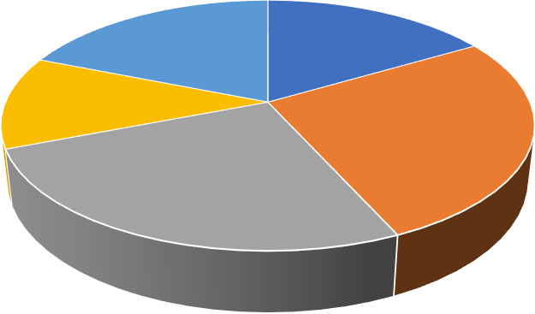
QUICK RATIO (IN TIMES)
1.67
1.46
1.06
2.36
2.28
1 2 3 4 5

Inference:

In chart 3.2.2, shows from 2019 to 2023, the quick ratio, which measures a company's ability to pay off current liabilities using only its most liquid assets, showed varying levels of liquidity. In 2020, the quick ratio peaked at 2.36 times, indicating that the company had a strong ability to cover its current liabilities with its most liquid assets (such as cash and receivables) by 23.6%. This peak in liquidity highlights an excellent financial position, possibly due to efficient asset management or a reduction in liabilities.

CASH RATIO

    - TABLE SHOWING CASH RATIO

YEARS | CASH&CASH EQ | C.L | CASH RATIOS
2019 | 5899174 | 50130580 | 0.117
2020 | 12737421 | 27917314 | 0.456
2021 | 69665189 | 23946808 | 2.909
2022 | 28474000 | 8044000 | 3.539
2023 | 211.23000 | 30104000 | 0.701

Findings:
In table 3.2.3, shows from 2019 to 2023, the company's cash ratio, which measures its ability to pay off current liabilities using cash and cash equivalents, showed considerable variation. In 2019, the ratio was low at 0.117 current liabilities covered by cash. It improved significantly in 2020 to 0.456, showing a stronger liquidity position. The ratio increased sharply in 2021 to 2.909 a strong cash position. In 2022, it further rose to 3.539, showing an excess of cash to cover liabilities by 2023, the cash ratio decreased to 0.701, reflecting a drop from previous years but still a reasonable cash position.

CHART SHOWING CASH RATIO
CASH RATIO
4
3.539
3.5
3
2.909
2.5
2
1.5
1
0.701
0.456
0.5
0.117
0
CASH RATIO
2019
0.117
2020
0.456
2021
2.909
YEARS
2022
3.539
2023
0.701
CASH RATIO
CASH RATIO

Inference:

In chart 3.2.3, shows from 2019 to 2023, the company's cash ratio, which measures its ability to pay off current liabilities using cash and cash equivalents, exhibited significant fluctuations. In 2022, the cash ratio peaked at 3.539 times, indicating an exceptional ability to cover its current liabilities using just cash and cash equivalents, with cash holdings 35.4% of current liabilities. This peak reflects an extremely strong liquidity position, suggesting a conservative approach to cash management or a significant reduction in current liabilities.

OPERATING CYCLE

    - TABLE SHOWING OPERATING CYCLE

YEARS | DIO | DSO | OPERATING CYCLE
2019 | 10442000 | 4212000 | 14654000
2020 | 14662000 | 2012000 | 16674000
2021 | 18948000 | 10027000 | 28975000
2022 | 8634000 | 9042000 | 17676000
2023 | 9524000 | 6774000 | 16298000

Findings:

In table 3.2.4, shows from 2019 to 2023, the company's operating cycle, which measures the time taken to convert inventory and accounts receivable into cash, varied over the years. In 2019, the operating cycle was 14,654,000, showing the overall efficiency of converting working capital. In 2020, the cycle lengthened slightly to 16,674,000. In 2021, the operating cycle increased significantly to 28,975,000, indicating a longer time to convert inventory and receivables into cash. The cycle decreased in 2022 to 17,676,000, suggesting improved efficiency. In 2023, the operating cycle decreased further to 16,298,000, reflecting continued efficiency improvements in the company's working capital management.

CHART SHOWING OPERATING CYCLE
OPERATING CYCLE

 | 2019 |  |  | 2020 |  | 2021 | 2022 | 2023
OPERATING CYCLE | 14654000 |  |  | 16674000 |  | 28975000 | 17676000 | 16298000

Inference:
OPERATING CYCLE
35000000
30000000
28975000
25000000

20000000
16674000
17676000
16298000
14654000
15000000

10000000

5000000

0
YEARS

In chart 3.2.4 shows from 2019 to 2023, the company's operating cycle, which measures the time taken to convert inventory and accounts receivable into cash, experienced changes. In 2021, the operating cycle peaked at 28,975,000, which is a 74% increase compared to the previous year. This significant extension in the cycle suggests potential inefficiencies in managing inventory and receivables, potentially impacting the company's cash flow and operational performance.

DAYS PAYABLES OUTSTANDING

    - TABLE SHOWING DAYS PAYABLES OUTSTANDING

YEARS | ACCOUNT PAYABLES | COGS | DPO
2019 | 10748994 | 55193 | 7108.57
2020 | 19599475 | 14159192 | 505.24
2021 | 5897488 | 10954636 | 196.49
2022 | 5766000 | 967000 | 2176.4
2023 | 5468000 | 293000 | 6811.67

Findings:
In table 3.2.5, shows from 2019 to 2023, the Days Payable Outstanding (DPO), which measures how long the company takes to pay its suppliers, showed significant fluctuations. In 2019, the DPO was high at 7,108.57 days, indicating a long period to pay off accounts payable. This dropped substantially in 2020 to 505.24 days, showing a quicker pace of payment. The DPO continued to decrease in 2021 to 196.49 days, reflecting a more efficient payment process. However, in 2022, the DPO increased again to 2,176.4 days, indicating a longer payment period. In 2023, the DPO reached its highest at 6,811.67 days, suggesting the company took an even longer time to pay its suppliers.

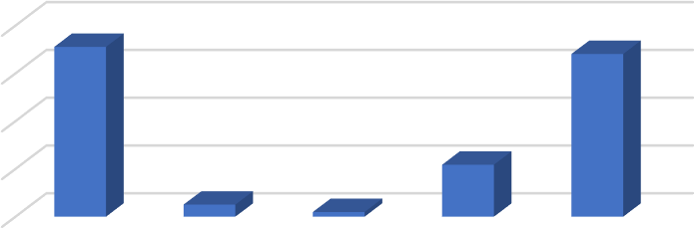
CHART SHOWING DAYS PAYABLES OUTSTANDING
DPO
8000
7108.57
6811.67
6000
4000
2176.4
2000 505.24
196.49
DPO
YEARS
DPO

0 | 2019 | 2020 | 2021 | 2022 | 2023
DPO | 7108.57 | 505.24 | 196.49 | 2176.4 | 6811.67

Inference:

From 2019 to 2023, the Days Payable Outstanding (DPO) experienced significant changes, reflecting the company's payment practices. In 2023, the days payable outstanding (DPO) reached its peak at 6,811.67 days, reflecting a dramatic increase of 213% compared to 2022. This substantial rise indicates the company took an unusually long time to pay its suppliers, potentially pointing to liquidity or working capital management challenges.

INVENTORY TURNOVER RATO

    - TABLE SHOWING INVENTORY TURNOVER RATIO

YEARS | COGS | AVERAGE INVENTORY | RATIOS
2019 | 55193 | 18930 | 2.91
2020 | 141591.92 | 78691 | 1.79
2021 | 10954636 | 3644360 | 3.00
2022 | 967000 | 321000 | 3.01
2023 | 293000 | 181500 | 1.61

Findings:

In table 3.2.6, shows from 2019 to 2023, the inventory turnover ratio, which measures how many times inventory is sold and replaced over a given period, showed fluctuations. In 2019, the ratio was 2.91, indicating moderate inventory turnover. In 2020, the ratio decreased to 1.79, suggesting a slower rate of inventory turnover. The ratio increased in 2021 to 3.00 and remained consistent in 2022 at 3.01, indicating a faster pace of inventory turnover. In 2023, the ratio dropped again to 1.61, suggesting a slower rate of inventory turnover compared to the previous two years.

CHART SHOWING INVENTORY TURNOVER RATIO
ITR
3.5
2.91
3
3.01
3

2.5

2
1.79
1.61
1.5

1

0.5

0
YEARS
ITR

 | 2019 | 2020 | 2021 | 2022 | 2023
RATIO | 2.91 | 1.79 | 3 | 3.01 | 1.61

Inference:

In chart 3.2.6, shows from 2019 to 2023, the inventory turnover ratio showed changes in the speed at which the company sold and replaced its inventory. In 2022, the inventory turnover ratio peaked at 3.01 times, reflecting the company's ability to convert its inventory into sales 301% of the time during the period. This high turnover rate indicates efficient inventory management, which can enhance cash flow and potentially boost profitability.

CASH CONVERSION CYCLE

    - TABLE SHOWING CASH CONVERSION CYCLE

YEARS | OPERATING CYCLE | DPO | CCC
2019 | 14654000 | 7589000 | 7065000
2020 | 16674000 | 8340500 | 98989000
2021 | 28975000 | 13930000 | 15045000
2022 | 17676000 | 9454000 | 8222000
2023 | 16298000 | 8490000 | 7808000

Findings:

In table 3.2.7 shows the data from 2019 to 2023 shows changes in the company's operating cycle, DPO, and CCC. The operating cycle fluctuated over the years, peaking in 2021 at 28,975,000 and declining to 16,298,000 by 2023. DPO showed a gradual increase, starting at 7,589,000 in 2019 and ending at 8,490,000 in 2023, with a peak in 2021. CCC had its highest point in 2021 at 15,045,000, followed by a decline to 7,808,000 in 2023. These trends suggest changes in the company's operational efficiency and cash management practices.

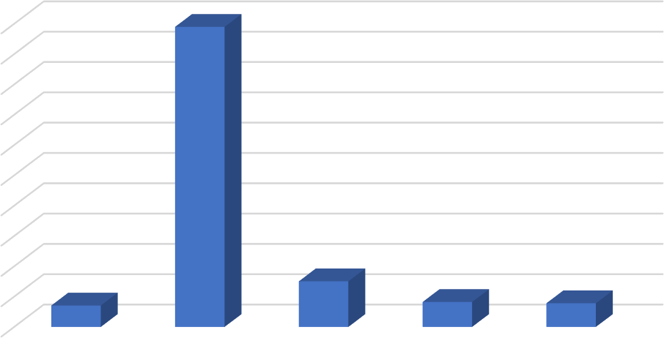
CHART SHOWING CASH CONVERSION CYCLE
CCC
98989000
100000000
90000000
80000000
70000000
60000000
50000000
40000000
30000000
15045000
20000000
10000000
7065000
8222000
7808000
YEARS
CCC

0 | 2019 | 2020 | 2021 | 2022 | 2023
CCC | 7065000 | 98989000 | 15045000 | 8222000 | 7808000

Inference:

In chart 3.2.7, shows analysing the data from 2019 to 2023, In 2021, the cash conversion cycle (CCC) reached its peak at 15,045,000, showing a 1,504.5% increase in time to convert resources into cash. This extended cycle suggests inefficiencies in working capital management, potentially impacting the company's liquidity and financial health.

RETURN ON TOTAL ASSETS

    - TABLE SHOWING RETURN ON TOTAL ASSETS

YEARS | NET INCOME | TOTAL ASSETS | ROA
2019 | 175114490 | 200114490 | 1.142
2020 | 134753709 | 159753709 | 0.8435
2021 | 145214405 | 170214405 | 0.8531
2022 | 164410000 | 189410000 | 0.8680
2023 | 206196000 | 231196000 | 0.8919

Findings:
In table 3.2.8, the data from 2019 to 2023 shows the company's net income, total assets, and return on assets (ROA). Net income increased over the years, rising from 175,114,490 in 2019 to 206,196,000 in 2023. Total assets followed a similar upward trend, starting at 200,114,490 in 2019 and reaching 231,196,000 in 2023. ROA also increased, starting at 1.142 in 2019 and ending at 0.8919 in 2023. This indicates that while net income and total assets have increased, the company's efficiency in generating profits from its assets has seen a slight decline.







CHART SHOWING RETURN ON TOTAL ASSETS
2023
2022
2021
YEARS
2020
2019
0.8

0.6

0.4

0.2

0
0.8919
0.868
0.8531
0.8435
1
1.142
1.2
R O A
ROA

Inference:

In chart 3.2.8, shows in 2023, the return on assets (ROA) peaked at 0.8919, representing an increase of 2.77% over the previous year. This peak suggests the company is effectively utilizing its assets to generate profit, indicating strong financial performance and efficient asset management.

WORKING CAPITAL INVESTMENT POLICY

    - TABLE SHOWING WORKING CAPITAL INVESTMENT POLICY

YEARS | CURRENT ASSETS | TOTAL ASSETS | WCIP
2019 | 73342395 | 200114490 | 0.3665
2020 | 66466863 | 159753709 | 0.4160
2021 | 54668053 | 170214405 | 0.3211
2022 | 8598054 | 189410000 | 0.0453
2023 | 50506790 | 231196000 | 0.2184

Findings:
In table 3.2.9, shows the data from 2019 to 2023 illustrates the company's trends in current assets, total assets, and working capital investment position (WCIP). Current assets declined from 73,342,395 in 2019 to 50,506,790 in 2023, showing a downward trend. Total assets consistently increased, from 200,114,490 in 2019 to 231,196,000 in 2023. WCIP varied over the years, starting at 0.3665 in 2019, dropping significantly to 0.0453 in 2022, and then rising slightly to 0.2184 in 2023. This suggests changing strategies in working capital management and investment positions, potentially impacting the company's liquidity and short-term asset utilization.

CHART SHOWING WORKING CAPITAL INVESTMENT POLICY
2021.5 2022 2022.5 2023 2023.5
2021
YEARS
0
2018.5 2019 2019.5 2020 2020.5
0.05
0.0453
0.2
0.15
0.1
0.2184
0.3
0.25
0.3211
0.35
0.3665
0.4
0.416
0.45
WCIP
WCIP

Inference:

In chart 3.2.9, shows in 2020, the working capital investment proportion (WCIP) peaked at 0.4160, showing an increase of 29% compared to 2019. This indicates that the company invested a significant portion of its total assets in working capital, suggesting a focus on maintaining a strong liquidity position or efficiently managing its day-to-day operations.

SCHEDULE OF CHANGE IN WORKING CAPITAL OF THE YEAR 2019&2020

Particulars | 2019 | 2020 | Increase | Decrease
Current Assets (A)
Inventories
Trade Receivable | 8878200 | 382214 |  | 8495986
Cash & Cash Equivalents | 5922294 | 12755393 | 6833099
Other Financial Asset | 49621690 | 44230260 | 5391430
Other Current Assets | 73342395 | 66466863 |  | 6875532
Total (A) | 137764579 | 123834730
Current Liabilities (B)
Borrowings
Trade Payable
Other Financial Liabilities | 105038927 | 138568251 | 33529324
Other Current Liabilities | 50130580 | 27917314 |  | 22213266
Provisions | 24485923 | 27099714 | 2613791
Total (B) | 179655430 | 55017028
Working Capital (A-B) | -41890851 | 68817702
Increase in Working  Capital |  | 26926851 | 26926851
Grand Total | 317420009 | 317420009

Findings:

In table 3.2.10, the data from 2019 to 2020 shows a significant change in the company's current assets and current liabilities, resulting in an increase in working capital. The company's working capital improved by approximately 110.7 million from 2019 to 2020, driven largely by a significant reduction in current liabilities, especially other financial liabilities, and other current liabilities. While trade receivables and other current assets decreased, cash and cash equivalents saw an increase. These changes suggest a shift towards better liquidity and short- term financial health for the company.

Inference:

In chart 3.2.10, shows from 2019 to 2020, the company's working capital improved by 110.7 million, representing a 264% increase. This was mainly due to a significant reduction in current liabilities, particularly in other financial and current liabilities. Additionally, there was an increase in cash and cash equivalents, while trade receivables and other current assets decreased. This shift indicates enhanced liquidity and improved short-term financial health.

SCHEDULE OF CHANGES IN WORKING CAPITAL IN THE YEAR 2020&2021

Particulars | 2020 | 2021 | Increase | Decrease
Current Assets (A)
Inventories
Trade Receivable | 382214
Cash & Cash Equivalents | 12755393 | 69676246 |  | 56920853
Other Financial Asset | 44230260 | 35586792 |  | 8643468
Other Current Assets | 66466863 | 54668053 |  | 11798810
Total (A) | 123834730 | 159931091
Current Liabilities (B)
Borrowings
Trade Payable
Other Financial Liabilities | 138568251 | 108369378 |  | 30198873
Other Current Liabilities | 27917314 | 23946808 |  | 3970506
Provisions | 27099714 | 25172732 |  | 1926982
Total (B) | 55017028 | 157488918
Working Capital (A-B) | 68817702 | 2442173
Increase in Working  Capital | 66375529 |  |  | 66375529
Grand Total | 317420009 | 317420009

Findings:

In table 3.2.11, shows from 2020 to 2021, the company's current assets increased significantly from 123,834,730 to 159,931,091 due to a rise in cash and cash equivalents. However, a sharp rise in current liabilities from 55,017,028 to 157,488,918 led to a decrease in working capital from 68,817,702 to 2,442,173. This shift indicates reduced liquidity and potential challenges in meeting short-term obligations.

Inference:

In chart 3.2.11, from 2020 to 2021, the company's working capital decreased by approximately
66.4 million, a 96% decline. This sharp drop was mainly due to a rise in current liabilities and decreases in other financial assets and other current assets. Despite higher cash and cash equivalents, the decrease suggests challenges in short-term liquidity and financial stability.

SCHEDULE OF CHANGES IN WORKING CAPITAL IN THE YEAR 2021&2022

Particulars | 2021 | 2022 | Increase | Decrease
Current Assets (A)
Inventories
Trade Receivable |  | 51100000
Cash & Cash Equivalents | 69676246 | 28487000 |  | 41189246
Other Financial Asset | 35586792 | 967000 |  | 34619792
Other Current Assets | 54668053 | 62582000 | 7913947
Total (A) | 159931091 | 143136000
Current Liabilities (B)
Borrowings |  | 7500000
Trade Payable |  | 4636000
Other Financial Liabilities | 108369378 | 967000 |  | 107402378
Other Current Liabilities | 23946808 | 8044000 |  | 15902808
Provisions | 25172732 | 30994000 | 25172732
Total (B) | 157488918 | 52141000
Working Capital (A-B) | 2442173 | 90995000
Increase in Working  Capital | -88552827 |  | -88552827
Grand Total | 299559000 | 299559000

Findings:

In table 3.2.12, shows from 2021 to 2022, the company's working capital increased significantly from 2.4 million to 90.9 million, indicating a dramatic improvement in liquidity and operational flexibility. This was primarily due to a substantial decrease in current liabilities, particularly other financial liabilities, and other current liabilities, despite reductions in cash and other financial assets.

Inference:

From 2021 to 2022, the company's current assets decreased by 10.6% due to reductions in cash and financial assets, while current liabilities dropped by 66.9%, mainly from decreased financial liabilities. This led to a significant increase in working capital from 2,442,173 to 90,995,000, indicating improved liquidity and operational flexibility.

SCHEDULE OF CHANGES IN WORKING CAPITAL IN THE YEAR 2022&2023

Particulars | 2022 | 2023 | Increase | Decrease
Current Assets (A)
Inventories
Trade Receivable | 51100000 | 67238000 | 16138000
Cash & Cash Equivalents | 28487000 | 21148000 |  | 7339000
Other Financial Asset | 967000 | 689000 |  | 278000
Other Current Assets | 62582000 | 11828000 | 50754000
Total (A) | 143136000 | 100903000
Current Liabilities (B)
Borrowings | 7500000
Trade Payable | 4636000 | 13077000 | 8441000
Other Financial Liabilities | 967000 | 293000 |  | 674000
Other Current Liabilities | 8044000 | 30104000 | 22060000
Provisions | 30994000 | 36925000 | 5931000
Total (B) | 52141000 | 80399000 | 28258000
Working Capital (A-B) | 90995000 | 20504000
Increase in Working Capital |  | 70491000
Grand Total | 299559000 | 299559000

Findings:

In table 3.2.13, shows from 2022 to 2023, the company's working capital decreased significantly by 70.49 million, dropping from 90.99 million to 20.5 million. This decline was primarily due to a reduction in current assets, particularly in cash and cash equivalents and other current assets. Meanwhile, current liabilities increased, especially in trade payables and other current liabilities, contributing to the decrease in working capital.

Inference:

From 2022 to 2023, the company's working capital decreased by 77.4%, from 90.99 million to
20.5 million. This decline was driven by a 29.6% decrease in current assets, particularly cash and other current assets, and a 54.2% increase in current liabilities, notably trade payables and other current liabilities. These changes suggest a significant reduction in liquidity and operational flexibility.

CAPITAL BUDGETING

When the Revele India private limited company depreciation 22% and share capital is Rs.20459060
find out:

      - Payback periods.
      - Discounted cash flow method taking cost of capital at 10 %.
      - Excess present value index.
      - Average rate of return on original investment.
      - Average rate of return on Average investment.

TABLE SHOWING PAYBACK PERIODS

a. Calculation of annual inflow cash

Particulars | 2019 | 2020 | 2021 | 2022 | 2023
Profit before tax and after dep% | 3358459 | 2061276 | 1578516 | 3260000 | 51820000
Less: tax 40% | 83961 | 51532 | 39463 | 81500 | 1295500
Profit after tax and dep | 3274498 | 2009744 | 1539053 | 3178500 | 50524500
Add: Dep% (20459060*22%) | 4500993 | 4500993 | 4500993 | 4500993 | 4500993
Annual Inflow cash | 7775491 | 6510737 | 6040046 | 7679493 | 55025493

Calculation of payback periods (Rs.20459060)

Years | Cash Inflow | Cumulative
2019 | 7775491 | 7775491
2020 | 6510737 | 14286228
2021 | 6040046 | 20326274
2022 | 7679493 | 28005767
2023 | 55025493 | 83031260

Payback period= 3 years+(204590-20326274)/7679493

= 37132786/7679493

= 3.017

Findings:

In table 3.2.14 shows from 2019 to 2023, the company's cash inflow steadily increased, with the most significant jump occurring in 2023 when it reached 55,025,493. The cumulative cash inflow consistently rose each year, starting at 7,775,491 in 2019 and ending at 83,031,260 in 2023. This shows a positive trend in the company's ability to generate cash over the years, with 2023 demonstrating a notable surge in cash inflow.

CHART SHOWING PAYBACK PERIODS
Cash Inflow

7775491

6510737

6040046

7679493
55025493

2019 2020 2021 2022 2023

Inference:

In chart 3.2.14 shows from 2019 to 2023, the company cash inflow experienced a significant increase of around 732.3%, rising from 7,775,491 in 2019 to 55,025,493 in 2023. The cumulative cash inflow also grew each year, reaching 83,031,260 in 2023, a cumulative rise of about 967.9%. This indicates the company's increasing success in generating cash, with 2023 showing exceptional growth.

TABLE SHOWING DISCOUNTED CASH FLOW METHOD/NET PRESENT VALUE
Years | Cash Inflow | Present value of 1@10% | Present value of cash inflows
 |  | (1*100/100)
2019 | 7775491 | 0.909 | 7067921
2020 | 6510737 | 0.826 | 5377868
2021 | 6040046 | 0.751 | 4536075
2022 | 7679493 | 0.683 | 52450947
2023 | 55025493 | 0.631 | 34170831
Total present value of cash inflows |  |  | 56397789
 |  | Investment | 20459060
 |  | Net present value | 35938729
*Net present value=present value of cash inflows-investments*

Findings:
The provided data shows the present value of cash inflows over five years from 2019 to 2023. There is a notable increase in cash inflows from 2019 to 2023, with the most significant rise occurring between 2021 and 2022. Specifically, the present value of cash inflows in 2022 is substantially higher compared to previous years, reaching a peak of 52,450,947. This upward trend continues, although to a lesser extent, into 2023 with a present value of 34,170,831. Overall, the data suggests a strong growth in cash inflows over the five-year period.

CHART SHOWING DISCOUNTED CASH INFLOW METHOD/ NET PRESENT VALUE
Present value of cash inflows
60000000
50000000
40000000
30000000
52450947
20000000
34170831
10000000
7067921
5377868
0
4536075
Years
Present value of cash inflows

 | 0 | 2019 | 2020 | 2021 | 2022 | 2023
Present value of cash inflows |  | 7067921 | 5377868 | 4536075 | 52450947 | 34170831

Inference:
The company's cash inflows show a volatile yet overall upward trend from 2019 to 2023. After a decrease of about 24% in cash inflows from 2019 to 2020, there was another decrease of roughly 15.7% from 2020 to 2021. However, cash inflows then surged dramatically by approximately 56% from 2021 to 2022, before a decrease of around 34.9% from 2022 to 2023.

TABLE SHOWING PROFITABILITY INDEX

Excess present value index = Present value of cash inflows/present value of cash outflows
= 56397789/20459060
= 2.75

ARR Calculation of profits after depreciation and tax

Particulars | 2019 | 2020 | 2021 | 2022 | 2023
Profit before tax and after  depreciation | 3358459 | 2061276 | 1578516 | 3260000 | 51820000
less: tax 40% | 83961 | 51532 | 39463 | 81500 | 1295500
Profit after tax and depreciation | 3274498 | 2009744 | 1539053 | 3178500 | 50524500

Average Profits = Total Profits/ No. of. Year’s
=83031260/5
=39010866
Average profits = 39010866

Findings:

The data presents the profit after tax and depreciation for the years 2019 through 2023. Initially, profits decrease steadily from 3,274,498 in 2019 to 1,539,053 in 2021. Following this decline, there is a significant recovery in 2022, with profits rising to 3,178,500. This upward trend continues into 2023 with a substantial increase in profits, reaching 50,524,500. Overall, the data suggests a strong upward shift in profits after 2021, culminating in a significant jump in 2023.

CHART SHOWING PROFITABILITY INDEX
Profit after tax and depreciation
60000000
50524500
50000000

40000000

30000000

20000000

10000000

0
Years
Profit after tax and dep%

 | 3274498 |  |  | 2009744 | 1539053 | 3178500
 | 2019 |  |  | 2020 | 2021 | 2022 |  |  | 2023
Profit after tax and depreciation | 3274498 |  |  | 2009744 | 1539053 | 3178500 |  |  | 50524500

Inference:

The data on profit after tax and depreciation from 2019 to 2023 shows a mixed trend. The company's profit after tax and depreciation saw a notable recovery, rising by 106.6% from 2021 to 2022 and then surging by approximately 1,489.6% from 2022 to 2023. This significant improvement highlights a strong turnaround in financial performance.

TABLE SHOWING ARR ON ORIGINAL INVESTMENT AND AVERAGE INVESTMENT
Calculation of ARR
Years | Cash inflows
2019 | 7775491
2020 | 6510737
2021 | 6040046
2022 | 7679493
2023 | 55025493
Total Profit | 83031260

Average Profits = Total Profits/ No. of. year
= 83031260/5
= 39010866
Average profits = 39010866

d. ARR on original investment

ARR on original investment = Average profit/original investment

= 39010866/20459060*100

= 52%

e. ARR on average investment

ARR on average investment = Average profit/average investment

= 39010866/10229530*100

= 26%

Findings:
The Accounting Rate of Return (ARR) on the original investment and average investment highlights the profitability of the investment. The ARR on the original investment shows a high return, indicating that the investment is highly profitable based on the initial amount invested. In comparison, the ARR on the average investment results in a lower return, suggesting a more moderate level of profitability when considering the average amount invested over the period. This difference shows the impact of the investment base on the rate of return.

CHART SHOWING ARR ON ORIGINAL INVESTMENT AND AVERAGE INVESTMENT
years
ARR
5 2023 55025493
4 2022 7679493
3 2021 6040046
2 2020 6510737
1 2019 7775491
0 10000000 20000000 30000000 40000000 50000000 60000000
 | 1 | 2 | 3 | 4 | 5
Calculation of ARR Cash inflows | 7775491 | 6510737 | 6040046 | 7679493 | 55025493
Calculation of ARR Years | 2019 | 2020 | 2021 | 2022 | 2023
Cash inflows

Calculation of ARR Cash inflows Calculation of ARR Years

Inference:
The Accounting Rate of Return (ARR) varies significantly depending on the investment base used. When calculated on the original investment, the ARR is 52%, indicating a strong return, whereas on the average investment, it is 26%, showing a more moderate profitability that is affected by the investment base size.

Solution:
 | Payback period | 3.02  years
 | Discounted Cashflow/Net present value | 35938729
 | Excess Present value index (or) profitability index | 2.75
 | ARR on Original Investment | 52%
 | ARR on Average Investment | 26%

FITTING A STRAIGHTLINE TREND (METHOD OF LEAST SQUARES)
    - TABLE SHOWING FITTING A STRAIGHTLINE TREND (METHOD OF LEAST SQUARES)
For the given time series, fit a straight-line trend of the type y=a+ bx by the method of least squares and find the trend value for the year 2024 and 2025.
YEARS | 2019 | 2020 | 2021 | 2022 | 2023
COST’S (OPERATING COSTS) | 46075052 | 33468635 | 31175905 | 44434000 | 58585000
YEARS(X) | COSTS(Y) | X=x-2021 | x2 | XY | TRENDLINE
2019 | 46075052 | -2 | 4 | -92150104 | 35550666
2020 | 33468635 | -1 | 1 | -33468635 | 39149192
2021 | 31175905 | 0 | 0 | 0 | 42747718
2022 | 44434000 | 1 | 1 | 44434000 | 46346244
2023 | 58585000 | 2 | 4 | 117170000 | 49944770
 | 213738592 | 0 | 10 | 35985261 | 213738590

Findings:

From 2019 to 2021, the data shows a downward trend, with values decreasing from 46,075,052 to 31,175,905. However, starting in 2022, values increase significantly, rising to 58,585,000 in 2023, and continue to grow steadily in 2024 and 2025, reaching 53,543,296 and 57,141,822 respectively.

CHART SHOWING FITTING A STRAIGHT-LINE TREND (METHOD OF LEAST SQUARES)
STRAIGHT FIT TRENDLINE
COSTS(Y)
90000000
80000000
70000000
60000000
50000000
40000000
30000000
20000000
10000000
0
Forecast(COSTS(Y))
Linear (Forecast(COSTS(Y)))
58585000
53543296
57141822
46075052
44434000
33468635
31175905
2019 2020 2021 2022 2023 2024 2025
COSTS(Y) 4607505233468635311759054443400058585000
Forecast(COSTS(Y)) 5354329657141822
YEAR'S
COST'S

Inference:

In chart 3.2.18, shows the data shows an initial decline from 2019 to 2021, with values decreasing by approximately 27.4% and then 6.9%. This trend reverses between 2021 and 2023 with a strong increase of around 42.5% and 31.9%, followed by a slight decrease in 2024 and a moderate increase in 2025, indicating overall growth with some fluctuations.

TABLE SHOWING DESCRIPTIVE STATISTICS OF VARIABLES

Variables | N | Range | Mean | Std. Error Mean | Std. Deviation | Minimum | Maximum
Current Ratio | 5 | 22.74 | 6.0540 | 4.44088 | 9.93010 | 1.06 | 23.80
Quick Ratio | 5 | 1.30 | 1.7660 | .24681 | .55189 | 1.06 | 2.36
Cash Ratio | 5 | 3.422 | 1.54440 | .699070 | 1.563168 | .117 | 3.539
Operating cycle | 5 | 1432100  0.00 | 1.8855E7 | 2.57631E6 | 5.76081E6 | 14654000.  00 | 28975000.  00
DPO | 5 | 6912.08 | 3.3597E3 | 1.50871E3 | 3.37358E3 | 196.49 | 7108.57
ITR | 5 | 1.40 | 2.4640 | .31368 | .70141 | 1.61 | 3.01
CCC | 5 | 9.19E7 | 2.7426E7 | 1.79482E7 | 4.01335E7 | 7.06E6 | 9.90E7
WCIP | 5 | .3707 | .273460 | .0657009 | .1469118 | .0453 | .4160
ROA | 5 | .2985 | .919700 | .0561716 | .1256036 | .8435 | 1.1420

Inference:
The descriptive statistics provide a comprehensive overview of the company's financial metrics. The mean current ratio, quick ratio, and cash ratio indicate the company's liquidity position, with values of 6.054, 1.766, and 1.5444 respectively. These values suggest that the company
has a healthy liquidity position, capable of meeting short-term obligations efficiently. Additionally, the descriptive statistics for operating cycle, days of payables (DOP) ratio, cash conversion
cycle (CCC), and others offer insights into various aspects of the company's financial operations, such as efficiency in inventory management and accounts payable turnover.

TABLE SHOWING THE CORRELATIONS

Correlations

 |  | Operating cycle | DOP | RATIO | CCC | WCIP
Operating cycle | Pearson  Correlation | 1 | -.630 | .406 | -.133 | .056
 | Sig. (2-tailed) |  | .255 | .498 | .831 | .929
 | N | 5 | 5 | 5 | 5 | 5
DOP | Pearson  Correlation | -.630 | 1 | -.179 | -.529 | -.065
 | Sig. (2-tailed) | .255 |  | .773 | .359 | .917
 | N | 5 | 5 | 5 | 5 | 5
RATIO | Pearson  Correlation | .406 | -.179 | 1 | -.512 | -.259
 | Sig. (2-tailed) | .498 | .773 |  | .378 | .674
 | N | 5 | 5 | 5 | 5 | 5
CCC | Pearson  Correlation | -.133 | -.529 | -.512 | 1 | .559
 | Sig. (2-tailed) | .831 | .359 | .378 |  | .328
 | N | 5 | 5 | 5 | 5 | 5
WCIP | Pearson  Correlation | .056 | -.065 | -.259 | .559 | 1
 | Sig. (2-tailed) | .929 | .917 | .674 | .328
 | N | 5 | 5 | 5 | 5 | 5

Inference:

The correlation analysis explores the relationships between various financial metrics, such as operating cycle, DOP ratio, CCC, and others. The correlation matrix reveals associations between these variables, providing insights into their potential interactions. For example, a negative correlation of -0.63 between the operating cycle and DOP ratio suggests that as the operating cycle decreases, the DOP ratio tends to increase, indicating potential efficiency gains in managing payables. These correlations offer valuable insights into the interconnectedness of financial metrics within the company.

TABLE SHOWING THE REGRESSIONS

Variables Entered/Removedb
Model | Variables Entered | Variables Removed | Method
1 | Cash ratio, quick  ratio, current ratioa | . | Enter
- All requested variables entered.
- Dependent Variable: ROA

Model Summary
Model | R | R Square | Adjusted R Square | Std. Error of the Estimate
1 | .817a | .668 | -.330 | .1448427
  - Predictors: (Constant), cash ratio, quick ratio, current ratio

ANOVA
Model |  | Sum of Squares | df | Mean Square | F | Sig.
1 | Regression | .042 | 3 | .014 | .669 | .691a
 | Residual | .021 | 1 | .021 | .669 | .691a
 | Total | .063 | 4 |  | .669 | .691a
- Predictors: (Constant), cash ratio, quick ratio, current ratio

- Dependent Variable: ROA

Coefficientsa
Model |  | Unstandardized Coefficients |  | Standardized Coefficients | t | Sig.
 |  | B | Std. Error | Beta | t | Sig.
1 | (Constant) | 1.162 | .291 |  | 3.991 | .156
 | Current ratio | -.006 | .010 | -.472 | -.599 | .656
 | Quick ratio | -.063 | .170 | -.276 | -.369 | .775
 | Cash ratio | -.062 | .050 | -.766 | -1.224 | .436
b. Dependent Variable: ROA

Inference:

The regression model assesses the relationship between ROA (return on assets) as the dependent variable and three predictors: current ratio, quick ratio, and cash ratio. The model summary indicates an R-squared value of 0.668, suggesting that the predictors account for approximately 66.8% of the variance in ROA, though the adjusted R-squared is negative, indicating possible overfitting.
The ANOVA results show that the model's F-value is 0.669 and is not statistically significant (p=0.691), suggesting that the overall model does not significantly predict ROA.
Examining the coefficients, the constant is statistically insignificant (p=0.156), indicating that the intercept may not be meaningful. None of the three ratios (current, quick, and cash) show

statistically significant relationships with ROA, as all p-values are well above 0.05. Current ratio, quick ratio, and cash ratio all exhibit negative coefficients, suggesting an inverse relationship with ROA, though these relationships are not strong enough to be significant. Overall, the model does not demonstrate a significant impact of the three liquidity ratios on ROA, indicating that other factors may have a more substantial influence on the company's return on assets.

SUMMARY OF FINDINGS

- The company's current ratio peaked at an unusually high 23.8 in 2020, suggesting excessive liquidity, which has since normalized.
- The company's quick ratio peaked at 2.36 in 2020, showing strong liquidity, but subsequently decreased, suggesting a shift in financial stability.
- The company's cash ratio peaked dramatically in 2022, reflecting an excess of cash reserves for covering current liabilities.
- The company's operating cycle experienced changes between 2019 and 2023, lengthening significantly in 2020 and 2021, indicating a slowdown in efficiency. However, the cycle improved in 2022 and 2023, showing a trend toward greater efficiency in converting working capital to cash.
- The company's Days Payable Outstanding (DPO) experienced significant fluctuations from 2019 to 2023, starting with a high DPO in 2019, decreasing until 2021, and then increasing significantly to reach its highest level in 2023, indicating a variable pace in the company's payment to suppliers.
- The inventory turnover ratio showed fluctuations, with moderate turnover in 2019, a slower rate in 2020, a rise to faster turnover in 2021 and 2022, and a significant slowdown in 2023, indicating varying efficiency in managing and selling inventory.
- The operating cycle increased significantly before decreasing, DPO showed a moderate rise, and the cash conversion cycle (CCC) peaked in 2021 before declining, indicating varying operational efficiency and changes in the company's cash management strategies.
- The company's net income and total assets increased over the years, but its efficiency in generating profit from assets, as indicated by ROA, gradually declined, reflecting a decrease in profitability relative to asset growth.
- The company's current assets decreased significantly while total assets increased, indicating a shifting approach to working capital management. Meanwhile, WCIP experienced a drastic drop before partially recovering in 2023, suggesting changing strategies in liquidity and asset utilization.
- The company's current assets decreased by 10.1%, while current liabilities fell by 69.4%. This led to a dramatic improvement in working capital, shifting from a deficit to a surplus, and greatly enhancing liquidity and operational capacity.

- The company's current assets increased by about 29.1%, while current liabilities rose dramatically by around 186.2%. This resulted in a sharp 96.5% decline in working capital, indicating a significant deterioration in liquidity and short-term financial stability.
- The company's current assets decreased by 10.6%, while current liabilities dropped by 66.9%, leading to a substantial increase in working capital and a significant improvement in liquidity and operational flexibility.
- The company's current assets decreased by about 10.6%, while current liabilities dropped by 66.9%, resulting in a substantial increase in working capital and a significant improvement in liquidity and operational flexibility.
- Over the five years from 2019 to 2023, the company's cash inflow rose significantly, reaching 55,025,493 in 2023. This led to a cumulative increase from 7,775,491 in 2019 to 83,031,260 in 2023, showcasing substantial success in generating cash, especially in 2023.
- The data reveals a volatile yet upward trend in cash inflows from 2019 to 2023, with significant fluctuations in the rate of increase, including a sharp rise between 2021 and 2022 followed by a decrease from 2022 to 2023.
- The data on profit after tax and depreciation from 2019 to 2023 shows a volatile pattern with initial declines from 2019 to 2021, followed by a significant recovery and surge in profits from 2021 to 2023, with the most notable improvement occurring between 2022 and 2023.
- The Accounting Rate of Return (ARR) varies depending on the investment base, with a strong 52% ARR on the original investment suggesting high profitability, while a more moderate 26% ARR on the average investment indicates lower profitability, reflecting the impact of the investment base on the return.
- The data shows an initial decline in annual values from 2019 to 2021, followed by a significant upward trend from 2021 to 2023. There is a slight decrease from 2023 to 2024, and then a moderate increase from 2024 to 2025, indicating an overall pattern of growth with some fluctuations.
- Descriptive statistics reveal strong liquidity with high mean ratios and provide insights into operational efficiency in inventory and accounts payable management.
- Correlation analysis shows the interconnectedness of financial metrics, such as a negative correlation of -0.63 between operating cycle and DOP ratio, indicating potential efficiency gains in managing payables as the operating cycle decreases.
- The regression model shows no significant impact of current, quick, and cash ratios on ROA, suggesting other factors may influence the company's return on assets.

SUGGESTIONS

- Implement stable liquidity management practices to mitigate fluctuations in the current ratio.
- Conduct further analysis to identify additional variables that may influence return on assets.
- Optimize working capital management, particularly in areas such as payables turnover and cash conversion cycle.
- Enhance efficiency in inventory management to reduce the operating cycle and improve cash flow.
- Explore opportunities to reduce debt levels and improve the debt-to-equity ratio.
- Monitor and analyse key financial metrics regularly to identify trends and areas for improvement.
- Consider diversifying revenue streams or product lines to enhance profitability and reduce risk.
- Invest in technology and automation to streamline financial processes and improve efficiency.
- Evaluate supplier relationships and negotiate favourable payment terms to optimize cash flow and working capital.

3.4 CONCLUSION

In conclusion, our analysis underscores the importance of maintaining a vigilant eye on key financial metrics to ensure the organization's continued success. While the company demonstrates strength in liquidity and operational efficiency, there are clear opportunities for improvement in managing liquidity fluctuations and optimizing working capital. By implementing the suggested strategies and closely monitoring financial performance, the organization can bolster its financial health, sustainability, and competitiveness in the marketplace.

APPENDIX

BIBLIOGRAPHY

REFERENCE BY

- Financial Planning Using Excel: Forecasting, Planning and Budgeting Techniques- By Sue Nugus
- Financial Planning, Budgeting, and Forecasting in the New Economy- By Nick Castellina and David Hatch. Aberdeen Group. A Report from March 2011.

- Financial Forecasting, Analysis. and Modelling- By Michael samonas.

- Financial analysis, planning and forecasting: Theory and application-AC Lee, JC Lee, CF Lee – 2009.
- Artificial Intelligence and human collaboration in financial planning-
July 2018 by Naveen Kunnathuvalappil Hariharan

- De Gooijer, J. G., & Hyndman, R. J. (2006). 25 years of time series forecasting. International Journal of Forecasting, 22, 443–473.

- “Financial statement analysis, forecasting and budgeting: an integrative teaching approach”- Harry white 2013.

WEBSITES

https://www.investopedia.com/ https://scholar.google.com/ https://ijrar.org/

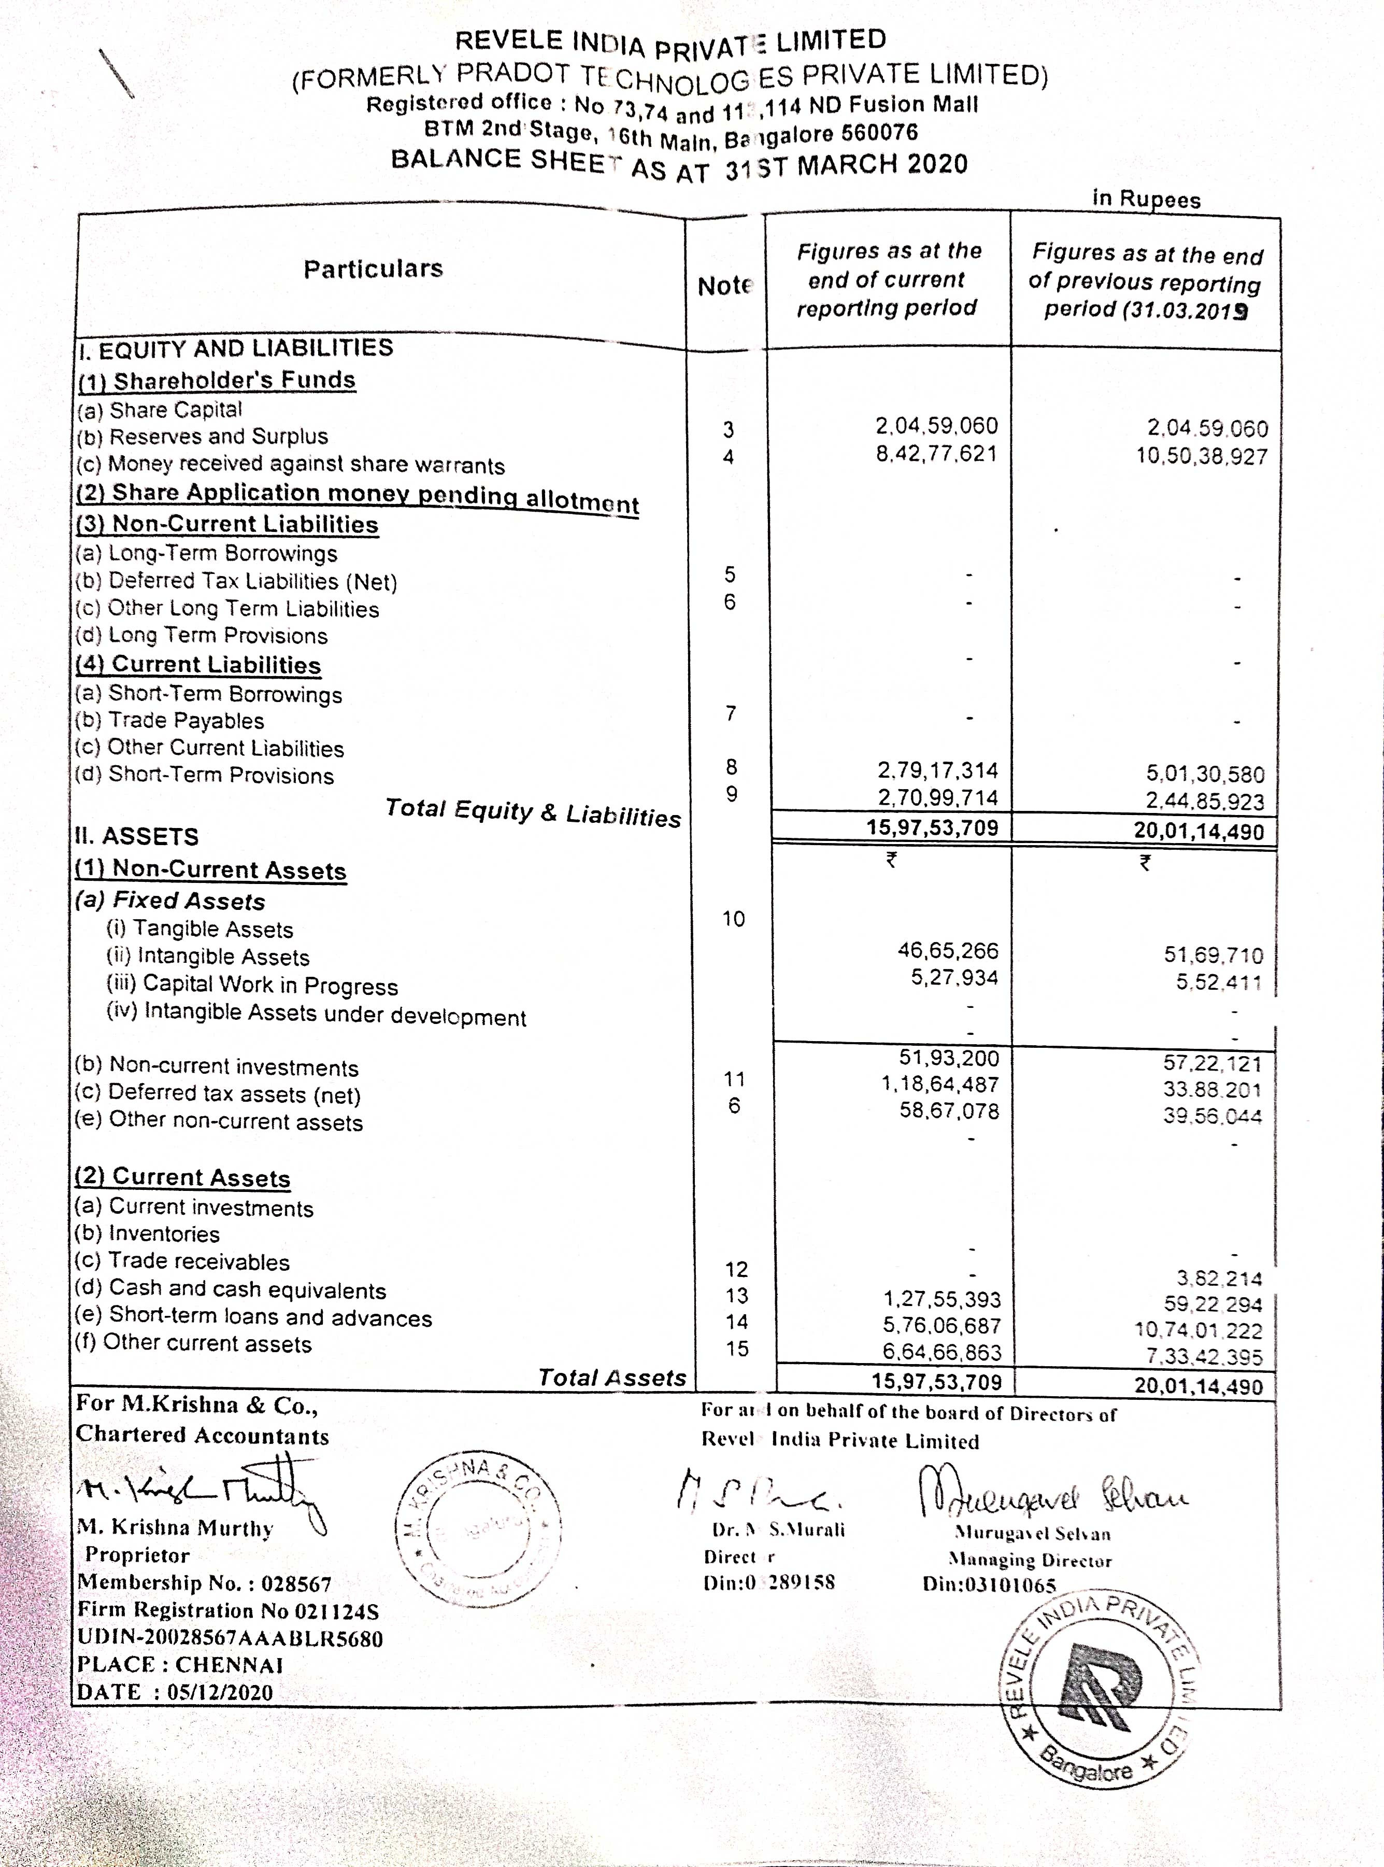

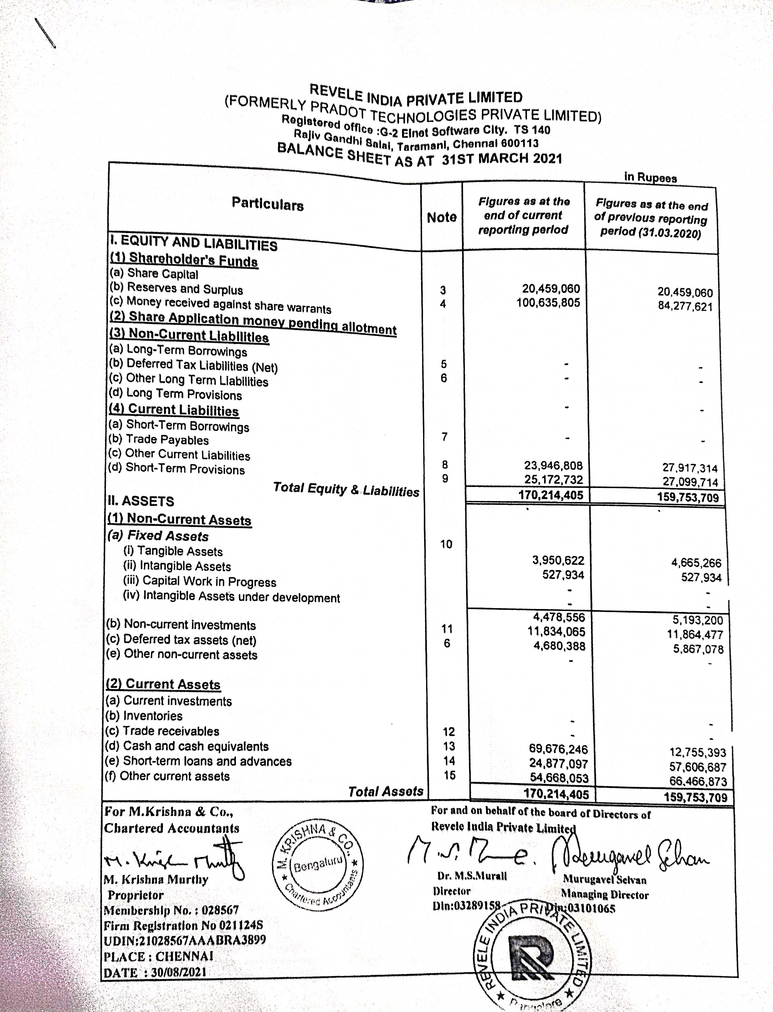

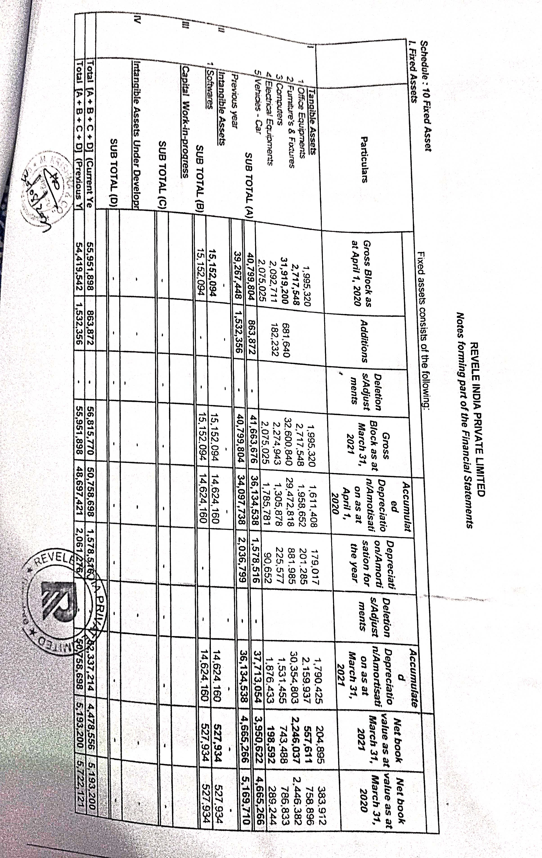

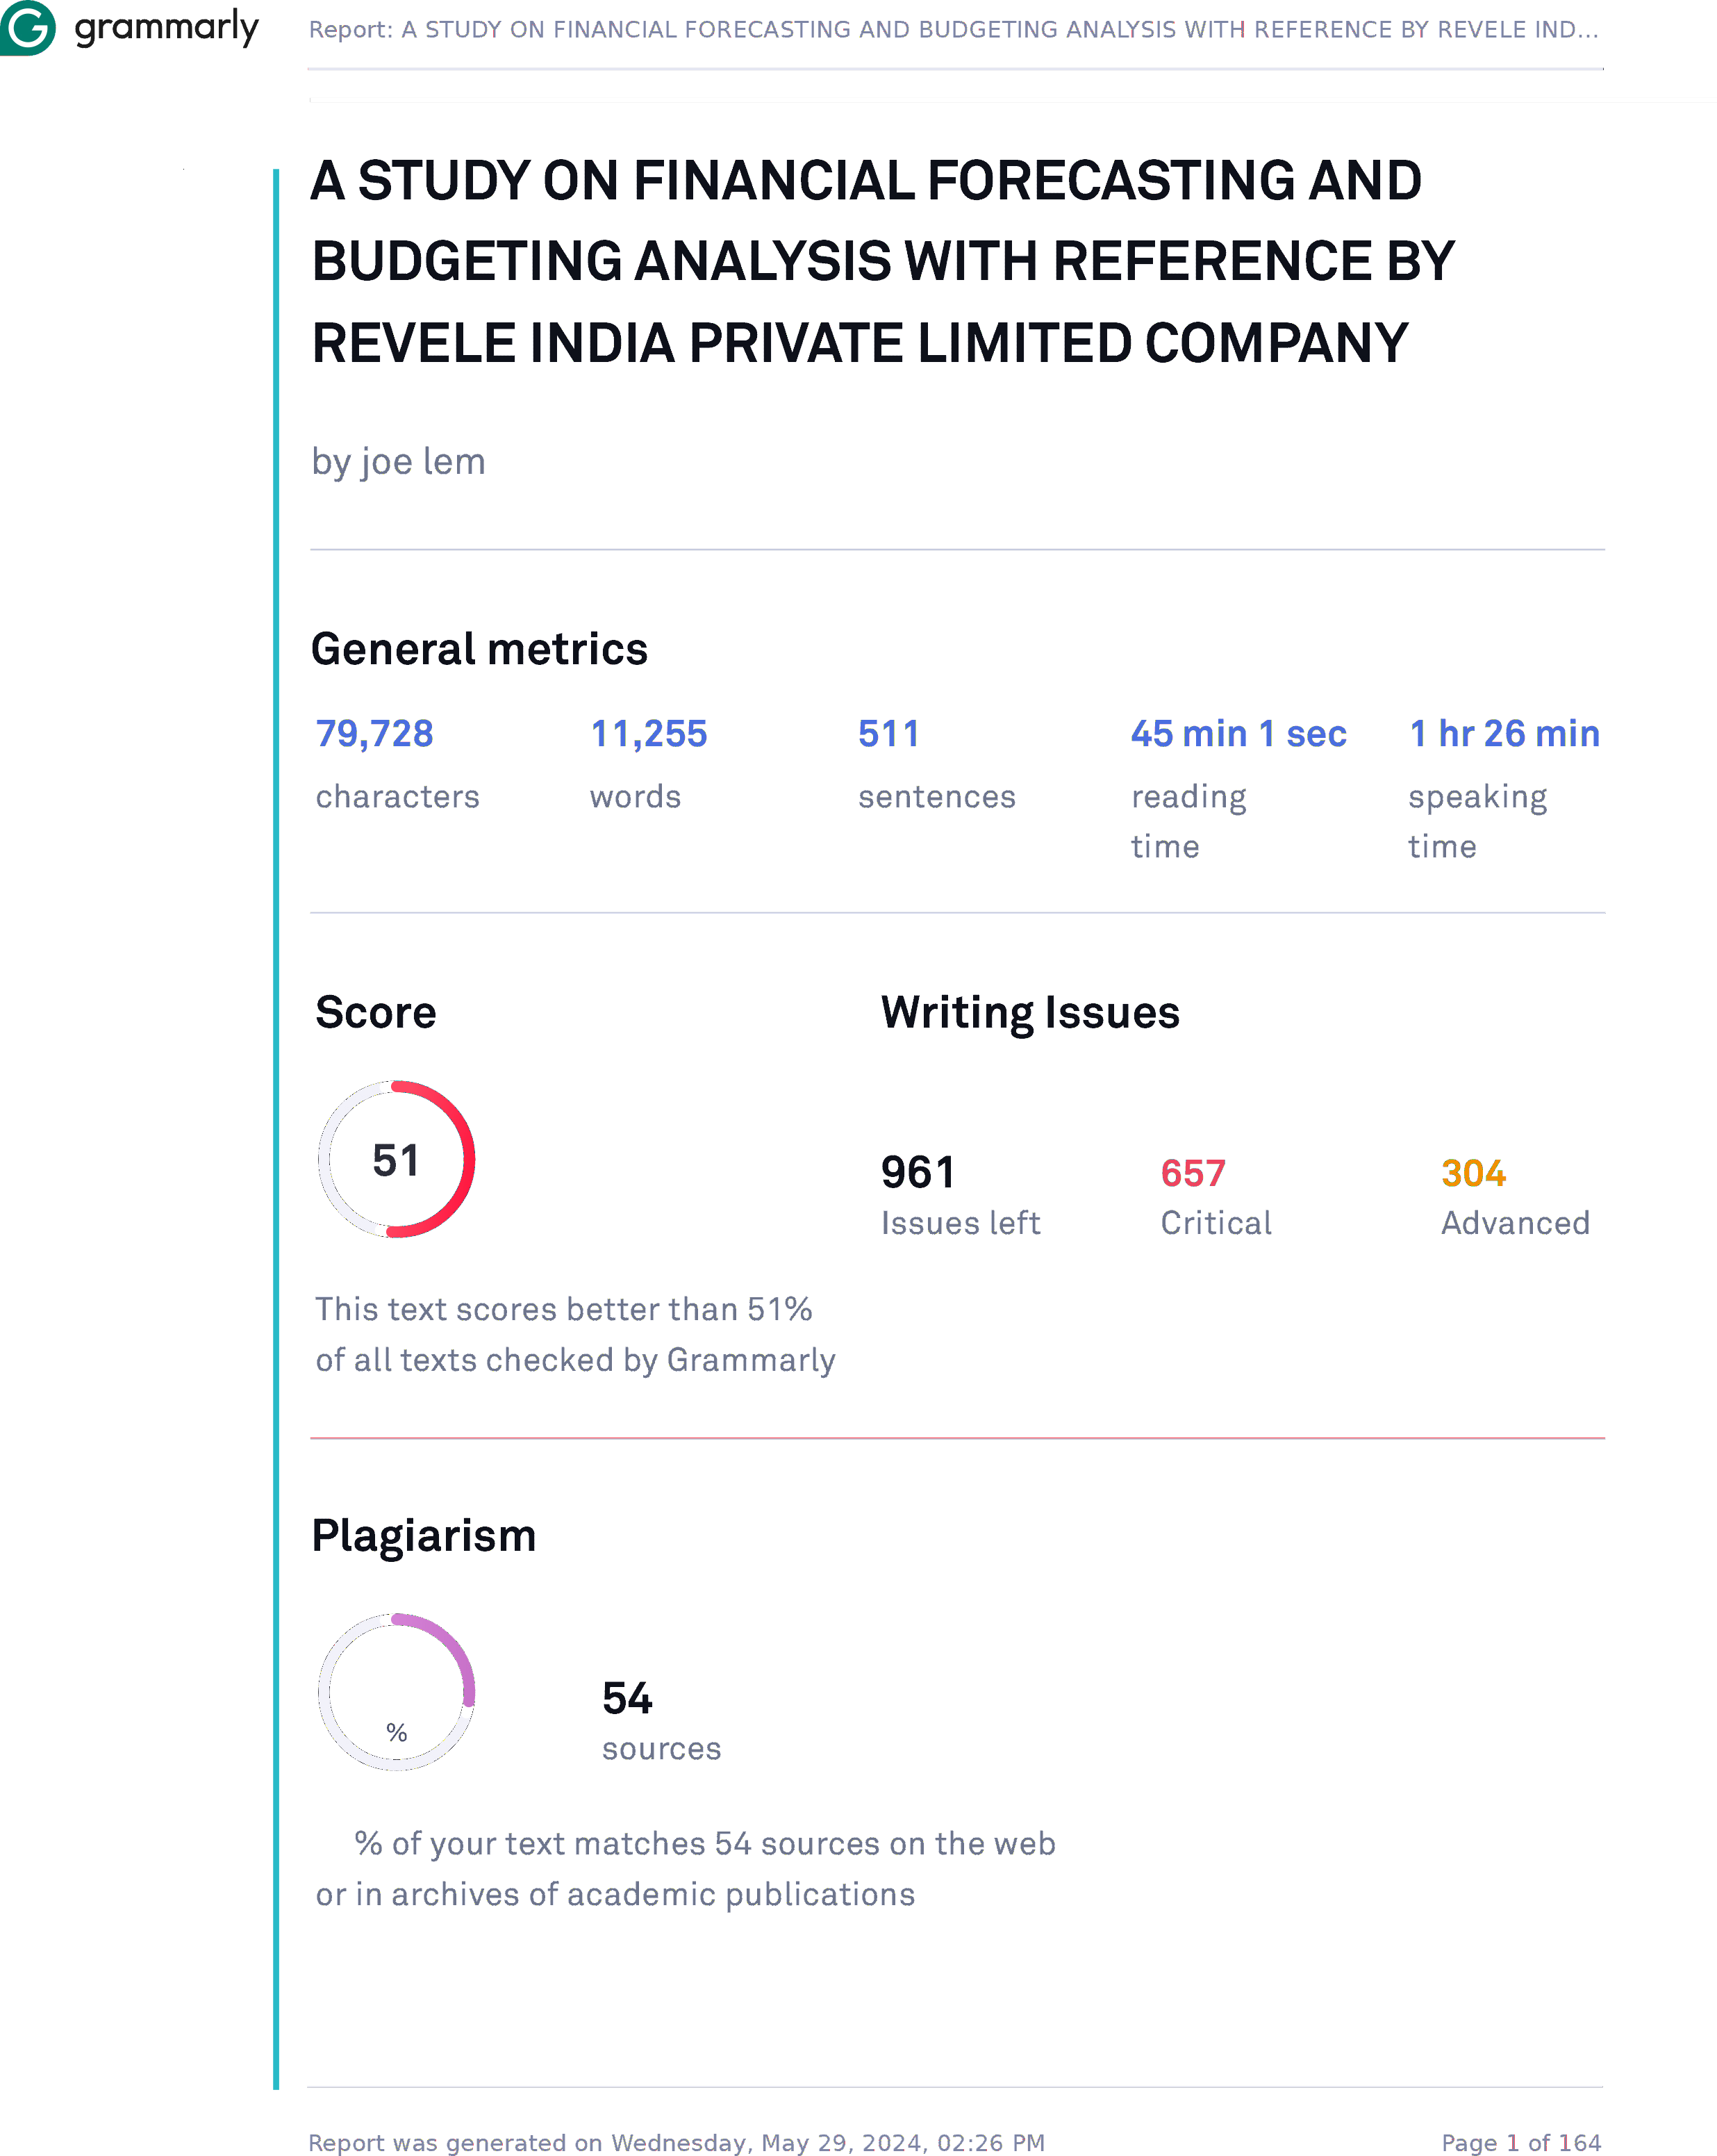

20

20

