ABSTRACT:-

Haldiram's, a leading Indian snack company, faces a dynamic business environment where effective HR decisions are crucial for its continued success. This study investigates the impact of HR decisions on various aspects of Haldiram's organization, including:

Employee performance and productivity:

HR practices such as recruitment, training, and performance management significantly influence employee morale, engagement, and ultimately, their contribution to the organization's goals.

Organizational culture and employer branding:
HR policies and practices shape the company culture, impacting employee satisfaction, loyalty, and brand image.

Cost management and profitability: HR decisions have a direct impact on costs associated with recruitment, training, compensation, and employee turnover.

INTRODUCTION

Human Resources is a basic need of any work to be done .Human Resource Management is concerned with the “human Being” in an organization. Human Resource Management is viewed in the way of staff and support which provides assistance in HRM matters to Line employees, or those directly involved in producing organization’s goals and services . HRM is a function of every manager’s job. Whether or not one in a “FORMAL HRM” department, the facts remain that to effectively managers to handle the activities. Human Resource planning helps determine the number and types of the people an organization needs . Recruitment follows Human resource planning and goes hand in hand with the selection process by which organizations evaluate the suitability of the prospective candidates for the job . Job analysis and job design specify the tasks and duties of jobs and the qualifications expected form prospective job holders . The next logical step is to select the right number of people the right type to fill the jobs. Selection involves two broad gropes of activities:

Recruitment
- Selection.

Recruitment is a process of searching out the potential applicants and inspiring them to apply for the actual or anticipated vacancy whereas Selection is a process of hiring employees among the shortlisted candidates and providing them a job in the organization. An organization small or large, profit or service oriented, the ultimate aim is to achieve organizational goal. This

achievement can only be possible through skilful and management of power. Selection is a key component in the acquisition of human resources. Without a reliable selection mechanism, a business can never flourish, especially in the present world market Economy, which is fiercely competitive and dynamic. Usually after successful completion of recruitment, selection and induction process the new employee must be developed to better fit the job and organization. Haldiram company has an enriched and skilled Human resource Division. HRD through definite and systematic recruitment and selection procedure selects and trains up its manpower for achieving its ultimate goal. This study is important because we find out the methods of Haldiram adopts for recruitment and selection and some recommendations for their better effect in future.

OBJECTIVES OF THE STUDY

BROAD OBJECTIVES

    - To make familiar with the terms what I have studied during BBA course.
    - To know about the HR functions and processes at Haldiram private ltd
    - To get an overall idea about the management functions and operation strategy of Haldiram company.

SPECIFIC OBJECTIVES

- To be familiar with the HR Management at Haldiram company
- To fulfill the partial requirement of BBA degree.
- To gather comprehensive practical knowledge on the Recruitment and selection process and to know how Haldiram company works at operational level

Hierarchy chart

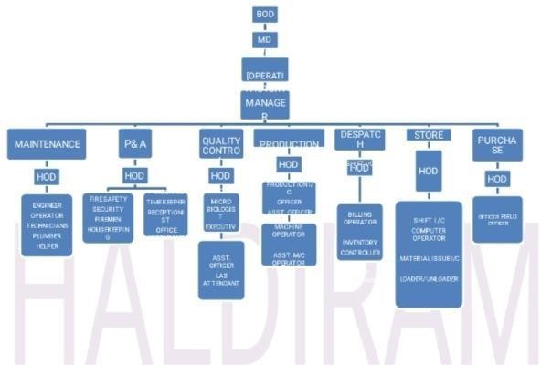

Haldiram's mission:-



Haldiram’s began as a tiny shop in Bikaner, the land as famed for its savouries as for its leather- faced pipe players and fierce warriors. By 1982, Haldiram’s had set up shop in Delhi and the capital had begun to stop by and take note of the savouries and sweets. It was word of mouth that grew the business manifold over the next decade till Haldiram’s came to stand for a food company that was synonymous with taste, hygiene and innovation.
USA was the first market we started exporting to, thanks to the large Indian population there.We began with about 15 products, all savouries, because they are a favourite with Indians.

What began as a small-town enterprise in india is today a global phenomenon. Haldiram’s is a way of life for Indians no matter which country they live in.And the Countries they live in are also fast developing a penchant for these products.

Their mission is fortified by 4 core beliefs:

- Dedication to manufacturing.
- Complete control over core components and technology.
- Nurturing and leveraging a powerful brand.
- Pursuing ethical business practices.

Haldiram’s products

Haldiram’s is very traditional in terms of advertising and promotions. However, to be in sync with current times, Haldiram’s tied up with the 2015 Bollywood film Prem Ratan Dhan Payo and more than 1.5 crore (15 million) Haldiram’s snack packets were printed with the logo of the film. The chain is actively expanding its franchises. Haldiram has following category of products:

Sr. No. | Products name
1. | Namkeen
2. | Tin packed sweets
3. | Sweets
4. | Syrups
5. | Pickle
6. | Papads
7. | Dry fruits

Namkeen’s:
- Chana bhujia
- Elaichi bhujia
- All in one
- Aloo bhujia
- Navratan mixture
- Chatpata mixture
- Corn flakes
- Nut cracker
- Aloo khelra
- Kaju dalmoth
- Badam laccha
- Badam dalmoth
- Bhujia
- Chana dal masala
- Khatta meetha
- Murukku.
- Chana chips

Tin packed sweets:
    - Raj bhog
    - Angoori petha
    - Orange rasgulla
    - Pineapple rasgulla
    - Gulab jamun
    - Mango rasgulla
    - Classic rasgulla

Sweets:

- Kesaria laddu | - Soan cake rose
- Kaju barfi | - Soan cake orange

- Sakkar para | - Soan cake cashew
- Badam barfi | - Dry fruits chikki
- Soan papdi | - Soan cake chocolate
- Kumra petha | - Soan cake strawberry
- Kesaria peda | - Chandrakala
- Moong laddu | - Mathura peda
- Milk peda

  - Syrups:
- Khus syrup
- Badam syrup
- Pineapple syrup
- Keshariya thandai syrup
- Rose syrup
- Orange syrup
- Green mango syrup

Pickles:
- Mixed pickle
- Mango pickle
- Green chilli pickle
- Lemon pickle
- Lime ginger garlic
- Garlic mango pickle
- Sweet mango laccha
- Crushed red chilli pickle
- Mango kasundi pickle

Papads:

- Plain papad
- Masala papad
- Crispy papad
- Bikaneri papad

Dry fruits:
- Cashew
- Almonds
- Akhrot
- Resin
- Almonds

Brand recognition

The strength of the HALDIRAM brand is reflected in the impressive list of achievements below:

- Consistently the most preferred brand.
- Company” in India’s “Most Admired Marketing Consumer Namkeens and Sweets.
- The “most preferred brand” in Namkeens and Sweets. – Brand Equity Survey.
- The “No. 1 FMCG Brand”.

One of the “top coolest brands among Family”. – Brand Equity Survey
QUALITY POLICY

HALDIRAM FOODS INTERNATIONAL LTD are committed to Manufacture variety of Sweets (Sweetmeats), Namkeens (Savouries), Pasta & 3 – D Snacks (Extruded Foods)to the complete satisfaction of Domestic & International Customers with regard to Quality & Food Safety.

They strive to provide world class quality products by:

- Utilizing hygienic, safe and premium quality ingredient and material.

- Adhering to good manufacturing and hygienic practices .

They are committed to continually improve all activities to enhance customer satisfaction, organizational performance and market leadership. They comply with Statutory, regulatory requirements and all their actions are planned and executed to fulfill this policy consistently through to dedicated involvement of all employee.

Company’s exports

EXPORTS:

Around 20 million ethnic Indians spread in over a number of countries around the world and they have started export of sweets and snacks in way back 1996 to reach the ethnic Indians abroad. They keep 50+ export worthy products and are successfully exporting them to around 16 countries.
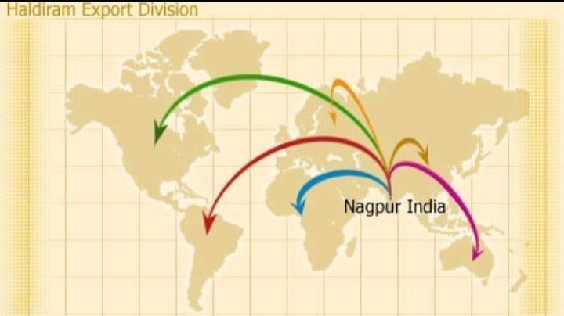

The quality of products is backed with ISO-9001:2000 and HACCP Certification. 20+ imported machineries and new techniques of manufacturing bases a true International look and helps in meMain exported products:

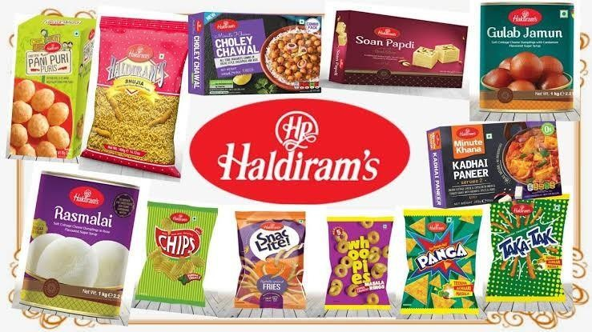

- NAMKEEN
- SWEETS
- PAPAD
- GIFT BOXES
- BAKERY PRODUCTS

Main exported products:

- NAMKEEN
- SWEETS
- PAPAD
- GIFT BOXES
- BAKERY PRODUCTS

THE ROAD AHEAD:

In the financial year 2001-2002, the combined turnover of all three units of Haldiram’s Was estimated at Rs. 4 billion. The company targeted a growth of 15% for the financial Year 2002-2003. Analysts felt that, given the competition in the industry, Haldiram’s Needed to develop new initiatives achieve this growth.

The competition in the ready-to-eat snack foods market in India was intensifying. Frito Lay India ltd. (Frito Lay), one of Haldiram’s major competitors, was expanding its Market share. Instead of directly competing with the market leader Haldiram’s, the Company launched innovative products in the market and backed them with heavy Publicity. Frito Lay’s product range consisted of a mixture of traditional Indian and Western flavors which appealed to younger and older generations. Its products included
Lehar Namkeens, Lehar Kurume (snack sticks), Lays (flavored Chips), and Cheetos (snack Balls), Uncle Chips and Nutyumz (nut snacks). Frito-Lay was the first company to launch Small 35 gm packs namkeens priced at Rs. 5 and also the first company in the organized Sector to launch Aloo Bhujia Another competitor, SM Foods, introduced a range of Innovative products.

RESEARCH METHODOLOGY

OBJECTIVE OF THE STUDY

The main objective of the study is to study the various roles of human resource at Haldiram’s . This study helps to determine what roles are carried out by the human resource personnel and how they are performed. This study highlights what lacks in human resource management and what can be done to improve the role of management in the Haldiram’s

RATIONALE OF THE STUDY

During the work ,I have studied the company’s manuals , human resource policies and the information collected from employees via interaction and then analysing them in order to make data meaningful.

SCOPE OF THE STUDY

This study defines the expectations of the employees from the company, company's expectations from the employees and existing human resource development policy, norms and operations that are taking place in haldiram's.

CRITICAL REVIEW OF LITERATURE

INTRODUCTION OF THE FMCG SECTOR

The Fast-moving consumer goods (FMCG) sector is the 4th largest sector of the Indian economy. It is characterised by high turnover consumer packaged goods, i.e. goods that are produced, distributed, marketed and consumed within a short span of time.FMCG companies maintain intense distribution network. Companies spend a large portion of their budget on maintaining distribution networks. New entrants who wish to bring their products in the national level need to invest huge sums of money on promoting brands. Manufacturing can be outsourced. A recent phenomenon in the sector was entry of multinationals and cheaper imports. Also the market is more pressurized with presence of local players in rural areas and state brands.
Fast Moving Consumer Goods (FMCG) goods are popularly named as consumer packaged goods. Item in this category include all consumables (other than groceries/pulses) people buy at regular intervals. The most common in the list are toilet soaps, detergents, shampoos toothpaste, shaving products, shoe polish, packaged foodstuff, household accessories and extends to certain electronic goods. These items are meant for daily of frequent consumption and have a high return. A major portion of the monthly budget of each household is reserved for FMCG products.

ANALYSIS

HUMAN RESOURCE OPERATIONS OF HALDIRAM’S MANUFACTURING LTD.

    - Recruitment
    - Job analysis
    - Competency analysis
    - Gap analysis or mapping process
    - Skill matrix

RECRUITMENT AND SELECTION

Recruitment and selection are the most Important functions in an organization because With the help of these functions the Management selects the best available Candidate from a batch of them. The Organizations in this growing competitive World, need to have the best of the manpower so as to have an edge over its competitive.

SOURCES OF RECRUITMENT AT HALDIRAM:

Internal Sources:-
- Present Employees who can be transferred or given promotions.
- The retired and retrenched employees who want to return to the company.
- Dependents and relatives of the deceased and disabled employees.

External Source: -
- Placement Agencies.
- Recommendations.
- Recruitment at factory gate.
- Employment Exchanges.

Selection
Selection is the process of choosing the best candidate out of the all the applicants. In this process, relevant information about the applicants is collected through a series of steps so as to evaluate their suitability for the job to be filled. It is the process of matching the qualifications with those required for the job so that the candidate can be entrusted with the task that matches with his credibility. It is a process of weeding out unsuitable candidates and finally identifying the most suitable candidates.
This process divides the candidates into two categories-the suitable ones and the unsuitable ones. The suitable people prove to be the asset for the organization. Selection is a negative process because in this process the management tries to minimize the number of people at each step so that the final decision can be in the light of all the factors and at the end best candidate is selected. Selected candidate the has to pass through the following :
- Stages in Haldiram-
- Preliminary Interview.
- Application Form.
- Selection Test.
- Selection Interview.
- Physical Examination.
- Reference Check.
- Final Approval.
- Employment

Job analysis

As shown above job analysis includes the following:

- Job description
- Job specification

.

SWOT ANALYSIS OF HALDIRAM

- Strength | - Weakness
- Opportunity | - Threats

Strength:-
- A nationwide manufacturer and strong distribution channel
- Strong control over distributors
- Haldiram is the master brand is Namkeen.
- Engage in proportioning throughout the year.
- Employees are very much devoted to their works

Weakness
- Feedback system doesn’t not proper due to stringent policies
- Low profit margin to the distributors.
- Weak in chips segment.
- Low profit margin to the retailers in Namkeen Segment.

Opportunity
- Steel big empty market
- Huge demand in the month of August to March.

Threats
- Facilities provided by the Lay’s, is offering credit sales.
- Lay’s and Kurkure paints the outlets regularly.

- Matter of low hygienic foods.
- Insects are found
- Entrance of Local product.

LIMITATIONS

- Every project has its limitation and it is wise to point them out instead of glossing over them. This project was having some limitation, which is written below, and the aim presentation is to increase confidence in the present result.
- Heavy reliance on secondary data
- Less time to cover wide Hr operations.

Stringent policies lead to less interaction with the employees.
CONCLUSION

The employees can be said to be quite well informed about the appraisal system, and also well followed within the organization. But it can be said about the bottom-most level of staff, which does not perform well irrespective of the new appraisal system.
The current appraisal system seems to be regarded as an effective tool for motivating employees. But, the system needs to be implemented more effectively to bring work responsibility in the bottom level staff.
Overall, the current performance appraisal system can be said to be a success. Though it still has scope for improvement. It still has been accepted by a majority of employees in the organization.
- This makes it necessary for organizations to implement the act effectively and bring in robust redressed processes at the earliest
- Work/life programs have the potential to significantly improve employee morale, reduce absenteeism, and retain organizational knowledge, particularly during difficult economic times.
- In today ‘s global marketplace, as companies aim to reduce costs, it falls to the human resource professional to understand the critical issues of work/life balance and champion work /life programs.
- Work life balance programmers create win – win situation for employees as well as employer.
- To conclude a very significant study that develops an idea that respondents realize the significance of a woman’s role
- To conclude a very significant study that develops an idea that respondents realize the significance of a woman’s role.

REFERENCES

REFERENCES

- "Haldiram's (foods) Limited" . Company Check. Retrieved September 2014.
- Balakrishna, Sidharth. Case Studies in Marketing . Pearson Education India. pp. 63– 68. ISBN 8131757978.
- Bikaneri Namkeen hits 1 billion sweet spot" . Economic Times. Retrieved 8 April 2019.
- Sohn, Timothy (8 April 2013). "Philadelphia students have a taste of India" . Metro (Philadelphia). Retrieved 2 September 2014.
- "Haldiram's to expand in northern region" . One India. 2 July 2006. Retrieved 30 July 2017.
- Ray (2010). Supply Chain Management for Retailing . Tata McGraw-Hill Education. p. 309. ISBN 0070145040.
- O' Brien, Charmaine (2013). The Penguin Food Guide to India . Penguin UK. ISBN 9351185753.
- Bhushan, Ratna; Damodaran, Harish (1 August 2003). "Haldiram lines up ready-toeat items for Western market" . The Hindu. Retrieved 2 September 2014.
- "India's Most Trusted Brands 2014" . Archived from the original on 2 May 2015.
- "Haldiram topples PepsiCo; regains top spot as country's largest snack company" . Economic Times. 21 December 2017. Retrieved February 2019.
- "Rating Rationale" . Crisil. 25 September 2018. Retrieved 16 February 2019.
- (Staff reporter) (9 May 2012). "Haldiram Launches New Line of Frozen Products" . India West. Retrieved 2 September 2014.
- India Today International, Volume 3, Issues 1-20 . Living Media International Ltd. 2004.
- "Maharashtra FDA gives clean chit to Haldiram snacks" . Economic Times. Retrieved 3 August 2015.
- India-made food products face USFDA heat, Haldiram's top list of rejected items , firstpost.com External links

