A STUDY ON THE GLORIFICATION OF VILLAINOUS TRAITS OF THE PROTAGONISTS IN MOVIES
Ishita Kalra, Student of MA in Journalism & Mass communication , Lovely Professional University, Punjab
Dr. Sumit Kumar Pandey, Assistant Professor, Lovely Professional University, Punjab
Abstract
This research paper examines the phenomenon of glorifying the villainous aspects of protagonists in movies. Through content analysis of a sample of 4 movies, the study will represent the portrayal of protagonists who possess anti-hero characteristics and their engagement in immoral behavior. The purpose of this research is to explore the extent to which movies glorify negative traits in protagonists and the impact such portrayal has on the audience. The study aims to highlight the problematic or evil traits of the protagonists with their complex motives. It contributes to the understanding of effects of media on social attitudes and provides insight into the need for ethical considerations in media productions
Keywords: Toxic Masculinity, Kabir Singh, Violence, Indian Cinema, Bollywood

Introduction
Harold Laswell's asserted that cultural transmission lies at the heart of communication underscores the profound influence of media on society. Cinema, as a powerful form of communication, serves as a mirror reflecting the values, beliefs, and concerns of a culture. It encapsulates the essence of societal dynamics, offering a panoramic view of its intricacies and transformations. The evolution of film parallels the shifts in culture, with each era producing cinematic narratives that resonate with the prevailing socio-political climate. During the late 1940s and early 1950s, cinema mirrored the conservatism that pervaded the socio-political landscape of the time. However, by the 1960s, a burgeoning youth culture emerged, challenging the established norms and institutions. This period marked a significant turning point in cinematic expression, as filmmakers embraced themes of rebellion and social change. The 1980s and 1990s witnessed a resurgence of family-oriented movies, reflecting shifting societal values and aspirations. Films, therefore, serve as both a reflection and a catalyst for societal development, influencing not only cultural trends but also individual behaviors and attitudes. As Mintz (2007) notes, the impact of cinema extends beyond the screen, shaping everything from fashion to lifestyle choices. For instance, the release of "Flashdance" in 1983 popularized torn T-shirts and leg warmers, becoming emblematic of the fashion trends of the era (Pemberton-Sikes, 2006). In essence, cinema serves as a dynamic force in the cultural landscape, perpetuating and challenging societal norms, and contributing to the collective identity of a nation. This paper seeks to explore the multifaceted relationship between cinema and culture, examining how film both reflects and shapes the values and beliefs of society. Through an analysis of cinematic trends and their socio-cultural implications, this research aims to deepen our understanding of the intricate interplay between media and culture.The Bollywood, also known as the Indian Hindi film industry, is India's largest film industry and one of the world's greatest entertainment industries. This business consistently creates a big number of motion pictures that are exported around the world. This massive viewership of Bollywood films has enormous sociological, psychological, and cultural consequences for its global audience.This research paper embarks on a comprehensive examination of the Glorification of Villainous Traits of Protagonists in movies, a trend that has reshaped the dynamics of contemporary storytelling. Within this exploration, we aim to delve deep into the nuances of how and why filmmakers are increasingly inclined to blur the lines between hero and anti-hero, between savior and saboteur. Our inquiry will not only shine a light on this fascinating narrative evolution but also provide critical insights into the societal, psychological, and cultural implications of such characterizations. The essence of our study hinges on the notion that the traditional conception of heroism has evolved, making space for characters who, while ostensibly protagonists, exhibit a compelling array of villainous traits. n recent years, Indian cinema has experienced a surge of interest in films that explore the lives of complex and morally ambiguous protagonists. Two such films, Kabir Singh (2019) and Animal (2023), have sparked significant discussions and debates due to their portrayals of protagonists who exhibit traits of toxic masculinity and violence. Both films center around intense narratives that highlight the turbulent journeys of male characters grappling with their inner demons and external conflicts.
Kabir Singh tells the story of Kabir Rajveer Singh, a talented yet volatile medical student whose struggles with anger management, possessiveness, and self-destructive behavior shape his relationships and professional life. The film follows Kabir's tumultuous romance with Preeti, a first-year medical student, and his downward spiral into substance abuse and aggression.
Animal, on the other hand, follows the journey of Ranvijay "Vijay" Singh, a man deeply influenced by his family's complicated history and quest for vengeance. Vijay's path is marked by his use of violence to protect his loved ones and achieve his goals, navigating a dangerous world of conflicts and betrayals.
Both films have been the subject of scrutiny for their depictions of protagonists who embody and sometimes glorify toxic masculinity and violence. Critics and audiences alike have raised concerns about the potential impact of these films on societal views of gender roles and aggressive behavior, particularly among younger viewers.
The research on the glorification of villainous traits in these films aims to understand how the narratives of Kabir Singh and Animal shape audience perceptions of toxic masculinity and violence. By examining these portrayals and their potential impact on viewers, the study seeks to contribute to the broader discourse on media's role in perpetuating or challenging harmful stereotypes and behaviors. Through this analysis, the research endeavors to shed light on the ethical responsibilities of filmmakers and the importance of critical engagement with media portrayals of masculinity and violence.

RESEARCH METHODOLOGY

This study's research design blends quantitative survey sampling with qualitative thematic analysis. A thorough investigation of the study question is made possible by the mixed-methods technique, which examines both textual and numerical data.
"Kabir Singh" and "Animal," two well-known motion pictures, are chosen as case studies. These films were picked because the main characters are portrayed as having evil qualities that could be connected to violence and toxic masculinity.
It is also considered for research as it is the highest grossing hindi film of sandeep vanga reddy.
Analyze content from movies using thematic coding to identify patterns, themes, and variations in the portrayal and Survey analysis for audience reception of negative traits in protagonists.
Selection of the Sample: Convenience sampling will be used to select 107 participants, guaranteeing variety in terms of age, gender, and cultural background.
Distribution of the Survey: In order to reach as many people as possible, the survey will be distributed online through email and social media.
Before taking part in the survey, participants will be informed about the study and required to grant their consent.
Questionnaire: To gather information on participants' opinions on the films as well as their views on toxic masculinity and violence, a structured questionnaire will be created in Google Forms.
Types of Questions: A multiple-choice, closed-ended question will be included in the survey to collect a variety of quantitative data on toxic masculinity and violence.
Descriptive statistics will be used to examine the data in order to compile participant replies and find general trends and patterns.
A way of examining a film to find and explain the underlying themes, patterns, and meanings that come from the story, characters, and other aspects is called thematic analysis of film. This method is frequently applied in media studies, cultural studies, and film studies to acquire a deeper comprehension of the meaning, impact, and message of the film.
A thorough framework for carrying out a theme analysis of a movie is provided by Braun and Clarke's six phases of thematic analysis.
Conduct a thematic analysis of the movies Kabir Singh and Animal. This will involve:
- Watching the movies multiple times.
- Identifying recurring themes related to masculinity, violence, and the glorification of villainous traits.
- Coding and analyzing the data to identify patterns and relationships.
Thematic analysis code for both animal and kabir singh

Themes in Toxic Masculinity | Themes in violence
Aggression & Control | Intense Confrontations
Substance Abuse and Self-Destructive Behavior | Impact on Protagonist's Character Arc

Strained Relationships

Table 1: Themes for toxic masculinity & Violence

RESULTS

- What are the common patterns in the portrayal of toxic masculinity and violence in these films?
The 2019 film Kabir Singh offers a complex portrait of its lead actor, Kabir Rajveer Singh, delving into issues of violence and toxic masculinity as evil aspects of his persona. The analysis that follows goes into great detail about these themes and how they affect the story and Kabir's character arc. It also looks at the film's social and cultural consequences.

Themes of Toxic Masculinity In kabir Singh:
Aggression and control
1) Bullying and intimidation: Kabir Singh is presented as a house surgeon at the Delhi Institute of Medical Sciences. He is well-known for both his exceptional academic credentials and his serious problems controlling his temper. Due to his violent behavior, which demonstrates his authority and control over others, he is called a bully by his juniors.
In a football game between two colleges, Kabir and his friend Kamal get into a brawl against the other team, demonstrating his violent temperament. The dean becomes enraged by this episode and demands an apology or he will leave the college.
2)Possessiveness and Entitlement: One of the earliest instances of Kabir's toxic masculinity is seen when he announces in front of his juniors that Preeti, a first-year student, is exclusive to him. This declaration showcases his possessiveness and entitlement over Preeti, treating her as an object rather than a person with autonomy.
As their relationship progresses, Kabir's overbearing attitude causes Preeti to initially fear him, but she gradually adapts to his behavior. This dynamic of adjustment to toxic traits reinforces unhealthy relationship patterns.
Kabir's controlling nature is expressed in his conversation with Preeti, where he tells her, "Tum kabhi mujhe chhodke nahi ja sakti" (You can never leave me). This dialogue reveals his expectation of her loyalty and compliance.
3) Aggressive Relationships: Kabir's relationships with others, particularly Preeti, are marked by intense emotions and controlling behavior. His intrusion into her classroom and subsequent actions toward her father reveal his lack of respect for her personal space and autonomy. Kabir's demand for Preeti to make a decision within six hours underlines his manipulative tendencies. This ultimatum forces Preeti into a difficult position and demonstrates his disregard for her feelings and circumstances.
When Preeti's father confronts Kabir about their relationship, Kabir responds, "Aapko sirf Preeti ka mangni karna hai, shaadi ki zaroorat nahi" (You just need to engage Preeti, not marry her). This dialogue demonstrates his dismissive and controlling attitude in a aggressive way to the elders

Substance Abuse and Self-Destructive Behavior:
- Coping Mechanisms: After Preeti is forcibly married to another man, Kabir spirals into self-destructive behavior, relying on drugs, alcohol, and casual relationships to cope with his emotions. His use of these substances is a clear manifestation of toxic masculinity, as he avoids confronting his emotional pain in a healthy manner. Kabir's high-functioning alcoholism and reliance on drugs demonstrate his inability to process his grief and loss constructively, ultimately leading to further self-destruction. Kabir's reckless behavior is highlighted in a conversation with Shiva, where Shiva expresses concern about his substance abuse. Kabir dismisses his worries, saying, "Main jaanta hoon ki main kya kar raha hoon" (I know what I'm doing).
- Impact on Professional Life: Kabir's substance abuse negatively impacts his professional life as a surgeon, leading to his medical license being canceled for five years due to his violation of professional ethics. His collapse from dehydration and the discovery of drugs and alcohol in his blood highlight the extent of his self-destructive habits.During the in-house court hearing, Kabir accepts the charges against him, stating, "Mujhe sab kuch pata hai, maine galti ki hai" (I know everything, I made a mistake). This moment of acceptance reflects his acknowledgment of his professional failings.

Strained Relationships:
- Conflict with Family: Kabir's relationships with his family, particularly his father, deteriorate due to his aggressive behavior and decisions. His father, frustrated by Kabir's actions, ostracizes him from the family home for damaging the family's reputation. Despite the strained relationship, Kabir and his father eventually reconcile after the death of Kabir's grandmother. This moment of reconciliation marks the beginning of Kabir's path towards healing and redemption. Kabir's father's disappointment is evident when he tells Kabir, "Tumne humara izzat kharab kar diya" (You have ruined our reputation). This dialogue highlights the impact of Kabir's actions on his family's standing.
- Fear and Concern from Friends: Kabir's friends, Shiva and Kamal, express concern over his self-destructive behavior and his refusal to move on from Preeti. They worry about his well-being, as his actions cause them to fear for his safety and future. Shiva tries to reason with Kabir, saying, "Yeh sab tu kyun kar raha hai?" (Why are you doing all this?), expressing his confusion and worry about Kabir's downward spiral.

Themes of Violence:

Intense Confrontations:
- Conflict with Preeti's Father: Kabir's confrontation with Preeti's father, after learning of Preeti's forced marriage, leads to his arrest and subsequent fallout with his own family. This intense altercation is indicative of his aggressive approach to handling conflicts, which often leads to negative consequences. Kabir, in his anger, responds to Preeti's father, "Aapko koi haq nahi hai Preeti ke zindagi ke faisle lene ka" (You have no right to make decisions about Preeti's life). This dialogue highlights his defiance and aggressive approach to conflicts.
- Altercations with Hospital Staff: Kabir's aggressive behavior extends to his professional life, where he is feared by the hospital staff members due to his high surgery count and dominant demeanor. His intense interactions with colleagues showcase his propensity for conflict and violence.

Impact on Protagonist's Character Arc:
- Journey of Self-Destruction: Kabir's character arc follows a journey of self-destruction fueled by toxic masculinity and violence. His aggressive behavior and reliance on substances contribute to his downward spiral and professional setbacks. His journey takes a turn as he starts to confront the consequences of his actions, which gradually leads him toward a desire for change and redemption. Kabir's self-destructive path is highlighted in a conversation with Preeti, where he admits, "Mujhe kuch samajh nahi aata, main sab kuch khatam karna chahta hoon" (I don't understand anything, I want to end everything). This moment of despair reveals his inner turmoil.
- Redemption and Reconciliation: The film explores Kabir's path to redemption as he reconciles with his family and abandons his self-destructive habits. His reunion with Preeti and their eventual marriage suggest a desire for personal growth and change. Kabir expresses his intent to change in a conversation with Preeti, saying, "Mujhe maafi chahiye, maine tumhare saath galti ki" (I need forgiveness, I made a mistake with you). This acknowledgment of his faults marks a turning point in his character arc.
The movie Kabir Singh presents a complex portrayal of the protagonist, Kabir Rajveer Singh, exploring his journey through themes of toxic masculinity and violence. His aggressive and domineering behavior drives the narrative and shapes his relationships with others. While the film attempts to navigate Kabir's path toward redemption and reconciliation, his toxic traits raise questions about the ethical implications of his actions. The way in which these issues are portrayed in the movie speaks to cultural conventions and expectations about relationships, personal development, and masculinity. It gives viewers a chance to participate in conversations on toxic masculinity and the negative effects of acting violently. The story's portrayal of Kabir's acts as both problematic and idealized, nevertheless, might make it more difficult for the movie to influence how society views these problems.
The movie Animal (2023), a detailed analysis and interpretation of the themes of toxic masculinity and violence as villainous traits in the protagonist, Ranvijay "Vijay" Singh, can be carried out. The following analysis will explore how these themes manifest in the film, their impact on the narrative, and the protagonist's character arc.

Themes of Toxic Masculinity:

Dominance and Control:
- Overprotective Behavior: Vijay's protection of his sister Reet by threatening her bullies with an AK-47 is a display of his inclination towards violence and dominance. His reaction is excessive, suggesting an overprotective and controlling nature that lacks regard for the consequences of his actions.
- Defying Authority: Vijay's refusal to respect the Chief Minister at his father's birthday party and his verbal confrontation with Reet's husband, Varun, indicate his defiance of authority and conventional norms. This behavior is emblematic of toxic masculinity, where asserting dominance takes precedence over respect for others.
- Patriarchal Attitudes: Vijay's attitude towards Geetanjali and her arranged marriage suggests a sense of entitlement and control over her choices. His interference in her life and decision-making process underscores patriarchal attitudes that view women as subordinates in need of male guidance.

Aggressive Behavior:
- Public Assassination: Vijay's public assassination of Varun at a conference exemplifies his propensity for violent solutions to conflicts. His aggressive actions prioritize immediate resolution over ethical considerations, showcasing a lack of restraint and moral ambiguity.
- Use of Force in Conflict Resolution: Vijay's decision to take down Asrar and his army in a hotel, using a monster machine gun and other weapons, highlights his reliance on violence as a means to achieve his goals. This approach aligns with the notion of toxic masculinity that equates strength with aggression.

Strained Relationships:
- Family Dynamics: Vijay's relationships with his family members, including his father Balbir and wife Geetanjali, are strained due to his aggressive and domineering behavior. His willingness to act independently, even at the cost of his relationships, demonstrates a disregard for the emotional well-being of those around him.
- Fear and Intimidation: Geetanjali's admission of being scared of Vijay reveals the impact of his violent tendencies on those closest to him. His unpredictability and lack of empathy contribute to an environment of fear and intimidation.
Themes of Violence:
Vendetta and Retaliation:
- Family Feud: The ongoing feud between Vijay's family and Abrar's family is driven by a cycle of vengeance and retaliation. This violent conflict perpetuates a destructive pattern that affects multiple generations, reinforcing the theme of violence as a villainous trait.
- Elimination of Enemies: Vijay's pursuit of Abrar and his brothers, culminating in their deaths, demonstrates his commitment to eliminating his enemies. His willingness to kill in order to protect his family and seek justice for past wrongs highlights his acceptance of violence as a means to an end.
Impact on Protagonist's Character Arc:
- Moral Ambiguity: Vijay's character is marked by moral ambiguity, as his violent actions often blur the lines between right and wrong. His willingness to engage in violence to achieve his goals raises questions about his moral compass and the ethical implications of his choices.
- Reconciliation and Redemption: The film explores Vijay's journey towards reconciliation with his father and Geetanjali, suggesting a desire for redemption and change. However, his continued reliance on violence and dominance complicates his path towards redemption.
Animal presents a complex narrative that weaves together themes of toxic masculinity and violence through the character of Vijay. His journey is marked by a desire for revenge, dominance, and retribution, often at the expense of his relationships and personal well-being. The film's portrayal of toxic masculinity and violence raises important questions about the impact of these traits on individuals and society. Through intense scenes and dialogues, Animal offers a nuanced exploration of these themes, prompting viewers to reflect on the consequences of aggressive and dominant behaviors.
b) What are audience perceptions of the portrayals of villainous protagonists in Kabir Singh and Animal in terms of masculinity and violence?
The largest age group in the survey is 18-24 , comprising 58% of the total responses (62 out of 107). This age group may represent a younger audience that is more attuned to contemporary issues, including toxic masculinity and violence.25-34 group accounts for 32.7% of the total responses (35 out of 107). This age group likely includes adults with more life experience and potentially more critical perspectives on the films' themes. 35-50 and 50+ are older age groups have very few responses (3 and 2, respectively), representing a small portion of the total survey participants. Their views may reflect generational differences in attitudes toward masculinity and violence. Under 18 age group includes only 5 responses, making up about 4.7% of the total survey responses. Given the small size of this group, any conclusions drawn from their responses may be less representative or reliable. There are 46 female respondents, representing about 43% of the total survey responses and 58 male respondents, representing about 54% of the total survey responses.3 respondents who identified as a gender other than male or female, accounting for approximately 2.8% of the total survey responses. Female respondents may have different perspectives on toxic masculinity and violence due to personal experiences and awareness of gender-related issues. They may be more critical of the films' portrayals of toxic behaviors, particularly in terms of how these affect female characters in the narratives. Male respondents might interpret the films' portrayals of toxic masculinity differently, depending on their own beliefs and attitudes towards masculinity and violence. They may identify more with the protagonists' experiences or justify certain behaviors within the context of the films. Respondents who identify as a gender other than male or female may bring unique perspectives to the research. Their views might include critiques of traditional gender norms and potentially more nuanced interpretations of the themes.
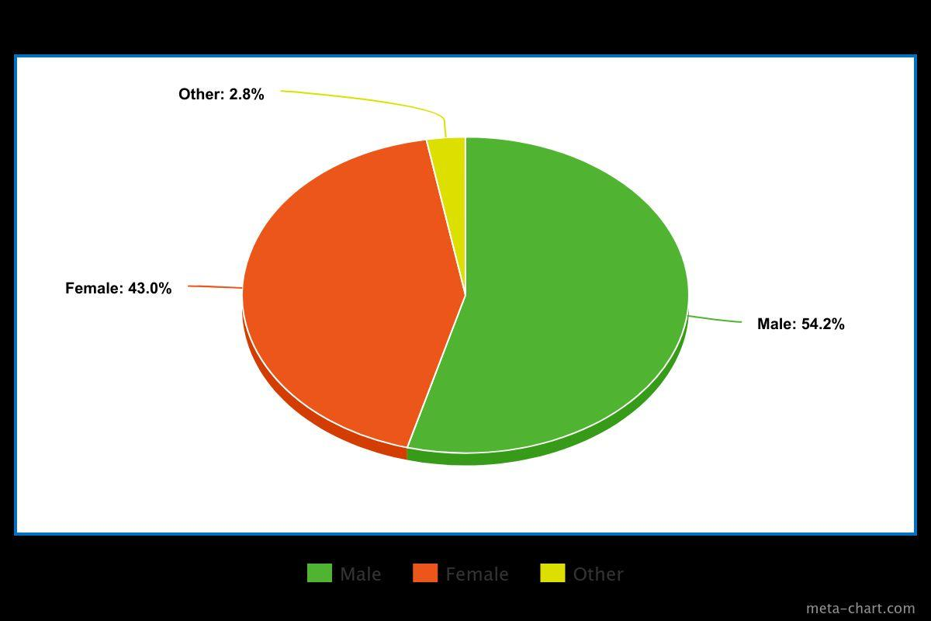
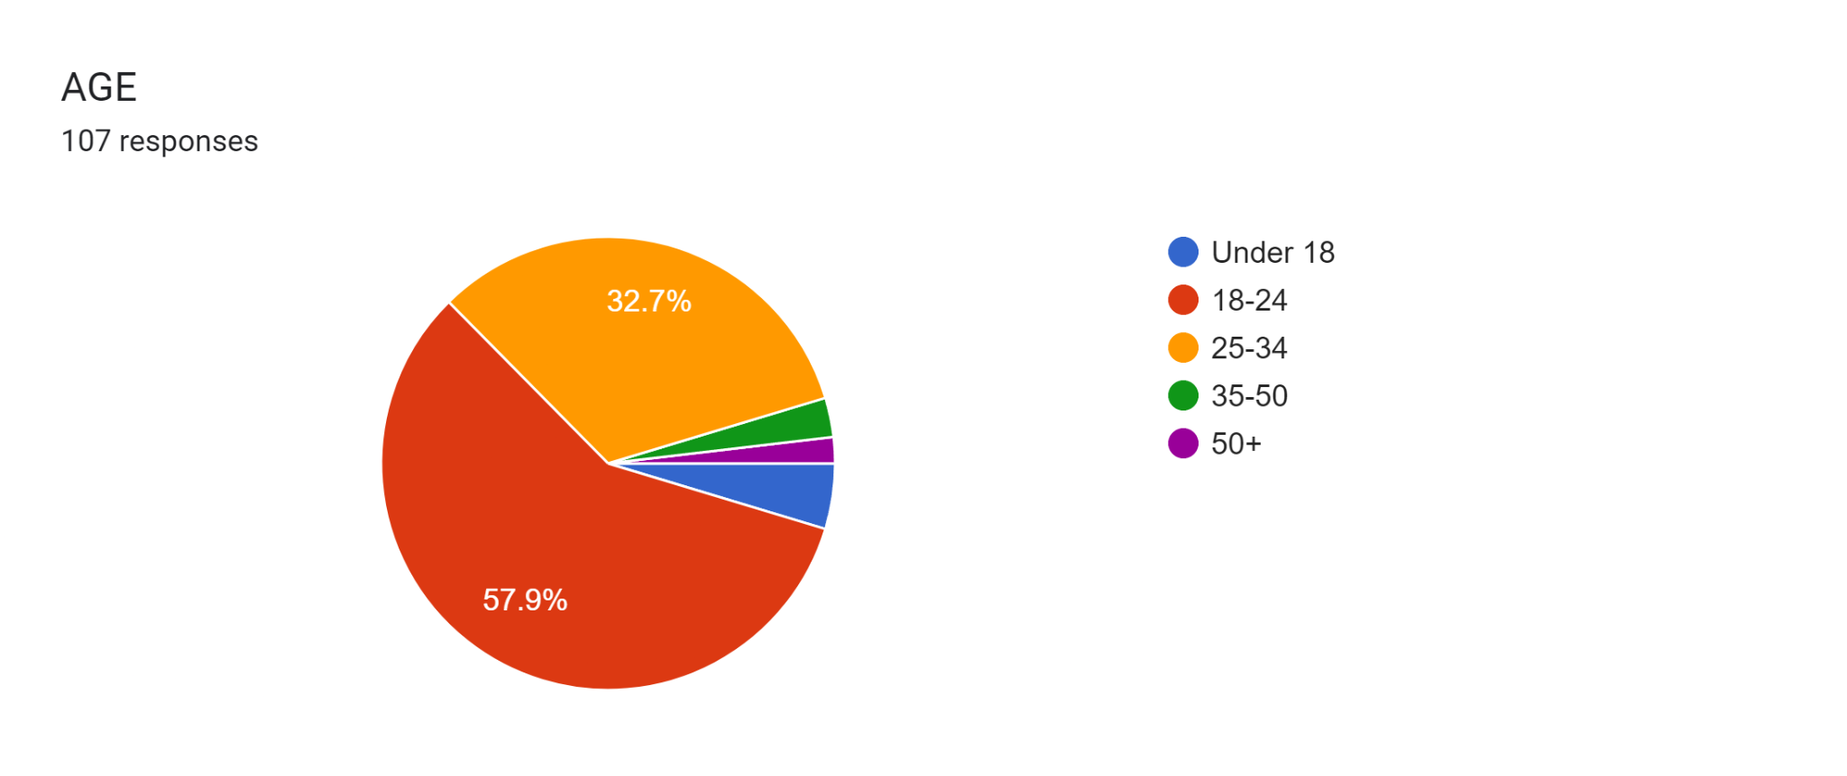
Fig 1 : Age Group Fig.2 : Gender

A majority of respondents (57.94%) have seen both Animal and Kabir Singh and significant portion (12.15%) have only seen Animal. Then smaller group (18.69%) have only seen Kabir Singh and also minority (11.21%) haven't seen either film.

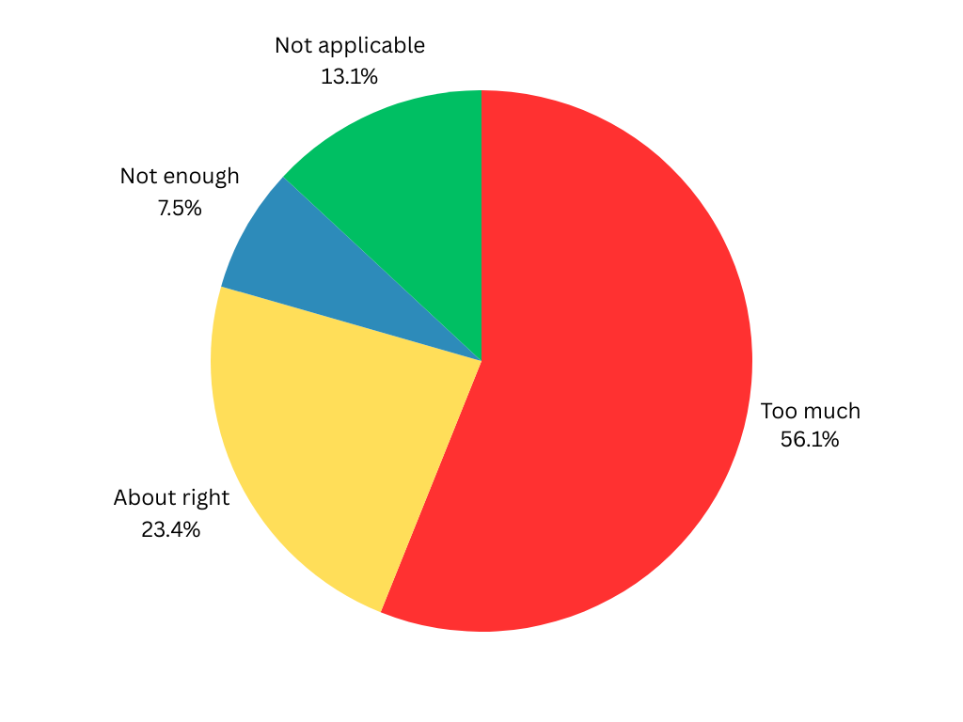
Participant rate for violence in Kabir Singh and Animal movie
Fig. 3: Rate of violence in Animal Movie by Respondent
The majority of respondents 60 (56.1%) feel the film contains too much violence, indicating that the film's level of violence may be perceived as extreme or beyond what is considered acceptable. This perception can inform researchers about the potential impact of the film on viewers, including concerns about the glorification of violence and its influence on audience attitudes toward conflict resolution.The group that rated the level of violence as "about right" 25 (23.4%) suggests that a significant portion of the audience finds the film's violence appropriate within the context of the narrative.
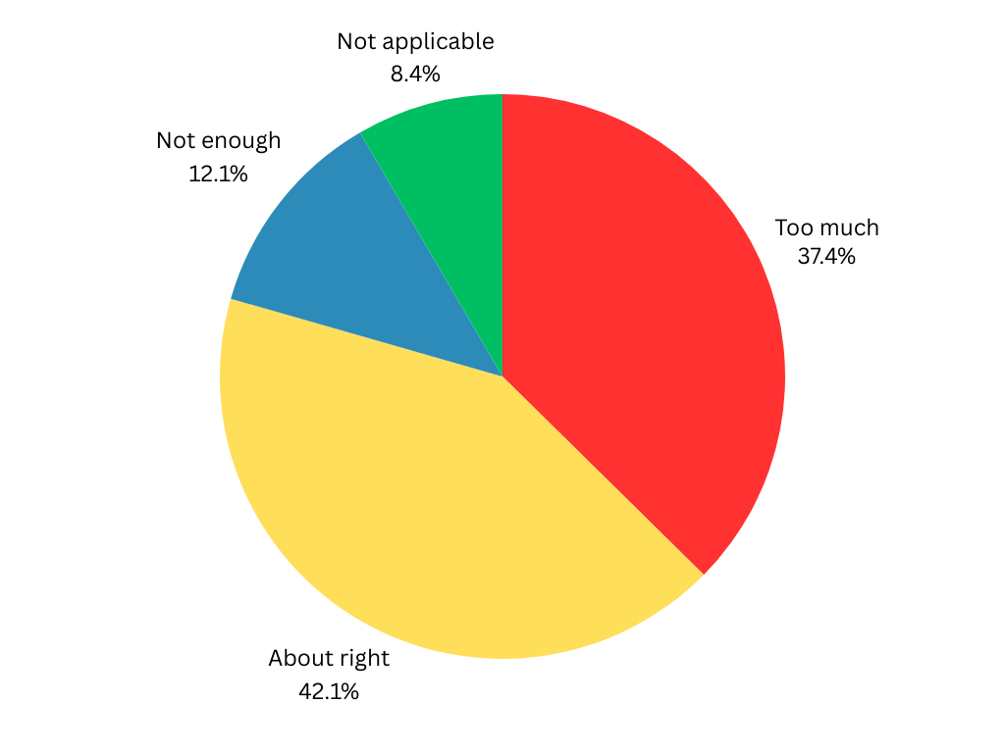
This acceptance may imply that the film successfully incorporates violence in a way that aligns with audience expectations or preferences, though it may also normalize violent behavior. Although a smaller group 8 (7.5%) felt the level of violence was "not enough," this perception indicates a subset of the audience that prefers more intense action or conflict. This response may raise questions about the potential impact of media portrayals on audience desensitization to violence and the desire for more extreme content. The group that found the question "not applicable" 14 (13.1%) likely includes individuals who have not seen the film or did not feel qualified to comment on its level of violence. While their responses may not directly contribute to understanding audience perceptions of violence in the film, it is important to acknowledge this group as a portion of the overall survey participants.
Fig. 4: Rate of violence in Kabir Singh Movie by Respondent

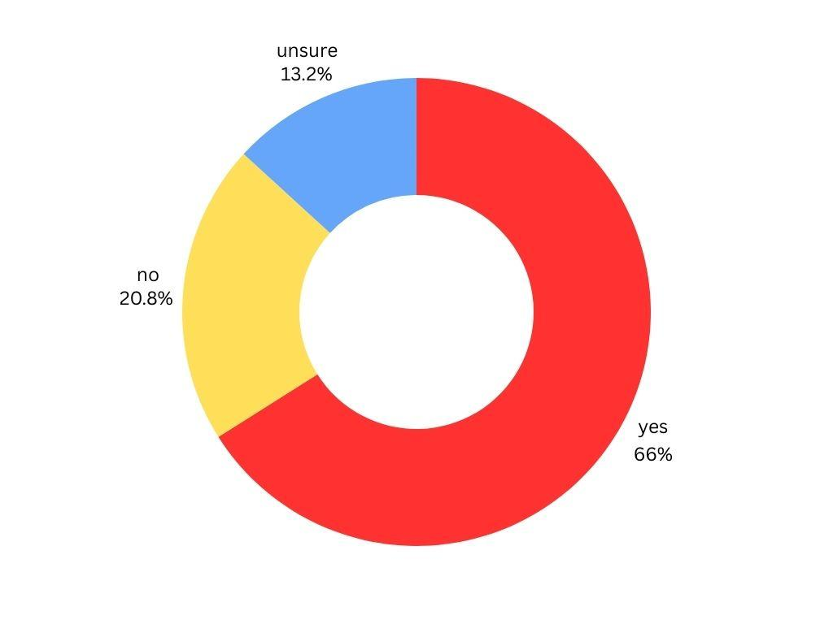
40 responses (37.4% of total respondents) perceives the level of violence in Kabir Singh as excessive, suggesting that they find the film's portrayal of violence to be beyond what they consider acceptable or necessary. Their assessment might be rooted in discomfort with the intensity, frequency, or gratuitousness of the violent scenes, potentially impacting their overall view of the film and its themes. 45 responses (42.1% of total respondents) constitutes the largest proportion of responses, indicating that they find the level of violence in Kabir Singh to be appropriate or fitting for the narrative. Their assessment may reflect an alignment with the film's use of violence as a narrative device or as a reflection of the protagonist's aggressive behavior. 13 responses (12.1% of total respondents) believes the level of violence in Kabir Singh is not sufficient, suggesting they expected more intensity or frequency of violent scenes. Their assessment might be rooted in personal preference for action or drama in films, rather than necessarily agreeing with the protagonist's behavior. 9 responses (8.4% of total respondents) does not provide a specific opinion on the level of violence in Kabir Singh, which could be due to a variety of reasons such as not watching the film or not remembering the level of violence.
Fig 5: the film (kabir singh) portray toxic masculinity
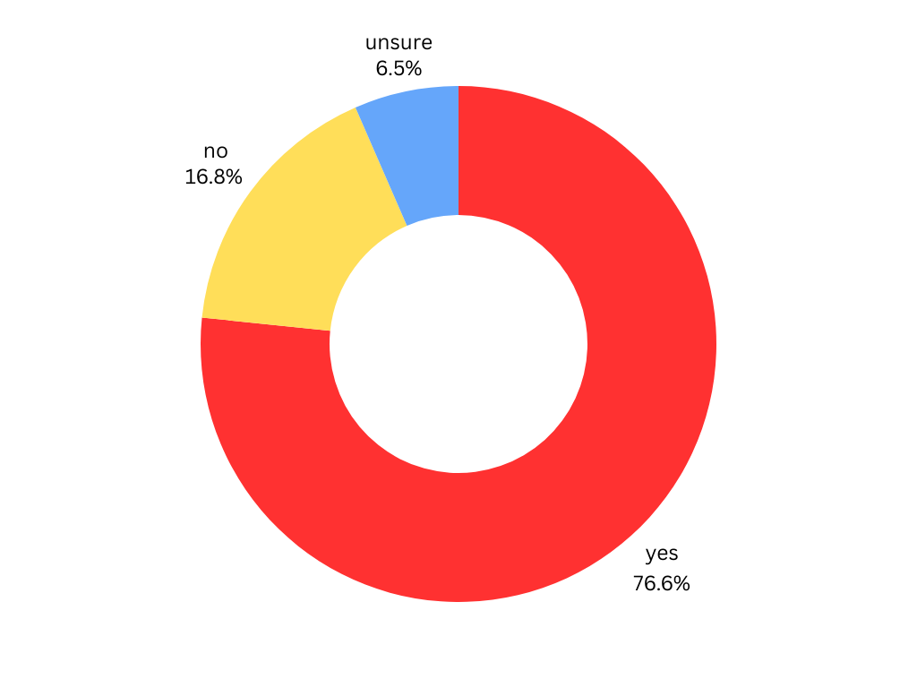
The survey data on whether respondents believe Kabir Singh portrays toxic masculinity provides insight into audience perceptions of the film's depiction of gender roles and aggressive behavior. 71 responses (66.4% of total respondents) believe that Kabir Singh portrays toxic masculinity. This is a significant proportion of the total responses and indicates a strong consensus on the film's depiction of this theme. Their assessment suggests that they recognize and acknowledge toxic masculinity in the protagonist's behavior, such as his possessiveness, aggression, and control over Preeti. 22 responses (20.6% of total respondents) does not believe Kabir Singh portrays toxic masculinity. This indicates a notable difference in opinion compared to the majority. These respondents may not recognize or agree with the characterization of Kabir's behavior as toxic masculinity, potentially viewing it as part of his complex character arc or justified by the story. 14 responses (13.1% of total respondents) is unsure whether Kabir Singh portrays toxic masculinity. This uncertainty could stem from a lack of clarity about what constitutes toxic masculinity or ambivalence about the film's message. Their responses might reflect a nuanced or mixed view of the film's depiction of gender roles and behavior.
Fig 6: the film (animal) portray toxic masculinity
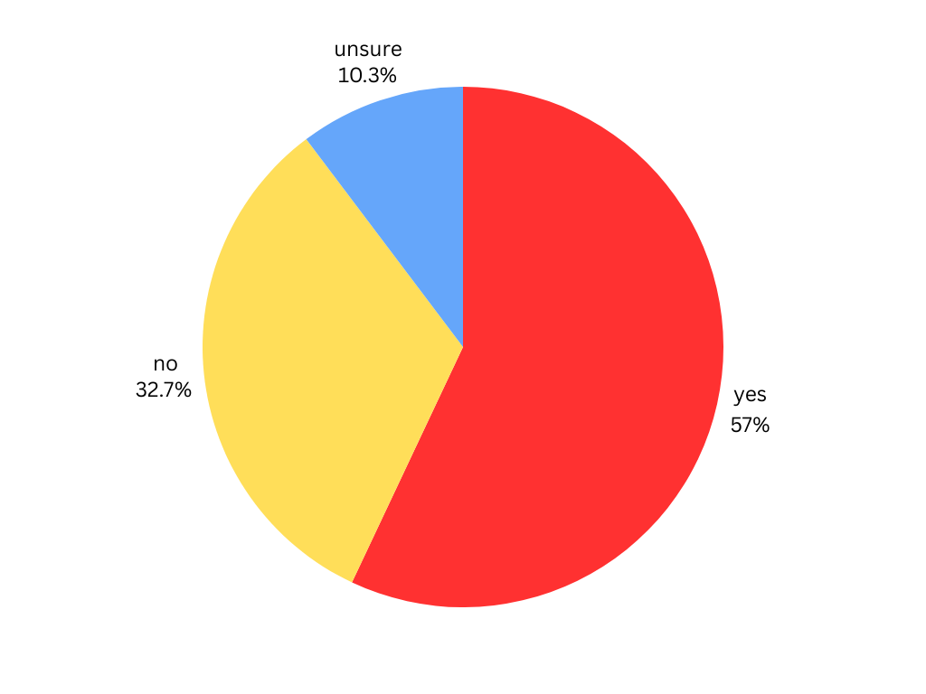
Analysis of these responses can provide insights into audience perceptions of how Animal portrays toxic masculinity. 82 responses (76.6% of total respondents) believe that Animal portrays toxic masculinity. This high proportion suggests that most viewers perceive elements of aggressive or domineering behavior in the film that align with the concept of toxic masculinity. 18 responses (16.8% of total respondents) does not believe that Animal portrays toxic masculinity. This group represents a minority view, suggesting either a different interpretation of the film or differing standards for what constitutes toxic masculinity. 7 responses (6.5% of total respondents) are unsure about whether Animal portrays toxic masculinity, indicating ambivalence or a lack of clear opinion on the issue.
Fig 7: the film (kabir singh) adequately addressed the consequences of violent and toxic behavior
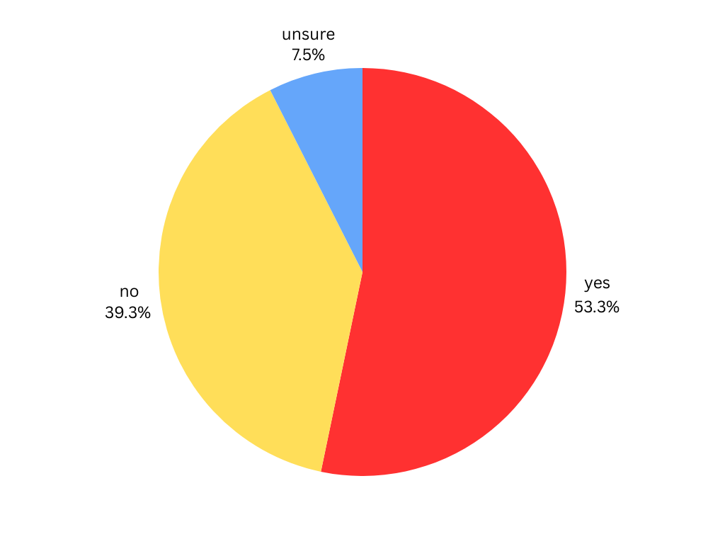
The survey data on whether the film Kabir Singh adequately addressed the consequences of violent and toxic behavior provides insights into audience perceptions of how the film handled these themes. 61 responses (57% of total respondents) believe that Kabir Singh adequately addressed the consequences of violent and toxic behavior. This suggests that they perceive the film as sufficiently showing the fallout of the protagonist's actions on himself and others. These respondents might point to specific plot points such as Kabir's struggle with substance abuse, loss of professional standing, or strained relationships as evidence of the film addressing the consequences of his behavior. 35 responses (32.7% of total respondents) believe the film did not adequately address the consequences of violent and toxic behavior. This suggests that they perceive the film as lacking in showing the full impact of Kabir's actions on himself and others. These respondents may feel that the film glossed over or minimized the negative outcomes of Kabir's behavior, such as his relationships with Preeti and his professional career. 11 responses (10.3% of total respondents) is unsure whether the film adequately addressed the consequences of violent and toxic behavior. This could indicate ambiguity in their perception of the film's treatment of these themes. The majority of respondents believe Kabir Singh adequately addressed the consequences of violent and toxic behavior, which suggests satisfaction with the film's handling of these themes. A significant portion of respondents disagrees, indicating that they perceive the film as not sufficiently showing the impact of Kabir's behavior, which could lead to concerns about the film's influence on audiences.
Fig 8 : the film (Animal ) adequately addressed the consequences of violent and toxic behavior

57 responses (53.3% of total respondents) believe that Animal adequately addressed the consequences of violent and toxic behavior. This suggests that they find the film's narrative to sufficiently tackle the repercussions of such behavior. 42 responses (39.3% of total respondents) A significant minority of respondents disagrees, suggesting they feel the film did not adequately address the consequences of violent and toxic behavior.
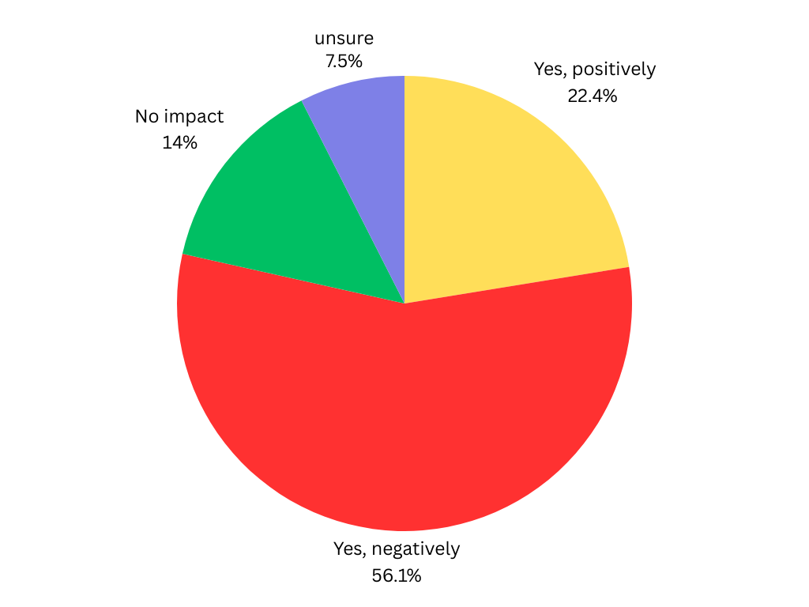
8 responses (7.5% of total respondents) is unsure whether the film adequately addressed the consequences of violent and toxic behavior, indicating some ambiguity in their interpretation of the film's approach.
Fig.9 : films like Animal and Kabir Singh have an impact on society's view of masculinity and violence
60 responses (56.1% of total respondents) believe the films have a negative impact on society's view of masculinity and violence. This indicates significant concern about the potential harm these films may cause. 24 responses (22.4% of total respondents) believes that films like Animal and Kabir Singh have a positive impact on society's view of masculinity and violence. 15 responses (14% of total respondents) believes the films have no impact on society's view of masculinity and violence, suggesting they perceive the films as not significantly shaping societal norms. 8 responses (7.5% of total respondents) is unsure about the films' impact on society's views of masculinity and violence, indicating mixed or unclear opinions. The majority of respondents express concern about the negative impact of films like Animal and Kabir Singh on society's view of masculinity and violence, suggesting significant apprehension about how these films may perpetuate harmful stereotypes.
CONCLUSION
The exploration into the glorification of villainous traits within protagonists in movies reveals a complex interplay between storytelling, audience reception, and societal norms. Throughout this study, it became evident that contemporary cinema often blurs the traditional boundaries between hero and villain, portraying protagonists with morally ambiguous or outright negative characteristics. This deliberate strategy, aimed at adding depth and complexity to characters, challenges conventional storytelling tropes.
Kabir Singh presents a complex portrayal of its protagonist, Kabir Rajveer Singh, exploring his journey through themes of toxic masculinity and violence. His aggressive and domineering behavior drives the narrative and shapes his relationships with others. While the film attempts to navigate Kabir's path toward redemption and reconciliation, his toxic traits raise questions about the ethical implications of his actions.
The film's depiction of these themes reflects societal norms and expectations surrounding masculinity, relationships, and personal growth. It offers opportunities for audiences to engage with discussions on toxic masculinity and the consequences of violent behavior. However, the narrative's framing of Kabir's actions as both problematic and romanticized may complicate the film's impact on societal attitudes towards these issues.
By critically engaging with the film's themes, viewers can gain insight into the broader cultural context and ongoing conversation around toxic masculinity and violence in Indian cinema and society.
The movie Animal presents a complex portrayal of the protagonist, Ranvijay "Vijay" Singh, exploring his journey through themes of toxic masculinity and violence. His aggressive and domineering behavior drives the narrative and shapes his relationships with others. While the film attempts to navigate Vijay's path towards reconciliation and redemption, his continued reliance on violence poses questions about the ethical implications of his actions.
The film's depiction of these themes reflects societal norms and expectations surrounding masculinity, family honor, and power dynamics. It offers opportunities for audiences to engage with discussions on toxic masculinity and the consequences of violent behavior. However, the narrative's framing of Vijay's actions as both heroic and morally ambiguous may complicate the film's impact on societal attitudes towards these issues.
REFERENCES

Krakowiak, K. M., & Tsay-Vogel, M. (2013). What Makes Characters' Bad Behaviors Acceptable? The Effects of Character Motivation and Outcome on Perceptions, Character Liking, and Moral Disengagement. Mass communication and society, 16(2), 179-199. doi:10.1080/15205436.2012.690926

Bordwell, D. (1985). Narration in the Fiction Film. Madison: University of Wisconsin Press.

Kohlberg, L. (1973). The Claim to Moral Adequacy of a Highest Stage of Moral Judgment. Journal of Philosophy, 70(18), 630–646. doi:10.2307/2025030

Janicke, S.H., & Raney, A.A. (2011, May). Exploring how we enjoy antihero narratives: A comparision of fans and nonfans of 24. Paper presented at the annual meeting of the International Communication Association, Boston.

Naremore, J. (1998). More than night: Film noir in its contexts. Berkeley, CA: University of California Press.

Viswamohan, A. I., & ChaudhurI, S. B. (2020). Bollywood’s angromance: Toxic masculinity and male angst in Tere Naam and Kabir Singh. Journal of Asia-Pacific Pop Culture, 5(2), 146-170.

Ganguly, D., & Singh, R. (2021). Reading patriarchal manhood, violence and love in Kabir Singh (2019). South Asian Popular Culture, 19(1), 15-32.

Joshi, N. (2020). Polarities in Gender Representation-Kabir Singh and Thappad. Global Media Journal: Indian Edition, 12(1).

Jitu, B. Cinema And the Society: Disturbing Realities of Animal and Advocating For Media Accountability by Sonal Srivastava and Jeetendra Kumar Patel.

Kharat, S., & Gagare, A. (2020). Male Audience Reception of ‘Female Objectivity’and ‘Female Passivity’Portrayed in the Hindi Film ‘Kabir Singh’: A Quantitative Study. MediaSpace: DME Media Journal of Communication, 1(01), 1-12.

Samraat, S. (2021). Bollywood's Toxic Masculinity: The Problematic Portrayal of Men & Women in Popular Hindi Cinema. Issue 1 Int'l JL Mgmt. & Human., 4, 424.

Sundke, A. (2022). A Case study on cinema-Kabir Singh: Hero or A Casanova.
Tiwari, S. (2022). Sympathetic Villains in Film and Literature: The Psychological Appeal of Immorality in Fiction. Journal The Criterion, 13(1), 331.

Stein, A. (2004). The Byronic hero in film, fiction, and television. SIU Press.

Jonason, P. K., Webster, G. D., Schmitt, D. P., Li, N. P., & Crysel, L. (2012). The antihero in popular culture: Life history theory and the dark triad personality traits. Review of General Psychology, 16(2), 192-199.

Kendrick, M. G. (2016). Villainy in western culture: Historical archetypes of danger, disorder and death. McFarland.

Hughey, M. W. (2009). Cinethetic racism: White redemption and black stereotypes in" magical Negro" films. Social Problems, 56(3), 543-577.

Munby, J. (2009). Public enemies, public heroes: Screening the gangster from Little Caesar to Touch of Evil. University of Chicago Press.

Himes, S. M., & Thompson, J. K. (2007). Fat stigmatization in television shows and movies: A content analysis. Obesity, 15(3), 712-718.

Goethals, G. R., & Allison, S. T. (2012). Making heroes: The construction of courage, competence, and virtue. In Advances in experimental social psychology (Vol. 46, pp. 183-235). Academic Press.

Norden, M. F. (1994). The cinema of isolation: A history of physical disability in the movies. Rutgers University Press.

Iswalono, A. N., & Arum, L. J. (2021). Disney Princess Sequels in the Perspective of Second Wave Feminism in America. Rubikon: Journal of Transnational American Studies, 8(1), 62-76.

