A NOVEL APPROACH TO DETECTING AND ASSESSING CYBER BULLYING SEVERITY USING DEEP LEARNING ALGORITHMS

ASHOKKUMAR R*1, AKASHPRADEEP M*2, PRADEEP V*3, RAHUL S *4, BALAMURALI S*5
*2,3,4,5Student, Anna University, Computer Science Engineering, Mahendra Institute Of Engineering And Technology, Namakkal, Tamil Nadu, India
*1Professor, Department of Computer Science Engineering, Mahendra Institute Of Engineering And Technology, Namakkal, Tamil Nadu, India

Abstract— Everyone is entitled to the right to free speech. However, in the guise of free expression, this privilege is being abused to discriminate against and harm other people. This prejudice is referred to as hate speech. A clear definition of hate speech is language that expresses hatred for an individual or a group of individuals based on traits including race, religion, ethnicity, gender, nationality, handicap, and sexual orientation. It can be communicated by voice, writing, gesture, or exhibition when someone is attacked due of the group to which they belong. Hate speech has been more prevalent both offline and online in recent years. The social media and other online platforms play a significant role in the development and dissemination of hateful information, which eventually fuels hate crimes. The growing use of social media and information sharing has brought about significant advantages for humanity. But this has also given rise to a number of issues, such as the disseminating and sharing of hate speech messages. Thus, recent studies used a range of machine learning and deep learning techniques with text mining method to automatically recognise the hate speech messages on real-time datasets in order to address this developing issue in social media sites. This project's goal is to examine comments on social networks using Natural Language Processing (NLP) and a Deep Learning method called Back Propagation Neural Network method. In order to identify the text as positive or negative, back propagation neural networks are used to extract the keywords from user-generated content. If it's negative, immediately block the comments in accordance with the user's preferences and block the friends in accordance with pre-established threshold values. The proposed framework was deployed in a real-time social networking site with an improved notification system, according to experimental findings.
Index Terms—Social media, Hate Speech, Machine learning, Deep learning, Text mining
_________________________________________________________________________________________

1. INTRODUCTION
People can communicate easily and broadly using social media, which is more crucial than anything else. Engage in online conversation and freely express your ideas and opinions with others. It is now a necessary component of day-to-day existence. People are particularly vulnerable to abuse or harassment during this phase from those who display hate in a number of contexts, such as politics, sexism, racism, and other forms. Cybertronic, online nuisance, and blackmail are becoming more and more common uses on these social media sites. Thanks to social networking sites (SNS), we may now readily communicate with a range of societies or organizations that interest us.Many technologies have advanced to the point that a significant section of the public can access these websites, such as portable devices and high-speed internet. Handlers in these networks are mostly less than thirty years old. Using the vast amounts of data available on various social networking platforms, researchers have undertaken extensive research in a range of disciplines. Sentiment analysis is a popular academic field that heavily leverages social media data. Figure 1 shows process of cyber bullying detection.
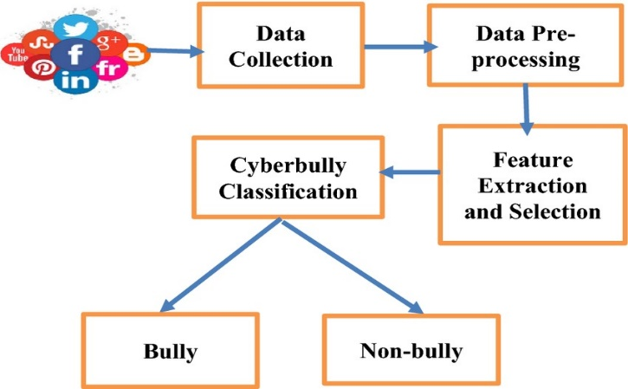
Fig 1: Social media types
2. RELATED WORK
A Framework for Hate Speech Detection Using Deep Convolutional Neural Network (IEEE-2020)
This research addresses the issue of hate speech detection on Twitter using a deep convolutional neural network. Initially, the machine learning based classifiers such as LR, RF, NB, SVM, DT, GB, and KNN were used to identify the HS related tweets on Twitter with the features extracted using tf-idf technique. However, the best ML model, i.e., SVM able to predict only 53% of HS tweets correctly on a 3:1 train-test dataset. The reason behind the low prediction of HS tweets may include the imbalanced dataset, hence the model biased towards the NHS tweets prediction as it is having the majority of instances. Deep learning-based CNN, LSTM, and their combinations C-LSTM models also have similar results with the fixed partitioned dataset. The experimental outcome on both the traditional machine learning based models and deep learning-based models confirmed that none of the models predicted the HS tweets with satisfactory accuracy on a fixed partitioned of train-test. Finally, 10-fold cross-validation was used with the proposed DCNN model and achieved the best prediction recall value of 0.88 for HS and 0.99 for NHS. The experimental results confirmed the k-fold cross-validation technique is a better choice with the imbalanced dataset. The current research addressed the HS issues with the textual data only; however, images also widely used for the same. Hence, in the future, the researcher may include images with text or can analyse the video dataset to capture more HS related posts from Twitter. This research only used the tweets written in the English language, which can be further extended by mixing other languages such as Japanese, Hindi, Tamil, etc. The developed model achieved the recall value of 0.88, which indicates few tweets are not detected properly [1].
Deep Learning Models for Multilingual Hate Speech Detection (arxiv-2020)
In this paper, we perform the first large scale analysis of multilingual hate speech. Using 16 datasets from 9 languages, we use deep learning models to develop classifiers for multilingual hate speech classification. We perform many experiments under various conditions – low and high resource, monolingual and multilingual settings – for a variety of languages. Overall, we see that for low resource, LASER + LR is more effective while for high resource BERT models are more effective. We finally suggest a catalogue which we believe will be beneficial for future research in multilingual hate speech detection. In the first scenario (monolingual setting), we only consider the training and testing from the same language. We observe that in low resource scenario models using LASER embedding with Logistic regression perform the best, whereas in high resource scenario, BERT based models perform much better. We also observe that simple techniques such as translating to English and using BERT, achieves competitive results in several languages. In the second scenario (multilingual setting), we consider training data from all the other languages and test on one target language. Here, we observe that including data from other languages is quite effective especially when there is almost no training data available for the target language (aka zero shot). Finally, from the summary of the results that we obtain, we construct a catalogue indicating which model is effective for a particular language depending on the extent of the data available. We believe that this catalogue is one of the most important contributions of our work which can be readily referred to by future researchers working to advance the state-of-the-art in multilingual hate speech detection.[2]
Advances in Machine Learning Algorithms for Hate Speech Detection in social media: A Review ( IEEE- 2021)
This article reviewed advances made so far in automatic hate speech detection in social media. Hate speech as a societal problem is an old research area in the arts and humanities, however, it is still a new research area in the computing domain. Therefore, there is a need to constantly update researchers with the advances or progresses made to keep researchers informed. We analysed the approaches from classical ML, Ensemble and deep learning approaches. In detecting hate speech in social media. This study found out that there is more research work in hate speech detection using classical ML than ensemble and deep learning techniques. That means researchers can explore more on hate speech detection using ensemble and deep learning methods. This research also discussed the weaknesses and strengths which can be of help in guiding the researchers’ choice of one technique over the other. This article also identified some open challenges in hate speech detection which include: Cultural variations, pandemic or natural disaster, data sparsity, imbalance dataset challenge and dataset availability concern. The application of ML for automatic HS detection on SM needs to be encouraged and supported. The needs to consider the HS variables based on each country is an issue that needs more researchers’ attention. Each country or region may have different variables for HS. For example, marital status and health status are commonly used as HS variable in Nigeria but it has not been addressed by any work in the past. [3]
2.4 deephate: Hate Speech Detection via Multi-Faceted Text Representations (ACM-2021)
In this paper, we proposed a novel deep learning framework known as deephate, which utilized multi-faceted text representations for automatic hate speech detection. We evaluated Deephate on three publicly available real-world datasets, and our extensive experiments have shown that Deephate outperformed the state-of-the-art baselines. We have also empirically analyzed the Deephate model and provided insights into the salient features that best aided in detecting hate speech in online social platforms. Our salient feature analysis provided some form of explanation to Deephate’s hate classification decision. Online hate speech is an important issue that breaks the cohesiveness of online social communities and even raises public safety concerns in our societies. Motivated by this rising issue, researchers have developed many traditional machine learning and deep learning methods to detect hate speech in online social platforms automatically. However, most of these methods have only considered single type textual feature, e.g., term frequency, or using word embeddings. Such approaches neglect the other rich textual information that could be utilized to improve hate speech detection. In this paper, we propose deephate, a novel deep learning model that combines multi-faceted text representations such as word embeddings, sentiments, and topical information, to detect hate speech in online social platforms. We conduct extensive experiments and evaluate deephate on three large publicly available real-world datasets. [4]
2.5 bichat: bilstm with deep CNN and hierarchical attention for hate speech detection (ELSEVIER-2022)
In this paper proposed a novel deep learning model, bichat, integrating the BERT-based contextual embedding with a deep convolutional network, bilstm, and hierarchical attention mechanism for hate speech detection. Unlike existing models, the bichat incorporates the strength of context-incorporating embeddings, attention mechanism with deep CNN, and bilstm to learn the spatial features and long-range contextual dependencies. The proposed model has been evaluated over three benchmark Twitter datasets – HD1, HD2, and HD3. The experimental evaluation showed that the bichat model outperformed the SOTA and baseline methods. We also performed an ablation study to investigate the efficacy of various neural network components used in the proposed model. We also investigated the impact of neural network hyperparameters on the performance of the bichat model. The bichat model lacks sentiment, content, and other profilerelated features. The evaluation of the bichat over various datasets is also a fascinating research direction. The extension of the proposed model to a multi-modal method is another important direction of research. The extension of bichat to classify the multilingual and code-mixed hate content is another direction of research. In terms of real-life application, the proposed model can be used by OSN service providers for hate speech detection, which will also establish the efficacy of the proposed model over the real dataset.[5]

3. EXISTING METHODOLOGIES
Social networking is a hip and, most importantly, simple way for people to respect one other's opinions and ideas even when they are communicating with each other virtually. It is become a necessary component of daily existence. People have been subjected to harassment and abuse by those who exhibit hatred through many means, such as politics, sexism, and racial prejudice, at this time. Blackmail and other forms of online tyranny are also becoming more common uses of social media platforms. It is now easier than ever to interact with a wide range of societies or organizations that interest us thanks to social networking platforms like Myspace.These websites have acquired a wide audience in society due to technology improvements like higher internet and portable gadgets. The handlers on these networks are mostly under thirty years old. Scholars have conducted extensive investigations in a variety of domains by utilizing the vast quantities of data that are accessible on different social networking sites. A popular topic of study that heavily utilizes data from social media is emotion analysis.
In content-based filtering, it has been believed that each user operates independently. Therefore, in contrast to a cooperative filtering system, which selects objects based on the correlation of people with similar interests, a material filtering system chooses elements based on the relationship between the items' content and the user preferences. Although the first research on information filtering concentrated on email, later works have covered a broad range of subjects, such as wire service articles, Internet "news" items, and larger network resources.Content-based filtering is comparable to text classification because the documents that are processed by it are primarily text-based. In reality, filtering may be modeled as a single tag classification process that separates incoming texts into relevant and irrelevant categories. A more intricate filtering method called multi-label text categorization automatically assigns labels to messages based on partial themes and categories. The main component of the machine learning (ML) paradigm used in content-based filtering is the classifier, which is automatically generated by needing to learn from the set of pre-classified samples. Recent years have seen the emergence of an astonishing variety of related research, with variations in feature extraction methods, model learning, and sample gathering. During the training and generalization stages, a tiny fraction of the text's content is extracted using a consistent process called feature extraction. Bag of Words (BoW) techniques perform better than more complex text representations, which may have higher statistical quality but poorer semantic meaning, according to several investigations.
4. PROPOSED METHODOLOGIES
One of the most widely used interactive platforms for sharing, interacting, and exchanging a lot of personal data is the Internet Social Network (OSN). Giving users the option to regulate their own privacy in order to prevent the broadcast of undesired content is a basic issue with today's online social media networks, or OSNs. OSNs haven't helped much with this requirement up to now. In this work, we suggest a mechanism that directly empowers OSN users to manage the messages on their walls, filling the hole. This is achieved using a machine learning-based soft classifier that automatically identifies messages in support of material filtering, and a flexible rule-based system that lets users customize the filtering criteria applied on their walls. Using deep learning (DL) text categorization algorithms, each brief text message is appropriately classified into one or more categories according to its content. A set of distinguishing and characterizing features must be selected, and this takes up most of the work in constructing a rigorous VADER algorithm. To check the words for improper words, a dataset of the categorized words is constructed. The communication will be filtered to remove any offensive language from the Blacklists if it appears in it. Finally, because of the material technique, the message will appear on the user's wall without any offensive language. Message content, buddy connections, and other attributes of the text writer are taken into account by a system that uses blacklists to filter out of context messages. Deep learning methods are included in the proposed framework to help users specify Filtering Rules (FRs), improve the fit of the rules within the domain under consideration, and broaden the collection of attributes initially examined during the classification process. The proposed framework as shown in fig 2.
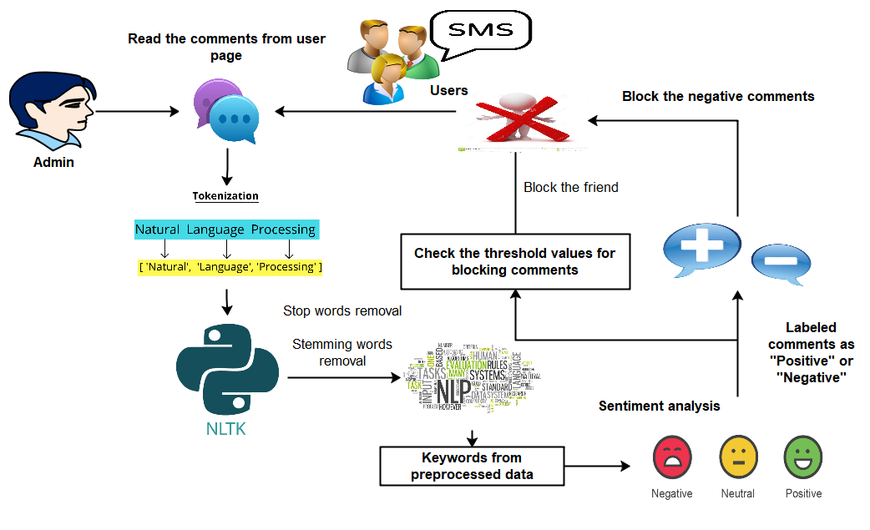
Fig 2: Proposed Framework
4.1 FRAMEWORK CONSTRUCTION
A social networking service (also known as a social networking site, SNS, or social media) is indeed an online platform that allows people to create social networking sites or social relationships with others who share similar personal or professional interests, activities, backgrounds, or real-life connections. The variety as well as evolving variety of hold and built-in social media platforms in the online environment presents a definitional challenge.
The term "social network" refers to human interaction in which people create, share, and/or transfer ideas and information in virtual networks and communities. Create a graphical user interface (GUI), which allows users to communicate with one another via integrated graphics and visual indicators. In this module, we can design the admin and user interfaces. The user can access the system as well as view the invitation. The images can be shared with friends by the user.
4.2 WORDS EXTRACTION
As social apps and websites proliferate, social networking is becoming an increasingly important part of everyday life online. Most conventional online media include different factors, such as user comment fields. Social networks is used in business to marketing, promote brands, connect with current customers, and foster new company. We can comment in an online social network using this module. Textual comments are welcome. The text can be unigrams, bigrams, or multigram. This component is used to collect feedback from social users. Comments can take many forms, including links, texts, and short texts. Comments are perused and forwarded to the server page.
TEXT MINING ALGORITHM
Most attempts in creating a powerful deep learning classifier are focused on the extraction and choice of a set of characterising and discriminating features. The text mining algorithm's steps are as follows:
- Tokenize text-based reviews as single terms
- Analyze unigrams, bigrams, and n-grams
- Remove stop words, analyses stemming words, and remove special characters
- Finally, extract key phrases
- Analyze extended words that can be substituted with right words
4.3 CLASSIFICATION
In this module, we designan automated system, called Filtered Wall (FW), able to filter unwanted messages from OSN user walls. The architecture in support of OSN services is a three-tier structure. The first layer commonly aims to provide the basic OSN functionalities (i.e., profile and relationship management). Additionally, some OSNs provide an additional layer allowing the support of external Social Network Applications (SNA). Finally, the supported SNA may require an additional layer for their needed graphical user interfaces (GUIs). The major efforts in building a robust back propagation neural network (BPNN) are concentrated in the extraction and selection of a set of characterizing and discriminant features. In order to specify and enforce these constraints, we make use of the text classification. From VADER point of view, we approach the task by defining a hierarchical two-level strategy assuming that it is better to identify and eliminate “neutral” sentences, then classify “non-neutral” sentences by the class of interest instead of doing everything in one step.
DEEP LEARNING ALGORITHM
A database of categorised terms is formed here, and the words are then checked for any offensive words. If the user says any vulgar terms, it will be sent to the Watchlists, that will filter those phrases out. Finally, a text free of outrageous terms would be posted here on user's ceiling as a result of a content-based filtering technique. The recommended deep learning classifier is as follows:
- Collect comments or text data with samples of both hateful and non-hateful language.
- Remove from the text any extraneous characters, symbols, or information.
- To create the hate speech detection model, use an effective deep learning strategy like VADER Algorithm
- By providing the model the preprocessed data and modifying its settings depending on the offered examples, you may train the model to recognise hate speech.
- Integrate the trained model into a programme or system to quickly and accurately identify hate speech.
- Integrate the trained model into a programme or system to quickly and accurately identify hate speech.
A system employs registries to automatically reject unwanted messages based on relationship and characteristics of both the message content and the message author. The outgrowth of the acquisition of features evaluated inside the classification stage, a distinct definition for filtering rules to best fit the considered domain, to assist users with Filtering Rules (FRs) spec, and a distinct semantic and syntactic for screening rules to better fit the thought domain.
4.4 RULES IMPLEMENTATION
Users should be able to specify constraints on text creators through the filtering rules. Thus, creators to whom a filtration rule applies should be chosen based on a variety of criteria, one of which is impinging conditions on profile page attributes. In this way, we can define rules that apply only to young creators, creators with a specific religious/political viewpoint, or creators who we believe are not experts in a particular ground (e.g. by posing constraints on the work attribute of user profile). This entails filtering rules that identify messages based on restrictions on their contents. And block users who leave negative feedback more than five times, as well as send mobile notifications to users.
4.5 ALERT SYSTEM
BLs are managed directly by system, which ought to be capable of determining who is embedded in the BL as well as when consumer customer loyalty in the BL is complete. This knowledge is in the framework by a set of guidelines designed to improve flexibility; the rules on BL. The server generates rules for setting thresholds. We can block friends who leave negative comments based on threshold values. Finally, give users mobile notifications.
5. EXPERIMENTAL RESULTS
In this chapter, we can construct the social network using Python as front end and MYSQL as Back end. The performance of the system can be analyzed in terms of F-measure parameter.
The performance of the system is evaluated using Precision, Recall and F-measure.
Precision =$\frac{TP}{TP+FP}$

Recall =$\frac{TP}{TP+FN}$

F measure = 2* $\frac{Precision*Recall}{Precision+Recall}$

The performance evaluation result is shown in fig 3.

Fig 3: Performance chart
Based on the calculations above, the proposed neural networks algorithm has higher level F-measure value systems than existing Ensure that the required Bayes and SVM algorithms.
6. CONCLUSION
We demonstrated a solution to filter unwanted messages from OSN walls in this project. The system uses a DL soft classifier to enforce a content-dependent filtered rules system that may be customized. The extraction and selection of a set of characterizing and discriminant features are the most time-consuming aspects of developing a robust short text classifier. Furthermore, the handling of BLs improves the system's versatility in terms of filtering choices. This project is the initial step in a larger one. The early promising results we've seen with the classification technique encourage us to keep working on other projects aimed at improving classification quality. The DL soft classifier is used in this system to filter out undesirable signals. BL is used to increase the filtering system's flexibility. We'll create a mechanism that takes a more comprehensive approach to determining when a user should be added to the BL. In addition to classification features, the system includes a strong rule layer that uses a flexible language to construct Filtering Rules (FRs), which allow users to decide which information should not be displayed on their walls. FRs can enable a wide range of filtering criteria that can be combined and tailored to meet the needs of the user. FRs leverage user profiles, user relationships, and the output of the DL classification process to specify the filtering criteria that will be used.
REFERENCES
[1] Roy, Pradeep Kumar, et al. "A framework for hate speech detection using deep convolutional neural network." IEEE Access 8 (2020): 204951-204962.
[2] Aluru, Sai Saketh, et al. "Deep learning models for multilingual hate speech detection." arXiv preprint arXiv:2004.06465 (2020).
[3] Mullah, NanlirSallau, and Wan Mohd Nazmee Wan Zainon. "Advances in machine learning algorithms for hate speech detection in social media: a review." IEEE Access 9 (2021): 88364-88376.
[4] Cao, Rui, Roy Ka-Wei Lee, and Tuan-Anh Hoang. "DeepHate: Hate speech detection via multi-faceted text representations." Proceedings of the 12th ACM Conference on Web Science. 2020
[5] Khan, Shakir, et al. "BiCHAT: BiLSTM with deep CNN and hierarchical attention for hate speech detection." Journal of King Saud University-Computer and Information Sciences 34.7 (2022): 4335-4344.
[6] Mozafari, Marzieh, Reza Farahbakhsh, and Noel Crespi. "A BERT-based transfer learning approach for hate speech detection in online social media." Complex Networks and Their Applications VIII: Volume 1 Proceedings of the Eighth International Conference on Complex Networks and Their Applications COMPLEX NETWORKS 2019 8. Springer International Publishing, 2020.
[7] Rabiul Awal, Md, et al. "AngryBERT: Joint Learning Target and Emotion for Hate Speech Detection." arXiv e-prints (2021): arXiv-2103.
[8] Alkomah, Fatimah, and Xiaogang Ma. "A literature review of textual hate speech detection methods and datasets." Information 13.6 (2022): 273.
[9] Malik, Jitendra Singh, Guansong Pang, and Anton van den Hengel. "Deep learning for hate speech detection: a comparative study." arXiv preprint arXiv:2202.09517 (2022).
[10] Khan, Shakir, et al. "HCovBi-caps: hate speech detection using convolutional and Bi-directional gated recurrent unit with Capsule network." IEEE Access 10 (2022): 7881-7894.
[11] Toraman, Cagri, Furkan Şahinuç, and Eyup Halit Yilmaz. "Large-scale hate speech detection with cross-domain transfer." arXiv preprint arXiv:2203.01111 (2022).
[12] Patil, Hrushikesh, Abhishek Velankar, and Raviraj Joshi. "L3cube-mahahate: A tweet-based marathi hate speech detection dataset and bert models." Proceedings of the Third Workshop on Threat, Aggression and Cyberbullying (TRAC 2022). 2022.
[13] Gravano, Agustín, et al. "Assessing the Impact of Contextual Information in Hate Speech Detection." IEEE Access, vol. 11, pp. 30575-30590, 2023, doi: 10.1109/ACCESS. 2023.3258973. (2023).
[14] Velankar, Abhishek, Hrushikesh Patil, and Raviraj Joshi. "A review of challenges in machine learning based automated hate speech detection." arXiv preprint arXiv:2209.05294 (2022).
[15] Akuma, Stephen, TyosarLubem, and Isaac Terngu Adom. "Comparing Bag of Words and TF-IDF with different models for hate speech detection from live tweets." International Journal of Information Technology 14.7 (2022): 3629-3635.
[16] Fortuna, Paula, et al. "Directions for NLP Practices Applied to Online Hate Speech Detection." Proceedings of the 2022 Conference on Empirical Methods in Natural Language Processing. 2022.
[17] Antypas, Dimosthenis, and Jose Camacho-Collados. "Robust hate speech detection in social media: A cross-dataset empirical evaluation." arXiv preprint arXiv:2307.01680 (2023).

[18] Zhou, Xianbing, et al. "Hate speech detection based on sentiment knowledge sharing." Proceedings of the 59th Annual Meeting of the Association for Computational Linguistics and the 11th International Joint Conference on Natural Language Processing (Volume 1: Long Papers). 2021.
[19] Mosca, Edoardo, Maximilian Wich, and Georg Groh. "Understanding and interpreting the impact of user context in hate speech detection." Proceedings of the Ninth International Workshop on Natural Language Processing for Social Media. 2021.
[20] Sabat, Benet Oriol, Cristian Canton Ferrer, and Xavier Giro-i-Nieto. "Hate speech in pixels: Detection of offensive memes towards automatic moderation." arXiv preprint arXiv:1910.02334 (2019).

