Seismic Analysis of High Rise Building with Transfer Floor

Pratik B. Murumkar ¹ and Dr.Vinesh S. Thorat²
1 P.G. Student, Structural Engineering,G H Raisoni college of Engineering Pune
2 Associate Professor P.G. Student, Structural Engineering, G H Raisoni college of Engineering
-------------------------------------------------------------------------***----------------------------------------------------------------------

Abstract- A transfer floor is the floor system which supports a vertical as well as lateral load resisting system and transfer its loading to different underneath system. Transfer floor distribute the load from closely spaced columns to the columns with long span. This study presented, a seismic analysis of high rise building with transfer floor. A number of proto type models of high rise building were analyzed using linear response spectrum analysis. The models were analyzed using structural software for building analysis ETABS 2016 software. The analyzed models has transfer slab system at different floor levels in high rise building. In this paper, five different models of 10 storey building had studied by providing a transfer slab at different floor levels such as first floor, second floor, third floor, fourth floor and fifth floor of the building. And the vertical position of transfer slab with respect to building height was investigated. The seismic response of high rise building such as storey shear, storey moment, storey displacement, inter-storey were numerically evaluated.
Key Words: Transfer slab, Response spectrum analysis, Storey shear, Storey moment, ETABS 2016.

INTRODUCTION
Now a days, there are new innovative architectural techniques are used in high rise buildings and in mega tall structures with the advanced and powerful structural analysis. Consequently, the architectural demands the high-rise buildings with columns may have different arrangement system between floor levels of the building are often seen. A high rise building with transfer floor system involves structure below transfer system that houses functional areas for a shopping mall, a large lift lobby, parking, commercial markets, multi-purpose halls, etc. And the structure above transfer floor, is used as office and residential units using more economical and shorter span design. To achieve these results, layout of podium structure use spaced columns with long span design while the upper floor implies columns with short span. Using transfer slab system between these two parts of the building has become common solution. Many buildings are constructed with these vertical irregularities (column and shear wall). As such Transfer floor is provided between these two different column arrangements. A transfer floor is the floor system which supports vertical as well as lateral load resisting system. A transfer floor had different floor systems such as transfer
slab and transfer girder. Depending upon the distribution of loads above the transfer structure, the type of transfer floor system is chosen.
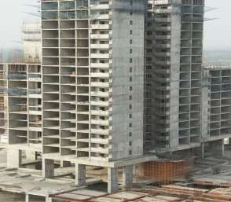
Fig 1. Transfer slab
The above figure 1 shows the transfer slab at first floor of the building in which the shear wall provided above the transfer floor for residential or office unit while below the transfer floor long spacing columns are provided to provide the parking facility.
Yoshimura and Li et al.[1] recommended that the sudden change in lateral stiffness at transfer floor from stiff shear wall structure to relative column system may create a weak storey mechanism and violates the design concept of strong column weak beam.
Yoshimura[1] also concluded that, if soft storey mechanism occure, the collapse should be unavoidable even for building with base shear of 60% of total weight.
Yong et al.[2] concluded that if this irregularity is not taken into account during analysis, then this irregularity may become major source of building damage during strong earthquake.

Y.M. Abdlebasset[4] Presented a state-of-the art review on seismic behavior of high rise buildings with transfer floors. The review discusses the effect of the sudden change in the building stiffness on the the building and story drifts distribution along the building height. And concluded that irregularity in upper stories would have a little effect on the floor displacements, while, irregularity in lower stories would have a significant effect on floor displacement along a building height.
Li et al.[7] Quantified the performance of transfer slab in high rise building using pseudo dynamic test. The 18 storey building with transfer plate tested in this study and concluded that shear wall remains elastic throughout loading history, whereas transfer plate is severely damaged when subjected to dynamic loading. Main damage occurred at transfer plate. So, transfer plate may have sufficient strength to resist possible earthquake actions.

BUILDING DETAILS
A prototype model was selected to be analyzed in this study by using linear response spectrum analysis using ETABS 2016 software. The building has floor plan of 28m x 48m. as shown
in figure 2. A 10 storey model was analyzed with transfer slab at different floors along the building height. The building plan was selected biaxially symmetric to eliminate the torsional effect. The floor height, above the transfer floor level and below the transfer level was taken to be 3.5m center to center of the floor slab. The building with five different transfer floor locations such as 1st floor, 2nd floor, 3rd floor, 4th floor and 5th floor were analyzed.
Transfer slab thickness = 1m Response reduction factor = 5
Live load seismic mass reduction factor = 0.5
Super dead load =3 kn/m2 (At and above transfer floor level) Super dead load =4.5 kn/m2 (Below transfer floor level)
Live load = 2 kn/m2 (At and above transfer floor level) Live load = 5 kn/m2 (Below transfer floor level)

Table 1: Description of building dimensions

Number of storey | Wall dimension above transfer floor (m) | Wall dimension below transfer floor(m) | Slab thickness above/below transfer floor(m) | Building height(m)
10 storey | 0.15x4 | 0.5x2 | 0.2/0.4 | 35
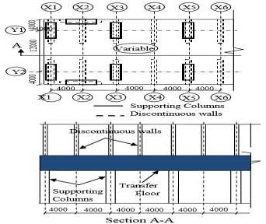

Fig 2. Transfer floor plan and cross section (transfer slab system)

The above fig 2 shows a typical plan and cross section of transfer slab system which shows transfer slab is provided between two different load resisting system. Below the transfer floor long spaced columns are provided with 8m spacing and above the transfer the transfer floor shear wall is provided with 4m spacing. In floor plan the continuous line shows position of columns below the transfer slab and the dotted lines shows position of shear wall above the transfer slab.

NUMERICAL ANALYSIS
To scrutinize the level of transfer slab in high rise building, the linear dynamic response spectrum analysis was conducted on models by using ETABS 2016 software.

Response Spectrum Function
Response spectrum analysis is linear dynamic statistical analysis method which indicate the maximum seismic response of an elastic structure from natural mode of vibration. Response spectrum analysis provides dynamic behavior by measuring spectral acceleration, velocity or displacement as a function of structural period for given time history and level of damping.
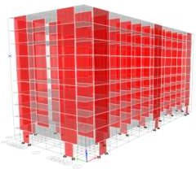
For the Response spectrum function the scale factor is given by,
Where, I= Importance factor G= gravity force
R= response modification factor
The figure 3 shows position of columns below the transfer floor with spacing between the columns is 8m.
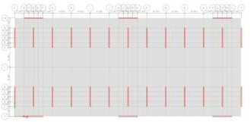

Fig 4. Position of shear wall above Transfer floor
The figure 4 shows the position of shear wall provided above the transfer floor with spacing between the shear wall is 4m.
To scrutinize the vertical position of transfer slab in high rise building a 10 storey building was analyzed using ETABS 2016 software. The figure 3 shows five different models with transfer slab provided at 1st floor, 2nd floor, 3rd floor, 4th floor and 5th floor levels has been analyzed using elastic response spectrum using ETABS 2016 software.

Re-scaling,
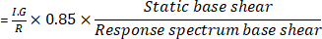
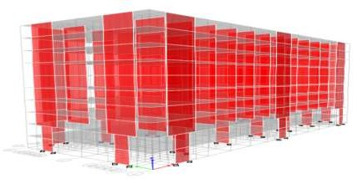

Modelling
A 10 storey building was selected for analysis of high rise building with transfer slab. Building has a shear wall structure above the transfer floor and long spacing columns below the transfer floor.
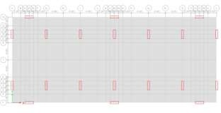
Fig 3. Position of columns below Transfer floor.
Transfer slab at 1st floor

Transfer slab at 2nd floor

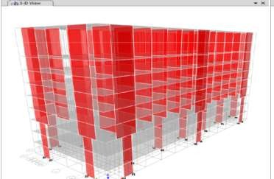
Transfer slab at 3rd floor
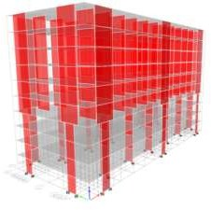

Transfer slab at 4th floor
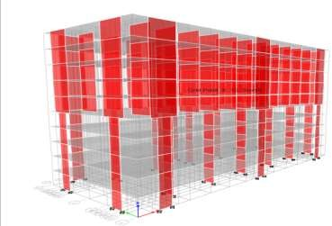
Transfer slab at 5th floor Fig 5. Position of transfer slab

RESULTS
A structural analysis program ETABS 2016 software was used for performance analysis of high rise building with transfer floor system. For this different building models were analyzed using response spectrum analysis. A five different models of 10 storey building with transfer floor provided at different floor levels such as 1st floor, 2nd floor, 3rd floor, 4th floor and 5th floor levels were analyzed. And vertical position of transfer floor with respect to building height was investigated. For this seismic response graphs of the building such as storey shear, storey moment, displacement and inter-storey drift were numerically evaluated.
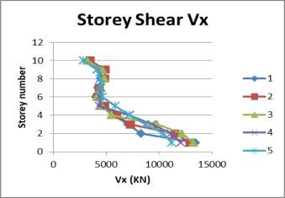
Fig 6. Storey shear distribution in x direction
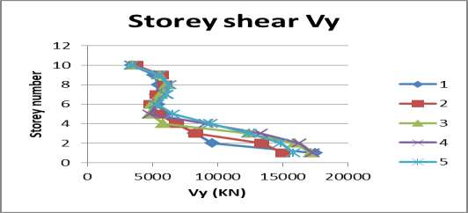
Fig 7. Storey shear distribution in y direction
The above figure 6 and figure 7 shows storey shear distribution in x and y direction for 10 storey building model with transfer slab provided at different floor levels resulting from linear response spectrum analysis. It is evident from the figure that a significant increase in storey shear in x and y direction is observed in building with lowest transfer slab located at the 10% of total height of building.

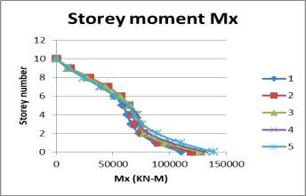
Fig 8. Storey moment distribution in x direction
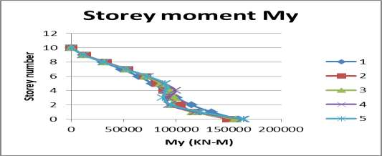
Fig 9. Storey moment distribution in y direction
The above figure 8 and figure 9 shows storey moment distribution in x and y direction for 10 storey building model with transfer slab provided at different floor levels resulting from linear response spectrum analysis. And from the figure it is clear that, the storey moment is more for transfer slab provided at higher level i.e for the transfer slab provided at 1st floor, storey moment values are less and then goes on increasing as transfer slab provided at higher level.
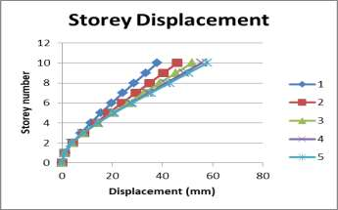
Fig 10. Storey displacement
Above figure 10 shows the displacement of building along the storey height. And it is concluded that every building has flexural mode upto a transfer floor level and then displacement goes on increase above the transfer level.

CONCLUSION
An analytical study was conducted to investigate vertical position of transfer floor in high rise building. A number of building models were analyzed using elastic response spectrum. The transfer slab system was considered and different level for transfer floor with respect height to building height was scrutinized.
Following are the silent conclusions obtained from the study,
- A significant increase in the storey base shear is observed in the building with the lowest transfer system located at 10% of the total building height.
- It should be noted that the storey shear force experience a significant reduction above the transfer floor location in all cases due to the sudden reduction in the mobilize mass.
- The total base shear moment is increase as transfer floor lies at higher level.
- The displacement distribution shown in displacement graph reveals that every building has a flexural behavior mode up to its transfer floor level. At this level, a large inertial force hit the building due to the significant mass of the transfer level which results a large displacement.
- Vertical location of transfer floors with respect to total height of the building has a significant effect on buildings performance; introduction of the transfer floor in the lower part of the structure (20-30% of the total height of the building from its foundation) is better than having it in a higher location.

REFERENCES
- Yoshimura M., “Nonlinear Analysis of a Reinforced Concrete Building with a Soft First Storey Collapsed by the 1995 Hyogoken-Nanbu Earthquake”, Cement and Concrete Composites, Vol. 19, No. 3, 1997, pp. 213-
221.
- Yong L., Tassios T.P., Zhang G.F., and Vintzileou E., “Seismic Response of Reinforced Concrete Frames with Strength and Stiffness Irregularities”, ACI Structural Journal, Vol. 96, No. 2, 1999, Title no. 96-S24

- ALI A. K., and Krawinkler H., “Effect of vertical irregularities on seismic behaviour on building structures”, The John A. Blume Earthquake Engineering Center, Department of Civil Engineering, Stanford University, Report no. 130 December 1998

- Y. M. Abdelbasset and Sherif Mourad , “Seismic analysis of high rise building with transfer floor: state of art of review”, Electronic journal of structural engineering Jan2016

- Chopra A. K., “Dynamics of Structures: Theory and Applications to Earthquake Engineering”, 2nd Ed., Prentice Hall, Englewood Cliffs, New Jersey, USA. 2001

- Elnashai A.S., "DO We Really Need Inelastic Dynamic Analysis" Journal of Earthquake Engineering, Vol. 6, Special Issue 1, 2002 123-130
- International Conference of Building Official., “Uniform Building Code UBC97”, Volume 2, 3rd printing, California, USA. 1997.

- Li C.S., Lam S. S. E., Zhang M. Z., and Wong Y. L., “Shaking Table Test of a 1:20 Scale High-Rise Building with a Transfer Plate System”, ASCE Journal of Structural Engineering, Vol. 132, No. 11, 2006, pp.
1732–1744.
- Mander, J.B., Preiestley, J.N., and Park, R., “Theoretical Stress Strain Model for Confined Concrete", ASCE Journal, structural division, 114 (12), 1989, 1804-
1826.

- Martlnez-Rueda J. M and Elnashai A.S., "Confined Concrete Model under Cyclic Load", Materials and Structures/Matriaux et Constructions, Vol. 30, April 1997, pp 139-147.
- Paulay T., and Priestley M. J. N., “Seismic Design of Reinforced Concrete and Masonry Buildings”, John Wiley & Sons, New York, USA. 1992. SeismoSoft Package, SeismoMatch Manual, “A computer program to match a specific target response spectrum data.” http://www.seismosoft.com

- eismoSoft Package, SeismoStruct Manual, “A computer program to simulate the dynamic and static loads that applied to structures.” http://www.seismosoft.com.

- Su R.K.L., “Seismic Behaviour of Buildings with Transfer Structures in Low-to-Moderate Seismicity Regions”, eJSE international Special Issue: Earthquake Engineering in the low and moderate seismic regions of Southeast Asia and Australia. 2008, pp. 99-109.
- Ye Y., Liangg X., Yin Y., Li q., Zhou Y., and Gaox., “Seismic Behavior and Design Suggestions on Frame Supported Shear Wall Structures in High-Rise Buildings”, Structural Engineers 4, 2003, pp7-12.

