Blood Bank Management System

Tarun S
Department of Computer Science And Engineering
Reva University
Banglore, India
2103110@reva.edu.in
Krishnaveni.B
Department of Computer Science And Engineering
Reva University
Banglore, India
2108225@reva.edu.in
Lalith Rao
Department of Computer Science And Engineering
Reva University
Banglore, India
2105176@reva.edu.in
Sinchal Somaiah.C
Department of Computer Science And Engineering
Reva University
Banglore, India
2106147@reva.edu.in

Abstract— Blood transfusion safety is a relevant and significant public health issue. Since most blood banks are still in paper-based system, various disadvantages are experienced by various stakeholders, which endanger the lives of patients and deter the healthcare system. The aim is to design, develop, and implement a blood bank management system (BBMS). This allows hospitals to make inventories of their blood bags online, subsequently, allowing each hospital to check the availability of blood bags anytime. It is perceived online blood bank management system is much better than the manual system. Therefore, with the use of blood bank management system, blood transfusion process is safe and secured. Threats on improper blood donor documentation, or misplaced records will be totally eradicated. Also, processes involving recording about blood donors, blood bag collection, storage, and inventory will be systematized and organized, hence, improving the healthcare management for blood banks.
List of Symbols, Abbreviations and Nomenclature—Blood bags: Designed for the collection, processing and storage of whole blood and blood components.
Blood bank: Place where blood bag that is collected from blood donation events is stored in one place. Refers to a division of a hospital laboratory where the storage of blood product occurs and where proper testing is performed to reduce the risk of transfusion related events.
Donor: Someone who gives a part of their body or some of their blood to be used by doctors to help a person who is ill.
Transfusion: Transfusion is done as a lifesaving maneuver to replace blood cells or blood products lost through severe bleeding. Transfusion of one's own blood (autologous transfusion) is the safest method, but it requires advanced planning, and not all patients are eligible.

Introduction
In today's fast-paced world, where medical emergencies and surgeries are routine occurrences, the efficient management of blood resources becomes a critical aspect of healthcare infrastructure. Ensuring a steady supply of safe and compatible blood for patients in need is essential for saving lives and improving health outcomes. The existing manual processes in many blood banks often lead to inefficiencies, errors, and delays in the blood donation and distribution pipeline. Therefore, the motivation behind undertaking the blood bank management project is to create a comprehensive solution that addresses these challenges and contributes to the seamless functioning of blood banks.

Front End Technologies: The front end of the blood bank management system will be developed using the .NET framework.
Back End Technologies: The back end of the blood bank management system will be developed using the .NET framework, utilizing:
1. C# (C-Sharp): As the primary programming language for .NET, C# will be used to implement the business logic, data processing, and integration with the database.
2. Entity Framework: To simplify data access and management, Entity Framework, an object-relational mapping (ORM) framework, will be employed. This allows developers to work with databases using .NET objects.
3. SQL Server: Microsoft SQL Server will be the database management system of choice. It offers robust data storage, retrieval, and management capabilities, ensuring the security and integrity of blood bank information.

By leveraging the .NET framework and associated technologies, the blood bank management system aims to provide a secure, scalable, and user-friendly solution that enhances the efficiency of blood donation and distribution processes while contributing to the overall improvement of healthcare services.

II . Literature Survey
According to Teena, C.A, Sankar, K. and Kannan, S. (2014) in their study entitled “A Study on Blood Bank Management”, they defined Blood Bank Information System as an information management system that contributes to the management of donor records and blood bank. Their system allowed an authorized blood bank administrator to sign in with a password to manage easily the records of donors and patients who need blood. The system provided many features including the central database, quick access to the system content through the login, includes the search code to find donors on a given basis, and the ease of adding and updating donor data. The main aim of the system was to complete the process of the blood bank. This system was designed to suit all types of blood banks. Once successful in the implementation of the application, it can be applied and rolled out in several blood banks. This application contains User Login Screen, Blood Management, Menu Form, Blood Stock, Donor Management, Donor Registration, Blood Reservation, Donor Blood Test, Recipient Management and Blood Reservation.

On the other hand, study entitled “Blood Bank Management System” done by Kumar, R., Singh, S. and Ragavi, V.A. (2017), the researchers developed a web-based blood management which assists the blood donor records management, and provides ease of control in the distribution of blood products in various parts of the country considering demands of hospitals. The developed system was scalable and adaptable to meet the complex needs usually of a blood bank. Based on this study, since entering the details about the blood donors and related records were done manually, thus, tracking of blood donation activities was difficult and complicated, and even led to erroneous information. Subsequently, the researchers mentioned that manual-based system can be waste of time, lead to the error-prone results, consumes a lot of manpower, lacks data security, data retrieval requires a lot of time, reports consumes a long time to produce, and there is less precise accuracy on the results. As such, by developing and implementing a web-based blood management information system, there was a quick and timely access to donor records, and the system provided management timely, confidential and secured medical reports. There were three (3) users in the system, namely: Administrator, Donor, and Acceptor. Each user has been given user ID and password to identify their identity. The said application was developed using ASP.NET, C#.NET, and using SqlServer 2000/2005 for the database.

Methodology

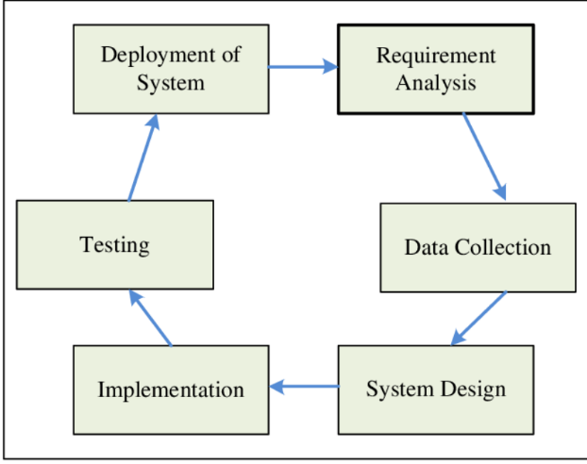
Fig. 1. Methodology Diagram

- Requirement Analysis: Understand the needs and requirements of blood banks, healthcare professionals, and end-users. Conduct interviews, surveys, and analysis to gather comprehensive requirements for the system.
- System Design: Design the architecture and user interface of the blood bank management system. Define the modules, components, and interactions between them. Create wireframes and mockups to visualize the system layout and flow.
- Database Design: Design the database schema using Microsoft SQL Server. Define tables, relationships, constraints, and indexes to efficiently store and retrieve blood bank data. Consider factors like data normalization, performance, and scalability.
- Front End Development: Develop the user interface of the blood bank management system using the .NET framework. Utilize ASP.NET and C# to create responsive and intuitive web or desktop interfaces. Implement features like user authentication, data input forms, and interactive dashboards.
- Back End Development: Implement the business logic and data processing logic using C# and .NET. Utilize Entity Framework for seamless integration with the SQL Server database. Implement functionalities such as blood donor management, inventory tracking, blood compatibility checks, and distribution scheduling.
- Integration Testing: Test the integration between the front end, back end, and database components of the blood bank management system. Verify that data flows correctly between layers and that functionalities work as expected. Conduct unit tests, integration tests, and system tests to ensure reliability and robustness.
- User Acceptance Testing (UAT): Involve end-users and stakeholders in UAT to validate the functionality, usability, and performance of the blood bank management system. Gather feedback and make necessary refinements to meet user expectations and requirements.
- Deployment: Deploy the blood bank management system to production servers or cloud platforms. Configure server environments, database settings, and security measures to ensure smooth operation and data protection.
- Training and Documentation: Provide training sessions for blood bank staff and administrators on how to use the system effectively. Develop comprehensive documentation, user manuals, and FAQs to support users in utilizing the system efficiently.
- Maintenance and Support: Provide ongoing maintenance and support for the blood bank management system. Monitor system performance, address issues and bugs promptly, and release updates or patches as needed to ensure continuous improvement and reliability.

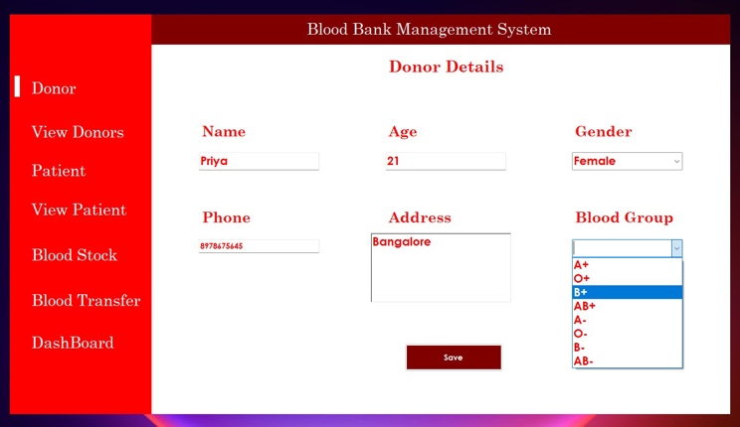
Fig. 2. Register
We have a form for registering new users. When the user types in the details and clicks the submit button, a message “register successfully” will pop up and the information will be stored in the database.
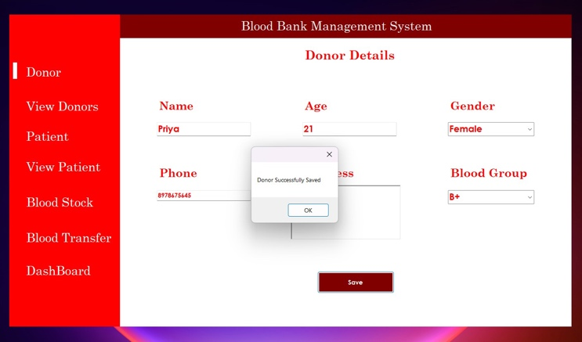
Fig 3. Successful registration

For updating, the user can type in the details and click the update button, a message “updated successfully” will pop up and the information will be updated in the database.
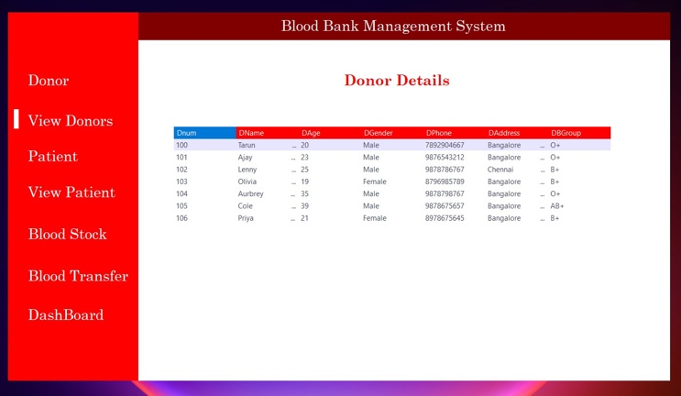
Fig 4. Donor details

Donor details includes list of donors with their id, name, age, gender, blood group ,etc

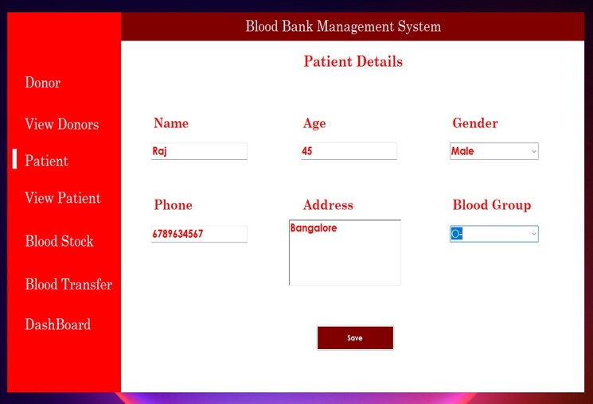
Fig 5. Patient registration
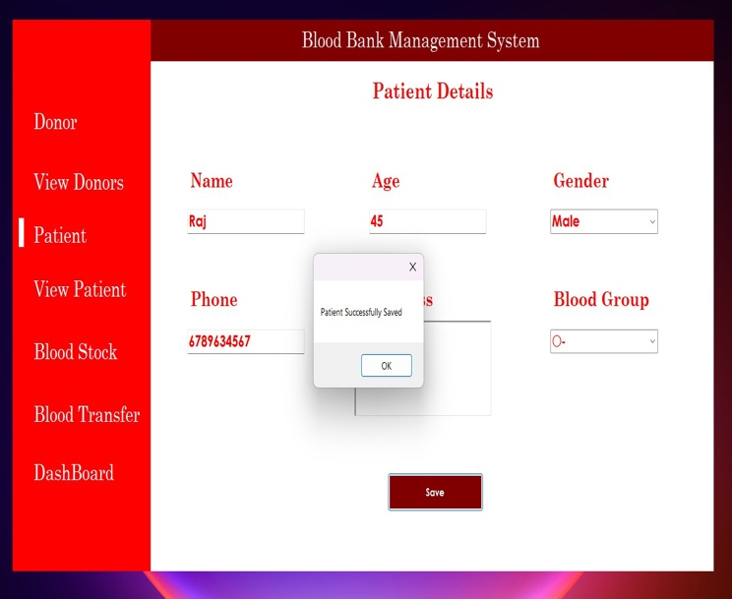
Fig 6. Successful registration

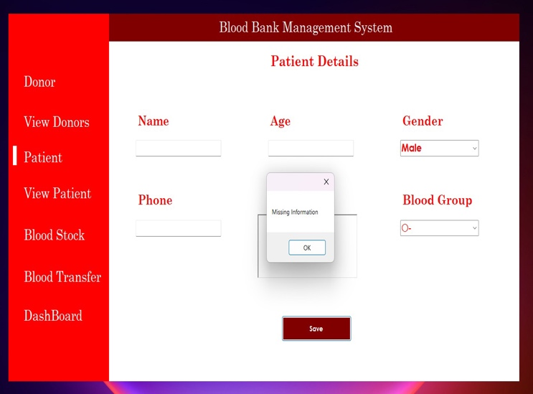
Fig 7. Unsuccessful registration

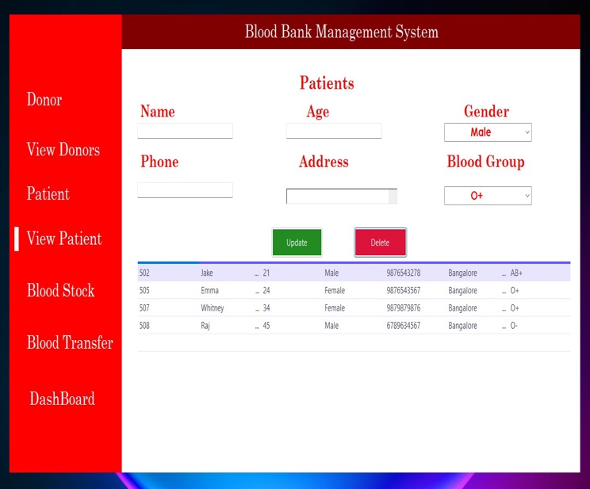
Fig 8. Patient details
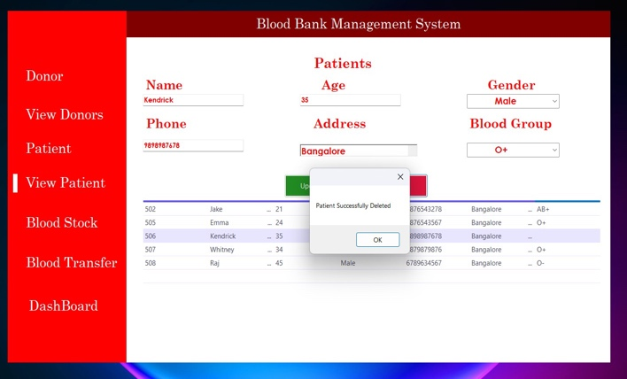
Fig 9. Deleting Patient details

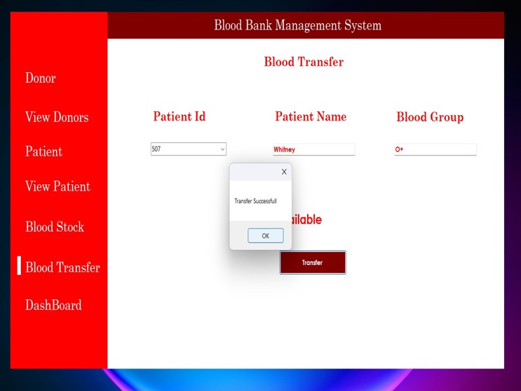
Fig 10. Blood Transfer

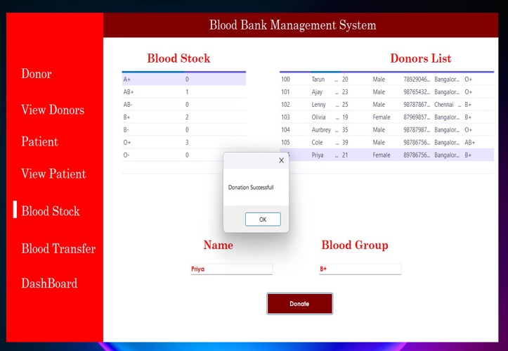

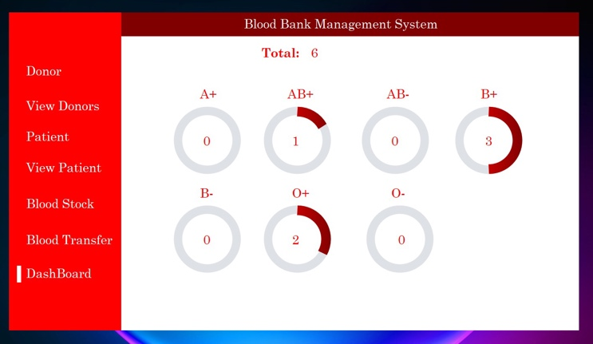
Fig 12. Blood Stock Table

Conclusion
Based on results, this study concluded that online blood bank management system is much better than the manual system. The findings showed that respondents prefer to use online blood bank management system rather than the manual system because it offers many advantages and benefits that lead to its effectiveness, and efficiency. Because of the increased confidence on the users on the system, it can be concluded that the online blood bank management system enhances blood transfusion safety because it provides better ways of handling the various processes in blood bank.

References

- "Blood Bank Management System" by K. Sravani, G. Naga Deepthi, and P. Sreenivasulu. International Journal of Computer Applications Technology and Research (IJCATR), Volume 4, Issue 10, October 2015.
- ".NET Documentation" by Microsoft Corporation.
- "Entity Framework Documentation" by Microsoft Corporation.
- "SQL Server Documentation" by Microsoft Corporation.
- "Software Engineering: A Practitioner's Approach" by Roger S. Pressman.
- "Web Application Security: A Beginner's Guide" by Bryan Sullivan.
- "Introduction to Database Systems" by C.J. Date and A.K. Kannan.
- "Health Information Technology and Management" by Richard
Fig 11. Blood Donation

