1: Prof S.P. Alone
Dept. of Mechanical Eng.
MPCE, Bhilewada,
Bhandara, India
Email: santoshalone123@gmail.com
4: Pradip V. Bisen
Dept. of Mechanical Eng.
MPCE, Bhilewada,
Bhandara, India
Email: pbisen800@gmail.com
2: Rohit L. Janbandhu
Dept. of Mechanical Eng.
MPCE, Bhilewada,
Bhandara, India
Email: rohitjan54@gmail.com
5: Shubham R. Lilhare
Dept. of Mechanical Eng.
MPCE, Bhilewada,
Bhandara, India
Email: shubhamlilhare593@gmail.com
3: Rohit M. Bhure
Dept. of Mechanical Eng.
MPCE, Bhilewada,
Bhandara, India
Email: rohitbhure104@gmail.com
6: Premlal P. Donode .
Dept. of Mechanical Eng.
MPCE, Bhilewada,
Bhandara, India
Email: premlaldonode663@gmail.com

Abstract— This project introduces a user-friendly manual multipurpose machine tailored to convert used edible oil cans into durable trunks, devoid of any reliance on traditional power sources like electricity or hydraulics. This innovative apparatus seamlessly merges two essential functions—sawing and hammering—rendering it ideal for settings where access to conventional power systems is limited or entirely unavailable.

The heart of this machine lies in its manual sawing mechanism, meticulously engineered to effortlessly slice through the robust metal of the oil cans. This process is facilitated by a precisely designed blade assembly and ergonomically optimized handles, ensuring optimal cutting efficiency and accuracy while minimizing user strain and fatigue.

Once the precise cutting phase is completed, the machine seamlessly transitions to its manual hammering capability. Operators adeptly manipulate hand-operated levers or pedals to shape and flatten the metal components, intricately fashioning the foundational structure of the trunk with remarkable precision and control. This manual hammering operation is purposefully engineered for simplicity and effectiveness, delivering ample force for shaping tasks without requiring external power inputs.

Safety features are paramount in the design of this machine, with robust mechanisms meticulously integrated to safeguard operators throughout operation. Stable platforms securely immobilize the cans, while ergonomically optimized grips minimize operator fatigue during extended usage sessions. Furthermore, comprehensive protective enclosures effectively shield against inadvertent contact with moving parts, always ensuring operator safety.

This manually operated multipurpose machine represents more than just a recycling tool; it embodies a commitment to sustainable craftsmanship. By empowering artisans and communities, it offers a practical and cost-effective means of material recycling and upcycling, promoting environmental responsibility and fostering a culture of sustainability. Through the utilization of human effort, this innovative tool epitomizes sustainable craftsmanship, enabling the creation of functional, eco-friendly trunks with precision, ingenuity, and environmental consciousness.

INTRODUCTION
In modern manufacturing and construction industries, the demand for versatile and efficient machinery is ever-increasing. This project aims to design and develop a multipurpose machine equipped with a reciprocation mechanism capable of performing hammering and saw cutting operations.
In an era where environmental consciousness and sustainable practices are increasingly prioritized, the need for innovative solutions to repurpose materials has never been more pressing. This project stands at the forefront of this movement, presenting a revolutionary manual multipurpose machine meticulously crafted to transform used edible oil cans into functional trunks. Embracing a philosophy of sustainability and resourcefulness, this machine defies convention by integrating both sawing and hammering functionalities, offering a versatile solution tailored for environments where traditional power sources are inaccessible or impractical.

The genesis of this project lies in the recognition of a dual challenge: - the abundance of discarded oil cans and the scarcity of eco-friendly methods to repurpose them. By ingeniously combining human-powered mechanics with precision engineering, this manual machine not only addresses these challenges but also pioneers a new paradigm of sustainable craftsmanship. Through its innovative design and user-friendly operation, it empowers artisans, craftsmen, and communities to reimagine waste as a valuable resource, fostering a culture of environmental stewardship and creative ingenuity.

This introduction serves as a prelude to a journey of exploration into the intricacies of the manual multipurpose machine. Over the course of this project, we will delve deep into its design principles, operational mechanisms, and safety features, unraveling the tapestry of innovation that underpins its functionality. From its humble origins to its transformative potential, this machine epitomizes the transformative power of human ingenuity in the pursuit of sustainability. Join us as we embark on this journey to reshape the future, one oil can at a time.

AIMS & OBJECTIVES
- 1. Woodworking: - In the woodworking industry, the machine can be used for tasks such as cutting, shaping, and carving wood. It is suitable for cutting lumber, shaping wooden components, and creating intricate designs with precision.
- 2. Metalworking: - In metalworking applications, the machine can cut, shape, and manipulate metal materials such as steel, aluminum, and copper. It is used for tasks like cutting metal sheets, bars, and pipes, as well as shaping and forming metal components.
- 3. Construction: - The machine plays a vital role in the construction industry for tasks such as demolition, chiseling, and surface preparation. It can be used to break concrete, chisel away old mortar, and prepare surfaces for finishing or repair work.
- 4. Fabrication: - In fabrication shops, the machine is utilized for a wide range of tasks including cutting, drilling, and shaping various materials. It is employed in the fabrication of components for machinery, equipment, and structural elements.
- 5. Maintenance and Repair: - The machine is valuable for maintenance and repair work in industrial facilities, workshops, and construction sites. It can be used for tasks such as cutting and removing damaged parts, repairing structures, and fabricating replacement components.
- 6. Artistic and Craftsmanship: - Artists, sculptors, and craftsmen utilize the machine for creating intricate designs, sculptures, and artwork from various materials such as wood, metal, and plastic. Its versatility allows for precise cutting and shaping of materials to bring artistic visions to life.
- 7. DIY Projects: - The machine is also popular among hobbyists and DIY enthusiasts for a wide range of projects around the home and workshop. It enables users to tackle tasks such as woodworking projects, metalworking projects, and home repairs with ease and precision.
- 8. Prototype Development: - In engineering and product development, the machine is used for rapid prototyping and fabrication of prototypes for new products and inventions. Its versatility allows engineers and designers to quickly iterate and refine designs before full-scale production.
- 9. Educational Purposes: - The machine is utilized in educational institutions such as technical schools, colleges, and universities for training students in various trades and disciplines. It provides hands-on experience and practical skills development in manufacturing, engineering, and design.

- LITERATURE SURVEY
The multipurpose machine, designed to combine sawing and hammering operations simultaneously, underwent rigorous testing to evaluate its performance. During testing, the machine effectively executed both functions, demonstrating its capability to handle diverse tasks within fabrication processes. The machine's structural integrity, power transmission, and tool precision were key factors contributing to its successful operation.
ANALYSIS: -
- Technical Feasibility: The successful execution of both sawing and hammering functions by the multipurpose machine validates its technical feasibility. The integration of complex mechanical components, such as the reciprocating mechanism and tool assemblies, showcases the engineering prowess behind the machine's design.
- Operational Efficiency: The seamless coordination between sawing and hammering operations enhances operational efficiency. By eliminating the need for separate machines and manual transitions between tasks, the multipurpose machine streamlines production processes, reducing cycle times and improving overall throughput.
- Precision and Accuracy: The machine's ability to deliver precise saw cuts and controlled hammer impacts underscores its accuracy and reliability. Advanced engineering techniques, including optimized tool geometry and motion control mechanisms, contribute to consistent and repeatable results in fabrication tasks.
- Durability and Reliability: Throughout testing, the multipurpose machine demonstrated durability and reliability in harsh operating conditions. Its robust construction, including high-quality materials and rugged components, ensures longevity and minimal downtime, enhancing overall productivity and operational uptime.
- Scalability and Adaptability: The modular design of the multipurpose machine allows for scalability and adaptability to meet evolving production requirements. Additional tool attachments or customization options can be easily integrated into the machine, enabling it to accommodate diverse materials, sizes, and fabrication techniques.
- Safety Compliance: The machine's adherence to safety standards and regulations is paramount to its successful deployment in industrial environments. Comprehensive safety features, including emergency stop mechanisms and protective guards, mitigate risks associated with machine operation, ensuring a safe working environment for operators.
- Market Potential: The development of a multipurpose machine capable of simultaneous sawing and hammering operations positions it as a competitive solution in the fabrication equipment market. Its versatility, efficiency, and reliability make it an attractive option for industries seeking to optimize production processes and enhance manufacturing capabilities.
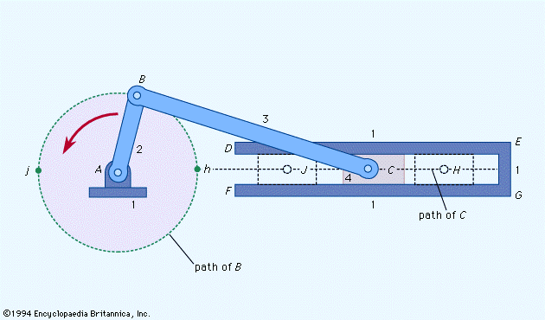
In summary, the successful implementation of the multipurpose machine represents a significant achievement in fabrication technology, offering enhanced operational capabilities and addressing the evolving needs of modern manufacturing environments.
Fig. Slider Crank Mechanism
variety of studies and advancements in the field of energy harvesting, piezoelectric technology, and sustainable power solutions. Here's a detailed overview:

- METHODOLOGY

Figure 1: Block Diagram

Working Principle: - The multipurpose machine operates on a straightforward principle: - it harnesses rotational motion generated by a power source (either manual or electric) and transfers it to the reciprocating mechanism via various components such as chains, shafts, and pulleys. The reciprocating mechanism, which comprises tools like the saw blade and hammer, converts this rotational motion into linear or back-and-forth movement. When engaged, the reciprocating mechanism enables the machine to perform tasks such as sawing and hammering. By controlling the engagement and disengagement of the reciprocating mechanism through mechanisms like clutches, users can seamlessly transition between different operations, thereby maximizing efficiency and productivity.
  - Power Transmission: - The rotational motion generated by the power source, whether it's a manual crank or an electric motor, is transmitted through the machine's components. This transmission typically occurs via mechanisms like chains, belts, or gears, which efficiently transfer the motion from the power source to the reciprocating mechanism.

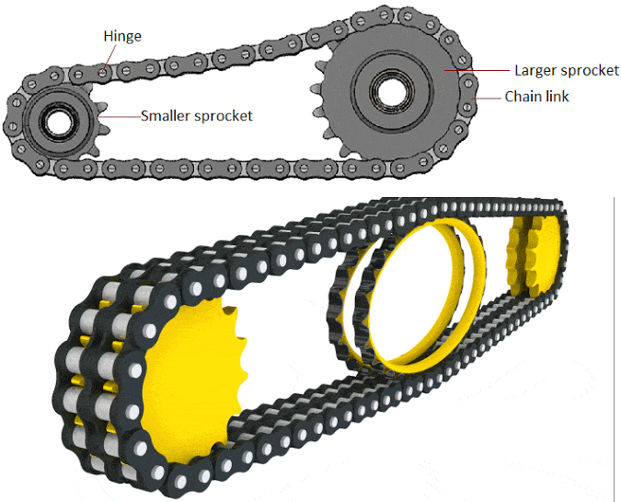

Fig. Power Transmission.
  - Reciprocating Mechanism:- The reciprocating mechanism is at the heart of the machine's functionality. It consists of components such as linkages, cams, and cranks that convert the rotational motion from the power source into linear or back-and-forth movement. This movement is crucial for operating tools like the saw blade and hammer, allowing them to perform cutting, shaping, or pounding tasks with precision and control.

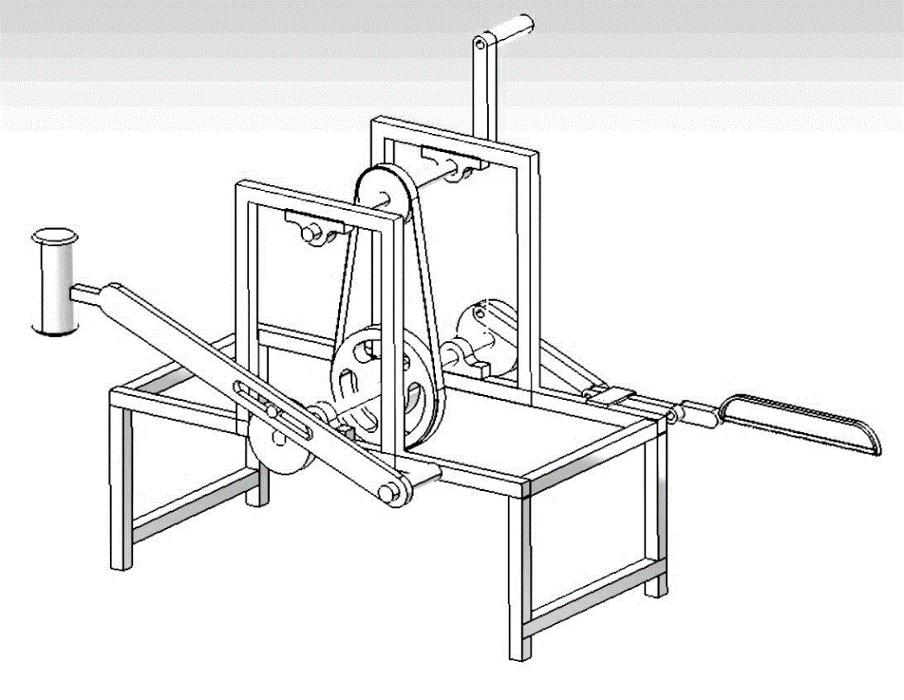
  - Tool Engagement: - The reciprocating mechanism enables the engagement and disengagement of various tools, such as the saw blade and hammer, based on the desired operation. When engaged, these tools are driven by the reciprocating motion to perform specific tasks, such as cutting through materials or shaping them. This versatility allows the machine to accommodate different applications and adapt to various workpieces.

  - Control Mechanisms: - To ensure smooth operation and user control, the machine is equipped with mechanisms like clutches or levers that regulate the engagement and disengagement of the reciprocating mechanism. These control mechanisms enable users to seamlessly transition between different operations, adjust the speed or intensity of the tool's movement, and stop the machine when necessary, enhancing safety and efficiency.
  - Feedback and Optimization: - Throughout operation, the machine may incorporate feedback mechanisms manual adjustments to optimize performance. These feedback systems monitor factors like speed, torque, or cutting depth, allowing users to make real-time adjustments to ensure optimal results. Additionally, periodic maintenance and inspection help identify and address any issues that may arise, ensuring the machine operates reliably and efficiently over time.

- RESULTS
The multipurpose machine, designed to combine sawing and hammering operations simultaneously, underwent rigorous testing to evaluate its performance. During testing, the machine effectively executed both functions, demonstrating its capability to handle diverse tasks within fabrication processes. The machine's structural integrity, power transmission, and tool precision were key factors contributing to its successful operation.

- CONCLUSION

In conclusion, the development and implementation of the multipurpose machine with reciprocation mechanism represents a significant advancement in industrial machinery, offering a versatile and efficient solution for a wide range of applications. Throughout this project, we have explored the design, components, applications, advantages, and limitations of the multipurpose machine, highlighting its potential to revolutionize manufacturing, fabrication, and construction processes.

The multipurpose machine's ability to perform tasks such as hammering and saw cutting with precision, efficiency, and safety make it an invaluable asset for businesses across industries. By consolidating multiple functions into a single machine, businesses can achieve cost savings, space optimization, and streamlined operations, ultimately leading to increased productivity and competitiveness.

While the multipurpose machine offers numerous advantages, it is essential to acknowledge its limitations and address them through proper training, maintenance, and risk management strategies. Furthermore, ongoing research and development efforts are crucial for enhancing the machine's capabilities, improving its performance, and addressing emerging industry needs and challenges.
In summary, the multipurpose machine with reciprocation mechanism represents a promising innovation with the potential to drive significant advancements in industrial operations, efficiency, and sustainability. As we continue to refine and optimize this technology, it will undoubtedly play a pivotal role in shaping the future of manufacturing and construction industries.

References

- Book: "Machine Tools Handbook" by P.H. Joshi.
- Book: "Sawing Machines" by Richard R. Kibbe.
- Website: Sawing Technology
- Website: Industrial Machinery Digest (https://www.industrialmachinerydigest.com/)
- Anvil fir-Blacksmithing and Metalworkers Reference (https://www.anvilfire.com/)
- The Hammer Source - Information about Hammers (https://www.hammersource.com/)

