“A STUDY OF INVESTOR BEHAVIOR TOWARDS TAX SAVING INSTRUMENTS. A STUDY IN RAIGARH”

- Ayushi Chelshi Bhagat, MBA
Amity Business School
Amity University Chhattisgarh
ayushichelshibhagat@gmail.com

- Dr. Sumita Dave,
Deputy pro vice chancellor
Amity Business School
Amity University Chhattisgarh
sdave@rpr.amity.edu

Abstract
The tax saving season start from 1st April for both salaried and businessmen as a smart investor, one should look for tax saving investment, which not only provides the benefit of tax exemption but also help earn tax- free income. with the plethora of investment option available for investors for tax saving, it become increasingly difficult to choose a right option. however, for most of the investors the tax planning is let-do-it-later affair. Tax saving is the legitimate way to save the tax out go and every income tax assesses should exercise the option to increase their wealth. the paper aims to analyse the investor behaviour towards tax saving. the tax saving option considered are tax saving fixed deposit, national saving certificates, public provident fund, tax saving mutual fund, life insurance, national pension system (NPS), pension policies and Sukanya Samriddhi yojana (SSY). The study revealed that life insurance, PPF and fixed deposit are the most preferred investment option and NPS and SSY are the least preferred option for tax saving.
Introduction
Income tax saving schemes are offered as per the relevant section of the income tax act 1961. The chief among these is the section 80c which offers potential tax saving option of up to Rs.1.5 lakh yearly. There is other section also that provide benefit to individual. Major income tax saving instrument include public provident fund, also called PPF, you can make a maximum contribution of Rs 1.5 lakh per year in this tax saving scheme. PPF cannot be withdrawn before 15 years without penalty. the public provident fund (PPF) scheme is a very popular long – term saving scheme in India because of its combination of tax saving, return and safety. the PPF scheme was launched in 1968 by the finance’s ministry national saving institute. The main objective of the scheme is to help individuals make small saving and provide return in the saving the PPF scheme offers an attractive rate of rate of interest and no tax is required to be paid on the return that are generated from the interest rate. the next tax saving instrument is tax saving fixed deposits which are available for a fixed tenure of 5 years and premature withdrawal, loans or overdraft (OD) facilities are not available for a tax saving FD. There is no auto – renewable facility for tax saving fixed deposits. A tax saving FD is a good choice for an investor, as it provides dual benefit of guaranteed return and low risk. Another avenue of tax savings the NSC scheme which is available at all NSC post offices and the Indian government promotes the NSC scheme. Due to the number of post offices present in Indian and the easy access to these post offices, the scheme has become very popular. The main aim of the scheme is for individual to make small or medium saving, and tax benefit are provided for these saving. Since the scheme is encouraged by the Indian government, the risks of investing in the scheme are low. The scheme was launched mainly for individuals, therefore, non-resident Indians (NRI) and Hindu undivided families (HUF) are not eligible to opt for this scheme. The next avenue is tax saving mutual fund, also known as equity linked saving scheme of ELSS. These funds offer the opportunity for capital appreciation through investment in equities while saving on taxes along the way. Also, long term capital gains from these schemes are tax efficient, while dividend option for such funds will enable capital gains even during the lock in period. the typical lick in period is 3 years for an open-ended scheme and the benefit are provided u/s 80C which entitle investor to tax befit up to Rs 1.5 lakh each year. a maximum of 2 account can be opened, and in the case of twins, a total of 3 account can be opened. The minimum deposit amount is Rs.250 per year and a maximum deposit amount is Rs 1,50,000 per year at interest rate of 7.6% p.a. which is revied by ministry of finance. Account will mature after 21 years from the date on which the account was created, or on the date of marriage of the girl child in whose name the account was created. The central government has introduction the national pension system (NPS) with effect from January 01,2004(except for armed force). NPS was made available to all citizen of India from May 01,2009. Pension fund regulatory and development authority (PFRDA), the regulatory body for NPS, has appointed NSDL as central record keeping agency (CRA) for national pension system. CRA is the first of its kind venture in India which will carry out the function of record keeping, administration and customer services for all subscribers under NPS. CRA shall issue a permanent retirement account number (PRAN) to each subscriber and maintain data base of each permanent retirement account along with recording transaction relating to each PRAN. An additional deduction for investment up to Rs.50,000 in NPS (tier I account) is available exclusively to NPS subscriber under subsection 80CCD(1B). the tax saving life insurance plans include policies taken for yourself, or your spouse, or dependent children. you can claim deduction under section 80C if premium paid is not over 10% of the sum assured in the policy, if the policy has been purchased after April 01,2012. if the policy has been purchased before April 01 ,2012 then the premium must not be over 20% of the sum assured.

Review Of Literature
Lall (1983) quantified the extend of tax savings due to fiscal incentives granted for corporation taxes on the basis of sample study of 223 companies for the period 1961- 62 to 1975. The study found that effective tax rate was 45.7 percent as compared to the average statutory tax rate 54.9 percent. So, the return on corporate investment substantially improved due to tax saving arising from fiscal incentives. The study also highlighted that the capital-intensive industries obtained maximum benefit from fiscal incentives and tax base diminution effect was highlight in engineering industry followed by textile and chemical industry. Further, larger companies were major beneficiaries as they availed tax holidays.

Kalyani (1991) conducted a study on tax planning of salaried employees in Coimbatore city for the financial year 1988-89. This study identified that older the age, higher the tax liability; graduates and professionals have higher tax liability; private sector employees get higher income than the government employees; tax payment decrease when tax-saving investments increases; tax-saving investments increase along the income; and employees preferred to invest in Life Insurance Corporation, Provident Fund and National Saving Certificates.

Job (1995) conducted a study on “Investment Planning with Special Reference to State Government Officers in Palakkad District”. This study identifies the relationship between income and saving schemes and awareness of various schemes of employees. This study also analyses the reasons for preferring a particular investment scheme and utilization of tax concession by the employees. The findings of the study are; the saving is made to get regular income in future: profitability, liquidity, safety, tax concession and appreciation are the main reasons for the investments.

Karthikeyan (2001) has conducted research on Small Investors' Perception on Post office Saving Schemes and found that there was significant difference among the four age groups, in the level of awareness for Kisan Vikas Patra (KVP), National Savings Schemes (NSS), and Deposit Scheme for Retired Employees (DSRE), and the overall score confirmed that the level of awareness among Investor in the old age group was higher than in those of the young age group. No difference was observed between male and female investors except for the NSS and KVP. Out of the factors analysed, necessities of life and tax benefits were the two major ones that influence the investors both in semi-urban and urban areas. Majority (73.3 per cent) of investors of both semi urban and urban areas were very much willing to invest in small savings schemes in future provided they have more for savings.

Chitta Ranjan Sarkar (2004) identified that the basic purpose of tax incentives in India was to motivate the tax payers to save and invest more, particularly in rural and backward areas of the country. The study described and critically evaluated the policy of liberal income tax exemptions and concessions to accelerate the face of growth in India. It was examined various theoretical issue related to the operation of tax incentives. It was provided an overview of present system of income tax incentives in India. Drawing on experience of other countries an attempt had been made to evaluate tax incentives in India.

R. Ganapathi and S. Anbu Malar (2010) Studied Investors Attitudes towards Post office Deposit Schemes. The post Office has long been known as a medium to inculcate the habit of thrift and savings among the agricultural workers. But over time, its role has changed and it has grown to become one of the best avenues to channel investment from even the wealthy invest and use them fruitfully in nation building activities. There has been introduction of several types of deposit schemes that cater to the differing needs of different classes of investors. They are well- known for their tax saving schemes, high interest rates and the safety and liquidity that they offer. This has enabled them to compete successfully with the other avenues of investment available to investors like commerce, etc. This study made an attempt to identify the awareness, preference and attitudes of investors towards various deposit schemes offered by the Post Office among 300 respondents of the Coimbatore District.

N. Geetha Dr. M. Ramesh (2011) studied about A Study on People’s Preferences in Investment Behaviour. The person dealing with the planning must know all the various investment choices and how these can be chosen for the purpose of attaining the overall objectives. it is concluded that in Kurumbalur respondents are medium aware about various investment choices but they do not know aware about stock market, equity, bound and debentures. All the age groups give more important to invest in Insurance, NSC, PPF and bank deposit. Income level of a respondent is an impotent factor which affects portfolio of the respondent. Middle age group, Lower income level groups respondents are preferred to invest in Insurance, NSC, PPF and bank deposit rather than any other investment avenues. In Kurumbalur respondents are more aware about various investment avenues like Insurance, PPF, bank deposits, small savings like post office savings etc.

Ashly Lynn Joseph, Dr M. Prakash (2014) conducted a study on avenues among the people and factors considered for investments. The investment basically refers to the buying of a financial product or any valued item with anticipation that positive returns will be received in the future. People are earning, but they do not know where, when and how to invest their funds or money earned by them. Many people are not willing to take risk for their funds, so many prefer to invest in bank deposits, insurance, post office saving etc. Many of the people are not aware about how to make an investment in share market, equity etc. There might be a chance that the preference of the respondents may be different because of difference in their awareness level, income level etc. All the age groups among my respondents give more importance to invest in bank deposit and Insurance. Income level of a respondent is an important factor which affects investment portfolio of the respondent. Respondents are more aware about various investment avenues like insurance, bank deposits, small savings like post office savings etc.

Sonali Patil, Dr. Kalpana Nandawar (2014) conducted A Study on Preferred Investment Avenues Among Salaried People with Reference to Pune, India. Investors are investing their money with the different objectives such as profit, security, appreciation, Income stability. The researcher has analysed that salaried employees consider the safety as well as good return on investment on regular basis. Respondents are aware about the investment avenues available in India except female investors. He found that there is no relationship between the income level & awareness of investment avenues, The main objectives of investors are future security followed by good return, Bank deposit is the first preference given by the investors for investment

Deepak Sood and Dr. Navdeep Kaur (2015) conducted a study of saving and investment pattern of salaried class people with special reference to Chandigarh. It was found from the analysis there is relationship between Annual Savings and Age, Income, Sector wise Employment, Education of people at Chandigarh. It was propounded here that the most preferred investment options are LIC and bank deposits and most of the factors influencing investment decisions were high returns, tax benefit and safety.

Ms. S. Mathumitha (2015) studied Investors attitude towards post office saving schemes in Cumbum town. Postal savings systems to provide depositors who do not have access to banks a safe, convenient method to save money and to promote saving among the poor. The post office has traditionally served as a financial institution for millions of people in the rural areas. It plays a vital role in rural areas. It connects these rural areas with the rest of the country and also provides banking facilities in the absence of banks in the rural areas.

Objectives Of the Study
- To study about various tax saving schemes.
- To study tax payer’s preference towards various tax saving schemes.
- To describe the reasons for investments in tax saving schemes.
- To identify the ways in which investors get information about various tax saving schemes.
Research Methodology
The study is designed on a descriptive cum analytical study conducted in Raigarh District based on both secondary and primary data. The government employees were selected as per snowball sampling method. The data were collected through structured Questionnaire method.

Source Of Primary Data
The study is mainly based on primary data; the primary data for this study is collected from 50 tax payers of Raigarh district through structured Questionnaire.
Sources Of Data
Secondary data are collected from;
- Publication book
- Magazine
- Journal
- Article
- Website
Sample Design and Sample Size
Primary data has been collected from different government employees in Malappuram district . Snowball sampling is used for selecting investors. A total of 50 Tax payers have been selected from different area were selected on a random basis.
Tools Used For Data Analysis
The following tools have been used to analyse and interpret the data.
ANOVA
Weighted Average
Ranking
Karl Pearson’s Correlation Coefficient
Percentage analysis

Limitations Of The Study
- The study is based on sampling techniques, so there is a chance of sampling error.
- The study was conducted and data collected within a short period which may affect in
getting the reliable data.
- The area of the study is restricted to Raigarh district.

Results And Discussion
This is exclusively for analysis of data collected by survey with the help of questionnaire. The present study intended to analyse the tax payer’s attitude and preference towards various tax saving schemes with special reference to Raigarh district. The data is analysed and presented in the form of table with necessary interpretation along side. Various types of statistical methods are used for analysis of data. This analysis is supplemented by explanation, tables and diagrams.

TABLE 1: - SOCIO-DEMOGRAPHIC PROFILE OF RESPONDENTS
PARTICULAR | STATUS | NO. OF RESPONSES | PERCENTAGE (%)
GENDER | MALE | 36 | 72
GENDER | FEMALE | 14 | 28
GENDER | TOTAL | 50 | 100
AGE | Below 25 | 4 | 8
AGE | 25-35 | 28 | 56
AGE | 35-45 | 8 | 16
AGE | 45-55 | 10 | 20
AGE | ABOVE 55 | 0 | 0
AGE | TOTAL | 50 | 100
EDUCATIONAL  QUALIFICAION | PLUS, TWO | 6 | 12
EDUCATIONAL  QUALIFICAION | DEGREE | 20 | 40
EDUCATIONAL  QUALIFICAION | POST GRADUATE | 24 | 48
EDUCATIONAL  QUALIFICAION | OTHERS | 0 | 0
EDUCATIONAL  QUALIFICAION | TOTAL | 50 | 100
ANNUAL INCOME OF RESPONDENT | BELOW 500000 | 3 | 6
ANNUAL INCOME OF RESPONDENT | 500000-750000 | 20 | 40
ANNUAL INCOME OF RESPONDENT | 750000-1000000 | 13 | 26
ANNUAL INCOME OF RESPONDENT | 1000000-1250000 | 10 | 20
ANNUAL INCOME OF RESPONDENT | ABOVE 1250000 | 4 | 8
ANNUAL INCOME OF RESPONDENT | TOTAL | 50 | 100
OCCUPATION | SOLE PROPRIETOR | 6 | 12
OCCUPATION | PARTNERSHIP | 20 | 48
OCCUPATION | CORPORATION | 24 | 40
OCCUPATION | TOTAL | 50 | 100

Interpretation
The above table shows the socio-demographic profile of the respondents. By analysing it we can conclude that majority of the respondents are male 72% and females are 28%. From the above table we can understand that 8% of respondents fall in the age group of less than 25 years, while 56% of the respondents are between 25-35 years of age and 16% respondents are in the age group of 35-45. 20% of the respondents are in between 45-55 and no one in this study is above 55 years. By analysing the educational qualification of the respondents, we can understand that majority of them are post graduate 48%. 40% of the respondents have degree and 12% have plus two qualifications. It is clear from the above table majority of the respondents (40%) have annual income in between 500000-750000, followed by (26%) of the respondents have annual income in between 750000-1000000 and (20%) have annual income between 1000000 to 1250000.it is clearly seen that in business occupation there is 48% of corporation more respondent in this were as there is a partnership business has 40% of the respondent, sole proprietorship 12% this make it clear that corporate is more responder her.

TABLE 2: - ANNUAL SAVINGS OF THE RESPONDENTS
SAVING | NO. OF RESPONDENT | PERCENTAGE (%)
UP TO 10% | 30 | 60
10%-20% | 14 | 28
20%-30% | 2 | 4
30%-40% | 2 | 4
ABOVE 40% | 2 | 4
TOTAL | 50 | 100
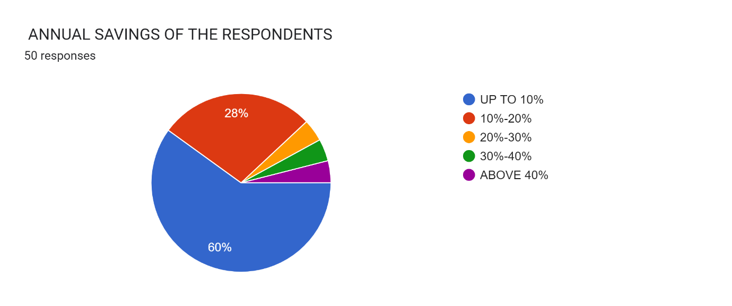

INTERPRETATION-
Above table shows that majority of the respondents (60%) have savings up to 10% of their income. It is followed by savings 10%-20% by 28% of the respondents. In 20%-30%, 30%- 40% and above 40% of savings, the percentages of respondents are equal (4%).

TABLE 3: - AWARENESS ABOUT TAX PLANNING
LEVEL OF AWARENESS | NO. OF RESPONDENTS | PERCENTAGE (%)
Strongly aware | 8 | 16
Aware | 14 | 28
Somewhat aware | 20 | 40
Unaware | 8 | 16
Strongly unaware | 0 | 0
Total | 50 | 100

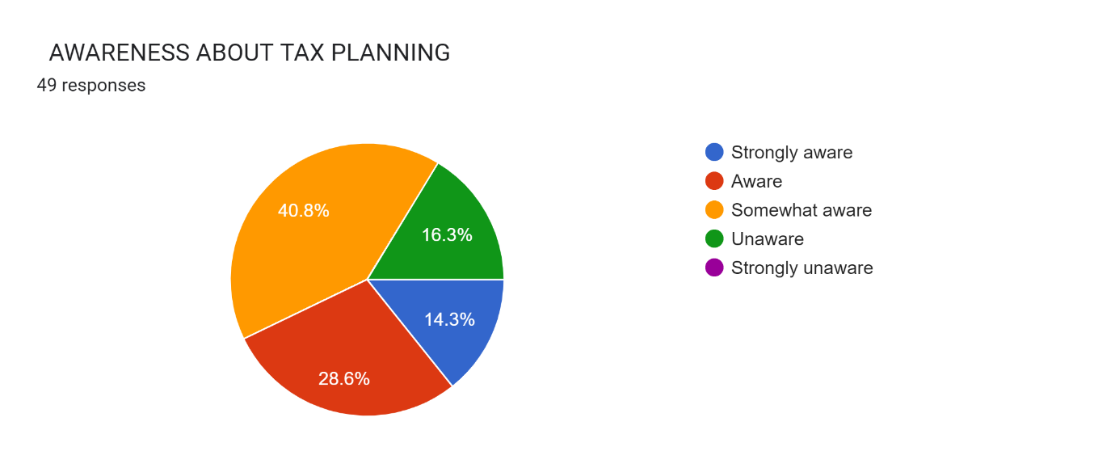
Interpretation
From the above table we can interpret that majority of the respondents (40%) are somewhat aware about tax planning. 28% of the respondents are aware about tax planning and 16% of the respondents are strongly aware and unaware about tax planning. So, it is obvious that majority of the respondents have knowledge about tax planning.
TACLE 4: - AWARENESS ABOUT VARIOUS TAX SAVING SCHEMES

TAX SAVING SCHEME | SA | A | SWA | UA | SUA | WEIGHT SUM | WEIGHT AVERAGE | RANK
LIFE AND MEDICAL INSURANCE | 10 | 20 | 14 | 6 | 0 | 184 | 3.68 | 3
HOUSING LOAN | 10 | 16 | 18 | 6 | 0 | 180 | 3.60 | 5
PPF &EPF | 14 | 22 | 10 | 4 | 0 | 196 | 3.92 | 1
TERM DEPOSIT | 10 | 20 | 12 | 8 | 0 | 182 | 3.64 | 4
KVP | 6 | 10 | 4 | 20 | 10 | 132 | 2.64 | 7
NSC OR NSS | 6 | 6 | 12 | 18 | 8 | 134 | 2.68 | 6
INFRASTRUCTURE BOND | 4 | 10 | 4 | 20 | 12 | 124 | 2.48 | 8
POSTAL SAVING | 4 | 2 | 8 | 20 | 16 | 108 | 2.16 | 10
ELSS | 14 | 18 | 16 | 0 | 2 | 192 | 3.84 | 2
(SA-Strongly Aware, A-Aware, SWA-Somewhat aware, UA-Unaware, SUA-Strongly Unaware)

Interpretation
From the above table it is clear that PPF&EPF are the most popular tax saving schemes as far as awareness is concerned. The second rank is becoming for postal savings. It is followed by Life and medical insurance, Term deposit, Housing loan, NSC or NSS respectively. Respondents in this study are least aware about ELSS, Infrastructure bonds, KVP etc. Low awareness about these schemes leads to poor saving decision.
TABLE5:-SCHEMES CHOSEN BY RESPONDENTS FOR INVESTMENT
TAX SAVING SCHEMES | NO. OF RESPONDENTS | PERCENTAGE (%)
LIFE AND MEDICAL INSURANCE | 34 | 68
HOUSING LOAN | 14 | 28
PPF & EPF | 36 | 72
TERM DEPOSIT | 30 | 60
KVP | 10 | 20
NSC OR NSS | 4 | 8
INFRASTRUCTURE BOND | 4 | 8
POSTAL SAVING | 42 | 84
ULIP | 0 | 0
ELSS | 4 | 8

Interpretation
Postal saving has been chosen by most of the respondents (84%), followed by PPF& EPF (72%), Life and medical insurance (68%), Term deposit (60%), Housing loan (28%), KVP (20%) etc. No respondents have chosen ULIP for investment.
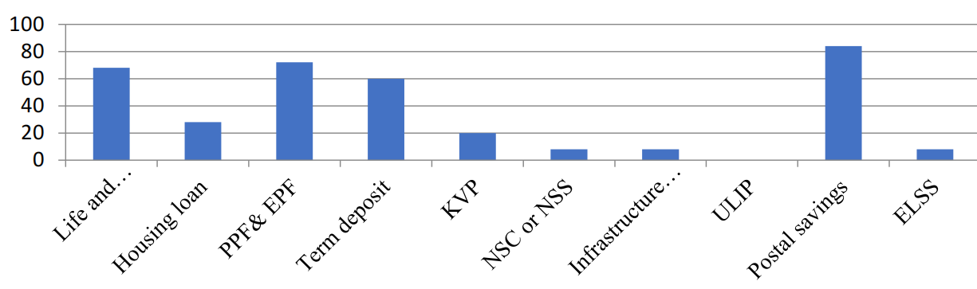
TABLE 6: - REASON FOR INVESTMENT IN TAX SAVING SCHEMES
REASON | SA | A | N | DA | SDA | Score | Weighted Average | Rank
TAX BENEFIT | 30 | 20 | 0 | 0 | 0 | 230 | 4.6 | 1
SAFETY | 18 | 20 | 12 | 0 | 0 | 206 | 4.12 | 2
LIQUIDITY | 10 | 12 | 18 | 10 | 0 | 172 | 3.44 | 4
REGULAR RETURN | 16 | 14 | 12 | 6 | 2 | 186 | 3.72 | 3
(SA-Strongly Agree, A-Agree, N-Neutral, DA-Disagree, SDA-Strongly Disagree)
Interpretation
The above table shows that Tax Benefit is the most important reason for investing in tax saving schemes, followed by safety. Regular return is the third important reason. Liquidity are not that much important for investment decision.
TABLE 7: - DECISION TO MAKE INVESTMENT IN TAX SAVING SCHEMES
PERIOD | NO. OF RESPONDER | PERCENTAGE (%)
Beginning of the year | 8 | 16
End of the year | 16 | 32
At any time | 20 | 40
No planning at all | 6 | 12
TOTAL | 50 | 100

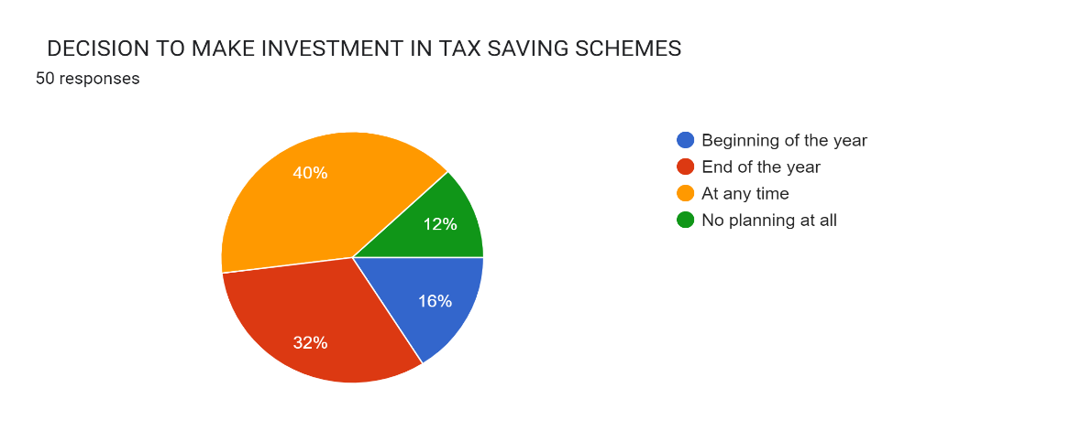
Interpretation
Above table shows that majority of the respondents (40%) make investment at any time during the year. 32% of the respondents decide to invest in tax saving schemes at the end of the year and 16% of the respondents decide to invest in tax saving schemes at the beginning of the year. 12% of the respondents not decided to invest in tax saving scheme.
TABLE 8:- TIME HORIZON OF INVESTMENT
TIME ZONE | NO. OF RESPONDENTS | PERCENTAGE (%)
Long term | 24 | 48
Short term | 26 | 52
TOTAL | 50 | 100

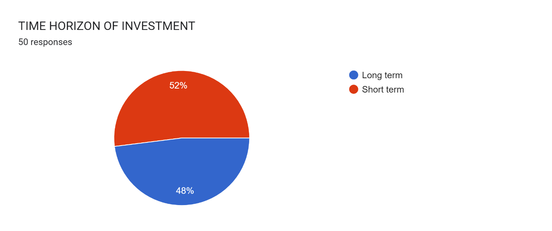

Interpretation
It is obvious from the above table is that the respondents select both short term and long-term investment almost equally. Majority of the respondents (52%) make investment in tax saving schemes for short term and 48% of the respondents invest for long term.

TABLE 9: - SATISFACTION WITH PRESENT TAX SAVING INVESTMENT
SATISFACTION | NO. OF RESPONDENTS | PERCENTAGE
YES (SATISFIED) | 44 | 88
NO (NOT SATISFIED) | 6 | 12
TOTAL | 50 | 100
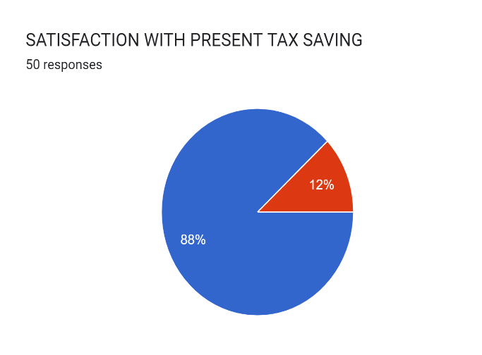

Interpretation
Majority of the respondents (88%) are satisfied with the present tax saving investment schemes. 12% respondents are not satisfied with the present tax saving investment schemes.
TABLE 10 : - ANNUAL INCOME AND AMOUNT INVESTED IN TAX SAVING SCHEMES
ANNUAL INCOME | NO. OF RESPONDENTS(X) | AMOUNT (IN RS.) | NO. OF RESPNDENTS
Below 500000 | 3 | Less than 50000 | 6
500000-750000 | 20 | 50000-75000 | 8
750000-1000000 | 13 | 75000-100000 | 13
1000000-1250000 | 10 | 100000-125000 | 14
Above 1250000 | 4 | Above 125000 | 10
Total | 50 | Total | 50
r = n ∑ xy − (∑ x ∑ y)
√n ∑ x 2 − (∑ x) 2 √n ∑ y 2 − (∑ y) 2

CO-EFFICIENT OF CORRELATION
X | Y | XY | X2 | Y2
3 | 6 | 18 | 9 | 36
20 | 8 | 160 | 400 | 64
13 | 12 | 156 | 169 | 144
10 | 14 | 140 | 100 | 196
4 | 10 | 40 | 16 | 100
∑X=50 | ∑Y=50 | ∑XY=514 | ∑X2=694 | ∑Y2=540

Interpretation
Since correlation coefficient is 0.159, there is a moderate positive correlation between annual income and amount invested in tax saving schemes. It implies that as the annual income increases, amount invested in tax saving schemes also increase.

TABLE 11: - AWARENESS ABOUT VARIOUS TAX SAVING SCHEMES IN DIFFERENT EDUCATIONAL QUALIFICATIONS
Tax saving scheme | EDUCATIONAL QUALIFICATIONAL |  |  | Total
Tax saving scheme | PLUS TWO | DEGREE | PG | Total
Life and medical insurance | 4.3 | 3.4 | 3.7 | 11.4
Housing loan | 4.6 | 3.3 | 3.5 | 11.4
PPF& EPF | 5 | 3.8 | 3.6 | 12.4
Term deposit | 4.3 | 3.9 | 3.3 | 11.5
KVP | 3.7 | 2.9 | 2 | 8.6
NSC or NSS | 3.7 | 2.2 | 2.9 | 8.8
Infrastructure bonds | 3.7 | 1.9 | 2.5 | 8.1
ULIP | 2.7 | 1.7 | 2.5 | 6.9
Postal savings | 5 | 4.1 | 3.4 | 12.5
ELSS | 2.7 | 1.7 | 2.7 | 7.1
Total | 39.7 | 28.9 | 30.1 | 98.7

ANOVA Table
SOURCES OF VARIATION | SUM OF SQUARES | DEGREE OF FREEDOM | MEANS SQUARE
Between samples | SSC= 7.008 | K-1= 2 | MSC= 3.504  MSE= 0.635
Within samples | SSE= 17.159 | N-K= 27 | MSC= 3.504  MSE= 0.635
Total | SST= 24.167 | N-1= 29 | MSC= 3.504  MSE= 0.635

F= 𝑴𝑺𝑪 /𝑴𝑺𝑬 =5.52
Calculated value = 5.52 The TABLE VALUE of F at 5% level of significance for (2, 27) degrees of freedom is 3.35. The calculated value of F is more than the table value of F. Therefore null hypothesis is rejected. Interpretation Since calculated value (5.52) is greater than Table value (3.35), null hypothesis (Ho) is rejected and alternative hypothesis is (H1) is accepted. It implies that, awareness about tax saving scheme is different in different educational qualifications.
Major Findings
- Under this study, the various tax saving schemes can be identified, The various
schemes are Life and Medical Insurance plans, Housing Loans, Public provident Fund
(PPF) and Employee Provident Fund (EPF), Term Deposit of Bank, Kisan Vikas
Patras (KVP), National Saving Certificate (NSC) or National Saving Scheme, Infrastructure Bond, Unit Linked Insurance Plan(ULIP), Postal Savings, Equity
Linked Saving Scheme(Mutual Fund).
- The respondents rank various tax saving schemes according
to their priority of saving tax. The most adopted tax saving scheme is Life and
Medical Insurance plans, which got the first rank in this study. The second most
adopted tax saving instrument is postal savings. Further the third choice is Public
Provident Fund and Employees Provident Fund. After that Term deposit, Housing
loan, KVP, NSC or NSS, ELSS respectively. scheme which are least adopted, as
tax saving instrument are Infrastructure Bonds and ULIP, they got the ninth and tenth
rank respectively in this study.
- Tax benefit is the most important reason for investing in tax saving schemes, followed by safety. Regular return is the third important reason for investing in tax
saving schemes.
- A majority of respondents (Rank 1) get information about tax saving
scheme from Internet. It is followed by Friends (Rank 2), Banks (Rank 3), Tax
consultants (Rank 4). As far as investment in tax saving scheme is concerned, people
largely depend on Internet as source of information. The study also reveals that people
also relies on Friends to get information about various tax saving schemes.
- PPF& EPF are the most popular tax saving schemes as far as awareness is concerned
(Rank 1). it followed by Postal Savings, Life and Medical insurance, Term Deposit
(Rank 2, 3, 4) respectively. in this study are least aware about ULIP, ELSS, Infrastructure Bonds etc.
- Majority of the respondents (84%) are strongly aware or aware or somewhat aware
about tax planning. (strongly aware- 16%, aware-28%, somewhat aware-40%) •
- Majority of the respondents (84%) are belongs to 5% tax bracket, and remaining
(16% )of respondents fall under the tax bracket of 20% and no one in this study under
30% tax bracket.
- Majority of the respondents (48%) never seek professional advice for making
investment in tax saving schemes.
- Respondents have selected the time horizon of investment almost equally. 52% of
them invest in short term investments and 48% are in the long-term investments.
- 88% of the respondents are satisfied with their present tax saving investment.
- Major concern about tax saving scheme is less returns from the investments. Lack of
awareness among people is also an important concern.
- This study reveals, increase in awareness among people about tax saving
schemes can improve investor’s interests in tax saving schemes and every investors
Favors raising the limit on total deduction U/S 80 C
- Tax bracket applicable to investors and the amount invested in tax saving schemes are
associated.
- Test of correlation shows that, there is positive relationship between annual income
and amount invested in tax saving schemes.
- Awareness about tax saving schemes is different in educational levels
Suggestions
- Tax planning alternatives are huge in number and that makes it difficult for investors to choose a specific scheme in limited span of time. So, it is suggested to standardize these schemes to an extent so that number of schemes can be brought down.
- Government should look for other ways and means to spread information through advertisements & other agencies and it should promote public awareness about benefits of investment & important guidelines to select different investment avenues.
- Government should introduce new attractive investment schemes and motivate public to invest in those schemes.
- Government should organize investor’s education programs to educate the public about the pros & cons of investment, how to choose better investment avenues, information about different regulatory Govt. bodies which protect the interest of investors and legal & regulatory aspect of investment.
- Raising the limit on total deduction U/S 80 C would attract more investment in tax saving schemes.
- It is better to invest in tax saving schemes of an amount above 100000, because maximum amount which can enjoy tax benefit is Rs 150000.
- More research activities are needed to be carried out in this area to help the government in formulating new schemes and to help the assesses in better Tax Planning.

Conclusion
Tax planning is not a simple and standard process. In fact, it is a complex collection of measures available to reduce one’s own tax incidence. Further the tax saving options or schemes or deductions provided as per Income-Tax Act 1961 are huge in number which further complicates the process. Thus, tax planning has evolved into an intellectual activity. One of the ways to plan the tax incidence for individuals is to invest in some avenues where government gives relaxation for various tax schemes. But this again is not as simple as it may sound to be. Investments in these avenues do not give the same advantage to all the individuals in the same manner. While some are suited for individuals paying higher taxes few other suits people belonging to lower tax bracket. Individuals are not always aware of all the technical details about the scheme which they choose for investment. They might choose a particular scheme for one benefit while being ignorant about other schemes which provide same or better benefits with better terms. So, what is important here is to know all the terms related to an investment. The study revealed that maximum number of tax payers wanted to save in Life and medical insurance, followed by postal savings, PPF& EPF, Term deposit and Housing loans in that order. It was found that tax benefit and safety are the major reason for investing in tax saving schemes. The study also revealed that low rate of return and lack of awareness are the major concerns about tax saving schemes. Low awareness about various tax saving schemes leads to poor Tax planning. So, it is necessary to increase the awareness level about Tax planning and various tax saving schemes.

References
1. David S. Murphy, Scott Yetmar, (2010), "Personal financial planning attitudes: a preliminary study of graduate students", Management Research Review, Vol. 33 Is: 8 pp. 811 – 817.
2. Direct Taxes: Dr Vinod K Singhania. A.Y. 2017-2018
3. Geetha R. and Sekar M., Nov 2012, E-Filing of Income Tax: Awareness and Satisfaction level of individual Tax payers in Coimbatore city, India Research Journal of Management Sciences, ISSN 2319–1171, Vol. 1(4), 6-11, November (2012)
4. Joyce K.H. Nag, Lisa H.L. Yong, Radhakrishnan D. Sellappan, (2010), "A study of financial awareness among youths", Young Consumers: Insight and Ideas for Responsible Marketers, Vol. 11 Iss: 4 pp. 277 – 290.
5. Ming-Ming Lai, Wei-Khong Tan,2009, An Empirical Analysis of Personal Financial Planning in an Emerging Economy, European Journal of Economics, Finance and Administrative Sciences ISSN 1450-2275 Issue 16 (2009).
6. REPORT ON FINANCIAL PLANNERS IN THE GROWING ECONOMY LIKE INDIA by the Indian Institute of Planning.
7. Tan Hui Boon*, Hoe Siew Yee AND Hung Woan Ting, 2011, Financial Literacy and Personal Financial Planning in Klang Valley, Malaysia, Int. Journal of Economics and Management 5(1): 149 – 168 (2011) ISSN 1823 - 836X. 8
8. Sudhir Kaushik, Ankur Sharma. Tax Planning for Salaried Employees
9.Amudhan S (2016), “A Study on Individual Investors Satisfaction Level of Existing Investment Schemes in Salem Districts” Vol-2 Issue-2, IJARIIE-ISSN(O)-2395- 4396.
10.Bharathraj Shetty (2013) “An Analysis of Investors Attitude Towards Various Tax Saving Schemes” International Research Journal of Business and Management – IRJBM, Volume No –I.
11.Deerajen Ramasawmy et All (2013) “A Study of the Level of Awareness of Financial Literacy among Management Undergraduates, Proceedings” Asia-Pacific Business Research Conference, Kuala Lumpur, Malaysia, ISBN: 978-1-922069-19- 1.
12.Dr. K. Krishnamurthy (2015) “Investment Pattern and Awareness of Salaried Class Investors in Tiruvannamalai District of Tamil Nadu”, Asia Pacific Journal of Research Vol: I. Issue XXVI, ISSN: 2320-5504, E-ISSN-2347- 4793.
13. Ledid Bin Abdul Khader (2017) “Tax Planning Among College Teachers, With Special Reference to MES Ponnani College” Intercontinental Journal of Finance Research Review Iss: 2321-0354 - Online Issn:2347- 1654 - Print - Impact Factor:4.236 Volume 5, Issue 2.
14. Manjunath. S. Awalakki (2015) “A Study on Investment Patterns and Awareness of Salaried Class Investors” IJSR - International Journal of Scientific Research Volume: 4 | Issue: 8 | ISSN No 2277 – 8179.
15. Mohd Rizal Palil (2013) “The Perception of Tax Payers on Tax Knowledge and Tax Education with Level of Tax Compliance: A Study the Influences of Religiosity” ASEAN Journal of Economics, Management and Accounting 1 (1): 118-129 ISSN 2338-9710.
16. Monika Arora (2017) “Reflection of Tax Saving Behaviour on Individual Income Tax Assessees” Pacific Business Review International Volume 9 Issue 10.
17. Nur Fikhriah Takril (2017) “Tax Expectation Gaps, Value Creations and Aggressive Tax Avoidance: A Literature Review” Proceeding of the 4th International Conference on Management and Muamalah 2017 (ICoMM 2017) e-ISBN: 978- 967-2122-15-9.
18. Prashant Chhajer (2013) “Study of Investor’s Awareness, Objectives and Constraints in Investment Planning in the city of Nagpur, India” Acme Intellects International Journal of Research in Management ISSN 2320 – 2939 (Print) ISSN 2320-2793 (online), Vol- 3 No. 3.
19. Rini Hastuti (2014) “Tax Awareness and Tax Education: A Perception of Potential Taxpayers” International Journal of Business, Economics and Law, Vol. 5, Issue 1 (Dec.) ISSN 2289-1552.
20. S. Umamaheswari1,2(2014) “A Special Study on Coimbatore Based Salaried Investors’ Awareness, Attitude, Expectation and Satisfaction Over Their Investments” International Journal of Research in Business Management (IMPACT: IJRBM) ISSN(E): 2321-886X; ISSN(P): 2347-4572 Vol. 2, Issue 8.
21. Dr. H.C. Mehothra, Dr. S.P. Goyal “Direct Taxes, Law and Practices” Sahithya Bavan Publications,58 edition, agra,2018.
22. R. Geetha Krishna Pai,” Income Tax Law & Practice 2-, Lilly Publishing House, Changanaserry.
23.Sharma, Saritha Sharma n.k, “Tax Planning” Rbsa Publishers, Jaipur, 2017
24. Singhaniya, Vinod K Singhania, Kapil, “Direct Taxes Law and Practices” Taxmann Publications (p) Ltd. 2018

