"Assessing Customer Satisfaction in Mahindra's Automotive Division: The Role of Service Quality and Technological Integration"

1.Manraj Bhatia Student, MBA
Amity Business School
Amity University Chhattisgarh
Manrajbhatia00023@gmail.com

2.Dr.AnnapurnaMetta sarjare
Associate Professor
Amity Business School
Amity University Chhattisgarh
ametta@rpr.amity.edu

Abstract

This study examines customer satisfaction in Mahindra's automotive division, highlighting the impact of technological integration and service excellence. Using a mixed-methods approach, the study examines qualitative insights from in-depth interviews with consumers and service staff in addition to quantitative data from customer surveys. The results show that excellent customer satisfaction is greatly increased by high service quality, with personnel competency, promptness, and reliability being important contributing variables. To further enhance the client experience, cutting-edge technology integration is essential. Examples of these are linked car features and digital service platforms. The report emphasizes how crucial it is for Mahindra to keep coming up with new ideas and tweaking its service plans in order to stay ahead of the competition and satisfy changing customer demands. The management implications emphasize how crucial it is to allocate resources to both human resources and The findings show that timeliness, dependability, and professionalism—the three qualities that make up service quality—are crucial in influencing consumer satisfaction. Additionally, by offering convenience and customized services, the integration of cutting-edge technologies—like digital service interfaces and linked car features—significantly improves the client experience. The results indicate that in order to exceed customer expectations and maintain competitive advantage, Mahindra should give equal weight to ongoing improvements in service quality and technology advances. In order to promote long-term customer loyalty and happiness, the study offers management practical insights by highlighting the necessity of strategic investments in personnel training and state-of-the-art technologies.

Keywords: Customer satisfaction, Technology integration, Strategic investments, Competitive advantage, Personalized services, Management insights, Digital service interfaces, Connected car features.

Introduction

Nowadays, "customer satisfaction" is the phrase used by businesspeople to characterize an organization's success. It's getting harder for companies to keep clients around for extended periods of time because of the rising competition in every product area. The marketer merely needs to concentrate on one thing in order to retain customers for longer: customer happiness. When a consumer is entirely satisfied with a product, the business gains success and reaps several rewards. They remain with the company for a longer period of time and are less process sensitive. As the company launches or enhances related items, they purchase more, expanding the customer base. As the business releases or enhances comparable products, customers buy more goods, and customer happiness rises. important. Every company surveys its clients to find out how happy they are with the products they provide. to raise the quality of the goods to the desired level for the customer. The purpose of this study is also to find out how satisfied Mahindra and Mahindra Automobiles' customers are. The automobile industry is referred regarded as a "second industrial revolution" because of the significant and pervasive impact it has had on the whole economy. It was essential in helping the nation produce higher-value goods and services, enhancing its skills, and generating a significant market for cars.

Employment prospects and lifestyles have changed as a result of the automobile sector. The first modern vehicle was created in 1895. Not long after, the automobile made its debut in India. As the century went on, three cars were brought into Mumbai (India). After ten years, there were 1025 cars in the city. The car originated when the first wheel was utilized for transportation in India 4,000 years ago. The self-turning wheel was among the many new inventions that came about as a result of the Portuguese presence in China at the start of the 15th century. Although small steam-powered engine models were first created in the 1600s, their widespread use did not occur until the 17th century. During the year The horseless vehicle was created in 1893 by brothers Charles and Frank Duryea. It was the first internal combustion vehicle in America, and the following year Henry Ford unveiled his first experimental vehicle. Of all the early luxury vehicles, the 1909 Rolls-Royce Silver was one of the most highly acclaimed.
A Ghost with an aluminium body, a six-cylinder engine, folding windscreens and hood, and leather interior. Usually driven by a chauffeur, comfort and style were prioritized over speed. In the 1920s, the cars had four-wheel brakes, pressed steel wheels, and balloon tires, among other design improvements. The 1929 Graham Paige DC Phaeton featured an 8-cylinder engine and an aluminium body. The 1937 Pontiac Deluxe sedan was the perfect car because of its roomy inside and rear-hinged back door.

There are four types of automobiles in India: passenger cars, commercial vehicles, three-wheelers, and two-wheelers. India ranks sixth in the world for commercial vehicles and is the world's largest manufacturer of two-wheelers.2020 started off poorly for the auto sector due to low consumer expenditure, increased private investment, a bad monsoon season, and the implementation of BS-VI regulations. The Society of Indian Automobile Manufacturers (SIAM) reports that in the 2019–20 fiscal year, domestic sales of Indian automobiles fell by approximately 18%.

One of the main forces behind the nation's economic growth is the automobile sector in India, which produces both complete vehicles and automotive parts. Owing to its high degree of integration with other industrial businesses, it is a major contributor to GDP, exports, and employment in manufacturing. This industry has grown because of its historical capabilities in fabrication (welding, grinding, and polishing), casting, forging, and precision machining, as well as cost advantages (from the availability of cheap, skilled labour), and significant inflows of foreign direct investment (FDI).Many international automakers seeking to grow in Asia choose India as their preferred location. It attracted cumulative FDI equity inflows of about US$ 14.48 billion between 2000 and 2015 (5.2 percent of total). 8 The primary advantages of investing in the nation goal are economical operations, productive labour, and a vibrant market that is growing quickly. In the past, major investments have been made by the United States, Japan, Italy, and Mauritius, in that order. The sector generates a wide range of commodities to meet demand from both domestic and international markets.

Research Objectives

The research will mostly focus on Chhattisgarh because its goal is to investigate consumer satisfaction with all Mahindra car types in India.

- Assessing consumer satisfaction with all Mahindra Motors models in Chhattisgarh Raipur , with an emphasis on the M&M models, is the primary objective of the study.

- To gather information about Mahindra & Mahindra Motors' Raipur customer satisfaction.

- To find out how customers view Mahindra & Mahindra Motors in terms of looks, low maintenance costs, and features.

- To learn how happy Mahindra and Mahindra's clients are with the comfort and safety of their cars.
- To offer suggestions for raising company sales and profitability in addition to improving customer pleasure.
- To determine the level of satisfaction that M&M's clients have with their post-purchase support.
Literature Review

The term "customer satisfaction" is frequently used in marketing. It's a measure of how successfully a business meets or surpasses the expectations of its clients with its products and services. The percentage of all consumers whose ratings—a measure of how happy they are—with a business, its goods, or services surpasses predetermined satisfaction thresholds is known as customer satisfaction.% of respondents believed that a customer satisfaction measure was extremely useful for monitoring and tracking businesses. In the business sector, it is considered a critical performance measure, and a balanced scorecard frequently includes it. In a competitive market where businesses fight for customers, customer happiness is viewed as a critical differentiator and has grown to be an important component of corporate strategy.
Customer satisfaction scores can significantly affect a business's final result. Workers are reminded of how crucial it is to satisfy clients. Moreover, a decline in these scores suggests problems that may hurt revenue and profitability. These numbers stand for a crucial dynamic. A business that enjoys a devoted following gains access to cost-free, highly productive word marketing."

Therefore, it is imperative that businesses successfully manage client happiness. Businesses require representative and reliable satisfaction metrics in order to achieve this. Consistency often necessitates the attention of top management. Individual contacts become less significant than the total experience because customers create clusters of interactions by utilizing a range of channels and starting an increasing number of engagements with businesses in an effort to meet specific demands. This client journey ought to cover every facet of a business and encompass anything from buying a product to using it, resolving product issues, or making straightforward exchanges.

A.K. Tiwari and Manish Kumar Srivastava study Jaipur's consumer behavior with regard to A3 segment trucks like the Honda City and SX4. One hundred individuals provided data: fifty from Honda City and fifty from Maruti SX4. While choosing responders, consideration was given to factors such as gender, income class, and occupation. A customer's preferences for price, safety, comfort, power and pickup, mileage, maximum speed, styling, after-sale support, brand name, and spare part costs are also taken into consideration. Customers place a high emphasis on safety, brand awareness, and comfort of the sitting and driving when purchasing an A3 segment vehicle, according to the analysis done based on the aforementioned factors.
In the economics, Prasanna Mohan Raj looked into what influences consumers' brand preferences for SUVs and MUVs. section. Data was gathered by direct communication and a customer intercept survey with a questionnaire. Descriptive analysis was performed to convert data into an intelligible format, and factor analysis was utilized to determine the factors influencing customer desire. The study's findings indicate that six elements can account for a brand's decision: the brand's reputation, trustworthiness, monetary considerations, stylish appeal, frequency of non-price promotions, and consumer association or sentiment. Marketers need to be aware of these.
Nikhil Monga, Bhupendra Chaudhary, and Saurabh Tripathi want to address some of the inquiries regarding the brand personality of selected cars in India through market research. Finding out through this personality sketch what a customer (or potential customer) thinks of a particular auto brand and the variables that could affect a decision to buy. In a similar vein, determining customer happiness can help determine customer perception. Thus, gauging the inclination of ardent automobile owners to suggest their vehicle to others will help automakers comprehend the full range of consumer purchasing patterns. According to the study, brand perception evolves before to an automobile being purchased, persists during use, and is reflected in suggestions. The client requests the identical vehicle for his pals. It's also evident that the consumer still has ideas about the car despite not being the driver. Consumers react to this by forming opinions about the vehicle, which is reflected in the brand image of the vehicle as a whole. Consequently, brand image.

Muhammad Sabbir Rahman, Goodarz Javadian Dehkordi, and Samin Rezvani This study looks at the relationship between the variables and customer buy intent, as well as the origin country and other factors that influence consumer purchase intent. A survey found that consumers are interested in the nation from where products originate and the location of manufacturing, and these factors are taken into account when determining the quality of a product. Customer preferences and national preconceptions have an impact on the purpose intended. Politics, culture, and the nation's political system can all make people more sensitive. The intention of consumers to make purchases is influenced by various factors. Despite the fact that customers
Evaluate every inherent feature of the product by expressing it. Studies and methods have demonstrated that external cues influence consumer products more than intrinsic ones assessment. Country of origin is one of the extrinsic cues, and it is without a doubt important in influencing the process of purchase intention.

Methodology

Research Method Used

Phases or steps in a research process take a project from its inception to its final analysis, recommendations, and actions. The study method offers a thorough, planned approach to the research project and guarantees that all of its components are consistent with one another. Research studies are developed according to a set of processes, each of which represents a response to a fundamental query.
By providing a framework for the appraisal and revaluation of primary and secondary research, this chapter seeks to clarify research methodologies. The concepts and procedures utilized in primary research to arrive at discoveries are also included, and they support the analysis and conclusions logically.

4.1 Design of the Research
In order to fully comprehend the impact and ramifications of the industry, I advise carrying out a significant amount of secondary research. Additionally, I advise examining and evaluating industry standards and reports, from which particular subjects will be selected that, in my opinion, are still open-ended or susceptible to modification and will be investigated further in the subsequent phase of an exploratory study. This phase will help me focus on and reduce to the most important queries and problems related to business development and segmentation. Among the numerous tasks I've finished during the study design phase is defining the information need. Arrange research that are causal, descriptive, and exploratory.

4.2 The Methodology of Research
The research process comprises four distinct yet connected processes for research interpretation that are arranged logically and hierarchically: identification of information research's conundrum. the development of an appropriate study design. carrying out the study plan. Results have to be shared. Every step is thought of as a separate process made up of a task, a step, and a particular method. The processes are lawful, consistent, unbiased, methodical, rational, and impersonal.

Exploratory Research

Primary data

Secondary data

DATA ANALYSIS

Which car category do you like best?
Table Car you prefer

Car you prefer | Respondents
SUV or Sports Utility Vehicles | 11
MUV or Multi-Utility Vehicles | 18
Sedans | 4
Hatchbacks | 2


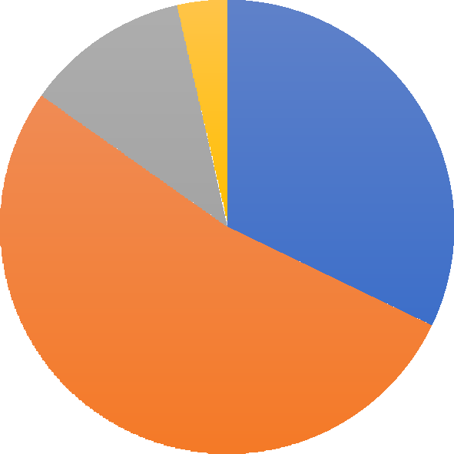
Fig: 1
Car you prefer

4%

12%
32%
53%
SUV or Sports Utility Vehicles MUV or Multi-Utility Vehicles Sedans Hatchbacks

Interpretation 1:

According to the probability-based sample, 32% of consumers were satisfied with SUVs, 12% with sedans, and only 3% with hatchbacks. Of the customers, 53% were satisfied with MUVs.
Observation:-
The majority of respondents said that MUVs or SUVs satisfied them.

Which vehicle brand do you drive?
Table brand of car you own

Brand | Respondents
Maruti Suzuki | 20
Mahindra | 20
Toyota | 5
Tata | 7
Renault | 7
Nissan | 6
Ford | 5

Fig: 2


Brand of cars

7%
9%
29%
10%
10%
7%
29%
Maruti Suzuki Mahindra Toyota Tata Renault Nissan Ford

Interpretation 2:

The probability-based sample indicates that 29% of respondents are satisfied with Maruti Suzuki and Mahindra, while 10% were shown Tata and Renault. Eight percent of customers are satisfied with Nissan, while just seven percent are with Ford and Toyota.

Observation:

The majority of customers have chosen Mahindra and Maruti Suzuki for their transportation need

Do you think Mahindra cars are satisfactory?

Table Satisfied with Mahindra Vehicles

Satisfied | Unsatisfied
85% | 15%

Fig: 3

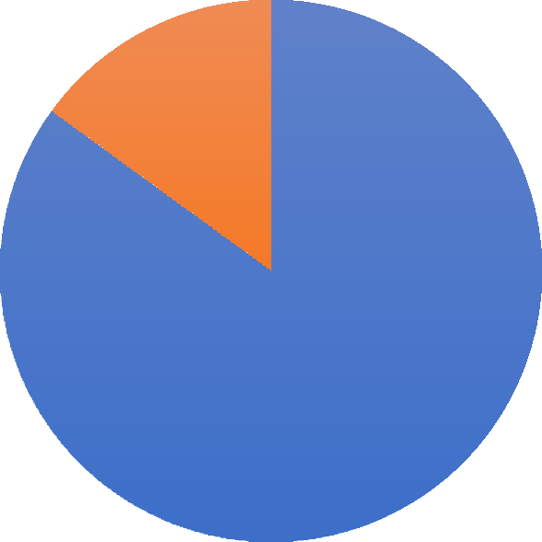
Satisfi ed with Mahindra Vehicles
Unsatisfied 15%
Satisfied 85%
Satisfied Unsatisfied

Interpretation 3:

The sample drawn on a probability basis shows that 85% of the customers were satisfied with Mahindra Vehicles and only 20% were not satisfied with Mahindra Vehicles.

Observation:

Most of the respondents approached were satisfied with Mahindra Vehicle

If the answer is "Yes," which factor most satisfies you?

Table satisfied you most

Factor | Respondents
Feature | 7
Low maintenance | 14
Comfort | 6
Style | 6
After Sales Service | 8



Fig: 4
Satisfaction
20%
17%
15%
34%
15%
Feature Low maintenance Comfort Style After Sales Service

Interpretation 4:

Based on probability, the sample was selected, and the results indicate that 34% of respondents believe that low maintenance is the key to contentment, and 19% believe that After Sales Service is a crucial component of customer satisfaction. Style comes in second place with 15%, and just 15% of them think that aspect of Mahindra vehicles contributes to their level of happiness.

Observation:

According to the majority of respondents, features, comfort style, after-sales services, and low maintenance at the factors that have the most impact on customer satisfaction.

Are you satisfied with the fuel consumption?
Table fuel consumption

Factor | Respondents
Extremely Satisfied | 15
Satisfied | 19
Neutral | 8
Dissatisfied | 4

Fig: 5

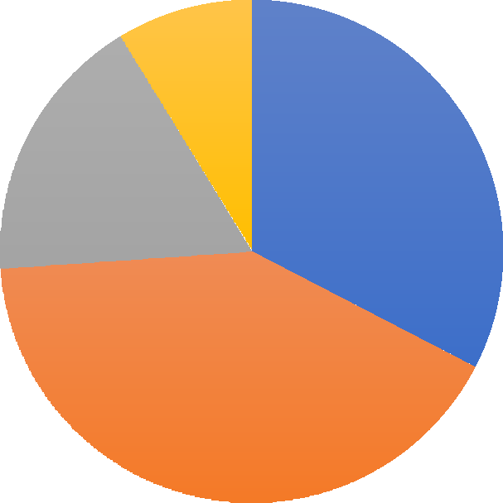
Fuel Consumption
Dissatisfied 9%
Neutral 17%
Extremely Satisfied 33%
Satisfied 41%
Extremely Satisfied Satisfied Neutral Dissatisfied

Interpretation 5:

Every single person who replied Of those surveyed, 41% thought that Mahindra automobiles' fuel consumption was satisfactory. After that, 33% expressed extreme satisfaction, 17% remained neutral, while the remaining 9% expressed disappointment in Mahindra Vehicles' fuel efficiency.

Observation:

The company should maintain the current level of fuel consumption for Mahindra Vehicles as most respondents are satisfied with it. It is also advised that suitable steps be taken to reduce negative feedback from customers who feel that fuel consumption is an unsatisfactory factor.

Are you satisfied with the Safety and Comfort?
Table Safety and Comfort

Factor | Respondents
Extremely Satisfied | 9
Satisfied | 19
Neither Satisfied & Dissatisfied | 7
Dissatisfied | 4

Fig: 6


Safety & Comfort
Dissatisfied 10%
Neither Satisfied & Dissatisfied
18%
Extremely Satisfied 23%
Satisfied 49%
Extremely Satisfied Satisfied
Neither Satisfied & Dissatisfied Dissatisfied

Interpretation 6:

Every single person who replied Of those surveyed, 49% thought that the safety and comfort characteristics of Mahindra vehicles were good. After that, 23% of respondents expressed extraordinary satisfaction, 18% expressed neutrality, and 10% expressed dissatisfaction with the safety and comfort characteristics of Mahindra vehicles.

Observation:

The majority of respondents expressed satisfaction with the safety and comfort features of Mahindra vehicles. It is advised that the company maintain these features and take the necessary steps to reduce the negative perception among customers who feel that fuel consumption is an unsatisfactory aspect.

- Do you think the design is satisfactory?

Table satisfied with the Design

Factor | Respondents
Extremely Satisfied | 15
Satisfied | 19
Neutral | 8
Dissatisfied | 4

Fig: 7

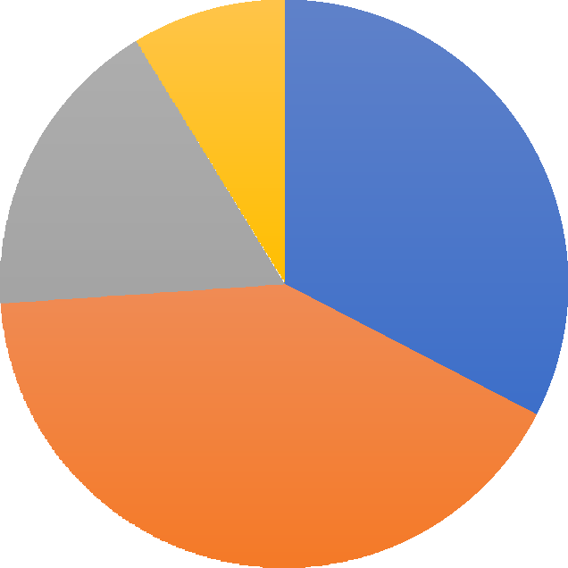
Design
Dissatisfied 9%
Neutral 17%
Extremely Satisfied 33%
Satisfied 41%
Extremely Satisfied Satisfied Neutral Dissatisfied

Interpretation 7:

All participants in the survey (100%) Fourteen percent of individuals surveyed thought positively about the design of Mahindra cars. 33% of respondents gave the Mahindra vehicle's design a higher satisfaction rating, 17% gave it a neutral rating, and 9% gave it a lower rating.

Observation:

The majority of respondents are happy with Mahindra vehicles' designs; the corporation should maintain this level of satisfaction, and it is advised that suitable steps be taken to reduce unfavourable perception among customers who feel that fuel consumption is an unsatisfactory feature.

- Are you happy with the amount of space in the vehicle?
Table space available in the car

Factor | Respondents
Extremely Satisfied | 12
Satisfied | 16
Neutral | 8
Dissatisfied | 5


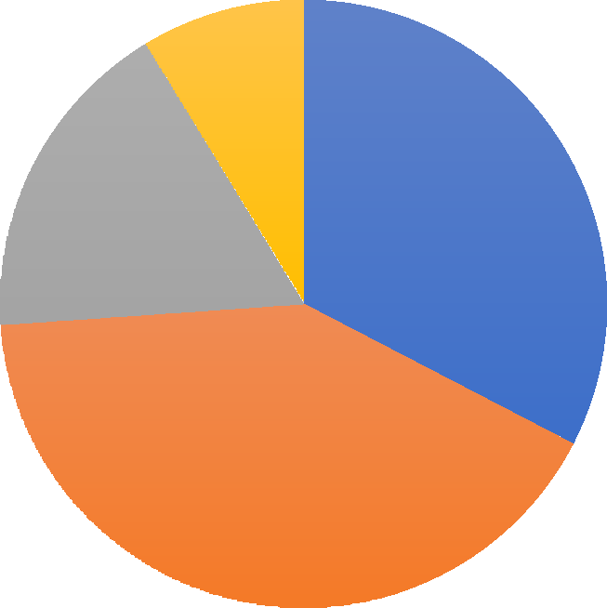
Fig: 8
space available

9%
17%
33%
41%
Extremely Satisfied Satisfied Neutral Dissatisfied

Interpretation 8:

The possible sample shows that 41% of respondents were happy with the amount of space available in Mahindra vehicles. 33% were more satisfied, 17% were neither satisfied nor disappointed, and 9% were disappointed with Mahindra Vehicles' space availability

Observation:

It may be inferred that the corporation has carried out sufficient research and development in this area given

that 70% of respondents are happy with the quantity of room provided in the Mahindra Vehicles car. It's possible that the 30% of respondents who gave unfavorable feedback were comparing the vehicle to a recently released model in the same class.

Are you happy with the expense of maintenance?
Table Maintenance cost

Factor | Respondents
Extremely Satisfied | 10
Satisfied | 18
Neutral | 7
Dissatisfied | 5

Fig: 9


Maintenance cost
Dissatisfied 10%
Neutral 18%
Extremely Satisfied 26%
Satisfied 46%

Extremely Satisfied Satisfied Neutral Dissatisfied

Interpretation 9:

The probability survey revealed that 46% of respondents were satisfied with Mahindra Vehicles' upkeep. 26% of respondents rated the upkeep as extremely satisfied, 18% as neutral, and 10% as unacceptable.

Observation:

While most consumers are pleased that Mahindra and Mahindra vehicles require less maintenance, 20% are not so happy. This could be because Mahindra vehicles are more expensive to maintain than recently introduced rival brands.

Limitation

Diversity and Sample Size: The study's conclusions are predicated on a sample size that might not accurately reflect the wide range of clients Mahindra's Automotive Division serves. Customer expectations and experiences vary by region, and this may not be sufficiently reflected.2. Survey Response Bias: Relying too much on self-reported information from surveys can lead to response bias, in which respondents give answers that are more socially acceptable than accurately reflect their actual experiences.3. Technological Disparities: The study might not have taken into consideration the differences in technological adoption and skill levels across various client categories, which might have an impact on how they view technological integration.4. Temporal Restrictions: Because the study is cross-sectional, it only records consumer happiness at one particular moment in time. This method ignores how customer happiness and service quality vary over time.

Future scope of the study

Longitudinal Studies: By tracking changes in customer satisfaction over time, longitudinal research can offer more profound insights into the ways that technological integration and service quality affect satisfaction trends and enduring customer loyalty.2. Broader Demographic Analysis: Increasing the study's sample size and diversity across various demographic groups and geographical areas would enable it to encompass a greater range of consumer experiences and expectations.3. Emerging Technology Impact: Researching how new technologies like augmented reality, machine learning, and artificial intelligence affect customer satisfaction can reveal important information about consumer preferences and future trends.4. Comparative Studies: Mahindra's service quality and technological integration performance against that of other automakers can be compared to provide a standard for industry norms and best practices.

Conclusion

This study emphasizes how important it is for Mahindra's Automotive Division to prioritize service quality and technological integration when assessing customer satisfaction. The results show that customer satisfaction is greatly increased by excellent service quality, which is defined by responsiveness, dependability, and professionalism. Furthermore, by offering convenience and customized services, the incorporation of cutting-edge technologies, like digital service platforms and linked car capabilities, improves the client experience even more.
According to the study, Mahindra must constantly innovate and modify its service plans to satisfy changing customer demands. Through the allocation of resources towards both advanced technologies and human capital, Mahindra can cultivate a long-term customer base and maintain a competitive edge. Additionally, the report recommends that a complete strategy that includes thorough training for ser of cutting-edge technologies, is crucial to preserving high standards of client satisfaction.
These results should be further investigated in the future through the use of longitudinal studies, more comprehensive demographic analysis, and the effects of developing technology. By making such efforts, Mahindra would be able to better understand the dynamics of customer satisfaction and develop plans that meet the needs of its customers and future market trends. In the end, Mahindra can maintain its competitive edge in the automotive business and build stronger customer relationships by emphasizing technology integration and service excellence vice workers and the strategic implementation

Reference

  - https://en.wikipedia.org/wiki/Mahindra_%26_Mahindra

MAHINDRA AND MAHINDRA WIKIPEDIA PAGE
  - https://en.wikipedia.org/wiki/Mahindra_Bolero

MAHINDRA BOLERO WIKIPEDIA PAGE
  - https://en.wikipedia.org/wiki/Mahindra_Thar

MAHINDRA THAR WIKIPEDIA PAGE
  - https://en.wikipedia.org/wiki/Mahindra_Scorpio

MAHINDRA SCORPIO WIKIPEDIA PAGE
  - https://en.wikipedia.org/wiki/Mahindra_XUV500

MAHINDRA XUV500 WIKIPEDIA PAGE
  - https://en.wikipedia.org/wiki/Mahindra_XUV300

MAHINDRA XUV300 WIKIPEDIA PAGE
  - https://www.businessinsider.in/independence-day-6-interesting-facts-about-mahindra-mahindra/ articleshow/53617894.cms

Business insider FACTS ABOUT MAHINDRA
  - http://www.businessworld.in/article/2020-for-Indian-Automobile-sector-A-Forgettable-Year- Which-Started-The-Build-Up-Of-The-Digital-Future-/06-01-2021-362187/

Business world INDIAN AUTOMOBILE SECTOR
  - https://www.mahindra.com/resources/investor-reports/FY20/Annual-Reports/MM-Annual- Report-2019-20.pdf

MAHINDRA ANNUAL REPORTS
  - https://link.springer.com/chapter/10.1007/978-981-13-8102-7_19

ARTICLE ABOUT MAHINDRA
  - file:///C:/Users/abilm/Downloads/MM-Postal-Ballot-Notice-2020.pdf

MM-Postal-Ballot-Notice-2020.pdf
  - file:///C:/Users/abilm/Downloads/Mahindra_&_Mahindra.pdf

Mahindra_&_Mahindra.pdf
  - file:///C:/Users/abilm/Downloads/URK18COM007_Project_PSP2998.pdf

URK18COM007_Project_PSP2998.pdf
  - https://www.mahindra.com/investors/reports-and-filings

MAHINDRA INVESTORS AWARDS REPORT AND FILINGS
  - https://www.mahindra.com/investors/annual-report-FY2020/index.html

MAHINDRA INVESTORS ANNUAL REPORT 2020

