OPEN AI DALLE’S RESHAPING CREATIVITY WITH FRAMER MOTION
Dr. U.NILABAR NISHA ,MAITHENKUMAR S¹ SATHEESH S² , kARTHIKAYEN S³ , kAMESHWARAN S⁴
¹Head of the Department, Computer Science And Engineering, Mahendra Institute Of Engineering And Technology, Namakkal-637503
¹Student, Computer Science And Engineering, Mahendra Institute Of Engineering And Technology, Namakkal-637503
²Student, Computer Science And Engineering, Mahendra Institute Of Engineering And Technology, Namakkal-637503
³Student, Computer Science And Engineering, Mahendra Institute Of Engineering And Technology, Namakkal-637503
⁴Student, Computer Science And Engineering, Mahendra Institute Of Engineering And Technology, Namakkal-637503

ABSTRACT Our project aims to revolutionize the fashion industry by seamlessly integrating technology with personal expression. We have developed a platform that goes beyond traditional boundaries, offering users a dynamic canvas for self-expression and creativity. At the core of our project is a commitment to innovation, leveraging technologies such as React.js, Three.js, Framer Motion, and Tailwind CSS to create an immersive environment for 3D t-shirt customization. Our platform also integrates OpenAI's Dell-E, introducing a new level of personalization and interactivity through sophisticated algorithms and machine learning. We are dedicated to pushing the boundaries of technology and fashion, constantly exploring new frontiers to inspire creativity and redefine personalized fashion. Join us on this transformative journey where imagination knows no bounds, and together, let's shape a world where every garment tells a uniquestory.
KeyWords: Desgin Generation, Machine learning ,Deep learning, CNN , Inceptionv3

- INTRODUCTION
The fashion industry has undergone significant transformation in recent years, driven by advancements in technology and shifting consumer preferences. As a result, there is a growing demand for innovative solutions that offer a more personalized and interactive shopping experience. Our project aims to address this need by revolutionizing the way people engage with fashion, blending technology seamlessly with personal expression.With meticulous attention to detail, we have crafted a platform that transcends traditional boundaries, offering users a dynamic canvas for self-expression and creativity. At the heart of our project lies a commitment to innovation, harnessing the power of cutting-edge technologies to create an immersive environment where users can explore endless possibilities in 3D t-shirt customization. The fashion industry is constantly evolving, and traditional retail models are no longer sufficient to meet the demands of today's consumers. Our platform represents a paradigm shift in fashion retail, offering a seamless online shopping experience that combines convenience with unparalleled personalization.By integrating technologies such as React.js, Three.js, Framer Motion, and Tailwind CSS, we have created a platform that not only meets the needs of modern consumers but also sets new standards for innovation in the fashion industry. Every element of our platform, from the fluid animations to the responsive design, is meticulously crafted to provide an unparalleled user experience.At the core of our project is the integration of OpenAI's Dell-E, which elevates our platform to new heights by introducing a level of personalization and interactivity never seen before.
A.1 ARCHITECTURE:
Our platform's 3D Graphics Rendering Module introduces a new dimension to online shopping, allowing users to interact with virtual clothing items in unparalleled detail. Powered by advanced rendering technologies such as Three.js, this module enables users to customize and visualize 3D garments from every angle, creating an immersive and personalized experience. Whether experimenting with different colors, patterns, or textures, users can express their unique style and preferences with lifelike realism. With fluid animations and high-fidelity rendering, we blur the boundaries between the virtual and physical worlds, revolutionizing the way users engage with fashion online. Working Function: This module enables users to interact with 3D clothing items in real-time, allowing them to customize colors, patterns, and textures. 23 4.1 Process Of The Execution 4.1.3 Animation and Interactivity Module: The Animation and Interactivity Module adds dynamism and engagement to our platform, enhancing user interactions and creating a captivating experience. Leveraging libraries like Framer Motion, we implement fluid animations, seamless transitions, and interactive gestures that captivate users and keep them immersed in the shopping journey. From subtle hover effects to immersive page transitions, every animation is thoughtfully crafted to delight users and draw their attention to key features and content. By prioritizing fluidity and responsiveness, we create a dynamic and visually compelling experience that fosters user engagement
A.3 Node.js: :
lScalability: Node.js excels in handling concurrent connections and asynchronous I/O operations, making it ideal for building scalable applications. Our platform can effortlessly handle a large number of users and adapt to fluctuating traffic demands, ensuring a smooth shopping experience even during peak hours. 2. Real-time Capabilities: Node.js's event-driven architecture enables real-time communication between clients and servers through technologies like WebSockets. This allows us to implement features such as live chat support, instant notifications, and dynamic updates, enhancing user engagement and satisfaction. 3. Performance: Node.js's lightweight and efficient runtime environment results in fast application performance. By minimizing overhead and maximizing resource utilization, our platform delivers quick response times and seamless user interactions, optimizing the overall shopping experience. 4. Ecosystem: Node.js boasts a vast ecosystem of libraries, frameworks, and tools that accelerate development and streamline workflow. We leverage popular Node.js frameworks like Express.js to build RESTful APIs and handle routing, middleware, and other backend tasks efficiently.
A.4 Image Generation
System testing of software or hardware is testing conducted on a complete, integrated system to evaluate the system's compliance with its specified requirements. System testing falls within the scope of black box testing, and as such, should require no knowledge of the inner design of the code or logic. As a rule, system testing takes, as its input, all of the "integrated" software components that have passed integration testing and also the software system itself integrated with any applicable hardware system(s). The purpose of integration testing is to detect any inconsistencies between the software units that are integrated together (called assemblages) or between any of the assemblages and the hardware. System testing is a more limited type of testing; it seeks to detect defects both within the "inter-assemblages" and also within the system as a whole

Key Features of Framer Motion:
Fluid Animations: Framer Motion empowers us to create fluid animations that enhance the overall user experience. From subtle transitions to eye-catching effects, animations breathe life into our platform, capturing users' attention and guiding them through their shopping journey seamlessly. 2.Seamless Transitions: With Framer Motion, we can implement seamless transitions between different pages, components, and elements within our platform. Smooth transitions create a cohesive and intuitive user experience, reducing friction and keeping users engaged as they explore our offerings. 3. Captivating Visual Effects: Framer Motion offers a wide range of visual effects and gestures that add depth and interactivity to our platform. By incorporating effects like parallax scrolling, hover animations, and drag gestures, we create an immersive environment that encourages exploration and discovery. 4. Intuitive User Interface: Framer Motion enables us to design an intuitive user interface that responds seamlessly to user interactions. With intuitive animations and gestures, users can navigate our platform effortlessly, finding the products and information they need with eyes
B. Support Vector Machine (SVM) for Crop Recommendation:
In this segment, we propose Support Vector Machine (SVM) as an alternative to Gaussian Naive Bayes for crop recommendation. By taking inputs like soil nutrient content, humidity, rainfall, and temperature, SVM is utilized to reduce the chance of wrong crop selection by farmers. SVM is chosen for its ability to handle high-dimensional data and find optimal hyperplanes to separate different classes. Feature selection techniques like correlation coefficient and heatmap analysis are employed to improve model accuracy.
C. SYSTEM IMPLEMENTATION:
Modules: The following the modules of the Open AI Dalle’s Reshaping Creativity With Framer Motion • User Interface and Components Module: • 3D Graphics Rendering Module: • Animation and Interactivity Module: • Machine Learning Model Integration Module: • Communication with Backend Module: • State Management Module: 4.1.1 User Interface and Components Module: The User Interface and Components Module is pivotal in our platform, blending aesthetics with functionality to deliver an engaging and intuitive user experience. Through modern UI design principles and frameworks like Framer Motion, we meticulously craft every interface element to ensure coherence, clarity, and user-friendliness. From sleek navigation menus to visually striking product showcases, each component is meticulously designed to guide users seamlessly through their shopping journey. By prioritizing user-centric design and accessibility, we create an inclusive and immersive experience that captivates users and encourages exploration. 22 Working Function: This module focuses on creating visually appealing and user-friendly interfaces using technologies like Framer Motion. Example: When a user navigates to the platform's homepage, they are greeted with a sleek and intuitive interface that showcases featured products through visually striking components such as carousels, sliders, and animations. These components are designed to capture the user's attention and encourage further exploration of the platform. 4.1.2 3D Graphics Rendering Module: Our platform's 3D Graphics Rendering Module introduces a new dimension to online shopping, allowing users to interact with virtual clothing items in unparalleled detail. Powered by advanced rendering technologies such as Three.js, this module enables users to customize and visualize 3D garments from every angle, creating an immersive and personalized experience
4. RESULTS
Usability testing for our fashion platform involves evaluating the intuitiveness, efficiency, and satisfaction of user interactions to ensure a seamless and enjoyable shopping experience. Test participants are given specific tasks to complete, such as browsing products, customizing clothing items, and completing purchases, while researchers observe their behavior and gather feedback. Through qualitative and quantitative analysis, we assess factors such as ease of navigation, clarity of information, and overall satisfaction with the platform. Usability testing helps identify pain points, usability issues, and areas for improvement, allowing us to refine the user interface and enhance the overall user experience. Usability testing is a technique used in user-centered interaction design to evaluate a product by testing it on users. This can be seen as an irreplaceable usability practice, since it gives direct input on how real users use the system. This is in contrast with usability inspection methods where experts use different methods to evaluate a user interface without involving users

- Output Genaration
Code Generation from Images: One of the primary objectives in image-to-code conversion is to generate executable code snippets from input images depicting visual representations of code. This task involves translating visual information, such as text, symbols, and layout, into syntactically correct and semantically meaningful code structures. Various techniques, including deep learning models such as CNNs and RNNs, have been employed to accomplish this task, with advancements in model architectures, training strategies, and dataset curation contributing to improved code generation capabilities. Syntax and Semantics Preservation: An essential consideration in output generation is the preservation of both syntax and semantics in the generated code. Syntax refers to the grammatical rules and structure of the programming language, while semantics pertain to the meaning and functionality of the code. Generating code that adheres to the syntax rules of the target programming language ensures its compilability and execution, while preserving semantics guarantees that the generated code accurately reflects the intended functionality depicted in the input image. Code Refinement and Optimization: In addition to generating initial code snippets, output generation processes often involve refinement and optimization steps to enhance the quality and efficiency of the generated code. This may include tasks such as variable renaming, code deduplication, and optimization of control flow structures to improve readability, performance, and maintainability of the code. Techniques such as code rewriting and reinforcement learning-based approaches have been explored for code refinement and optimization in image-to-code conversion tasks. Error Handling and Debugging: Output generation systems must incorporate mechanisms for error handling and debugging to address potential inaccuracies, inconsistencies, and ambiguities in the generated code. This may involve incorporating error detection and correction mechanisms, providing feedback to users on potential issues in the generated code, and enabling interactive debugging functionalities to iteratively refine the output based on user feedback. Evaluation Metrics and Quality Assessment: Assessing the quality and correctness of generated code is paramount in output generation tasks. Various evaluation metrics and quality assessment techniques have been proposed to measure the fidelity, readability, and functionality of generated code compared to ground truth or reference implementations. These metrics may include measures of code similarity, execution correctness, and user satisfaction, providing insights into the performance and effectiveness of output generation systems.
- Output code
For Pesticide Management the model was able to achieve an accuracy of 97.9575% as shown in figure 2.


Fig. 2. Accuracy achieved using LGBM.

F . Integrated Web Application
We have developed an integrated web app that utilises all the proposed models and provides a all-in-one interface for all the features mentioned in this paper. Figure 3 and Figure 4 are some of the snippets of the web application developed.

5. CONCLUSION AND FUTURE ENHANCEMENT
Our system revolutionizes agriculture with crop recommendation and disease detection using LightGBM and Inceptionv3 algorithms.

for seamless interaction, facilitating optimized yields and sustainable practices. Continued research ensures ongoing innovation for enhanced productivity and global food security.
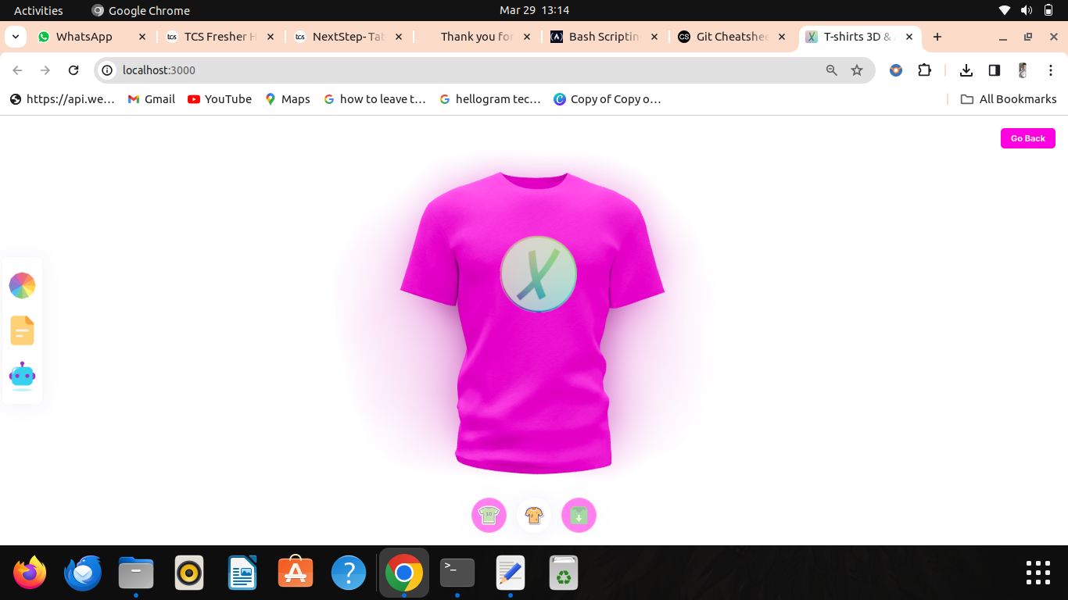

Fig 3 : Desgin Genaration
By leveraging advanced technologies such as the
LightGBM algorithm for crop recommendation and the Inceptionv3 algorithm for disease detection, we aim to
empower farmers with data-driven insights and actionable recommendations. The integration of a user-friendly chatbot interface further enhances accessibility and usability, facilitating seamless interaction between farmers and the system. Through the collaborative efforts of data collection, preprocessing, model selection, training, and deployment, our system offers a holistic approach to agricultural decision-making, enabling farmers to optimize yields, mitigate risks, and foster sustainable practices. Moving forward, continued research and development in this field hold the potential to further revolutionize agriculture, paving the way for increased productivity, resilience, and food security on a global scale.
6 . REFERENCES
[1]. Goodfellow, J. Pouget-Abadie, M. Mirza, B. Xu, D. Warde-Farley, S. Ozair, A. Courville, and Y. Bengio, ‘‘Generative adversarial nets,’’ in Proc. Adv. Neural Inf. Process. Syst., vol. 27, 2014, pp. 1–9. [2] X. Huang, M.-Y. Liu, S. Belongie, and J. Kautz, ‘‘Multimodal unsupervised image-to-image translation,’’ in Proc. Eur. Conf. Comput. Vis. (ECCV), 2018, pp. 172–189. [3] J. Ho, A. Jain, and P. Abbeel, ‘‘Denoising diffusion probabilistic models,’’ in Proc. Adv. Neural Inf. Process. Syst., vol. 33, 2020, pp. 6840–6851. [4] Y. Deldjoo, F. Nazary, A. Ramisa, J. Mcauley, G. Pellegrini, A. Bellogin, and T. Di Noia, ‘‘A review of modern fashion recommender systems,’’ 2022, arXiv:2202.02757. [5] L. Regenwetter, A. H. Nobari, and F. Ahmed, ‘‘Deep generative models in engineering design: A review,’’ J. Mech. Des., vol. 144, no. 7, Jul. 2022, Art. no. 071704. [6] M.-F. de-Lima-Santos and W. Ceron, ‘‘Artificial intelligence in news media: Current perceptions and future outlook,’’ Journalism Media, vol. 3, no. 1, pp. 13–26, Dec. 2021. [7] K. Hara, V. Jagadeesh, and R. Piramuthu, ‘‘Fashion apparel detection: The role of deep convolutional neural network and pose-dependent priors,’’ in Proc. IEEE Winter Conf. Appl. Comput. Vis. (WACV), Mar. 2016,pp. 1–9. [8] Z. Liu, S. Yan, P. Luo, X. Wang, and X. Tang, ‘‘Fashion landmark detection in the wild,’’ in Computer Vision—ECCV. Amsterdam, The Netherlands: Springer, 2016, pp. 229–245. [9] K. Yamaguchi, M. H. Kiapour, L. E. Ortiz, and T. L. Berg, ‘‘Parsing clothing in fashion photographs,’’ in Proc. IEEE Conf. Comput. Vis. Pattern Recognit., Jun. 2012, pp. 3570–3577. 42 [10] Z. Li, Y. Li, W. Tian, Y. Pang, and Y. Liu, ‘‘Cross-scenario clothing retrieval and fine-grained style recognition,’’ in Proc. 23rd Int. Conf. Pattern Recognit. (ICPR), Dec. 2016, pp. 2912–2917. [11] S. Jiang and Y. Fu, ‘‘Fashion style generator,’’ in Proc. 26th Int. Joint Conf. Artif. Intell., Aug. 2017, pp. 3721–

