ACCIDENT DETECTION SYSTEM USING ARDUINO
MEETU RANI, ABDUS SAMAD, HARSH ARORA , MOHD. UVAIS NADEEM, VINAYAK GAUR
DEPARTMENT OF COMPUTER SCIENCE & ENGINEERING[IOT], MIET COLLEGE ,MEERUT, INDIA.

Abstract
Traffic on road has been increased worldwide. While technology and better roads have made life easier, they've also brought more risks. Every day, accidents happen on roads, causing loss of life and property because emergency help isn't always available. These accidents waste time and money and, sadly, many turn fatal because medical help doesn't arrive quickly enough. To tackle this problem, we've developed a system using an accelerometer to detect crashes and a vibration sensor to measure a car's movements. When a severe accident occurs, the system sends an alert, along with the car's location, to the family members. This way, help can arrive promptly, especially in remote areas where accidents might go unreported. Our research shows that this system can save lives by ensuring a rapid response. We've studied various papers on accident detection systems and their practical uses.
KEYWORDS: VIBRATION SENSOR, GSM MODULE, LCD, ARDUINO UNO, ACCELEROMETER, GPS MODULE.
1.INTRODUCTION
Automobiles are essential components of our everyday lives. We rely on them to commute to work, stay connected with loved ones, and transport goods. However, along with their convenience, they also pose a serious risk of accidents, which can lead to tragedy and loss of life. Speed is a major factor in driving risks, increasing both the likelihood and severity of accidents. Despite numerous awareness campaigns by both government and non-governmental organizations worldwide, accidents continue to occur frequently. Access to timely crash data could have potentially numerous lives for emergency services. To address this issue, we propose an alert system that enhances emergency response to accidents. This system automatically detects accidents and immediately notifies rescue teams of the accident's location using GPS coordinates. When the accelerator and the vibration sensor detect sudden acceleration or notable vibrations alterations, the system initiates an alert via GSM &GPS module. Our research focuses on improving the emergency response system by providing prompt assistance after accidents occur. integrating unmanned aerial vehicles (UAVs) into the accident tracking system presents a promising avenue for improving emergency response efforts. UAVs, or drones, offer unique capabilities that can complement existing systems and enhance the overall effectiveness of accident response. Unlike existing systems that primarily focus on passenger safety, our system emphasizes immediate post-accident help. By rapidly transmitting vital information medical response teams immediately follow an accident, it is possible to rescue lives. The alert message contains information about the location, time, and angle of the accident. The activation of the system occurs through sensors that transmit data to a microcontroller, subsequently initiating the alert. Additionally, unmanned aerial vehicles (UAV) present an attractive solution for accident tracking. These lightweight drones offer enhanced performance and cost-effective solutions in various fields, including commercial and combat operations. Integrating UAV into accident tracking systems could provide valuable assistance in monitoring and responding to vehicle accidents effectively.
The paper delineates the proposed system design and the various components employed in Section 2, while Section 3 elucidates the findings, and Section 4 deliberates on the conclusion and future prospects.
- SYSTEM DESIGN

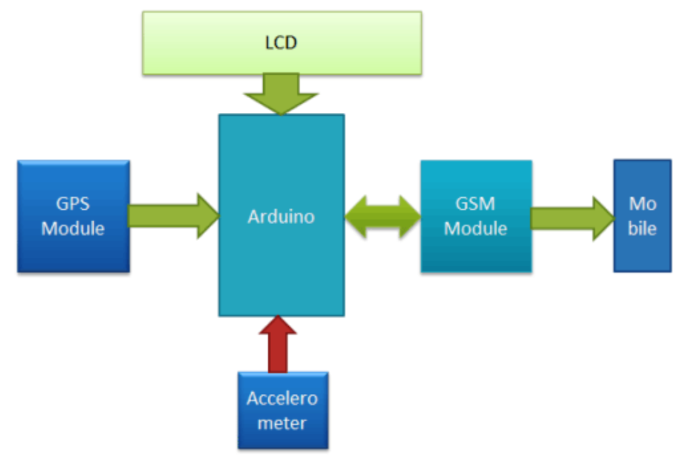 Fig. 2.1 System design

COMPONENTS
1.ACCELEROMETER - The ADXL335 accelerometer ,renowed for its compact design and energy efficiency ,is proficient in accurately measuring acceleration along three axes.it offers pre-conditioned voltage outputs and boasts a minimum full scale range of 3 g, enabling detection of both static acceleration like gravitation tilt and dynamic accelerations induced by movement, impact, or vibration.
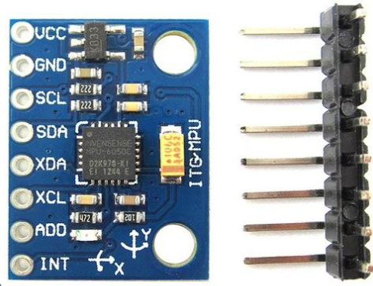
Fig.2.2 Accelerometer

2.VIBRATION SENSOR – A vibration sensor serves as a device employed for accessing both magnitude and recurrence of vibrations occurring within a system, machinery or equipment aiding in the detection of imbalances potential issues within the assets and facilitating the predictions of future malfunctions.
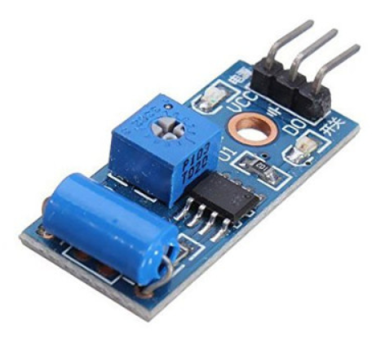
Fig. 2.3 Vibration Sensor

3.GPS MODULE - GPS module consists of small processors and antennas designed to receive data transmitted by satellites via specific radio frequencies. These modules receive timestamps and other relevant data from each visible satellite, allowing them to determine precise location information.
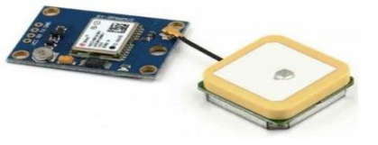
Fig 2.4 GPS module

4. GSM MODULE – Incorporated into diverse devices and equipment interacting with mobile phone network, a GSM module, or GSM modem, leverages GSM mobile phone technology to establish wireless connections. These modules employ SIM cards for network identification.
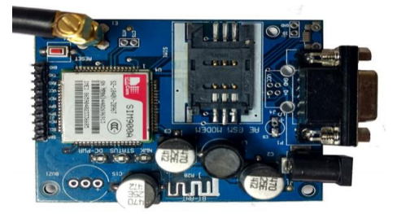
Fig. 2.5 GSM module

5. ARDUINO- The Arduino, driven by ATmega 328P chip, stands as a microcontroller board boasting 1414 digital input/output pins, with 6 having the capacity to serve a as PWM(Pulse with Modulation) outputs, in addition to accommodating 6 analog inputs. Outfitted with16 MHZ ceramic resonator (CSTCE16MOV53-RO), a USB connection, power jack, ICSP header, and reset button. It encompasses all essential components to facilitate the microcontroller’s operation, Connectivity to a computer is effortless through a USB cable, while power cane be supplied via an AC to DC adaptor or battery, enabling seamless initiation of projects. Engineered for experimentation, it encourages exploration of its functionalities with a safety net against errors, offering the flexibility of replacing the chip inexpensively for a fresh start in the event of any mishaps.

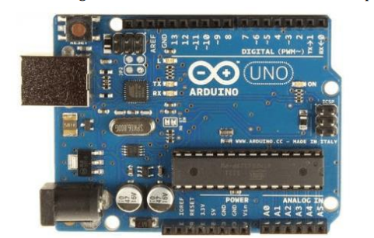
Fig. 2.6 Arduino

6. LCD- A liquid crystal display, commonly referred to as an LCD, is a type of screen that combines solid and liquid states of matter to produce images. Using liquid crystal technology, LCD screens produce aesthetically pleasing visuals commonly seen in laptops, televisions, cell phones, and portable gaming devices in contrast to older, cumbersome Cathode Ray tube (CRT)displays, LCD screens boast an ultrathin profile owing to their layered composition, incorporating polarized panels, filters and electrodes. This technology is widely used in devices like mini computers and notebooks for displaying images. Within framework of LCD technology, as light traverses the lens of the display, it engages with the liquid crystal layer, culminating in the production of the greyscale depiction. The greyscale images are subsequently merged with coloured illumination, resulting in the generation of vivid and superior display. Fundamentally, LCD technology presents a refined and effective substitute for conventional display mechanisms.

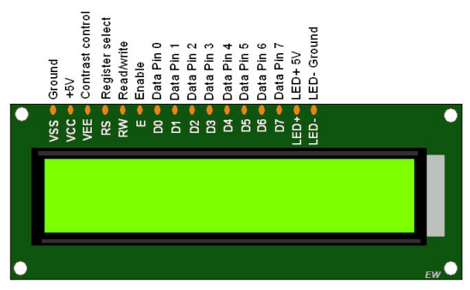
Fig. 2.7 LCD
The way the system works is that the accelerometer constantly measures the acceleration forces acting on the vehicle. If the accelerometer detects a sudden change in acceleration that is consistent with a collision, it sends a signal to the Arduino. The Arduino then retrieves the GPS coordinates from the GPS module and sends an SMS alert to emergency contacts using the GSM module. The SMS will typically include a message stating that an accident has occurred, as well as the GPS coordinates of the accident scene. This information can be critical for emergency responders to locate the accident scene and provide assistance.
3.RESULT AND DISCUSSION
In the event of the accident, the vibration sensor identifies collisions and transmits the signals to microcontroller. Through the integration of GPS & GSM technologies, an SMS containing
accident details including latitude and longitude coordinates represented via Google maps, is dispatched to the designated mobile number specified in the program, Subsequently the recipient receives message on their registered device, accompanied by the precise location information.
Following the transmission of the SMS containing accident details, the system initiates a series of predefined actions to ensure timely assistance and support. Once the designated mobile number receives the accident notification, the recipient is prompted to respond with confirmation or further instructions within a specified timeframe.

Simultaneously, the system activates an emergency response protocol, which includes notifying local emergency services and designated contacts such as family members or friends. This notification includes the exact location of the accident obtained from the GPS coordinates provided in the SMS.

Additionally, the system can integrate with vehicle telematics systems to assess the severity of the collision and provide relevant information to emergency responders. This data might include the impact force, number of passengers involved, and any potential hazards such as leaking fluids or deployed airbags.

Furthermore, the system can establish a voice communication link between the vehicle occupants and emergency services, allowing for real-time assessment of the situation and provision of instructions for administering first aid or safely exiting the vehicle.

In cases where the vehicle occupants are unable to respond or require immediate medical attention, the system can automatically escalate the emergency by contacting nearby medical facilities or dispatching an ambulance to the accident location.

Throughout the entire process, the system maintains communication with all stakeholders involved, providing updates on the status of the emergency response efforts until the situation is resolved or assistance arrives at the scene.



Fig. 3.1 Registered mobile no.
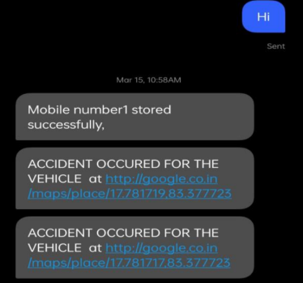
Fig. 3.2 location on registered no.
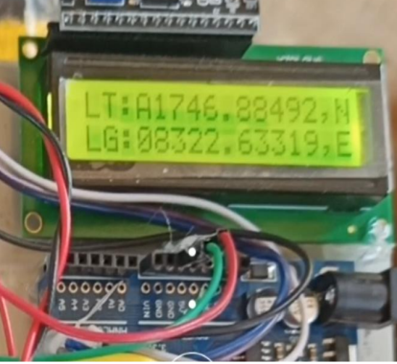
Fig.3.3 Direction
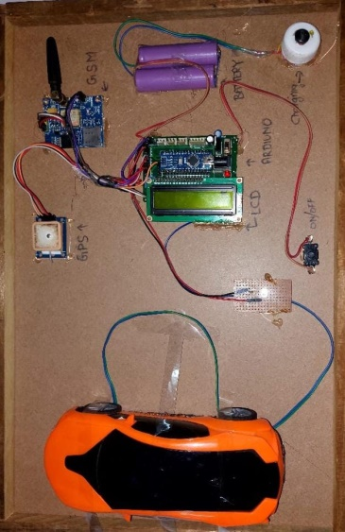
Fig. 3.4 Prototype model

5. CONCLUSION AND FUTURE SCOPE
This ground breaking system offers a vital remedy to the inadequate emergency assistance accessible to road accident victims. Through harnessing cutting-edge technology, prompt notifications can be dispatched to pertinent stakeholders via messaging platforms, facilitating rapid response. It is imperative to recognize that the functionality of this system hinges on network connectivity and may be compromised in regions with limited coverage.
This approach presents considerable advantages to the automotive sector by facilitating swift responses from medical teams, thereby potentially preserving lives. Moreover, vehicle tracking systems are indispensable for enhancing fleet management efficiency, which translates into augmented profitability via enhanced scheduling and route planning. Whether utilized for personal or commercial purposes, vehicle tracking enhances aspects such as safety, security, communication, performance monitoring, and productivity. It is anticipated that this technology will assume a pivotal role in shaping our daily lives in the foreseeable future.
The principal aim of the accident alert and detection project is to mitigate fatalities arising from unforeseeable accidents. By swiftly notifying paramedics, the chances of preserving lives are significantly enhanced. This functionality of vehicle tracking and accident alert is anticipated to assume heightened importance in our everyday routines in the forthcoming years. Nevertheless, it's pertinent to acknowledge that communication hurdles may arise in regions with inadequate GSM network coverage.

FUTURE ACOPE-
1. These systems are affordable to implement.
2. They greatly enhance safety measures.
3. They enable rapid lifesaving responses for accident victims.
4. They consume minimal power.
5. They offer improved accuracy.
6. They optimize time efficiency.
7. They minimize the risk of human error

REFERENCES
[1] A. Doshi, B. Shah, J. Kamdar, “Accident Detection And Alert System”, International Journal of All Research Education and Scientific Methods (IJARESM), Vol 9, No 11, pp. 114-119, Available online at: www.ijaresm.com, November-2021.

[2] N. Kattukkaran, A. George, M. Haridas T.P, “Intelligent Accident Detection and Alert System for Emergency Medical Assistance”, 2017 International Conference on Computer Communication and Informatics (ICCCI - 2017), Jan. 05 – 07, 2017, Coimbatore, INDIA.

- D. A. Borikar, M. B. Chandak, “Accident Detection and Emergency Alerting System for Road Safety”, Biosc. Biotech. Res .Comm., Vol 13, No 14, Available at: http//www.bbrc.in/ Doi: http://dx.doi.org/10.21786/bbrc/13.14/60, pp. 256-259, 29th Dec 2020.

[4] C. K. Gomathy, K Rohan, B. M. K. Reddy, V Geetha, “Accident Detection and Alert System”, Journal of Engineering, Computing & Architecture, Vol. 12, No 3, http://www.journaleca.com/, pp. 32-43, MARCH 2022.

[5] Nanda, S., Joshi, H., & Khairnar, S. (2018). An IOT Based Smart System for Accident Prevention and Detection. 2018 Fourth International Conference on Computing Communication Control and Automation (ICCUBEA).

[6] Syedul Amin, M., Jalil, J., & Reaz, M. B. I. (2012). Accident detection and reporting system using GPS, GPRS and GSM technology. 2012 International Conference on Informatics, Electronics & Vision (ICIEV). doi:10.1109/iciev.2012.6317382 .

[7] Wadhahi, N. T. S. A., Hussain, S. M.,Yosof, K. M., Hussain, S. A., & Singh, A. V. (2018). Accidents Detection and Prevention System to reduce Traffic Hazards using IR Sensors. 2018 7th International Conference on Reliability, Infocom Technologies and Optimization (Trends and Future Directions) (ICRITO). doi:10.1109/icrito.2018.8748458.

[8] Suryawanshi, S. S., & Thombare, S. S. (2019). Real-time Accident Detection and Alert System using IoT and Android Application. 2019 International Conference on Computing, Communication, Control and Automation (ICCUBEA). doi:10.1109/iccubea47929.2019.9002386.

[9] Patil, S. A., & Yadav, S. S. (2020). Smart Accident Detection and Notification System using IoT. 2020 International Conference on Emerging Trends in Information Technology and Engineering (ic-ETITE). doi:10.1109/icetite48511.2020.9315334.

[10] Kalia, S., & Mehta, R. (2016). Real-Time Accident Detection and Notification System using IoT and Android Application. 2016 5th International Conference on Reliability, Infocom Technologies and Optimization (ICRITO). doi:10.1109/icrito.2016.7785042.

[11] Pathak, P., & Kulkarni, A. (2018). Accident Detection and Notification System using IoT and GSM Technology. 2018 International Conference on Advances in Computing, Communication Control and Networking (ICACCCN). doi:10.1109/icacccn.2018.8488714.

[12] Rathi, S., & Jain, P. (2019). Smart Accident Detection and Reporting System using IoT. 2019 10th International Conference on Computing, Communication and Networking Technologies (ICCCNT). doi:10.1109/icccnt45670.2019.8945208.

