The Role of Auditors in Fraud Prevention and Detection in Companies

TABLE OF CONTENT

Chapter no. | Particulars | Page. No
Introduction pages | Introduction pages Front page  Certificate from the University Certificate from the company Declaration Acknowledgement  Executive Summary | 1-6
Chapter -1 | Introduction  - Background of the topic  - Need/importance of the topic  - Theoretical implication of the topic.  - Recent trends related to the topic | 11-15
Chapter -2 | Literature review | 16-25
Chapter -3 | Company Profile | 26-29

Chapter -4 | Research Design  - Objectives of the study  - Scope of the study  - Statement of the problem  - Need of the study  - Limitation of the study  - Research methodology  - Population  - Sample design  - Sample size  - Sampling unit  - Sampling method  - Method of data collection  - Primary data  - Secondary data | 30-35
Chapter-5 | Data Processing and Analysis | 36-47
Chapter-6 | Summary and Findings | 48-49
Chapter-7 | conclusion | 50-51
Chapter-8 | Recommendation | 52-53
Chapter-9 | Bibliography, Annexture | 54-58

LIST OF TABLES

TABLE  NO. | CONTENT | PAGE  NO.
1 | In your experience, have auditors successfully identified instances of  potential fraud within your organization? | 37
2 | Do you feel confident that the auditors you engage with have the necessary  expertise to detect fraudulent activities? | 38
3 | Have auditors provided recommendations or suggestions to improve your  company's internal controls and reduce the risk of fraud? | 39
4 | Do you believe that auditors adequately communicate with your company  about fraud risks during the audit process? | 40
5 | Have auditors ever reported instances of suspected fraud to your company's  management or board? | 41
6 | Would you consider auditors as valuable partners in your company's efforts  to prevent and detect fraud? | 42
7 | Have auditors ever uncovered instances of fraud that your company was  previously unaware of? | 43
8 | Have auditors ever identified weaknesses in your company's anti-fraud  policies or procedures during audits? | 44
9 | Have auditors helped your company in implementing fraud risk assessment  methodologies? | 45
10 | Overall, how would you rate the effectiveness of auditors in assisting your  company with fraud prevention and detection? | 46

LIST OF GRAPH

TABLE  NO. | CONTENT | PAGE  NO.
1 | In your experience, have auditors successfully identified instances of  potential fraud within your organization? | 37
2 | Do you feel confident that the auditors you engage with have the necessary  expertise to detect fraudulent activities? | 38
3 | Have auditors provided recommendations or suggestions to improve your  company's internal controls and reduce the risk of fraud? | 39
4 | Do you believe that auditors adequately communicate with your company  about fraud risks during the audit process? | 40
5 | Have auditors ever reported instances of suspected fraud to your company's  management or board? | 41
6 | Would you consider auditors as valuable partners in your company's efforts  to prevent and detect fraud? | 42
7 | Have auditors ever uncovered instances of fraud that your company was  previously unaware of? | 43
8 | Have auditors ever identified weaknesses in your company's anti-fraud  policies or procedures during audits? | 44
9 | Have auditors helped your company in implementing fraud risk assessment  methodologies? | 45
10 | Overall, how would you rate the effectiveness of auditors in assisting your  company with fraud prevention and detection? | 46

CHAPTER 1 INTRODUCTION

Introduction to The Role of Auditors in Fraud Prevention and Detection in Companies

  - Background of the topic:

The role of auditors in fraud prevention and detection in companies is a critical aspect of corporate governance and financial integrity. Auditors, often external to the company, are responsible for reviewing financial records, internal controls, and operational processes to ensure accuracy, transparency, and compliance with regulatory standards.

Fraud poses a significant threat to businesses, ranging from financial misstatements to cyber fraud. Auditors play a crucial role in identifying and preventing such fraudulent activities by applying their expertise in accounting principles, risk assessment, and forensic analysis.

In their role, auditors are tasked with assessing a company's financial statements and internal controls to detect any signs of fraud or mismanagement. They conduct thorough examinations of financial records and transactions, looking for irregularities or inconsistencies that may indicate potential fraud. Auditors also evaluate the effectiveness of internal controls designed to prevent and detect fraud, assessing their design and implementation.

Moreover, auditors often employ specialized techniques like data analytics and forensic accounting to identify patterns of suspicious activities or potential fraud schemes. By analyzing large datasets and transaction records, auditors can uncover anomalies that might otherwise go unnoticed.

In addition to detecting fraud, auditors also contribute to its prevention by recommending improvements to internal controls and processes. They provide valuable insights and

recommendations to management and stakeholders on how to strengthen governance practices and reduce the risk of fraud occurring within the organization.

Overall, auditors play a critical role in safeguarding the integrity of financial reporting and maintaining trust in corporate operations. Their expertise and independence are essential in ensuring transparency and accountability in the face of evolving fraud risks and regulatory challenges.

Need/importance:

Fraud is a serious threat to the integrity and reliability of financial reporting, and it can have significant negative consequences for the stakeholders of an organization, such as investors, creditors, regulators, and the public. Therefore, it is important to understand how auditors can help detect, identify, and report fraud in the course of their audit engagements.

Understanding the role of auditors in fraud detection is crucial because fraud can undermine trust in financial reporting, impacting investors, creditors, regulators, and the public. Auditors play a vital role in uncovering fraudulent activities within organizations, helping to ensure the accuracy and reliability of financial information. By detecting and reporting fraud, auditors contribute to maintaining transparency and accountability in business operations, which is essential for fostering confidence among stakeholders.

Understanding the role of auditors in fraud detection is critical due to the significant impact of fraud on various stakeholders and the overall integrity of financial reporting. Fraud

can erode trust in financial information, leading to negative consequences for investors, creditors, regulators, and the public. When fraud occurs, it can distort financial statements, misrepresenting the true financial health of a company and misleading stakeholders into making uninformed decisions.

Auditors play a crucial role in detecting, identifying, and reporting fraud during their audit

engagements. They are trained to meticulously examine financial records, transactions, and internal controls to uncover signs of potential fraud or irregularities. By conducting thorough assessments, auditors can identify red flags that may indicate fraudulent activities, such as fictitious transactions, manipulation of accounts, or unauthorized fund diversions.

Detecting and reporting fraud is essential for maintaining the accuracy and reliability of financial reporting. Auditors act as independent watchdogs, ensuring that financial statements reflect the true financial position of a company and comply with regulatory standards. By uncovering fraud and promptly reporting their findings, auditors contribute to transparency and accountability in business operations, which is crucial for fostering trust and confidence among stakeholders.

In summary, the role of auditors in fraud detection is fundamental to safeguarding the integrity of financial reporting and protecting the interests of stakeholders. Their efforts help to maintain transparency, uphold ethical standards, and mitigate risks associated with fraudulent activities, ultimately promoting trust and reliability in the financial markets.

Theoretical implication of the topic:

The theoretical implication of auditors in fraud prevention and detection lies in strengthening corporate governance models. Drawing from theories of accountability and agency, auditors act as external checks, ensuring companies adhere to ethical practices. The agency theory suggests that auditors mitigate conflicts of interest between managers and shareholders. Additionally, their role aligns with stakeholder theory, emphasizing transparency for all involved parties. Integrating these theories informs practices that enhance auditors' effectiveness in safeguarding against fraud, fostering trust in financial reporting, and contributing to a more accountable and reliable corporate landscape.

The theoretical implications of auditors in fraud prevention and detection are rooted in enhancing corporate governance frameworks. Drawing on theories such as accountability and agency, auditors serve as external monitors that promote ethical behavior within companies. According to

agency theory, auditors help mitigate conflicts of interest between managers and shareholders by ensuring the accuracy and transparency of financial information. Moreover, their role aligns with stakeholder theory, emphasizing the importance of transparency and accountability to all parties involved. By integrating these theories into practice, auditors can enhance their effectiveness in detecting and preventing fraud, ultimately fostering trust in financial reporting and contributing to a more accountable and reliable corporate environment.

Recent trends related to the topic:

Recent trends in the role of auditors in fraud prevention and detection emphasize the integration of technology and data analytics. Auditors are adopting advanced tools such as artificial intelligence (AI) and machine learning to analyze large volumes of financial data efficiently.
These technologies enable auditors to detect complex patterns and anomalies that may indicate fraudulent activities, enhancing the effectiveness and precision of fraud detection efforts.

Moreover, there is a shift towards continuous monitoring and real-time auditing processes. Auditors are moving away from traditional periodic audits towards more dynamic and proactive approaches. By continuously monitoring transactions and operational data in real-time, auditors can promptly identify and respond to potential fraud risks as they emerge, reducing the likelihood of financial losses and reputational damage for organizations.

Another notable trend is the collaboration between auditors and cybersecurity experts. Given the increasing prevalence of cyber fraud and data breaches, auditors are working closely with cybersecurity professionals to assess and strengthen internal controls related to data security and fraud prevention. This collaboration helps organizations address evolving cyber threats and enhances the overall resilience of their fraud prevention measures.

Overall, these recent trends underscore the evolving nature of auditors' roles in combating fraud, emphasizing the importance of leveraging technology, adopting proactive auditing approaches, and enhancing collaboration across disciplines to effectively mitigate fraud risks in modern business environments.

CHAPTER 2 REVIEW OF LITERATURE

(Alhassan, 2021) explores the role of forensic accounting in fraud detection and prevention within the Nigerian public sector. The study highlights the significance of forensic accounting techniques, such as data analytics, in combating fraud and enhancing financial integrity. By examining various case studies and practical applications, the review underscores the importance of proactive measures to prevent fraud, including robust internal controls, risk assessments, and compliance frameworks. Alhassan emphasizes the critical role of auditors and forensic accountants in identifying red flags and conducting thorough investigations to uncover fraudulent activities. The review also discusses the challenges faced in fraud detection within the Nigerian context, including resource constraints and the need for capacity building in forensic accounting expertise. Overall, the literature review provides valuable insights into the evolving landscape of fraud detection and prevention strategies, emphasizing the role of forensic accounting as a key component in safeguarding public sector finances and improving accountability and transparency.

(Alleyne, 2005) Alleyne's research emphasizes the importance of understanding cultural and contextual factors that influence auditors' effectiveness in detecting fraud. The study discusses the complexity of fraud schemes and the limitations auditors face in uncovering sophisticated fraudulent activities. It also explores the ethical dilemmas auditors encounter when balancing their responsibilities to detect fraud while maintaining professional skepticism and independence.
The literature review underscores the need for ongoing professional development and training for auditors to enhance their fraud detection skills and keep pace with emerging fraud risks. Additionally, Alleyne's study suggests the importance of collaboration between auditors, management, and other stakeholders to foster a strong control environment that deters fraudulent behavior.

Overall, the literature review by Alleyne provides valuable insights into the challenges and opportunities surrounding auditors' responsibilities for fraud detection in Barbados, highlighting the complexities of this critical aspect of audit engagements.

(Aziz, 2021) examines internal auditors' perceptions of the effectiveness of fraud prevention and detection within the public sector. The literature review explores the challenges faced by internal auditors in detecting and preventing fraud, particularly in governmental organizations. The study highlights the importance of internal controls, governance structures, and organizational culture in mitigating fraud risks.
The literature underscores the critical role of internal auditors as frontline defenders against fraud, emphasizing the need for robust fraud prevention strategies and continuous monitoring of internal processes. Aziz's research discusses various factors that impact the efficacy of fraud prevention measures, including resource constraints, inadequate training, and limited access to information.
Moreover, the study explores internal auditors' perceptions of their roles and responsibilities in detecting fraud, including the challenges associated with maintaining independence and objectivity while conducting fraud investigations. Aziz's literature review also examines the role of technology and data analytics in enhancing fraud detection capabilities within the public sector.
Overall, Aziz's literature review provides valuable insights into the perceptions and experiences of internal auditors regarding fraud prevention and detection in the public sector. The study underscores the importance of addressing organizational and resource- related challenges to strengthen fraud prevention efforts and improve accountability and transparency in governmental organizations.

(Chui, 2013) examines auditors' responsibilities for fraud detection, questioning whether these responsibilities represent a genuinely new approach or merely a reiteration of existing practices. The literature review explores the historical evolution of auditors' roles in fraud detection and the challenges they face in meeting these expectations.

The study delves into the complexities of fraud detection within the context of auditing, emphasizing the need for auditors to possess specialized skills in forensic accounting and data analysis. Chui's research highlights the tension between auditors' traditional focus on financial statement audits and the increasing demand for them to play a more proactive role in fraud prevention and detection.
The literature review discusses emerging trends in auditing practices, such as the integration of technology and data analytics, to enhance fraud detection capabilities. Chui examines the ethical dilemmas auditors encounter when balancing their responsibilities to detect fraud while maintaining professional skepticism and independence.
Overall, Chui's literature review challenges the conventional notions of auditors' responsibilities for fraud detection, calling for a reevaluation of audit practices to align with evolving fraud risks and regulatory expectations. The study underscores the importance of continuous professional development and innovation in auditing to address the complexities of fraud detection effectively.

(Finance, 2014) explores the role of internal audit in fraud prevention and detection, focusing on the effectiveness of internal audit functions in identifying and mitigating fraud risks. The literature review highlights the importance of internal audit as a critical component of organizations' governance frameworks, particularly in addressing fraud- related challenges.
The study emphasizes the proactive role of internal audit in preventing fraud through the implementation of robust internal controls, risk assessments, and fraud detection techniques. Finance's research underscores the value of internal audit's independence and objectivity in conducting fraud investigations and providing assurance to management and stakeholders.
The literature review discusses the evolving nature of fraud risks and the need for internal audit functions to adapt by leveraging technology and data analytics tools. Finance examines the key factors that contribute to the success of internal audit in fraud prevention, including leadership support, organizational culture, and continuous professional development.

Overall, Finance's literature review provides insights into the multifaceted role of internal audit in fraud prevention and detection. The study underscores the importance of collaboration between internal audit, management, and other stakeholders to strengthen controls and enhance transparency and accountability within organizations. By leveraging their expertise and independence, internal audit functions can play a pivotal role in mitigating fraud risks and safeguarding organizational assets.

(Iftikar Arif Yuri, 2022) emphasizes the significance of creating a culture of integrity and ethical behavior within organizations to deter fraudulent activities. Yuri's research highlights the role of training and education in enhancing fraud awareness among employees and stakeholders, enabling them to recognize and report suspicious activities.
The literature review discusses various fraud detection and prevention methods, including internal controls, segregation of duties, and the use of technology such as data analytics and artificial intelligence. Yuri examines the challenges organizations face in implementing these methods effectively and the importance of continuous monitoring and evaluation to adapt to evolving fraud schemes.
Overall, Yuri's literature review provides valuable insights into the landscape of fraud awareness and detection-prevention strategies in Indonesia. The study underscores the need for proactive measures to combat fraud, emphasizing the importance of collaboration between stakeholders, regulatory authorities, and law enforcement agencies. By adopting comprehensive fraud prevention measures and fostering a culture of vigilance and transparency, organizations in Indonesia can mitigate fraud risks and protect their financial integrity.

(Lee, 2008) examines the impact of organizational culture, governance structures, and regulatory frameworks on auditors' effectiveness in detecting fraud. Lee explores the role of technology and data analytics in enhancing auditors' capabilities to detect and analyze fraud-related patterns and anomalies.

Moreover, the study discusses the challenges auditors face in navigating legal and ethical considerations when uncovering fraud, including confidentiality and reporting
obligations. Lee's research underscores the need for continuous professional development and training to equip auditors with the skills and knowledge necessary to address the complexities of fraud detection effectively.
Overall, Lee's literature review provides valuable insights into the multifaceted nature of auditors' responsibilities in fraud detection within the Southern African region. The study highlights the importance of adopting a proactive and rigorous approach to fraud
detection while upholding professional standards and ethical principles in auditing practice.

(Olatunji, 2018) discusses the regulatory framework governing audit practices in Nigerian DMBs and the expectations placed on auditors by stakeholders, including shareholders, regulators, and the public. Olatunji examines the importance of collaboration between auditors, management, and regulatory bodies in combating fraud and enhancing governance practices.
Moreover, the study explores emerging trends in fraud detection, such as the use of technology and continuous monitoring techniques, to strengthen auditors' capabilities in detecting and preventing fraud within DMBs. Olatunji's research highlights the evolving nature of auditors' roles and the importance of adapting to changing fraud risks and regulatory requirements.
Overall, Olatunji's literature review provides valuable insights into the challenges and responsibilities of auditors in fraud detection and prevention within Nigerian Deposit Money Banks, underscoring the importance of robust audit practices in maintaining financial stability and trust within the banking sector.

(Othman, 2017) emphasizes the importance of proactive approaches to fraud detection, including the implementation of robust internal controls, risk assessments, and whistleblowing mechanisms. Othman's research highlights the role of technology, such as

data analytics and forensic accounting tools, in augmenting auditors' capabilities to detect and investigate fraud within the public sector.
The literature review discusses the regulatory framework governing fraud prevention in Malaysia and the expectations placed on accountants and internal auditors to adhere to professional standards and ethical guidelines. Othman examines the significance of collaboration between stakeholders, including government agencies, regulatory bodies, and professional associations, in strengthening fraud detection and prevention efforts.
Overall, Othman's literature review provides valuable insights into the challenges, strategies, and regulatory considerations surrounding fraud detection and prevention in the Malaysian public sector, highlighting the importance of collaborative efforts and technological advancements in enhancing financial integrity and accountability.

(Oyinlola, 2010) discusses the regulatory framework governing audit practices in Nigeria and the expectations placed on auditors to adhere to professional standards and ethical guidelines. Oyinlola examines the significance of collaboration between auditors, management, and regulatory bodies in combating fraud and enhancing governance practices.
Moreover, the study explores emerging trends in fraud detection, such as the use of technology and continuous monitoring techniques, to strengthen auditors' capabilities in detecting and preventing fraud within Nigerian organizations. Oyinlola's research underscores the evolving nature of auditors' roles and the importance of adapting to changing fraud risks and regulatory requirements.
Overall, Oyinlola's literature review provides valuable insights into the challenges, strategies, and regulatory considerations surrounding the role of auditors in fraud detection, prevention, and reporting in Nigeria, emphasizing the critical role of auditors in maintaining financial integrity and transparency within organizations.

(PhD, 2019) emphasizes the critical role of internal auditors as frontline defenders against fraud, highlighting the importance of independence, objectivity, and professional

skepticism in their approach. M.M. PhD's research underscores the need for continuous training and development to equip internal auditors with the skills and knowledge necessary to identify fraud risks and conduct thorough investigations.
The literature review discusses the regulatory framework governing internal audit practices in the banking sector and the expectations placed on auditors to adhere to professional standards and ethical guidelines. M.M. PhD examines the significance of leveraging technology, such as data analytics and forensic tools, to enhance auditors' capabilities in detecting and analyzing fraudulent activities.
Moreover, the study explores the importance of collaboration between internal auditors, management, and regulatory authorities in strengthening fraud prevention measures and promoting transparency and accountability within banking institutions. M.M. PhD's research provides valuable insights into the evolving role of internal auditors in fraud detection and prevention within the banking industry, highlighting the importance of proactive measures and continuous improvement in combating financial fraud.

(Research, 2019) emphasizes the importance of implementing robust internal controls, risk assessments, and governance frameworks to mitigate fraud risks within public sector organizations. Research underscores the role of technology, data analytics, and forensic accounting techniques in augmenting fraud detection capabilities and strengthening audit processes.
The literature review discusses the regulatory landscape governing fraud prevention in the Indian public sector and the expectations placed on organizations to adopt proactive measures and transparency initiatives. Research examines the significance of capacity- building and training programs to equip professionals with the skills and knowledge necessary to combat fraud effectively.
Moreover, the study explores emerging trends in fraud detection, such as the use of artificial intelligence and machine learning, to analyze large datasets and identify patterns indicative of fraudulent activities. Research's analysis provides valuable insights into the evolving strategies and best practices for fraud detection and prevention in the Indian

public sector, emphasizing the importance of collaboration, technology adoption, and regulatory compliance in safeguarding financial integrity and accountability

(Salleh, 2015) Salleh examines the regulatory framework governing fraud prevention and detection in public organizations and the expectations placed on stakeholders to uphold transparency and accountability.
Moreover, the study explores the use of technology and data analytics tools to enhance fraud detection capabilities and identify anomalies indicative of fraudulent activities. Salleh's analysis provides valuable insights into the evolving landscape of fraud prevention in the public sector, emphasizing the importance of proactive measures, collaboration between stakeholders, and continuous improvement in combating financial misconduct and safeguarding public resources. Overall, Salleh's literature review contributes to the body of knowledge on fraud prevention strategies tailored for the unique challenges faced by public sector organizations.

(Sule, 2019) emphasizes the importance of understanding users' perceptions and expectations regarding auditors' responsibilities in fraud prevention and detection. Sule's research highlights the complexities auditors face in fulfilling these responsibilities while maintaining independence and objectivity.
The literature review discusses the factors contributing to the audit expectation gap, including misaligned perceptions between auditors and stakeholders regarding the scope and effectiveness of audit procedures in detecting and preventing fraud. Sule examines the role of regulatory bodies and professional standards in addressing these gaps and enhancing audit quality.
Moreover, he study explores the impact of organizational culture, governance structures, and ethical considerations on auditors' effectiveness in fraud detection and prevention.
Sule's analysis provides insights into stakeholders' perspectives on the evolving role of auditors in combating financial misconduct and promoting transparency and

accountability within Asian economies.

(TAMAȘ, 2018) highlights the proactive approach of internal auditors in assessing fraud risks through comprehensive risk assessments and the implementation of internal controls. Tamaș underscores the importance of independence and objectivity in internal audit activities to effectively detect and report fraudulent activities.
The literature review discusses the use of technology and data analytics tools by internal auditors to enhance fraud detection capabilities and identify irregular patterns indicative of fraudulent activities. Tamaș examines the challenges faced by private companies in implementing effective fraud prevention measures and the strategies employed to overcome these challenges.
Moreover, the study explores the regulatory landscape governing internal audit practices in private companies and the expectations placed on internal auditors to uphold professional standards and ethical guidelines. Tamaș' analysis provides insights into the evolving role of internal audit functions in combating financial misconduct and promoting transparency within private sector organizations.

CHAPTER 3 COMPANY PROFILE



M/s. Murali Reddy & Associates has over 2 decades of experience in various areas like

Finance & Accounts, Banking, Forex Management, Imports, Exports, Secretarial Compliance's, Mergers, De-Merger, Acquisitions, New Projects, Taxation, Auditing, Internal Controls, Budgeting, Product & Project Costing and Statutory Compliance.

MR Associates is a team of distinguished chartered accountant, corporate financial advisors and tax consultants in India. Our firm of chartered accountants represents a coalition of specialized skills that is geared to offer sound financial solutions and advices.
We are a firm of Chartered Accountants, serving various public and private corporate, charitable institutions, colleges, banking and financial institutions, high net worth individuals, firms and executives.
Proprietor is having 20+ years of experience and worked in many areas like finance & Accounts, banking, forex management, imports, exports, secretarial compliances, mergers, de-merger, acquisitions, new projects, taxation, auditing, internal controls, budgeting, product & project costing etc
We as a auditing firm have been servicing various Indian and Multinational Corporations including banks. The clients we service span across various industries such as Infrastructure, Motors, Construction, Engineering, Financial services, Hotels and Restaurants, Educational Institutes, Textiles, Hospitals, Energy sectors and Retail sectors.

SERVICES

- Audit & Consultancy Services

- Finance & Banking Services

- Internal Controls & Systems Improvements

- New Company Start-up Support Services

MISSION
Honesty, integrity and ethics in all we do. Teamwork in an atmosphere of mutual respect Employ talented, caring and responsible people..Develop leaders for the growth and health of our Firm Provide an enjoyable work environment Give back to the communities we serve. We will provide businesses, entrepreneurs and individuals with the highest quality accounting, auditing, tax planning and business advisory services delivered in a timely, efficient and innovative
manner by a professional team that clearly enjoys working together to exceed their clients’ needs and expectations. We will provide intelligent, dynamic and practical advice to our clients, to help them to attain their full potential, improve the profitability of their business and to meet the challenges of the business and economic world .

VALUES


Honesty, integrity and ethics in all we do Teamwork in an atmosphere of mutual respect Employ talented, caring and responsible people
Develop leaders for the growth and health of our Firm Provide an enjoyable work environment
Give back to the communities we serve

VISSION

Our vision is to be the most highly respected professional firm where we seek to build strong and lasting relationships with our clients by providing them quality services which are personalized, reliable and value driven Where clients will be confident that their interests and business are being cared for by a trusted firm that enjoys working with them and one another. A firm that will offer comprehensive business and tax related services and assist enterprises to tackle complex situations in the fast-changing scenarios of business with the power of rightful decision making.

CHAPTER 4 RESEARCH DESIGN

OBJECTIVES OF THE STUDY:

    - To explore the challenges and opportunities faced by auditors in dealing with fraud risk in companies
    - To analyze the impact of fraud on the financial performance and reputation of companies
    - To explore the role of audit committees and regulators in overseeing and supporting the audit function in fraud prevention and detection

SCOPE OF THE STUDY:

The scope of study for investigating the role of auditors in fraud prevention and detection in companies using primary data collection methods involves several key aspects. Firstly, the study will focus on understanding auditors' perceptions, challenges, and best practices related to fraud prevention and detection through primary data collection techniques such as surveys or interviews. This will include exploring the specific tools, techniques, and procedures employed by auditors to identify and mitigate fraud risks within companies.
The scope also encompasses examining the impact of internal controls, governance structures, and organizational culture on auditors' effectiveness in fraud prevention. The study will assess the level of awareness and compliance with regulatory standards among auditors and companies regarding fraud prevention practices.

STATEMENT OF PROBLEM:

Despite the critical role of auditors in safeguarding against fraud, challenges persist in effectively detecting and preventing fraudulent activities within companies. These challenges may include inadequate resources and expertise, evolving fraud schemes that bypass traditional audit methods, and conflicts of interest that compromise auditor independence. Additionally, there may be gaps in regulatory oversight and internal control frameworks that enable fraud to go undetected. Furthermore, there can be issues related to organizational culture, such as a lack of commitment to ethical standards or insufficient whistleblower protections, which impede auditors' efforts to identify and report fraudulent behavior.

NEED OF THE STUDY:

The study on the role of auditors in fraud prevention and detection in companies is crucial due to the significant impact of fraud on financial integrity, investor confidence, and corporate governance. Understanding auditors' effectiveness in combating fraud is essential for enhancing transparency, accountability, and ethical practices within organizations. The study will contribute valuable insights into the challenges faced by auditors, the efficacy of current fraud prevention measures, and opportunities for improvement.

RESEARCH METHODOLOGY

Population- 40 -60

Sample design - PI CHART

Method of data collection - Primary data Instrument for data collection - GOOGLE FORMS
Testing of questionnaire/pilot study - Charted Accountants & Clients

LIMITATIONS OF THE STUDY:

- Limited Generalizability: Findings may be specific to the sample of auditors and companies studied and may not be fully representative of the broader population.
- Response Bias: The accuracy and completeness of data collected through surveys or interviews may be influenced by respondent bias or reluctance to disclose sensitive information.

- Resource Constraints: Limited resources such as time, budget, or access to certain data or stakeholders may constrain the depth and breadth of the study.
- Complexity of Fraud: Fraud schemes can be highly sophisticated and constantly evolving, making it challenging to capture all aspects of fraud prevention and detection within a single study.
- Regulatory Variations: Differences in regulatory frameworks and practices across jurisdictions or industries may impact the applicability of findings in different contexts.

Instrument for a data collection

Instrument for data collection was drafting of a questionnaire and obtaining the responses through google forms.

Drafting a questionnaire

- In your experience, have auditors successfully identified instances of potential fraud within your organization?
Yes, consistently Sometimes
No, rarely

- Do you feel confident that the auditors you engage with have the necessary expertise to detect fraudulent activities?
Yes, very confident Moderately confident No, not confident

- Have auditors provided recommendations or suggestions to improve your company's internal controls and reduce the risk of fraud?
Yes, frequently Occasionally No, rarely

- Do you believe that auditors adequately communicate with your company about fraud risks during the audit process?
Yes, always Sometimes No, rarely

- Have auditors ever reported instances of suspected fraud to your company's management or board?
Yes, regularly Occasionally No, never

- Would you consider auditors as valuable partners in your company's efforts to prevent and detect fraud?
Yes, definitely Maybe
No, not really

- Have auditors ever uncovered instances of fraud that your company was previously unaware of?
Yes multiple times Occasionally
No never

- Have auditors ever identified weaknesses in your company's anti-fraud policies or procedures during audits?
Yes, frequently Occasionally No, rarely

- Have auditors helped your company in implementing fraud risk assessment methodologies? Yes, extensively
To some extent No, not at all

- Overall, how would you rate the effectiveness of auditors in assisting your company with fraud prevention and detection?
Highly effective Moderately effective Ineffective

CHAPTER 5
DATA PROCESSING AND ANALYSIS

DATA ANALYSIS AND PRESENTATION:

TABLE NO.1

TITLE OF THE TABLE: In your experience, have auditors successfully identified instances of potential fraud within your organization?
 |  | Frequency | Percentage
 | Yes, consistently | 25 | 56.8%
 | Sometimes | 17 | 36.7%
 | No, rarely | 2 | 6.7%
CHART NO.1

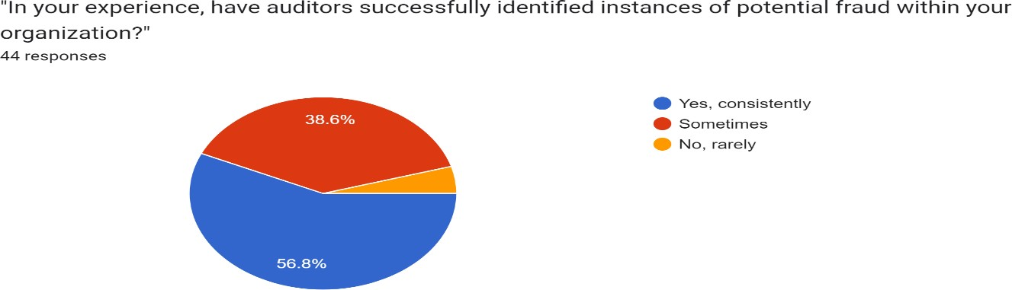

INTERPRETATION: The chart in the image represents responses to a question about the effectiveness of auditors in identifying potential fraud within organizations. It shows that 56.8% of respondents believe auditors consistently identify fraud. Meanwhile, 38.6% of respondents
37

stated that auditors sometimes identify fraud, suggesting some inconsistency in audit effectiveness. A small fraction believes that auditors consistently identify fraud.

TABLE NO.2

TITLE OF THE TABLE: Do you feel confident that the auditors you engage with have the necessary expertise to detect fraudulent activities?

 | Frequency | Percentage
Yes, very confident | 11 | 25%
Moderately confident | 6 | 13.6%
No, not confident | 27 | 61.4%

CHART NO.2

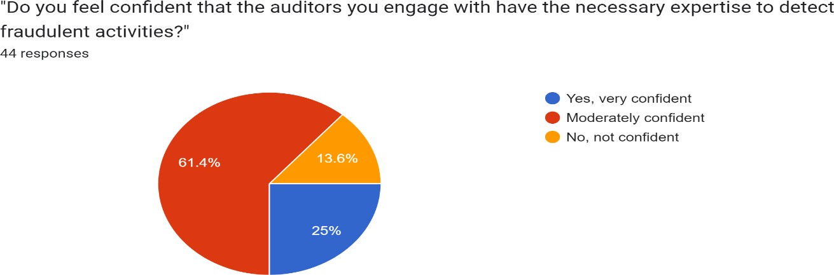

INTERPRETATION: The chart in the image represents responses to a question about the confidence in auditors’ expertise to detect fraudulent activities. It shows that a majority of respondents, 25%, are very confident in their auditors’ abilities, indicating a high level of trust in their expertise. Meanwhile, 13.6% of respondents are moderately confident, suggesting some room

for improvement. However, 61.4% of respondents are not confident at all, pointing to a need for enhancing the skills and capabilities of auditors in detecting fraud.

TABLE NO.3

TITLE OF THE TABLE: Have auditors provided recommendations or suggestions to improve your company's internal controls and reduce the risk of fraud?

 | Frequency | Percentage
Yes, frequently | 13 | 29.5%
Occasionally | 3 | 6.8%
No, rarely | 28 | 63.6%

CHART NO.3

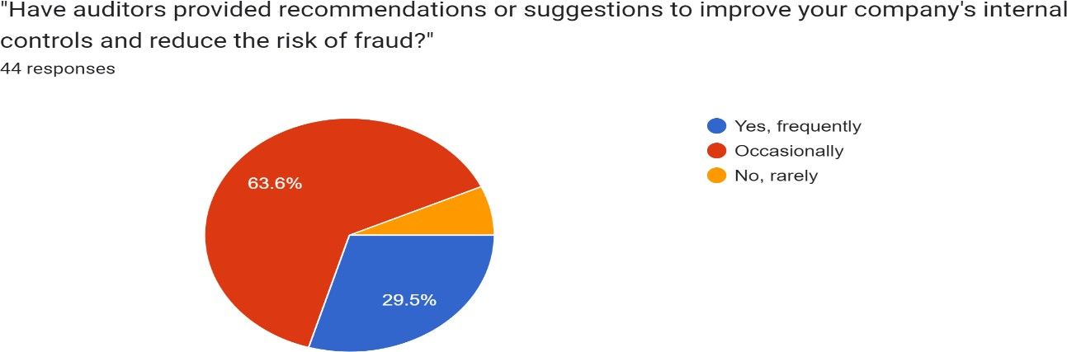

INTERPRETATION: The pie chart represents the responses of 44 participants to a question about whether auditors have provided recommendations to improve their company’s internal controls and reduce the risk of fraud. The majority of respondents (6.8%) indicated that auditors rarely provide such recommendations. However, (29.5%) of respondents reported that they

frequently receive advice from auditors on enhancing internal controls and mitigating fraud risks. A small portion of the respondents (63.6%) stated that they occasionally receive these recommendations.

TABLE NO.4

TITLE OF THE TABLE : Do you believe that auditors adequately communicate with your company about fraud risks during the audit process?

 | Frequancy | Percentage
Yes, always | 9 | 20.5%
Sometimes | 6 | 13.6%
No, rarely | 29 | 65.9%

CHART NO.4

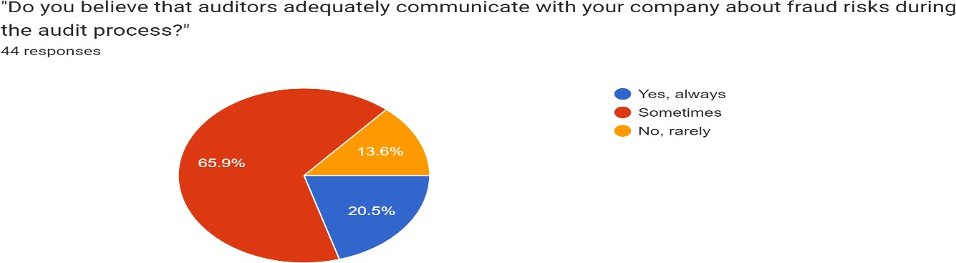

INTERPRETATION: The pie chart represents the responses of 44 participants to a question about whether auditors adequately communicate with their company about fraud risks during the audit process. The majority of respondents (65.9%) indicated that auditors sometimes communicate about these risks. However, (20.5%) of respondents reported that they always

receive adequate communication from auditors about fraud risks. Only a small portion of the respondents (13.6%) stated that they rarely receive adequate communication

TABLE NO.5

TITLE OF THE TABLE: Have auditors ever reported instances of suspected fraud to your company's management or board?

 | Frequency | Percentage
Yes, regularly | 15 | 34.1%
Occasionally | 3 | 6.8%
No, never | 26 | 59.1%

CHART NO.5

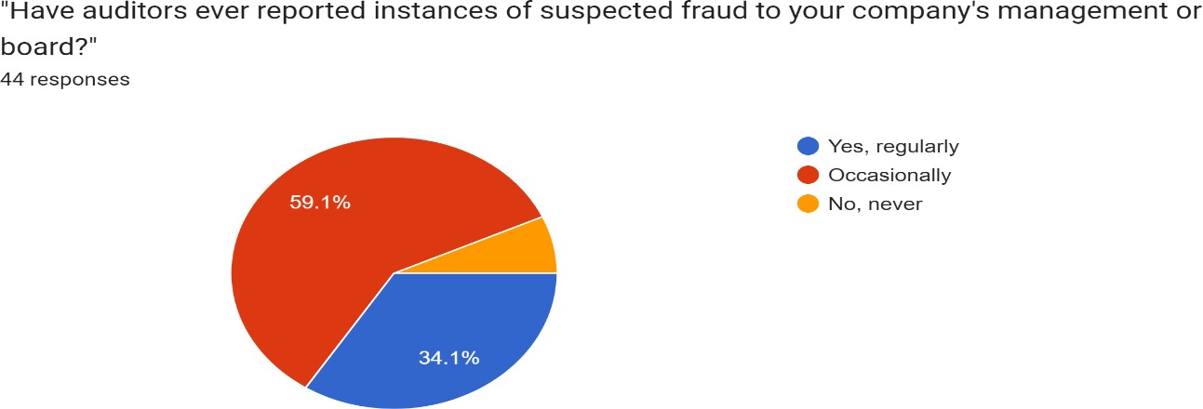

INTERPRETATION: The pie chart represents the responses of 44 participants to a question about whether auditors have ever reported instances of suspected fraud to their company’s

management or board. The majority of respondents (59.1%) indicated that auditors have occasionally reported such instances. However, (34.1%) of respondents reported that they regularly receive reports of suspected fraud. Only a small portion of the respondents (6.8%) stated that they never receive such reports.

TABLE NO.6

TITLE OF THE TABLE: Would you consider auditors as valuable partners in your company's efforts to prevent and detect fraud?

 | Frequency | Percentage
Yes, definitely | 14 | 31.8%
Maybe | 10 | 22.7%
No, not really | 20 | 45.5%

CHART NO.6

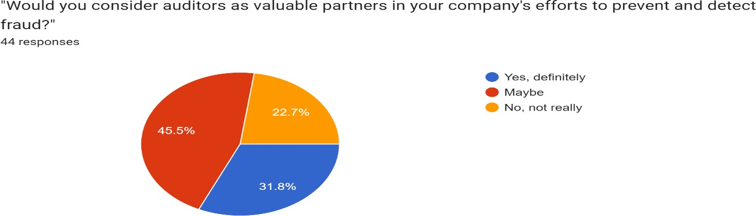

INTERPRETATION: The pie chart represents the responses of 44 participants to a question about the value of auditors in fraud prevention and detection. The majority of respondents (31.8%)

definitely consider auditors as valuable partners in their company’s efforts to prevent and detect fraud. However, (45.5%) of respondents are uncertain and responded with “Maybe”. A significant portion of the respondents (22.7%) do not really consider auditors as valuable partners in fraud prevention and detection.

TABLE NO.7

TITLE OF THE TABLE: Have auditors ever uncovered instances of fraud that your company was previously unaware of?

 | Frequency | Percentage
Yes multiple times | 14 | 31.8%
Occasionally | 6 | 13.6%
No never | 124 | 54.5%

CHART NO.7

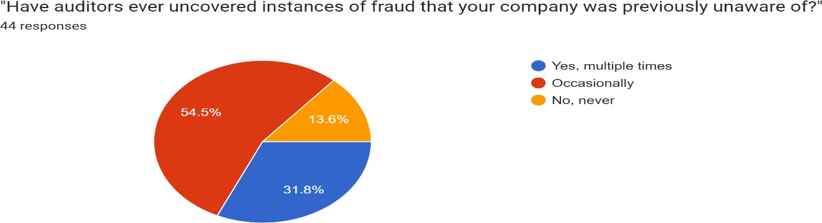

INTERPRETATION: The pie chart represents the responses of 44 participants to a question

about whether auditors have ever uncovered instances of fraud that their company was previously unaware of. The majority of respondents (54.5%) indicated that auditors have occasionally uncovered such instances. However, 31.8% stated that they have multiple occurrences of auditors uncovering previously unknown frauds. A small portion of the respondents (13.6%) of respondents reported that they never have instances where auditors revealed previously unknown frauds.

TABLE NO.8

TITLE OF THE TABLE: Have auditors ever identified weaknesses in your company's anti-fraud policies or procedures during audits?

 | Frequency | Percentage
Yes, frequently | 19 | 43.2%
Occasionally | 10 | 22.7%
No, rarely | 15 | 34.1%

CHART NO.8

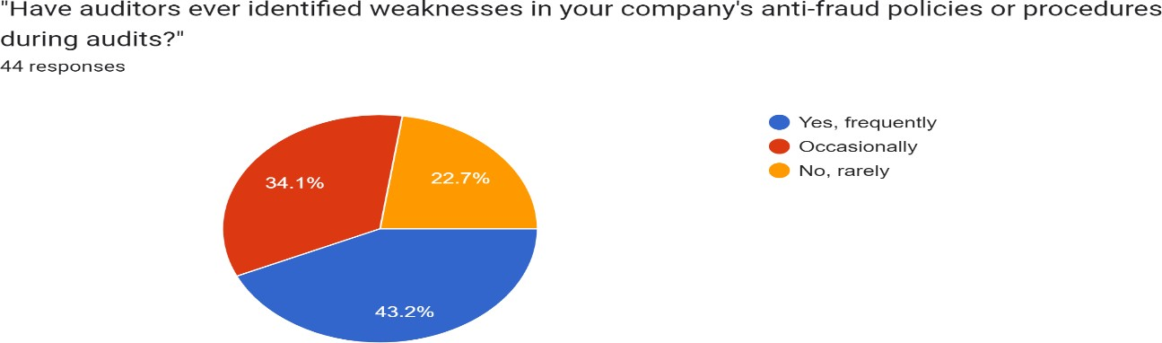

INTERPRETATION: The pie chart in the image represents the responses to a question about

the effectiveness of a company’s anti-fraud policies or procedures. The question asked was “Have auditors ever identified weaknesses in your company’s anti-fraud policies or procedures during audits?” Out of 44 responses, 43.2% responded “Yes, frequently,” indicating that weaknesses were found. However, 34.1% answered “Occasionally” suggesting that there are companies where weaknesses are often identified. Lastly, 22.7% responded “No, rarely, ,” implying that weaknesses are not found.

TABLE NO.9

TITLE OF THE TABLE: Have auditors helped your company in implementing fraud risk assessment methodologies?

 | Frequency | Percentage
Yes, extensively | 22 | 50%
To some extent | 5 | 11.4%
No, not at all | 17 | 38.6%

CHART NO.9

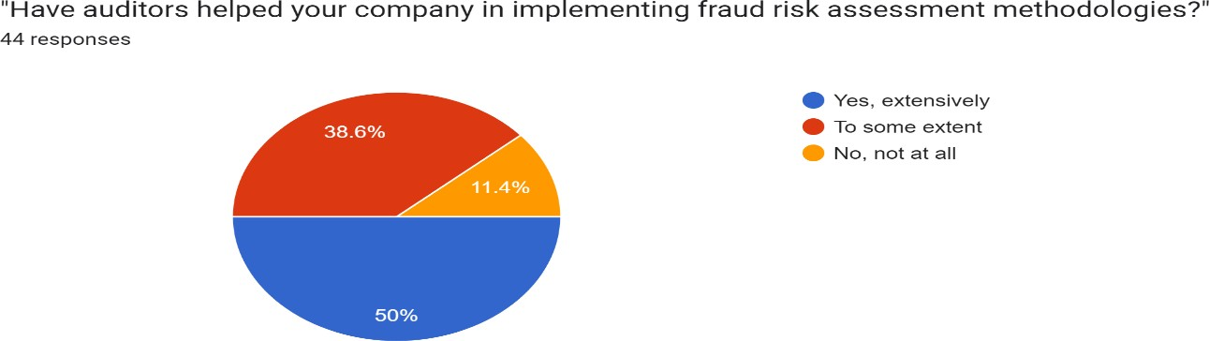

INTERPRETATION: The pie chart in the image represents the responses to a survey question about the role of auditors in implementing fraud risk assessment methodologies in companies. Out of 44 responses, 50% indicated that auditors have extensively helped their companies,

suggesting a significant role of auditors in this area. However, 38.6% stated that they received help to some extent, indicating a partial role of auditors. Lastly, 11.4% reported no assistance at all, implying that there are companies where auditors do not contribute to the implementation of fraud risk assessment methodologies.

TABLE NO.10

TITLE OF THE TABLE: Overall, how would you rate the effectiveness of auditors in assisting your company with fraud prevention and detection?

 | Frequency | Percentage
Highly effective | 23 | 52.3%
Moderately effective | 2 | 4.5%
Ineffective | 19 | 43.2%

CHART NO.10

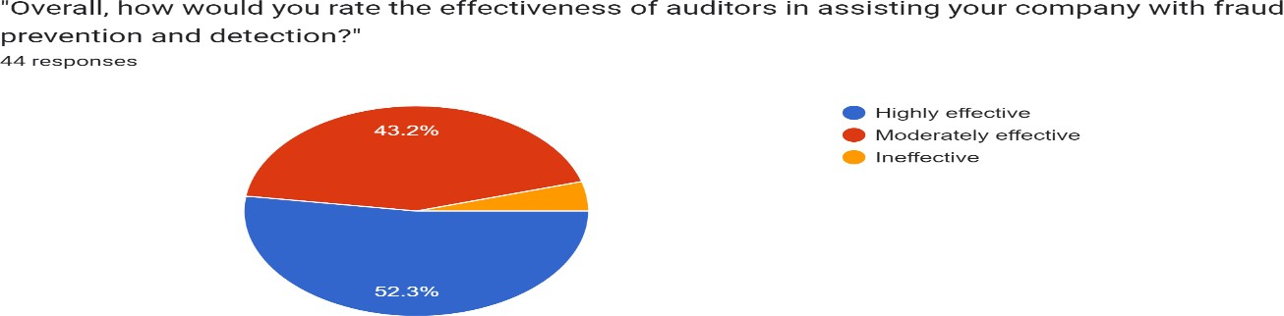

INTERPRETATION: The pie chart in the image represents the responses to a survey question about the effectiveness of auditors in assisting with fraud prevention and detection. Out of 44 responses, 52.3% believe auditors are highly effective, suggesting a significant role of auditors in

this area. However, 43.2% consider them moderately effective, indicating a partial role of auditors. Lastly, a small portion finds them ineffective, implying that there are companies where auditors do not contribute significantly to fraud prevention and detection.

CHAPTER 6 SUMMARY FINDINGS

SUMMARY AND FINDINGS

- Effectiveness in Identifying Fraud: The majority of respondents (56.8%) believe that auditors consistently identify fraud, but a notable portion (38.6%) stated that auditors only sometimes identify fraud, indicating room for improvement in audit effectiveness.
- Confidence in Auditors' Expertise: While 25% of respondents are very confident in auditors' abilities to detect fraudulent activities, a significant majority (61.4%) lack confidence, suggesting a need to enhance auditors' skills and capabilities in fraud detection.
- Recommendations on Internal Controls: A substantial number of respondents (63.6%) receive occasional or frequent recommendations from auditors on improving internal controls and reducing fraud risks, but a notable percentage (36.4%) reported receiving such advice rarely.
- Communication on Fraud Risks: The survey shows that auditors sometimes (65.9%) adequately communicate about fraud risks during audits, indicating potential areas for improvement in communication effectiveness.
- Reporting Instances of Suspected Fraud: A majority of respondents (59.1%) indicated that auditors occasionally report suspected fraud instances, highlighting the importance of auditors' role in raising awareness of potential fraud within organizations.

CHAPTER 7 CONCLUSION

CONCLUSION

In conclusion, the interpretations of the survey responses highlight both strengths and areas for improvement in the role of auditors in fraud prevention and detection within organizations. The findings reveal that while a significant percentage of respondents believe auditors are effective in identifying potential fraud and have confidence in their expertise, there is still a notable proportion of respondents who express varying levels of uncertainty or lack of confidence in auditors' abilities.
Furthermore, the survey indicates that auditors often provide recommendations to enhance internal controls and communicate about fraud risks during audits. However, there are opportunities to strengthen these aspects, particularly in terms of consistency and frequency of communication, as well as the depth of recommendations provided.
Additionally, the survey responses underscore the value of auditors in uncovering instances of fraud and identifying weaknesses in anti-fraud policies and procedures. While many respondents acknowledge the contributions of auditors in implementing fraud risk assessment methodologies, there is room for improvement in ensuring a more comprehensive and proactive approach in this area.
In summary, the survey outcomes emphasize the critical role of auditors in fraud prevention and detection, but also highlight the need for continuous enhancement of audit practices, communication, and collaboration between auditors and organizations to strengthen financial integrity and mitigate fraud risks effectively. Adapting to these insights can lead to improved audit effectiveness and greater confidence in auditors' contributions to fraud prevention efforts within companies.

\

CHAPTER 8 RECOMMENDATIONS

RECOMENDATION

Based on the interpretations of the survey responses related to auditors' effectiveness in fraud prevention and detection, several recommendations can be made to enhance the role and impact of auditors in combating fraud within organizations:

Enhance Auditor Training and Expertise: Invest in continuous professional development programs to enhance auditors' skills in fraud detection, data analytics, and forensic accounting techniques. This will empower auditors to stay updated with evolving fraud schemes and effectively identify red flags.
Strengthen Communication and Reporting: Encourage auditors to improve communication with stakeholders about fraud risks and provide timely, clear, and actionable recommendations to enhance internal controls and mitigate fraud risks. This can foster transparency and accountability within organizations.
Promote Collaboration with Management and Board: Foster closer collaboration between auditors, management, and the board of directors to ensure auditors have sufficient access to information and resources needed to effectively detect and report suspected fraud instances. Implement Robust Anti-Fraud Policies and Procedures: Develop and implement comprehensive anti-fraud policies and procedures based on auditors' recommendations to strengthen internal controls and prevent fraudulent activities.
Utilize Technology and Data Analytics: Invest in advanced technologies and data analytics tools to augment auditors' capabilities in detecting anomalies and patterns indicative of fraud within large datasets.
Promote Auditor Independence and Objectivity: Emphasize the importance of auditor independence and objectivity in audit engagements to ensure unbiased assessments of fraud risks and incidents.
Regular Audit Reviews and Assessments: Conduct regular reviews and assessments of audit processes and practices to identify areas for improvement and ensure alignment with industry standards and best practices.

CHAPTER 9
Bibliography, annexure

References
Alhassan, I. (2021). Forensic Accounting and Fraud Detection and Fraud Detection and Prevention in the Nigerian Public Sector (Vols. Vol-3, no.1). International Journal of Empirical Finance and Management Sciences. Retrieved from https://www.academia.edu/resource/work/58049601
Alleyne, P. (2005). An exploratory study of auditors’ responsibility for fraud detection inBarbados.
Managerial Auditing Journa. Retrieved from https://www.academia.edu/resource/work/3255480
Aziz, F. L. (2021). Internal Auditors'Perception on the Efficacy of Fraud Prevention and Detection inthe Public Sector (Vols. VOL-9 NO 4). Universal Journal of Accounting and Finance. Retrieved from https://www.academia.edu/resource/work/64049330
Chui, L. (2013). Auditors' responsibility for fraud detection: New wine in old botles? (Vol. Vol. 5). Journal of Forensic & Investigative. Retrieved from
https://www.academia.edu/resource/work/29274843
Finance, P. E. (2014). The Role of Internal Audit in Fraud Prevention and Detection. Procedia Economics and Finance. Retrieved from https://www.academia.edu/resource/work/83346160
Iftikar Arif Yuri, M. R. (2022). FRAUD AWARENESS AND FRAUD DETECTION-PREVENTION METHODS IN
THE INDONESIAN (Vols. vol-6 no-01). Global Financial. Retrieved from https://www.academia.edu/resource/work/86821530
Lee, T. (2008). A study of auditors’ (Vol. Vol 8). Southern African Journal of. Retrieved from https://www.academia.edu/resource/work/10625631
Olatunji, O. C. (2018). The Roles of Auditors in Fraud Detection andPrevention in Nigeria Deposit Money Banks: (Vols. Vol-7 no.2). Department of Accounting, Ekiti State University, Ado Ekiti,. Retrieved from https://www.academia.edu/resource/work/57908197
Othman, R. (2017). Fraud Detection and Prevention Methods in the Malaysian Public Sector:
Accountants’ and Internal Auditors’ (Vols. Vol-8). Accounting Research Institute,. Retrieved from https://www.academia.edu/resource/work/72032221
Oyinlola, A. O. (2010). THE ROLE OF AUDITORS IN FRAUD DETECTION, PREVENTION AND REPORTING IN
NIGERIA. Library Philosophy. Retrieved from
https://www.academia.edu/resource/work/83346160
PhD, M. M. (2019). Fraud Detection onBanking Industry in South Sumatera: A Study on the Role of Internal Auditors (Vols. Vol-1, no 3). 2019. Retrieved from
https://www.academia.edu/resource/work/59958087
Research, E. (2019). Analysis of Fraud Detection and Prevention Strategies in the Indian Public Sector (Vols. Vol-3, no.1). International Journal of Applied Engineering Research. Retrieved from https://www.academia.edu/resource/work/83024227
Salleh, K. (2015). Fraud profile and fraud prevention in public. Proceedings of the International. Retrieved from https://www.academia.edu/resource/work/112973518

Sule, S. (2019). Users’ Perceptions onAuditors’ Responsibilities for Fraud Prevention, Detection and Audit Expectation GAP in (Vols. vol-18 no.1). Asian Journal of Economics, Business and Accounting.
Retrieved from https://www.academia.edu/resource/work/77723865
TAMAȘ, A. (2018). Importance of Internal Audit Missions for Private Companies in Fraud Prevention and Detection (Vols. Vol-6, no.3). Finance - Challenges of the Future. Retrieved from
https://www.academia.edu/resource/work/86111191
Widiyati, D. (2021). The Role of PublicAccountants in Tax Fraud Prevention, and Detection During COVID- 19 (Vols. vol-1 no.2). Dian Widiyati et al., Golden Ratio of Auditing Research. Retrieved from https://www.academia.edu/resource/work/96203833

ANNEXURE

  - In your experience, have auditors successfully identified instances of potential fraud within your organization?
Yes, consistently Sometimes
No, rarely

  - Do you feel confident that the auditors you engage with have the necessary expertise to detect fraudulent activities?
Yes, very confident Moderately confident No, not confident

  - Have auditors provided recommendations or suggestions to improve your company's internal controls and reduce the risk of fraud?
Yes, frequently Occasionally No, rarely

  - Do you believe that auditors adequately communicate with your company about fraud risks during the audit process?
Yes, always Sometimes No, rarely

  - Have auditors ever reported instances of suspected fraud to your company's management or board?
Yes, regularly Occasionally No, never

  - Would you consider auditors as valuable partners in your company's efforts to prevent and detect fraud?
Yes, definitely Maybe
No, not really

  - Have auditors ever uncovered instances of fraud that your company was previously unaware of?
Yes multiple times Occasionally
No never

  - Have auditors ever identified weaknesses in your company's anti-fraud policies or procedures during audits?
Yes, frequently Occasionally No, rarely

  - Have auditors helped your company in implementing fraud risk assessment methodologies? Yes, extensively
To some extent No, not at all

  - Overall, how would you rate the effectiveness of auditors in assisting your company with fraud prevention and detection?
Highly effective Moderately effective Ineffective

