A REVIEW OF MACHINE LEARNING IN EDUCATION

Name of Author: Dr. Jasmin Bhootwala

Atmanand Saraswati Science College

Abstract: Every person has the fundamental right to an education. It involves learning about the world around us. It makes everything in our lives more balanced and makes it easier for us to comprehend and handle any issue. Over the past 20 years, there have been numerous changes to education at all levels. The method that professors teach and how students learn has changed significantly as a result of the numerous technological breakthroughs. The development of machine learning and artificial intelligence has been one of the major turning points in the history of technology. Every aspect of human existence has been impacted by these two improved technologies, including business, finance, communication, travel, health, and education. It's true that educators and teachers are indispensable. But the role of a teacher and best practices in education will alter significantly as a result of technology. The general idea of machine learning in education is covered in this review.

Index Terms - Artificial Intelligence, Machine Learning, Digitalization, Supervised Learning, Unsupervised Learning

- Introduction:

Nowadays, technology permeates every aspect of life, including education, where it has shown to be crucial to achieving students' learning objectives. The traditional classroom setup, where teachers stand in front of the class and pupils sit in rows, staring at the same textbook, is becoming less common in education. In addition to incorporating more technology and digital resources, modern classrooms are also investing in machine learning. Education now faces a new frontier in machine learning. It may completely alter not only the way that education is provided but also the environment in which pupils are encouraged to learn well. By giving real-time feedback based on each student's unique behavior and other variables, machine learning promises to give personalized instruction in the classroom. This raises the possibility of improved learning. By eliminating biases, machine learning also has a significant impact on assessments and evaluations. Machine learning, one of the most potent recent technologies, is a major player in artificial intelligence and human interaction. As a result, without being specifically designed to do so, machine learning assists computers in discovering hidden insights. Furthermore, machine learning is an effective predictor.

Related Work:
Tom M. Mitchell [1] in their book “Machine Learning " outlined the discipline of machine learning, which is the study of techniques that enable computer programs to automatically learn from experience and deduce broad rules from particular facts.

Ibtehal Talal Nafea [2] in their research paper “Machine learning in education technology” described the fundamental viewpoints of machine learning in education and came to the conclusion that highly customized learning environments will probably be a feature of future learning environments, enabling students to reach their full potential in the most rewarding manner.

Ilkka Tuomi [3] in their report describes "The Impact of Artificial Intelligence on Learning, Teaching, and Education: Policies for the Future". The goal of this paper is to outline the advantages and restrictions of machine learning in the classroom.

Havan Agrawal, Harshil Mavani [4] They used a machine learning technology known as neural networks to create a model that forecasts student success in an academic setting. The review delves into the use of machine learning in the classroom as well.

Machine Learning:
A fundamental component of artificial intelligence, machine learning advances the idea that machines should have access to data in order to facilitate human labor more easily and to acquire knowledge on their own. One important characteristic of artificial intelligence is learning [5]. The robots' capacity to process real-time data and feedback to enhance performance over time required the creation of self-learning algorithms that would learn from the data in order to forecast future events. One of the most significant technical approaches to AI is machine learning, which is the foundation of many recent developments and industrial uses of AI. The statistical method of modern machine learning aids in defining the results and potential applications of data [6].
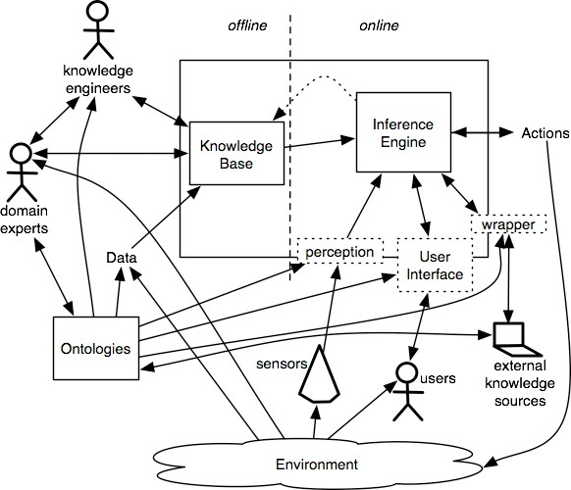

Fig. a) Machine Learning Mechanism
There are following types of learning:
  - Supervised learning.
  - Unsupervised/predictive learning.
  - Reinforcement learning.

3.1 Supervised Learning: If the researcher instructs the computer on the proper response for a specific input during this process. It is the most often used method for training machine learning architectures such as neutral networks [7]. Additionally examined is the computer's prediction accuracy throughout training. Acquiring knowledge of how to map a set of inputs to a target variable is required. Real, distinct value is the goal. Neutral networks with decision trees, naïve trees [8], boosting trees, and multi-layer trees [9] are able to solve it.
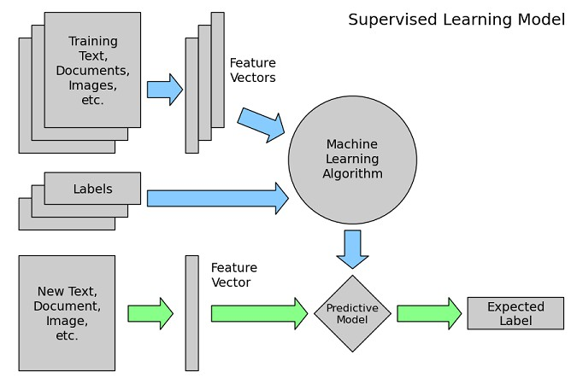

Fig. b) Supervised learning model

3.2 Unsupervised/predictive learning: In this strategy, the learning algorithm is left to find a structure in its data without being labeled. It can be a goal in itself, such as a hidden pattern [10] or data. Researchers do not know what to do at this time; study is still ongoing. No target variables are specified. It is solved by organizing into K groups. Unsupervised learning is usually used with transactional data. It is used for more complicated activities. It uses another iterative approach known as deep learning to arrive at some results.
.
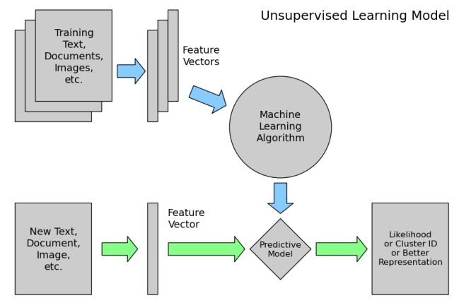

Fig. c) Unsupervised learning model

  - Reinforcement Learning: In this algorithm, The AI, Agent [10] decides how to behave in order to get most of the work is done. A computer interacts with dynamic environment in which is must perform a certain task to win against opponent. The program gives feedback in terms of punishment or reward. The machine itself selects actions to be performed for better output. The main goal in reinforcement learning is to find the best possible policy.

Application of machine learning in education:
Artificial intelligence and machine learning have the potential to substantially alter the future of education. With machine learning, we are moving away from one-size-fits-all approaches. It is a great teaching tool since it can adjust and provide personalized curricula. Machine Learning-enabled systems can assess an individual's present level of comprehension, detect gaps in the student's learning, and suggest real-time remedies. The system may also detect places where teachers are outnumbered by pupils and design optimum learning packages that reach the greatest number of kids. Here are some advantages of machine learning that show it has become a game changer in the realm of education.

4.1 Predict Student Performance: One significant advantage of machine learning is its capacity to anticipate student success. By "learning" about each learner, the system may identify shortcomings and provide appropriate learning aids, such as further practice exams.

4.2 Grade Students Fairly: Machine learning may also grade pupils fairly by eliminating human prejudice. While AI is currently grading multiple choice examinations, we are seeing machine learning being used to analyze writing through programs such as Grammarly.

4.3 Organize Content Effectively: Machine learning can improve content organization by finding vulnerabilities. For example, as students acquire one ability, they go to the next, building on their previous knowledge.

4.4 Suggested learning path: Once the software has analyzed pupils' performance, it may recommend a better way to learn new content. It begins by analyzing the curriculum's existing knowledge. Once weak points have been identified, pupils are given ideas for resources and additional learning methods.

4.5 Career Path Prediction: Machine learning systems for career path prediction can track students' interests, aptitudes, and dislikes. It examines students' behaviour and reactions. Based on the study, it is possible to reasonably estimate the student's interests and areas of strength.

4.6 Group Students and Teachers: Another way machine learning will benefit education is by categorizing students and teachers based on their needs and availability.

Benefits and Limitations of Machine Learning:
It is difficult to dismiss individualized education as the most significant advantage [12] of machine learning. Students can begin with material that is appropriate for their ability and progress to more difficult material as they become ready. This unique approach to learning benefits not only pupils, but also teachers, who can save a lot of time. Lesson plans for students of all ability levels and grade levels do not need to be created by them anymore. The automated grading system is another area where machine learning is advantageous. This offers the chance for totally objective grading that is unaffected by the teacher's relationship with any particular student. In addition to saving teachers time, it provides a more accurate summary of a student's academic progress. Additionally, machine learning can support instructors in planning for the future. Soon, patterns that indicate the student's main area of weakness and if they require additional assistance will become apparent through the system's analysis of their data. In the event that the problem is intellectual, the computers can offer online tutoring. But it can also tell you whether a pupil is likely to fail out or face harsher punishment. The main drawback of machine learning is that it is depriving students of face-to-face interaction. In the years to come, this may have a significant effect on their capacity to form friendships and carry oneself professionally at work. It is still necessary to prioritize social skills while utilizing machine learning. Using a computer to grade student papers can be useful, but it isn't always going to work. Teachers will still have to prepare to grade essays and other assignments in the traditional manner. Items that don't have a clear technological need attached to them cannot be evaluated by computers. The longer essay assignments are difficult for them to grade, while multiple choice questions come naturally to them. Naturally, given the intrinsic cost of machine learning, many schools are assessing its benefits. Buying all new tools and software to enable individualized learning to be a successful solution for teachers and students can be quite costly. One of the main drawbacks of machine learning may be this.

V. Conclusion:
The notions of artificial intelligence and machine learning are crucial to the global digitalization process that is underway. Our entire research work is focused on the process by which new machine technologies and intelligence are developed within the educational system. The machines of today are in charge of enhancing intellect and are prepared to provide knowledge-based schooling. We won't consider or envisage how education technology will advance in the future if it weren't for machine learning. In the near future, machine learning and artificial intelligence in education will transform the game. Along with lowering effort and closing learning gaps between students and teachers, it will also present a number of new chances for management maintenance. Machine learning will become even more effective and yield even better outcomes soon.

References:
  - Tom M. Mitchell. Machine Learning. McGraw-Hill Science/Engineering/Math; (March 1, 1997)
  - Ibtehal Talal Nafea(2018),"Machine Learning in Educational Technology" In Machine Learning(), IntechOpen, Rijeka. Retrieved from http://dx.doi.org/10.5772/intechopen.72906
  - The Impact of Artificial Intelligence on Learning, Teaching, and Education: Policies for the Future. Retrieved from https://www.researchgate.net/publication/329544152 .
  - Student Performance Prediction using Machine Learning by Havan Agrawal , Harshil Mavani . International Journal of Engineering Research & Technology (IJERT) ISSN: 2278-0181 IJERTV4IS030127 www.ijert.org l. 4 Issue 03, March- 2015
  - Sally Goldman; Yan Zhou, "Enhancing Supervised Learning with Unlabeled Data", Department of Computer Science, Washington University, St. Louis, MO 63130 USA.
  - Niklas Lavesson, "Evaluation and Analysis of Supervised Learning Algorithms and Classifiers", Blekinge Institute of Technology Licentiate Dissertation Series No 2006:04, ISSN 1650-2140, ISBN 91-7295-083-8.
  - Bing Liu, "Supervised Learning", Department of Computer Science, University of Illinois at Chicago (UIC), 851 S. Morgan Street, Chicago.
  - T.S. Anantharman, M.S. Campbell, F.-h. Hsu, Singular extensions: Adding selectivity to brute-force searching, Artificial Intelligence 43 (1) (1990) 99–110. Also published in: ICCA J. 11 (4) (1988) 135–143.
  - Rich Caruana; Alexandru Niculescu- Mizil, "An Empirical Comparison of Supervised Learning Algorithms", Department of Computer Science, Cornell University, Ithaca, NY 14853 USA Dissertation Series No 2006:04,ISSN 1650-2140,ISBN 91-7295-083-8
  - Zoubin Ghahramani, "Unsupervised Learning", Gatsby Computational Neuroscience Unit, University College Lond Unsupervised”, “Genetic Learning Algorithms”, “Reinforcement Learning and Control", Department of Computer Science, Stanford University,450 Serra Mall, CA 94305, USA.
  - Girish Kumar jha, "Artificial Neural Networks and its applications" international journal of computer science and issues 2005.
  - The Benefits and Limitation of Machine Learning in Education. Retrieved from https://www.thetechedvocate.org/the- benefits-and-limitations-of-machine-learning-in-education/

