Hospital Appointment and Bed Booking
Vijay K Itnal, Aryaa Sharma, Arya Manve, Arshal Agarwal, Divyansh Arya, Arush Badhe, Arth Sharma.
Department of Engineering, Sciences and Humanities (DESH)
Vishwakarma Institute of Technology, Pune, 411037, Maharashtra, India
Abstract — The Hospital Bed Booking and Doctor Appointment Website represents a transformative leap in healthcare management, offering a comprehensive digital solution to streamline patient access and resource utilization. This innovative platform serves as a virtual gateway, providing users with a user-friendly interface for reserving hospital beds and scheduling doctor appointments. Real-time bed availability information ensures swift and efficient admissions, allowing patients to navigate through the often complex and stressful process of securing a hospital bed with ease. The integrated doctor appointment scheduling system further enhances the platform's utility, allowing patients to book consultations with their preferred healthcare providers. This not only reduces waiting times but also facilitates continuity of care by ensuring patients can connect with their chosen doctors. The website employs robust security measures to safeguard sensitive patient data, incorporating encryption and authentication protocols to ensure privacy and compliance with healthcare regulations.
Automated notifications and reminders play a important role in enhancing patient engagement. Users receive timely alerts about upcoming appointments, minimizing the likelihood of no-shows and optimizing the utilization of healthcare resources. The platform's responsiveness across various devices ensures accessibility for a diverse user base, promoting inclusivity in healthcare delivery.
The Hospital Bed Booking and Doctor Appointment Website leverages technology to address longstanding challenges in healthcare administration. By digitizing and automating key processes, the platform not only enhances patient experiences but also empowers healthcare providers to operate more efficiently. The centralized data management system facilitates coordination between bed bookings and appointment schedules, offering healthcare institutions valuable insights into resource allocation and demand forecasting. In essence, this website stands at the forefront of the digital revolution in healthcare, offering a holistic solution that prioritizes patient convenience, data security, and operational efficiency. As healthcare continues to evolve, platforms like these play a crucial role in shaping a more accessible, responsive, and patient-centric future for the industry.

Keywords — Medical Bed Reservation, Doctor Appointment Scheduler, Healthcare Booking Platform, Inpatient Bed Availability, Online Doctor Consultation Booking.

INTRODUCTION
This research paper explores the pivotal intersection of healthcare and technology, presenting a comprehensive analysis of a Hospital Bed Booking and Doctor Appointment Website. In an era marked by the convergence of digital innovations and medical services, our study delves into the profound impact of this integrated platform on healthcare accessibility and patient outcomes. By examining the underlying mechanisms and functionalities of the website, we aim to elucidate its potential to streamline the critical processes of hospital bed booking and doctor appointment scheduling. This research not only investigates the technological infrastructure supporting such a system but also evaluates its implications for healthcare efficiency, resource utilization, and overall patient experience. As we navigate the intricate landscape of healthcare digitization, this paper endeavors to contribute valuable insights into the transformative role played by technology in shaping the future of healthcare services.

Methodology

Flowchart:

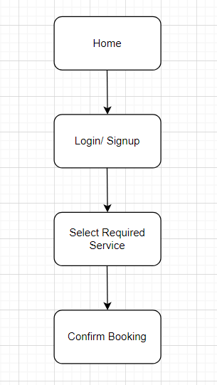
Fig. A – Flowchart for User Interface

Algorithm:
User Interface:
Step 1: User will login or signup.
Step 2: User will choose their required service, i.e, bed booking or doctor appointment booking.
Step 3: User will choose the required sub-service, i.e. a particular bed, doctor or ambulance
Step 4: User will choose the most convenient fields.
Step 5: User will fill in their personal details and a form with their medical history.
Step 6: User will complete payment.
Step 7: User will receive a confirmation email.

Hospital Interface:
Step 1: Hospital will enter the password to view database.
Step 2: Hospital can access database to see the list of patients or beds booked.

Technology Used:
Frontend: Wix
Database: Velo, Google Sheets

Results and Discussions

Results:

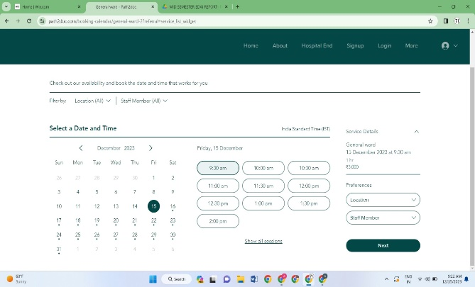
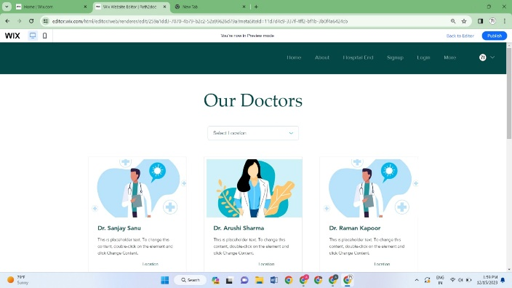

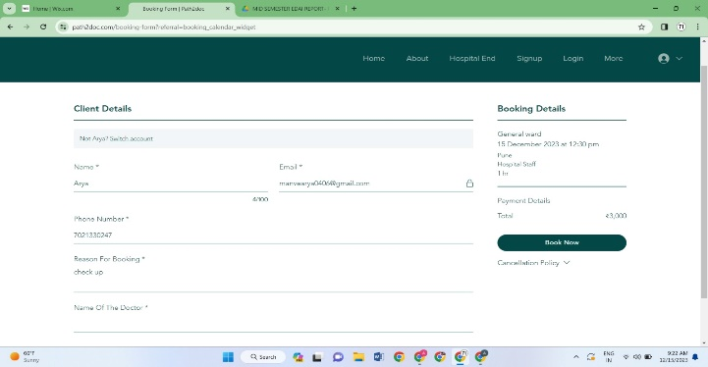
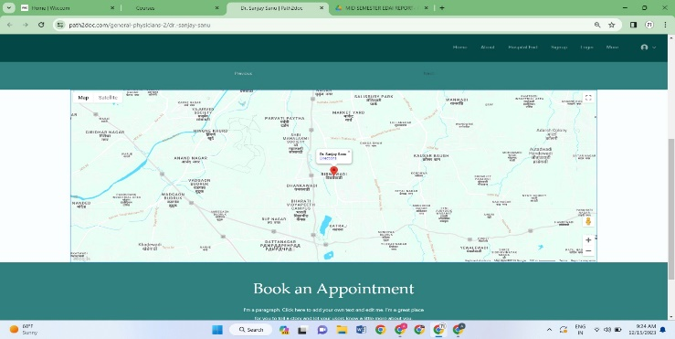

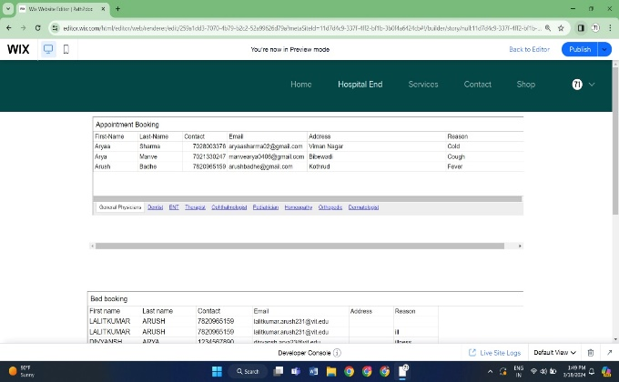
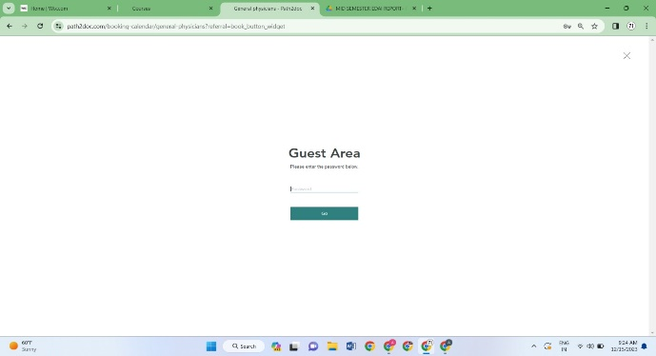

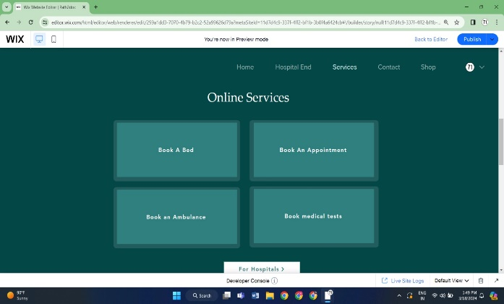

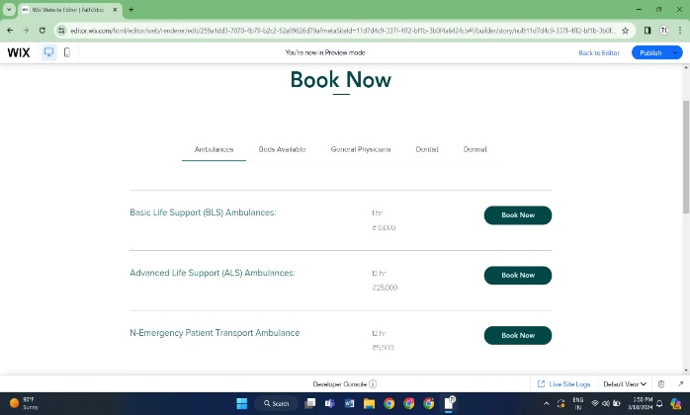

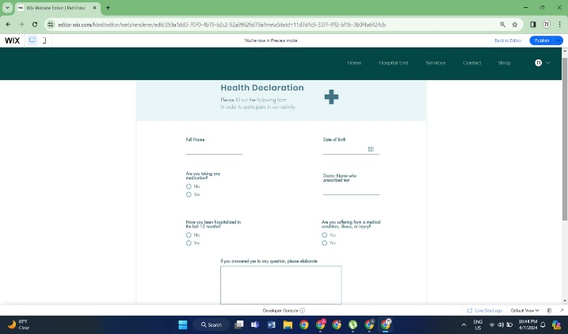

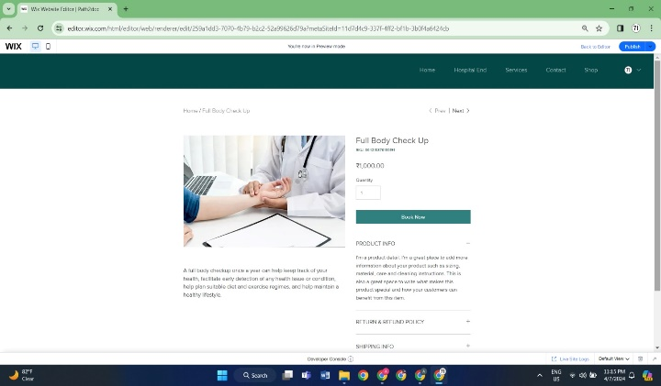

Future Scope:
Upon further improving, and upscaling, our website has the potential to digitalize and
therefore streamline the entire healthcare process. It will increase efficiency and save a lot of valuable time.

Conclusion
In conclusion, using our website will make it easier for patients and their loved ones to get timely access to potentially lifesaving healthcare in critical conditions, as well as their day to day lives. It will make management easier for the hospitals we well, therefore making the entire process convenient for everyone involved.

Acknowledgment
We would like to express our immense gratitude to Prof. Vijay K Itnal, and Prof. Mahajan, HOD DESH for providing the necessary guidance and advice that proved crucial in the completion of this project. Finally, we would like to thank The Vishwakarma Institiute of Technology, for providing us with the golden opportunity to complete this project and publish this research paper.

References
- Yaman Goyal, Abhishek Mishra, Dr. Yojna Arora, and Dr. Ashima Gambhir, A Novel Healthcare Application for Hospital Bed Booking System, 2022.
- Wenjun Cao, Yi Wan, Haibo Tu, Fujan Shang, Dandong Liu, Zhijun Tan, Caihong Sun, Qing Ye, and Yonghong Xu, A Web Based Appointment Service to Reduce Waiting Time for Outpatients, 2016.
- Robert Schmidt, Sandra Geisler, and Cord Spreckelsen, Decision Support for Hospital Bed Management Using Adaptable Individual Length Of Stay Estimations And Shared Resources, 2014.

