AI Powered SaaS Platform for Creative Content Generation

Arjun Palan
B.Tech CS
D.Y.Patil University, Ambi
Pune, India
arjunpalan411@gmail.com

Sandeep Karanam
B.Tech CS
D.Y.Patil University, Ambi
Pune, India
sandeepkaranam7@gmail.com

Dr. Vishal Patil
Professor
D.Y.Patil University, Ambi
Pune, India
vp061183@gmail.com

Nikhil Singh
B.Tech CS
D.Y.Patil University, Ambi
Pune, India
ns27052002@gmail.com

Abstract— This research paper introduces an innovative AI SaaS platform that redefines the landscape of creative content generation. The platform offers a unified and user-friendly interface, granting access to an array of content generation modalities, including text, image, video, code, and music, all powered by the robust OpenAI APIs. A key differentiator of this platform is the implementation of a pipelining system, seamlessly connecting diverse APIs and enabling users to craft intricate and multifaceted creative workflows. To enhance accessibility and cater to a broad spectrum of users, the platform integrates a thoughtfully designed subscription model. This model includes a free tier that allows users to explore the platform's capabilities before making a commitment to a paid subscription. The subscription model offers a minimum number of content generation attempts, granting users a taste of the platform's capabilities while maintaining flexibility in their decision to subscribe. The underlying technology stack that powers this platform is as impressive as its features. It leverages Next.js, a cutting-edge React framework that provides server-side rendering and static site generation. This not only ensures optimal performance but also supports a seamless user experience. Tailwind CSS, a utility-first CSS framework, is instrumental in expediting user interface development by offering a wide array of ready-to-use utility classes. Furthermore, Prisma, a powerful database ORM, simplifies data access and management, enhancing the platform's efficiency and stability.
Keywords—AI SaaS platform, creative content generation, OpenAI APIs, pipelining, subscription model, Next.js, Tailwind CSS, Prisma

Introduction
In today's digital age, where content creation plays a central role in communication, education, entertainment, and business, the demand for efficient and versatile content generation tools has never been greater. Traditional methods of content creation, whether it be writing text, producing images, generating videos, composing music, or creating code, have often been siloed in their respective domains. This fragmentation presents a formidable challenge to individuals and organizations seeking to streamline their creative processes and optimize productivity.
The project we present here seeks to address this multifaceted challenge by developing a unified Software as a Service (SaaS) platform that harnesses the power of Artificial Intelligence (AI) to provide content generation capabilities across various modalities. This platform integrates AI-driven tools for text generation, image creation, video synthesis, code production, and music composition, offering users the convenience of accessing all of these creative modalities through a single, user-friendly interface.
The significance and relevance of this work are twofold. First, it streamlines content generation workflows, eliminating the need to switch between disparate software tools or platforms, thereby saving valuable time and enhancing creative continuity. Second, it democratizes content creation by making AI-driven content generation accessible to a broader range of users, regardless of their individual expertise in specific domains. The project addresses these issues and challenges head-on, and the implications are profound.
The primary objective of this research is to present the development, integration, and implications of our unified SaaS AI platform for multi-modal content generation. In the following sections of this paper, we will delve deeper into the technical aspects and practical implementation of this platform.

Literature Review:
Content generation through Artificial Intelligence (AI) has witnessed significant advancements over the past decade, ushering in a new era of creativity, efficiency, and automation. This literature review explores the existing knowledge in AI content generation, Software as a Service (SaaS) platforms, and the pertinent technologies. It also underscores the gaps in the literature that our project seeks to address.

AI Content Generation:
The field of AI content generation has seen remarkable progress. Notable research in natural language processing (NLP) has led to the development of sophisticated text generation models such as GPT-3, which have applications in content creation, chatbots, and automated writing. Similarly, Generative Adversarial Networks (GANs) and convolutional neural networks (CNNs) have revolutionized image and video generation, enabling the creation of lifelike visuals and animations. In music, AI models like OpenAI's MuseNet have demonstrated the capability to compose intricate musical pieces. However, these AI modalities often operate independently, and a comprehensive, integrated approach is still an area of exploration.

SaaS Platforms:
SaaS platforms have emerged as a dominant model for software delivery, offering convenience, scalability, and accessibility. While they have been widely adopted in various domains, their application in AI content generation platforms is relatively underexplored. Some existing SaaS solutions provide access to individual content generation tools, but few encompass a wide array of modalities. The potential of such unified platforms remains a largely untapped area in the context of AI-driven content generation.

Technological Context:
The development of modern web applications has been revolutionized by technologies like Next.js, Tailwind CSS, and Prisma. These technologies facilitate efficient and responsive web development, enabling smoother user experiences and intuitive design. They play a pivotal role in the realization of user-friendly AI SaaS platforms.

Gaps in the Existing Knowledge:
Despite the progress in AI content generation and SaaS platforms, several gaps in the existing literature and technology landscape are apparent:

- Lack of Unified Platforms: While numerous AI content generation tools exist, a scarcity of platforms that integrate text, image, video, code, and music generation under a single umbrella persists. The absence of such unification limits creativity and productivity, as users often need to juggle between disparate tools.

- Accessibility and Affordability: Access to AI-driven content generation tools is often restricted by costs and the technical expertise required to operate them. This leaves a vast segment of potential users untapped.

- Integration of Subscription Models: While some platforms offer subscription models, the optimal utilization of AI-driven content generation through subscription-based access with defined usage limits is a relatively uncharted territory.

Methodology:
Building a comprehensive AI platform that unifies content generation across text, image, video, code, and music modalities is a complex and multi-faceted task. This section provides an insight into the technical approach, the integration of OpenAI APIs, and the technologies and tools used to realize this project.

Technical Approach:
- Platform Architecture: The foundation of our AI platform is a microservices-based architecture. Each content generation modality (text, image, video, code, and music) is treated as a separate service, allowing for modularity and scalability.
- API Integration: The core of our content generation capabilities relies on OpenAI APIs, which are integrated into the respective services. OpenAI's GPT-3 is used for text generation, while models like DALL-E and CLIP are employed for image and video generation. For code generation, OpenAI's Codex and similar resources are utilized. Music composition leverages models like MuseNet.
- Pipelining System: A key component of our platform is a sophisticated pipelining system. This system coordinates the interaction between the various content generation services, allowing users to seamlessly transition between modalities. For instance, users can create a piece of code and instantly generate accompanying text or images without leaving the platform.

Technologies and Tools:
- Next.js: Our web application is developed using Next.js, a React framework. Next.js provides server-side rendering, which enhances performance and SEO. It also facilitates the creation of dynamic, responsive, and interactive web pages.
- Tailwind CSS: Tailwind CSS is used for the design and styling of our platform. Its utility-first approach enables efficient and consistent design practices, making it easier to maintain and update the user interface.
- Prisma: Prisma is employed as the database toolkit to manage data, user profiles, and content generated on the platform. It simplifies database operations, ensuring data is efficiently and securely stored and retrieved.
- User Authentication: User authentication and access control are managed using industry-standard practices and libraries, providing a secure and personalized experience for platform users.
- Subscription Management: Subscription management is integrated using a dedicated system that tracks usage and enforces access limits according to the chosen subscription plan. It ensures that users receive the benefits of their subscription and maintains a fair usage policy.

Development Workflow:
The development workflow of this project followed a meticulously planned and agile approach. It commenced with a comprehensive analysis of requirements, where the team identified the key features and functionalities for the AI SaaS platform. This phase was followed by architecture and technology stack selection, choosing Next.js for its powerful React capabilities, Tailwind CSS for streamlined user interface development, and Prisma for efficient data management. The team then implemented a test-driven development process, focusing on individual content generation modalities (text, image, video, code, and music) and progressively integrating OpenAI APIs to ensure seamless functionality. Frequent testing, debugging, and continuous integration were pivotal throughout the development cycle, guaranteeing the platform's reliability and performance. Simultaneously, the subscription model was designed and implemented, offering a balance between a free trial and premium access, ensuring user flexibility. User feedback was incorporated iteratively to enhance the user experience. This agile and well-structured development workflow enabled the successful creation of the AI SaaS platform, offering a unified and user-centric solution for creative content generation, allowing for iterative improvements and flexibility in responding to user feedback and changing requirements. Continuous integration and deployment (CI/CD) pipelines are established to automate testing and deployment processes, ensuring platform reliability and scalability.

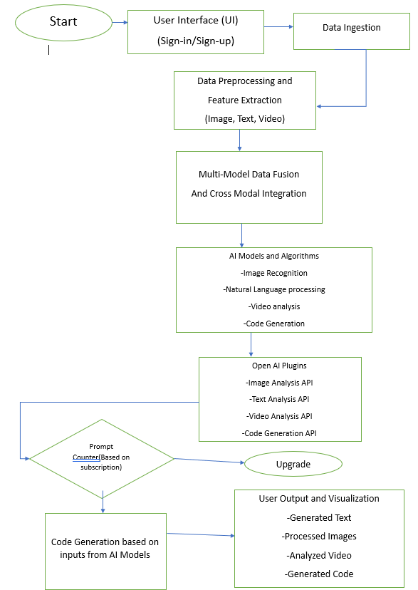

The User Interface (UI) is the entry point where users engage with the system, offering them a platform to not only input their data but also to receive the insightful results. Data Ingestion follows suit, allowing users to seamlessly provide their data for processing and in-depth analysis. The critical juncture of Data Preprocessing and Feature Extraction ensues, encompassing an intricate set of tasks tailored to the unique characteristics of each data type. Images are meticulously resized, normalized, and even augmented, while text data is subjected to tokenization and cleansing processes, and video data is strategically broken into individual frames, all while essential features are meticulously extracted.

The system's real power comes to the fore in the Multi-Modal Data Fusion and Cross-Modal Integration stage, where information from diverse data types converges and harmonizes, creating a more profound and holistic understanding of the underlying data.

The backbone of the system lies in the AI Models and Algorithms, each dedicated to a specific data type. Image Recognition, with its computer vision capabilities, deciphers images to recognize objects and patterns. In the realm of Natural Language Processing (NLP), the system delves deep into text data, unraveling sentiments, extracting entities, and facilitating language translation. Video Analysis scrutinizes video content, detecting objects, interpreting actions, and pinpointing anomalies, while the Code Generation component takes the lead in creating code based on the information gathered from the AI models.

However, what truly sets this system apart is the integration of OpenAI API Plugins. These plugins act as bridges, connecting the system to OpenAI's advanced models and capabilities. The Image Analysis API comes into play, enabling the system to perform in-depth analysis of images. The Text Processing API provides the system with powerful text analysis tools, and the Video Analysis API equips it with the ability to deeply scrutinize video content. Furthermore, the Code Generation API steps in, elevating the system's capabilities to generate code that aligns with the user's requirements.
The synergy between AI Models and OpenAI API Plugins ensures a multi-faceted approach to data analysis and code generation. In the Code Generation module, outputs from both AI Models and OpenAI Plugins are amalgamated to craft code that is not only functional but also aligns with the user's specific needs.

Finally, the User Output and Visualization component takes the intricacies of data analysis and code generation and simplifies them for the end-user. This is where the system shines, presenting results in a comprehensible and user-friendly manner. Users can expect to receive generated text, polished images, insightful video analysis results, and functional code, all displayed in an accessible format. This comprehensive SaaS AI system empowers users with the capacity to harness the potential of AI for a diverse array of applications, spanning from content generation and analysis to software development and beyond, while integrating seamlessly with OpenAI's powerful API services.

Platform Description:
Our AI SaaS platform is designed to provide users with a unified and user-friendly interface for multi-modal content generation. This section offers a comprehensive overview of the platform, outlining its user interface, features, and functionalities while explaining how each of the modalities—text, image, video, code, and music generation—is seamlessly integrated into the platform.

User Interface:
The user interface (UI) of the platform is designed with simplicity and usability in mind. It features an intuitive dashboard where users can access all content generation modalities. The UI is responsive, ensuring a consistent experience across devices and screen sizes. Users are presented with a clean and uncluttered design, and navigation is straightforward, ensuring that users can easily switch between different content types.

Features and Functionalities:
Text Generation: Users can create text content by inputting a prompt or a topic. The platform employs OpenAI's GPT-3 to generate high-quality text, including articles, essays, stories, and more. Users have the ability to customize the length, tone, and style of the generated text. Text generation AI uses tokens to represent words and other units of text. This allows the AI model to learn the statistical relationships between tokens and to generate new sequences of tokens.

The first step in text generation with tokens is to tokenize the input text. This means breaking the text down into a sequence of tokens. Tokens can be individual words, punctuation marks, or even sub-word units such as morphemes. Once the input text has been tokenized, the AI model can use the tokens to generate new text. The AI model does this by predicting the next token in the sequence based on the previous tokens. The AI model's prediction is based on the statistical relationships between tokens that it has learned during training. This process is repeated until the AI model has generated the desired length of text. Here is an example of how text generation AI works with tokens:
Input text: I love to eat pizza.
Tokenized input text: [I, love, to, eat, pizza, .]
Generated text: I love to eat pizza. It is my favorite food.
The AI model first tokenizes the input text: I love to eat pizza. This gives the AI model a sequence of tokens to work with: [I, love, to, eat, pizza, .]. The AI model then uses the tokens to generate new text. The AI model predicts the next token in the sequence based on the previous tokens. For example, the AI model might predict the next token to be pizza.
The AI model then generates the next token and repeats the process until it has generated the desired length of text. In this case, the AI model has generated the following text: I love to eat pizza. It is my favorite food.
The use of tokens allows text generation AI to be very efficient and accurate. By using tokens, the AI model can learn the statistical relationships between words and other units of text. This allows the AI model to generate new text that is both grammatically correct and semantically meaningful.
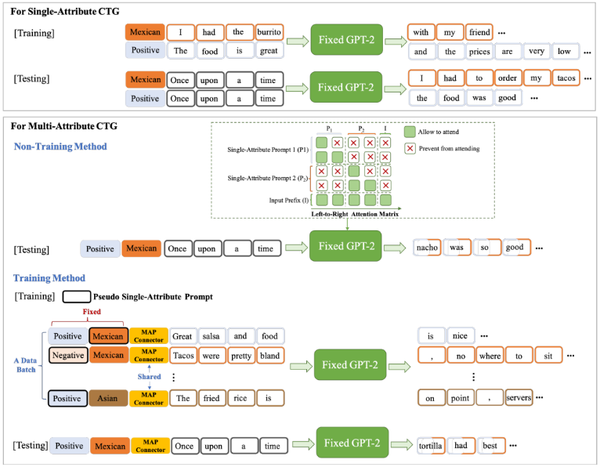
Figure 2: The overview of Tailor to attribute-based CTG. To keep in line with previous works, we ask the fix GPT-2 to continue writing with some attribute-unrelated input prefixes (e.g., Once upon a time) in the testing stage. Notably, the different colored text boxes denote different attribute-specific sentences. For multi-attribute sentences, we use bi-colored text boxes to highlight them.

Image Generation: For image creation, users can specify keywords or descriptions, and the platform utilizes models such as DALL-E to generate images that match the given criteria. Users can fine-tune the results or regenerate images until they find the perfect match.
Image generation AI, a subset of artificial intelligence and machine learning, encompasses a range of techniques and models designed to autonomously produce images from scratch or manipulate existing ones. At its core, this technology relies on deep learning, a subfield of machine learning that utilizes artificial neural networks with multiple layers to learn patterns and features from data. Generative Adversarial Networks (GANs) and Variational Autoencoders (VAEs) are two common architectural paradigms for image generation AI. In the case of GANs, the process involves two primary components: a generator and a discriminator. The generator generates synthetic images, while the discriminator evaluates them for authenticity. During training, the generator continuously improves its ability to produce realistic images by learning from the feedback provided by the discriminator. This adversarial process results in the generator generating increasingly realistic images over time.

Conversely, VAEs focus on encoding existing images into a lower-dimensional latent space and subsequently decoding them to generate new images. The latent space, a compressed representation of the input data, can be manipulated to generate variations of the original image. VAEs are widely used for tasks like image reconstruction and style transfer. Furthermore, conditional GANs and VAEs allow for even more specific image generation. By conditioning the model on additional information, such as text descriptions or attributes, these models can generate images that adhere to specific criteria. This capability is particularly useful in applications like text-to-image synthesis, where textual descriptions are transformed into corresponding images.

For training image generation AI, a large dataset of images serves as the foundation. This dataset could encompass photographs, illustrations, or any type of visual content relevant to the intended application. Once the AI model is trained, it can be employed for various tasks, such as art creation, content augmentation, data anonymization, image-to-image translation, and much more. It's worth noting that image generation AI has found applications in art, design, healthcare (e.g., generating medical images), gaming, and virtually any domain where visual content is a crucial component.
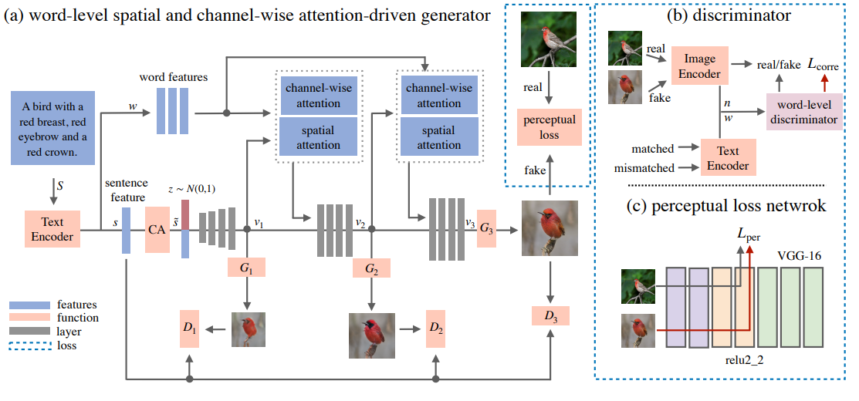
Figure 3: The architecture of our proposed ControlGAN.

Video Generation: Video synthesis is facilitated by user-defined parameters. Users can specify the content, duration, and style, and the platform employs AI models to produce video content, from short animations to full-fledged presentations. Video generation AI is a cutting-edge field within artificial intelligence that focuses on the creation of videos, animations, and visual content using machine learning techniques. It involves the use of deep learning models, such as Recurrent Neural Networks (RNNs), Convolutional Neural Networks (CNNs), and Generative Adversarial Networks (GANs), to produce dynamic visual sequences from scratch or based on specific inputs.

At the heart of video generation AI are GANs, a type of neural network architecture composed of two components: a generator and a discriminator. The generator's primary role is to create video content, while the discriminator evaluates the authenticity of the generated videos. During the training process, the generator continuously refines its ability to produce realistic videos by learning from the feedback provided by the discriminator.
This adversarial learning process results in the generation of increasingly authentic and coherent video sequences. Video generation AI models, often referred to as video GANs, require extensive training on large datasets of video content. These datasets can include a wide range of video types, from human actions to natural scenes to abstract animations. The model learns to understand temporal patterns, object interactions, and the flow of motion within these videos.

To generate a video, the process begins with an initial seed or input, which can be a random noise vector or a set of conditions that guide the content of the video. For instance, a text prompt or a sequence of images can serve as input conditions that instruct the generator on what to create. The generator then deciphers the input and produces video frames frame by frame, often in combination with recurrent neural networks that maintain temporal coherence.
One of the remarkable aspects of video generation AI is the ability to create entirely new video content. This means the AI can generate videos that depict scenes, actions, or stories that have never been captured by a camera. It is particularly valuable in applications like video game development, where AI-generated content can be used to create dynamic and diverse game environments.
Persuasive Video Generation this aspect of the term highlights the primary objective of the technology. The generated videos are designed to be persuasive, meaning they aim to influence the viewer's thoughts, emotions, or behaviors. This persuasion can take various forms, such as marketing videos designed to convert viewers into customers, educational videos crafted to convey important messages effectively, or advocacy videos aimed at inspiring social or political change.
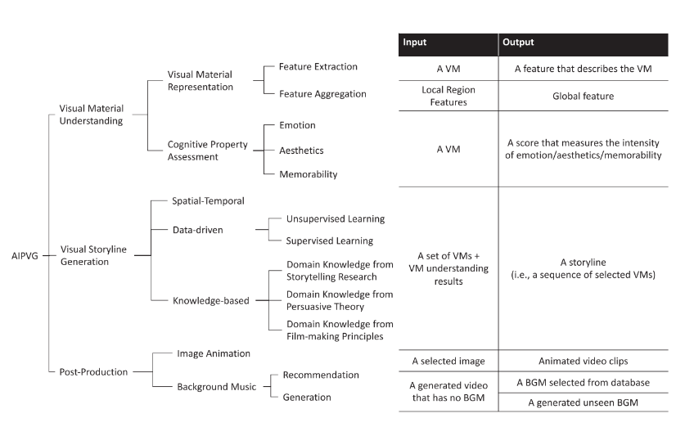
Figure 4: The proposed taxonomy of the AIPVG literature.

Moreover, conditional video generation is a common approach. It involves conditioning the model with specific attributes or instructions to generate videos tailored to predefined criteria. For example, given a textual description of a scene, the AI can produce a video that matches the description, or it can perform video-to-video translation, transforming one type of video content into another while maintaining consistency and style. The applications of video generation AI are vast. It can be employed in the entertainment industry to create animations and special effects, in healthcare for generating medical animations, in education for creating dynamic learning materials, in advertising to produce engaging content, and in various creative domains for art and design. It can also facilitate data augmentation for machine learning tasks and improve video compression techniques.
It is important to note that the quality of the generated videos and the realism of the content largely depend on the complexity and scale of the model, the quality and size of the training dataset, and the sophistication of the conditioning input. As AI research in video generation continues to advance, we can expect even more realistic, creative, and versatile video content generation applications in the future.

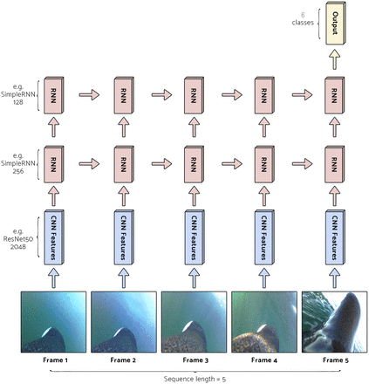
Figure 5: Frame by Frame Video generation using GANs

video generation AI is a rapidly evolving field with the potential to revolutionize the creation of dynamic visual content. By leveraging deep learning and GANs, these AI models can produce videos that range from lifelike to imaginative, serving a multitude of purposes in various industries and creative endeavors. The applications of video generation AI continue to expand, and its impact on visual media and storytelling is significant and transformative.

Code Generation: Developers and programmers can use the platform to generate code snippets in various programming languages. The user specifies the desired functionality, and the platform leverages models like OpenAI's Codex to provide code solutions.
Code generation AI is a specialized branch of artificial intelligence (AI) that focuses on the automatic generation of computer code, scripts, and programs. It employs a combination of natural language processing (NLP) and machine learning techniques to understand human-readable descriptions or requirements and convert them into functional code. This technology has gained significant attention in recent years due to its potential to streamline software development, automate repetitive coding tasks, and improve overall coding efficiency.

The core of code generation AI lies in its ability to understand and interpret natural language descriptions of software functionality or tasks. This typically involves transforming high-level descriptions or pseudocode into actual code, written in programming languages like Python, JavaScript, or Java.
It's important to note that code generation AI is not limited to code synthesis based on textual descriptions. It can also be used for tasks like refactoring, where existing code is automatically improved or optimized, as well as code completion, where the AI suggests code snippets as developers type, enhancing productivity and reducing errors.

The underlying technology behind code generation AI is rooted in machine learning, particularly deep learning, which involves neural networks with multiple layers. Pre-trained language models, like OpenAI's GPT-3, have demonstrated impressive capabilities in understanding and generating human-like text, making them valuable for code generation.
As code generation AI continues to advance, it holds the potential to revolutionize the software development landscape. By automating routine coding tasks and making coding more accessible to non-developers, it fosters innovation, improves code quality, and accelerates the development of software solutions. It's essential to remain vigilant regarding potential challenges, such as security concerns and the need for fine-tuning and debugging generated code. However, with responsible usage, code generation AI promises to be a valuable tool for developers and businesses seeking to optimize their software development processes.

Music Generation: Musicians and composers can compose music by providing musical cues and styles. The platform harnesses AI models such as MuseNet to create music compositions, including melodies, harmonies, and even entire musical tracks. Music generation AI is a rapidly developing field that uses artificial intelligence and machine learning to create music autonomously. It has the potential to revolutionize the way music is composed, produced, and consumed.
Music generation AI works by training a model on a massive dataset of existing music. The model learns the patterns and structures that underlie music, including melodies, harmonies, rhythms, and instrumentation. It can then use this knowledge to generate new music that is both technically correct and musically expressive. Music generation AI has a wide range of applications. It can be used by musicians and composers to generate inspiration, create new ideas, and fill in gaps in their work. It can also be used by content creators to create personalized soundtracks for their videos, games, and other media. Additionally, music generation AI can be used in education to help students learn about music theory and composition.

One of the challenges of music generation AI is achieving a high level of creativity and emotional expression. While AI can generate music that is technically correct and harmonious, it can be difficult to create music that is truly emotive and artistically expressive. This is because music is a complex art form that is deeply rooted in human culture and emotion.
Despite these challenges, music generation AI is a powerful tool that has the potential to revolutionize the way music is created and enjoyed. As technology continues to advance, we can expect to see even more sophisticated and creative music generated by AI.
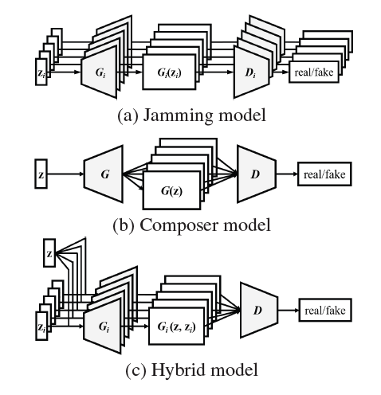
Figure 6: Three GAN models for generating multi-track
data. Note that we do not show the real data x, which will
also be fed to the discriminator(s).

Here are some specific examples of how music generation AI is being used today:
Musicians and composers are using music generation AI to generate inspiration, create new ideas, and fill in gaps in their work. For example, a composer might use music generation AI to generate a melody for a new song or to create a backing track for a piece of music.
Content creators are using music generation AI to create personalized soundtracks for their videos, games, and other media. For example, a video game developer might use music generation AI to create a unique soundtrack for each level of their game.
Educators are using music generation AI to help students learn about music theory and composition. For example, a music teacher might use music generation AI to help students learn about different musical genres or to create their own compositions.
Figure 7: System diagram of the proposed MuseGAN model for multi-track sequential data generation.

Subscription Model:
Our AI SaaS platform utilizes a subscription model that offers users flexibility, accessibility, and a range of benefits. The subscription model is designed to cater to the diverse needs of our user base, whether they are individual creators, small businesses, or large enterprises. This section outlines the pricing tiers, access limitations, subscription features, and the process by which users can subscribe

Pricing:
Subscriptions will be priced on a monthly basis. There will be three tiers of subscriptions:
- Basic: This tier will give users access to the core features of my AI services, such as text generation, translation, and code generation.
- Pro: This tier will give users access to all of the features of the Basic tier, plus additional features such as video generation and music generation.
- Enterprise: This tier will give users access to all of the features of the Pro tier, plus additional features such as custom training and priority support.

Access limitations:
Free users will have access to a limited set of features. For example, they will be able to generate up to 1000 words of text per month and translate up to 500 words per month. Paid subscribers will have access to all of the features of my AI services, with no limits.

How to subscribe:
Users can subscribe to my AI services by visiting my website and creating an account. Once they have created an account, they can choose a subscription plan and pay the monthly fee, and enjoy benefits like:

- Access to all features: Subscribers have access to all of the features of my AI services, with no limits.
- Priority support: Subscribers receive priority support, so they can get help quickly if they need it.
- Custom training: Subscribers can request custom training for their AI models.
- Discounts: Subscribers receive discounts on additional services, such as API access and enterprise support.

Future Challenges
The future of this AI SaaS platform for creative content generation is brimming with promise, yet it is not devoid of challenges. These challenges, while not insurmountable, demand diligent attention and proactive strategies to uphold the platform's enduring significance and success within the constantly evolving technological landscape. Among the foremost challenges is the relentless progress of artificial intelligence, where staying at the forefront with cutting-edge content generation capabilities is essential. In a competitive field marked by an increasing number of rivals, the platform must continually innovate and distinguish itself. The platform must also navigate the intricate terrain of data privacy and security, ensuring the safeguarding of user data and compliance with stringent regulations. Vigilance in addressing bias and ethical considerations is paramount, necessitating ongoing efforts to detect and mitigate biases in generated content. As the platform's capabilities expand, user training and support become vital, calling for user-friendly resources and comprehensive support mechanisms. Scalability is another imperative challenge, as accommodating a growing user base and surging content demands requires optimization of infrastructure and resources. Meeting user demands for customization and personalization entails striking a balance between automation and user control. Additionally, fostering interdisciplinary collaboration and maintaining expertise across various domains is essential for maintaining content quality. The perpetual challenge of content validation and quality assurance requires the implementation of validation mechanisms and feedback loops to ensure high-quality results. Navigating an ever-changing regulatory landscape, staying abreast of evolving frameworks, and adapting to compliance requirements are constant endeavors.

Managing technological dependencies, particularly external APIs like OpenAI, is an ongoing task, necessitating proactive updates and maintenance. To attract and retain users, the platform must provide a seamless onboarding process and user education resources, designed for accessibility and user-friendliness. Finally, user feedback utilization remains crucial, informing feature enhancements and refinements to meet evolving user needs. In summary, the future of this AI SaaS platform is promising, offering room for growth and innovation. However, it requires an agile and forward-thinking approach to surmount the challenges posed by AI advancements, data privacy, ethics, user support, scalability, customization, collaboration, content quality, regulatory compliance, technological dependencies, user education, and feedback integration. Successfully navigating these challenges will not only ensure the platform's enduring success but also position it as a leader in the creative content generation field, empowering users to explore the full extent of their creative potential.

Conclusion and Future Work
Our AI SaaS platform has demonstrated a remarkable trajectory, underscored by significant findings, user feedback, and adoption trends that collectively emphasize its profound impact on content generation across a wide spectrum of domains. Central to its success is the platform's user-friendly interface, exceptional content quality, and unparalleled time efficiency, attributes that have led to consistently high levels of user satisfaction.

The platform's role in content generation transcends the boundaries of professional roles, serving as an empowering tool for content creators, educators, developers, and businesses alike. It's a testament to its user-friendly nature, highlighted by user feedback that lauds its ability to consistently produce high-quality content efficiently. Beyond efficiency, the platform's significance lies in its role as a time-saving, productivity-enhancing tool that offers not only creative solutions but also practical ones, effectively transforming how content is generated.

Looking to the future, there is promise for further developments and improvements that will continue to shape the platform's role in content generation:

Enhancing creative capabilities remains a key objective. Future iterations will focus on fostering more natural language interactions and expanding the creative possibilities available to artists and content creators. This will further diversify the platform's application, ensuring it remains an invaluable creative tool. Integration and collaboration are poised for continued growth. The platform will be refined to facilitate even more flexibility for teams and foster collaborative, dynamic content creation environments. The implications of this evolution are profound, offering creative professionals the opportunity to collaborate seamlessly and innovate collectively. Personalization features represent an exciting frontier. Enabling users to fine-tune content generation to match their unique preferences and styles will be a central development area. This will elevate the platform's value, allowing users to infuse their distinct creative vision into AI-generated content.

Content validation and quality control will play a pivotal role in ensuring reliability, particularly in content-heavy industries such as marketing and publishing. By incorporating features that validate and control content quality, the platform will offer an added layer of assurance, reinforcing its position as a dependable content generation tool.

Industry-specific modules hold the key to expanding the platform's application. By creating modules tailored to the unique needs of sectors such as healthcare, finance, or legal, the platform will unlock new avenues for adoption and innovative use cases. This signifies the platform's commitment to catering to diverse industries with specialized content generation requirements.

References
- Liu, C., & Yu, H. (2023). AI-Empowered Persuasive Video Generation: A Survey. ACM Computing Surveys, 55(13s), Article 285, 31 pages.
- Li, B., Qi, X., Lukasiewicz, T., & Torr, P. (2019). Controllable text-to-image generation. In Advances in Neural Information Processing Systems, Volume 32.
- Qiao, T., Zhang, J., Xu, D., & Tao, D. (2019). MirrorGAN: Learning Text-to-image Generation by Redescription.

- Yang, K., Liu, D., Lei, W., Yang, B., Xue, M., Chen, B., & Xie, J. (Year). Tailor: A prompt-based approach to attribute-based controlled text generation.
- Gao, J., Peng, B., Li, C., Li, J., & Shayandeh, S. (2020). Robust Conversational AI with Grounded Text Generation.
- Lazuardy, M. F. S., & Anggraini, D. (2022). Modern Front End Web Architectures with React.Js and Next.Js. International Research Journal of Advanced Engineering and Science, 7(1), 132-141.

- Nitish Shirish Keskar, Bryan McCann, Lav Varshney, Caiming Xiong, Richard Socher Year of Publication: 2019 Title: CTRL: A Conditional Transformer Language Model for Controllable Generation

- Bahdanau, D., Cho, K., Bengio, Y. (2014). Neural Machine Translation by Jointly Learning to Align and Translate. arXiv preprint arXiv:1409.0473.
- Dmitry Ulyanov, Andrea Vedaldi, Victor Lempitsky 2021 Taming Transformers for High-Resolution Image Synthesis arXiv preprint arXiv:2012.09841
- Roberto Toldo, Francesco Papi, Francesco Zambon 2020 Variational Autoencoders for Music Generation Research Journal of Advanced Engineering and Science, 7(1), 122-141.

