AN ANALYSIS ON TRENDS AND MAJOR FACTORS REGARDING ABORTION AND ACCESSIBILITY

AUTHOR:

Vageshwari.E

BA.LLB(Hons)
SAVEETHA SCHOOL OF LAW
SAVEETHA INSTITUTE OF MEDICAL AND TECHNICAL SCIENCES (SIMATS)
Chennai-77

AN ANALYSIS ON TRENDS AND MAJOR FACTORS REGARDING ABORTION AND ACCESSIBILITY

Vageshwari

ABSTRACT
The abortion or the termination of a pregnancy by chemical,surgical or other means became legal in 1971.Any women seeking an bortion would be entitled be have one under the medical termination of pregnancy (MTP) Act, was adopted that year as along as the grounds she claims are legal.The act modifies the 1971 enactment by increasing the number of weeks a women can terminate her pregnancy and establishing specific conditions in which a pregnancy can be terminated at any time.while the amendme has increased abortion access to some extent it fails to address one fundamental flaw in the medical termination of pregnancy act of 1971,that a woman does not have the right to Terminate a pregnancy but may be allowed to so only in certain specified circumstances,and only if a medical professional determines that does circumstances are met.The main objective of this research is to whether the sexual activity among the youth is a grave cause for concern and immoral activity of abortion.

Key words
Termination,pregnancy,MTP ACT,specific conditions

INTRODUCTION
In India, abortion, or the termination of a pregnancy by chemical, surgical, or other means, became legal in 1971. Any woman seeking an abortion would be entitled to have one under the Medical Termination of Pregnancy (MTP) Act, which was adopted that year, as long as the grounds she claims are legal. Despite the fact that it is legal in India, many women are either uninformed of their entitlement to a medical abortion or seek unsafe abortions outside of the formal health care system owing to the shame associated with the practice.The Act modifies the 1971 enactment by increasing the number of weeks a woman can terminate her pregnancy and establishing specific conditions in which a pregnancy canl be terminated at any time. While the amendment has increased abortion access to some extent, it fails to address one fundamental flaw in the Medical Termination of Pregnancy Act of 1971 (MTP Act), that a woman does not have the right to terminate a pregnancy, but may be allowed to do so only in certain specified circumstances, and only if a medical professional (and, in some cases, a medical board) determines that those circumstances are met. According to a 2007 study published by India’s Ministry of Women and Child Development, 150 million girls and 73 million boys under the age of 18 have been exposed to forced sexual intercourse or other types of sexual assault.according to the Pre-Conception and Pre-natal Diagnostic Techniques (Prohibition of Sex Selection) Act, 1994. Anyone who seeks an abortion based on the foetus’s sex, as well as the doctor who performs the abortion on such grounds, can face up to seven years imprisonment.The Bombay High Court’s Nagpur Bench on 4th February 2022, permitted a rape victim to terminate her 25-week-old pregnancy, stating that a pregnancy caused by rape would bring sorrow and substantial harm to the girl’s mental health while deciding on the case of X v. State of Maharashtra (2022).According to the NCRB report, Maharashtra, Rajasthan and Gujarat have the highest numbers of abandoned children, with 1,232, 674 and 660 cases, respectively, over the past five years.

OBJECTIVES
- To identify the legality of termination of pregnancy
- To identify whether fathers consent is important for getting abortion
- To identify whether the sexual activity among the youth is grave cause for concern and immoral activity of abortion
- To identify whether people are accepting the fact that women have complete rights over her body and carrying the child is her choice

REVIEW OF LITERATURE
Stanley k.Jenshaw (1999) International Conference on Popu- lation and Development urged gov- ernments and other relevant organizations "to deal with the health impact of unsafe abortion as a major public health concern and to reduce the recourse to abortion.Robert D. Rutherford (2004) This article examines the effects of family composition on sex-selective abortion in the Indian state of Punjab. Because of the lack of reliable statistics on sex-selective abortion , sex-selective abortion is measured indirectly by the sex ratio.Anika Rahman (1998)In this article, we update and expand on earlier work' to briefly summarize the laws governing abortion in most countries around the world, and discuss all major changes in abortion laws since 1985 in coun- tries with populations of more than one mil- lion.Stanley k.Henshaw (1994) Recent Trends in the Legal Status of Induced Abortion some effort to control fertility is present in almost all societies, this effort becomes much more prominent during the fertility transition.Joanna N.Erdman(2017)The legal regulation of abortion by gestational age, or length of pregnancy, is a relatively undertheorized dimension of abortion and human rights. Yet struggles over time in abortion law, and its competingNavtej purewal (2018) This article explores sex selective abortion (SSA) as a form of structural violence within the broader notion of women’s ‘protection’ in contemporary India . While SSA tends to be framed more generally within ethical and choice-based frameworks around abortion access and reproductive ‘rights’,Barbara D.miller (2001) Estimates indicate that several million female fetuses were aborted in the last two decades of the twentieth century. This article takes a currently unusual approach for a cultural anthropologist in pursuing cross-national comparisons of trends in sex-selective abortion.Navtej purewal (2018) This article explores sex selective abortion (SSA) as a form of structural violence within the broader notion of women’s ‘protection’ in contemporary India . While SSA tends to be framed more generally within ethical and choice-based frameworks around abortion access and reproductive ‘rights’, and specifically.Sylvie Dubuc (2007) Evidence for Sex-Selective Abortion Sylvie Dubuc David Coleman The average sex ratio at birth worldwide (the number of male live births per 100 females births) is around 105Jeffrey edmeades (2010) This article examines the determinants of contraceptive and abortion behavior and how each of these influences the other, with an emphasis on the role of women's life-course stage and experience.Yvonne Macpherson (2007) Harnessing the power of the media to reduce sex-selective abortion in India Yvonne MacPherson1 Sex-selective abortion is an increasing problem in India . Previous awareness-raising efforts on the issue havefocused largely on the act of abortion , without substantively addressing.Dennis Hodgson (2009) Abortion , Family Planning, and Population Policy: Prospects for the Common-Ground Approach Dennis Hodgson Over time and in different places, those formulating population policy have produced widely divergent assessments of induced abortion.J.P.H.Rossouw (1994)The interaction between abortion and contraception is sketched and factors that could constrian the provision of abortion services are indicated. The current abortion legislation in South Africa and its interpretation restricts access to safe abortion.Suzanne O.Bell Although induced abortion is common, measurement issues have long made this area of research challenging. The current analysis applies an indirect method known as the list experiment to try to improve survey-based measure- ment of induced abortion.Heidi Moseson (2017) We discuss the lessons learned from completed studies, when the list experiment may and may not be appropriate, and open questions regarding the use of the list experi ment for abortion research.Suchitra dalvie (2015)Abortion shows lack of understanding about the Medical Termination of Pregnancy Act and the subseguent amendments. Many lawyers believe that even if it did become a regular component of the law curriculum, there would be few takers, given the low potential for such cases in the practice.Andrea Whittaker (2010)The study of abortion challenges us as researchers and advocates. This book strives to refl ect current concerns in social science scholarship on abortion in Asia and consider the status of advo- cacy in the region. In this brief epilogue, I consider some of the contributions of this book.Batool Zaidi (2016)part, this may reflect the strict ban on abortion services in most of these countries, supported by Islamic restrictions/taboos against abortion . Pakistan, with its high abortion rate (albeit, illegal still) and strong cultural history shared with north India.Claire Pierson (2017)Debate on abortion is constantly in flux, with progressive and regressive movements witnessed globally. This paper examines the translation of human rights norms into discourses on abortion in Northern Ireland, a region where abortion is highly restricted, with extensive contemporary public debate into potential liberalization of abortion.Stanley k.Hanshaw (1990)A World Review, 1990 "The absence of restrictions does not guarantee that [abor- tion] services will be available. In India and Bangladesh, the overall shortage of medical facilities makes legal abortion and menstrual regulation unavailable to most women

METHODOLOGY

This research is an empirical research.The present paper used both primary and secondary information.The primary information was collected from the general public through an online survey .The well structured questionnaire about the legality of abortion was circulated among the respondents.The secondary information for the study was collected from the articles ,journals , newspapers ,legislations ,rules and bye laws enacted for the safe termination of pregnancy .This study also analyzes the loopholes of the present law to curb this menace. The sample size for the study is 200.The sampling method used in the research is convenient sampling method.The independent variable is age ,gender,occupation and educational qualification and the dependent variable increase in legality of abortion.The present study deals with analytical and descriptive study .The statistical tool used by the researchers is graphical representation.

Fig:1
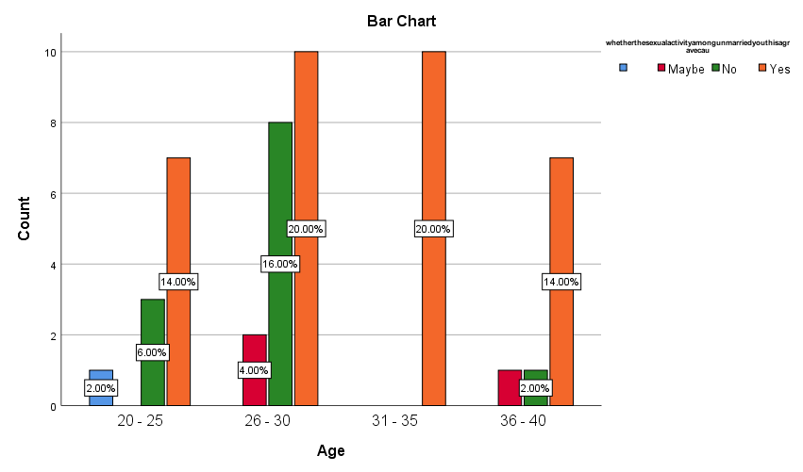

LEGEND
The fig 1 represents the sexual activity among the youth is a grave cause for concern and immoral activity of abortion with respect to age

Fig 2

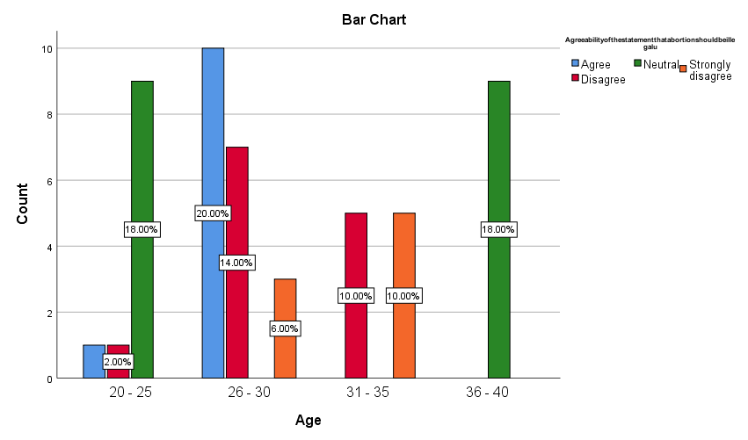
LEGEND
The fig 2 represents the agreeability of the statement that abortion should be illegal with respect to age
Fig 3
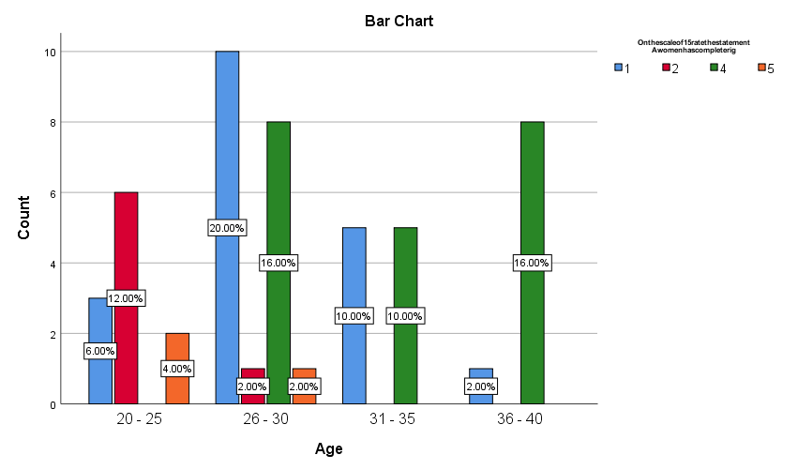
LEGEND
The fig 3 represents rate of the statement that women has complete right over her body and the choice to abort is solely her own irrespective of marital status with respect to age

Fig 4
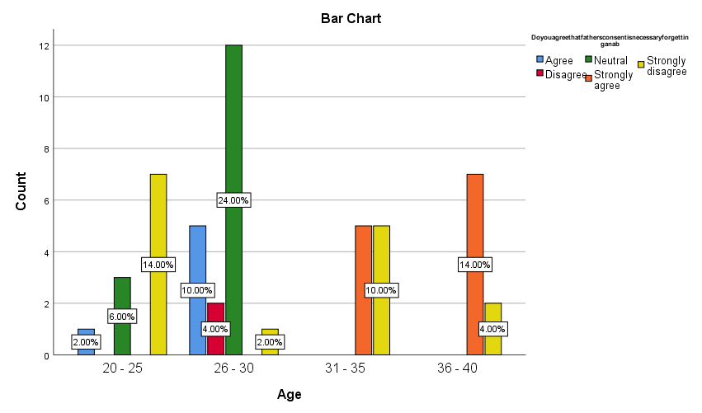
LEGEND
The fig 4 represents the rate of the statement that fathers consent is necessary for abortion with respect to age
Fig 5
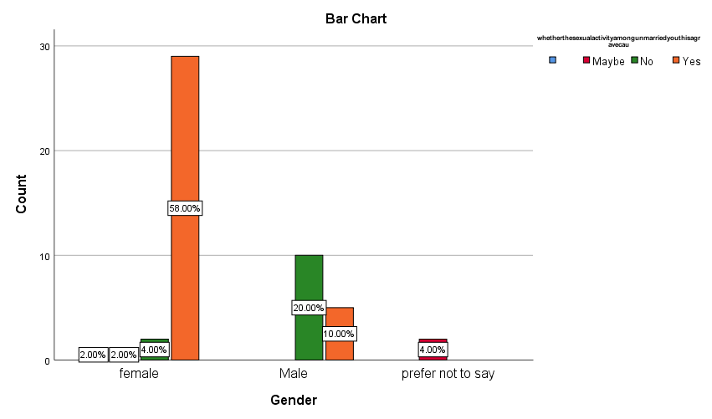
LEGEND
The fig 5 represents the sexual activity among the youth is a grave cause for concern and immoral activity of abortion with respect to gender

Fig 6
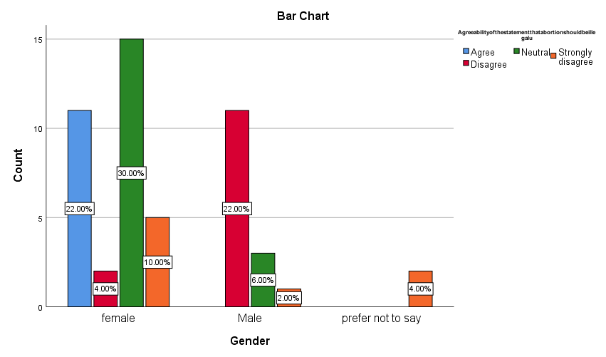
LEGEND
The fig 6 represents the the agreeability the statement that abortion should be illegal with respect to gender

Fig 7
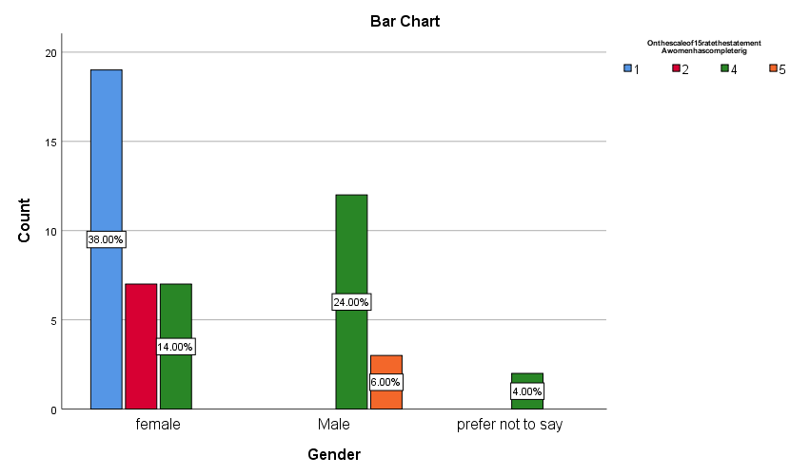
LEGEND
The fig 7 represents the rate of the statement that women has complete right over her body and the choice to abort is solely her own irrespective of marital status with respect to gender

Fig 8
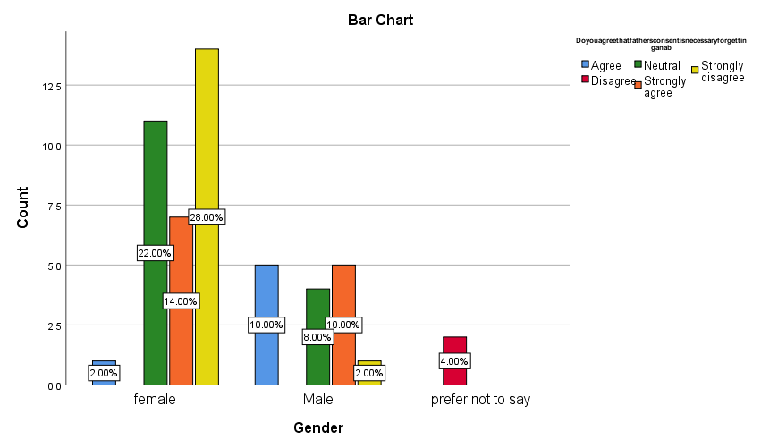
LEGEND
The fig 8 represents the rate of the statement that fathers consent is necessary for abortion with respect to gender

Fig 9
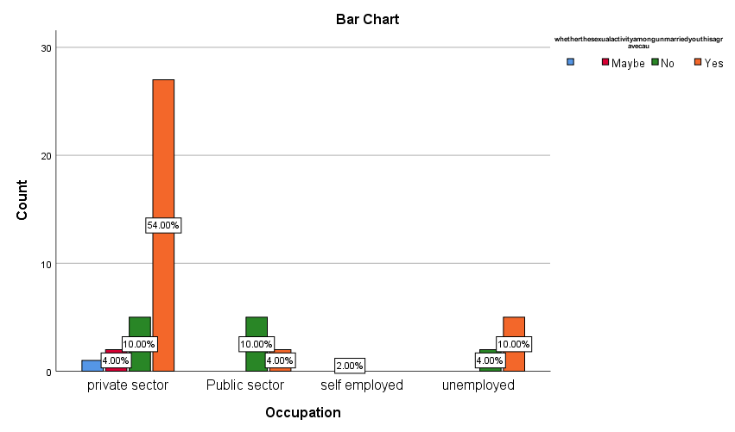
LEGEND
The fig 9 represents the sexual activity among the youth is a grave cause for concern and immoral activity of abortion with respect to occupation
Fig 10
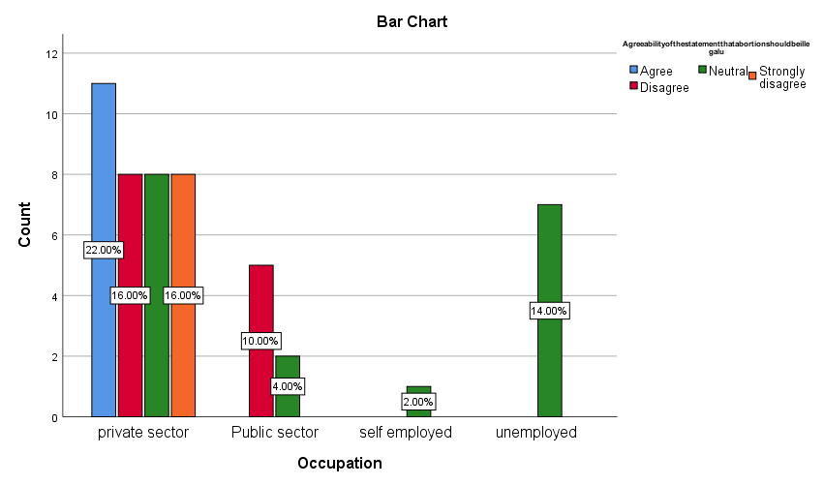
LEGEND
The fig 10 represents the agreeability the statement that abortion should be illegal with respect to occupation

Fig 11
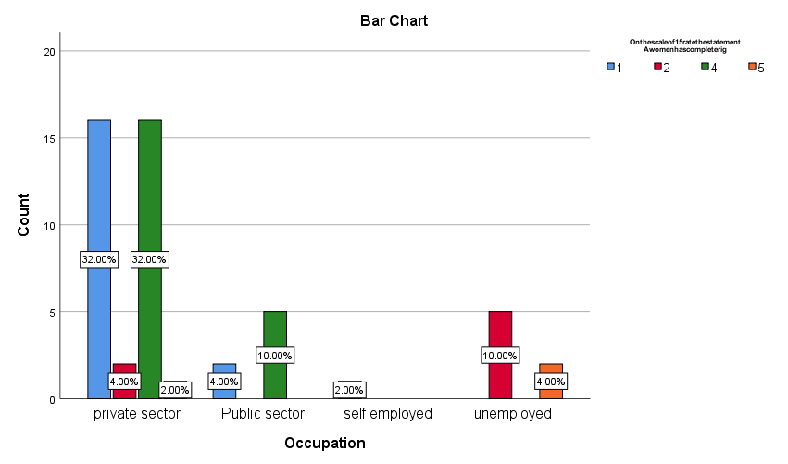
LEGEND
The fig 11 represents the rate of the statement that women has complete right over her body and the choice to abort is solely her own irrespective of marital status with respect to occupation

Fig 12
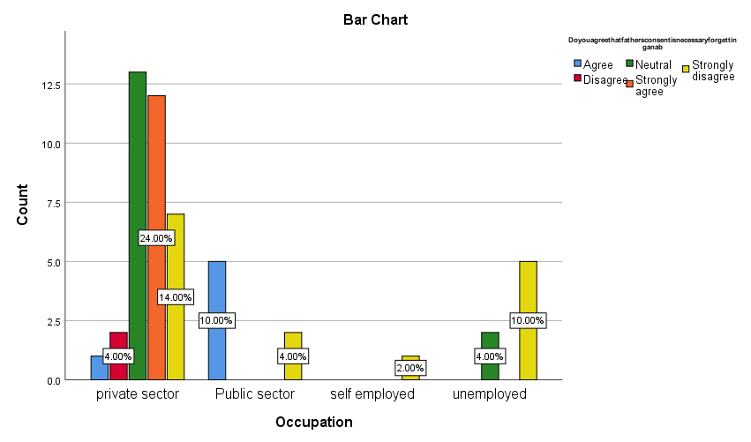
LEGEND
The fig 12 represents the rate of the statement that fathers consent is necessary for abortion with respect to occupation
Fig 13
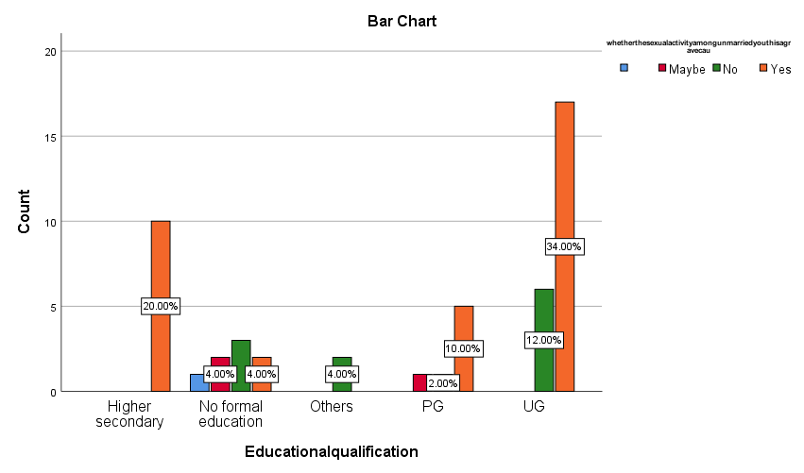
LEGEND
The fig 13 represents the sexual activity among the youth is a grave cause for concern and immoral activity of abortion with respect to Educational qualification

Fig 14
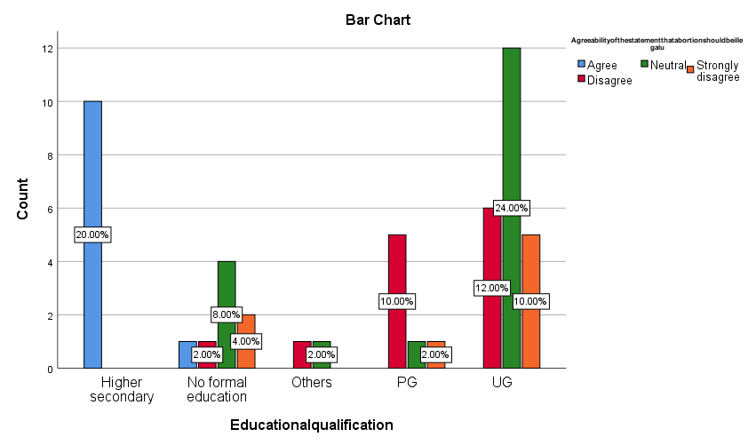
LEGEND
The fig 14 represents the agreeability the statement that abortion should be illegal with respect to educational qualification

Fig 15
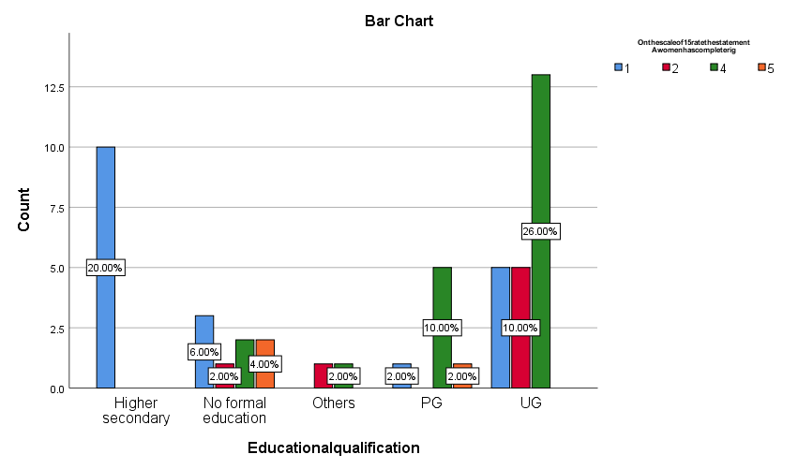
LEGEND
The fig 15 represents the rate of the statement that women has complete right over her body and the choice to abort is solely her own irrespective of marital status with respect to educational qualification

Fig 16
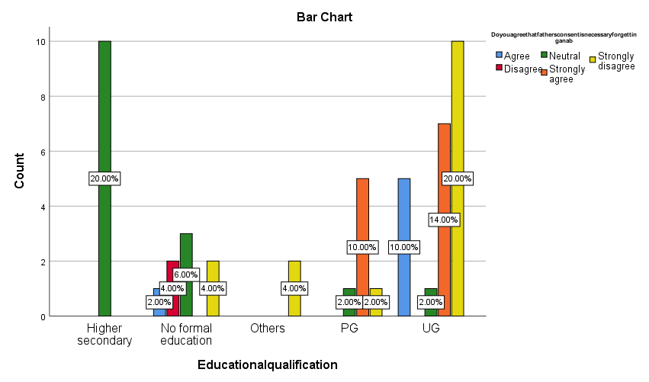

LEGEND
The fig 16 represents the rate of the statement that fathers consent is necessary for abortion with respect to Educational qualification

RESULT
The fig 1 represents the sexual activity among the youth is a grave cause for concern and immoral activity of abortion with respect to age.The fig 2 represents the agreeability that abortion should be illegal with respect to age.The fig 3 represents rate of the statement that women has complete right over her body and the choice to abort is solely her own irrespective of marital status with respect to age .The fig 4 represents the rate of the statement that fathers consent is necessary for abortion with respect to age.The fig 5 represents the sexual activity among the youth is a grave cause for concern and immoral activity of abortion with respect to gender.The fig 6 represents the the agreeability the statement that abortion should be illegal with respect to gender.The fig 7 represents the rate of the statement that women has complete right over her body and the choice to abort is solely her own irrespective of marital status with respect to gender.The fig 8 represents the rate of the statement that fathers consent is necessary for abortion with respect to gender.The fig 9 represents the sexual activity among the youth is a grave cause for concern and immoral activity of abortion with respect to occupation.The fig 10 represents the agreeability the statement that abortion should be illegal with respect to occupation.The fig 11 represents the rate of the statement that women has complete right over her body and the choice to abort is solely her own irrespective of marital status with respect to occupation.The fig 12 represents the rate of the statement that fathers consent is necessary for abortion with respect to occupation.The fig 13 represents the sexual activity among the youth is a grave cause for concern and immoral activity of abortion with respect to Educational qualification.The fig 14 represents the agreeability the statement that abortion should be illegal with respect to educational qualification.The fig 15 represents the rate of the statement that women has complete right over her body and the choice to abort is solely her own irrespective of marital status with respect to educational qualification.The fig 16 represents the rate of the statement that fathers consent is necessary for abortion with respect to Educational qualification

DISCUSSION
The fig 1 represents the sexual activity among the youth is a grave cause for concern and immoral activity of abortion with respect to age.People who are all between the age of 26 - 30 have said yes at the rate of 20.0.%.The fig 2 represents the agreeability that abortion should be illegal with respect to age.people have highly agreed at the rate of 20.00% between the age of 26 - 30.The fig 3 represents rate of the statement that women has complete right over her body and the choice to abort is solely her own irrespective of marital status with respect to age .people have highly rated at the rate of 16.00% between the age of 36 - 40.The fig 4 represents the rate of the statement that fathers consent is necessary for abortion with respect to age.People have highly rated for agree at the rate of 20.00% for disagree.The fig 5 represents the sexual activity among the youth is a grave cause for concern and immoral activity of abortion with respect to gender.The fig 6 represents the the agreeability the statement that abortion should be illegal with respect to gender.The people have highly rated at the rate of 30.00% especially females.The fig 7 represents the rate of the statement that women has complete right over her body and the choice to abort is solely her own irrespective of marital status with respect to gender. The women have highly for four at the rate of 38.00 percentage .The fig 8 represents the rate of the statement that fathers consent is necessary for abortion with respect to gender. The females have strongly disagreed at the rate of 28.00 %The fig 9 represents the sexual activity among the youth is a grave cause for concern and immoral activity of abortion with respect to occupationThe private sector is highly rated for Yes at the rate of 54.00 %.The fig 10 represents the agreeability the statement that abortion should be illegal with respect to occupation. The 22.00 percentage especially for neutral .The fig 11 represents the rate of the statement that women has complete right over her body and the choice to abort is solely her own irrespective of marital status with respect to occupation. The letter of 32.00 %for one and 32.00 % for 4.The fig 12 represents the rate of the statement that fathers consent is necessary for abortion with respect to occupation. The people who are unemployed have it of 10.00 %and we are strongly disagreed it people to have strongly agreed at the rate of 24.00%.The fig 13 represents the sexual activity among the youth is a grave cause for concern and immoral activity of abortion with respect to Educational qualification. graduation people highly rated for this a date of 34.00 %.The fig 14 represents the agreeability the statement that abortion should be illegal with respect to educational qualification. no formal education paper hydrated for 8.00%specially for neutral and under graduation people they have also said neutral at the rate of 24.00%.The fig 15 represents the rate of the statement that women has complete right over her body and the choice to abort is solely her own irrespective of marital status with respect to educational qualification. other people help us in Delhi at the rate of 26.00 %for four .The fig 16 represents the rate of the statement that fathers consent is necessary for abortion with respect to Educational qualification.The undergraduate eople have highly rated for 20.00 %for strongly disagree.

SUGGESTION
The women have the independence over her body and nobody has the right to question and carrying a child is her choice and nobody should question her that awareness must be spread to every person and if she couldn’t have the capability to give birth to a child and that also must be accepted.And even she is an unmarried is she is carrying a child that should not be blamed

LIMITATION
Many people in the society, especially men, are still conservative and they want women to ask their permission, especially in the termination of a child . They are not ready to accept the girl who is actually a rape victim.If she is pregnant due that she is blamed ashamed in the society.And the laws are provided for the benefit of women but family and relations are not ready to accept it.

CONCLUSION
The abortion or the termination of a pregnancy by chemical,surgical or other means became legal in 1971.Any women seeking an bortion would be entitled be have one under the medical termination of pregnancy (MTP) Act, was adopted that year as along as the grounds she claims are legal.The act modifies the 1971 enactment by increasing the number of weeks a women can terminate her pregnancy and establishing specific conditions in which a pregnancy can be terminated at any time.while the amendme has increased abortion access to some extent it fails to address one fundamental flaw in the medical termination of pregnancy act of 1971,that a woman does not have the right to Terminate a pregnancy but may be allowed to so only in certain specified circumstances,and only if a medical professional determines that does circumstances are met.The main objective of this research is to whether the sexual activity among the youth is a grave cause for concern and immoral activity of abortion. With this it is concluded that women can abort the child with her partner.

REFERENCES
ERDMAN, JOANNA N. “Theorizing Time in Abortion Law and Human Rights.” Health and Human Rights, vol. 19, no. 1, 2017, pp. 29–40. JSTOR, http://www.jstor.org/stable/90007913. Accessed 27 Aug. 2022.
Sedgh, G., Singh, S., Henshaw, S. K., & Bankole, A. (2011). Legal Abortion Worldwide in 2008: Levels and Recent Trends. Perspectives on Sexual and Reproductive Health, 43(3), 188–198. http://www.jstor.org/stable/23048853
RETHERFORD, ROBERT D., and TARUN K. ROY. “Effects of Family Composition on Sex-Selective Abortion in Punjab, India.” Genus, vol. 60, no. 3/4, 2004, pp. 71–97. JSTOR, http://www.jstor.org/stable/29788824. Accessed 27 Aug. 2022.
Rahman, Anika, et al. “A Global Review of Laws on Induced Abortion, 1985-1997.” International Family Planning Perspectives, vol. 24, no. 2, 1998, pp. 56–64. JSTOR, https://doi.org/10.2307/2991926. Accessed 27 Aug. 2022.
Purewal, Navtej. “Sex Selective Abortion, Neoliberal Patriarchy and Structural Violence in India.” Feminist Review, no. 119, 2018, pp. 20–38. JSTOR, https://www.jstor.org/stable/26776499. Accessed 27 Aug. 2022.
Miller, Barbara D. “Female-Selective Abortion in Asia: Patterns, Policies, and Debates.” American Anthropologist, vol. 103, no. 4, 2001, pp. 1083–95. JSTOR, http://www.jstor.org/stable/684130. Accessed 27 Aug. 2022.
Purewal, Navtej. “Sex Selective Abortion, Neoliberal Patriarchy and Structural Violence in India.” Feminist Review, no. 119, 2018, pp. 20–38. JSTOR, https://www.jstor.org/stable/26776499. Accessed 27 Aug. 2022.
Dubuc, Sylvie, and David Coleman. “An Increase in the Sex Ratio of Births to India-Born Mothers in England and Wales: Evidence for Sex-Selective Abortion.” Population and Development Review, vol. 33, no. 2, 2007, pp. 383–400. JSTOR, http://www.jstor.org/stable/25434611. Accessed 27 Aug. 2022.
Edmeades, Jeffrey, Susan M. Lee-Rife, and Anju Malhotra. “Women and Reproductive Control: The Nexus between Abortion and Contraceptive Use in Madhya Pradesh, India.” Studies in Family Planning 41, no. 2 (2010): 75–88. http://www.jstor.org/stable/25681347.
MacPherson, Yvonne. “Images and Icons: Harnessing the Power of the Media to Reduce Sex-Selective Abortion in India.” Gender and Development, vol. 15, no. 3, 2007, pp. 413–23. JSTOR, http://www.jstor.org/stable/20461226. Accessed 27 Aug. 2022.
Hodgson, Dennis. “Abortion, Family Planning, and Population Policy: Prospects for the Common-Ground Approach.” Population and Development Review, vol. 35, no. 3, 2009, pp. 479–518. JSTOR, http://www.jstor.org/stable/25593662. Accessed 27 Aug. 2022
Rossouw, J. P. H., and G. E. du Plessis. “Unwanted Fertility, Contraception and Induced Abortion in South Africa.” Southern African Journal of Demography, vol. 4, no. 1, 1994, pp. 12–28. JSTOR, http://www.jstor.org/stable/20853211. Accessed 27 Aug. 2022.
Bell, Suzanne O., and David Bishai. “Can a List Experiment Improve Validity of Abortion Measurement?” Studies in Family Planning, vol. 50, no. 1, 2019, pp. 43–61. JSTOR, http://www.jstor.org/stable/45211117. Accessed 27 Aug. 2022.
Moseson, Heidi, et al. “The List Experiment for Measuring Abortion: What We Know and What We Need.” Studies in Family Planning, vol. 48, no. 4, 2017, pp. 397–405. JSTOR, http://www.jstor.org/stable/26384490. Accessed 27 Aug. 2022.
DALVIE, SUCHITRA, et al. “Safe Abortion as a Women’s Right: Perceptions of Law Enforcement Professionals.” Economic and Political Weekly, vol. 50, no. 33, 2015, pp. 61–66. JSTOR, http://www.jstor.org/stable/24482410. Accessed 27 Aug. 2022.
Whittaker, Andrea. “Epilogue: Further Challenges.” Abortion in Asia: Local Dilemmas, Global Politics, edited by Andrea Whittaker, NED-New edition, 1, Berghahn Books, 2010, pp. 240–47. JSTOR, http://www.jstor.org/stable/j.ctt9qddj2.16. Accessed 27 Aug. 2022.
Zaidi, Batool, and S. Philip Morgan. “In the Pursuit of Sons: Additional Births or Sex-Selective Abortion in Pakistan?” Population and Development Review, vol. 42, no. 4, 2016, pp. 693–710. JSTOR, http://www.jstor.org/stable/44132231. Accessed 27 Aug. 2022.PIERSON, CLAIRE, and FIONA BLOOMER. “Macro- and Micro-Political Vernaculizations of Rights: Human Rights and Abortion Discourses in Northern Ireland.” Health and Human Rights, vol. 19, no. 1, 2017, pp. 173–85. JSTOR, http://www.jstor.org/stable/90007924. Accessed 27 Aug. 2022.
Henshaw, Stanley K. “Induced Abortion: A World Review, 1990.” International Family Planning Perspectives, vol. 16, no. 2, 1990, pp. 59–76. JSTOR, https://doi.org/10.2307/2133470. Accessed 27 Aug. 2022.BARKAN, S. E. (2014). GENDER AND ABORTION ATTITUDES: RELIGIOSITY AS A SUPPRESSOR VARIABLE. The Public Opinion Quarterly, 78(4), 940–950. http://www.jstor.org/stable/24545976

PLAGIARISM REPORT

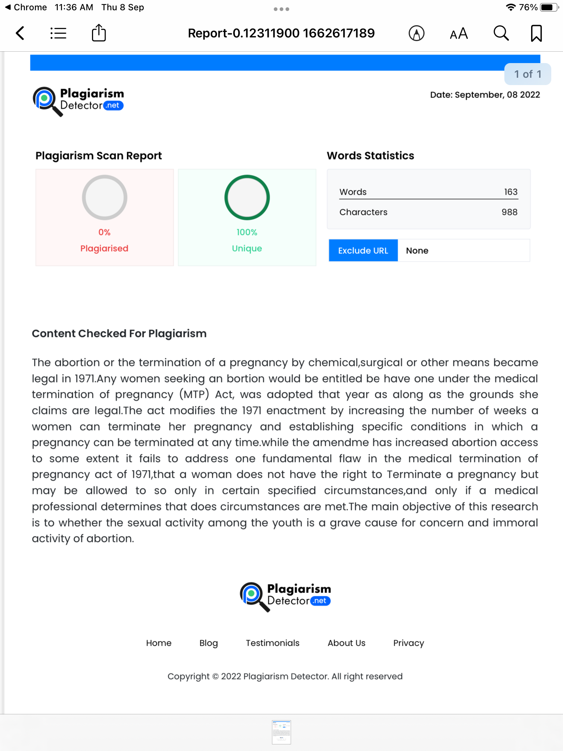
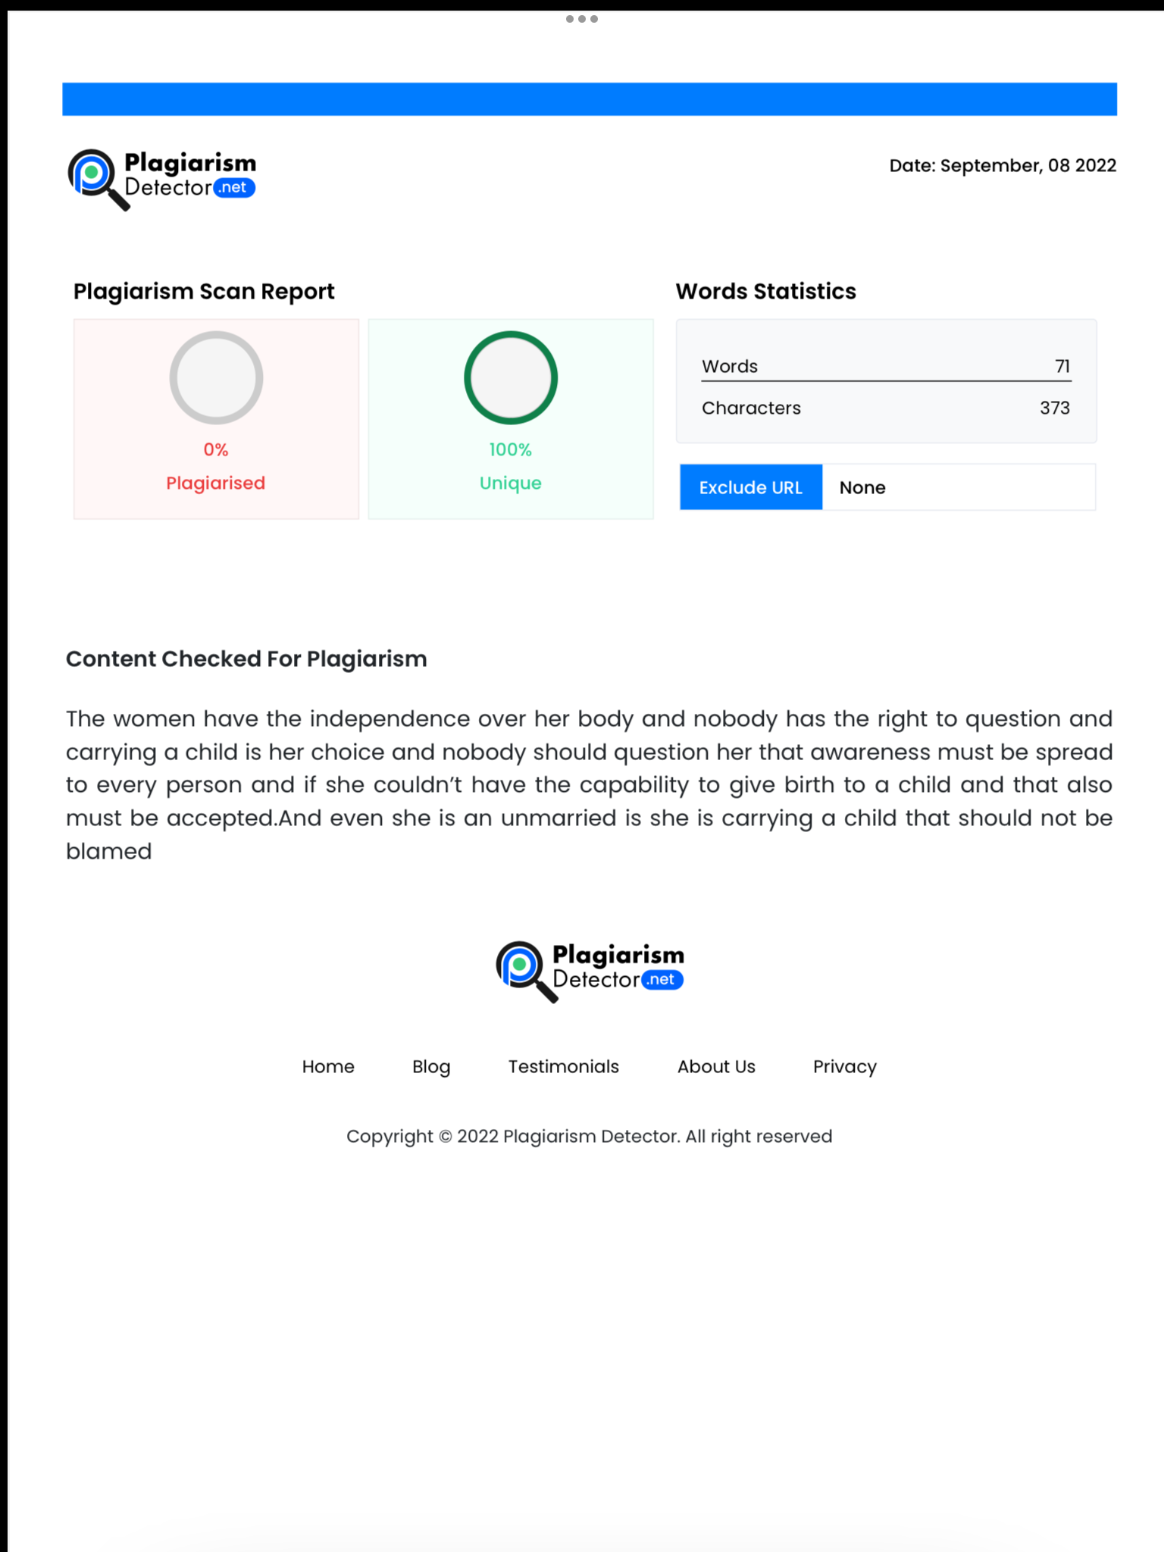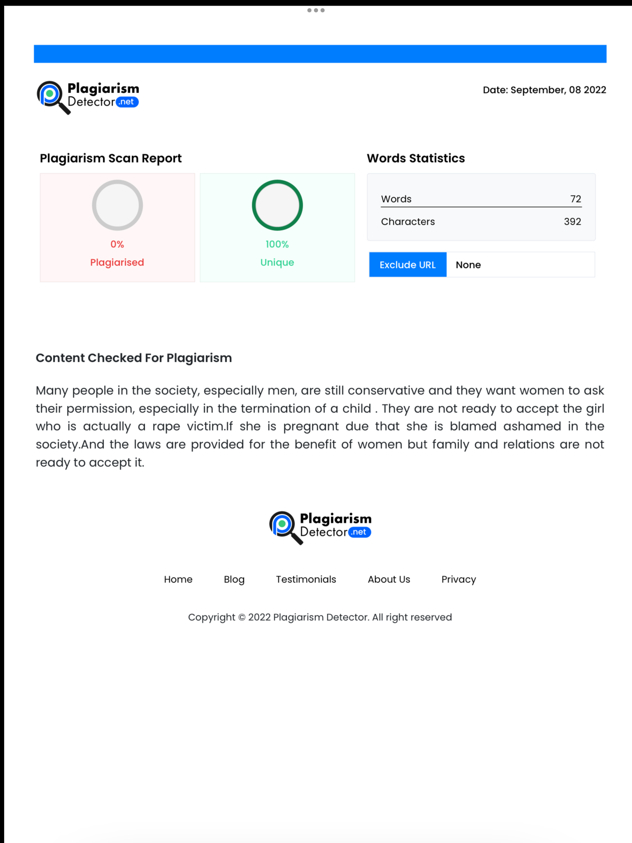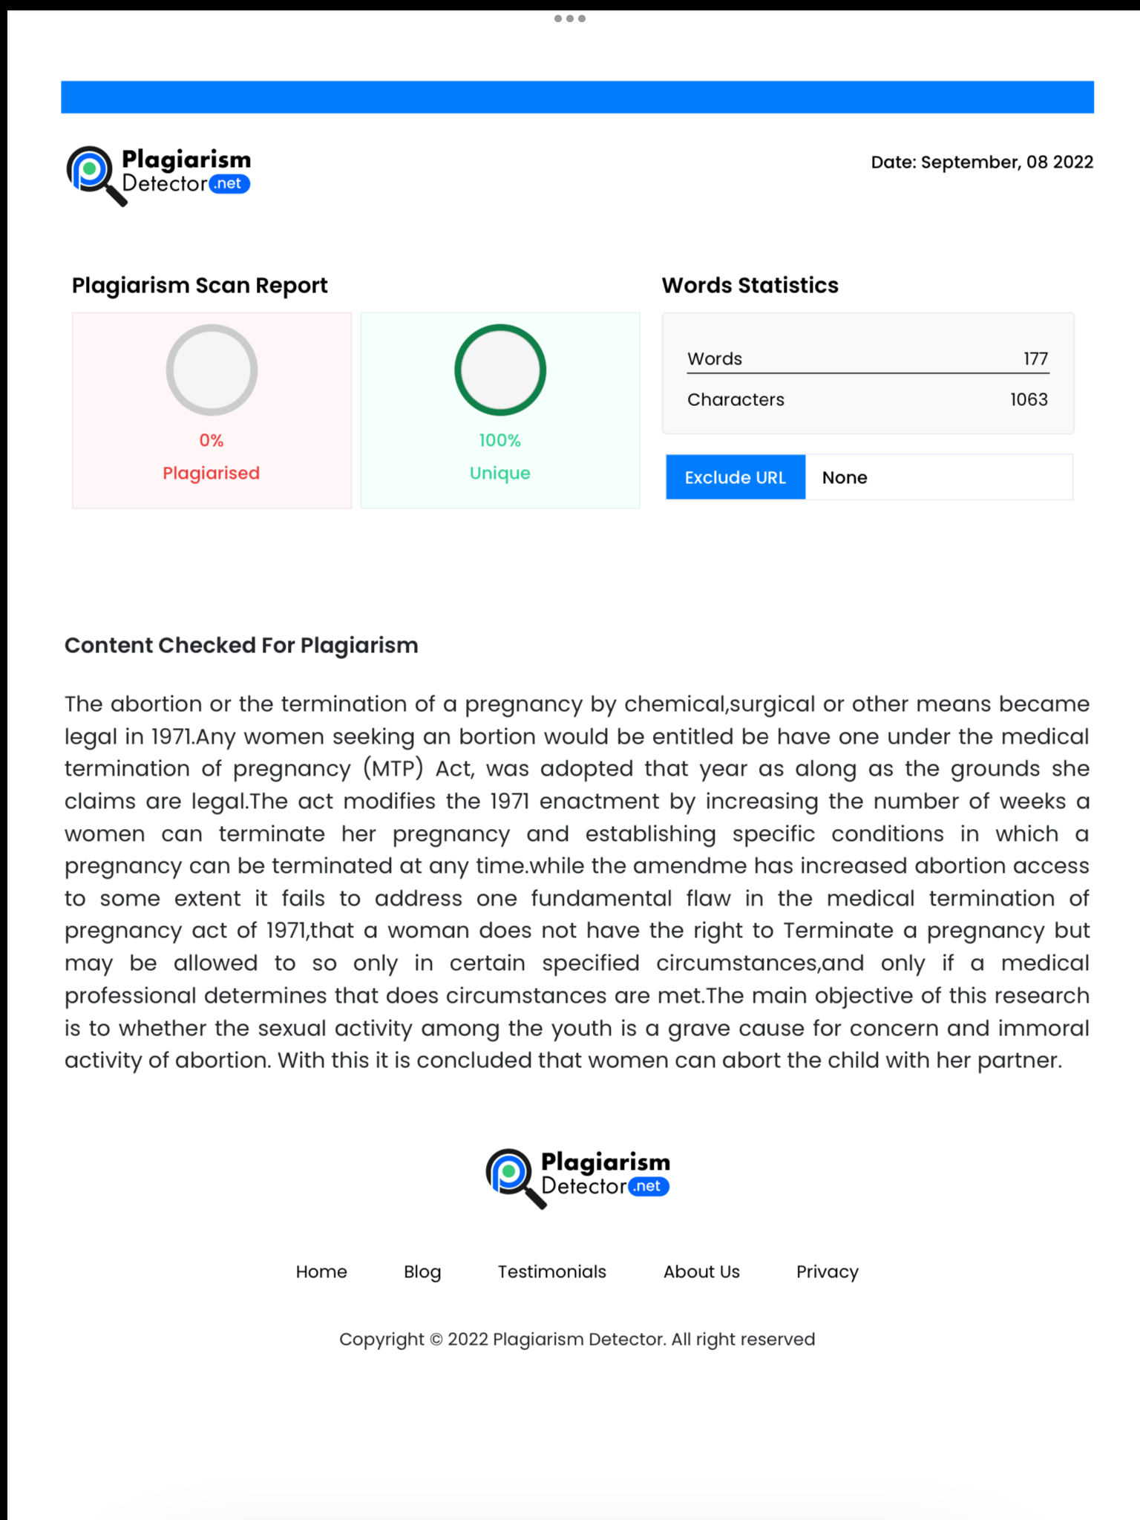

Vageshwari.EBA.LLB(Hons)SAVEETHA SCHOOL OF LAW SAVEETHA INSTITUTE OF MEDICAL AND TECHNICAL SCIENCES (SIMATS),Chennai-77

