A COMPARATIVE STUDY BETWEEN DEMOCRACY AND HUMAN RIGHTS WITH RESPECT TO INDIAN CONSTITUTION

AUTHOR
Paventhan. I
4th-year BBA, LLB(Hons),
Saveetha School of Law,
Saveetha Institute of Medical and Technical Sciences (SIMATS),

A COMPARATIVE STUDY BETWEEN DEMOCRACY AND HUMAN RIGHTS WITH RESPECT TO INDIAN CONSTITUTION
Author: Paventhan.I
ABSTRACT:
Human rights are basic rights available to all human beings because of their human birth. It is unique to all human beings, regardless of nationality, religion, language, gender, skin color or other considerations. The Human Rights Protection Act 1993 defines human rights as: “Human Rights” means the rights to life, liberty, equality, and dignity of an individual guaranteed by the Constitution or embodied in international treaties and enforceable by the Indian courts. Human rights are basic rights available to all human beings because of their human birth. It is unique to all human beings, regardless of nationality, religion, language, gender, skin color, or other considerations. The main aim of the research is to know about the factors which link democracy with human rights in the Indian constitution and to know whether people were aware of their fundamental rights given under the constitution of India. To analyze whether the method or ways to compare democracy and human rights with respect to the Indian constitution and to create an impact among the people about the merits of the relationship between democracy and human rights in India. To spread awareness among the people about the motive of framing fundamental rights with respect to human rights. The sample size covered by the researcher is 200. The result of the research is that most people were aware of the concept of Democracy and human rights but they don't know the difference and how to make it available for themself. And the researchers suggest creating awareness about these concepts among all the individuals protected under the Indian Constitution.

KEYWORDS:
Human rights, Democracy, International treaties, UDHR, Fundamental rights

INTRODUCTION:
During the last six decades, human rights became a live and vibrant issue within the accumulation. Human rights because the recognition of inherent and basic individual worth and dignity are as old as human civilization. a person attains by birth some rights as an individual. Thus the concept of human rights is civilization because it may be a political idea with a moral base. The priority for and of human rights has been institutionalized after the General Assembly of the UN adopted and proclaimed the Universal Declaration of Human Rights within the mid twentieth century. The expression “human rights' ' suggests rights of all citizens. The moral foundation of human rights to universality has not been questioned yet a minimum of in essence, though there are some instances of rejection to the current aspect of universality, either manifest or disguised, are fairly large altogether parts of the planet. the thought of democracy has led to great expectations to the people. it's become a key point of political legitimacy. of course it's producing the best disillusionment and frustration recently. From the late 19th Century democracy and capitalism appear to have moved along independent yet parallel paths. During the 20th Century they gained in strength, interacting mutually and establishing an interface. The results of which the concept of state emerges, defines the role of the state in an interventionist manner.Democracy is very important for human development. When people have free will to live freely, they will be happier. Moreover, we have seen how other forms of government have turned out to be. Citizens are not that happy and prosperous in a monarchy or anarchy. Furthermore, democracy lets people have equal rights. This ensures that equality prevails all over the country. Subsequently, it also gives them duties. These duties make them better citizens and are also important for their overall development. Most importantly, in a democracy, the people form the government. So, this selection of the government by the citizens gives everyone a chance to work for their country. It allows the law to prevail efficiently as the rules are made by people whom they have selected. On representative democracy Benjamin Barber says, ‘Representation destroys participation and citizenship when it serves accountability and personal rights.’ Indian Constitution, the foremost right-based Constitution of the planet, provides the ethical foundation of human rights in its Preamble, while the legal expression of those found in Part-III and part-IV of the Constitution. The meaning and definition of the concept of right. Human Rights are universal, and that they apply equally to any or all individuals whatever their inborn or acquired differences is also. As personalities are rational, they possess certain rights which are commonly called human rights. Human rights belong to the individuals from the very inception of their birth, these rights become operative. Human rights are birth rights inherent to all or any individuals no matter their caste, creed, religion, sex and nationality. Human rights are absolutely essential as these rights are concerned with freedom and dignity of individuals and are associated with physical, moral, social, and spiritual welfare. These rights are essential for moral and material development. Human rights are spoken as fundamental rights, basic rights and birth rights as of immense significance to kinsfolk.y associated with human rights. Human rights not only uphold human dignity and price but also affirm an honored life to every individual. To kinsmen there's a life to measure but live without dignity, life becomes meaningless. But unfortunately some structures prevailing within the society don't permit people to measure with dignity or to affirm rights. The dominant forces within the society attempt to explain human rights from their own perspective, which is selfish and unjust. So, for the right utilization of human rights, the transformation of the structure is crucial. this may result in the right dissemination of justice, because the denial of justice is denial of human rights. The constitution of India contemplates the parliamentary style of government and ensures the establishment of a sovereign, socialist, secular, democratic republic within the country. The constitution also guarantees to the citizens of India some fundamental rights. The Indian Constitution is one in every of the foremost right-based constitutions of the planet. It provides the moral foundation of human rights in its Preamble, while the legal expression of those is found in Part-III and Part-IV of the Constitution where the elemental rights and Directive Principles of State Policy are described respectively. The Preamble of the Indian Constitution aims to secure to any or all citizens justice-social, economic and political; liberty of thoughts, expression, belief, faith and worship; equality of status and opportunity and to push among all fraternity assuring the dignity of the individual. The Constitution of India also guarantees fundamental rights to any or all citizens with none discrimination on any ground in Part- III. It deals mostly with civil and political rights. There are a collection of Directive Principles of State Policy which functions as guiding principles for the govt. to run administration. The parliamentary sort of government under democracy is representative democracy within which people of the country are entitled to exercise their sovereign authority through the legislature, the members of which are elected on the idea of adult franchise.

OBJECTIVES:
- To know about the factors which links democracy with human rights in Indian constitution
- To know whether people were aware of their fundamental rights given under constitution of India
- To analyse whether the method or ways to compare democracy and human rights in respect to Indian constitution
- To create an impact among the people about the merits of the relationship between democracy and human rights in India
- To spread awareness among the people about the motive of framing fundamental rights in respect to human rights.

REVIEW OF LITERATURE:

Juss (2019), This volume presents an integrated collection of essays around the theme of India’s failure to grapple with the big questions of human rights protections affecting marginalized minority groups in the country’s recent rush to modernization. The book traverses a broad range of rights violations from: gender equality to sexual orientation, from judicial review of national security law to national security concerns, from water rights to forest rights of those in need, and from the persecution of Muslims in Gulberg to India’s parallel legal system of Lok Adalats to resolve disputes. It calls into question India’s claim to be a contemporary liberal democracy. The thesis is given added strength by the authors’ diverse perspectives which ultimately create a synergy that stimulates the thinking of the entire field of human rights, but in the context of a non-western country, thereby prompting many specialists in human rights to think in new ways about their research and the direction of the field, both in India and beyond. (Juss)

Winkler (2014), The United Nations General Assembly and the Human Rights Council recognised the human right to water in 2010. This formal recognition has put the issue high on the international agenda, but by itself leaves many questions unanswered. This book addresses this gap and clarifies the legal status and meaning of the right to water through a detailed analysis of its legal foundations, legal nature, normative content and corresponding State obligations. (Winkler)

Jones (2010), Women's Global Health and Human Rights serves as an overview of the challenges faced by women in different regions of the world. Ideal as a tool for both professionals and students, this book discusses the similarities and differences in health and human rights challenges that are faced by women globally. Best practices and success stories are also included in this timely and important text. Major Topics include: „X Globalization „X Gender Based Terrorism and Violence „X Cultural Practices „X Health Problems „X Progress and Challenges. (Murthy and Smith)

W.W. Noroton (2008), The books Book Reviews about, How were human rights invented, and how does their tumultuous history influence their perception and our ability to protect them today. From Professor Lynn Hunt comes this extraordinary cultural and intellectual history, which traces the roots of human rights to the rejection of torture as a means for finding the truth. She demonstrates how ideas of human relationships portrayed in novels and art helped spread these new ideals and how human rights continue to be contested today.(Hunt)

UDHR (1978), The human right to water has wide-ranging implications for the distribution of water. Examining these implications requires putting the right to water into the broader context of different water uses and analysing the linkages and competition with other human rights that depend on water for their realisation. (The Universal Declaration of Human Rights)

UN(1978), In mapping out the field of human rights for those studying and researching within both humanities and social science disciplines, the Handbook of Human Rights not only provides a solid foundation for the reader who wants to learn the basic parameters of the field, but also promotes new thinking and frameworks for the study of human rights in the twenty-first century.(United Nations. General Assembly)

Cushman (2012), The Handbook comprises over sixty individual contributions from key figures around the world, which are grouped according to eight key areas of discussion, foundations and critiques;, new frameworks for understanding human rights;, world religious traditions and human rights;, social, economic, group, and collective rights;, critical perspectives on human rights organizations, institutions, and practices;, law and human rights;, narrative and aesthetic dimension of rights, geographies of rights In its presentation and analysis of the traditional core history and topics, critical perspectives, human rights culture, and current practice, this Handbook proves a valuable resource for all students and researchers with an interest in human rights. (Cushman)
Hellum A (2013), As an instrument which addresses the circumstances which affect women's lives and enjoyment of rights in a diverse world, the CEDAW is slowly but surely making its mark on the development of international and national law. Using national case studies from South Asia, Southern Africa, Australia, Canada and Northern Europe, Women's Human Rights examines the potential and actual added value of the Convention on the Elimination of All Forms of Discrimination against Women in comparison and interaction with other equality and anti-discrimination mechanisms. The studies demonstrate how state and non-state actors have invoked, adopted or resisted the CEDAW and related instruments in different legal, political, economic and socio-cultural contexts, and how the various international, regional, and national regimes have drawn inspiration and learned from each other.(Hellum and Aasen)
Ajevski (2017), This book explores the effects of institutional fragmentation in international human rights law, by comparing the rights jurisprudence of three human rights courts and bodies, namely the European Court for Human Rights, the Inter-American Court for Human Rights and the Human Rights Committee. Contributions cover the areas of freedom of expression (journalism and the media), right to privacy, freedom of assembly and freedom of association (political parties), and measure the extent of fragmentation of human rights protection. Moreover, the volume argues that, while the conflict of laws approach, favored by the International Law Commission, might work in avoiding outright conflict in obligation, in practice it is not an approach that presents a viable research agenda when it comes to understanding the causes and consequences of institutional fragmentation. This is especially evident in areas like international human rights, where the possibility of a silent drift between the jurisprudence of the three courts is a real possibility. (Ajevski)
Danieli (2018), Containing contributions by specialists from the intergovernmental and non-governmental worlds and voices of victim/survivors, the book critically reviews the international and regional human rights systems established over the past 50 years in terms of their effectiveness for the victims of human rights violations and provides future directions for the promotion and protection of human rights. (Danieli et al.)
Liu (2022), The increasing evidence of stress-strain hysteresis in large animal or human myocardium calls for extensive characterizations of the passive viscoelastic behavior of the myocardium. Several recent studies have investigated and modeled the viscoelasticity of the left ventricle while the right ventricle (RV) viscoelasticity remains poorly understood. Our goal was to characterize the biaxial viscoelastic behavior of RV free wall (RVFW) using two modeling approaches. We applied both quasi-linear viscoelastic (QLV) and nonlinear viscoelastic (NLV) theories to experimental stress relaxation data from healthy adult ovine. A three-term Prony series relaxation function combined with an Ogden strain energy density function was used in the QLV modeling, while a power-law formulation was adopted in the NLV approach. (Liu et al.)

Blatter (2022), Technocratic intergovernmentalism has undermined the preconditions for its own success as a democratic project of transnational cooperation. It has triggered populist reactions within nation states and helped to discredit the intermediary institutions (parties and parliaments) that connect democratic will-formation and joint decision-making. This rise of populism and its alignment with nationalism, in consequence, hampers joint decision-making in the international realm. We argue that representative democracies can overcome the negative spiral between technocratic intergovernmental and nationalist populism by mutually granting their citizens the right to elect representatives not only in their domestic parliament, but also in the parliaments of ‘consociated democracies’. (Blatter and Schulz)
Dominici (2022), Before discussing the prospects for educating young people toward becoming global citizens, we must ask ourselves: is global citizenship reality or illusion? What can be stated is that plain citizenship itself can no longer be considered merely a legal or judicial question. Today, citizenship is only partially linked to rights and duties deriving from the recognition of an individual as belonging to a community (local, national or international). Future citizens of the digitally hyper-connected global village face two dangers: simulation of participation and the illusion of having a less asymmetrical relationship to power. (Dominici)
Muller (2021), In this short, elegant volume, he explains how democracy is founded on three vital principles: liberty, equality, and also uncertainty. The latter, he argues, is crucial for ensuring democracy's dynamic and creative character. Authoritarians, as well as Big Tech, seek to render politics (and individual citizens) predictable; democracy holds open the possibility that new ideas, movements and identities can be created. Acknowledging fully the dangers posed by populism, by kleptocratic autocracies like Russia's and by the digital authoritarianism of Xi, Müller also challenges the assumptions made by many liberals defending democracy in recent years. (Müller)
Doorenspleet (2018), This book is the first comprehensive analysis of the instrumental value of democracy in a comparative perspective. Based on extensive analyses of quantitative studies from different disciplines, it explores both the expected beneficial and harmful impact of democracy. Democracy’s reputation as delivering peace and development while controlling corruption is an important source of its own legitimacy. Yet, as this book acutely demonstrates, the arguments tend to be normatively driven interventions in ideologically charged policy debates. The book argues that we need neither a utopian framing of democracy as delivering all ‘good things in politics nor a cynical one that emphasizes only the ‘dangerous underbelly’ of this form of government. The author also raises critical questions about the value of the study of democracy: the choice for particular concepts and measures, the unknown mechanisms, and the narrow focus on specific instrumental values. This volume will be necessary reading for anyone interested in debates on democracy in the contemporary global context. (Doorenspleet)
Alain Touraine (2018), questions the social and cultural context of democracy today. At a time when state power is being increasingly eroded by the economic might of transnational capital, what possible value can we ascribe to a democratic idea that is defined merely as a set of guarantees against the totalitarian state?If democracy is to survive in the postcommunist world, Touraine argues, it must accomplish two urgent goals: It must somehow protect the power of the nation-state at the same time as it limits that power (for only the state has sufficient means to counterbalance the global corporate wielders of money and information); and it must reconcile social diversity with social unity and individual liberty with integration (Touraine)
Dahl (2020), Written by the preeminent democratic theorist of our time, this book explains the nature, value, and mechanics of democracy. In a new introduction to this Veritas edition, Ian Shapiro considers how Dahl would respond to the ongoing challenges democracy faces in the modern world. “Within the liberal democratic camp, there is considerable controversy about exactly how to define democracy. Probably the most influential voice among contemporary political scientists in this debate has been that of Robert Dahl.”—Marc Plattner, New York Times (Dahl)

Urbinati (2008), It is usually held that representative government is not strictly democratic, since it does not allow the people themselves to directly make decisions. But here, taking as her guide Thomas Paine’s subversive view that “Athens, by representation, would have surpassed her own democracy,” Nadia Urbinati challenges this accepted wisdom, arguing that political representation deserves to be regarded as a fully legitimate mode of democratic decision making—and not just a pragmatic second choice when direct democracy is not possible. (Urbinati)
Gracia (2009), "This is not a democracy," Antonio García-Trevijano denounces in the first pages of this book. To confront the great lie that Europe does have democratic regimes, a lie rooted in people's confounding of the liberties they enjoy with the political freedom that they lack, the author builds a realistic theory of democracy to end the false idea that corruption, state crime, and public immorality are democracy's (undesirable) products and not the natural and inevitable fruits of oligarchic regimes. Thanks to a superb review of the events that mark the history of democracy, the author reveals the obstacles that, from the 17th century English revolution, the United States' War of Independence, and the French Revolution, opposed political freedom, deviating old Europe's democratic possibilities toward the current parties' state.(García-Trevijano)

Arthur (2009), The SAGE Handbook of Education for Citizenship and Democracy brings together new work by some of the leading authorities on citizenship education and is divided into five sections. The first section deals with key ideas about citizenship education including democracy, rights, globalization and equity. Section two contains a wide range of national case studies of citizenship education including African, Asian, Australian, European, and North and South American examples. (Arthur et al.)
METHODOLOGY:
The research method followed here is empirical research. A total of 200 samples have been taken out of which is taken through convenient sampling. The sample frame was taken by the researcher through online methods and also by nearby people. The Independent variable taken here is age, gender, education qualification, and occupation. The dependent variables are factors affecting the interrelation between democracy and human rights, usage of human rights while drafting the constitution of India, Related laws and regulations, duties of government, etc. The statistical data used by the researcher is a graphical representation.

SPSS ANALYSIS:

FIG 1:
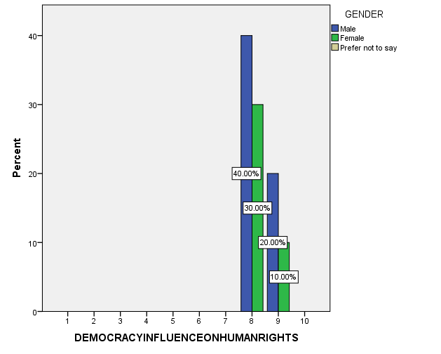
Legend: The graph shows the comparison between Gender and Democracy influencing human rights.

FIG 2:
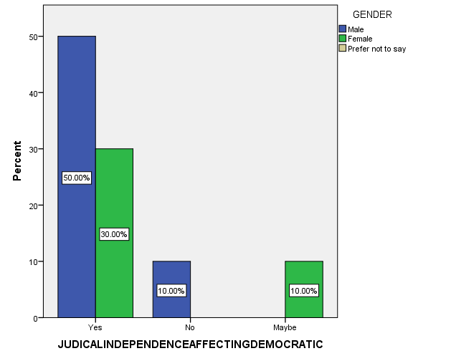
Legend: The graph shows the comparison between Gender and Democracy influencing human rights and judicial independence affecting the democratic nature of the Indian Constitution.

FIG 3:
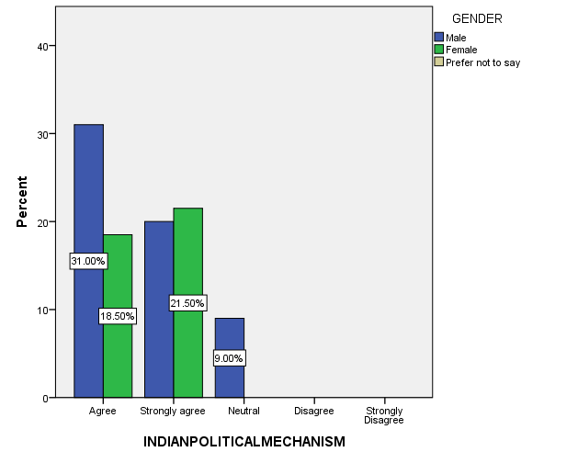
Legend: The graph shows the comparison between gender and Indian political mechanisms
FIG 4:

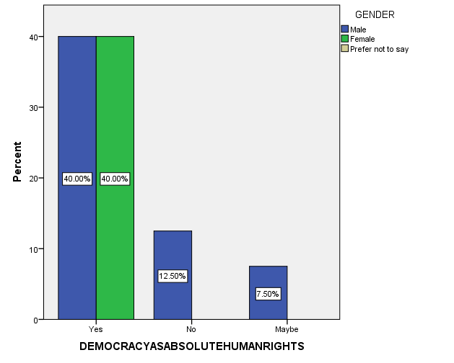
Legend: The graph shows the comparison between gender and democratic absolute human rights.

FIG 5:
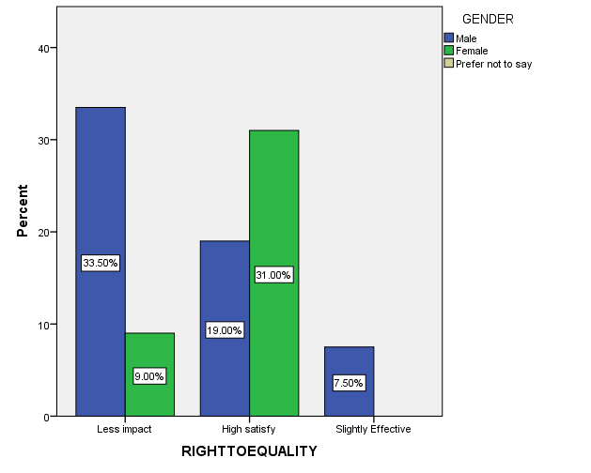
Legend: The graph shows the comparison between gender and right to equality.
FIG 6:

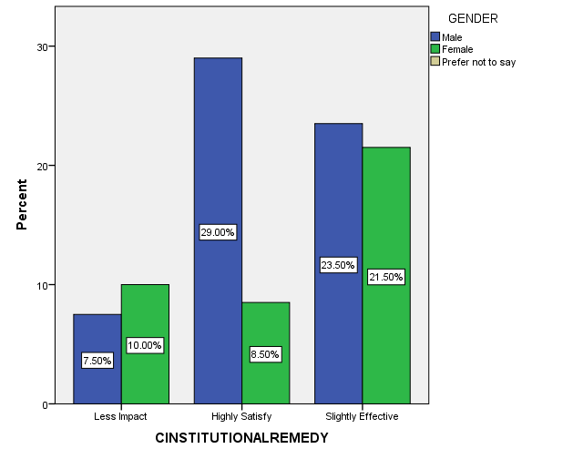
Legend: The graph shows the comparison between gender and constitutional remedy.
FIG 7:
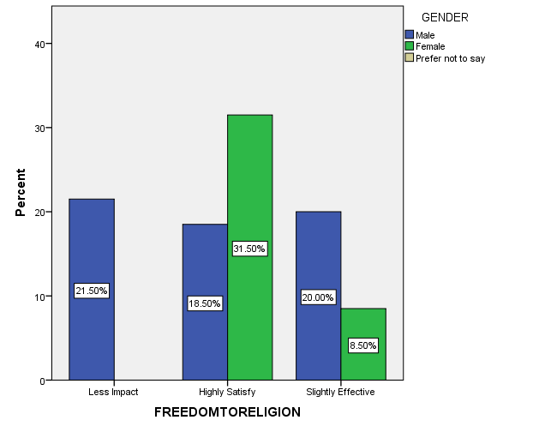

Legend: The graph shows the comparison between gender and freedom to religion.

FIG 8:
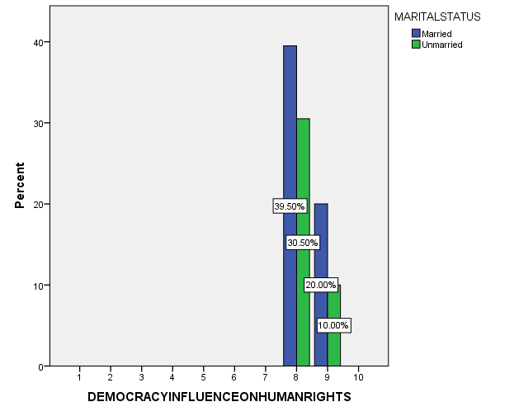
Legend: The graph shows the comparison between gender and democratic influence on human rights.

FIG 9:
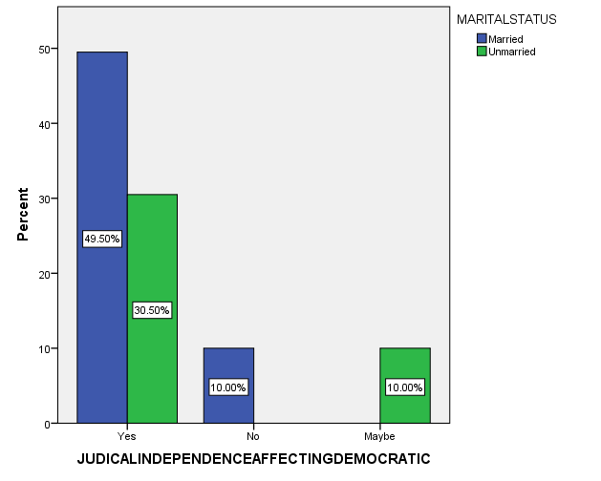
Legend: The graph shows the comparison between gender and judicial independence affecting democracy.
RESULTS:
From fig 1, we came to know that most of the respondents are from the gender group of male (40%) and followed by females (30%). From fig 2, we came to know that most of the respondents have agreed to the given statement as they preferred yes as their option and most of the respondents are from the gender group of male (50%). From fig 3, we came to know that most of the responses from the gender group of male (31%) have agreed to the given statement and followed by the female group (18.50)%. From fig 4, we can observe that responses are equally from both male and female groups (40%) and they strongly agreed that democracy must have absolute human rights. From fig 5, we came to know that most of the responses are from male groups who have said the right to equality has less impact on the people. From fig 6, we came to know that most of the responses have suggested that constitutional remedies given under the Indian constitution have a high impact on the people. From fig 7, we came to know that respondents are highly satisfied with the effectiveness of freedom of religion given under the Indian constitution. From fig 8, we came to know that most of the responses are from the married persons and they have rated upto 8 to 9 to the given statement. From fig 9, we came to know that most of the responses have agreed that judicial independence affects democracy in general.

DISCUSSION:
By observing Fig 1, we came to know that most of the respondents irrespective of their gender have rated 8 as their rating towards democracy influencing human rights, and females opted for 9 as their rating towards the question. 30% of the females have rated 8 as their response and 40% of the male have rated 8 as their rating towards the democracy influence. And 20% of the male rated 9 as their responses. And this shows that the individual thinks that human rights have evolved out of the democratical feature of the Indian Constitution. From Fig 2, we can see that most of the respondents up to 50% of males have opted for yes as their response towards Judicial independence has affected the Indian Constitution’s democracy. And 30% of females have opted ‘yes’ towards the question raised. And 10 percent of the male have even opted for No to the question raised. By observing Fig 3, we came to know that most of the respondents up to 50% of males have opted for yes as their response towards Judicial independence has affected the Indian Constitution’s democracy. And 30% of females have opted ‘yes’ towards the question raised. And 10 percent of the male have even opted No to the question raised and this shows that both genders have opted yes and think that judicial independence or activism affect the democratic nature. From fig 4, we can observe that most of the people have agreed to the given statement as they think Indian political mechanisms and democratic nature would affect human rights in general. From fig 5, we can observe that most of the respondents have agreed that the right to equality has an effect on the citizens in India. But in cases of some other male respondents, they seem to disagree with the statement as they are slightly satisfied with the effect of the right to equality in India. From fig 6, we can observe that most of the responses have not been satisfied with the effectiveness of constitutional remedies provided under the Indian constitution and some of the male respondents still chosen highly satisfied as their option. From fig 7, we can observe that most of the people are highly satisfied with the effectiveness of the right to religion in India as they think India follows the principle of unity in diversity, which made a law for all the people from different religions equally with respect to their legal customs. From fig 8, we came to know that most of the responses are from married people and they have rated upto 8 as their highest rating as they think democracy has a greater influence in guaranteeing the human rights to the citizens through the constitution of India. From fig 9, we came to know that most of the responses, especially from the married group, have agreed to the given statement that judicial independence and activism of the court affect the democratic feature of the Indian citizens.

LIMITATION :
The major limitations of my study are sample frames. The sample size is one of the major drawbacks as we are in a pandemic situation. The respondents were connected through different online sources, including sending questionnaires through email. The restrictive area of sample size is also another limitation. The researcher is limited to a comparison between democracy and human rights with respect to the Indian constitution. The research doesn’t cover other types of comparison specified only to this democracy and human rights.

SUGGESTION :
Abraham Lincoln’s dream of ideal democracy is shattered because today democracy appears to be ‘of the people, ‘by the people but not properly /truly ‘for the people. the govt. apparatus and therefore the government itself faced a credibility crisis. Political parties because the legitimizing vehicle of the republic suffered an absence of credibility because of the criminalization of politics and the motto of grabbing the facility. After considering leading theories of the relationship between justice and democracy, the priority of justice and human rights should run, in essence, over the authority of democratic decisions. Democracy is predicated on the need of justice as equal freedom, itself one in every one of human rights, it follows, that interventions on behalf of justice should be carefully delimited, specifically to cases where fundamental rights are violated. The Indian Constitution abolished “untouchability” in Article 17.

CONCLUSION:
Human rights are fundamental rights that form an essential part of human development. The Constitution serves to protect these fundamental rights as Fundamental Rights and DPSP. Fundamental rights are now more emphasized and directly enforceable in court. A thorough study of Parts III and IV of the Indian Constitution makes it easy to see that almost all the rights stipulated in the UDHR (Universal Declaration of Human Rights) are covered in these two parts. The judiciary has also made great strides. B. Relaxation of the “Locus Standby” Rule. Others can now go to court on behalf of the parties involved. The Supreme Court has interpreted the fundamental rights available to citizens and now interprets rights such as the right to privacy, the right to a clean environment, the right to free legal aid, and the right to a fair trial. . They also find their place in basic rights.

REFERENCE:
Levski, Marjan. Fragmentation in International Human Rights Law: Beyond Conflict of Laws. Taylor & Francis, 2017.

Arthur, James, et al. SAGE Handbook of Education for Citizenship and Democracy. SAGE, 2008.

Blatter, Joachim, and Johannes Schulz. “Intergovernmentalism and the Crisis of Representative Democracy: The Case for Creating a System of Horizontally Expanded and Overlapping National Democracies.” European Journal of International Relations, vol. 28, no. 3, Sept. 2022, pp. 722–47.

Cushman, Thomas. Handbook of Human Rights. Routledge, 2012.

Dahl, Robert A. On Democracy. Yale University Press, 2020.

Danieli, Yael, et al. The Universal Declaration of Human Rights: Fifty Years and Beyond. Routledge, 2018.

Dominici, Piero. “The Weak Link of Democracy and the Challenges of Educating toward Global Citizenship.” Prospects, Aug. 2022, pp. 1–21.

Doorenspleet, Renske. Rethinking the Value of Democracy: A Comparative Perspective. Springer, 2018.

García-Trevijano, Antonio. A Pure Theory of Democracy. Rowman & Littlefield, 2009.
Hellum, Anne, and Henriette Sinding Aasen. Women’s Human Rights: CEDAW in International, Regional and National Law. Cambridge University Press, 2013.

Hunt, Lynn. Inventing Human Rights: A History. W. W. Norton & Company, 2008.
Juss, Satvinder. Human Rights in India. Routledge, 2019.

Liu, Wenqiang, et al. “Strain-Dependent Stress Relaxation Behavior of Healthy Right Ventricular Free Wall.” Acta Biomaterialia, Aug. 2022, https://doi.org/10.1016/j.actbio.2022.08.043.
Müller, Jan-Werner. Democracy Rules. Penguin UK, 2021.

Murthy, Padmini, and Clyde Smith. Women’s Global Health and Human Rights. Jones & Bartlett Learning, 2010.

The Universal Declaration of Human Rights. 1978.

Touraine, Alain. What Is Democracy? Routledge, 2018.

United Nations. General Assembly. The Universal Declaration of Human Rights. 1978.

Urbinati, Nadia. Representative Democracy: Principles and Genealogy. University of Chicago Press, 2008.

Winkler, Inga. The Human Right to Water: Significance, Legal Status and Implications for Water Allocation. Bloomsbury Publishing, 2014.

PLAGIARISM:

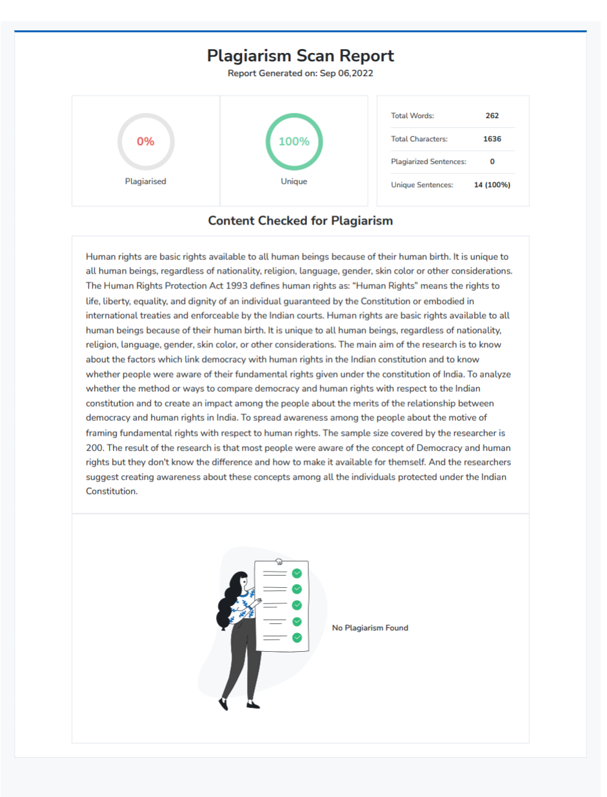

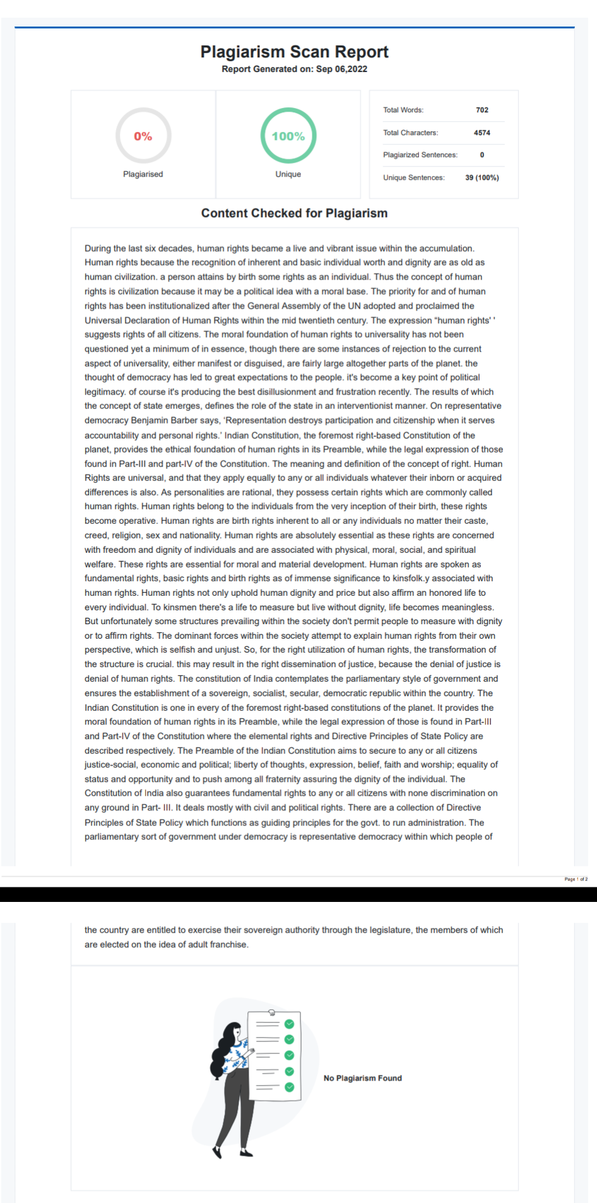

4th-year BBA, LLB(Hons), Saveetha School of Law, Saveetha Institute of Medical and Technical Sciences (SIMATS),

