EXPERIMENTAL RESEARCH ON THE ANALYSIS OF A WASTE HEAT HARVESTING SYSTEM USING A THERMO-ELECTRIC GENERATOR AND AN AUTOMATIC CATALYTIC CONVERTER

Rone¹, Himani Yadav², Himanshu Kumar³
¹Assistant Professor FCEM College, faridabad
²Research Scholar FCEM College, faridabad
³Research Scholar FCEM College, faridabad

---------------------------------------------------------------------***---------------------------------------------------------------------
Abstract - Current scenario concerns include increasing world power consumptions and raising greenhouse heat emission posing serious considerations. Thermoelectric energy conversion incorporates direct energy conversion from heat sources to electric energy conservation. It incorporates direct energy conversion from heat sources to electric energy conservation and the underlying physical into rapid effect has been well recovered in this past century. The thermoelectric effect is that the use of temperature differences to electric voltage creation and vice versa. A considerable amount of primary fuels could be stored if some of the waste heat generated from Ovens, Kilns, Boilers, Furnaces, IC engines etc. are recovered through waste heat generating system. In a diesel engine, substantial energy (10 to 30%) is lost through the engine exhaust gas as waste heat. It means a large fraction of the fuel energy remains untapped and gain of energy from waste heat is appreciable. This waste heat can be used for generating the thermoelectric power by using thermoelectric materials. Recently, the "nanoparticle-in- nanocomposite" is formulated to enhance thermoelectric characteristics which augment the interface scattering of photons for reducing the lattice as well as bipolar thermal conductivities. The high-energy ball-milling is an effective methodology to produce thermoelectric nanocomposites in large scale. The desirable characteristics of the thermoelectric materials are high Seebeck coefficient, high conductivity and low thermal conductivity.

Key Words: TEG, Thermo-electric generator, See-beck effect

1.INTRODUCTION

In recent decades, human activities such as deforestation and construction have its significant impact on the atmosphere and the energy absorbed by the distribution market is increasing each year, because of the growth in the industrial disciplines. Although highly environmental user friendly, efficient and cleaner battery such as artificial recovered systems are used to alter the number of ways to provide latent heat, the consumption and reliance on electricity generated from coal have still increased to synchronize with the vehicle expansion year by year. It is allowed to pass through the environment without being reused for its usefulness or economic values. The value of the heat generated is to be considered rather than its amount. The mechanism to recover the unused heat depends on the temperature of the waste heat gases. Large quantities of hot flue gases are generated from diesel engine, boilers, kilns, ovens and furnaces. This chapter briefly describes various methods to extract and utilize the waste heat from automobile spares. While some waste heat losses from industrial processes are inevitable, facilities can reduce these losses by improving equipment efficiency or installing waste heat recovery technologies (Diffey 1991) year .of the Automobile sectors. The Indian authorities promised a 7.1% reduction in greenhouse gasses from 2017 in keeping with the "Prathama green yochana system" succeeding in Gujarat. Preparations are made in order to reach the aforementioned reduction target in the legal arena, through such efforts as an amendment to the Energy Conservation Law. This legislation demands action, such as the entry of energy consumption reports on the part of individual industries, with the duties executed on company operators and franchise operators participated in convenience shop and dining businesses on a scale that surpasses a certain level, to manage energy consumption.
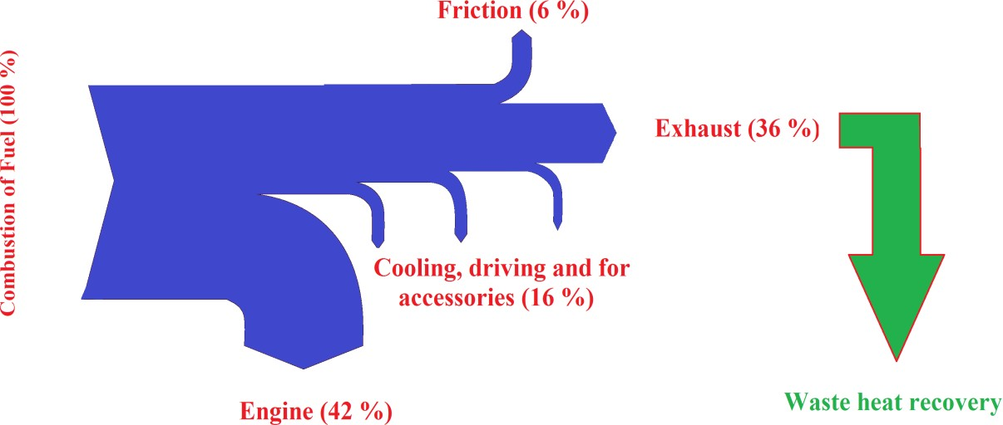
The typical energy balance flow chart of the diesel Engine is given in Figure 1.1 in which considerable portion of the heat is lost (about 36 %) as exhaust.
Figure 1.1 Typical heat balance of diesel engine systems

1.2. NEED FOR WASTE HEAT RECOVERY SYSTEM

The waste heat can be generated from fuel combustion or chemical reaction, and then deserted into the surroundings as it is not reusable again. The hot flue gases are generated from Ovens, Kilns, Boilers, Furnaces, IC engines etc. If some of the waste heat could be regained thereby the considerable amount of primary fuels could be stored. The waste heat can't be fully recovered. However, a considerable amount of the heat could be recovered through waste heat generating system.

1.3. BENEFITS OF WASTE HEAT RECOVERY SYSTEM

The uses of waste heat include generating electricity, preheating combustion air, preheating furnace loads, absorption cooling and space heating. The direct and indirect benefits of the waste heat recovery are given below,
It is also necessary to evaluate the selected waste heat recovery system on the basis of financial analysis such as investment, depreciation, payback period, the rate of return etc.
1.4. Thermoelectric Generators

Generally, it consists of many N-type and P-type semiconductors which are connected thermally in parallel and electrically in series (Figure 1.2). A voltage is generated when one side of the TEG is cooled and the other side is heated.
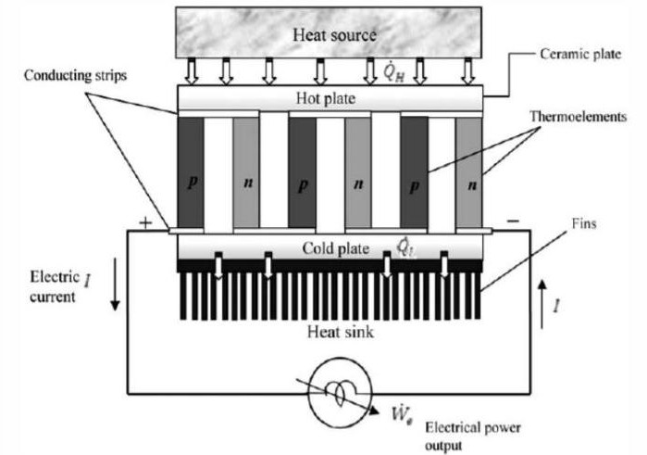
Figure 1.2 Typical Single-Stage Thermoelectric Power Generator
It generates electrical energy from any temperature difference and their efficiency depends on the temperature difference. Generally the efficiency of TEG system is less than 3%. Another factor which can be used to compare the efficiencies of different TEGs which are operating at same temperatures is their electric figure of merit (ZT).

1.5. THERMOELECTRICITY

The thermoelectric effect is a phenomenon in which either temperature variation produces an electric energy, and vice versa. It is specifically known as the Seebeck effect. The electric energy is generated due to the temperature difference between the junctions. And its proportionality constant is known as the Seebeck coefficient, is also known as the thermoelectric power. The desirable characteristics of the thermoelectric materials are huge Seebeck co-efficient, squat thermal conductivity and high electrical conductivity. The Seebeck voltage does not contingent on the supply of temperatures across the metals and between the junctions.

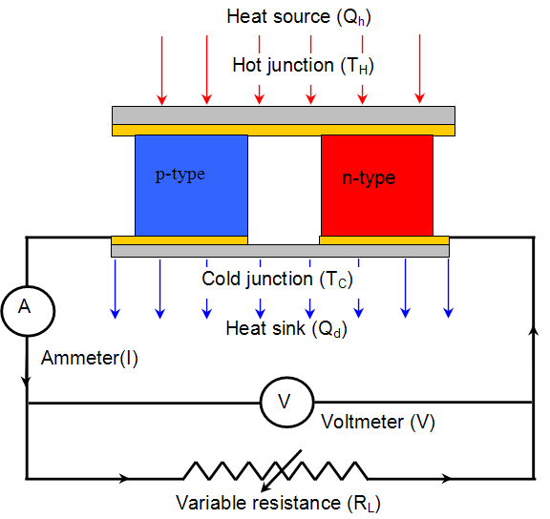

Figure 1.3 Thermoelectric Generator

The electric energy is generated due to the temperature difference between the junctions and its proportionality constant is known as the Seebeck coefficient or thermoelectric power or thermoelectricity (Kim and Choi 2008). The first commercial Thermo Electric generator has been launched in 1925 in the name "Thermattaix" and it is shown in Figure 1.3
The thermoelectric generator comprises p-type semi-conductors combined metal plate. If the junctions of b and a are maintained at different temperatures T1 and T2 at which T1> T2,an open-circuit electromotive force (emf) is induced in the circuit. The figure of merit is proportional to the efficacy of the device. Values of ZT=1 are deemed great, and worth of ZT is about 3-4 which would be considered for further applications.

1.6. COMMERCIAL TEG SYSTEMS

Some of the commercially available TEG systems of automobile are given below,
The BMW uses a 750W energy capacity shell and tube type of TEG heat exchanger.
The Ford uses many small parallel channels lined heat exchanger with thermoelectric material at the exhaust gas flow regimes that produces approximately 400W power.
The Renault uses a counter flow heat exchanger arrangement, using liquid cooling in a diesel truck engine.
The Honda uses thin flat rectangular TEGs with the liquid cooling system that produced a maximum energy of about 500W. The claimed fuel consumption reduction is less than 3%.
In this study, thermoelectric generator is placed over the automobile catalytic converter and its thermoelectric power production capability is experimentally investigated.

1.7. CATALYTIC CONVERTER OF THE DIESEL ENGINE
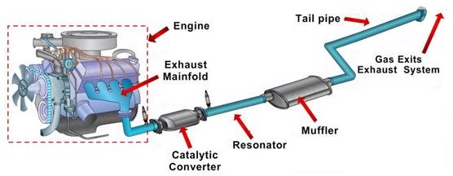
Figure 1.4 Automobile Catalytic Converter

A catalytic converter is a vehicle emissions control system which converts toxic by-products of an internal combustion engine into less toxic substances by way of catalyzed chemical reactions. The catalytic converter
assembly consists of inlet/outlet pipes/flanges, steel housing, insulation material, seals, inlet/outlet cones, substrate(s), coating and sensor boss (Figure 1.4).

1.8. Oxidation Catalyst

The oxidation catalyst is the second stage of the catalytic converter. It reduces the unburned hydrocarbons and carbon monoxide by burning (oxidizing) them over a platinum and palladium catalyst. This catalyst aids the reaction of the CO and Hydrocarbons with the remaining oxygen present in the exhaust gas (Equation 1.2) and also Oxidation of hydrocarbons into carbon dioxide and water (Equation 1.3).
2CO + O2 2CO2 (1.2)
CxH4x + 2xO2 → xCO2 + 2xH2O (1.3)
In this study, thermoelectric generator is placed over the automobile catalytic converter and its thermoelectric power production capability is experimentally investigated.

- METHODLOGY

The exhaust gas temperature of the diesel engine varies with speed and load where elevated load and speeds generate maximum temperatures. It is about 500°C to 700°C (932°F to 1293°F) at 100% load and 200°C to 300°C (392°F to572°F) at no load. This waste heat can be used for generating the thermoelectric power by using thermoelectric materials. The thermoelectric generator is solid- state devices that directly convert thermal energy into electrical energy based on thermoelectric effects. Recently, the "nanoparticle-in-nanocomposite" is formulated to enhance thermoelectric characteristics which augment the interface scattering of photons for reducing the lattice as well as bipolar thermal conductivities. An efficient semiconductor must be selected with that nanomaterials can be added to enhance their thermoelectric characteristics at different temperatures. The semiconductor having the added nanomaterials is referred as nanocomposite
The predominant characteristics of the thermoelectric materials are huge Seebeck co-efficient, minimum thermal conductivity and high electrical conductivity. The efficiency of a nanocomposite is estimated by their thermoelectric figure of merit. The thermoelectric power production capabilities of the nanocomposite are estimated in natural convection, forced convection, air cooled and liquid cooled regimes.
Further, the effectiveness of the fabricated nanocomposite is evaluated by using the exhaust gas temperature of the diesel engine.

  - THERMOELECTRIC POWER OF AIR AND LIQUID COOLEDNANOCOMPOSITE HEAT SINK

The sources of waste heat include hot combustion gases discharged to the atmosphere, heat exiting during industrial processes and heat from the surface of the hot equipment’s. The various studies estimated that about 10% to 30% of diesel engine energy consumption is discharged as waste heat. While some waste heat losses from industrial processes are inevitable, facilities can reduce these losses by improving equipment efficiency or installing waste heat recovery technologies.
The rectangular fins added nanocomposite plate heat sink is only considered for the further study as it produces maximum thermoelectric efficiency.
Maximum thermoelectric efficiency of 3 vol.% of TiO2 added Bismuth Telluride/Titanium Dioxide/Graphene oxide nanocomposite was observed as 2.65 % (section 5.5). In this chapter, air as well as liquid cooling is further employed to enhance the thermoelectric efficiency.
The study on the thermoelectric efficiency of the rectangular fins added Bismuth Telluride/Titanium Dioxide/Graphene oxide nanocomposite in air and water cooled conditions regimes are presented in this chapter.

  - AIR COOLED HEAT SINK
The ultimate objective of this study is to generate thermoelectric power from the waste heat produced by the diesel engine driven automobiles.The thermoelectric efficiency mainly depends on the temperature difference between its hot and cold junction in which temperature of the cold junction plays a vital role. The forced convective 3 vol.% of TiO2 added Bismuth Telluride/Titanium Dioxide/Graphene Oxide nanocomposite heat sink is employed with an axial fan and temperature controller is presented in the Figure 1.5
In this section, cool air is forced by the axial fan at the cold junction of the Bismuth Telluride/Titanium Dioxide/Graphene oxide nanocomposite plate heat sink for getting lowest temperature. The air is cooled by the evaporator of the automobile through the process such as compression, condensation and expansion. The mass flow rate, pressure and temperature of air are controlled to estimate its performance. By using the temperature controller, the inlet air temperature is adjusted in the range of 400 K to 550K by a PID controller

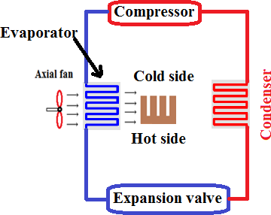
Figure 1.5 Air cooled nanocomposite heat sink

  - WASTE HEAT HARVESTING SYSTEM ANALYSIS BY THERMO-ELECTRIC GENERATOR USED IN AUTOMOBILE CATALYTIC CONVERTER
Current scenario concerns include increasing world power consumptions and raising greenhouse heat emission posing serious considerations. Thermoelectric energy conversion incorporates direct energy conversion from heat sources to electric energy conservation. Automobile thermoelectric energy production is one of the procedures of turning vehicle radiation into usable electric energy through energy conversion that is overburdened through Seeback effect. This phase, briefly describes the possibilities of developing waste heat recovery from automobile catalytic converter using Bismuth Telluride/Titanium Dioxide/Graphene Oxide nanocomposite heat sink having rectangular fins.

  - BISMUTH TELLURIDE/TITANIUM DIOXIDE/GRAPHENE OXIDE NANOCOMPOSITE HEAT SINK ADDED CATALYTIC CONVERTER

In vehicles, exhaust gas is emitted to the environment. By applying a thermodynamic process, the heat of the exhaust gas can be converted into mechanical power for the vehicle. The ORC is a very promising technology for the recovery of engine waste heat. The mechanical energy generated by the Rankine process can be directly delivered to the engine or the expansioncatalytic converter is an emission control apparatus that reduces poisonous gases and pollutants in the exhaust gas of an internal combustion engine. In an ideal converter, the flow at the departure of the inlet diffuser would be uniform and, thus, would be evenly distributed to each of monolith passages of the catalytic converter. Before testing the actual concentrator thermoelectric generator, it was crucial to establish an experiment to analyze the traits of single nanocomposite cells and to generate a specification of all the parameters like thermal status of the cells, heat transfer condition and power output. The catalytic converter, whose depth is 200 mm and thickness is 5 mm, is a casing with a 50 mm radius. the muffler, whose depth is 150 mm and thickness is 5 mm, is an elliptic cylindrical casing having a43 mm and 70 mm radius modeled in Solid works.
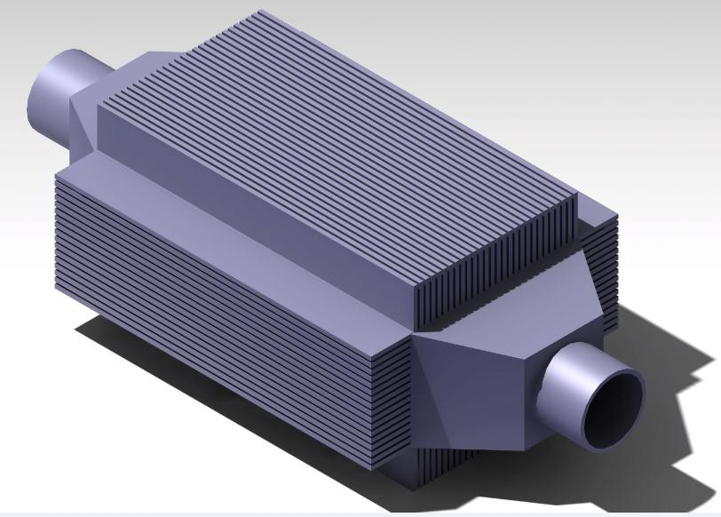
Figure 1.6 Catalytic converter in solid works

  - FORCED CONVECTIVE PERFORMANCE TESTING CONFIGURATION

The forced convective Bismuth Telluride/Titanium Dioxide/Graphene Oxide nanocomposite heat sink is employed with the catalytic converter which consists of an axial fan, nanocomposite heat sink with the rectangular fins, data logging system, electrical load controller, thermocouple, temperature controller and the configuration of test bench is presented in the Figure 1.6.
The mass flow rate (vortex flow meter) of inlet air is maintained at 4 m3/min by using the rotary switch.
The temperature difference between inlet and outlet is recorded on the data logger using K-type temperature sensor.
The vortex flow meter and K-type temperature sensor is attached with pipes using flange.
The usable electric energy through energy conversion that is overburdened through Seeback effect is recorded and its power is estimated.
Furthermore, the power output is the key parameter to estimate the characteristics of Bismuth Telluride/Titanium Dioxide/Graphene Oxide nanocomposite rectangular fin heat sin
Figure 1.6. Forced convective nanocomposite heat sink employed automobile catalytic converter test bench
The experimental procedure for estimating the thermal performance of this nanocomposite automobile catalytic converter test bench is described below,
The mass flow rate, pressure and temperature of air are controlled to estimate its performance.
By using the temperature controller, the inlet air temperature is adjusted in the range of 400 K to 550K by a proportional– integral–derivative (PID) controller.
- SUMMARY

Thermoelectric materials are utilized for power generation by using thermo-electric devices that occurs even at relatively normal temperature differences. The catalytic converter is an emission control apparatus that reduces poisonous gases and pollutants in the exhaust gas of an internal combustion engine. The maximum temperature difference is generated from the forced convective rectangular fin added Bismuth Telluride/Titanium Dioxide/Graphene Oxide nanocomposite heat sink. Hence, it is employed with the catalytic converter of automobile for generating the thermoelectric power is reported in this chapter

- CONCLUSION

The exhaust gas temperature of the diesel engine varies with speed and load where elevated load and speeds generate maximum temperatures (300- 500°C) which are used for generating the thermoelectric power by using thermoelectric generator. A single thermoelectric Bismuth Telluride/Titanium Dioxide/Graphene oxide nanocomposite cell is formulated and investigated the possibility of using as a thermoelectric device for power generation from automobile energy source. The experimental results exhibits that the addition of a small percentage of Graphene oxide (1.5 vol.%) improves the electrical conductivity and Titanium dioxide nanomaterials (1-3 vol.%) reduce the thermal conductivity of Bismuth Telluride (ZT between 0.8-1).
The thermoelectric property results of different volume percentages of Titanium Dioxide added Bismuth Telluride/Titanium Dioxide/Graphene oxide nanocomposites it can be concluded that 3 vol.% of TiO2 added nanocomposite has a maximum electrical conductivity (955-1620 S/cm), Seebeck co-efficient (-102 to -111.4 µV/K) and figure of merit (1.725- 3.09) in the measured temperature regime (300-600 K). The efficiency of a nanocomposite is estimated by their thermoelectric figure of merit (ZT). Further, 2 cm thickness of water cooled rectangular fin added nanocomposite heat sink produces maximum thermoelectric efficiency (3%) than a plate heat sink (2.9%) and cylindrical fins added nanocomposite heat sink (2.8%) and it is employed with the catalytic converter for generating the thermoelectric power. The watecooled forced convective Bismuth Telluride/Titanium Dioxide/Graphene Oxide nanocomposite heat sink is also employed with the catalytic converter for thermo-electric power generation in which the maximum power output of about 19 W is observed at the load resistance of 25 Ω. This electric energy can be stored in a battery and fed to the vehicle’s electrical system. The experimental outcome of this thesis can provide referable evidence in the means of studying and developing further mechanisms in renewable energy conversion system.

- FUTURE SCOPE

With the recent energy crisis, researchers and industries are looking methods of handling energy in a better way which demands the use of generators. Thermo electric generators are now used to produce energy from intensive environments by optimizing the design of generators. Then a nanocomposites produce superior thermoelectric performances than their base stock like great ZT and energy output, which will play a significant role in many industrial applications. However, in spite of the ongoing efforts, their low conversion efficiency currently limits the application of thermoelectric devices to a few highly specialized niches.

- References

- Ahmad, K, Pan, W & Wu, H. 2015, ‘High performance alumina based graphene nanocomposites with novel electrical and dielectric properties’. RSC Advances, vol. 5, pp. 33607-33614.
- Ahmad, K, Wan, C, Al-Eshaikh, MA & Kadachi, AN. 2019, ‘Enhanced thermoelectric performance of Bi2Te3 based graphene nanocomposites’. Applied Surface Science, vol. 474, pp. 2-8.
- Ahmad, S, Singh, A, Bohra, A, Basu, R, Bhattacharya, S, Bhatt, R, Meshram, KN, Roy, M, Sarkar, SK & Hayakawa, Y. 2016, ‘Boosting Thermoelectric Performance of p-Type SiGe Alloys through in-situ Metallic YSi2 Nanoinclusions’. Nano Energy, vol. 27, pp. 282–297.
- Ali, E, Firdaus B, Thamir, KI, Khairul, H, Hassan, I & Daing, MNDI. 2017, ‘A review on heat sink for thermo-electric power generation: Classifications and parameters affecting performance’. Energy Conversion and Management, vol. 134, pp. 260–277.
- Arash, MD, Mona, Z, Jian, H & Terry, MT. 2015, ‘Thermoelectric power factor: Enhancement mechanisms and strategies for higher performance thermoelectric materials’. Materials Science and Engineering R, vol. 97, pp. 1–22.
- Bathula, S, Jayasimhadri, M, Gahtori, Kumar, A, Srivastava, AK & Dhar,2017, ‘Enhancement in Thermoelectric Performance of SiGe Nanoalloys Dispersed with SiC Nanoparticles’. Physical Chemistry Chemical Physics, vol. 19, pp. 25180–25185.
- Beibei, L, Zijun, S, Minghui, W, Lianjun, W & Wan, J. 2013, ‘Fabrication and Thermoelectric Properties of Graphene/Bi2Te3, Composite Materials’. Journal of Nanomaterials, vol. 2013, No. 210767.
- Bittner, M, Kanas, N, Hinterding, R, Steinbach, F, Groeneveld, D, Wemhoff, P, Wiik, K, Einarsrud, MA & Feldhoff, A. 2019, ‘Triple-phase
- Ceramic 2D Nanocomposite with Enhanced Thermoelectric Properties’. Journal of the European Ceramic Society, vol. 39, pp. 1237–1244.
- Bittner, M, Kanas, N, Hinterding, R, Steinbach, F, Rathel, J, Schrade, M, Wiik, K, Einarsrud, MA & Feldhoff, A. 2019, ‘A Comprehensive Study on Improved Power Materials for High-Temperature Thermoelectric Generators’. Journal of Power Sources, vols. 410-411, pp. 143–151.
- Bo, Y, Mona, Z, Hui, W, Kevin, L, Hengzhi, W, Dezhi, W, Cyril, O, Mildred, D, Gang, C & Zhifeng, R. 2012, ‘Enhancement of Thermoelectric Properties by Modulation-Doping in Silicon Germanium Alloy Nanocomposites’. Nano Letters, vol. 12, pp. 2077−2082.
- Bocher, L, Aguirre, MH, Logvinovich, D, Shkabko, A, Robert, R, Trottmann, M & Weidenkaff, A 2008, ‘CaMn1-xNbxO3 (x < 0.08) Perovskite-Type Phases As Promising New High-Temperature n-Type Thermoelectric Materials’. Inorganic Chemistry, vol. 47, pp. 8077–8085.
- Broido, DA & Reinecke, TL. 2001, ‘Recent Trends in Thermoelectric Materials Research III, Semiconductors and Semimetals’. Academic, New York, vol. 71, pp. 123–155.
- Brown, SR, Kauzlarich, SM, Gascoin, F & Snyder, GJ. 2006, ‘Yb14MnSb11: New High Efficiency Thermoelectric Material for Power Generation’. Chemistry of Materials, vol. 18, pp. 1873–1877
- Bumroongsri, P, Witchayanuwat W& Kheawhom, S. 2013, ‘Experimental Heat Transfer Coefficients of Waste Heat Recovery Unit in Detergent Manufacturing Process’. Experimental Heat Transfer, vol. 26, pp. 114-125.
- Culp, S, Poon, R, Hickman, SJ, Tritt, N & Blumm, TM. 2006, ‘Effect of substitutions on the thermoelectric figure of merit of half-Heusler phases at 800 °C’. Applied Physics Letters, vol. 88, No. 042106.
- Curtin, BM, Codecido, EA, Kramer, S & Bowers, JE. 2013, ‘Field-Effect Modulation of Thermoelectric Properties in Multigated Silicon Nanowires’. Nano Letters, vol. 13, pp. 5503-5508.
- Dae, HL., Jae, SP, Mi, RR & Jeong, HP. 2013, ‘Development of a highly efficient low-emission diesel engine-powered co-generation system and its optimization using Taguchi method’. Applied Thermal Engineering, vol. 50, no. 1, pp. 491-495

