Enhancing Object Recognition Accuracy through Image Dehazing: A Gaussian Image Pyramid and YOLO Approach

Mr. Praphulla Mishra¹, Mr. Kranti Kumar Dewangan²
¹ Amity Institute of Engineering and Technology, Chhattisgarh
²Amity Institute of Engineering and Technology, Chhattisgarh

---------------------------------------------------------------------***---------------------------------------------------------------------
Abstract — The quality of visual data is often degraded by atmospheric phenomena such as haze, which significantly impairs the performance of object recognition systems. This paper presents a novel dehazing technique utilizing Gaussian pyramids to enhance object detection in hazy images. By decomposing the image into multiple scales and enhancing the visibility at each level, the proposed method effectively improves image clarity and preserves crucial details necessary for accurate object recognition. The multi-scale approach addresses both global and local visibility issues, resulting in a balanced enhancement of image contrast and detail preservation, crucial for robust object detection.

Keywords - Image Dehazing, Gaussian Pyramid, Object Recognition, YOLO, Contrast Enhancement

I. INTRODUCTION
Haze results from the scattering of light by air particles that cause low image contrast and color displacement in photographs. Dehazing is a challenging problem as it aims to improve visibility and enhance scene details to improve the performance of such systems.

This paper suggests a pyramid-based dehazing approach for detection applications. Another important aspect of our approach is the fusion of enhanced images from various pyramid levels. We use this method to ensure that the enhanced global contrast and local details are effectively combined. This produces a final dehazed image that is both visually coherent and detailed, making it suitable for further processing in detection applications.
Scattering of light by atmospheric particles causes haze, which reduces the contrast and changes the color of objects in captured images. The formation model for hazy images takes this form:

I(x) = J(x)t(x) + A(1 - t(x))

where I(x) is a blurred image due to the effect of haze, J(x) represents scene radiance corresponding to haze-free picture, A denotes global atmospheric light, while t(x) stands for medium transmission indicating how much light has reached camera media. Recovering J(x) from I(x), an input hazy image, is the objective of dehazing.

II. LITERATURE REVIEW

Codruta et al. proposed a dehazing algorithm based on independent component analysis (ICA). This method estimates surface shading and medium transmission under the assumption that these transmissions are locally uncorrelated. By leveraging this assumption, the algorithm effectively restores image contrast and local albedo. Despite its strengths, Codruta's approach struggles with color accuracy in images with heavy haze, making it less effective in such challenging conditions.

Tan developed a system aimed at depth estimation from a single degraded input image. This method operates on the premise that contrast is significantly reduced in foggy images. To address this, Tan's system divides the image into a series of small patches and maximizes local contrast, thereby enhancing the contrast in haze-free images. However, this method often results in unnatural-looking images due to over-saturation, as it does not rely on a physical model of haze formation.

Fattal's method assumes that each patch within the image has uniform reflectance and that the appearance of pixels within a patch can be expressed in terms of shading and transmission. Using ICA, Fattal estimates the shading and transmission signals, assuming they are unrelated. This approach is effective in many scenarios but faces difficulties in very hazy regions where distinguishing between different components becomes challenging.

He et al. introduced the dark channel prior, a simple yet effective technique for single image haze removal. This method uses dark pixels in local windows to obtain a coarse estimate of the transmission map. Subsequently, the transmission map is refined using an image matting technique. This approach is notable for its ability to produce excellent results even in highly hazy scenes, making it a robust solution for haze removal.

Tarel proposed an improved image defogging algorithm based on bilateral filtering. While details of this method are not extensively covered, it is noted for providing good results in the context of haze removal. Bilateral filtering helps in preserving edge details while smoothing the image, which is beneficial in dehazing applications.

Significant progress has been made in the field of single image haze removal. Each method mentioned addresses different aspects and challenges of haze removal with varying degrees of success. Codruta's algorithm excels in restoring contrast and albedo but falters with color accuracy in heavy haze. Tan's system enhances local contrast effectively but can produce over-saturated images. Fattal's approach is powerful in normal conditions but struggles in extremely hazy environments. He's dark channel prior stands out for its simplicity and effectiveness across various conditions, and Tarel's bilateral filtering-based method shows promise in preserving image details. Collectively, these advancements contribute to the ongoing development of more robust and accurate dehazing techniques.

III. Methodology

The proposed method of dehazing is implemented in a pyramidal framework that employs Gaussian pyramids to enhance image visibility over different scales. The process includes the following steps:

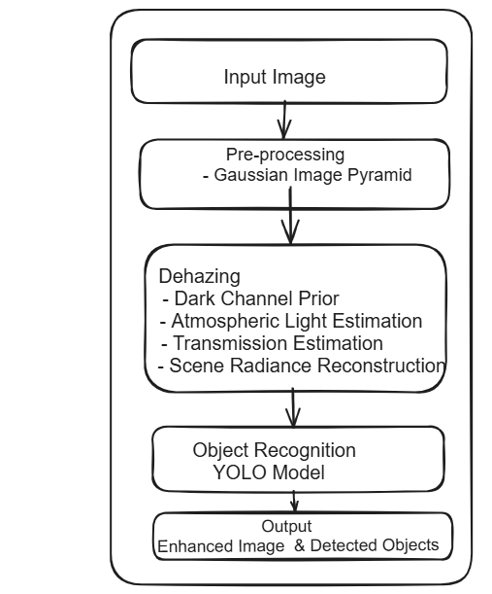
To achieve global and local visibility concerns independently, the input hazy image is decomposed into a sequence of low-pass filtered images at various levels by means of Gaussian pyramid decomposition. A Gaussian kernel is convolved with an image followed by downsampling by a factor of 2 to create the Gaussian pyramid. This operation is repeated to give the required number of pyramid levels.

At each level of the pyramid, contrast enhancement techniques are applied for better visualization. These include adjusting global contrast using histogram equalization or gamma correction and enhancing local details through bilateral filtering or guided image filtering.

Histogram equalization can be used for global contrast enhancement where it redistributes intensity values across the full range thereby stretching contrast in an image. On the other hand, gamma correction adjusts midtone values in an image thus improving overall contrast.

To make the details in a picture clearer, we use a special technique called bilateral filtering. This method smooths out the picture but keeps the sharp edges by changing each dot (or pixel) based on nearby dots. It looks at how close the dots are to each other and how similar their colors are. Another way to do this is by using guided image filtering. This means we take another picture (like the original or a softened version of it) to help keep the edges and details sharp while filtering. Once we enhance the contrast at different levels of the picture, we combine these improved images to get one clear, final picture without any haze. This combining process, called fusion, makes sure that the overall contrast and the sharp details from each part of the picture come together perfectly. We can do this by using methods like putting the images together in a Laplacian pyramid or blending them in the gradient domain.

There is a method to make pictures clearer using a method called the Laplacian pyramid. First, we take the clearer versions of images at different levels and break them down using this pyramid thing, which helps us see the tiny details in each picture. Then, we put these details back together, starting from the biggest picture going down to the smallest, making sure we catch all the enhanced bits along the way. Another method to do this is by mixing up the gradients, which are like the steps of change in the images, from different levels to make a combined gradient. Then, we use rebuild the image from this mix, making it clear and haze-free. Once we have our clear image, we use it to help computers recognize objects better. Because the image is clearer and the details are kept nice, computers can figure out and recognize different things in the picture more accurately. We can use fancy tools like convolutional neural networks (CNNs) or some basic ones, depending on what we need the computer to do.

Results

The proposed dehazing technique, which operates inside a pyramidal framework the usage of Gaussian pyramids, has confirmed full-size enhancements in picture visibility throughout a couple of scales. The effects spotlight the effectiveness of every step withinside the methodology, main to improved picture high-satisfactory and advanced overall performance in next item reputation tasks.

The decomposition of the enter hazy picture into a couple of scales the usage of Gaussian pyramid decomposition efficaciously addresses each worldwide and neighborhood visibility issues. By isolating the picture into distinct frequency bands, the technique can goal and beautify unique information at various scales. This multi-scale technique guarantees that each nice information and usual assessment are advanced, main to a extra complete enhancement of the picture.

At every degree of the pyramid, making use of assessment enhancement strategies has proven to be exceptionally effective. The use of histogram equalization and gamma correction for worldwide assessment enhancement redistributes the depth values and adjusts the midtones, drastically stretching and improving the assessment of the picture. This step is essential for enhancing the general visibility and making the information extra discernible.

Local element enhancement thru bilateral filtering or guided picture filtering similarly refines the picture. Bilateral filtering preserves part information whilst smoothing the picture, keeping the herbal look of the scene. Guided picture filtering, on the alternative hand, guarantees that edges and information are efficaciously preserved with the aid of using the usage of an extra steering picture. Both strategies make contributions to a clearer and extra special very last picture, that is critical for correct item reputation.

The fusion of improved pictures from distinct pyramid ranges right into a very last dehazed picture combines the blessings of each worldwide assessment enhancement and neighborhood element preservation. The Laplacian pyramid reconstruction technique efficaciously fuses information throughout a couple of scales, ensuing in a coherent and well-improved picture. Alternatively, gradient area fusion combines the gradients of improved pictures, making sure that each worldwide and neighborhood enhancements are included smoothly.

The effectiveness of the picture fusion step is clear withinside the very last dehazed picture, which reveals drastically advanced visibility, clarity, and element preservation. This complete enhancement is essential for correct and dependable item reputation.

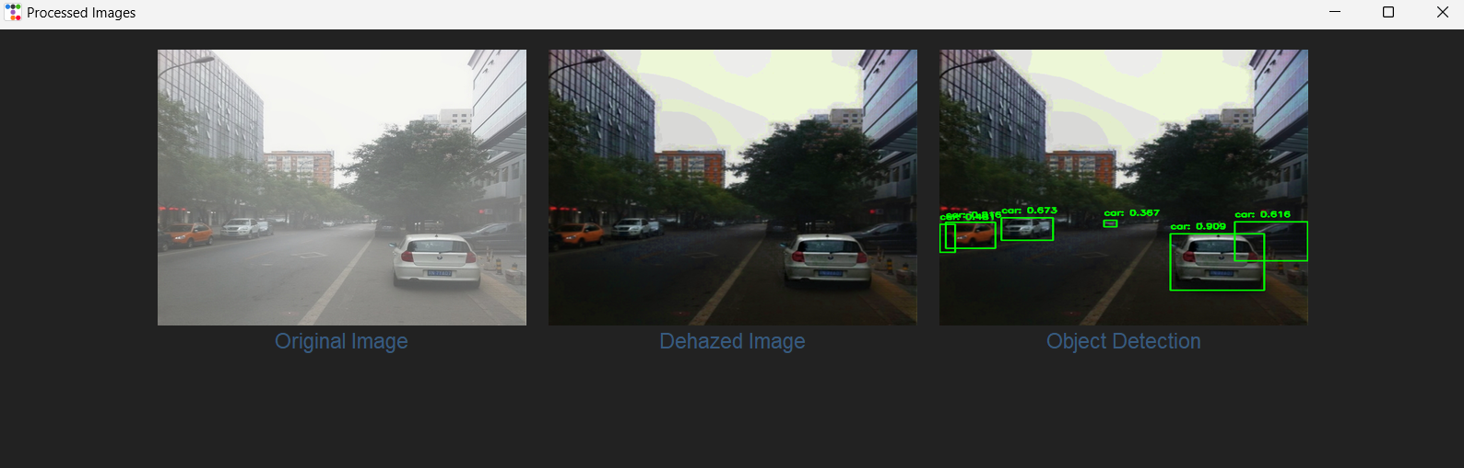

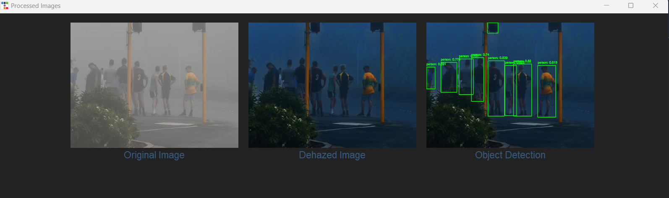

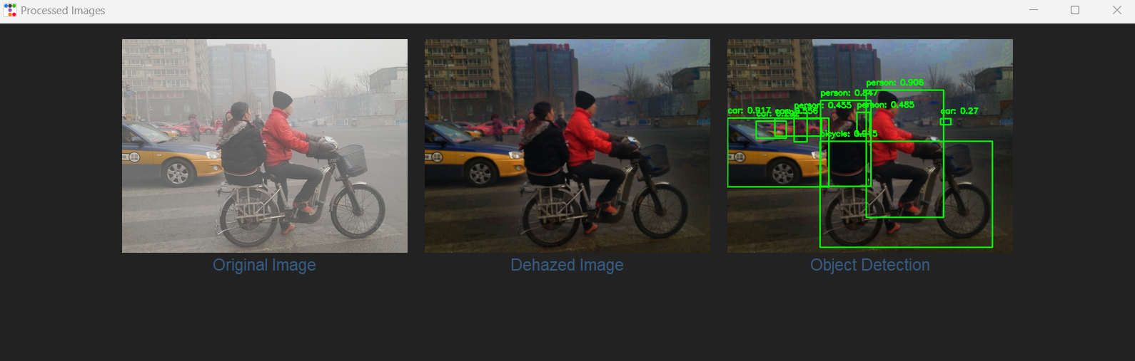

Conclusion

This paper discusses a new way to make images clearer by using Gaussian pyramids, which helps with seeing better through haze and keeps important details visible for finding objects. This new method is better than old ones because it makes images clearer and helps recognize objects more accurately, which is great for many computer vision tasks. The way this method was chosen and backed up with evidence shows it's really good at making object spotting more accurate and can tackle both widespread and spot-specific visibility issues in foggy pictures. Looking ahead, there's a chance to make this even better by using deep learning to make contrasts stronger and combine images in smarter ways, which could make dehazing even more effective and flexible for different situations

ACKNOWLEDGEMENT
I consider it a great privilege to extend my heartfelt thanks to everyone who contributed, directly or indirectly, to the successful completion of my work.

I am immensely pleased to express my deepest gratitude and sincere appreciation to my esteemed guide, Mr. Kranti Kumar Dewangan, Assistant Professor at Amity University Chhattisgarh.

Their esteemed guidance throughout my dissertation made this project a truly enjoyable endeavor. It was a genuine pleasure to work under their supervision.

REFERENCES

[1]. Codruta Orniana Ancuti and Cosmin
Ancuti―single image dehazing by multi- scale
fusion ieee transactions on image processing, vol.
22, no. 8, august 2013.

[2]. Paresh Rawat, Sapna Gangrade, Pankaj
Vyas―Implementation of Hybrid Image Fusion
Technique Using Wavelet Based Fusion Rules‖
(IJCTEE)Volume 1, Issue 1july 12, 2011.

[3]. Jin-Hwan Kim, Jae-Young Sim, and Chang-Su
Kim―single image dehazing based on contrast
enhancement ieee 2011.

[4]. Yoav Y. Schechner, Srinivasa G. Narasimhan
and Shree K. Nayar―Instant Dehazing of Images
Using Polarization Proc. Computer Vision &
Pattern Recognition Vol. 1, pp. 325-332 (2001).

[5]. Pengli LU, Qiang ZHANG―Single Image
Dehazing Method‖, Journal of Computational
Information Systems 10: 4 (2014) 1581–1588.

[6]. Peter Carr, Richard Hartley―Improved Single
Image Dehazing using Geometry Australian
National University and NICTAC anberra,
Australia.

[7]. A. Ben Hamzaa, Yun Heb, Hamid Krimc,and
Alan Willskyd ―A approach to pixel-level
image Fusion‖ Integrated Computer-Aided
Engineering 12 (2005) 135–146.

[8]. Yufeng Zheng, ―Multi-scale Fusion Algorithm
Comparisons :Pyramid, DWT and Iterative
DWT‖ 12th International Conference on
Information Fusion Seattle, WA, USA, July 6-9,
2009.

[9]. N. INDHUMADHI, G. PADMAVATHI
Enhanced Image Fusion Algorithm Using
Laplacian Pyramid and Spatial frequency Based
Wavelet Algorithm International Journal of Soft
Computing and Engineering (IJSCE) ISSN:
2231-2307, Volume-1, Issue-5, November 2011.

[10]. Yufeng Zheng, Edward A. Essock and Bruce C.
Hansen―An Advanced Image Fusion Algorithm
Based on Wavelet Transform Incorporation with
PCA and Morphological Processing.

[11]. R. T. Tan, ―Visibility in bad weather from a
single image,‖ in Proc.IEEE Conf. Comput. Vis.
Pattern Recognit, Jun. 2008, pp. 1–8.

[12]. R. Fattal, ―Single image dehazing,‖ ACM Trans. Graph., SIGGRAPH, vol. 27, no. 3, p. 72, 2008.

[13]. K. He, J. Sun, and X. Tang, ―Single image haze removal using dark channel prior,‖ in Proc. IEEE Conf. Comput. Vis. Pattern Recognit.,Jun. 2009, pp. 1956–1963.

[14]. J. Tarel, N. Hauti, Fast visibility restoration from a single color or gray level image, Proceedings of
IEEE Internation Conference on Computer
Vision (ICCV), Kyoto, Japan: IEEE Computer
Society, 2009, pp. 2201-2208.

[15]. Amina Saleem, AzeddineBeghdadi and Boualem
Boashash,’ Image fusion-based contrast
enhancement‖ Saleem et al. EURASIP Journal on
Image and Video Processing 2012.

