Hand Gesture Virtual Mouse

Aman Mehra
Acropolis Institute of Technology and Research Indore, India
mehraaman618@gmail.com

Akshat Paliwal
Acropolis Institute of Technology and Research
Indore, India
paliwal08akshat@gmail.com

Akash Patel
Acropolis Institute of Technology and Research
Indore, India aakashppmm@gmail.com

Adarsh Underiya
Acropolis Institute of Technology and Research
Indore, India adarshunderiya805@gmail.com

Abstract— The mouse is one of the exceptional innovations of Human-Computer Interaction (HCI) generation. Currently, wi-fi mouse or a Bluetooth mouse nonetheless uses devices and isn't freed from gadgets absolutely since it makes use of a battery for energy and a dongle to attach it to the PC. In the proposed AI virtual mouse gadget, this trouble may be triumph over by using employing webcam or a built-in digicam for shooting of hand gestures and hand tip detection using laptop vision. The algorithm used inside the device uses the machine learning algorithm. Based at the hand gestures, the pc may be controlled honestly and can perform left click on, right click, scrolling functions, and computer cursor function without the usage of the physical mouse. The set of rules is based on deep gaining knowledge of for detecting the fingers. Hence, the proposed machine will avoid COVID-19 spread through getting rid of the human intervention and dependency of devices to manipulate the laptop. Python programming language is used for growing the AI digital mouse machine, and additionally, OpenCV that's the library for computer imaginative and prescient is used inside the AI digital mouse machine. In the proposed AI digital mouse gadget, the version makes use of the MediaPipe bundle for the tracking of the palms and for tracking of the tip of the fingers, and additionally, Pinout, Autopy, and PyAutoGUI applications have been used for transferring across the window display of the pc for acting functions consisting of left click on, right click, and scrolling capabilities. The effects of the proposed model showed very high accuracy degree, and the proposed model can work very well in real-global software with the usage of a CPU with out the usage of a GPU.

Introduction
With the development technology in the regions of augmented fact and gadgets that we use in our daily existence, those gadgets have become compact inside the form of Bluetooth or wi-fi technology. This paper proposes an AI virtual mouse gadget that makes use of hand gestures and hand tip detection for performing mouse features within the laptop using pc imaginative and prescient. The most important goal of the proposed device is to perform computer mouse cursor functions and scroll function the usage of an internet camera or an integrated camera within the pc rather than the use of a traditional mouse device. Hand gesture and hand tip detection by way of using pc imaginative and prescient is used as a HCI with the laptop. With using the AI digital mouse machine, we will track the fingertip of the hand gesture with the aid of the use of an integrated digicam or internet digital camera and perform the mouse cursor operations and scrolling feature and additionally move the cursor with it. While using a wireless or a Bluetooth mouse, some devices consisting of the mouse, the dongle to connect to the PC, and additionally, a battery to power the mouse to operate are used, however on this paper, the person makes use of his/her integrated digicam or a webcam and uses his/her hand gestures to govern the laptop mouse operations [1].
Project Aim: The fundamental goal of the proposed AI digital mouse gadget is to develop an opportunity to the ordinary and traditional mouse device to carry out and manipulate the mouse functions, and this could be carried out with the assist of an internet digicam that captures the hand gestures and hand tip and then tactics those frames to carry out the precise mouse function which includes left click, proper click on, and scrolling feature.
Problem Statement: The projected AI digital mouse the use of hand signal shape should in like manner be acquainted with beat issues inside the spot like matters wherein there isn't always any space to use a genuine mouse and set up for people who've issues in their grip and do not seem, reputedly, to be prepared to manage a real mouse. Moreover, the COVID situation, it is not safeguarded to include the gadgets by way of accomplishing them as an eventual effects of it is intending to acquire what is going on of spread out of the disease with the aid of achieving the contraptions, that the projected AI virtual mouse ought to in like manner be adjusted vanquished those problems on the grounds that hand signal and hand tip disclosure is used to control the tool mouse limits by way of the use of a digicam or a function camera like webcam. While using a far off or a Bluetooth mouse, more than one gadget specially like the mouse, the contraption to connect with the pc.

Problem identification and need
The contemporary creation contains a nonexclusive mouse and song pad screen manipulate framework, as well as the mishap of a hand development manipulate shape. The utilization of a hand improvement to get to the display from a nice method is impossible. No count what it is essentially attempting to execute, the diploma is just constrained inside the digital mouse field. The cutting-edge digital mouse manipulate shape consists of direct mouse responsibilities utilizing a hand attestation framework, wherein we have a few manipulate over the mouse pointer, left click, proper snap, and drag and many others The utilization of hand confirmation in the destiny may not be utilized. Despite how there are a amassing of frameworks for hand certification, the development they applied is static hand attestation, which is only an affirmation of the shape made by way of the hand and the which means of hobby for every form made, that is restricted to three depicted activities and makes a tremendous deal of unsettling have an effect on. As progression drives, there are something else and more decisions as opposed to making use of a mouse. Coming up next are a chunk of the techniques that were used [2].

Use Of Camera:
Open- CV is python imaginative and prescient library that includes Associate in the prepared AI virtual mouse shape depends upon the rims which might be gotten with the aid of the camera in associate in nursing passing laptop.

Input System:
Pictures in Computer Vision are portrayed as associations of numbers watching out for the discrete eclipsing or power values present in each picture pixel. Each picture is considered as information displayable in various ways, whether as collections of pixel values or either complex plot keeping an eye on the course of pixel powers. [3].

Project Need:

The PC mouse is one of the wondrous developments of people in the field of Human-Computer Interaction (HCI) innovation. In new age of innovation, remote mouse or a contact less mouse actually utilizes gadgets and isn't liberated from gadgets completely, since it utilizes power from the gadget or might be from outside power sources like battery and gain space and electric power, likewise during COVID pandemic it is encouraged to make social separating and keep away from to contact things which gave by various people groups. Inside the projected AI virtual mouse utilizing hand signal framework, this constraint might be resolve by involving advanced camera or sacred camera for perceive the hand motions and fingers recognition abuse PC machine vision. The algorithmic rule used in the framework utilizes the man-made consciousness and AI algorithmic rule. Upheld the hand signals, the gadget might be controlled pretty much and might do left click, right snap, looking over capacities, and PC gadget pointer perform while not the utilization of the genuine mouse [4].

Hand Tracking Algorithm
For the reason of detection of hand gestures and hand tracking, the MediaPipe framework is used, and OpenCV library is used for computer vision. The algorithm uses the system studying ideas to tune and understand the hand gestures and hand tip.

MediaPipe:

MediaPipe is a framework which is used for applying in a machine learning pipeline, and it is an opensource framework of Google. The MediaPipe framework is useful for cross platform development since the framework is built using the time series data. The MediaPipe framework is multimodal, where this framework can be applied to various audios and videos. The MediaPipe framework is used by the developer for building and analyzing the systems through graphs, and it also been used for developing the systems for the application purpose. The steps involved in the system that uses MediaPipe are carried out in the pipeline configuration. The pipeline created can run in various platforms allowing scalability in mobile and desktops. The MediaPipe framework is based on three fundamental parts; they are performance evaluation, framework for retrieving sensor data, and a collection of components which are called calculators, and they are reusable. A pipeline is a graph which consists of components called calculators, where each calculator is connected by streams in which the packets of data flow through. Developers can replace or define custom calculators anywhere in the graph creating their own application. The calculators and streams combined create a data-flow diagram; the graph (Figure 1) is created with MediaPipe where each node is a calculator and the nodes are connected by streams Personal: Everyday users looking for security and privacy storage solutions for personal data, photos, documents and more.
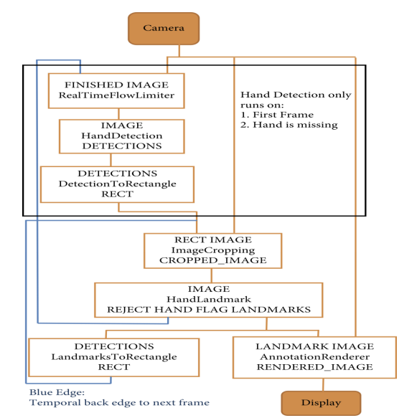
Fig.1. Working model of MediaPipe

Module of Open-CV:
PC vision is an interaction by which we can comprehend the pictures and recordings how they are put away and how we can control and recover information from them. PC Vision is the base or generally utilized for Artificial Intelligence. The primary Open-CV form was 1.0. Open-CV is delivered under a BSD permit and thus it's free for both scholar and business use. It has C++, C, Python and Java connection points and supports Windows, Linux, Mac OS, iOS and Android. At the point when Open-CV was planned the fundamental center was continuous applications for computational productivity.

Methodology
Pre-processing or to be specific picture handling is an earlier advance in PC vision, where the objective is to change over a picture into a structure reasonable for additional investigation. Instances of tasks, for example Openness rectification, shading adjusting, photograph sound decrease, or increasing image sharpness are fantastically full-size and very attention soliciting for to accomplish good enough outcomes. For this article, I propose to introduce part of the usually used image taking care of method the usage of an outstandingly remarkable Computer Vision library, Open-CV. I'll enterprise to portray right away the way by way of which every motion works and highlight more on coping with the factor even extra essentially, giving you all the code you sincerely want so you have a functioning experience of the fabric [5].
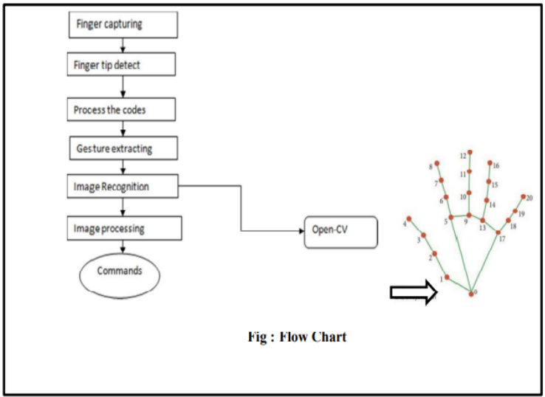
Fig. 2. Working flow for the model
- Use Of Camera in AI Virtual Mouse System:
The proposed AI virtual mouse system is based on the frames that have been captured by the webcam in a laptop or PC. By using the Python computer vision library OpenCV, the video capturable is created and the web camera will start capturing video,

Fingure performing which mouse functions:
In this stage, we are detecting which finger is up using the tip Id of the respective finger that we found using the MediaPipe and the respective co-ordinates of the fingers that are up, as shown and according to that, the mouse function is performed.
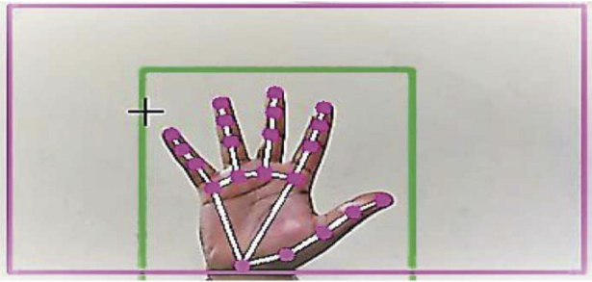
Fig. 3 Hand movement capture

Right Button Click Function:
If both the index finger with tip Id = 1 and the middle finger with tip Id = 2 are up and the distance between the two fingers is lesser than 40 px, the computer is made to perform the right mouse button click using the pynput Python package.

Model Propoosed:
For the characteristic of area of hand signals and hand development, the Media Pipe system is utilized, and Open-CV library is utilized for PC machine vision the standard purposes the AI contemplations to keep and see the hand developments and fingertip.
Pre-processing or to be specific picture handling is an earlier advance in PC vision, where the objective is to change over a picture into a structure reasonable for additional investigation. Instances of tasks, for example, openness rectification, shading adjusting, picture sound decrease, or expanding picture sharpness are exceptionally significant and very consideration requesting to accomplish adequate outcomes. For this article, I propose to introduce a part of the typically used picture taking care of methodology using an outstandingly notable Computer Vision library, Open-CV. I'll endeavor to portray immediately how each movement works and spotlight more on dealing with the point even more basically, giving you all the code you truly need so you have a functioning experience of the material [6].

Analysis of the Model

In the proposed AI virtual mouse system, the concept of advancing the human-computer interaction using computer vision is given. Cross comparison of the testing of the AI virtual mouse system is difficult because only limited numbers of datasets are available. The hand gestures and fingertip detection have been tested in various illumination conditions and been tested with different distances from the webcam for tracking of the hand gesture and hand tip detection. An experimental test has been conducted to summarize the results shown in Table .The test was performed 25 times by 4 persons resulting in 600 gestures with manual labelling, and this test has been made in different light conditions and at different distances from the screen, and each person tested the AI virtual mouse system 10 times in normal light conditions, 5 times in faint light conditions, 5 times in close distance from the webcam, and 5 times in long distance from the webcam, and the experimental results are tabulated in Table.
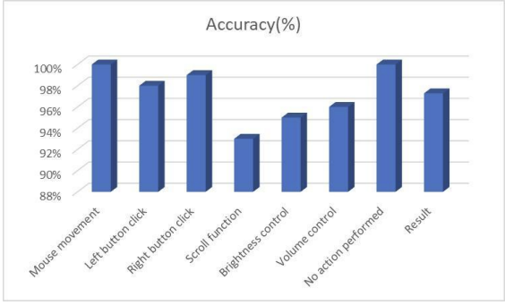
Fig. 4. Analysis chart of model

Major Applications:

(i) The proposed model has a greater accuracy of 99% which is far greater than the that of other proposed models for virtual mouse, and it has many applications.
(ii) Amidst the COVID-19 situation, it is not safe to use the devices by touching them because it may result in a
possible situation of spread of the virus by touching the devices, so the proposed AI virtual mouse can be used to control the PC mouse functions without using the physical mouse.
(iii) The system can be used to control robots and automation systems without the usage of devices.
(iv) 2D and 3D images can be drawn using the AI virtual system using the hand gestures.
(v) AI virtual mouse can be used to play virtual reality- and augmented reality-based games without the wireless or wired mouse devices.
(vi) Persons with problems in their hands can use this system to control the mouse functions in the computer.
(vii) In the field of robotics, the proposed system like HCI can be used for controlling robots.
(viii) In designing and architecture, the proposed system can be used for designing virtually for prototyping [7].

COnclusion
The main objective of the AI virtual mouse system is to control the mouse cursor functions by using the hand gestures instead of using a physical mouse. The proposed system can be achieved by using a webcam or a built-in camera which detects the hand gestures and hand tip and processes these frames to perform the mouse functions. From the results of the model, we can conclude that the proposed AI virtual mouse system has performed very well and has greater accuracy compared to the existing models and the model overcomes most of the limitations of the existing systems. Since the proposed model has greater accuracy, the AI virtual mouse can be used for real-world applications, and, it can be used to reduce the spread of COVID-19, since the proposed mouse system can be used virtually using hand gestures without using the traditional physical mouse. The model has some limitations such as small decrease in accuracy in right click mouse function and some difficulties in clicking and dragging to select the text. Hence, we will work next to overcome these limitations by improving the fingertip detection algorithm to produce more accurate results

Acknowledgement

It is moment of gratification and pride to look back with sense of contentment of at the long travelled path, to be able to recapture some of the fine moment, to be able to thank infinite number of people, some who with me from beginning some who joined me at some stage during the journey, whose kindness, love and blessing has brought this day, We wish to thank each one of them with all my heart. Words seem insufficient to express my deep sense of gratitude, to be loved and respected guide Prof. Sushma Khatri for his excellence guidance, critical supervision, and keen interest and continue encouragement throughout this study. His active guidance helped me to develop skills and insight in research and scientific presentation for his constant support and inspiration during this complete journey of two year. Thanks to my all friends for their unforgettable help and moral support. Above all, we thank Almighty God for showering me with his blessing throughout my life.

References
[1] S. Shriram” Deep Learning-Based Real-Time AI Virtual Mouse System Using Computer Vision to Avoid COVID-19 Spread”, Applied Sciences, Volume 2021, Article ID 8133076, 31 Jul 2021, View at: Publisher Site Hindawi.
[2] Akshay L Chandra” Mouse Cursor Control Using Facial Movements — An HCI Application, View at: Publisher Site| data science.
[3] Abdul Wahid Ali” Energy efficiency in routing protocol and data collection approaches for WSN: A survey, view at: Publisher Site| ieee explore.
[4] Aynur Unal” Smart Trends in Information Technology and Computer Communications, View at: Publisher Site|link.springer.com
[5] S. U. Dudhane, “Cursor control system using hand gesture recognition,” IJARCCE, vol. 2, no. 5, 2013. View at: Publisher Site| Google scholar
[6] K. H. Shibly, S. Kumar Dey, M. A. Islam, and S. Iftekhar Show rav, “Design and development of hand gesture based virtual mouse,” in Proceedings of the 2019 1st International Conference on Advances in Science, Engineering and Robotics Technology (ICASERT), pp. 1–5, Dhaka, Bangladesh, May 2019.View at: Publisher Site| Google Scholar
[7] A.Haria, A. Subramanian, N. Asok Kumar, S. Poddar, and J. S. Nayak, “Hand gesture recognition for human computer interaction,” Procedia Computer Science, vol. 115, pp. 367–374, 2017. View at: Publisher Site| Publish site |Scholar
[8] https://www.tutorialspoint.com› open CV
[9] Google, MP, https://ai.googleblog.com/2019/08/on-device-real-time-hand-tracking-with.html.
[10] J. Katona, “A review of human–computer interaction and virtual reality research fields in cognitive Info. Communications,” Applied Sciences, vol. 11, no. 6, p. 2646, 2021. View at: Publish site| Google Scholar.
[11] V. Bazarevsky and G. R. Fan Zhang. On-Device, MediaPipe for Real-Time Hand Tracking.

