“Web 3.0 Based Crowd Funding Platform Using Blockchain”
Sudhanshu Singh, Ariyan Laskar, Love Sharma, KiranKumar Yadav

ABSTRACT:
Crowdfunding has revolutionized the way individuals and organizations raise funds for their endeavors. This mini project explores the design and implementation of a cutting-edge blockchain crowdfunding platform that harnesses the power of Web 3.0 principles.
The primary objective of the project is to create a decentralized and transparent crowdfunding ecosystem, leveraging blockchain technology to enhance security, trust, and efficiency. Users on the platform can initiate and participate in crowdfunding campaigns with the assurance of security and automated fund disbursement.
Key features of the proposed platform include identity verification through decentralized identifiers (DIDs), enabling users to maintain control over their personal information. Blockchain, will automate the crowdfunding process, ensuring that funds are securely held and released based on predefined conditions.
The mini project involves the development of a prototype that showcases the essential functionalities of the Web 3.0-based blockchain crowdfunding platform. Through this initiative, we aim to contribute to the advancement of decentralized technologies and their practical applications in the realm of crowdfunding, fostering a more inclusive and trust-driven fundraising environment. The project also aims to explore the challenges and opportunities associated with integrating Web 3.0 principles into the crowdfunding paradigm.

Index Terms— Keywords — Blockchain, DAOs, Decentralized, Transparency.

1. INTRODUCTION:
Crowdfunding has become one of the most popular methods of raising funds for any project, cause, or individual in need. With the launch of Covid, Crowdfunding activities have been increased all around the world, ranging from tiny campaigns to help individuals acquire oxygen and medical assistance to huge funds like PM Cares. Contributors, crowdfunding platforms, and project administrators were the primary players in the crowdfunding event. Kickstarter.com, Indiegogo.com, and Mystartr.com are some of the most popular crowdfunding platforms. The biggest advantage of crowdfunding is that it can quickly raise the funds required.
Blockchain is a decentralized, immutable database that makes it easier to track assets and record transactions in a corporate network. Solidity and Vyper are programming languages used to create Ethereum smart contracts. MetaMask is a cryptocurrency wallet that provides access to the Ethereum network through browser extensions or a mobile app. These programs automatically execute when predefined conditions are met, allowing anonymous parties to transact securely and trustingly without the need for a central authority. MetaMask is a cryptocurrency wallet that provides access to the Ethereum network through browser extensions or a mobile app. Created by ConsenSys Software Inc.
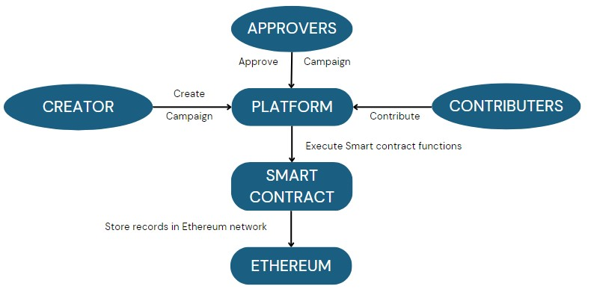
Figure 1: System Architecture

II. LITERATURE REVIEW
A. Literature Review
1. Crowdfunding Platform Using Blockchain Technology June 2022: The primary objective of the authors is to address the limitations of existing crowdfunding platforms by leveraging a decentralized application powered by the Ethereum Blockchain. By doing so, they aim to provide a platform where all campaign details, donations, withdrawals, and funds are stored on an open blockchain network that is accessible to everyone. With a shared ledger, transactions only need to be recorded once, eliminating the need for redundant efforts. This approach improves the transparency and security of the crowdfunding process, ensuring that all transactions are immutable and irreversible.
2. Applying Ethereum Smart Contracts to Blockchain-Based Crowdfunding System to Increase Trust and Information Symmetry July 2021: The focus of the author's investigation is the creation of a crowdfunding platform utilizing the Ethereum Blockchain. This platform's key feature is a smart contract that tracks the status of user-generated contracts and executes them automatically when the conditions are satisfied. The usage of this system leads to greater transparency, minimizing information asymmetry. However, the study does not cover the use of smart contract tokens, which may be difficult to comprehend for users lacking a fundamental understanding of blockchain technology.
3. Study on Crowdfunding Platform at International Conference Of ICT: This study proposes an innovative approach to fund the development of smart cities using crowdfunding. The study examines the investment behaviour of individuals participating in crowdfunding and their response to such platforms. The idea is presented in a theoretical manner, providing a framework for the creation of a crowdfunding platform for smart cities. It should be noted that the framework proposed in this study is centralized, which means it is controlled by a central authority.
4. Study on Conventional Crowdfunding Platform at Shingai: This study employs text analytics to examine the effect of sentiment orientation on crowdfunding. The proposal aims to eliminate intermediaries in crowdfunding applications. To achieve this goal, a blockchain-based crowdfunding platform is proposed, although no detailed framework is presented. The study concentrates on the behaviour of investors and developers in crowdfunding, but the platform does not account for the self-interested motives of developers.
5. Crowdfunding - A Literature Review and Research Direction: The literature on crowdfunding primarily concentrates on the motivations behind capital-seeking parties, factors contributing to crowdfunding success, and legal limitations of equitybased crowdfunding. However, most of these platforms are confined to a single country, and governmental access is essential for their operation.
6. Kickstarter, Facebook: This study employs social network analysis to examine the correlation between the success of crowdfunding projects and the social networks of initiators and media activities. However, the platform utilized in this research is not available on GitHub.
B. Survey of Existing Systems
1. Crowdfunding platform in a centralized system: In a centralized crowdfunding platform, building a trustworthy relationship between the product team and supporters is crucial. The product team relies on receiving funding based on project progress and completion, while supporters expect their funds to be allocated properly and refunded if the project fails. The crowdfunding platform serves as a middleman, charging significant fees to both the product team and supporters to cover risks such as incomplete projects or lack of further support. However, the need for trust in the platform and high fees may deter potential supporters and product teams.
2. Research of Charity: Researchers have proposed various methods to increase the credibility of charity organizations. For instance, Liu Na has suggested the need to supervise charity in law, administration, industry, and society. Bi Rui Xiang has concluded that Chinese charity organizations have low financial information disclosure. Yu Yu Xi has recommended improving the liability system and government supervision to restrict the power of charity organizations. Wang Jian and Xu Yuchao have designed a charity donation information management system to manage and publicize charity donations. Various other researchers have explored the use of blockchain technology to manage and increase transparency in charitable donations, including the use of Bubi blockchain and Ethereum platforms. Danushka Jayasinghe et al. have even built a Bitcoin charity platform based on blockchain technology to facilitate safe and convenient donations to difficult areas without an Internet connection. These studies collectively inform our proposed new model of a charity system that leverages blockchain technology.
C. Limitations in Existing System / Research Gap
1. High Fees: Crowdfunding platforms have become an increasingly popular option for startups to raise funds. However, one downside of these platforms is the fees that are charged. These fees can vary from platform to platform and may be a fixed amount or a percentage of the total amount raised. For startups, who are often operating on tight budgets, these fees can be a hindrance to accessing the funds they need. It is important for entrepreneurs to carefully consider the fees associated with different crowdfunding platforms before deciding which one to use.
2. Scam Campaigns: While crowdfunding platforms can be a valuable source of funding for startups, there are certain risks associated with investing in these campaigns. One such risk is the possibility of falling victim to a scam campaign. Unfortunately, it is not uncommon for some fraudulent campaigns to appear on crowdfunding platforms, which can result in investors losing their entire investment. This can be damaging not only for the affected investors but also for the reputation of crowdfunding platforms as a whole.
3. Non-Transparent: Transparency is a critical aspect of any financial transaction, and this is no different when it comes to crowdfunding platforms. However, in some cases, the transactions on these platforms may lack transparency, making it difficult to trace the source of the funds. This can be a concern for investors who want to know where their money is going and how it is being used. It is crucial for crowdfunding platforms to ensure that all transactions are transparent, with clear documentation and disclosure of the flow of funds.
4. Centralized Authority: One concern is the centralized authority that controls and manages the data. This centralized authority has the power to change and modify the data, making it vulnerable to data theft and loss in the event of a cyberattack or backup failure. This centralized control can be a risk for both investors and startups, as it puts their data and investments in the hands of a single entity.
III. METHODOLOGY
Campaign Creation: Users can create a Campaign by connecting their Metamask wallet to the web application. After connecting their wallet, they can create a unique campaign by entering the campaign details such as Campaign Title, Campaign Details, Fund-Raising Amount. All the contract code is written in Solidity which is used to deploy the contract in the blockchain platform. A new campaign is created by making an instance of the Campaign factoryThus, when the user clicks on "Create Campaign" button a new campaign will be created. After the campaign is created it will be displayed in the home page of the website. Other users can interact with it.
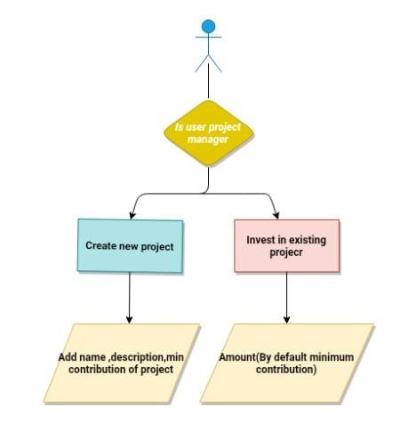

Figure 2: Creating or contributing to project
Contributors & Approvers: Contributors are the users who contribute and fund the campaigns. After connecting their Metamask wallet to the application, they can search for the campaigns they want to fund. The funds will go to the address of the campaign and not to the creator of the campaign, thus making the process more efficient and anti-fraudulent. Approvers are the contributors who have contributed more than the Minimum Contribution, and they can approve the withdrawal requests.
Withdrawal of Funds: Contributors who have contributed more than a certain amount are known as approvers and are given the power to either approve or deny the request. This process ensures that the funds are being used in a manner that is agreed upon by the community of investors. In order to withdraw the funds, the approval of at least 50% of the approvers is required. Once approved, the funds will be transferred to the address that has been decided upon by the group. All transactions and decisions made during this process are securely stored in the blockchain, ensuring that they are transparent and cannot be altered or manipulated.
IV. BLOCK DIAGRAMS AND ARCHITECTURE
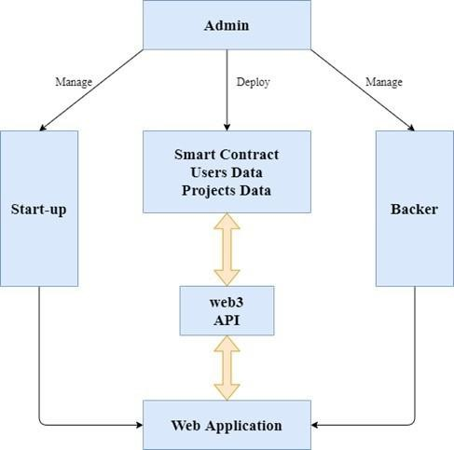

Figure 3: Blockdiagram and Architecture

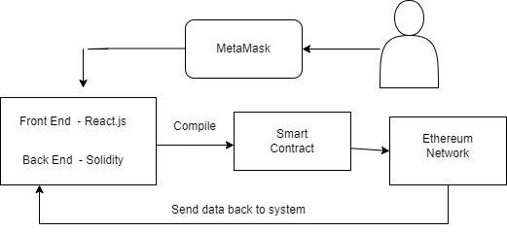

Figure 4: System Architecture

V. ADVANTAGES:
1.Transparency and Trust: Blockchain provides a transparent and immutable ledger of transactions, ensuring that all crowdfunding activities and transactions are recorded and visible to all participants. Smart contracts on the blockchain can automate the execution of crowdfunding agreements, ensuring transparency and reducing the need for intermediaries. Participants can verify and audit the transactions and flow of funds, fostering trust between project creators and backers.
2.Security: Blockchain utilizes advanced cryptographic techniques to secure transactions, making it highly resistant to fraud, tampering, or unauthorized access. Funds raised through crowdfunding can be securely stored in blockchain-based wallets, reducing the risk of theft or loss associated with traditional banking systems.
3.Global Accessibility: Blockchain technology enables global participation in crowdfunding campaigns, regardless of geographical location or access to traditional financial infrastructure. Anyone with an internet connection and a cryptocurrency wallet can participate in crowdfunding campaigns, fostering inclusivity and expanding the pool of potential backers.
4.Immutability: Blockchain is a distributed ledger containing numerous copies, making it nearly hard to edit a single transaction without changing all the copies at once. Because of this, using blockchain in the crowdfunding increases trustworthiness and fraud resistance.
5.Reduced Intermediaries and Costs: By leveraging blockchain, crowdfunding platforms can eliminate or reduce the need for intermediaries, such as banks or payment processors, which can lower transaction fees and administrative costs. Smart contracts can automate the distribution of funds and disbursements to project creators, streamlining the process and reducing overhead expenses.

VI. DISADVANTAGES:
1. Complexity and Technical Knowledge: Blockchain technology is still relatively complex and requires specialized knowledge for development, implementation, and maintenance. This can create barriers for nontechnical users or project creators who may not be familiar with blockchain concepts or have the technical expertise to navigate the platform.
2. Volatility and Risk: Cryptocurrencies, often used for transactions on blockchain-based crowdfunding platforms, can be subject to significant price volatility. This introduces risk for both project creators and backers, as the value of funds raised or pledged can fluctuate during the campaign, affecting the project's financial viability or backers' potential returns.
3. Scalability: Due to the fixed size of the block used to store information, it is one of the main shortcomings of blockchain technology. Due to the 1 MB block size, only a few transactions may be stored on a single block.
4. Storage: The fact that blockchain databases are kept on every node of the network causes a storage problem; as the volume of transactions rises, more storage space will be needed. Time-Consuming: Since miners must compute nonce values numerous times to add the next block to the chain, this time-consuming procedure needs to be sped up to be employed for commercial purposes.
5. Irreversibility of Transactions: Once transactions are recorded on the blockchain, they are typically irreversible. In the context of crowdfunding, this means that backers may not have recourse if a project fails to deliver on its promises or turns out to be fraudulent. This lack of dispute resolution mechanisms can pose risks

CONCLUSION
In this paper we conclude that the proposed web-based crowdfunding system developed using blockchain technology addresses the critical issues faced by traditional crowdfunding platforms by leveraging Ethereum smart contracts and the solidity programming language this system offers enhanced trust transparency control over funds and secure storage of transactions the use of Infura provides a reliable connection between the web system and the Ethereum network ensuring that all transactions are recorded in a safe and credible manner this innovative approach to crowdfunding eliminates the need for charging fees and offers a more secure and trustworthy way for startups to raise funds overall this system offers a promising solution to the challenges faced by traditional crowdfunding platforms and it has the potential to revolutionize the way startups are funded.

ACKNOWLEDGMENT
We wish to express our sincere gratitude to our guides, teachers, family and friends for support and providing us with the opportunity to work on our project, "Web 3 Based Crowdfunding Platform Using Blockchain." This project would not have been possible without the guidance and encouragement of our project guide, Prof. Hemant Shiyal Sir. We would also like to thank our colleagues and friends who helped us in completing this project successfully.

REFERENCES

- Blockchain-BasedCrowdfunding Application IEEE, https://iee explore.ieee.org/document/ 9640888, 2021 Fifth International Conference on I-SMAC (IoT in Social, Mobile, Analytics and Cloud) (I-SMAC), 11-13 November 2021, 10.1109/I-SMAC52330.2021.9640888 at
Palladam, India.
- Bhavya Sri, K., et al. “Crowdfunding Using Blockchain,” International Journal of Scientific Research in Computer Science, Engineering and;’[Information Technology, Mar. 2020, pp. 128–34. DOI.org (Crossref), https://doi.org/ 10.32628/CSEIT1206233.
- M. Zichichi, M. Contu, S. Ferretti and G. D'Angelo, "LikeStarter: a Smart-contract based Social DAO for Crowdfunding," IEEE INFOCOM 2019 - IEEE Conference on Computer Communications Workshops (INFOCOM WKSHPS), Paris, France, 2019, pp. 313-318.
- Ashari, Firmansyah. “Smart Contract and Blockchain for Crowdfunding Platform,”. International Journal of Advanced Trends in Computer Science and Engineering, vol. 9, no. 3, June 2020, pp.3036–
41.DOI.org(Crossref).
- N. Yadav and S. V., "Venturing Crowdfunding using Smart Contracts in Blockchain," 2020 Third International Conference on Smart Systems and Inventive Technology (ICSSIT), Tirunelveli, India, 2020, pp. 192- 197.

