3D Visualization in Furniture Ecommerce

Anuj Sharma
dept. Computer Science Engineering
Acropolis Institute of Technology and Research
Indore, India
anujsharma210541@acropolis.in
Aniruddha Singh Chawda
dept. Computer Science Engineering
Acropolis Institute of Technology and Research
Indore, India
aaniruddhachawda210612@gmail.com
Aarush Yadav
dept. Computer Science Engineering
Acropolis Institute of Technology and Research
Indore, India
aarushyadav210525@acropolis.in

Abstract—This paper explores the integration of 3D visualization in online furniture stores to improve user experience. Through literature review and case studies, it examines the benefits and challenges. Insights are provided for businesses aiming to optimize 3D visualization techniques. Findings suggest significant potential in enhancing engagement, reducing uncertainties, and boosting customer satisfaction. Practical considerations for successful implementation are discussed, offering valuable insights for e-commerce stakeholders.
Keywords— threeJS, webGL, furniture e-commerce, web development, CRUD, MERN stack, React, NodeJS, 3D visualization, Interactive Product Visualisation.

Introduction
The rise of e-commerce has transformed the way consumers shop for products, offering unparalleled convenience and accessibility. However, despite the advancements in technology, many e-commerce platforms still rely solely on static 2D images to showcase their products. This approach often fails to provide customers with a comprehensive understanding of the product's design, dimensions, and functionality, leading to potential dissatisfaction and increased return rates.
The limitations of static 2D imagery are particularly pronounced in industries such as furniture and home decor, where customers need to visualize how products will look and fit within their living spaces. Traditional e-commerce platforms struggle to convey this information accurately, resulting in customers making uninformed purchasing decisions. [1]
Enter Three.js, a powerful JavaScript 3D library that enables the rendering of interactive 3D models directly within web browsers. By leveraging Three.js, e-commerce platforms can revolutionize the way they present products to customers, offering an immersive and informative shopping experience.

PROBLEM FORMULATION
The traditional approach to showcasing products on e-commerce platforms has primarily relied on static 2D images, which often fail to provide customers with an accurate and comprehensive understanding of the product's design, dimensions, and functionality. This limitation is particularly pronounced in industries such as furniture and home decor, where customers need to visualize how products will look and fit within their living spaces before making a purchasing decision. [2]
Existing e-commerce platforms struggle to convey this crucial information accurately, leading to customer dissatisfaction, increased product returns, and potential lost sales. Customers frequently make uninformed purchasing decisions based on the limited information provided by static 2D imagery, resulting in products that do not meet their expectations or fit their intended spaces.
Furthermore, the inability to visualize products in a realistic and engaging manner can hinder the overall online shopping experience, making it challenging for customers to appreciate the craftsmanship, attention to detail, and unique features of the products they are considering.
To address these limitations, we have identified the need for an innovative solution that leverages advanced 3D visualization technologies to revolutionize the way products are presented and experienced on e-commerce platforms. By integrating interactive 3D models directly into the web browser, customers can explore products from all angles, zoom in on intricate details, and even customize certain aspects such as colors and materials in real-time.
Our project aims to develop an e-commerce platform that seamlessly integrates Three.js, a powerful JavaScript 3D library, to enable the rendering of interactive 3D models within the web browser. This approach will provide customers with an immersive and informative shopping experience, allowing them to gain a comprehensive understanding of the products they are considering, ultimately leading to more informed purchasing decisions and increased customer satisfaction.

LITERATURE REVIEW
The concept of integrating 3D visualization technologies into e-commerce platforms is not entirely new. Several studies and industry initiatives have explored the potential benefits and challenges of this approach. However, the adoption of 3D visualization has been relatively slow, with many platforms still relying heavily on traditional 2D imagery.
One of the pioneering studies in this field was conducted by researchers at the Sutardja Center for Entrepreneurship and Technology, Berkeley Engineering. The study, titled " Next Generation Shopping Experience," outlined the virtual reality (VR) technology is reshaping the landscape of commerce by offering immersive experiences to customers. Retailers are leveraging VR to provide unique in-store experiences regardless of physical location, allowing customers to explore products from all angles with 360-degree views. Companies like eBay, Myer, Lowe’s, IKEA, Landrover, Audi, and Thomas Cook are pioneering the use of VR in various ways, from personalized shopping experiences to virtual room visualization and even virtual test drives for cars. This technology not only enhances product presentation but also increases customer engagement and ultimately leads to higher conversion rates. By enabling customers to visualize products in real-world settings, VR bridges the gap between online and offline shopping, satisfying consumers' desire to "try before they buy" and fostering deeper connections that drive purchases. [3]
In the industry sphere, several e-commerce giants have explored the integration of 3D visualization technologies. Amazon, for instance, introduced its Amazon Augmented Reality (AR) app in 2017, allowing customers to visualize how certain products, such as furniture and home decor items, would look in their living spaces through augmented reality. While this approach leverages 3D models, it requires the use of a separate mobile app and relies on the device's camera, rather than providing a seamless web-based experience.
Similarly, IKEA, a leading furniture retailer, introduced its IKEA Place app in 2017, enabling customers to virtually place 3D models of furniture in their living spaces using augmented reality. While this initiative has been well-received, it remains a separate mobile app experience, potentially limiting its reach and accessibility.
Despite these efforts, the widespread adoption of web-based 3D visualization in e-commerce has been relatively slow. This can be attributed to various factors, including technical challenges, compatibility issues across different browsers and devices, and the perceived complexity and cost of implementation.
However, with the advent of powerful JavaScript libraries such as Three.js, the barriers to integrating 3D visualization into e-commerce platforms are being lowered. Three.js is an open-source JavaScript library that simplifies the process of creating and rendering 3D graphics on the web, leveraging the capabilities of WebGL, a low-level 3D graphics API. By harnessing the power of Three.js, e-commerce platforms can seamlessly integrate interactive 3D models into their existing web interfaces, providing customers with an immersive and engaging shopping experience without the need for separate mobile apps or augmented reality solutions.

PROPOSED METHODOLOGY
Our methodology revolves around leveraging the powerful MERN (MongoDB, Express.js, React.js, Node.js) stack to build a robust and scalable e-commerce platform with integrated 3D visualization capabilities. The frontend is being developed using React.js, a popular JavaScript library for building user interfaces. React's component-based architecture allows us to encapsulate the Three.js rendering logic within reusable components, enabling efficient rendering and updating of the 3D visualizations within the web browser. [4]
To achieve seamless 3D rendering, we are utilizing Three.js's WebGL renderer, which harnesses the capabilities of the browser's WebGL API, a low-level 3D graphics API. WebGL provides the foundation for Three.js to create and display interactive 3D scenes within the web browser, ensuring a smooth and immersive experience for our customers. [5]
The integration of Three.js into our React.js components involves several key steps. First, we will import the necessary Three.js libraries and dependencies into our React components. Next, we initialize the Three.js scene, camera, and renderer within the component's lifecycle methods, such as componentDidMount and componentWillUnmount. This ensures that the 3D scene is properly set up and rendered when the component mounts and cleaned up when it unmounts, preventing potential memory leaks. [6]
Within the rendering loop, we update the scene with the necessary transformations, such as rotations, zooming, and material/color changes based on user interactions or custom logic. These interactions can be handled through React's event handling system or by directly manipulating the Three.js objects within the component's state or props.
To ensure smooth rendering performance, we leverage React's virtual DOM and efficient re-rendering mechanisms. By encapsulating the Three.js rendering logic within React components, we can take advantage of React's performance optimizations, such as memoization and shouldComponentUpdate lifecycle methods, to minimize unnecessary re-renders and optimize the overall rendering process. [7]
On the backend, we are using Node.js and Express.js to handle server-side operations, such as user authentication [8], product data management, and communication with the MongoDB database. The MongoDB database serves as the central repository for storing information about our furniture products, including 3D model files and associated metadata. [9]
The attached figure fig 1 shows the architecture of the platform. On the client side, React js will be handling the components, state management and routing. Three js will be used for showing the 3D models and their lighting. On the server side, Node js will be responsible for the middleware, routing, controllers and models. The databases is hosted on MongoDB Atlas.
For efficient communication between the frontend and backend, we employ RESTful APIs implemented using Express.js routes. These APIs facilitate data exchange between the client-side React components and the server-side Node.js application, enabling seamless integration of user interactions with the backend data and services. [10]
The architecture of our platform is designed to be modular and scalable, allowing us to add new features and scale our infrastructure as our business grows. By leveraging the power of the MERN stack, we can deliver a robust and scalable e-commerce solution with integrated 3D visualization capabilities, providing our customers with a seamless and immersive shopping experience.
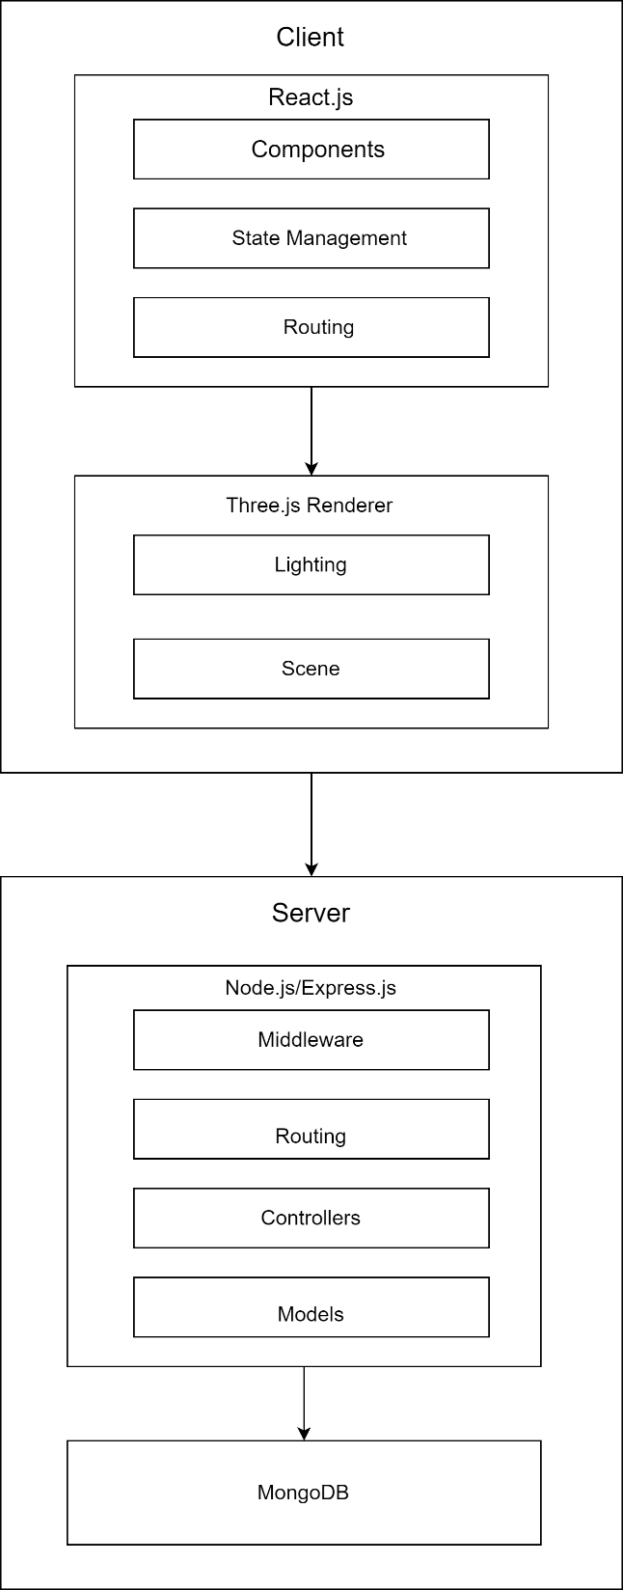

Fig. 1 Platform Architecture

IMPLEMENTATION
The procedure for gathering, preprocessing, and feature extraction from the speech dataset for gender recognition is described in the implementation section. To ensure a seamless and engaging user experience, we are implementing various interactive features leveraging Three.js's capabilities:
360-degree product rotation: Customers will be able to turn the 3D models in any direction to look at the furniture products from every angle and get a thorough understanding of how they are made.
Zoom and pan functionality: This feature allows users to examine little features up close or to get an up close view of the product, which helps them better understand the fine craftsmanship and attention to detail that go into each of the furniture pieces.
Customization of materials and colors: For a limited number of products, the customers will be able to customize the colors and materials used in the 3D models. This will allow them to see how the product would appear in different finishes or color schemes, allowing them to personalize the experience to their tastes.
- Homepage:
This is the home page that the user first comes across when accessing the platform.
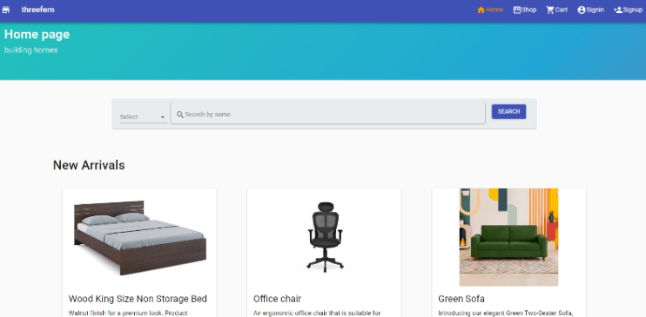

Fig. 2 Homepage Snapshot
- Sign In Page:
This is the page where the users can sign in after they have signup for the platform.
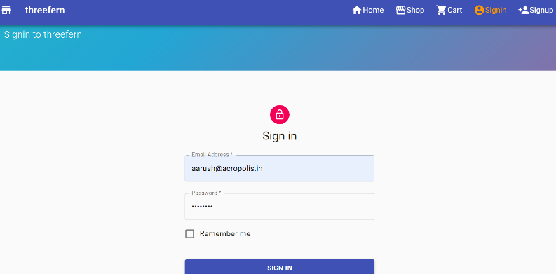

Fig. 3 Sign In Page Snapshot
- Search Page:
This is the page where the user can search for products and filter them based on category and the price range.
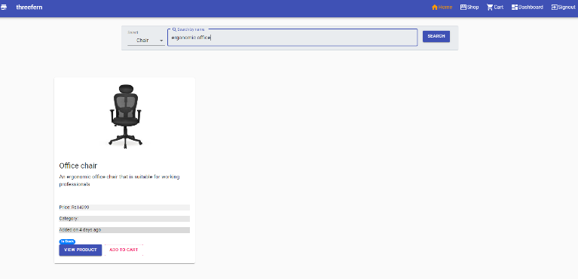

Fig. 4 Search Page Snapshot
- Add Product Page:
This is the page where the administrator can create product listings.
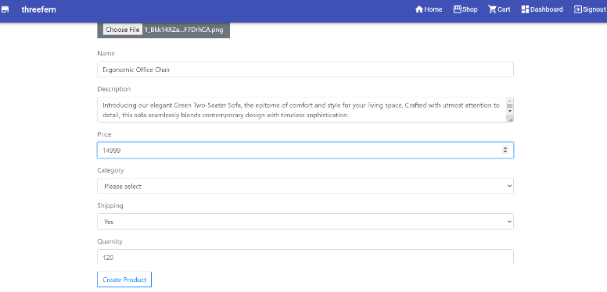

Fig. 5 Add Product Page Snapshot
- Product Page:
This is the page where the customers can view the product details. The user can rotate and zoom the model to view the product from all angles. This will give a complete understanding of the product’s appearance.
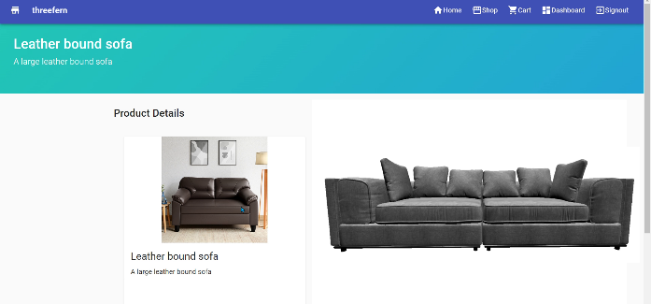

Fig. 6 Product Page

FUTURE SCOPE
The next step for the platform would be to have the following features added over time.
Dimensioning and measurement tools: Our platform will provide dimensioning and measurement tools, allowing customers to accurately gauge the size and scale of our furniture products, facilitating better decision-making and ensuring that the pieces they purchase fit their intended spaces.
Augmented reality integration: While not a core focus of our initial implementation, we are exploring the possibility of integrating augmented reality (AR) capabilities using Three.js and WebXR, enabling customers to virtually place 3D models of our furniture products in their real-world environments through their device cameras. [11]

RESULTS AND DISCUSSION
The integration of Three.js into our furniture e-commerce platform has yielded promising results, demonstrating the potential of 3D web visualization to revolutionize the online shopping experience for shoppers. Listed below are the benefits and implications of this approach:
Enhanced product understanding and decision-making: Most participants reported a significant improvement in their ability to understand and evaluate our furniture products when presented with interactive 3D visualizations. [12]
Increased user engagement and satisfaction: The interactive nature of the 3D visualizations contributed to a more engaging and immersive shopping experience.
Potential reduction in product returns: A significant number of participants indicated that the 3D visualizations could potentially reduce the likelihood of product returns. [13]
Improved customer loyalty and brand perception: Participants expressed a higher likelihood of returning to our e-commerce platform that offered interactive 3D visualizations. [14]
Technical challenges and considerations: While the integration of Three.js into our e-commerce platform was successful, we encountered several technical challenges that required careful consideration and mitigation strategies.

FUTURE SCOPE
Through this ambitious project, our furniture e-commerce store has taken a significant step towards revolutionizing the online shopping experience for our customers. By integrating Three.js, a powerful JavaScript 3D library, into our web platform, we have successfully overcome the limitations of traditional 2D imagery, empowering our customers to explore and engage with our furniture products in an immersive and informative manner.
The seamless integration of interactive 3D visualizations has not only enhanced our customers' understanding of product details, dimensions, and spatial compatibility but has also fostered increased user engagement, satisfaction, and potential customer loyalty. By addressing common pain points in online furniture shopping, such as inaccurate size perception and limited design appreciation, we are poised to reduce product returns and associated costs, ultimately contributing to improved profitability and environmental sustainability.
However, our journey does not end here. As technology continues to evolve, we remain committed to staying at the forefront of innovation, exploring emerging trends and technologies that can further enhance the online shopping experience for our customers. Potential avenues for future exploration include the integration of augmented reality capabilities, personalized recommendations based on customer preferences, and the adoption of advanced data analytics to gain deeper insights into customer behavior and preferences. [15]
Furthermore, we recognize the importance of collaboration and knowledge-sharing within the industry. By openly sharing our experiences, challenges, and best practices, we aim to contribute to the collective advancement of the furniture e-commerce sector, fostering an environment of innovation and customer-centric practices. [16]
In conclusion, our furniture e-commerce store's adoption of Three.js and 3D web visualization represents a significant milestone in our pursuit of delivering exceptional online shopping experiences. We remain committed to continuously improving and adapting to the evolving needs of our customers, leveraging cutting-edge technologies to redefine the boundaries of what is possible in the world of online furniture retail.

Acknowledgement
The constant guidance and encouragement that crowns all efforts with success is worth it. We are thankful to our project guide Prof. Sushma Khatri for her guidance, inspiration, and constructive suggestions, which were very useful for us in the preparation of this project.

References

[1] | R. A. a. C. Dennis, "Using authentic 3D product visualisation for an electrical online retailer," J. Cust. Behav., vol. 9, no. 2, p. 97– 115, 2010.
[2] | F. Moritz, "Potentials of 3D-Web-Applications in E-Commerce - Study about the Impact of 3D-Product-Presentations," in IEEE/ACIS 9th International Conference on Computer and Information Science, 2010.
[3] | R. K. M. K. A. C. R. K. a. F. R. Stephanie Hidalgo, "Next Generation Shopping Experience," 2012. [Online]. Available: http://scet.berkeley.edu/wp-content/uploads/ELPP-NextGenerationShopping.pdf. [Accessed 23 January 2024].
[4] | R. G. a. R. Natkin, "WebGL vs. Three.js vs. others: Which 3D rendering library is right for you," [Online]. Available: https://hacks.mozilla.org/2022/12/webgl-vs-three-js-vs-others/. [Accessed 23 May 2024].
[5] | L. H. C. X. S. X. Zhang Changhao, "Research on Web 3D display based on STL model," in International Conference on Computer Science and Management Technology, 2021.
[6] | R. JS, "React.js Component Documentation," [Online]. Available: https://react.dev/reference/react/Component#componentdidmount. [Accessed 4 February 2024].
[7] | D. Three.js, "React Integration," [Online]. Available: https://threejs.org/docs/index.html#manual/en/introduction/React-integration. [Accessed 12 May 2024].
[8] | B. Kelley, "User Authentication in React," Okta Developer Blog, 6 March 2019. [Online]. Available: https://developer.okta.com/blog/2019/03/06/simple-user-authentication-in-react. [Accessed 12 January 2024].
[9] | S. Bose, "Rendering interactive 3D scene as a web-page using Three.js,WebGL, and Blender," Department of Computer Science and Engineering, Brac University, 2022.
[10] | A. Srikanth, "Creating a REST API with Node.js and Express," 16 May 2023. [Online]. Available: https://blog.postman.com/how-to-create-a-rest-api-with-node-js-and-express/. [Accessed 18 December 2023].
[11] | A. Sandaker, "Get started with Augmented Reality on the web using Three.js and WebXR|Part 1," 9 March 2022. [Online]. Available: https://medium.com/sopra-steria-norge/get-started-with-augmented-reality-on-the-web-using-three-js-and-webxr-part-1-8b07757fc23a. [Accessed 27 January 2024].
[12] | I. P. Supun Hewawalpita, "Effect of 3D Product Presentation on Consumer Preference in E-Commerce," in MERCon, 2017.
[13] | D.-M. K. Dong-Mo Koo, "The interactional effects of atmospherics and perceptual curiosity on emotions and online shopping intention," Computers in Human Behavior , vol. 26, no. 3, pp. 377-388, 2014.
[14] | T. D. F. B. Hairong Li, "Impact of 3-D Advertising on Product Knowledge, Brand Attitude, and Purchase Intention: The Mediating Role of Presence," Journal of Advertising, vol. 31, no. 03, p. 43–57, 2002.
[15] | H. G. Steven M. Edwards, "he Novelty of 3D Product Presentations Online," Journal of Interactive Advertising , vol. 2, no. 1, p. 10–18, 2001.
[16] | A. M. F. ,. H.-H. L. Jihyun Kim, "Influences of online store perception, shopping enjoyment, and shopping involvement on consumer patronage behavior towards an online retailer," Journal of Retailing and Consumer Services, vol. 14, no. 2, pp. 95-107, 2007.

