DRIVERLESS TRACTOR
Mr. K LAKSHMANA KANNAN, Mr. B MITHRAN, Mr. M K PRADEEP, Mr. M SACHIN
DR. S. PRAKASH(MENTOR)

INFORMATION TECHNOLOGY
SRI SHAKTHI INSTITUTE OF ENGINEERING AND TECHNOLOGY
COIMBATORE
---------------------------------------------------------------------***---------------------------------------------------------------------
Abstract - The integration of driverless tractors into agriculture signifies a major leap in technological advancement, driven by the collaboration between farmers and tech developers. Early plowing methods, once labor-intensive and inefficient, have evolved significantly, paving the way for the adoption of autonomous farming solutions. These driverless tractors, equipped with advanced GPS, sensors, and AI, address traditional plowing challenges, offering precision, efficiency, and environmental sustainability. The literature review highlights the critical roles of GPS, AI, and sensor technologies in enhancing autonomous tractor performance, emphasizing benefits such as reduced labor dependency and higher crop yields. Python and Turtle Graphics provide software foundations for these technologies, while hardware components like radar, LiDAR, and ultrasonic sensors ensure robust and reliable operation. As the industry moves forward, the integration of IoT and big data promises even greater advancements, underscoring the transformative potential of driverless tractors in modern agriculture.

Key Words: autonomous vehicle, GPS, sensors, python, turtle graphics, journals,IoT

1. INTRODUCTION
The advent of driverless tractors marks a revolutionary stride in agricultural technology, transforming the way farmers approach the cultivation process. As agricultural practices continue to evolve, the integration of autonomous systems represents a significant shift from traditional, labor-intensive methods to advanced, precision-driven operations. This article explores the development and implementation of driverless tractors, focusing on the synergistic efforts between farmers and technology developers. By delving into the historical evolution of plowing techniques and examining the roles of critical technologies such as GPS, AI, and various sensors, we highlight the profound impact of these innovations on farming efficiency and sustainability. Furthermore, the article discusses the software and hardware foundations essential for the functionality of autonomous tractors and anticipates future advancements driven by the integration of IoT and big data. Through this exploration, we aim to underscore the transformative potential of driverless tractors in shaping the future of agriculture.

2. BODY OF PAPER
Driverless tractors, a groundbreaking innovation in agricultural technology, are reshaping traditional farming practices by integrating precision and efficiency into operations. These autonomous machines utilize advanced technologies such as GPS, artificial intelligence, and sensors to navigate fields and perform tasks with minimal human intervention. Farmers collaborate closely with technology developers to tailor these tractors to specific agricultural needs, enhancing productivity and reducing labor costs. The integration of precise mapping and real-time data collection allows for optimized planting, fertilization, and harvesting processes, ultimately leading to more sustainable farming practices. The incorporation of sophisticated software and robust hardware ensures that these tractors can operate reliably in various conditions, adapting to the dynamic demands of modern agriculture.

Looking ahead, the future of driverless tractors is poised for even greater advancements with the integration of the Internet of Things (IoT) and big data analytics. These technologies will enable tractors to communicate seamlessly with other farm equipment and infrastructure, creating a cohesive and highly efficient agricultural ecosystem. Big data will allow for more accurate predictions and decision-making, further optimizing resource usage and crop yields. Additionally, advancements in machine learning and AI will enhance the tractors' ability to handle complex tasks and adapt to unforeseen challenges. As the agricultural industry continues to embrace these innovations, driverless tractors will play a pivotal role in addressing global food security challenges and promoting sustainable farming practices, transforming the future of agriculture.

Turtle drawing was originally created as an educational tool, to be used by teachers in the classroom. For the programmer who needs to produce some graphical output it can be a way to do that without the overhead of introducing more complex or external libraries into their work.
3.METHODOLOGY
The methodology underpinning driverless tractor technology is a sophisticated amalgamation of cutting-edge innovations in several key domains. At its core lies the utilization of advanced GPS technology, which serves as the foundation for precise positioning and navigation within agricultural environments. Through the integration of high-precision GPS systems, driverless tractors are endowed with the capability to autonomously traverse fields with unparalleled accuracy, ensuring optimal coverage and minimal overlap during various farming operations.
Complementing this spatial awareness is the intricate utilization of machine learning algorithms, meticulously trained on vast datasets encompassing diverse agricultural scenarios. These algorithms empower driverless tractors with the cognitive ability to perceive and comprehend their surroundings in real-time, enabling adaptive decision-making tailored to the exigencies of the farming context. Furthermore, the integration of Internet of Things (IoT) technologies, including an array of sensors such as LiDAR and ultrasonic sensors, augments the perceptual acuity of driverless tractors. These sensors afford the vehicles with a comprehensive understanding of their environment, facilitating precise obstacle detection, terrain mapping, and environmental monitoring
This holistic approach not only revolutionizes the efficiency and productivity of agricultural operations but also heralds a paradigm shift towards sustainable and environmentally conscious farming practices. As ongoing research and development endeavors continue to push the boundaries of innovation, driverless tractors are poised to emerge as indispensable assets in the modern agricultural landscape, catalyzing transformative advancements and shaping the future of food production.

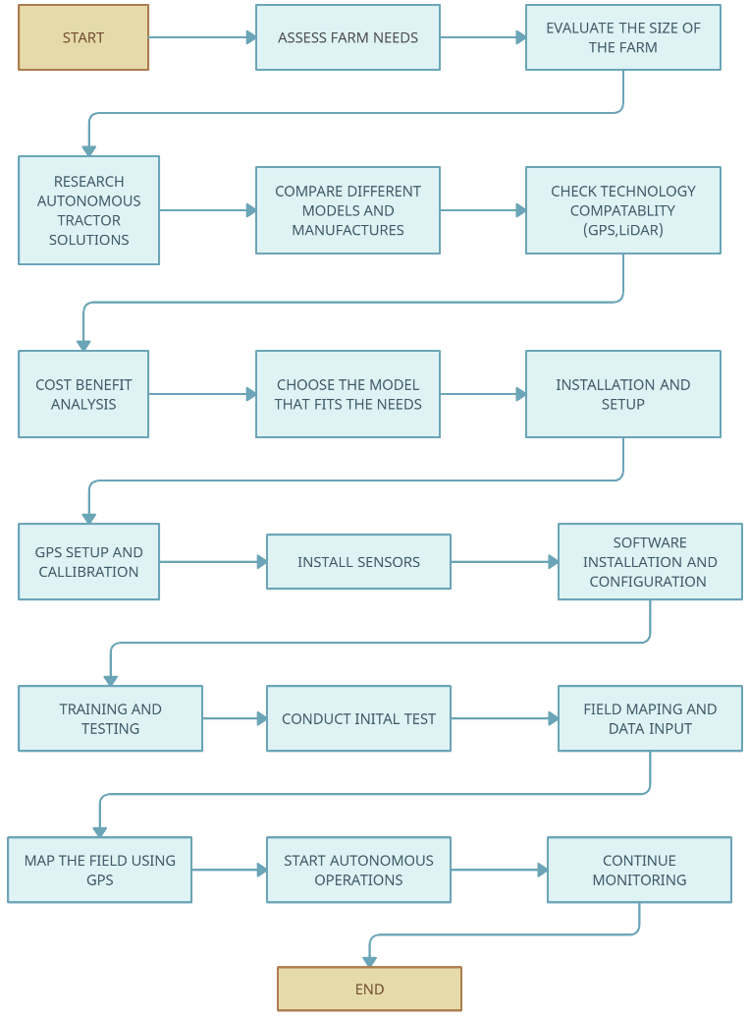

Fig -1: Flowchart

4. CONCLUSIONS

The literature on driverless tractors illustrates a swift progression in technology alongside increasing acknowledgment of their benefits in farm operations. Their development is intricately linked to advancements in GPS technology, machine learning, and IoT, facilitating precise and real-time decision-making. These innovations address various drawbacks of traditional farming methods, such as labor shortages and environmental impacts. Integration of advanced sensors like LiDAR further enhances the reliability and efficiency of autonomous tractors. There's a notable emphasis on environmental sustainability and socioeconomic impacts, indicating a comprehensive approach to agricultural modernization. Despite existing challenges like refining machine learning models and mitigating socioeconomic effects on farming communities, the future of driverless tractors appears promising. As technology continues to advance, they are poised to revolutionize modern agriculture, offering solutions to current challenges and ushering in more efficient, sustainable, and technologically integrated farming practices.

ACKNOWLEDGEMENT

We express our deepest gratitude to our honorable Chairman, Joint Secretary, Principal, Head of the Department and our Project Mentor for their invaluable support, guidance, and cooperation throughout the research period, ensuring the successful completion of the project.

REFERENCES

  - Blackmore, B., Moore, M., & Griepentrog, H. W. (2017). Autonomous agriculture: automatically farming the fields. Trends in Biotechnology, 25(2), 75-82.
  - Hansen, S. F., Jensen, T. K., & Pedersen, S. M. (2019). Challenges in using autonomous agricultural vehicles. Biosystems Engineering, 183, 34-50.
  - John Deere. (2020). The future of farming: John Deere autonomous tractors. John Deere Technology Review.
  - Khatri, V., Patel, N., & Upadhyay, P. (2020). Precision farming with DGPS technology. Journal of Precision Agriculture, 12(3), 155-168.
  - Rossi, C., Brindesi, I., & Petitti, L. (2021). Swarm robotics in agriculture: A review. Robotics and Autonomous Systems, 141, 103759.
  - Silva, J., Barron, E., & Kessler, R. (2018). Addressing labor shortages in agriculture: The role of automation. Agricultural Economics, 49(3), 251-265.
  - Smart Ag. (2019). Precision agriculture and autonomous tractors: Enhancing productivity and sustainability. Smart Ag Insights.
  - Wang, J., Li, Z., & Zhou, J. (2019). LIDAR and computer vision in autonomous agricultural vehicles. Journal of Field Robotics, 36(1), 45-58.
  - Zhang, H., & Li, X. (2021). Artificial intelligence in autonomous tractors: A review. Computers and Electronics in Agriculture, 185, 106137
  - Bacco, M., Barsocchi, P., Ferro, E., Gotta, A., & Ruggeri, M. (2020). The Internet of Things for Smart Urban Agriculture. Internet of Things, 10, 100127.

