Innocuous Design of BMS for EV’s
Raghav N¹
PG Scholor, Department of Computer Science, SRM Institute of Science and Technology (Deemed to be University, Tamilnadu, India.
---------------------------------------------------------------------***---------------------------------------------------------------------
Abstract - The implementation of battery management systems (BMS) ensures the safety, reliability, and longevity of batteries without causing damage. Various monitoring techniques, including voltage, current, and ambient temperature measurements, are utilized to maintain the battery's charge level. Numerous analog/digital sensors and microcontrollers are used for analytical purposes. This study investigates the maximum capacity, charge level, health, and lifespan of batteries under Indian conditions. The prototype developed ensures safe charging and discharging as well as optimal cell performance, providing a secure riding experience for users. By incorporating additional safety features into the existing Battery Management System, we aim to create a safer and more efficient prototype. In this prototype, we utilize the Blynk Application to connect with the microcontroller, which helps monitor the status, faults, and other errors in the Battery Management System. We opted for lithium ferrous phosphate (LiFePo4) batteries instead of lithium-ion batteries due to their lower risk of overheating and fire. Additionally, lithium ferrous phosphate batteries are more efficient and safer in terms of the chemical reactions occurring within the cells compared to lithium-ion batteries. The DHT 11 sensor, positioned outside the system, collects ambient temperature data and sends signals to the microcontroller, which then communicates with the thermoelectric Peltier module. This module responds to external temperature changes accordingly. Furthermore, the prototype supports Bluetooth, Bluetooth LE, and Wi-Fi connectivity. Bluetooth allows rapid phone connections and low-energy transmissions for target identification, while Wi-Fi provides broader event and activity coverage along with direct Internet access. Keywords: Battery Management System, Blynk Application, LiFePo4 battery, DHT 11 sensor, thermoelectric Peltier module, Bluetooth connectivity.

Key Words: Battery Management System, Blynk Application, LiFePo4 battery, DHT 11 sensor, thermoelectric Peltier module, Bluetooth connectivity.

1.INTRODUCTION

This article outlines the crucial role of a Battery Management System (BMS) in ensuring the safety and longevity of electric vehicles (EVs). Despite its importance, BMS faces challenges such as thermal runaway and charge imbalance, which can pose risks to passengers and affect battery efficiency. This project aims to develop a safer, more efficient BMS prototype, focusing on optimal temperature management and cell-specific charging. The future of EVs looks promising, but issues like temperature variations and inefficient charging persist. This project addresses these challenges with advanced safety features and an efficient charging system for each battery cell.

2. Body of Paper

DESCRIPTION OF THE PROPOSED WORK AND WORKING

The Concept of this Design is to make the whole system much safer. The whole point of this innocuous design of the BMS and cell monitoring system, carried out in a way that it is safer in all means.
It starts with the selection of the cell, every regular EV battery is designed with lithium polymer cell. The proposed model Constructed As in such Taken all the variables in hand, such as temperature, humidity, thermal Throttling short-circuiting and many other variables which are responsible for the damage or accidents in the BMS, especially in EV.
Construction of this module is of eight lithium iron phosphate cells in series, with each cell attached with a separate LM35 Temperature sensor, ACS712 and voltage sensor to measure temperature, current and voltage Of each cell separately. And this battery pack will be attached to a Peltier module, to increase and decrease the temperature around the batteries for ideal conditions. Refer Figure 5 for the complete prototype
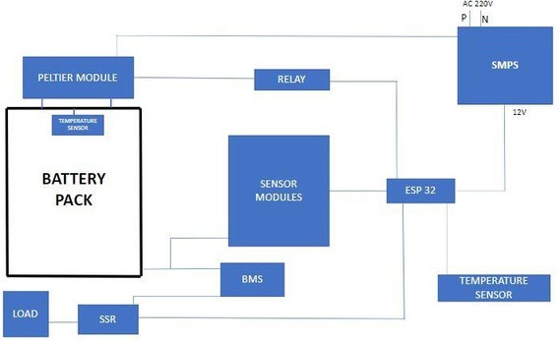
To control all this ESP 32 micro-controller is used as a brain of this operation and the data being collected is being sent through a mobile application and in a webpage. And collected data is used to control the temperature around the battery with the help of the Peltier module. And, solid-state Relay is used as a fail-safe switch in case anything goes wrong in the System. And all this is constructed and put in a block diagram which is shown below in Figure 1.
Fig -1: Block diagram of the proposed work

A microprocessor, sensors, relays, a LiFePO4 battery, a current sensor, and a Peltier module comprise the proposed system. During the working of this Battery Management System each of the cells are monitored with the help of an ACS712. This ACS712 helps to examine the health of the cells. This way we will be able to get to know the current condition of each cell. This keeps track of each cell's charge level, current health, switch-mode power supplies and load detection and management and over-current fault protection. Data is given to the ESP32 after the cells have been analyzed. This ESP32 is the micro-controller used in this prototype and it controls the working of this Battery Management System. If any of the cells requires charging or discharging, it will be sorted with the help of ESP32.

We This proposed system consists of a micro-controller, sensors, relays, LiFePO4 battery, current sensor and a Peltier module. We used Arduino IDE to configure this micro-controller with the system. There are two DHT 11 sensors.one fixed inside the battery pack and the other one outside the battery pack. There are eight ACS712 30 ampere sensors connected in series with 8 lithium ferrous phosphate cells and these eight cells are connected in series to make up a 24-volt battery pack. This battery pack is charged and discharge via 8s 24-volt common port BMS. This BMS is monitored by ESP 32 which is in the circuit. The voltage across the battery pack is measured by a voltage sensor and the data is sent to ESP 32 for computing and monitoring purpose the ACS 712 sensors measuring current between each cell

cell current = (2.5 - (data from AC 3712(5÷1024)) /0.185

The current for each cell is calculated using a specific formula. All collected data is then sent through Blynk IO for monitoring purposes. Blynk IO can remotely control hardware, display sensor data, and store data via virtual pins (see Figure 4). A thermoelectric Peltier module is used to regulate temperature, determining the optimal values for effective and safe battery pack operation by changing the polarity of the module's hot and cold sides. Relays are utilized as an H-bridge to achieve this polarity change (see Figure 2). The system compares the ambient temperature with the temperature inside the battery pack.
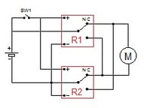
Fig -2: The Relay configuration an H-Bridge

An "if statement" is used to control the relays responsible for switching the hot and cold sides outside the battery pack. For example:
if (batteryPackTemperature < 30) {
// Polarity is switched to cool down the battery pack
} else if (batteryPackTemperature < 21) {
// Polarity is switched to the hot side, warming up the batteries
} else {
// Both relays are turned off, stopping the Peltier module switching
}
In this prototype, we use two DHT11 sensors to monitor the temperature inside and outside the system. The microcontroller is programmed with data for the lowest and highest temperatures a battery cell can handle, tailored to the atmospheric conditions of a specific location. Both sensors continuously monitor the temperature of the cell and the atmosphere. Based on the readings, the ESP32 decides whether the cell needs to be cooled or heated.

Research {REFERENCES 4),5),9) &10)} has shown that the operating temperature of a battery should be below 45°C. Specifically, for Li-ion batteries, the optimal range is -20°C to 60°C with a temperature difference of 5°C. If the temperature reaches 120°C, the battery capacity can drop by 1/5th. The thermoelectric Peltier module will maintain the temperature according to the data analyzed by the Temperature and Humidity sensors.

Maintaining the operating temperature between 15°C and 35°C addresses performance, reliability, and safety issues of Li-ion batteries.

By adding these additional features to the existing Battery Management System, we aim to create a safer and more efficient prototype. In this prototype, we use the Blynk Application to connect with the microcontroller, which helps monitor the status, faults, and other errors in the Battery Management System.

RESULT AND DISCUSSIONS

In this project we have come up with a safer and more eﬃcient Prototype of an existing Battery Management System, which in many ways is better than the current existing system. We have added two humidity and temperature sensors, a current sensor and with the help of a Microcontroller we are providing cooling and heating solution depending on the battery cell status

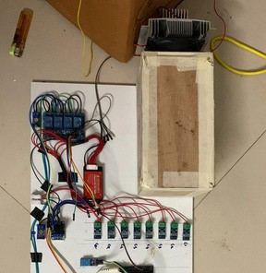
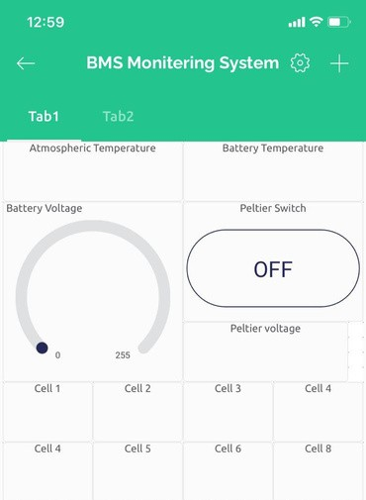

Fig -3: Mobile application for the cell monitoring

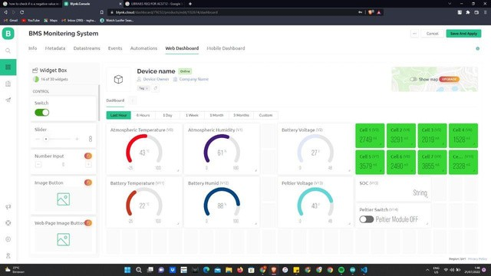

Fig -4: Blynk Web platform with the live data from the BMS prototype

Fig -5: The complete working prototype of “Innocuous Design of BMS for EV’s”

3. CONCLUSIONS

The proposed work aims to enhance the performance of the Battery Management System (BMS) through remote access, allowing regular monitoring of battery status, as shown in Figure 15. This is particularly useful for EVs in Indian conditions. The Blynk application facilitates the creation of interfaces for controlling and monitoring the BMS from iOS or Android devices. We have developed a project dashboard and interface to provide insights into the current battery condition.

ACKNOWLEDGEMENT

We extend our sincere gratitude to our advisors for their invaluable guidance and support. Special thanks to our colleagues for their constructive feedback and to the institutions that provided essential resources. Lastly, we appreciate our families and friends for their unwavering support.

REFERENCES

- Bergveld H.J, Battery Management Systems Design by Modelling, Datasheet rev 1.Lithium-Ion battery monitor and secondary protection IC, (2001).
- Cao J; Schofield N; Emadi A, Battery balancing methods: A comprehensive review, 2008 IEEE Vehicle Power
- and Propulsion Conference, pp. 1–6, (2008).
- Electropaedia, Temperature and discharge rate.
- Energy E, Cost and performance of eV batteries. Final report for The Committee on Climate Change, (2012).
- Faria R; Marques P; Moura, P; Freire F; Delgado J; de Almeida A.T, Impact of the electricity mix and use profile in the life-cycle assessment of electric vehicles. Renewable and Sustainable Energy Reviews, (2013).
- Kuhn B; Pitel G; Krein P, Electrical Properties and Equalization of Lithium-Ion Cells in Automotive Applications.
- 2005 IEEE Vehicle Power and Propulsion Conference, pp. 55–59, (2005).
- Ng K. S; Moo C.-S; Chen Y.-P; Hsieh Y.-C, Enhanced coulomb counting method for estimating state-of-charge and state-of-health of lithium-ion batteries. Applied Energy, 86(9), pp. 1506–1511, (2009).
- Parthiban T; Ravi R; Kalaiselvi N, Exploration of artificial neural network [ANN] to predict the electrochemical characteristics of lithium-ion cells. Electrochimica Acta, 53(4), pp. 1877–1882, (2007).
- M. H. Abdelaziz, Battery Management Systems in Electric and Hybrid Vehicles, Elsevier, 2014.
- S. B. Park, et al., "Design of Battery Management System for Electric Vehicle with Active Balancing Circuit," 2017 IEEE 11th International Conference on Compatibility, Power Electronics and Power Engineering (CPE-
- POWERENG), 2017.
- R. A. Brandt, "Battery management systems for large lithium-ion battery packs," Journal of Power Sources, vol.
- 131, no. 1-2, pp. 56-61, 2004.
- Y. Zhang, et al., "A Review on Battery Management System for Electric Vehicles," 2017 IEEE 3rd International Future Energy Electronics Conference and ECCE Asia (IFEEC 2017 - ECCE Asia), 2017.
- J. P. Zheng, et al., "A Review on Battery Management System of Lithium-Ion Battery Packs for Electric Vehicle
- Applications," Energies, vol. 8, no. 10, pp. 11998-12029, 2015.
- J. Liu, et al., "A Smart Battery Management System Design for Electric Vehicles," 2019 2nd IEEE International Conference on Power Electronics for Renewable Energy and Energy Management (PREEM), 2019.
- K. Zheng, et al., "Development and application of battery management system for electric vehicles," Journal of Power Sources, vol. 196, no. 10, pp. 4814-4823, 2011.

