INTELLI GLOVE

MS. ANU BABU
Assistant Prof. Department of Electronics and Communication Engineering St.Thomas Institute for Science and Technology,Trivandrum.

ABSTRACT

The main objective of this project is to reduce communication barrier between normal people and special person who are not able to make a normal conversation be it a disabled one or dumb and deaf or palsied or any foreigner etc. As human Beings communicate and know each other through thoughts and ideas. The best way to present your idea is through speech. But some people don’t have the power of speech; the only way to communicate with others is through sign language. The problem with sign language is that it is confined to the people who are also deprived of the power of speech. These people are often termed as deaf and dumb. We can say that it is limited to the same set of persons that cannot speak. So, there is a need of technology which reduces this gap through systems that converts sign language into speech. The project aims to facilitate people by means of a glove- based communication interpreter system. The glove is internally equipped with five flex sensors. For each specific gesture, the flex sensor produces a.
NIKHIL AV, NIKHIL BOBY, NIRANJAN LAL, RICHU SHIJU
S6 Students Bachelor of Technology Department of Electronics and Communication Engineering St.Thomas Institute for Science and Technology,Trivandrum

proportional change in resistance. The processing of these hand gestures is in Arduino nano Board which is an advance version of the microcontroller and the LABVIEW software. It compares the input signal with predefined voltage levels stored in memory. According to that required sound is produced which is stored is memory with the help of speaker. In such a way it is easy for deaf and dumb to communicate with normal people recognition system for facilitating communication among deaf and dumb individuals. It explores the integration of flex sensors with Arduino Nano to capture hand movements, and discusses the implementation of algorithms for gesture classification and translation. Evaluation of Flex Sensor Performance in Smart Gloves for Deaf and Dumb Communication: This study evaluates the performance of flex sensors in smart gloves designed for deaf and dumb communication. It assesses factors such as sensor accuracy, reliability, and durability in capturing hand gestures and transmitting data to Arduino Nano for further processing.

INTELLI GLOVE

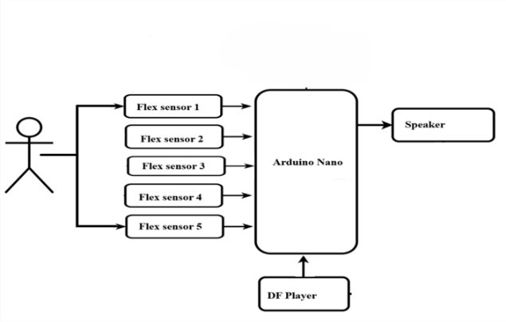INTRODUCTION
In the present world it is very complicated for the deaf & dumb people to talk with the ordinary people as impaired people lacks the amenities which a normal person should own. It actually becomes the same problem of two persons which knows two different languages, no one of them knows any common language so it becomes a problem to talk with each other and so they require a translator physically which may not be always convenient to arrange and this same kind of problem occurs in between the Normal Person and the Deaf person or the Normal Person and the Dumb person. Although technology has been evolving rapidly in this information age, deaf/mute people still use sign language as their only way of communication. Using sign language as a communication tool can be beneficial among those who are familiar with this language, but the problem remains when communicating with the wider community. Sign Language Translator is the appropriate solution that enables deaf/mute people to communication fluently through technology in
different languages. As sign language is a formal language employing a system of hand gesture for communication (by the deaf). Many projects used glove-based systems for automatic understanding of gestural languages used by the deaf community

11. LITERATURE SURVEY

- Design and Implementation of Smart Gloves for Deaf and Dumb Communication Using Flex Sensors and Arduino Nano:
This study presents the design and implementation of smart gloves equipped with flex sensors and Arduino Nano microcontrollers. It discusses the integration of these components to capture hand gestures and convert them into text or speech for communication purposes.

Gesture Recognition System Using Flex Sensors and Arduino Nano:
This research explores the development of a gesture recognition system based on flex sensors and Arduino Nano for individuals with speech and hearing impairments. It
investigates the calibration of flex sensors, signal processing techniques, and machine learning algorithms for accurate gesture detection and interpretation.

Arduino-Based Smart Glove for Sign Language Recognition:
This study focuses on building an Arduino- based smart glove for recognizing sign language gestures. It discusses the use of flex sensors to detect finger movements and Arduino Nano for processing and transmitting data wirelessly to a receiver for interpretation and communication.

Real-Time Gesture Recognition for Deaf and Dumb Communication with Arduino Nano:
This research presents a real-time gesture recognition system for facilitating communication among deaf and dumb individuals. It explores the integration of flex sensors with Arduino Nano to capture hand movements, and discusses the implementation of algorithms for gesture classification and translation. Evaluation of Flex Sensor Performance in Smart Gloves for Deaf and Dumb Communication: This study evaluates the performance of flex sensors in smart gloves designed for deaf and dumb communication. It assesses factors such as sensor accuracy, reliability, and durability in capturing hand gestures and transmitting data to Arduino Nano for further processing.

111. PROPOSED SYSTEM

INTELLI GLOVE

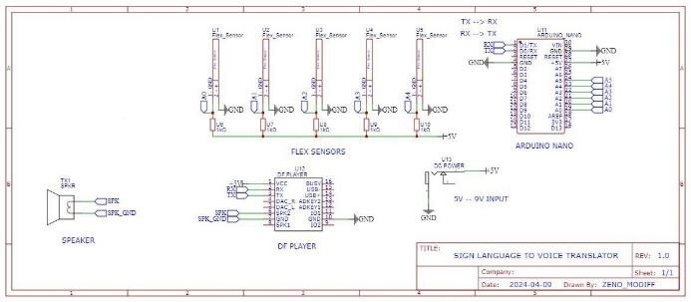1V. CIRCUIT DIAGRAM

Creating smart gloves for deaf and mute individuals using Arduino,flex sensors and a DF Mini involves a multifaceted approach. Firstly, you'll need to attach flex sensors to the gloves on each finger to detect finger movements and connect them to an Arduino board. With the hardware set up, the software implementation comes next. Arduino code needs to be written to interpret the sensor data, mapping finger movements to specific sign language gestures or alphabets. The DF Mini or similar device is then used to convert these gestures into audio output, such as spoken words or phrases corresponding to the hand geasture language.

V. WORKING
The Arduino Nano is connected to 5 flex sensors and a mini Df player. The flex sensors which have internal resistance from 10k to 100k values , the values change when we bend the flex sensor inwards or outwards expecting on the resistance change it will give analog readings , which is then fed back to the Arduino as analog input by using this values the Arduino calculates the resistance change and this is set to a scale in the Arduino code using if else . In that parameter if the resistance change some parameter need to be worked on like if resistance change play an audio file from df player , and else do nothing . All the communication parameters for serial and software serial are programmed for baud rates of 9600 . The Df player Sd card have 5 MP3 files attached to a folder with name "mp3" lower case since the manipulated data is case sensitive and the files which are included inside the folder need to named like 0001_filename.mp3 and it continues till the
required file .Tp play the file simply say the file name (1) , (2) and Etc and the df player
volume is set to max 30 and the out put file is forwarded to void loop where it played infinite number of time under the resistance is changed. . The commands are “I Need Water”, “I Need Help”, “I Need Food”, “I Need to go to toilet”, “I Need Medicine”.

These gloves detect finger movements through the flex sensors, translating them into specific sign language gestures or alphabets using Arduino code. The DF player then converts these gestures into audio output, aiding communication for the deaf and mute.

V1. RESULT
Smart sensing gloves are wearable devices equipped with special sensors that can detect and understand hand movements and gestures. These gloves, embedded with an array of sensors, serve as sophisticated interfaces capable of capturing and interpreting intricate hand movements, gestures, and physiological signals. Users benefit from the flexibility to customize the vocabulary associated with gestures, tailoring the system to their specific needs. This device is a useful tool for speech impaired and partially paralyzed patients which fill the communication gap between patients, doctors and relatives. As it is portable, cost effective. Requires low power operating on a single lithium-ion rechargeable battery and having less weight and robust gives patient liberty to carry it anywhere at their will. It will give dumb a voice to speak for their needs and to express their gestures. Hence this device is an attempt to make it easy to understand the actions of the dumb people by getting the output in the form of voice.

INTELLI GLOVE

individuals with speech impairments or limitations by providing them with a versatile and intuitive means of expressing themselves The creation of a glove-based sign language translator was discussed in this presentation.
Using five types of sensors, the devised device can read the movements of five fingers. The results confirm the effectiveness of the suggested gadget by showing that it can almost entirely translate the movement of the fingers into spoken and written English phrases. Since this was only a prototype, our main goal was to create a design that can help impaired individuals communicate more effectively. We did not decode any words for this prototype; we merely represented some English phrases.

ACKNOWLEDGMENT

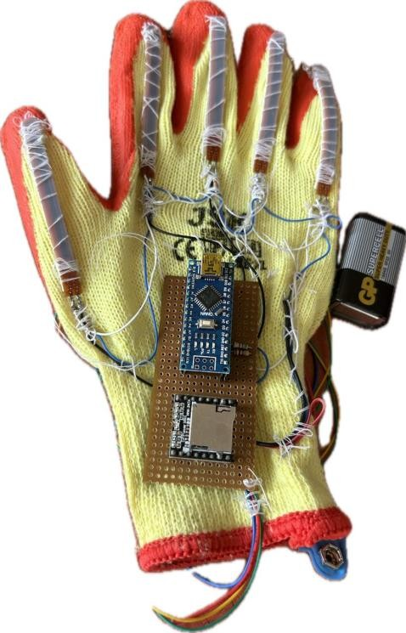
V11. FUTURE SCOPE
Looking ahead, the future scope for smart gloves converting gestures to voice is promising. Advancements in gesture recognition technology will likely lead to more accurate translations, making communication even more efficient. Expanding the gloves' vocabulary database can increase their versatility, allowing users to express a broader range of ideas. Integrating artificial intelligence (AI) algorithms could personalize the experience by learning users' gestures and speech patterns. Additionally, incorporating support for multiple languages can make the technology globally accessible. By integrating with other wearable devices, such as augmented reality glasses or smartwatches, the gloves can enhance functionality, enabling seamless interaction with digital environments. This ongoing innovation holds the potential to revolutionize communication for individuals with speech impairments, fostering greater inclusivity and accessibility in society.

V111. CONCLUSION
In conclusion, the development of smart gloves capable of converting gestures into voice represents a significant step forward in accessibility and communication technology. These gloves have the potential to empower

We would like to take this opportunity to express our profound gratitude towards many individuals, as without their kind support, it would not be possible for us to complete this project. We would like to extend our sincere thanks to our respected principal Dr A G Mathew for his immense support. We addressed many difficulties in coordinating the activities of the project, but we are highly indebted to Ms. Anu Babu, our project guide for her continuous guidance and constant supervision as well for providing necessary information regarding this project and also for her support in completing the project. We would like to express my gratitude towards our project coordinator Dr Anju S for her kind support and guidance. Also we express our sincere thanks to our HOD, Dr Geenu Paul for helping as and for encouraging as. We also thank all our faculties for their valuable support throughout this project .We end up by thanking our dear parents, friends and all who helped us in finalizing the project with in the limited time frame.
Last but not the least we thank Almighty, for letting us through all the difficulties we’ve experienced and for providing us with everything.


INTELLI GLOVE

REFERENCE
- Arsh.A.Ghate,Vishal.G.Chavan, “Smart Gloves for Blinds” , International Research Journal of Engineering and
Technology(IRJET).

- P. Mohan, M. Mohan Raj, M. Kathirvel | P. A. Kasthuringan, S. Musharaff, T. Nirmal Kumar, “Smart speaking gloves for Deaf and Dumb” , INTERNATIONAL JOURNAL OF ENGINEERING RESEARCH & TECHNOLOGY (IJERT).

- Pavan L P, Vinayaka S K, Chetan S, Yashavanth M R,Asha R, “Design of the Smart Gloves to Aid the Visually Impaired” , International Journal of Advanced Research in Science & Technology (IJARST).

- Sanjay S Dineshkumar S, Dr.Suresh M, Vasanthakumar S, Saravana kumar K, Mohamed Rifayee Hussain Z, “Development of Smart Glove for Deaf-mute People” , NVEO – NATURAL VOLATILES & ESSENTIAL OILS.

