FISHERMEN TRACKING SYSTEM USING WATER COMMUNICATION MODULE

Ms,Neetha Merin Thomas Dhanya R L, Reshma M, Kevin Renjudas, Hanna Thomas

Lecturer-Bachelor of Technology Department of Electronics and Communication Engineering St.Thomas Institute for Science and
Technology,Trivandrum

Abstract -

The most difficult medium for data communication is the underwater medium. It is due to its characteristics.
The various existing mode of the communication in water medium are acoustic waves and optical signal. The fishing industry is essential for livelihoods worldwide, yet it faces numerous challenges, including safety concerns for fishermen at sea. To address this, a Fishermen Tracking System (FTS) employing water communication modules (WCMs) is proposed. This abstract outlines the key components and functionalities of such a system At the heart of the FTS is the central monitoring station, which receives real-time data from the WCMs. . It uses electric pulses for transmission of data.This will ensure the maximum transmission rate and it is more efficient and cheaper than the other existing methods. In this project, water communication module also amplify the weak signals and filters the noise present in it. Our proposed system has the aim to give a well understandable user friendly technology. This project gives full secureness and reliable safety for Indian Fisherman lives.This project rapid deployment of assistance in emergencies, improving the safety of fishermen at sea. Overall, the Fishermen Tracking System utilizing water communication modules represents a promising solution to enhance the safety and efficiency of fishing operations. By leveraging advanced technology, this system has the potential to revolutionize the way we monitor and support fishermen at sea, contributing to a more sustainable and secure fishing industry.The designing of the project consists of Arduino UNO,LCD display,water communication module,power supply.l The Arduino Uno serves as the central processing unit of the system. It's responsible for controlling various components and processing data from sensors and the water communication module.WCO transmits the data to the receiver side and amplifies the data.

- INTRODUCTION
Fishing is a crucial industry that provides
livelihoods for millions of people around the
world. However, it is also a dangerous occupation, and fishermen face various challenges such as unpredictable weather conditions.
Electronics and Communication Engineering St.Thomas Institute for Science and
Technology,Trivandrum

failures, and accidents at sea. Therefore, it is crucial to have a reliable communication system that can track fishermen and provide them with timely assistance in case of emergenciesThe system operates by continuously monitoring fishermen's boat and transmitting data into a water communication module which filters and amplifies the weak signal and ensures proper communication. This data is processed and analyzed to offer actionable insights, including potential hazards. In addition to tracking, the system facilitates seamless communication between fishermen and relevant authorities, enabling swift response in case pf emergencies or distress situations. Whether it’s requesting assistance, reporting incidents, or receiving critical updates, the water communication module ensures that fishermen remain connected and supported throughout their voyages

- LITERATURE SURVEY
  - BORDER LINE DISPUTE SHIP BORDER SECURITY SYSTEM FOR FISHERMEN USING WIRELESS WATER COMMUNICATION.
AUTHOR: Asst. Prof. A. Palanisamy, C. Anuchandhar, M. Boobalan, P. Gokul, A. Mathiyarasan Department of Electronics and Communication Engineering,Nandha College of Technology, Perundurai –Tamilnadu, India
This system is used to detect the maritime boundary of the country where the long time dispute between Sri Lanka and India still exists. This mainly happens when fisherman crosses maritime border of neighboring country as he is not aware of the limits in sea. The proposed border alert system is designed to protect the innocent life of fisherman. The main contribution of

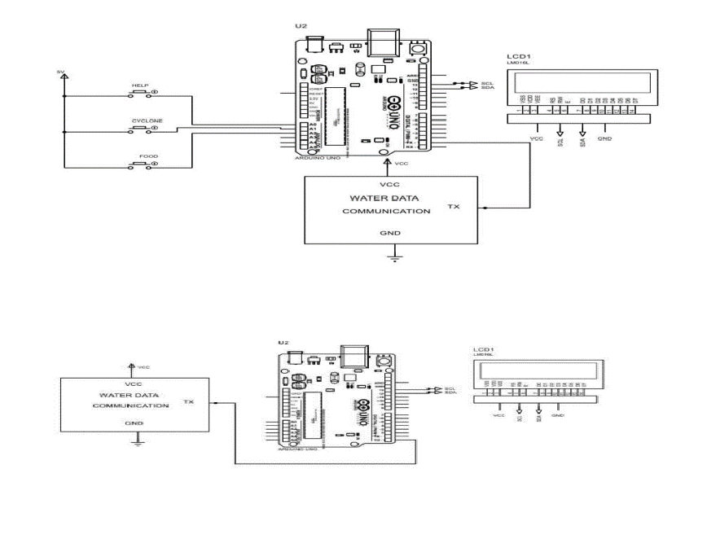
this system alerts the fisherman and rescues them from international maritime line crossing punishments. This system uses RFID Reader to monitor and track the movement of spinning boat vessel which is strayed in sea. It also uses a message transmitter to send message to the base station which monitors the boat s in the sea. The experimental setup for border alert and safety system is initially when the motor is started the system is also switched on and the GPS location of the boat is tracked continuously with the help of software. When the boat is approaching the border of the other countries the signal is sent to the microcontroller and an alert message is displayed on LCD display and also a voice alert is given to the people on boat. Along with the alert, a signal is sent to engine of the boat through microcontroller and the boat stops automatically. Later the boat can be started manually and navigated in the safer direction. In case if the boat is facing any danger or if they are lost in the sea, system has a feature of emergency switch which can be pressed. At this point of time the location of the boat is sent to coastal guards.
.

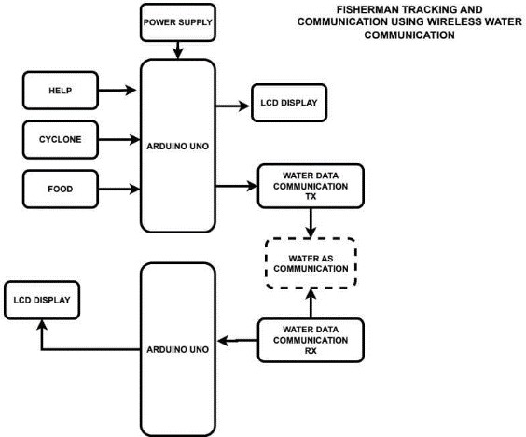

- CIRCUIT DIAGRAM

  - IOT-BASED GSM AND GPS-BASED FISHERMEN TRACKING AND ALERT SYSTEM AUTHOR:Chittiboina.Venkateswarlu1,S.PavanKuma rReddy2,Yeggireddy.Harshitha,D
Student, Department of ECE, Adisankara College of Engineering and Technology(A), Gudur, AP, India
In this sytem they are using Nodemcu ,GSM module,GPS module and Wifi are used for fisher man communication.In this system embedded based model is developed to save the fishermen life and to avoid the problem between two countries.Each fisherman who is sailing in the boat has this device. This device consists of GPS receiver which continuously receives the GPS location of the fishermen. The GPS location is stored in a cloud storage which is monitored by the control room. The particular layer land that is border level is predefined and it is stored in the microcontroller memory. A hazardous button is placed in this system,whenever fisher man pressed the button a message will be sent to the control room with location.If any cyclone occurs,control room will be alerted through message
  - PROPOSED SYSTEM

    - WORKING
The circuit is divided into 2 sections- one is transmitter side and the other is the receiver side.On the transmitter side that is on the fishermens boat a keypad is placed. The keypad has 3 switches .The switches are used for transferring the informations such as food,cyclone and help.There is an voltage of 5V is applied to the keypad. For the help switch the analog input terminal AO is designated and for cyclone the analog input terminal A1 is designated.For food the analg input terminal A2 is designated .

When any of the switch in the keypad is pressed the data is transferred to the Arduino UNO.For

example,when the switch food is pressed in the keypad the analog terminal A2 will be activated.As Arduino UNO is the brain of his system it connects and controls all other components in the system.According to the instructions fed to the Arduino UNO it will perform certain actions .Then it will send this data to the receiver pin of water communication module.The Arduino UNO and water communication module has got voltage from power supply.The water communication module further amplifies the data and it transmits the data to the receiver pin of Arduino UNO placed on the receiver side. The data from the Arduino UNO on the receiver side is given to the LCD display through the pin 13 which is the SCL pin(Serial Clock Pin). SCL pin that the Arduino Controller Board pulses at a regular interval and a serial data pin that is pin number 12 over which the data is sent between these two.Here the data transmission is following YART communication. UART communication is that
,it is a hardware communication protocol that uses asynchronous serial communication with configurable speed. Asynchronous means there is no clock signal to synchronize the output bits from the transmitting device going to the receiving end.Here the data are transmitted serially as electric pulses that is it transmitted by bitwise.

.

    - RESULT
.On pressing the help switch on the keypad ,it was dispayed on the lcd display of transmitter side as well as receiver side.when no switches are pressed it remains in initial state
.On checking the water communication module it shows that its more efficient for transmission of data.

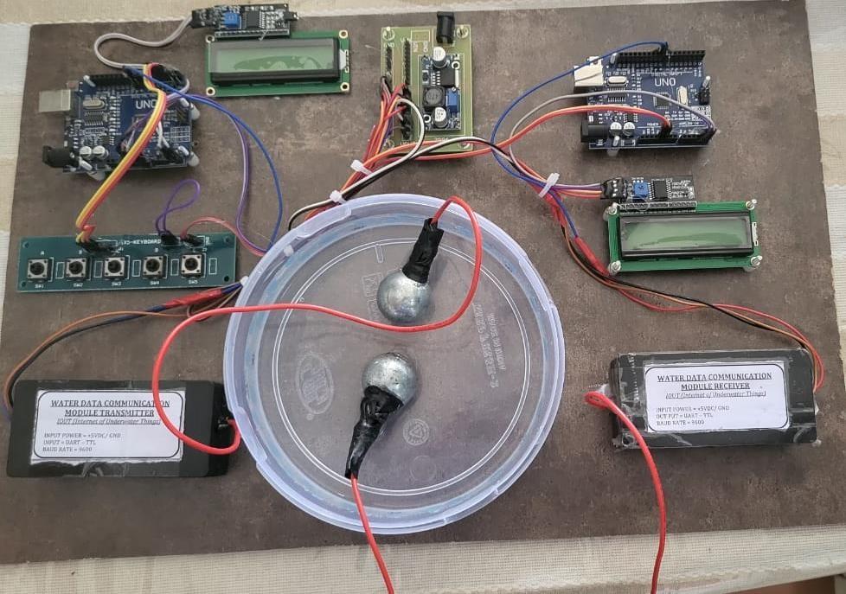
The system could help track the location of fishermen in real-time, ensuring their safety at sea. In case of emergencies or accidents, rescue teams can quickly locate and assist them. Fishermen can use the water communication module to communicate with each other, share information about fishing spots, weather conditions, and potential dangers, thus enhancing collaboration and safety among them. By tracking the movement patterns of fishermen, authorities can better manage fishing resources and enforce fishing regulations to prevent overfishing and protect marine ecosystems. In case of emergencies, such as a vessel going off-course or a fisherman getting lost at sea, the system can significantly reduce search and rescue time by providing precise location data.
The system can also collect valuable data about fishing activities, migration patterns of marine species, and oceanographic conditions, which can be used for research and conservation purposes. Authorities can use the tracking data to ensure that fishermen comply with fishing regulations, such as fishing in designated areas and adhering to catch limits, thereby promoting sustainable fishing practices.

    - FUTURE SCOPE
As technology continues to advance, there may be opportunities to improve the efficiency, reliability, and affordability of water communication modules, making them more accessible to fishermen in different parts of the world. Future using this system in miniaturization could lead

to the development of smaller, wearable communication devices for fishermen, making them more convenient to use and increasing adoption rates. Integration with autonomous vessels or drones could enable remote monitoring and management of fishing activities, reducing the need for constant manual intervention by fishermen. Implementation of blockchain technology could ensure transparent and immutable records of fishing activities, providing consumers with confidence in the origin and sustainability of seafood products. The system could evolve to provide more comprehensive tools for regulatory compliance, including automated reporting of catch data and adherence to fishing quotas and regulations. Collaboration between governments, technology companies, and fishing communities could lead to the development of standardized systems and protocols, fostering interoperability and scalability of the tracking system. Future developments could involve integrating the tracking system with other technologies such as drones or satellite imagery for more comprehensive coverage and monitoring capabilities. In case of emergencies, the system could facilitate quicker and more precise search and rescue operations, potentially saving lives and reducing the time it takes to locate missing fishermen.Overall, the future scope of a fishermen tracking system using water communication modules is expansive, with opportunities for innovation and collaboration to address challenges and maximize benefits for the fishing industry and marine ecosystems.

REFERENCES

      - IOT based Fisherman Tracking System Using Node Microcontroller Unit: B S APEKSHA, B RAMESH , A K SUKRUTHA , M DHANYA , N CHANDANA;Department of
Computer Science and Engineering, Malnad College of Engineering,Karnataka,India
      - -"Border Line Dispute Ship Border Security System for Fishermen using Wireless Communication "-2021. Asst. Prof. A. Palanisamy, C. Anuchandhar, M. Boobalan, P. Gokul, A. Mathiyarasan
      - IOT-based GSMAND GPS-based fishermen tracking and alert system
Chittiboina.Venkateswarlu1,S.PavanKumarReddy2,Y eggireddy.Harshitha,D:Student, Department of ECE, Adisankara College of Engineering and Technology(A), Gudur, AP, India;R.Ramamohan- Assistant professor, Department of ECE, Adisankara
College of Engineering and Technology(A), Gudur, AP, India
      - "A Low-cost Boat Distress Alert And Safety System "- 2020,A.S.M. Nawroz Jahan, Ifrat Ikhtear Uddin, MD. Nasim Mahmud Rone, Dr. Nova Ahmed
.

