EMERGENCY ALERT SYSTEM

Mr .Rony K Thomas
Lecturer-Bachelor of Technology Department of Electronics and Communication Engineering
St. Thomas Institute for Science and Technology, Trivandrum

ABSTRACT

:In times of crisis, effective communication can be a matter of life and death. The Community Emergency Alert System (CEAS) is a vital tool
designed to improve emergency communication and response within communities. This web-based platform integrates various communication channels such as SMS, email, and push notifications to rapidly disseminate critical information to residents and
authorities alike. With features like geo targeting for location-specific alerts and subscriber management for tailored communication preferences, the CEAS ensures that alerts are relevant and reach the right audience at the right time. Furthermore, the system facilitates
coordination among emergency responders, enhancing overall response effectiveness. By
promoting awareness, preparedness, and swift action, the CEAS plays a crucial role in bolstering
community resilience and safety during emergencies.

COMPONENTS REQUIRED
I2C Board of LCD Arduino
GND <---> GND

VCC <---> 5V SDA <---> A4 SCL <---> A5
Arduino Board Pulse Sensor GSM

Gayathri J R , Gouri Krishna R D, Nidhi Prasad C
Student- Bachelor of Technology
Department of Electronics and Communication Engineering St. Thomas Institute for Science and Technology,
Trivandrum

INTRODUCTION

The Emergency Alert System (EAS) is a nationwide network in the United States designed to quickly disseminate important emergency information to the public via broadcast, cable, satellite, and wireless communication pathways. Its primary purpose is to provide timely warnings and instructions during emergencies, including natural disasters, severe weather events, Amber Alerts, and national security threats. At its core, the EAS operates through a hierarchical structure involving federal, state, and local authorities, ensuring a coordinated response to emergencies at all levels. The President has the authority to activate the system for national emergencies, while state and local officials can activate it for regional or local events. The system relies on a series of protocols and technologies to deliver alerts efficiently. These include the Common Alerting Protocol (CAP), which standardizes the format of emergency messages, and the Integrated Public Alert and Warning System (IPAWS), which serves as the backbone for distributing alerts across various communication platforms. Broadcasters, cable operators, satellite providers, and wireless carriers are required by law to participate in the EAS and to regularly test their equipment to ensure its effectiveness. This ensures that alerts reach as many people as possible through multiple channels, increasing the likelihood of a timely response.
While the EAS has greatly improved emergency communication and response capabilities, it continues to evolve to address new challenges and technologies. Efforts are ongoing to enhance its accessibility, effectiveness, and interoperability with other alerting systems, both domestically and internationally .Overall, the Emergency Alert System plays a critical role in keeping the public informed and safe during emergencies.
Today, the EAS stands as a multifaceted platform capable of delivering alerts ranging from severe weather warnings to presidential announcements, ensuring that the public

remains informed and prepared in the face of emergencies. Its hierarchical structure, with federal, state, and local components, fosters a coordinated response to crises of varying scales.

2. LITERATURE REVIEW
- Strengths of Previous Solutions:
Previous solutions have demonstrated several strengths in enhancing women's safety. Personal safety devices such as alarms and panic
buttons provide immediate access to help and can act as deterrents. Mobile applications equipped with safety features enable quick and discreet
communication with emergency contacts. Location- based emergency alert systems leverage GPS technology to accurately track and relay the user's location to authorities or trusted contacts.
- Limitations of Previous Solutions:
While previous solutions have made notable contributions, they also possess certain limitations. Some personal safety devices may have limited range or require manual activation, making them less effective in certain situations. Mobile applications may rely on an internet connection,
which can be unreliable in emergency scenarios. Location-based emergency alert systems may face challenges in terms of accuracy, battery life, and integration with existing emergency response systems.
- Identified Gaps and Research Objectives:
Through this research, we aim to address several
gaps in the existing literature and solutions related to women's safety. These include: Evaluating the effectiveness of utilizing the ESP8266
microcontroller in automatic women safety devices and its impact on real-time communication.
Investigating the integration of GPS technology to accurately track and transmit location coordinates during emergencies .Exploring the usability and user experience of automatic safety devices, ensuring they are intuitive and easily accessible.
Assessing the feasibility of connecting with local authorities or pre-defined contact lists to enable swift response and support.

3. REFERENCE

*Dr C K Gomathy, Ms D.Geethe,”WOMEN SAFETY DEVICE USING IOT” International Journal of Scientific Research in
Engineering & Management: Vol 05, Issue 10, pp 1-9 ,ISSN 25823930 Oct 2021.
[1]. Dhruvil Parikh,Prof Sudhir kadametal,”IOT based Wearable Safety Device for
Women”International Journal of Engineering Research & Technology” Vol 9,Issue 05,pp 1086-
1089,ISSN 2278-0181 May 2020
[2] V. Belagiannis, C. Rupprecht, G.
Carneiro, and N. Navab. Robust optimization for deep regression. In
Proceedings of the IEEE International
Conference on Computer Vision, pages 2830–2838, 2015.
[3 ]P.-J. Bristeau, F. Callou, D.
Vissie`re, N. Petit, et al. The navigation and control technology
inside the ar. drone micro uav. In 18th IFAC World Congress, 2011.
[4] J. Bruna and S. Mallat. Invariant scattering convolution net- works. IEEE transactions on pattern analysis and machine intelligence, 35(8):1872– 1886,
2013.
[5] T.-H. Chan, K. Jia, S. Gao, J. Lu,
Z. Zeng, and Y. Ma. Pcanet: A simple deep learning baseline for image
classification? IEEE Transactions on Image Processing, 2015.

BLOCK DIAGRAM 4.WORKING
  - Hardware Setup:

Arduino Board: Arduino acts as the central processing unit of the system. It receives data from sensors, processes it, and controls the GSM module for sending alerts.
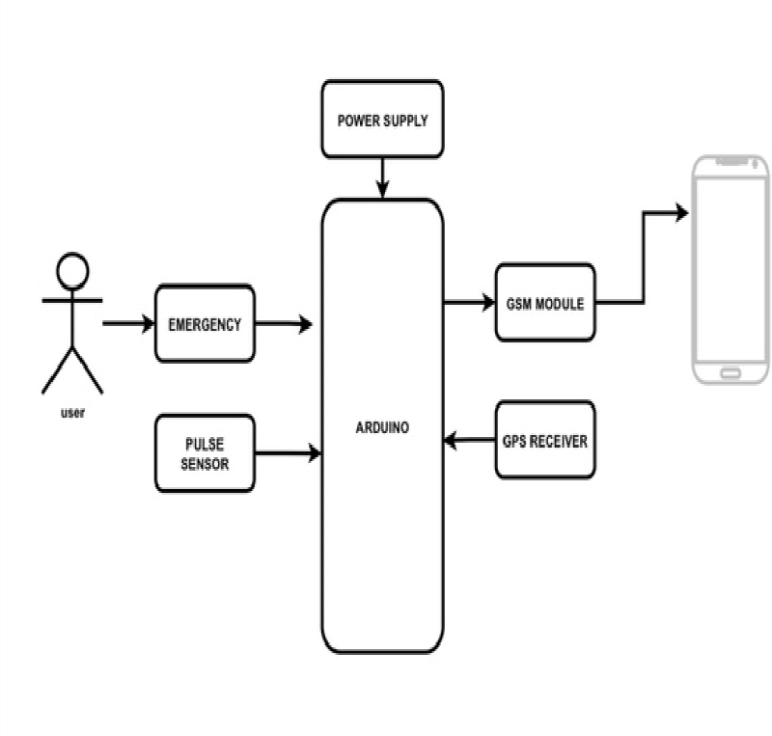
GSM Module: The GSM module enables the system to communicate via text messages. It typically connects to the Arduino via UART (Universal Asynchronous Receiver Transmitter) communication protocol. The GSM module needs a SIM card with an active subscription to a mobile network.
GPS Module: This module provides accurate location data by receiving signals from GPS satellites. It communicates with the Arduino via serial communication (UART). It
continuously provides latitude and longitude coordinates,
which are essential for including location information in the emergency alerts.
Pulse Sensor: The pulse sensor detects the heartbeat rate of an individual. It typically works by emitting light onto the skin and measuring the amount of light that is reflected
back. The variations in reflected light are used to determine the pulse rate. The sensor is connected to one of the Analog pins of the Arduino to measure these variations.
  - Connections:
Ensure proper connections between the Arduino and each module. Follow the datasheets and pinout diagrams provided for each component.
  - Code:
Write code to initialize the libraries required for each module (GSM, GPS, and pulse sensor).
Configure the GSM module to set up parameters such as the recipient's phone number, message format, and communication protocol (usually AT commands).

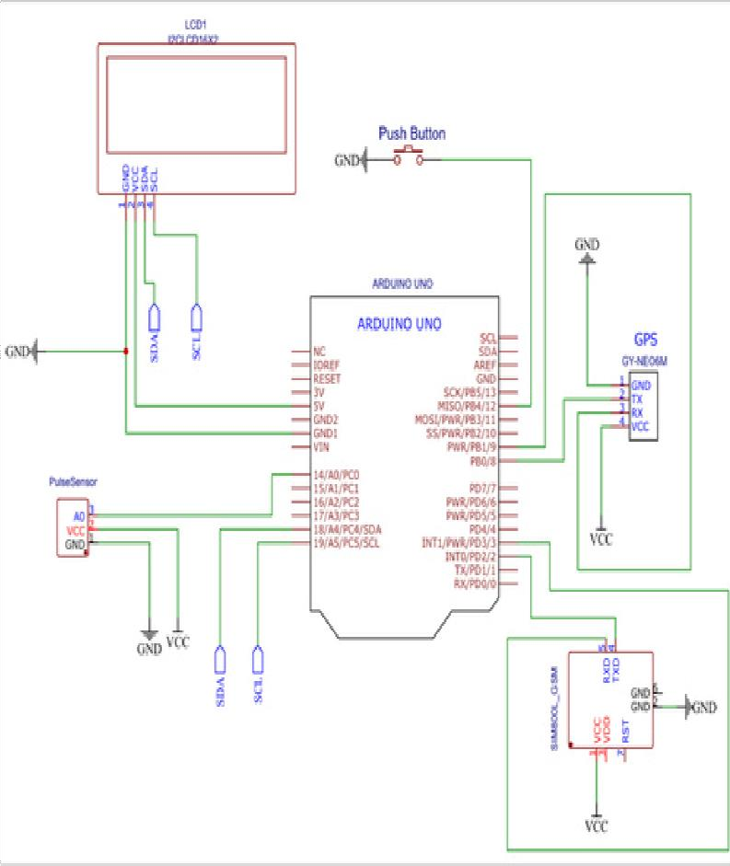
Configure the GPS module to obtain location data. Parse the received data to extract latitude and longitude coordinates.
Continuously monitor the pulse sensor for any abnormal readings. Define thresholds for abnormal pulse rates.
Implement logic to trigger the emergency alert when an abnormal pulse rate is detected. This includes obtaining the current GPS coordinates and composing an SMS message with the location information

4. Testing:

Test the system under various conditions to ensure its reliability and accuracy.
Verify that the GSM module can reliably send SMS alerts to the predefined emergency contacts.
Test the accuracy of the GPS module by comparing its output with known locations.
Validate the functionality of the pulse sensor by comparing its readings with manually measured pulse rates.
5. Power Supply:

- Testing: Test the system under various conditions to ensure its reliability and accuracy. Verify that the GSM module can reliably send SMS alerts to the
predefined emergency contacts. Test the accuracy of the GPS module by comparing its
Ensure that the system has a reliable power supply to operate in emergency situations. Consider using batteries or backup power sources to ensure continuous operation.
6. Deployment: Once thoroughly tested, deploy the system in locations where it may be needed during emergencies, such as healthcare facilities, public places, or personal use scenarios.
Maintainence:
Regularly check the system for any issues or malfunctions.
Update the software as needed to improve
performance, add new features, or address any issues identified during operation.
By following these steps, you can create a robust emergency alert system that leverages Arduino, GSM, GPS, and a pulse sensor to provide timely assistance during critical situations.
output with known locations. Validate the functionality of the pulse sensor by comparing its readings with manually measured pulse rates.
- Power Supply: Ensure that the system has a reliable power supply to operate in emergency situations. Consider using batteries or backup

power sources to ensure continuous operation.
- Deployment:
Once thoroughly tested, deploy the system in locations where it may be needed during emergencies, such as healthcare facilities, public places, or personal use scenarios.
- Maintenance:
Regularly check the system for any issues or malfunctions.
Update the software as needed to improve performance, add new features, or address any issues identified during operation.
By following these steps, you can create a robust emergency alert system that leverages Arduino,
GSM, GPS, and a pulse sensor to provide timely assistance during critical situations.

VI.RESULT
Here's what you can expect as a result of implementing the emergency alert system using Arduino, GSM, GPS, and a pulse sensor: Detection of Abnormal Pulse Rate: The system continuously monitors the user's pulse rate using the pulse sensor.
If an abnormal pulse rate is detected (e.g., too high or too low), the system triggers an emergency alert. Location- Based Alerting: The system includes a
GPS module to determine the current location of the user. When an emergency is detected, the system retrieves the GPS coordinates and includes them in the alert message. This allows emergency responders or contacts to locate the individual quickly. Timely Notification:
Upon detecting an emergency situation, the system promptly sends an SMS alert to predefined
emergency contacts. The message contains information about the abnormal pulse rate and the current GPS coordinates, enabling swift assistance. Reliable Communication:
The GSM module ensures reliable communication by sending SMS alerts over the cellular network.
The emergency alert system using Arduino, GSM,
GPS, and a pulse sensor has several future scope possibilities for improvement and expansion:

Enhanced Sensor Integration: Integrate additional sensors such as temperature, humidity, or motion sensors to detect a wider range of emergency situations, such as fires, floods, or falls.
Advanced Data Processing: Implement machine learning algorithms to analyze sensor data for predictive analytics, allowing the system to anticipate emergencies before they occur based on patterns and trends. Mobile Application Integration: Develop a companion mobile application that pairs with the system to provide real-time alerts, remote
monitoring, and configuration options for users and emergency contacts.
Voice Recognition: Integrate voice recognition technology to enable hands-free operation of the system, allowing users to trigger alerts or request assistance verbally. Geofencing: Implement geofencing capabilities to automatically trigger alerts when the user enters or leaves predefined geographical boundaries, such as home or workplace.
Cloud Connectivity: Utilize cloud services for data storage, analysis, and remote access, enabling users to view
historical data, receive alerts on multiple devices, and access the system from anywhere with an internet connection.
Emergency Services Integration: Establish partnerships with emergency services providers to enable direct
communication and coordination in case of emergencies, streamlining the response process and reducing response times.
Customizable Alerts: Allow users to customize the types of alerts they receive and the recipients, such as family
members, caregivers, or emergency services. Localization and Internationalization: Adapt the system to support multiple languages and localization settings to cater to users worldwide.
Energy Efficiency: Optimize power consumption to prolong battery life or enable energy harvesting techniques to power the system using renewable energy sources. These future scope possibilities demonstrate the potential for the emergency alert system to evolve into a comprehensive, intelligent, and user-friendly solution for ensuring safety and providing assistance during emergencies. This ensures that the alert messages reach the intended recipients, even in areas with poor or no internet connectivity. User Safety and Peace of Mind: By having an emergency alert system in place, users can feel safer knowing that help can be summoned quickly in case of medical emergencies or other critical situations. This system provides peace of mind for both users and their loved ones, especially for individuals with medical

conditions that may require immediate attention.
Overall, the result is a functional and potentially life-saving emergency alert system that leverages modern technology to provide timely assistance and support during emergencies.

- CONCLUSION
In our prototype we are providing help to the humans especially women who need support. So here we introduced an Arduino based system. Arduino is used to control the entire system and hence the device is automated. The Arduino-based women safety device with GSM and GPS modules provides a practical solution for enhancing women's safety in potentially risky situations. As we have designed it for human's Safety it is very use full for them. The target of our project is to design and fabricate a small, straightforward, intelligent security gadget that provides humans with the benefit of personal security in perilous circumstances. It is an affordable system that can keep track of friends and family members phone numbers in a certain location and instantly send out an emergency warning. Therefore our device has the potential to ensure the safety of human lives from the dangerous situations. Further refinements could include compact design improvements and integration with mobile apps for. Our project has been successfully completed and the results obtained are satisfactory. It will be easier for the people who will use the project for the further modification.

ACKNOWLEDGE

We would like to take this opportunity to express our profound gratitude towards many individuals, as
without their kind support, it would not be possible for us to complete this project. We would like to extend
our sincere thanks to our respected principal Dr. A G Mathew Sir for his immense support. We addressed many difficulties in coordinating the activities of the project, but we are highly indebted to Mr. Rony K
Thomas, our project guide for her continuous guidance and constant supervision as well for providing
necessary information regarding this project and also for her support in completing the project.
We would like to express my gratitude towards our project coordinator Dr. Anju S for her kind support and guidance. Also we express our sincere thanks to our HOD ,Dr. Geenu
Paul for helping as and for encouraging as. We also thank all our faculties for their valuable support throughout this project
.We end up by thanking our
dear parents, friends and all who helped us in finalizing the project
with in the limited time frame .
Last but not the least we thank Almighty, for letting us through all the difficulties we’ve experienced and for providing us with everything.
10. FUTURE SCOPE
Customizable Alerts: Allow users to customize the types of alerts they receive and the recipients, such as family
members, caregivers, or emergency services. Localization
and Internationalization: Adapt the system to support multiple languages and localization
settings to cater to users worldwide. Energy Efficiency: Optimize power consumption to prolong battery life or enable energy
harvesting techniques to power the system using renewable energy sources. These future scope possibilities demonstrate the potential for the emergency alert system to evolve into a comprehensive, intelligent, and user- friendly solution for ensuring safety and providing assistance during emergencies. Enhanced Sensor Integration:
Integrate additional sensors such as temperature, humidity, or motion sensors to detect a wider range of emergency situations, such as fires, floods, or falls. Advanced Data Processing:
Implement machine learning algorithms to analyze sensor data for predictive analytics, allowing the system to anticipate emergencies before they occur based on patterns and trends. Mobile Application Integration: Develop a companion mobile application that pairs with the system to provide real-time alerts, remote monitoring, and configuration options for users and emergency contacts.
Voice Recognition: Integrate voice recognition technology to enable hands- free operation of the system, allowing

users to trigger alerts or request assistance verbally.
Geofencing: Implement geofencing capabilities to automatically trigger alerts when the user enters or leaves predefined geographical boundaries, such as home or workplace.

9.FINAL PRODUCT



