ARDUINO BASED JOYSTICK CONTROLFOR UP TO 4 APPIANCES

Ms. Neetha Merin Thomas Nandana S Babu, Lima A S, Saranya S L

St. Thomas Institute for Science and Technology, Trivandrum | St. Thomas Institute for Science and Technology, Trivandrum
Dr Geenu Paul HOD ECE department St. Thomas Institute for Science and Technology, Trivandrum
Assistant Professor-Bachelor of Technology Department of Electronics and Communication Engineering Bachelor of Technology Department of Electronics and Communication Engineering

Abstract - This paper presents the design and implementation of an Arduino-based joystick control system capable of operating up to four appliances. The system utilizes an Arduino microcontroller along with a joystick module and relay modules to facilitate the control of appliances. The joystick module provides intuitive and precise control inputs, allowing users to manipulate the appliances with ease. The system employs a modular approach, with each appliance connected to a dedicated relay module controlled by the Arduino. This modular design enables scalability, allowing for the addition or removal of appliances without significant modifications to the overall system. The Arduino microcontroller serves as the central processing unit, receiving input from the joystick module and translating it into commands to control the relay modules. A user interface is implemented to provide feedback to the user, indicating the status of each appliance and facilitating interaction with the system.
The implementation also incorporates safety features to prevent accidental activation of appliances, including confirmation prompts and fail-safe mechanisms. Additionally, the system is designed to be energy-efficient, minimizing power consumption during idle periods.
Experimental results demonstrate the effectiveness and reliability of the proposed system in controlling multiple appliances using a joystick interface. The system exhibits low latency and high responsiveness, providing users with a seamless control experience.
Overall, the Arduino-based joystick control system offers a versatile and user-friendly solution for managing multiple appliances, suitable for various applications including home automation and industrial control systems. Its simplicity, scalability, and reliability make it a practical choice for both hobbyists and professionals seeking an intuitive control interface for their appliances.

INTRODUCTION
Designing an Arduino-based joystick control system for managing up to four appliances offers a fascinating intersection of hardware and software innovation. Combining the versatility of Arduino microcontrollers with the intuitive input of a joystick opens up a realm of possibilities for remote control applications. This project not only showcases the ingenuity of modern electronics but also provides a practical solution for home automation enthusiasts.At its core, Arduino serves as the brains behind the operation, providing the necessary computational power and flexibility to interpret joystick inputs and transmit corresponding commands to the designated appliances. The joystick, acting as the primary user interface, allows for intuitive and precise control over the connected devices, enhancing the user experience by eliminating the need for complex interfaces or multiple remote controls.
The system architecture encompasses several key components, including the Arduino board, joystick module, and relay modules for controlling the appliances. Additionally, various sensors and actuators may be integrated to expand the functionality and automation capabilities of the system further.The Arduino board serves as the central hub, orchestrating the flow of data between the joystick, relay modules, and connected appliances. Through its programmable nature, Arduino enables custom logic and functionality to be implemented, empowering users to tailor the system to their specific needs and preferences.The joystick module provides multidirectional control inputs, translating physical movements into digital signals that the Arduino can interpret. This intuitive interface simplifies the user interaction, making it easy to navigate and manipulate the connected appliances with precision and accuracy.
Relay modules act as the interface between the Arduino and the appliances, allowing for electrical isolation and safe switching of high-power loads. By utilizing relays, the system can control a diverse range of appliances, from lights and fans to motors and actuators, with ease.The integration of up to four appliances expands the system's utility and versatility, enabling users to control multiple devices simultaneously or independently. Whether it's adjusting the lighting ambiance, regulating room temperature, or automating routine tasks, the Arduino-based joystick control system offers unparalleled convenience and control.In terms of software, the Arduino code plays a crucial role in defining the system's behaviour and functionality. By writing and uploading custom firmware to the Arduino board, users can define how joystick inputs are interpreted and translated into commands for the connected appliances. This programming flexibility allows for endless customization possibilities, from simple on/off control to more complex automation routines and conditional logic.

Furthermore, the Arduino IDE provides a user-friendly platform for writing, compiling, and uploading code to the Arduino board, making the development process accessible to both beginners and experienced enthusiasts alike. With a vast online community and extensive documentation, troubleshooting and expanding upon the project is made more manageable, fostering collaboration and innovation within the Arduino ecosystem.Overall, the Arduino-based joystick control system for up to four appliances represents a compelling fusion of hardware and software engineering, showcasing the potential of DIY electronics in modern home automation. By leveraging the power of Arduino microcontrollers and intuitive input devices like joysticks, users can create personalized solutions that enhance comfort, convenience, and efficiency in their everyday lives. Whether it's for hobbyist tinkering or practical home improvement, this project exemplifies the limitless possibilities of creative electronics design and innovation.

LITERATURE SURVEY
The integration of Arduino-based control systems with various appliances, particularly through joystick interfaces, has garnered significant interest due to its simplicity, versatility, and potential for various applications. This literature survey aims to provide an overview of existing research and projects related to Arduino-based joystick control for up to four appliances, highlighting key methodologies, implementations, and advancements in the field. Overview of Arduino-Based Control Systems discuss the fundamental principles of Arduino microcontrollers and their suitability for interfacing with different sensors and actuators. Highlight the flexibility of Arduino programming and the availability of various libraries and modules for rapid prototyping. Joystick Control Interface: Review existing literature on joystick interfacing with Arduino, including analog and digital joystick implementations. Explore different types of joysticks (e.g., potentiometer-based, Hall-effect) and their respective advantages and limitations. Appliance Control: Examine studies and projects involving the control of appliances using Arduino, covering diverse applications such as home automation, robotics, and gaming. Discuss methods for interfacing Arduino with appliances, including relay modules, transistor switches, and wireless communication protocols.
Multi-Appliance Control: Investigate approaches for extending Arduino-based control systems to manage multiple appliances simultaneously. Explore multiplexing techniques, software algorithms, and hardware configurations for efficient management of multiple devices. Case Studies and Project Examples: Provide detailed case studies and project examples showcasing the implementation of Arduino-based joystick control for up to four appliances. Highlight innovative features, design considerations, and practical applications of these projects. Challenges and Future Directions: Identify common challenges and limitations encountered in implementing Arduino-based joystick control systems. Discuss potential inresearch directions and emerging technologies that could enhance the functionality and usability of such systems. Comparative Analysis: Compare different approaches and methodologies used in the reviewed literature, highlighting their strengths and weaknesses. Evaluate factors such as cost, complexity, scalability, and performance to provide insights for future developments.

PROPOSED SYSTEM

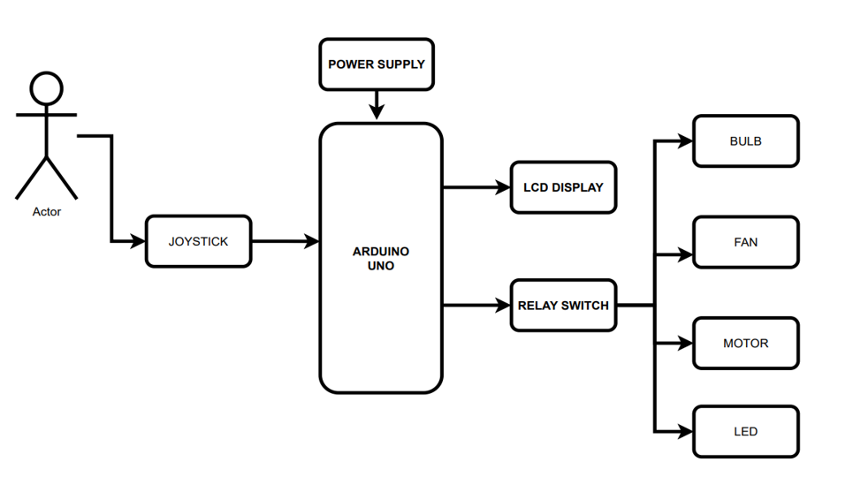

CIRCUIT DIAGRAM

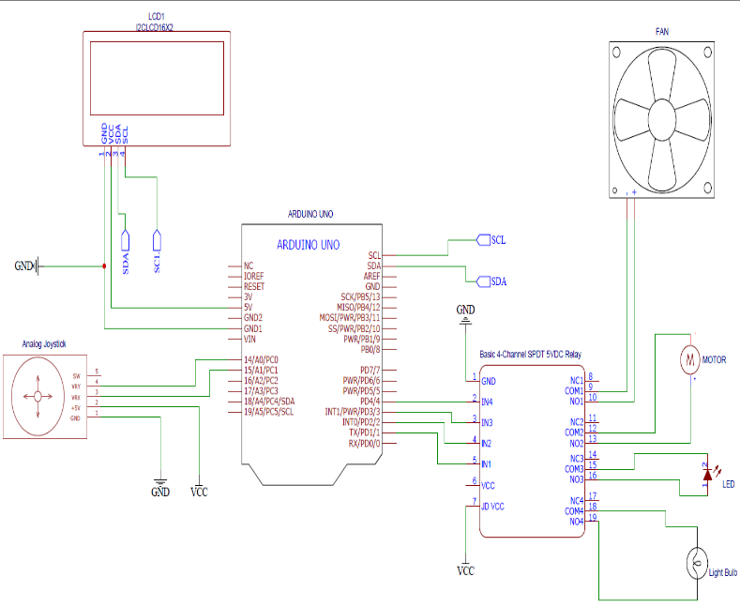
We have a Analog joystick, Arduino uno, ,Relay, ,LCD display,4 loads and connecting wires

WORKING
In the world of technology, innovation is constantly pushing boundaries and creating new possibilities. One such innovation that has been gaining attention in recent years is the use of a joystick to operate multiple devices simultaneously. This technology allows users to control four different devices with just one joystick, making it a convenient and efficient solution for various applications.
The joystick-operated four other devices system is a game-changer in industries such as gaming, virtual reality, robotics, and more. By using a single joystick to control multiple devices, users can streamline their tasks and improve their overall efficiency. This technology is particularly beneficial in situations where users need to control multiple devices simultaneously, such as in gaming competitions, virtual reality experiences, or industrial automation processes.
One of the key advantages of using a joystick to operate multiple devices is the ease of use and convenience it provides. Instead of having to switch between different controllers or interfaces, users can simply use the joystick to control all four devices seamlessly. This not only saves time and effort but also reduces the risk of errors or confusion that can arise from using multiple controllers.
Furthermore, the joystick-operated four other devices system offers a high level of precision and control. The joystick allows users to make precise movements and adjustments, ensuring that each device responds accurately to their commands. This level of control is essential in applications where precision is crucial, such as in robotics or medical devices.
Another benefit of this technology is its versatility. The joystick-operated four other devices system can be customized to suit a wide range of devices and applications. Whether it is controlling drones, robotic arms, cameras, or other devices, users can easily adapt the system to meet their specific needs.
Overall, the joystick-operated four other devices system is a game-changing technology that offers convenience, precision, and versatility. As technology continues to advance, we can expect to see more innovative solutions like this that push the boundaries of what is possible. Whether it is in gaming, virtual reality, robotics, or other industries, this technology has the potential to revolutionize how we interact with and control multiple devices.
In the realm of electronics and automation, the integration of Arduino boards has revolutionized the way we interact with and control various devices. One fascinating application of Arduino technology lies in the creation of a sophisticated control system that utilizes a joystick module for seamless operation. In this blog post, we delve into the intricacies of how such a system operates and orchestrates the control of multiple electrical devices.
The system commences its operation by powering up essential components, including the Arduino board, joystick module, relay modules, and a display module. Each element plays a pivotal role in ensuring the smooth functioning of the control system. The analog joystick, a key input device, is interfaced with the Arduino through its analog input pins, enabling it to provide continuous voltage signals that are proportional to its displacement along the X and Y axes.
As the user manipulates the joystick, the Arduino diligently reads the analog values generated by the joystick module. These values serve as a representation of the joystick's position along the X and Y axes. Through a mapping process, the Arduino deciphers these analog values to determine the direction of movement of the joystick—whether it is being moved up, down, left, or right.
The real magic unfolds when the user moves the joystick in a specific direction, triggering the activation of the corresponding relay connected to the electrical device of interest. This action effectively powers up the associated appliance, be it an LED, a light bulb, a fan, or a motor. Subsequently, repeating the movement in the same direction prompts the deactivation of the relay, leading to the shutdown of the device.
Central to the functionality of this system is the 4-channel SPDT relay module, which serves as the bridge between the Arduino and the electrical devices. Each relay output within the module is linked to a distinct electrical load, enabling the control of multiple appliances with ease and efficiency.
Simultaneously, the Arduino communicates with the display module, relaying pertinent information to the user in a clear and concise manner. This information may encompass the status of each appliance (whether it is on or off), details regarding the current action being executed (e.g., turning on or off an appliance), as well as feedback on the system's status or any potential errors that may arise during operation.
Users are empowered to control the various appliances connected to the system and receive real-time feedback through the display module as long as the system remains powered on. The firmware running on the Arduino acts as the brain of the operation, processing the analog joystick input and orchestrating the activation and deactivation of relays based on the direction of movement detected.
In conclusion, the amalgamation of Arduino technology, joystick interfaces, relay modules, and display units culminates in the creation of a sophisticated control system that offers users a seamless and intuitive means of interacting with electrical devices. This system not only exemplifies the power of Arduino in automation but also underscores the endless possibilities that arise from merging hardware and software to create innovative solutions for modern-day challenges.

RESULT
The Arduino-based joystick control system for up to four appliances represents a versatile and accessible solution with considerable potential for future development. Currently, the system enables users to manipulate multiple appliances through a joystick interface connected to an Arduino microcontroller board. This setup offers a straightforward and intuitive means of interacting with various devices, from lights and fans to motors and actuators. The Arduino board acts as the intermediary, receiving input from the joystick and translating it into commands that control the appliances. Looking ahead, several avenues for future improvement and expansion exist. Firstly, advancements in sensor technology could enhance the system's feedback capabilities, enabling more precise control and interaction. Additionally, the integration of wireless communication protocols such as Bluetooth and Wi-Fi could facilitate remote monitoring and control of appliances, expanding the system's utility and accessibility.
Furthermore, as the Internet of Things (IoT) ecosystem continues to evolve, there's an opportunity to integrate Arduino-based systems with IoT platforms, enabling seamless connectivity and interoperability with other smart devices and services. Moreover, advancements in artificial intelligence and machine learning algorithms could enable more intelligent and adaptive control strategies based on user preferences and environmental conditions. The future scope of Arduino-based joystick control systems also encompasses the potential for standardization and widespread adoption within the smart home automation market. As demand grows, the development of compatible peripherals and accessories, as well as a vibrant community of developers and enthusiasts, could further fuel innovation and expansion in this space.
Overall, the Arduino-based joystick control system offers a foundation for future enhancements and applications, ranging from home automation to robotics and beyond, driven by advancements in technology and the evolving needs of users.
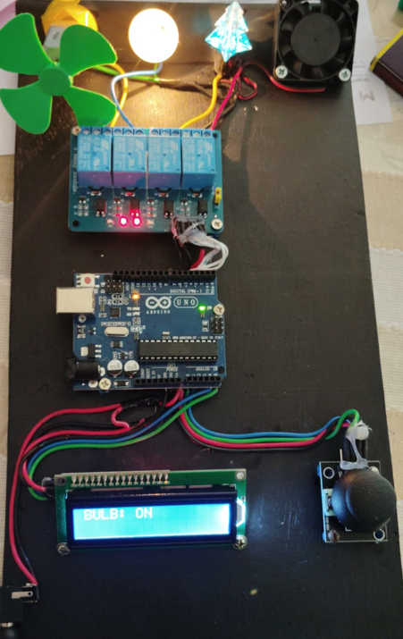

FUTURE SCOPE
Implementing an Arduino-based joystick control for up to four appliances opens up several exciting possibilities. some future scope ideas are:
Enhanced User Interface: Integrate a graphical user interface (GUI) using LCD screens or LED displays to provide users with visual feedback and control options.
Wireless Connectivity: Incorporate wireless communication modules like Bluetooth or Wi-Fi to enable remote control of appliances via smartphones or computers.
Voice Control: Integrate voice recognition technology to allow users to control appliances using voice commands, adding convenience and accessibility.
Internet of Things (IoT) Integration: Connect the Arduino system to the internet to enable remote monitoring and control of appliances from anywhere in the world.
Home Automation: Expand the system to control a wider range of home appliances and devices, creating a comprehensive home automation solution.
Sensor Integration: Incorporate various sensors such as temperature, humidity, motion, and light sensors to enable automated actions based on environmental conditions or user preferences.
Machine Learning Algorithms: Implement machine learning algorithms to analyse user behaviour patterns and optimize appliance control for energy efficiency or user comfort.
Customizable Profiles: Allow users to create and save customized profiles for different scenarios or preferences, enhancing the versatility and usability of the system.
Safety Features: Implement safety features such as overload protection, emergency shut-off, and notification alerts to ensure the safe operation of appliances.
Scalability and Modularity: Design the system with scalability and modularity in mind, allowing users to easily expand the number of controlled appliances or integrate additional features as needed.
By exploring these avenues, you can create a versatile and sophisticated Arduino-based control system that enhances user convenience, efficiency, and safety in home appliance management.

CONCLUSION
In conclusion, developing an Arduino-based joystick control system with a display for controlling up to four appliances offers a versatile and interactive solution for various applications. This project combines hardware interfacing, sensor input, real-time processing, and visual feedback to create an intuitive user experience.
By integrating a joystick module, relay modules, an Arduino board, and a display module, users can seamlessly interact with the system to control appliances in their environment. The joystick serves as a user-friendly input device, allowing users to navigate through different control options effortlessly. Meanwhile, the display provides real-time feedback, indicating the status of appliances or actions being performed, enhancing user understanding and engagement. involves careful hardware setup, joystick calibration, appliance control logic, relay control, user interface design (optional), through testing, safety considerations, and documentation. By following these steps, users can create a versatile and efficient control system that offers intuitive manipulation of multiple appliances through joystick inputs. This approach provides a customizable solution for various applications, from home automation to industrial control systems, offering both functionality and flexibility.
This project demonstrates the potential of Arduino-based systems in home automation, robotics, and interactive installations. It showcases how simple components can be integrated and programmed to create complex functionalities, empowering hobbyists, students, and professionals to explore the realm of embedded systems and IoT applications.
Overall, the Arduino-based joystick control system with a display for up to four appliances offers a practical and educational platform for learning, experimentation, and innovation in the field of embedded electronics and human-computer interaction. Its modular design and customizable features make it adaptable to various use cases and provide a foundation for further exploration and expansion in the realm of DIY electronics and automation.

REFERENCES

- By Suresh Dwivedi, circuit designer at EFY
- Chand A N and Onwublo G C developed joystick-based control for a differential drive robot in innovative algorithms and techniques, in automation industrial electronics and telecommunications(pp.37-41) springer, Dordrecht.
- Vardan Agarwal developed joystick-controlled Arduino car in 2020.

