Stock Management and Analysis
B VARUN KUMAR AP/IT, K NAVANEETHA KRISHNAN, K S RETHINA PRAKASH, M SAGAR
INFORMATION TECHNOLOGY
SRI SHAKTHI INSTITUTE OF ENGINEERING AND TECHNOLOGY
COIMBATORE
---------------------------------------------------------------------***---------------------------------------------------------------------
Abstract - The Stock Management System (SMS) is a desktop-based application designed to manage the stock system of any organization. It involves technology systems and processes to efficiently handle stock-related tasks. The SMS allows organizations to store stock details, perform stock maintenance, update stock based on sales data, and generate daily or weekly sales and stock reports. By categorizing individual aspects of sales and stock management, this system addresses various challenges related to direct sales and purchase management.

Key Words: Stock , Organisation , Analysis.

1.INTRODUCTION :

In Today's fast-paced and competitive business landscape, effective stock management plays a pivotal role in the success of organizations across various industries. Stock management, also referred to as inventory management, en compasses the processes and strategies used to oversee the flow of goods from suppliers to customers while balancing the costs associated with holding inventory. The introduction outlines the challenges commonly encountered in stock management, such as stock outs, overstocking, inventory obsolescence, and supply chain disruptions. These challenges can have detrimental effects on profitability, customer satisfaction, and overall business performance. In recent years, the landscape of publishing has witnessed unprecedented transformation driven by technological advancements, evolving consumer preferences, and shifting market dynamics. Amidst this backdrop of change, publishers face the dual challenge of adapting to emerging trends while ensuring sustainable financial performance. Effective stock management and analysis emerge as linchpins in this endeavor, empowering publishers to make informed decisions, mitigate risks, and capitalize on opportunities in the ever-evolving market ecosystem. As publishers embark on this journey of exploration and discovery, this guide stands as a steadfast companion, offering practical guidance, expert insights, and real-world examples to illuminate the path forward.

2. Body of Paper :
A fundamental aspect of stock management for journal publishing companies is understanding the intricacies of stock markets. This involves grasping key concepts such as stocks, bonds, and market indices, as well as the factors that influence stock prices, including macroeconomic trends and company-specific developments. Armed with this knowledge, publishers can navigate the market with greater confidence, seizing opportunities and mitigating risks effectively. Portfolio optimization emerges as a cornerstone of stock management, wherein publishers seek to construct diversified portfolios that balance risk and return. By applying modern portfolio theory principles and employing techniques such as asset allocation and rebalancing, publishers can optimize their investment portfolios to align with their strategic objectives while minimizing exposure to market volatility. This involves analyzing key financial metrics such as earnings per share, return on equity, and liquidity ratios to evaluate the profitability, solvency, and efficiency of publishing operations.

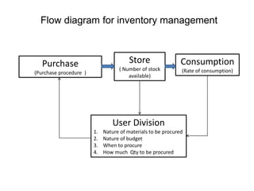

Fig-1: Concept Map

Effective stock management and analysis are indispensable for journal publishing companies seeking to navigate the complexities of the market and achieve financial resilience. By understanding key financial principles, implementing portfolio optimization strategies, assessing financial performance, valuing companies accurately, and managing risks effectively, publishers can enhance their stock management practices and maximize shareholder value in an ever-evolving landscape. This paper provides a roadmap for publishers to navigate the intersection of finance and publishing, empowering them to thrive amidst market uncertainties and technological disruptions. It encompasses a range of activities aimed at optimizing investment portfolios, assessing financial performance, valuing companies accurately, and managing associated risks.

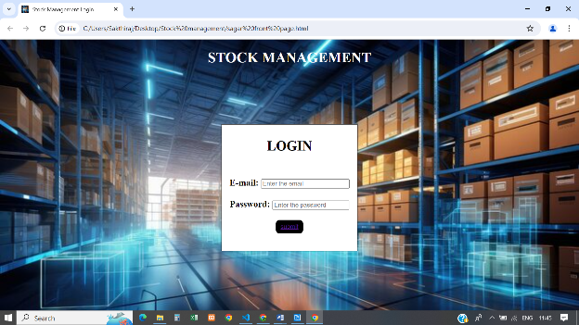
Fig-1: Login Page
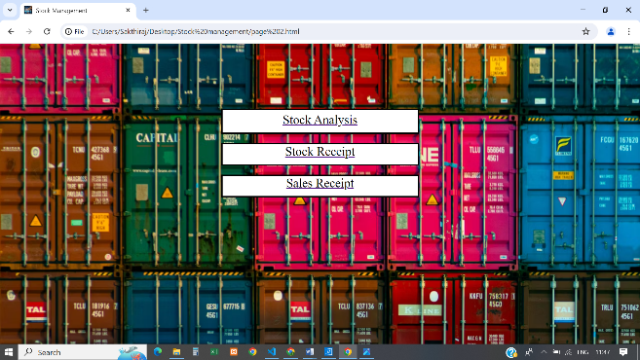

Fig -2: Home Page



Fig-3: Analysis Page

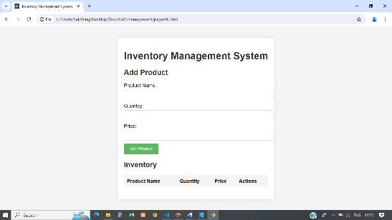

Fig-4: Inventary Page

3. CONCLUSIONS

This project has navigated through the intricacies of inventory control, forecasting, and optimization to underscore the critical importance of efficient stock management in organizational success. It is a used a few languages such as a HTML, CSS, JS and for the back end connectivity this project has an inclusion of fire base.

ACKNOWLEDGEMENT

We would like to express our sincere gratitude to all those who contributed to the publication of this paper on stock management and analysis for journal publishing companies.

REFERENCES

- Chopra, S., & Meindl, P. (2016). Supply chain management: Strategy, planning, and operation. Pearson Education.
- Silver, E. A., Pyke, D. F., & Peterson, R. (1998). Inventory management and production planning and scheduling. John Wiley & Sons.
- Simchi-Levi, D., Kaminsky, P., & Simchi-Levi, E. (2008). Designing and managing the supply chain: Concepts, strategies, and case studies. McGraw-Hill Education.
- Nahmias, S. (2014). Production and operations analysis. McGraw-Hill Education.
- Mentzer, J. T., Myers, M. B., & Stank, T. P. (2006). Handbook of global supply chain management. SAGE Publications.

