Financial Literacy Management and Mastering (FILIM.in)
C NAVEEN KUMAR, A R RITHIN, S PRAVEEN KUMAR
INFORMATION TECHNOLOGY
SRI SHAKTHI INSTITUTE OF ENGINEERING AND TECHNOLOGY
COIMBATORE
---------------------------------------------------------------------***---------------------------------------------------------------------
Abstract - This Financial Literacy Quiz is to make users to bring up the idea about money, economy, and Financial Literacy. Financial Literacy is a vital knowledge to run our day-to-day life economically. This Quiz enlightens the users with Money and Its Important aspects. The Website consists of pages including Learning, Evaluating and also Exploring. Benefits of financial literacy include better financial decisions, effective debt management, greater financial goals achievement, reduced expenses, less financial stress, increased ethical decision-making, and the creation of a structured budget. Developing financial literacy is essential for ensuring financial stability and reducing anxiety.

Key Words: Learn , Leap , Debt Management.

1.INTRODUCTION :

Filim.in is a website which helps you to learn and evaluate your financial knowledge . Here, your ultimate destination for mastering financial literacy through engaging quizzes and interactive learnings. In today world, understanding money management, investments, budgeting, and financial planning is crucial for personal and professional success. This project is designed to make financial education both fun and accessible, offering a wide range of quizzes that help to educate all levels of financial knowledge. Whether you're a beginner looking to grasp the basics or an experienced individual aiming to refine your expertise, this project provides the tools and resources you need to boost your financial confidence. This website leads you to the journey towards financial empowerment. This project dedicated to enhancing your financial literacy in an engaging and interactive manner. It is a great platform which offers a diverse set of quizzes that cover essential topics such as budgeting, investing, saving, credit management, and financial planning. Each quiz is designed to evaluate in various levels, ensuring that whether you are a beginner or a financial expert, you will find some challenges and educates. This project’s mission is to empower individuals with the knowledge and skills necessary to make informed financial decisions, promoting financial independence and securities.

2. Body of Paper :

Financial Literacy is one of the most important aspects to learn for our daily needs and to lead an Economical life. Filim.in helps you to learn about all the topics of the financial literacy and helps you to evaluate your own self with others who also use this website. This website allows you to Learn, Evaluate and Master the art of Financial Literacy. This also helps you to manage the Economy of your personal and professional Life. The levels are in this website makes you to deeply learn one and move to the next level by mastering the levels. This is a next level website to learn and evaluate yourselves with the Finance and Economy. As per the title given, this project allows the users to Learn about the topics involved in the Finance and Economy. This website will help the users to learn and evolve around the topics of Financial Literacy.

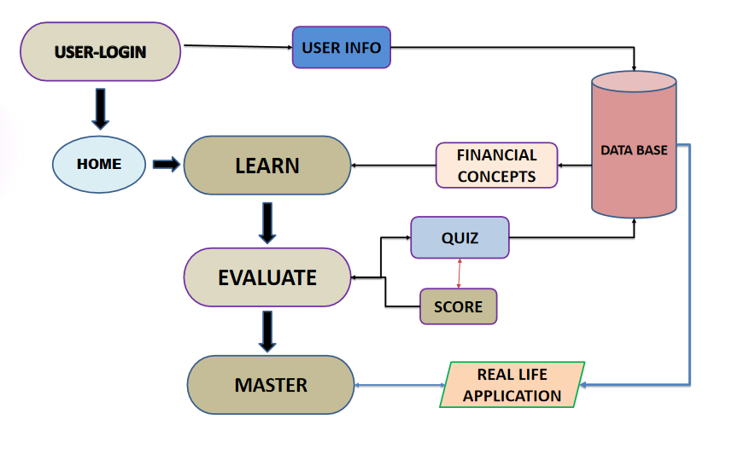
Fig-1: Concept Map

Filim.in helps you to learn about all the topics of the financial literacy and helps you to evaluate your own self with others who also use this website. This website allows you to Learn, Evaluate and Master the art of Financial Literacy.This also helps you to manage the Economy of your personal and professional Life.The levels are in this website makes you to deeply learn one and move to the next level by mastering the levels.

Fig-2: Home Page
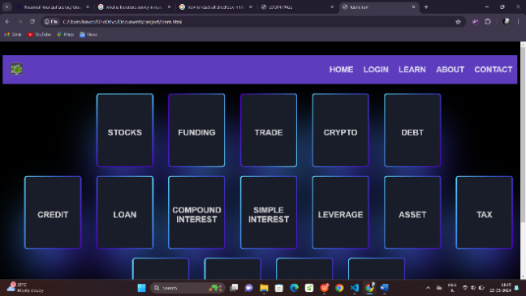

Fig -3: Learn page

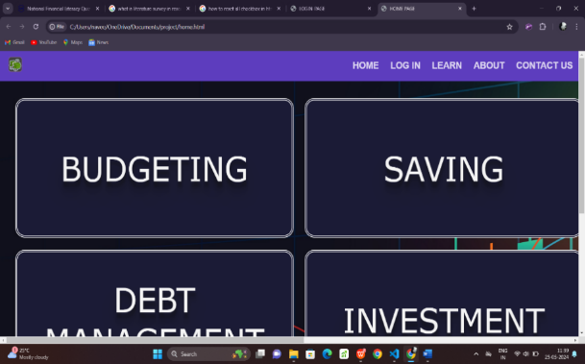

Fig-3:Quiz Title

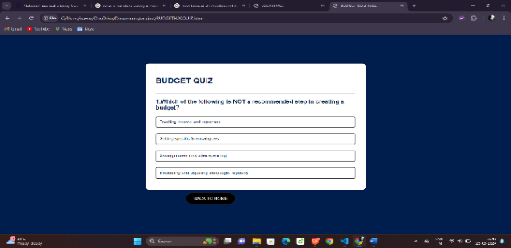

Fig-4:Quiz Page

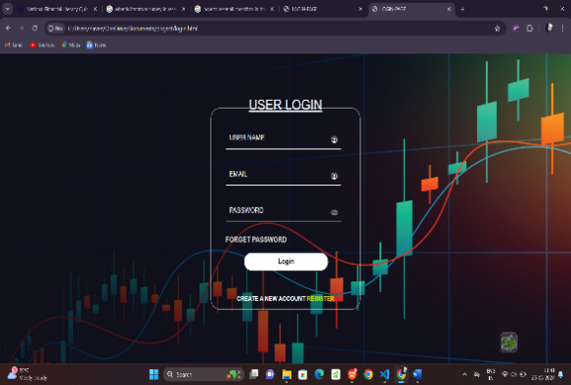

Fig-5:Login Page

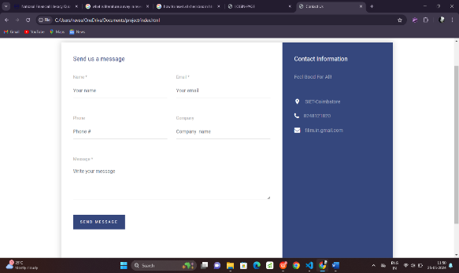
Fig-6:Contact Page

3. CONCLUSIONS

Financial literacy Management and Mastering FILIM.in is a website to Learn and Master the Aspects of Financial Literacy and for that it used a Few Languages such as HTML,CSS,JS and for the backend connectivity this project has an inclusion of the Firebase .With that this website has an inclusion of a homepage, Login page , register page, a page to learn about Financial Literacy,and a linked page in the home page to quizzes and to evaluate yourselves.

ACKNOWLEDGEMENT

We extend our heartfelt gratitude to our honourable Chairman, Dr. S. Thangavelu for providing a wonderful platform to educate our minds, inculcate ideas and implement the technological changes in the real-world environment.

Deepest thanks to our dynamic Joint Secretary, Mr. T. Sheelan for monitoring the infrastructure and for providing the work atmosphere to implement the project and providing an excellent and maintaining the decorum and discipline of the students.
We are tremendously thankful to our beloved Principal, Dr.D. Elangovan,M.E.,Ph.D. for his incredible support to make us follow ethics and morality in our life and also for allocating sufficient time and resources.

A big salute to our vibrant Head of the Department, Dr. S. Prakash for imbibing scope of the project and systematic procedure in execution. We express our genuine thanks for encouraging us throughout the project period to complete it successfully.

Our great thanks to the Project mentor, Mrs.M. Kirubadevi for her ever lasting contribution in making the project a smooth journey and also for her valuable guidance and for making us realize our potential and be successful.

Our great thanks to the Project Co-Ordinator, Dr. M. Deepa for her ever lasting contribution in making the final year project phase a smooth journey and also for her valuable guidance and for making us realize our potential and be successful. We also thanks for her kind help and Cooperation throughout the research period to make us a grant successful completion of project.

REFERENCES

- Faulkner, Ash. (2022). Financial literacy resources in US public libraries: website analysis. Reference Services Review. 50. 10.1108/RSR-02-2022-0008.
- Pšenák, Peter & Ildikó, Pšenáková & Szabo, Tibor & Kovac, Urban. (2019). The Interactive Web Applications in Financial Literacy Teaching. 661-666. 10.1109/ICETA48886.2019.9040011.
- D. L. Remund, “Financial Literacy Explicated: The Case for a Clearer Definition in an Increasingly Complex Economy,”
- Journal of Consumer Affairs, vol. 44, no. 2, pp. 276–295, 2010.
L. Klapper, A. Lusardi, and P. van Oudheusden, “Financial
Literacy Around the World:” p. 28.
- K. Rentková, Ľ. Mitková, and V. Mariak, “Financial (i)literacy: does the financial advisor help?” in Leadership & management: integrated politics of research and innovations : LIMEN 2018, Belgrade: Association of Economists and Managers of the Balkans, 2018, pp. 166–172.

