UZHAVAN – AN AGRI PRODUCT BASED WEBSITE
(WWW.UZHAVAN.COM)
MS.M. GAYATHRI DEVI , MR. K NAVEEN , MR.G NITHIN, MR.M POOBESH
INFORMATION TECHNOLOGY
SRI SHAKTHI INSTITUTE OF ENGINEERING AND TECHNOLOGY
COIMBATORE
---------------------------------------------------------------------***---------------------------------------------------------------------
Abstract - About 75% people are living in rural areas and are still depend on agriculture. About 43% of INDIAN geographical area is used for agriculture activity. Agriculture continues to play a major role in INDIAN economy. Product rate will be constant always. Agriculture provides food more than 1 billion people. All products will be able arrange in a single place. Transportation cost will be reduced, because it will taken care by our company. Easy to sale ,it reduces the risk of farmers to sale and all the farmers will get the same rate and constant rate will fixed.We are the first to invite the direct sales between farmer to consumer. Till now there is no website or application for direct contact between farmer and consumer. This project concept was completely based on the farmers struggles to sale their products.

Key Words: Buy,Gather,Sell at constant price.

1.INTRODUCTION :

The entire world is depending on the food but it is a type of agricultural product . But the products bought from the farmers are very less according to the market rate. Efforts to develop agricultural marketing have, particularly in developing countries, intended to concentrate on a number of areas, specifically infrastructure development; information provision; training of farmers and traders in marketing and post-harvest issues; and support to the development of an appropriate policy environment. In the past, efforts were made to develop government-run marketing bodies but these have facilitates tended to become less prominent over the years .Up-to-date information on prices and other market factors enables farmers to negotiate with traders and also spatial distribution of products from rural areas to towns and between markets

2. Body of Paper :
Agricultural marketing plays an important role not only in stimulating production and consumption, but also in accelerating the pace of economic development. It is the most important multiplier of agricultural development. In the process of shifting from traditional to modern agriculture, marketing emerges as the biggest challenge because of production surpluses generated by the shift. Understanding Consumer Preferences: The success of agriculture product sales hinges on understanding consumer preferences. By conducting market research and staying attuned to consumer trends, farmers and producers can tailor their offerings to meet the demands of their target market.
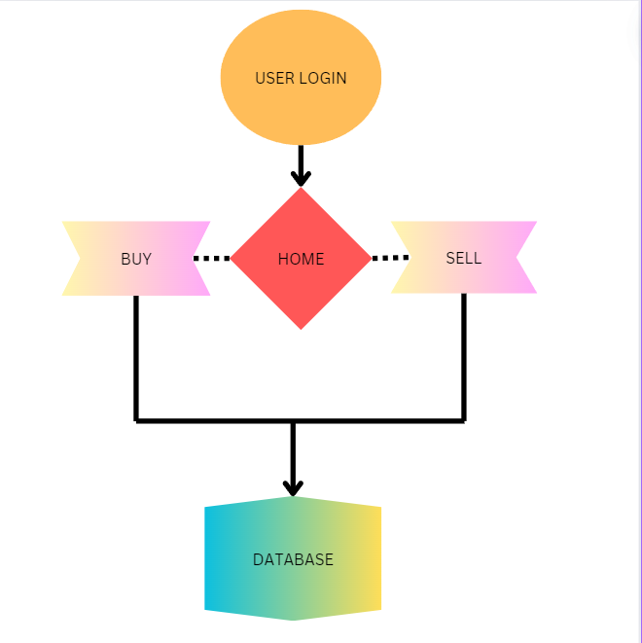
Fig-1: Concept Map
Selling farm produce the traditional way puts numerous middlemen between farmers and customers. While this business model remains highly profitable for retailers and local grocery stores, it cuts off a substantial portion of the farmers’ profit margins. Thus, to resolve this problem, many farmers are transitioning to online marketplaces and websites to sell organic produce.

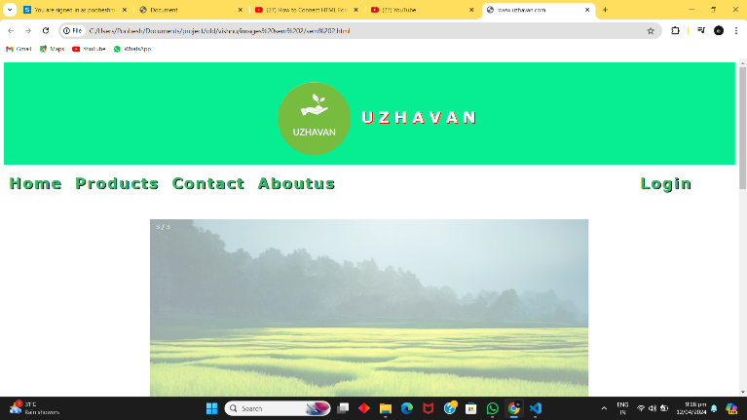
Fig-2: Home Page
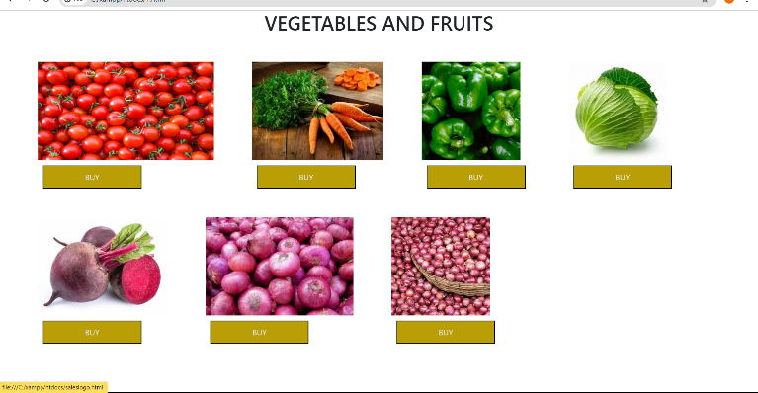

Fig -3: Buy page

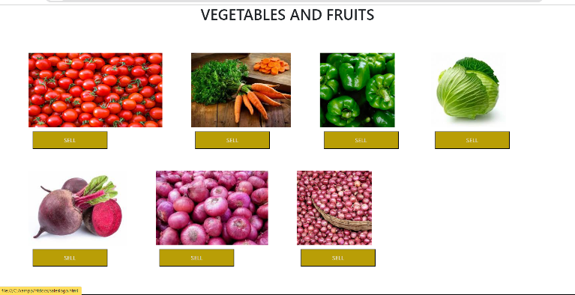

Fig-3:Sell page

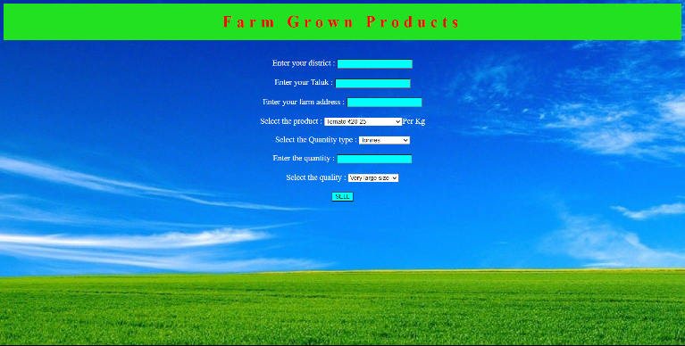

Fig-4:Order details page



Fig-5:Login Page


Fig-6:Contact Page

3. CONCLUSIONS

By eliminating the intermediates our website Directly contacts with the farmers and our website .By creating profit for the farmers .Accessing with Online website so no intermediate or broker involves .Each and every farmer can easily access and it user friendly.
ACKNOWLEDGEMENT
We extend our heartfelt gratitude to our honourable Chairman, Dr. S. Thangavelu for providing a wonderful platform to educate our minds, inculcate ideas and implement the technological changes in the real-world environment.

Deepest thanks to our dynamic Joint Secretary, Mr. T. Sheelan for monitoring the infrastructure and for providing the work atmosphere to implement the project and providing an excellent and maintaining the decorum and discipline of the students.
We are tremendously thankful to our beloved Principal, Dr.D. Elangovan,M.E.,Ph.D. for his incredible support to make us follow ethics and morality in our life and also for allocating sufficient time and resources.

A big salute to our vibrant Head of the Department, Dr. S. Prakash for imbibing scope of the project and systematic procedure in execution. We express our genuine thanks for encouraging us throughout the project period to complete it successfully.

Our great thanks to the Project mentor, Mrs.M. Gayathri devi for her ever lasting contribution in making the project a smooth journey and also for her valuable guidance and for making us realize our potential and be successful.

Our great thanks to the Project Co-Ordinator, Dr. M. Deepa for her ever lasting contribution in making the final year project phase a smooth journey and also for her valuable guidance and for making us realize our potential and be successful. We also thanks for her kind help and Cooperation throughout the research period to make us a grant successful completion of project.

REFERENCES

1. "Marketing for Farmers: A Guide to Business Skills" by Jules Pretty.
2. "Agricultural Marketing and Price Analysis" by Bailey Norwood and Jayson L. Lusk.
3. "Principles of Agricultural Marketing" by Richard Kohls and Joe Uhl.
4. "Farm Marketing from the Heart: How to Attract Your Dream Customers and Build Your Profit" by Charlotte Smith.
5. "Agricultural Marketing: Structural Models for Price Analysis" by Ronald A. Schrimper.
6. "The New Food Activism: Opposition, Cooperation, and Collective Action" by Alison Hope Alkon and Julie Guthman.
7. "Agricultural Marketing and Consumer Behavior in a Changing World" by Zuzana Bednářová, Jana Mazancová, and Vladimír Rychetský.
8. "Agricultural Markets and Prices" by David Colman and Trevor Young.
9. "Value Chain Struggles: Institutions and Governance in the Plantation Districts of South India" by Jeff Neilson and Bill Pritchard.
10. "Agricultural Product Prices" by World Bank Group.

