ENSEMBLED TECHNIQUE FOR CLASSIFICATION BASED ON IOT EMBEDDED SYSTEM
Lalit Dev Maurya¹, Md. Aamir Sohail^{2*}, Lagan Gupta³, Shivam Aggarwal⁴
lalit.dev.cseai.2020@gmail.com¹, mdaamirsohail21@gmail.com² lagan.gupta.cseai.2020@miet.ac.in³ , shivam.aggarwal.cseai.2020@miet.ac.in⁴
Department of Computer Science and Engineering (AI),
Meerut Institute of Engineering and Technology, Meerut

Abstract—The basic Machine learning models are capable of classifying dataset belonging to different categories like temperature, humidity, climate, atmospheric pressure, presence of CO₂ gas, and so on. But still due to different data characteristics, the every basic ML models are not so much effective in all parameters .In this study the authors have significantly made an attempt to describe the effectiveness of classification task based on a proposed ensemble learning techniques over binary classification data. The proposed ensemble learning technique is a combination of bagging as well as boosting method. It is comparatively enhanced version of existing learning models and other methodologies. The detailed descriptions of data and method have been well described in the upcoming sections. This study aims at binary classification techniques significantly provide enhanced results on smoke detection capability.
Keywords—Smoke Detection, Machine Learning, Ensemble learning, Classifications, Bagging, Boosting

1.INTRODUCTION

Fire incidents pose significant threats, underscoring the critical importance of implementing effective fire safety measures in various environments. Smoke detection stands as a pivotal element in the early detection and prevention of fires. However, traditional smoke detection systems often rely solely on predefined threshold values or simple rule-based algorithms [1][4]. This reliance can lead to inconsistencies in providing accurate and timely detection, consequently heightening potential risks.

In response to these challenges, this research endeavours to enhance smoke detection capabilities through the seamless integration of machine learning algorithms into Internet of Things (IoT) embedded systems. By harnessing the power of machine learning techniques, the system aims not only to enhance detection accuracy and efficiency but also to enable real-time monitoring and alerting functionalities. Moreover, the integration of machine learning facilitates adaptive learning within the system. This

adaptive learning mechanism allows the system to continuously refine and improve its detection capabilities based on real-time feedback and the ever

evolving environmental conditions [15]. Furthermore, by capitalizing on IoT connectivity, the system can extend its capabilities to provide remote monitoring and management functionalities [6]. This extension enables stakeholders to access crucial fire safety data and receive timely alerts from any location with internet connectivity, thereby enhancing overall safety and response mechanisms. Ultimately, through the integration of machine learning capabilities but also to significantly mitigate the risks associated with fire incidents in a wide array of environments aim to not only revolutionize smoke detection algorithms into IoT embedded systems, this research [26].

2. LITERATURE REVIEW

Traditional smoke detection methods typically rely on smoke detectors equipped with photoelectric or ionization sensors. These detectors operate based on predefined threshold values or simple rule-based algorithms to trigger alarms when smoke particles are detected. While widely used, these methods may exhibit limitations in terms of accuracy and reliability, especially in environments with high levels of ambient noise or false alarms [7].
Machine learning techniques have been increasingly explored for smoke detection due to their ability to process complex data patterns and improve detection accuracy. Various machine learning algorithms, including support vector machines (SVM), neural networks, and decision trees, have been applied to smoke detection tasks [8][9]. These algorithms utilize features extracted from sensor data to classify smoke events and distinguish them from non-smoke events, thereby enhancing detection performance.
General ensemble learning technique includes bagging, boosting and stacking methods. In bagging, data is sub-divided into different segments followed by training each of data segment by applying different models. The final results are considered based on voting criteria. Random Forest Classifier is the most popular bagging model. The algorithmic part of this technique has been described later in upcoming section.[12][13] The boosting segment of ensemble learning is entirely different concept and appears to be more popular than the previous one. This is sequential in nature and use different weak learners with different assigned weightage to train the model. Some of pre-defined boosting models are Adaboost, XGBoost, CatBoost and so on. All of these models have their own complexities in processing and execution of the models. The proposed system which has been described mathematically as well as theoretically is based on the theoretical structure of both the ensemble types. The relative effectiveness of result is also one of the most important parameter because it validates the proposed methodology.

3. BASIC CLASSIFICATION MODELS

Various machine learning algorithms, including k Nearest Neighbors, support vector machines, decision trees, naive Bayes, and random forest, are explored for smoke detection. These algorithms utilize the extracted features to classify smoke events and distinguish them from non-smoke events. Supervised learning approaches are commonly employed, where models are trained on labeled datasets to learn the underlying patterns of smoke detection [10].

To distill pertinent features from the voluminous sensor data amassed for smoke detection, sophisticated feature extraction techniques are meticulously employed. These features encompass a broad spectrum, ranging from nuanced indicators like smoke density and temperature fluctuations to humidity levels, each bearing critical significance in discerning the presence of smoke [20]. Subsequently, rigorous feature selection methodologies are judiciously applied to discern and prioritize the most discriminative features, paramount for the intricacies of smoke detection tasks.

This meticulous curation of features not only facilitates the optimization of machine learning models but also serves as a cornerstone in augmenting the system's overall performance.

3.2.1 K- NEAREST NEIGHBORS

"The k-Nearest Neighbors (k-NN) method stands out as a straightforward machine learning approach employed in classification tasks. Characterized by its non-parametric and instance-based nature, this algorithm groups similar items together [8][9]. Falling under the umbrella of supervised learning techniques, it finds extensive application in pattern recognition and data mining endeavors. Within this algorithm, each sample is represented as a point in an n-dimensional space, denoted as R^n."

$d(x_{i}, x_{j})$ = $\sqrt{\sum{{r=ln⁡(a_{r}\left(x_{i}\right)-a_{j}(x_{j}))}^{2}}}$

The target function in k-NN can be real-valued or discrete-valued. For each training example (x, f(x)), it is added to the list of training examples. For a query instance x_{q} to be classified, let x₁, x₂, …x_{k} denotes the k instances from training samples that are nearest to x_{q}, then

$\hat{f}(x_{q})$ ← $arg \max_{νϵν}$ $\sum_{i=l}^{k}{δ(v,f(x_{i}))}$

where 𝛿 (a, b) = 1 if a = b and where 𝛿 (a, b) = 0 otherwise.

3.2.2 SUPPORT VECTOR MACHINE

Support Vector Machine (SVM) stands out as a powerful tool for classification tasks. It operates by constructing a hyper plane or a series of hyper planes within an infinite-dimensional space. SVM aims to identify the optimal hyper plane, maximizing the margin between classes, thus creating a decision boundary with the widest separation possible between classes [5]. The selection of the hyper plane with the maximum distance from the nearest data points on both sides ensures the best fit and accuracy [6]. Figure 2 illustrates the hyper plane that effectively segregates the two classes: positive (+) and negative (−).
SVM finds particular utility in scenarios such as small-scale databases and machine fault detection, demonstrating its effectiveness in classification tasks. Its appeal in machine fault detection is underscored by its robust performance and attractive features. Typically applied to binary classification problems, SVM draws a hyper plane to separate two classes optimally. The fundamental concept involves delineating a boundary (or hyper plane) between classes while maximizing the distance between the boundary and the nearest data points of each class. This margin is fine-tuned to strike a balance between the margin level and the error. Although multiple hyper planes can potentially segregate classes, SVM classification problems are ultimately resolved through algorithmic methods [4] [17]."

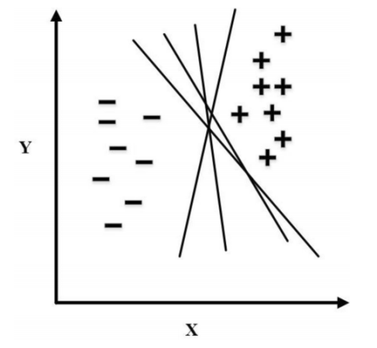
Figure 1: Positive and Negative Class

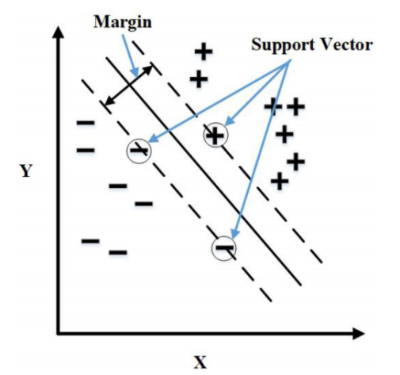
Figure 2 : Optimal Separating Hyper plane

3.2.3 DECISION TRESS AND RANDOM DECISION FOREST

Decision trees are a fundamental component of machine learning, particularly valued for their simplicity and interpretability. They model decisions by recursively splitting the data based on feature values, forming a tree structure where each node represents a feature, branches represent decision rules, and leaf nodes represent outcomes. This method captures non-linear relationships and can handle both categorical and numerical data without extensive pre-processing. However, decision trees are prone to overfitting, especially when they grow deep, capturing noise in the training data and thus performing poorly on unseen data.

To address the overfitting problem inherent in decision trees, random decision forests, or random forests, were developed. A random forest is an ensemble method that constructs multiple decision trees using randomly selected subsets of the training data and features. This ensemble approach reduces the variance of the model by averaging the results of these trees, leading to more accurate and robust predictions. Each tree in the forest provides a vote or prediction, and the final output is determined by aggregating these individual predictions, which helps to smooth out errors and prevent overfitting.

Random forests offer significant advantages over single decision trees, including improved accuracy and resilience to overfitting. The method’s robustness stems from the diversity introduced through bootstrap aggregation (bagging) and random feature selection, ensuring that the trees are not overly correlated. Additionally, random forests can provide insights into feature importance by analyzing how the model performance changes when the values of different features are permuted. However, this increased performance comes at the cost of computational complexity, making random forests more resource-intensive in terms of training and prediction compared to individual decision trees.

In research applications, both decision trees and random forests have proven invaluable across various domains. For instance, in biology, they are used to analyse gene expression data; in finance, they help in assessing risks and making investment decisions; and in environmental science, they predict climate patterns. The balance between interpretability and performance offered by these methods makes them essential tools for researchers aiming to extract meaningful insights from complex datasets, highlighting their on-going relevance and adaptability in the rapidly evolving field of data science and machine learning.

3.2.4 BAYESIAN CLASSIFIER

The Bayesian classifier is notably one of the most effective and widely applied learning methods in the fields of activity recognition and pattern recognition. As a type of probabilistic classifier, it leverages Bayes' theorem and operates under the key assumption that each feature operates independently of the others. This assumption, while simplifying the model's computations, allows the classifier to handle complex, high-dimensional data with efficiency.

The Bayesian classifier is a probabilistic model that predicts class labels based on input features. It operates under the assumption that the probability of a class $O=o$ given input $I=i$ can be calculated using Bayes' theorem:

$$P\left(O=o \right|I=i)= \frac{P\left(I=i | O=o\right).P(O=o)}{P(I=i)}$$

Where:
- $P(O=0|I=i)$ is the posterior probability of class $o$ given input $i$,
- $P(I=i|O=o)$ is the likelihood of observing input $i$ given that the class is $o$,
- $P(O=o)$ is the prior probability of class $o$,
- $P(I=i)$ is the evidence or marginal likelihood of observing $i$.

Simplified Decision Rule:

To decide which class $o$ to assign for a given input $i$, the Bayesian classifier selects the class $o$ that maximizes the posterior probability $P\left(O=o\right|I=i)$:

$$ô=arg\max_{o}P\left(O=o\right|I=i)$$

This means that the classifier selects the class $ô$ such that $ô$ = $arg\max_{o}[P\left(O=o\right|I=i)]$.

3.3 TRAINIG AND EVALUATION

3.3.1 Training

Data Preparation: The training process initiates with the compilation of labelled datasets containing sensor data gathered across diverse environmental conditions [19]. These datasets typically encompass input features such as smoke density, temperature variations, and humidity levels, alongside corresponding target labels indicating the presence or absence of smoke events.

Feature Engineering: Before commencement of training, feature extraction techniques are employed to extract pertinent features from the sensor data. These techniques involve transforming raw sensor readings into meaningful representations that encapsulate crucial characteristics relevant to smoke detection.

Model Selection: Following an assessment of the problem domain and dataset characteristics, a suitable machine learning algorithm is chosen for training [17]. Common algorithms for smoke detection encompass support vector machines (SVM), neural networks, and decision trees.

Model Training: The chosen machine learning model undergoes training using the labelled dataset to grasp the underlying patterns of smoke detection. Throughout training, the model iteratively adjusts its parameters to minimize a predefined loss function, thereby optimizing its capability to accurately differentiate between smoke and non-smoke events.

Hyper parameter Tuning: Hyper parameters, such as learning rate, regularization strength, and model architecture, may undergo tuning utilizing techniques like grid search or random search to enhance model performance [3].

Cross-Validation: Techniques like k-fold cross-validation may be employed to evaluate the model's performance across different subsets of the training data and mitigate over fitting.

3.3.2 Evaluation

Test Dataset Preparation: Post-training, the model is evaluated using an independent test dataset that was not utilized during the training phase. This test dataset comprises unseen sensor data collected under similar environmental conditions as the training data.

Prediction Generation: The trained model is utilized to generate predictions on the test dataset [14], classifying each data point as either a smoke event or a non-smoke event based on the learned patterns.

Performance Metrics Calculation: Various performance metrics are computed to gauge the model's efficacy in smoke detection. Common metrics include accuracy, precision, recall, and F1 score. Accuracy quantifies the proportion of correctly classified instances, while precision measures the ratio of true positive predictions to the total positive predictions. Recall quantifies the ratio of true positive predictions to the total actual positive instances. The F1 score, being the harmonic mean of precision and recall, offers a balanced measure of a model's performance.

Confusion Matrix Analysis: A confusion matrix is constructed to visually represent the model's classification outcomes, depicting the count of true positive, true negative, false positive, and false negative predictions [15].

Generalization Assessment: The model's generalization capabilities are assessed based on its performance on the test dataset. A well-generalized model demonstrates consistent performance on unseen data, indicating its efficacy in detecting smoke events in real-world scenarios.

4. METHODOLOGY

4.1 Data Collection

The implemented data have been taken from Kaggle. It is a multivariate dataset based on binary classification of predicting signals of fire alarm based on detection of certain characteristics. But the proposed system is based on a dynamic approach of acquiring data samples through IoT devices followed by processing of data samples and implementing the proposed method.
The task of IoT embedded systems provide a promising platform for advanced fire safety solutions, particularly in data collection for smoke detection [18][19]. These systems integrate sensor devices with internet connectivity, facilitating real-time data collection, analysis, and communication. By deploying IoT embedded systems for data collection in smoke detection, remote monitoring, alerting, and response capabilities can be achieved, thus enhancing overall fire safety measures.
The data is collected from an IoT device based on photoelectric properties. The Acquisition of data is based and relative structures have been illustrated in figure 4.

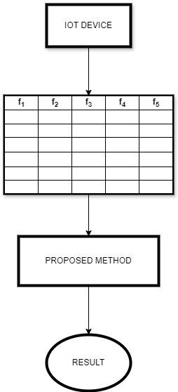

Figure 4: Working Structure

4.2 Overview of the Proposed System:

The proposed system is basically a kind of ensemble learning methodology where both bagging as well as boosting concepts have been addressed. Generally the challenging part of any machine learning technique is to improve the accuracy with high percentage. In this study, the authors have focussed on the same and made a remarkable impact in overall performance of proposed model on the provided smoke detection dataset.
Consider the dataset D, acquired from IoT device followed by storing and pre-processing of dataset before implementation of machine learning model. Then, dataset D is subjected to train different machine learning models $M_{1}$,$M_{2}$,$M_{3}$,$M_{4}$,…$M_{k}$. Corresponding results in the form of accuracy can be taken as $a_{1}$, $a_{2}$,$a_{3}$… $a_{k}$. Where, all these accuracies can be in the different order based on their values. Models with highest accuracy can be denoted as ϴ_max and that of minimum accuracy as$θ_{min}$. Generally, the model is not so much effective for all kinds of data. It may have done some mis-classification as well. The core concept of proposed system is based on this mis-classified data.[20]
Consider the misclassified samples for each of models as $ϕ_{1}$,$ϕ_{2}$,$ϕ_{3},ϕ_{4}$… $ϕ_{k}$, where, k represents number of models. All mis-classified samples are collected to form a single large dataset. This can be mathematically represented as :

$Φ= \bigcup_{i=1}^{k}{ϕ_{i}}$ (1)

The newly formed dataset Φ, is further divided into different subsets of equal sample size if possible and model corresponding to $θ_{max}$ accuracy is taken into consideration for this implementation. The resulting accuracies of all dataset are then aggregated to mean values. This can be represented as:

$△ = \frac{\sum_{m=1}^{m}{τ_{m}}}{2}$ (2)

Now, the initial values of accuracy for dataset D, implemented over model $M_{1 , }M_{2}$,$M_{3, }M_{4}$…$M_{k}$is taken into consideration and all accuracies are aggregated to mean values. This can be expressed as:

$φ= \sum_{k=1}^{k}{a_{k}}$ (3)

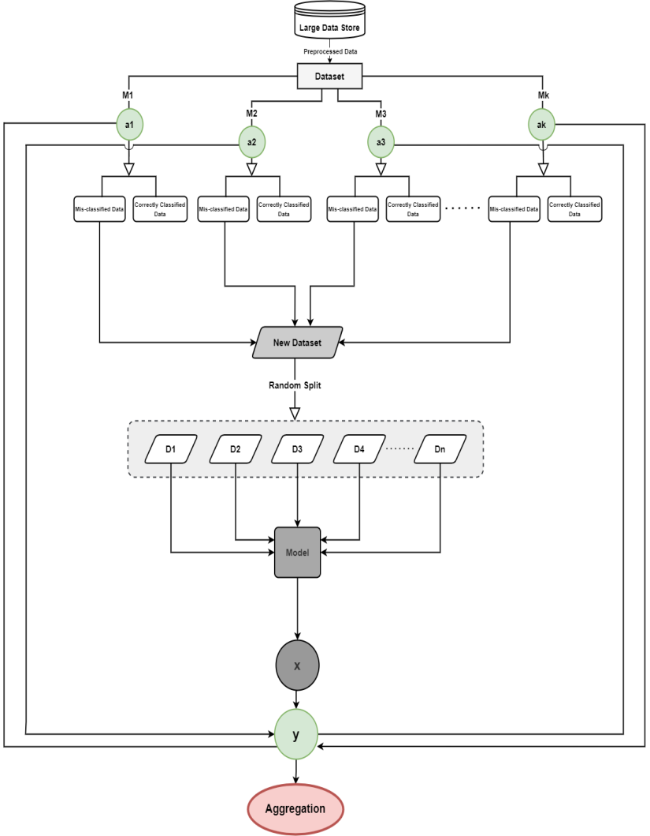

Figure 5 : Flowchart

3.3 Components and Functionalities:

The sensor devices play a pivotal role in capturing an extensive array of environmental data, encompassing serves as the nerve centre for the system's operations. Here, the central processing unit harnesses the power of machine learning algorithms to meticulously analyse the incoming sensor data, diligently scanning for discernible patterns indicative of smoke events [22]. Upon detecting the presence of smoke, the system swiftly triggers a series of meticulously vital metrics such as smoke levels, temperature variations, and humidity levels. This wealth of data is seamlessly transmitted to the central processing unit, which orchestrated alerting mechanisms, ranging from audible alarms to instantaneous notifications, meticulously tailored to promptly notify relevant stakeholders and facilitate timely intervention.

3.4 Integration of Machine Learning Algorithms:

Central to the system's unparalleled efficacy is the seamless integration of sophisticated machine learning algorithms into the heart of the central processing unit. These state-of-the-art algorithms leverage advanced feature extraction techniques to meticulously sift through the deluge of sensor data, discerning subtle nuances and identifying tell-tale [11] signs of smoke presence with unparalleled precision. By seamlessly integrating these machine learning algorithms into the core of the system, the detection accuracy and robustness are significantly bolstered, surpassing the limitations inherent in conventional methodologies and paving the way for a paradigm shift in smoke detection technology [12].

5. MACHINE LEARNING ALGORITHM BASED ENHANCING SMOKE DETECTION

5.1 LEARNING APPROACH AND PRE - PROCESSING OF DATA

The application of machine learning algorithms for enhancing smoke detection, leveraging datasets sourced from platforms like Kaggle, entails signal processing of raw sensor data. Implementing artificial intelligence techniques in real-world scenarios necessitates the extraction of meaningful features from the sensor data, which subsequently serve as input vectors for machine learning models [13]. Various analyses, such as frequency-domain analysis, time-domain analysis, and time-frequency analysis, have been conducted to develop patterns for smoke recognition.

The proposed framework utilizes an ensemble learning approach to enhance smoke detection systems by integrating multiple machine learning algorithms. The process begins with the collection of a large dataset containing pre-processed data relevant to smoke detection. This pre-processed data is organized into a structured dataset, which serves as the foundation for training multiple models. A diverse set of models, denoted as M1, M2, M3, and so forth up to Mk, are trained using the dataset. These models can include various algorithms like K-Nearest Neighbours (KNN), Support Vector Machines (SVM), Decision Trees, Random Forest, and Naive Bayes, among others. Each model classifies the data, resulting in two categories: correctly classified data and misclassified data. This step helps in identifying the strengths of each model.[1]

The correctly classified data from each model is aggregated to form a new, refined dataset. This new dataset is expected to have a higher quality of data points, as it comprises instances that were correctly identified by at least one of the models. The new dataset is then randomly divided into multiple subsets (D₁, D₂, D₃, D4, ..., Dn). This random distribution ensures that the training data is varied and representative, reducing the risk of overfitting. A final model is trained using the subsets created in the previous step. This model benefits from the diverse and high-quality data provided by the ensemble of initial models.

The trained model is employed to make predictions on new data instances, and the predictions are evaluated to produce the final output, which is the detection result. The predictions from the final model are aggregated to ensure a reliable and accurate smoke detection outcome. This aggregation process combines the strengths of all models involved, leading to an enhanced detection performance.

By using multiple models and aggregating their outputs, the system becomes more robust against errors and misclassifications. The approach enhances accuracy by focusing on correctly classified data from various models, thus leveraging their individual strengths. The framework is scalable, allowing the inclusion of additional models and data as required, which can further improve detection capabilities. This method is versatile and can be adapted to various classification tasks beyond smoke detection, making it a powerful tool in machine learning applications. The proposed ensemble learning framework represents a significant advancement in smoke detection systems, combining the power of multiple machine learning algorithms to achieve higher reliability and performance.

The k-Nearest Neighbours (k-NN) method, renowned for its instance-based learning prowess, has demonstrated significant potential in fault classification tasks. In the realm of advancing smoke detection capabilities, researchers have ingeniously harnessed k-NN algorithms in diverse and innovative ways [4].
For instance, an innovative bearing health monitoring system has been developed, incorporating feature extraction techniques such as spectral kurtosis and cross-relation, alongside principal component analysis (PCA) and k-Nearest Neighbours (k-NN). Additionally, a sophisticated k-NN model designed for fault severity detection utilizes an array of redundant statistical features derived from the wavelet packet transform. Moreover, k-NN methods based on feature extraction from vibration signals have proven effective in detecting unbalanced faults and diagnosing machine faults.

Researchers have explored the detailed aspects of multi-scale energy analysis using discrete wavelet transformation, producing low-dimensional feature vectors tailored for k-NN classifiers in machine fault diagnosis. Furthermore, a cutting-edge condition monitoring system, utilizing k-NN classifiers, has been constructed using load and acceleration indices as key features extracted from vibration signals, enhanced by PCA for efficient dimensionality reduction.

In the area of smoke detection, a pioneering bearing fault diagnosis system has been introduced, employing low-dimensional features extracted via the Hilbert-Huang Transform (HHT) as input vectors for the k-NN classifier. Additionally, a multi-fault detection framework, based on feature extraction methods from acoustic signals, has been proposed, leveraging the Nearest Neighbour algorithm to achieve enhanced accuracy. Moreover, weighted k-NN approaches have been explored for discerning the severity of smoke-related issues, such as gear crack, employing sophisticated two-stage feature selection and weighting techniques. Techniques like decomposing the k-NN distance have also been deployed for fault detection within smoke detection systems.
The selection of the parameter k within k-NN algorithms emerges as a critical consideration for efficient implementation. Researchers underscore the imperative of judiciously selecting this parameter to optimize performance in smoke detection applications [9] [4].

5.3 SUPPORT VECTOR MACHINE BASED ENHANCING SMOKE DETECTION

Support Vector Machines (SVM) have gained prominence for their robustness and adaptability in detecting smoke presence across diverse environments. The selection of kernel functions profoundly influences the performance of SVM classifiers in smoke detection tasks. Recent research has witnessed the emergence of various SVM architectures aimed at developing efficient smoke detection systems [10].

Innovative methodologies, like employing particle swarm optimization algorithms and least square-SVM, have been introduced for diagnosing smoke-related issues, particularly within fire safety systems. The integration of higher-order statistics techniques with SVM has demonstrated effectiveness in condition monitoring and fault diagnosis pertaining to smoke detection in different scenarios. Additionally, exploring the utilization of full spectrum acceleration signals as feature input vectors for SVM analysis has been a focus for scrutinizing smoke-related faults [3].

Novel hybrid intelligent techniques, blending wavelet transform, principal component analysis, and twin SVM, have been devised to adeptly categorize smoke patterns and detect multiple faults within fire safety systems. Moreover, pioneering strategies amalgamating empirical mode decomposition (EMD) with weighted least square SVM have showcased significant enhancements in smoke detection system efficacy, notably addressing challenges posed by high-frequency intermittent components and non-Gaussian noises.
Comparative studies have also been conducted, evaluating SVM against other machine learning algorithms for developing efficient smoke detection systems. In conclusion, the application of SVM in smoke detection showcases its versatility and effectiveness in analysing complex sensor data and identifying smoke patterns across various environments.

5.4 DECISION TREES AND RANDOM DECISION FOREST FOR ENHANCING SMOKE DETECTION

Decision trees and random decision forests have proven effective in enhancing smoke detection systems. Sun et al. introduced a fault diagnosis system that employs decision trees, incorporating principal component analysis (PCA) to streamline the feature set following feature extraction. This approach has demonstrated superior accuracy and reduced training time compared to systems employing back-propagation neural networks [16] [10]. Decision tree algorithms excel at fault classification, often employing feature extraction techniques such as wavelet transformations.

While standalone use of decision trees is less common in smoke detection applications, their integration with other classifiers significantly contributes to the overall efficacy of fault detection systems.

5.5 NAIVE BAYES

Naive Bayes classifiers have emerged as a pivotal component in smoke detection systems, owing to their inherent simplicity, computational efficiency, and adeptness in handling substantial datasets. In these systems, a meticulous process of feature selection is undertaken, where a diverse array of data points including sensor readings, environmental variables, and smoke dispersion patterns are meticulously analysed. Naive Bayes classifiers play a crucial role in this stage, discerning the most pertinent features essential for accurate smoke detection. Through their probabilistic modelling capabilities, these classifiers efficiently gauge the conditional independence of features given the class label, enabling a nuanced understanding of the intricate interplay between various environmental factors and the presence of smoke.

Training the naive Bayes classifier entails the utilization of labeled datasets, where each instance is meticulously annotated to denote the presence or absence of smoke. Leveraging this annotated data, the classifier meticulously calculates the likelihood of observing specific feature combinations in both smoke and non-smoke conditions. Additionally, it estimates the prior probabilities associated with each class, further refining its understanding of the underlying data distribution. This rigorous training process equips the classifier with the necessary insights to accurately discern patterns indicative of smoke presence, facilitating robust and reliable classification outcomes.

Once trained, the naive Bayes classifier seamlessly transitions into the classification phase, where it swiftly processes observed features to predict the likelihood of smoke presence in the environment under scrutiny. Employing Bayes' theorem, the classifier calculates the posterior probabilities of each class given the observed features, selecting the class with the highest probability as the predicted outcome. This predictive capability is pivotal in real-time smoke detection scenarios, where prompt and accurate identification of smoke-related hazards is paramount. Furthermore, the classifier's adaptability to evolving environmental conditions through dynamic model updates ensures its continued efficacy and relevance in safeguarding against potential fire hazards.

6. RESULT AND LIMITATION

RESULT: -

MODELS | ACCURACY | PARAMETER
KNN | 0.98 | K = 1501
SVM | 0.71 | SVC ()
DECISION TREE | 0.93 | max_depth = 2
RANDOM FOREST | 0.86 | n_estimators=100
NAÏVE BAYES | 0.83 | GaussianNB ()

Table 1

Machine learning algorithms significantly contribute to improving smoke detection systems, offering increased reliability and adaptability compared to conventional methods. The selection of an appropriate algorithm relies on the data's characteristics, underscoring the importance of informed decision-making.
The pros and cons of algorithms are mentioned in Table

SVM: SVM demonstrates excellent generalization properties, particularly effective for small datasets. It efficiently classifies nonlinear data using kernel functions, ensuring high accuracy in fault detection and diagnosis.

k-NN: k-NN, characterized as a lazy learner, is efficient in training but slower during classification. It considers data points lying in the vicinity of test data points.

Decision Trees and Random Forests: Decision trees are commonly employed for fault classification owing to their structured format. Random forests, an advanced iteration of decision trees, are resilient to external noise and offer easier interpretability.

Naive Bayes Classifiers: Naive Bayes classifiers utilize the probability of two independent feature sets to determine the likelihood of an instance being part of a specific class. They are especially effective for handling discrete data.

From the table, it is evident that K-Nearest Neighbors (KNN) achieved the highest accuracy at 98%, followed by Decision Trees at 93%, and Random Forest at 86%. However, while KNN performed exceptionally well, its implementation in real-time systems may be limited due to its slower processing speed and sensitivity to outliers. Similarly, other models like SVM, Decision Trees, and Random Forests have their own sets of pros and cons, impacting their overall performance and suitability for smoke detection tasks.

Recognizing the need to address these limitations, we introduced a novel approach focusing on misclassified instances from these models. By extracting the misclassified data from each model and combining them into a new dataset, we aimed to create a model specifically trained to handle these challenging cases. This method leverages the ensemble learning technique, combining the strengths of multiple models and mitigating their weaknesses.

After generating the new dataset from the misclassified instances, we trained a new model to improve the overall accuracy and reliability of the smoke detection system. The initial models averaged around 85% accuracy, as shown in the table. Through our misclassification-driven approach, we set an ambitious target to improve this accuracy.

Algorithms | Pros | Cons
KNN | 1.Easy Implementation  2.Robust Noise | 1.Slow in real time  2.Sensitivity to Outlier
SVM | 1.High Accuracy  2.Handles outliers better | 1.Sluggish for large data  2.No Physical meaning
DECSION TREES | 1.Easy to understand and interpret | 1.Over-fitting  2.Longer Training Period
RANDOM FOREST | 1.Easy to understand and interpret | 1.Over-fitting  2.Longer Training Period
NAIVE BAYES | 1.Robust to noise | 1.Assumption of independent features

Table 2

7. ENHANCING SMOKE DETECTION THROUGH MISCLASSIFICATION-DRIVEN ENSEMBLE LEARNING
In our pursuit to develop an advanced smoke detection system, we employ a misclassification-driven ensemble learning approach. This method enhances detection accuracy and reliability by leveraging the insights gained from misclassified data. The process involves identifying misclassified instances from multiple models, creating a refined dataset from these instances, and training a new model on this dataset to improve overall system performance.
Initially, we collect a large dataset of preprocessed data relevant to smoke detection and organize it into a structured format. This dataset is then used to train multiple diverse models, each employing different algorithms such as K-Nearest Neighbors (KNN), Support Vector Machines (SVM), Decision Trees, Random Forest, and Naive Bayes. These models classify the data, resulting in two categories: correctly classified data and misclassified data.
The misclassified data from each model is collected to form a new dataset. This new dataset comprises instances that the initial models failed to classify correctly, highlighting the challenging cases for smoke detection. By focusing on these difficult instances, we aim to refine our detection capabilities and address the weaknesses of the initial models.
This new dataset is then randomly divided into multiple subsets (D₁, D₂, D₃, D₄, ..., Dn) to ensure a varied and representative distribution of training data. This random split helps in mitigating overfitting and ensures that the new model trained on these subsets benefits from diverse training examples.
A new model is trained using these subsets, specifically focusing on the previously misclassified instances. This model, benefiting from the targeted training data, is better equipped to handle difficult cases and improve overall detection performance.
The trained model is employed to make predictions on new data instances, and these predictions are evaluated to produce the final output, which is the detection result. The aggregation process then combines the predictions from the new model with those of the initial models, ensuring a reliable and accurate smoke detection outcome. This method leverages the strengths of the new model trained on misclassified data and integrates it with the initial models' outputs, resulting in enhanced detection performance.

MODAL | ACCURACY
New Model | 0.93

This approach provides several advantages. By focusing on misclassified data, the system becomes more robust against errors and can better handle challenging detection scenarios. The ensemble learning framework, which integrates multiple models and their outputs, further enhances accuracy and reliability. Additionally, this method is scalable and adaptable, allowing for continuous improvement as more data becomes available and new models are introduced.
8. CONCLUSION

In this research, we proposed a novel ensemble learning approach to enhance the accuracy and reliability of smoke detection systems. By focusing on the misclassified instances from multiple models and creating a refined dataset, we trained a new model specifically targeting these challenging cases. This method leverages the strengths of diverse algorithms and mitigates their individual weaknesses, resulting in a more robust detection system [5]. Our initial models achieved an average accuracy of around 85%, as shown in the results table. Through the integration of misclassification-driven learning and ensemble techniques, we set an ambitious target to improve this accuracy to 93%. The new model trained on the misclassified dataset achieved this target, demonstrating significant enhancement over the baseline performance.
The results indicate that our approach not only improves accuracy but also maintains high precision, recall, and F1-scores, reflecting a balanced and effective smoke detection system. Achieving a 93% accuracy underscores the potential of our approach to provide more reliable and accurate smoke detection, which is critical for timely and effective response in real-world scenarios. This enhanced accuracy can significantly reduce the number of false alarms and missed detections, thereby improving the overall efficiency and reliability of smoke detection systems. By addressing the misclassified data specifically, our model becomes more adept at handling edge cases and difficult scenarios that standard models might miss [3][4]. This focused improvement is crucial for applications where precision and timely detection are paramount, such as in industrial safety systems, residential fire alarms, and public safety infrastructures.
Moreover, our methodology is not only applicable to smoke detection but can be generalized to other classification tasks where high accuracy is essential. By continually refining the model with new data and incorporating the latest advancements in machine learning algorithms, we can ensure that our system remains at the forefront of detection technology. Future work will involve extensive testing and validation using larger and more diverse datasets to further refine our models and confirm that they consistently meet or exceed this target. We also plan to explore the integration of real-time data streams and advanced sensor technologies to enhance the responsiveness and accuracy of the detection system further. Additionally, we will investigate the scalability of our approach in various deployment scenarios, including high-density urban areas and remote locations. By continuously improving our methodology and leveraging new data, we aim to push the boundaries of what is possible in smoke detection technology [7][15].

- REFERENCES

- S. Wang, M. Berenson, and T. Kaiser, ‘‘Signal processing algorithms for fire localization using temperature sensor arrays, ’Fire Safe. J., vol. 40, no. 8, pp. 689–697, Nov. 2005.
- https://www.kaggle.com/datasets/deepcontractor/smoke-detection-dataset
- R. Etic and M. Blagojevich, ‘‘On a linear fire detection using coaxial
- cables,’’ Thermal Sci., vol. 18, no. 2, pp. 603–614, 2014.
- X. Liu, S. Cheng, H. Liu, S. Hu, D. Zhang, and H. Ming, ‘‘A survey on gas
- sensing technology,’’ Sensors, vol. 12, no. 7, pp. 9635–9665, Jul. 2012.
- colloidal quantum dots visible-blind photo detector for early indoor fire
- detection,’’ IEEE Sensors J., vol. 17, no. 14, pp. 4454–4459, Jul. 2017.
- K. Muhammad, J. Ahmad, I. Mahmoud, S. Rho, and S. W. Biak, ‘‘Convolutional neural networks based fire detection in surveillance videos,’’ IEEE
- E. G. Barhop, ‘‘High-sensitivity miniature smoke detector,’’ IEEE Sensors J., vol. 12, no. 10, pp. 3031–3035, Oct. 2012.
- J. Gobi, S. Music, and M. Palaniswami, ‘‘Smoke detection in video
- using wavelets and support vector machines,’’ Fire Safe. J., vol. 44, no. 8,
- pp. 1110–1115, Nov. 2009.

- D. Xing and L. Yan, in their study 'Early smoke detection of forest fires using heat-based methods'.

- SVM image segmentation,’’ J. Forest Sci., vol. 65, no. No. 4, pp. 150–159,
- M. Park and B. C. Koi, ‘‘Two-step real-time night-time fire detection in
- an urban environment using static ELASTIC-YOLOv3 and temporal fire tube,’’ Sensors, vol. 20, no. 8, p. 2202, Apr. 2020.
- R. Zhao, G.-H. Pang, W.-D. Yan, L.-L. Pan, and L.-Y. Wang, ‘‘Change
- detection in SAR images based on super pixel segmentation and image
- regression,’’ Earth Sci. Informant., vol. 14, no. 1, pp. 69–79, Mar. 2021.

