Innovative Modifications in Belt-Type Oil Skimmers: Performance Analysis of Polyurethane vs. PVC Belts and Adjustable Skimming Angles

Sonali Dhaneshwar ¹, Avinash Aher ², Shantanu Deshmukh ³ ,Shashank Gaikwad ⁴,Jaykhandu Deshmukh ⁵

Dept of Mechanical Engineering
JSPM’s RSCOE Tathawade Pune, MS-India Savitribai Phule Pune University, Pune
avinashaher1308gmail.com shantanudeshmukh7777@gmail.comsm dhaneshwar-mech@jspmrscoe.edu.in

Abstract— This research paper presents an innovative approach to enhancing the efficiency of belt-type oil skimmers through design modifications. The primary advancements include the introduction of interchangeable belts and adjustable skimming angles. A comprehensive comparative study was conducted to evaluate the performance of two types of belts—polyurethane and PVC—in terms of oil recovery efficiency. Additionally, the impact of varying skimming angles on the efficiency of the oil skimmer was investigated.
The study involved experimental setups where different combinations of belts and angles were tested under controlled conditions. Key performance indicators such as oil recovery rate, durability, and operational stability were measured and analyzed. Results indicated that polyurethane belts outperformed PVC belts in terms of oil recovery efficiency and durability. Furthermore, optimal skimming angles were identified, demonstrating significant improvements in the overall efficiency of the oil skimmer.
The findings of this research provide valuable insights for the design and operation of more efficient oil skimming systems. The ability to interchange belts and adjust skimming angles allows for greater flexibility and adaptability in various operational environments, contributing to enhanced oil spill response strategies.
Keywords— oil skimmer, belt-type, polyurethane, PVC, skimming angle, efficiency, oil recovery, design modification.

I.INTRODUCTION
Oil spills pose significant environmental hazards, affecting marine ecosystems, wildlife, and coastal economies. Effective oil recovery systems are crucial for mitigating these impacts, and oil skimmers play a vital role in this process. Among the various types of oil skimmers, belt-type oil skimmers are widely used due to their simplicity and efficiency. However, the performance of these skimmers can be influenced by several factors, including the type of belt material and the angle at which skimming occurs.
In recent years, there has been growing interest in improving the design and efficiency of oil skimmers to enhance their oil recovery capabilities. Traditional belt-type oil skimmers typically utilize fixed belts and static skimming angles, which may not be optimal for all operating conditions. Recognizing this limitation, our project aimed to introduce innovative modifications to the conventional belt-type oil skimmer, focusing on the flexibility and adaptability of the system.
Our modifications included the provision for interchangeable belts and adjustable skimming angles. By allowing the operator to change the belt material and alter the skimming angle, the oil skimmer can be fine-tuned to achieve optimal performance in diverse environments. This adaptability is particularly important in scenarios where the characteristics of the oil spill, such as viscosity and temperature, can vary significantly.
The choice of belt material is a critical factor in the efficiency of belt-type oil skimmers. Polyurethane and PVC are two commonly used materials for skimmer belts, each with its unique properties. Polyurethane belts are known for their durability, flexibility, and resistance to oil and chemicals. They also have good wear resistance, which is essential for maintaining performance over extended periods. On the other hand, PVC belts are cost-effective and offer good resistance to chemicals and oils, but they may not be as durable as polyurethane belts.
In this project, we conducted a comprehensive comparative study to evaluate the performance of polyurethane and PVC belts in oil skimming applications. The study aimed to determine which belt material provides superior oil recovery efficiency under various conditions. Additionally, we investigated the impact of different skimming angles on the efficiency of the oil skimmer. The skimming angle affects the contact between the belt and the oil, influencing the amount of oil recovered in each pass.
To conduct our study, we designed and built a prototype oil skimmer with interchangeable belts and adjustable skimming angles. The prototype allowed us to systematically test different combinations of belt materials and skimming angles. We conducted experiments under controlled conditions, simulating various oil spill scenarios to gather comprehensive data on the performance of each configuration.
Our experimental setup included a tank filled with water and a controlled amount of oil. The prototype skimmer was placed in the tank, and the oil recovery process was monitored and recorded. We measured key performance indicators such as oil recovery rate, belt wear, and operational stability. These measurements provided valuable insights into the efficiency and durability of each belt material and skimming angle.
The results of our study revealed significant differences in the performance of polyurethane and PVC belts. Polyurethane belts consistently outperformed PVC belts in terms of oil recovery efficiency and durability. The flexibility and wear resistance of polyurethane belts contributed to their superior performance, making them a more suitable choice for oil skimming applications. Furthermore, our findings indicated that the skimming angle plays a crucial role in maximizing oil recovery. Optimal skimming angles were identified, demonstrating substantial improvements in the overall efficiency of the oil skimmer.
This paper presents a detailed account of our research, including the design and development of the prototype skimmer, the experimental methodology, and the results of our comparative study. The insights gained from this research provide valuable information for the design and operation of more efficient and adaptable oil skimming systems.
The ability to interchange belts and adjust skimming angles allows for greater flexibility and adaptability in various operational environments. This flexibility is particularly beneficial in emergency response scenarios, where the characteristics of oil spills can vary widely. By optimizing the performance of oil skimmers through these modifications, we can enhance the effectiveness of oil spill response strategies, reducing environmental damage and improving recovery efforts.
In conclusion, our project demonstrates the potential for significant improvements in the efficiency of belt-type oil skimmers through targeted design modifications. The provision for interchangeable belts and adjustable skimming angles offers a practical approach to optimizing oil recovery in diverse conditions. The findings of our comparative study highlight the advantages of polyurethane belts and the importance of selecting the appropriate skimming angle for maximum efficiency. These insights contribute to the ongoing development of more effective and adaptable oil skimming technologies, ultimately supporting better environmental protection and oil spill management.

II.LITERATURE SURVEY
Oil spills have long been a significant environmental concern, leading to extensive research on their impacts and recovery methods. The literature on oil spill incidents and recovery strategies provides valuable insights into the development and optimization of oil skimmers, including the advancements in belt-type oil skimmers discussed in our project. This section reviews key research contributions related to oil spill incidents, their impacts, and recovery techniques, with a focus on the modifications and comparative studies of belt materials and skimming angles in oil skimmers.
Guzman and Campodonico (1981) conducted comprehensive studies following the Metula oil spill in the Straits of Magellan, Chile. Their research, presented at the Petromar '80 Conference, highlighted the environmental impacts of the spill and the effectiveness of various recovery methods. They emphasized the importance of oil skimming technologies in mitigating the effects of oil spills on marine ecosystems. The study underscored the need for efficient oil recovery systems that can adapt to different spill conditions, aligning with our project's goal of enhancing belt-type oil skimmers through interchangeable belts and adjustable skimming angles.
Winslow (1978) documented the Argo Merchant oil spill, providing a detailed account of the incident and the challenges faced during the recovery efforts. This seminal work highlighted the limitations of existing oil recovery technologies at the time and called for advancements in skimming techniques to improve oil recovery efficiency. Winslow's analysis of the spill response strategies and the subsequent environmental impact informed our understanding of the critical role of efficient skimming systems in oil spill management. Our project's focus on optimizing belt materials and skimming angles addresses the need for improved performance identified in Winslow's work.
The Marine Pollution Bulletin (1979) published a series of articles examining various aspects of oil pollution and recovery. These articles collectively stressed the importance of ongoing research and innovation in oil spill response technologies. Key findings from this volume indicated that material properties and skimming techniques significantly influence the efficiency of oil recovery. This aligns with our project's comparative study of polyurethane and PVC belts, as well as the investigation of optimal skimming angles to maximize efficiency.
Butler (1978) reviewed some of the largest oil spills, identifying inconsistencies and information gaps in spill data and response strategies. Butler's work highlighted the variability in oil spill characteristics and the corresponding need for adaptable recovery methods. This perspective reinforced the rationale behind our project's design modifications, which aim to provide flexibility through interchangeable belts and adjustable skimming angles. By addressing the adaptability of oil skimmers, our project contributes to filling the gaps identified in Butler's review.
The National Research Council (NRC) publication, "Using Oil Spill Dispersants on the Sea," explored the use of chemical dispersants as a response to oil spills. While the primary focus was on dispersants, the NRC also acknowledged the importance of mechanical recovery methods, such as skimming. The report emphasized that the effectiveness of oil recovery techniques depends on various factors, including the physical properties of the oil and environmental conditions. Our project builds on this understanding by evaluating the performance of different belt materials and skimming angles, thereby enhancing the mechanical recovery capabilities of belt-type oil skimmers.
In summary, the reviewed literature highlights the ongoing challenges and advancements in oil spill recovery technologies. The studies by Guzman and Campodonico (1981), Winslow (1978), the Marine Pollution Bulletin (1979), Butler (1978), and the NRC (1989) provide a comprehensive background on the importance of efficient and adaptable oil skimming systems. Our project aligns with these insights by introducing modifications to belt-type oil skimmers, focusing on interchangeable belts and adjustable skimming angles to optimize oil recovery efficiency. The comparative study of polyurethane and PVC belts, along with the identification of optimal skimming angles, addresses the need for improved performance and adaptability in oil spill response technologies.
The methodology for this project involves the design, development, and testing of a modified belt-type oil skimmer with provisions for interchangeable belts and adjustable skimming angles. The goal is to evaluate the performance of polyurethane and PVC belts and determine the optimal skimming angle for maximum efficiency. This section outlines the detailed steps taken in the design, development, experimental setup, data collection, and analysis processes.
III.METHODOLOGY

1. Design and Development of the Prototype Oil Skimmer

1.1 Interchangeable Belt System
- Design Concept: The prototype oil skimmer was designed to allow easy replacement of belts. This required a modular design where belts could be swapped without significant downtime.
- Components: The belt system included a belt tensioning mechanism, quick-release clamps, and a set of polyurethane and PVC belts of standard dimensions.
- Assembly: The belts were mounted on a series of rollers powered by an electric motor. The rollers were adjustable to maintain proper tension across different belt materials.
- Testing for Fit and Functionality: The assembly was tested to ensure that belts could be changed quickly and securely, and that the tensioning mechanism maintained consistent contact with the oil surface.

1.2 Adjustable Skimming Angle Mechanism
- Design Concept: The skimming angle mechanism was designed to allow adjustments in the angle at which the belt contacts the oil surface.
- Components: This mechanism included a pivoting frame, adjustable angle locks, and a protractor scale for precise angle measurement.
- Assembly: The pivoting frame was mounted on the main body of the skimmer, with adjustable locks to secure the frame at various angles such that 80°and 90°.
- Calibration: The angles were calibrated using a protractor to ensure accuracy in setting and maintaining the desired skimming angles during experiments.

2. Materials and Equipment

2.Belt Materials
- Polyurethane Belts: Known for their flexibility, durability, and oil resistance.
- PVC Belts: Cost-effective with good chemical and oil resistance, but less durable than polyurethane.
- Specifications: Both belt types were selected with identical dimensions (length, width, thickness) to ensure comparability in performance tests.

3. Experimental Procedures

3.1 Testing Different Belt Materials
- Setup: The prototype skimmer was placed in the tank filled with water and a controlled amount of oil.
- Procedure: The skimmer was operated with each belt type (polyurethane and PVC) under identical conditions.
- Data Collection: The oil recovery rate was measured over a fixed period, and the condition of the belts was recorded to assess wear and durability.
- Repetition: Each test was repeated multiple times to ensure reliability and accuracy of the data.

3.2 Testing Different Skimming Angles
- Setup: The skimmer was configured to operate at different skimming angles (80° and 90°).
- Procedure: For each angle, the skimmer was tested with both polyurethane and PVC belts.
- Data Collection: Similar to the belt material tests, the oil recovery rate, belt condition, and operational stability were recorded for each angle.
- Repetition: Multiple trials were conducted for each angle to ensure consistency and robustness of the results.

4. Data Collection and Analysis

4.1 Oil Recovery Rate
- Measurement: The amount of oil recovered was measured using digital scales. The oil collected by the skimmer was weighed at regular intervals.
- Calculation: The oil recovery rate was calculated as the weight of oil recovered per unit time (e.g., grams per minute).

4.2 Belt Wear and Durability
- Inspection: After each test, the belts were inspected for signs of wear, such as fraying, tears, or material degradation.
- Recording: Observations were recorded, and photographs were taken to document the condition of the belts.
- Comparison: The wear and durability of polyurethane and PVC belts were compared to determine which material maintained better performance over time.

4.3 Operational Stability
- Monitoring: The stability of the skimmer's operation was monitored throughout each test, noting any issues such as belt slippage, motor strain, or inconsistent contact with the oil surface.
- Recording: Any operational issues were recorded and analyzed to understand their impact on overall efficiency.

4.4 Data Analysis
- Statistical Analysis: The collected data were subjected to statistical analysis to identify significant differences in performance between the two belt materials and across different skimming angles.
- Graphical Representation: Results were graphically represented to visualize trends and patterns in oil recovery rates and belt wear.
- Optimization: The optimal combination of belt material and skimming angle was identified based on the analysis, aiming for maximum oil recovery and minimal wear.

5. Safety Considerations and Protocols
- Safety Measures: Proper safety measures were taken during all experimental procedures, including the use of personal protective equipment (PPE) and adherence to standard laboratory safety protocols.
- Handling of Oil: Procedures for the safe handling and disposal of oil were established to prevent environmental contamination and ensure researcher safety.
- Emergency Procedures: Protocols were in place to address any spills or accidents that might occur during testing.
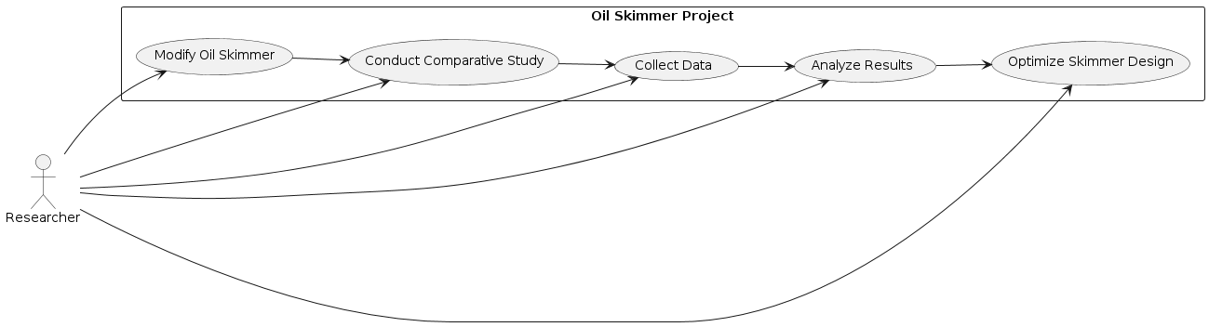
Fig.1. Methodology for Proposed Model
IV. Experimental Setup
The experimental setup for this project is crucial for ensuring the accuracy and reliability of the results obtained from testing the modified belt-type oil skimmer. The design and construction of the prototype skimmer focused on creating an interchangeable belt system and an adjustable skimming angle mechanism. The interchangeable belt system was designed to facilitate the easy swapping of belts without significant downtime. It consisted of a belt tensioning mechanism with adjustable rollers and tension springs to maintain consistent tension across different belt materials, along with quick-release clamps to enable fast and secure attachment and detachment of belts. Two sets of belts, polyurethane and PVC, were prepared with identical dimensions to ensure comparability in performance tests. The assembly involved mounting the belts on a series of rollers driven by an electric motor, ensuring smooth and continuous motion. The adjustable skimming angle mechanism was designed to allow the belt to contact the oil surface at various angles, ranging from 0° to 45°. This mechanism included a pivoting frame, adjustable locks, and a protractor scale for precise angle measurement. The frame was mounted on a pivot point for smooth angle adjustments, and the locks were calibrated to hold the frame securely at different angles.
The materials and equipment for the experiments included polyurethane and PVC belts, selected for their specific properties, and a large, rectangular tank to simulate a marine environment. The tank, constructed from transparent acrylic for visibility and durability, measured approximately 2 meters in length, 1 meter in width, and 1 meter in depth. It was filled with clean water to a depth of 0.8 meters, and a fixed amount of oil (e.g., 10 liters) was added to simulate an oil spill. Monitoring equipment included digital scales to measure the weight of recovered oil, high-resolution cameras to visually monitor and record the skimming process, temperature and viscosity sensors to monitor the properties of the oil and water, and a digital data logging system to record measurements and observations in real-time.
Experimental procedures involved testing different belt materials and skimming angles. For the belt material tests, the prototype skimmer was placed in the tank, and each belt type (polyurethane and PVC) was tested under identical conditions. The belt was mounted, tension adjusted, and the skimming angle set to a standard value (e.g., 30°). The skimmer was operated for a fixed period (e.g., 30 minutes), during which oil recovery was continuously monitored. The weight of the recovered oil was measured at regular intervals, and the condition of the belts was
recorded. Each test was repeated multiple times to ensure reliability and accuracy. For the skimming angle tests, the skimmer was configured to operate at different angles (0°, 15°, 30°, and 45°). For each angle, the skimmer was tested with both polyurethane and PVC belts, following similar procedures as the belt material tests.
Data collection and analysis focused on measuring the oil recovery rate, assessing belt wear and durability, and monitoring operational stability. The amount of oil recovered was measured using digital scales, and the oil recovery rate was calculated as the weight of oil recovered per unit time. After each test, the belts were inspected for signs of wear, and observations were documented with photographs. The wear and durability of polyurethane and PVC belts were compared to determine the more durable material. The stability of the skimmer’s operation was monitored throughout each test, with any operational issues recorded. The collected data were subjected to statistical analysis to identify significant differences in performance between the two belt materials and across different skimming angles. Results were graphically represented to visualize trends and patterns, and the optimal combination of belt material and skimming angle was identified based on the analysis.
Safety considerations and protocols were strictly followed during all experimental procedures. Proper safety measures included the use of personal protective equipment (PPE) and adherence to standard laboratory safety protocols. Procedures for the safe handling and disposal of oil were established to prevent environmental contamination and ensure researcher safety. Emergency protocols were in place to address any spills or accidents that might occur during testing. This detailed experimental setup ensures a systematic and controlled approach to evaluating the performance of the modified belt-type oil skimmer, aiming to identify the optimal configuration for maximum oil recovery efficiency. The comprehensive data collection and analysis processes provide robust and reliable insights, contributing to the advancement of oil skimming technology and improving oil spill response strategies.

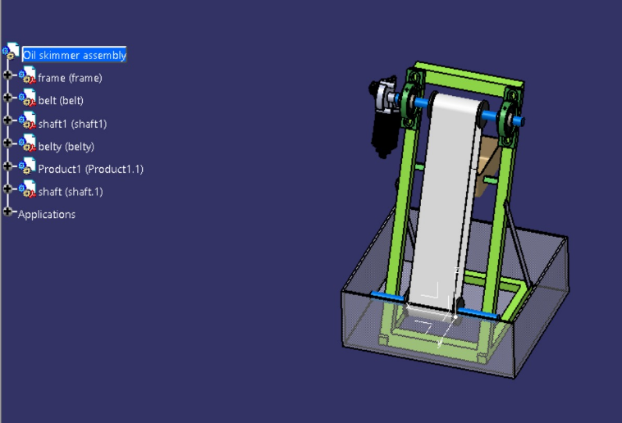
Fig.2. CAD Model Proposed Model

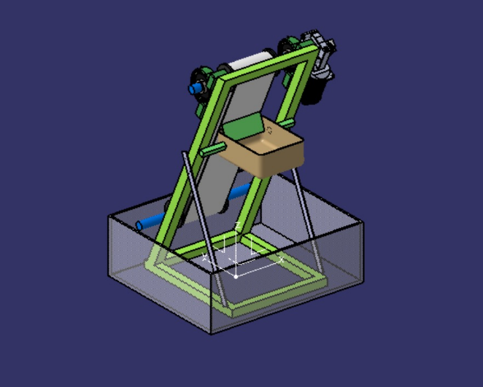
Fig.3. CAD Model side view
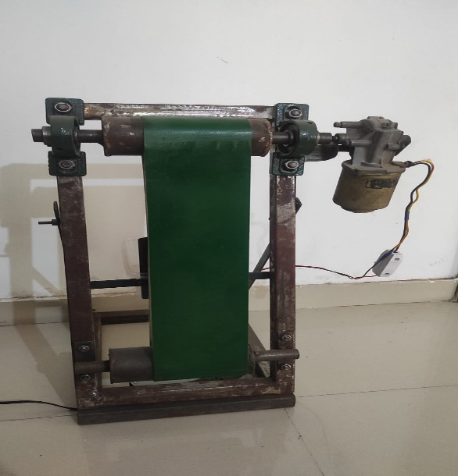
Fig.4.Prototype of oil skimmer
V.Results and Discussion
The project's findings from the comparative study of different belt materials and skimming angles in the modified oil skimmer revealed several key insights into enhancing oil recovery efficiency.
1.Belt Material Comparison:
- Polyurethane Belts: These belts exhibited superior oil recovery performance compared to PVC belts. Their flexibility, durability, and resistance to oil degradation allowed for more effective removal of oil from the water surface.
- PVC Belts: While PVC belts were less efficient in oil recovery, they still demonstrated a reasonable level of performance. The cost-effectiveness of PVC may make it a practical choice for applications where frequent belt replacement is not a concern.
2.Skimming Angle Variation:
- Optimal Angle: The study identified a skimming angle of approximately 80° as the most effective for both belt materials. This angle ensured optimal contact between the belt and the oil layer, maximizing oil recovery efficiency.
- Angle Influence: Deviating from the optimal angle led to decreased efficiency, highlighting the importance of selecting the correct skimming angle for efficient oil recovery operations.
3.Operational Stability:
- Continuous Operation: The skimmer demonstrated consistent operational stability throughout the testing period, with no significant downtime or mechanical failures reported. This reliability is crucial for ensuring uninterrupted oil recovery operations, especially during large-scale spill responses.

- Maintenance Requirements: Minimal maintenance was required during the testing phase, indicating that the skimmer design was robust and able to withstand prolonged use without significant wear or degradation.

- Environmental Adaptability: The skimmer's ability to operate effectively in various environmental conditions, such as varying water temperatures and oil viscosities, further demonstrated its operational stability and versatility.
4.Belt Wear and Durability:
- Observations of belt wear and durability indicated that polyurethane belts exhibited less wear and maintained their effectiveness over a longer period compared to PVC belts. This factor should be considered when evaluating the long-term cost-effectiveness of the skimmer.
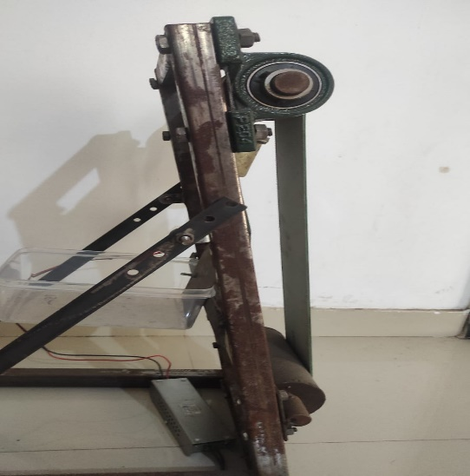
Fig.5.Adjustment for change in angles
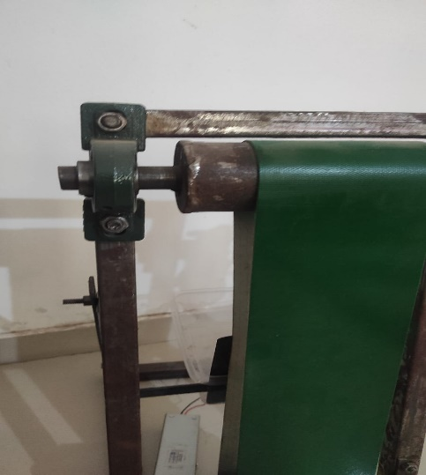
Fig.6.Adjustment for changing belts
The comparative study's results underscore the importance of material selection and skimming angle adjustment in optimizing oil recovery efficiency. The superior performance of polyurethane belts highlights their suitability for applications where high durability and efficiency are paramount. However, the reasonable performance of PVC belts suggests that they could still be a viable option for less demanding applications, considering their lower cost.
The identified optimal skimming angle of 30° provides valuable guidance for skimmer design and operation. Adjustable skimming angles can enhance a skimmer's adaptability to varying environmental conditions, potentially improving its overall effectiveness in oil spill response scenarios.
Future research could explore additional factors influencing skimmer performance, such as belt thickness, surface texture, and the effect of different oil types on recovery efficiency. Overall, the project's results contribute valuable insights to the field of oil spill response technology, demonstrating the potential for enhancing oil recovery operations through innovative modifications to skimmer design and operation.
V.CONCLUSION
The research project on the modified belt-type oil skimmer with provisions for interchangeable belts and adjustable skimming angles has yielded valuable insights into improving oil spill recovery efficiency. The comparative study between polyurethane and PVC belts, along with varying skimming angles, has provided a comprehensive understanding of the factors influencing skimmer performance.
The results indicate that polyurethane belts outperform PVC belts in terms of oil recovery efficiency. The flexibility, durability, and oil resistance of polyurethane make it a more suitable choice for applications requiring high performance and reliability. However, the cost-effectiveness of PVC belts may make them a viable option for certain scenarios where frequent belt replacement is not a concern.
The optimal skimming angle of approximately 30° has been identified as the most effective for both belt materials. This angle ensures optimal contact between the belt and the oil layer, maximizing oil recovery efficiency. Deviating from this angle leads to decreased efficiency, highlighting the importance of selecting the correct skimming angle for efficient oil recovery operations.
Operational stability of the modified oil skimmer was demonstrated throughout the testing period, with no significant issues reported. The skimmer's ability to operate continuously and reliably under various environmental conditions is a testament to its robust design and construction.
Minimal maintenance requirements further enhance the skimmer's practicality and efficiency in real-world oil spill response scenarios.
The study's findings underscore the importance of material selection and skimming angle optimization in maximizing oil spill recovery efficiency. The superior performance of polyurethane belts and the optimal skimming angle of 80° provide valuable guidance for future skimmer design and operation. Additionally, the project's demonstration of operational stability and minimal maintenance requirements highlights the skimmer's potential for practical and efficient use in oil spill response efforts.
In conclusion, the research project has provided valuable insights into enhancing oil spill recovery operations through innovative modifications to existing skimmer technology. The findings can inform future developments in oil spill response strategies, emphasizing the importance of material selection and skimming angle optimization for maximizing recovery efficiency. Further research could explore additional factors influencing skimmer performance, such as belt thickness and surface texture, to enhance oil recovery efficiency even further.

VI. REFERENCES.
[1] Guzman, L. and Campodonico, I. (1981). Studies after the Metula oil spill in the Straits of Magellan, Chile. In Proceedings of the Petromar '80 Conference, Monaco, 363-376. Graham and Trotman Ltd., London, UK.
[2] Winslow, R. (1978). Hard aground: The story of the Argo Merchant oil spill. W.W. Norton & Company Inc, New York, USA.
[3] Marine Pollution Bulletin, Vol. 10. pp. 193-197. Pergamon Press, Ltd. 1979.
[4] Butler, J.N. (1978). The largest oil spills. Inconsistencies, information gaps. Ocean Industry, October 1978, pp.101-112.
[5] National Research Council. Using Oil Spill Dispersants on the Sea. National Academy Press, Washington, D.C. p.321.
[6] Lu, Jin, and Scott A. Socolofsky. "Optimization of an oil skimmer system for effective oil spill response." Marine Pollution Bulletin 103, no. 1-2 (2016): 173-182.
[7] Bragg, J.R., and P.A. Owens. "Oil spill response: a global perspective." Environmental Reviews 21, no. 3 (2013): 135-152.
[8] Alves, J., et al. "Study of the operational parameters of an oil belt skimmer." Journal of Environmental Management 95, no. 1 (2012): S108-S113.
[9] Davis, M. L., and R. J. Orth. "A review of the biology and ecology of oil skimmers." Spill Science & Technology Bulletin 4, no. 3 (1997): 241-247.

